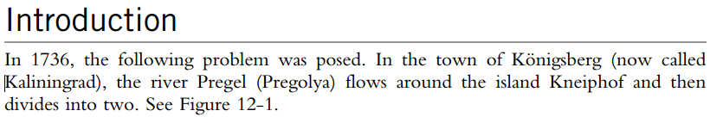

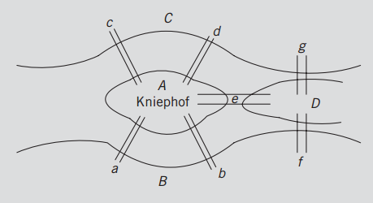

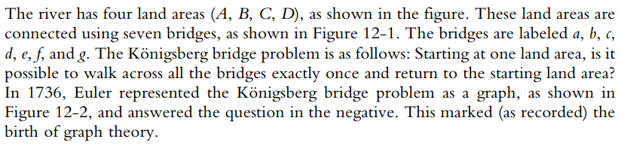

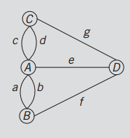

**Example: Flowcharts**

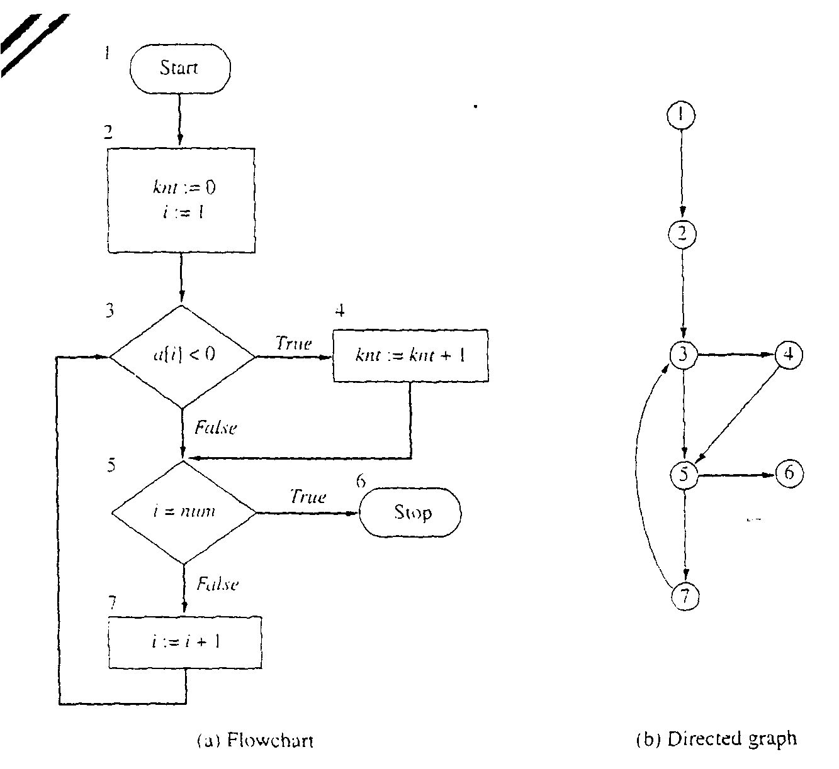

**Example: Computer Networks:**

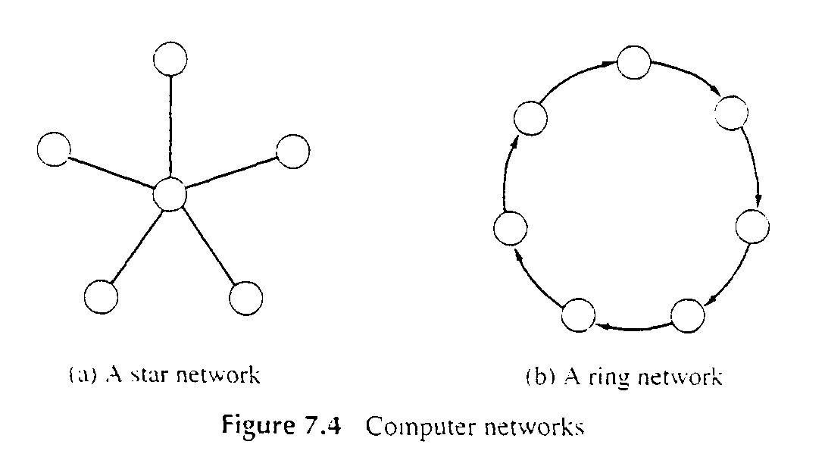

* **Directed Graph**

1. A directed graph, or digraph, is a pair
2. G = (V, E)
3. where V is a set whose elements are called vertices, and
4. E is a set of ordered pairs of elements of V.
   * + Vertices are often also called nodes.
     + Elements of E are called edges, or directed edges, or arcs.
     + For directed edge (v, w) in E, v is its tail and w its head;
     + (v, w) is represented in the diagrams as the arrow, v -> w.
     + In text we simple write vw.

* **Undirected Graph**
  + A undirected graph is a pair
  + G = (V, E)
  + where V is a set whose elements are called vertices, and
  + E is a set of *unordered* pairs of *distinct* elements of V.
    - Vertices are often also called nodes.
    - Elements of E are called edges, or undirected edges.
    - Each edge may be considered as a subset of V containing two elements,
    - {v, w} denotes an undirected edge
    - In diagrams this edge is the line v---w.
    - In text we simple write vw, or wv
    - vw is said to be *incident* upon the vertices v and w

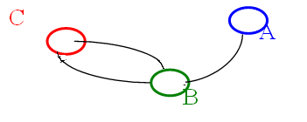

C

B

A

**If Undirected**

**V = {C, B, A}**

**E = {{A, B},**

**{C, B},**

**{B, C}}**

**If Directed**

**V = {C, B, A}**

**E = {(A, B),**

**(C, B),**

**(B, C)}**

**Adjacency Matrix:**

A |V| x |V| array in which an element (u, v) is true if and only if there is an edge from u to v

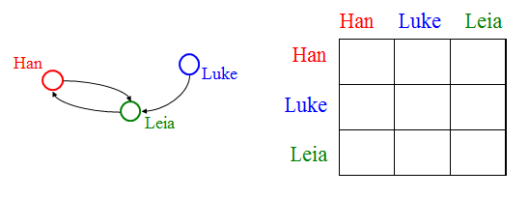

**Adjacency List:**





