

**Elements are added and removed from one end only.**

**Last In First Out (LIFO) data structure.**

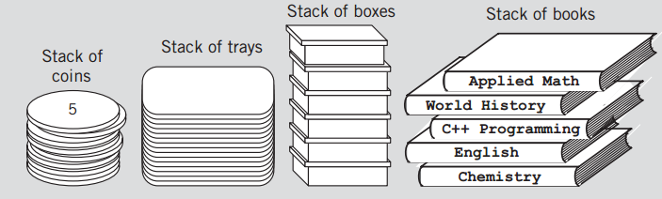

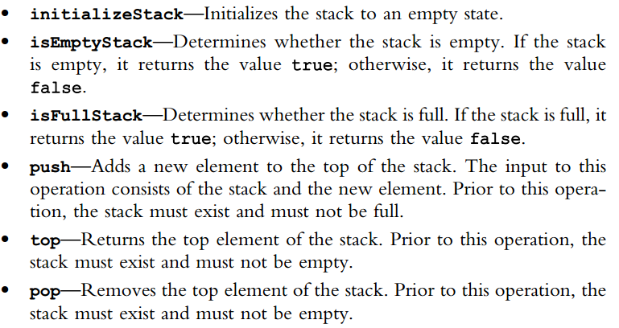

**Infix, Postfix and Prefix**

Infix, Postfix and Prefix notations are three different but equivalent ways of writing expressions.

Postfix notation (also known as "Reverse Polish notation"): X Y +

Prefix notation (also known as "Polish notation"): + X Y

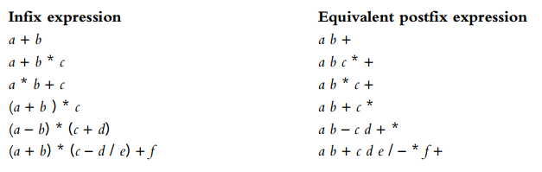

(a+b) = ab+

a+b*c = (a+(b*c)) =(a+(bc)*)=(a(bc)*)+ = abc*+

a*b+c= ((a*b)+c) = ((ab)*+c) = ab*c+

(a+b)*c = ((a+b)*c) = ab+c*

