**Airbnb Growth Case Study: Performance Marketing Analysis**

**Intro**

Airbnb is a two-sided marketplace which matches guests to hosts. The Growth Marketing team runs guest acquisition campaigns across a variety of paid channels including Google AdWords and Facebook Ads. This team's operational goal is to maximize booking revenue within a given budget. This is a sample analysis of the paid acquisition campaigns run from June - August 2018. The paid marketing campaign used is fabricated.

**Prompt**

1. How much money did Airbnb spend on the paid marketing in August and how many bookings did they drive?
2. What other key metrics would you propose to measure the overall success of this program? Make sure to clearly define these metric(s) and explain how each is computed.
3. What areas of the program are doing well and what could be improved? This includes (but is not limited to) advertising platforms, languages, origin/destination markets, campaign types, etc.
4. The team has an additional $1m to invest next month. Which areas should we invest in to get the best return?
5. There is also interest from executives at Airbnb about the work the team is doing, and a desire to understand the broader framing of paid user acquisition, thinking beyond the data provided. What other research, experiments, or approaches could help the team and the company get more clarity on the problem?

---

**1. Finding total spend and total bookings for August 2.**

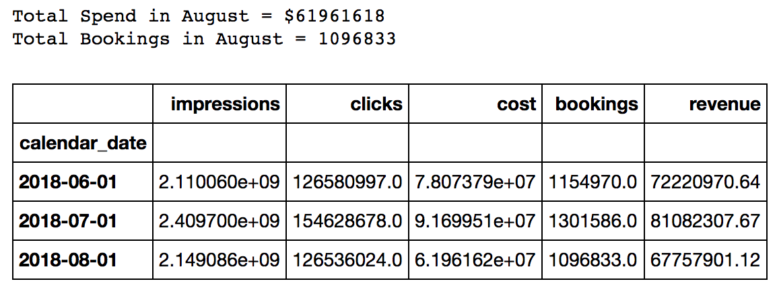

---

**2. What other key metrics should be measured?**

**See-Think-Do**

See-Think-Do is a helpful framework for viewing the paid acquisition funnel. ‘See’ is your total addressable market These are all the folks who are a good fit for our core home rental product because they like to travel and connect with new places around the world. ‘Think’ is the percentage of those people who are starting to consider buying from your industry. ‘Do’ is the subset of those folks who are actively looking to book a new trip on Airbnb or a similar Homes service. They are typically the most cost-effective segment to target with paid advertising.

|  |  |  |
| --- | --- | --- |
| Segment | Channels | KPIs |
| See | **Facebook (Non-Remarketing) Display, App Brand, App Non-Brand** | **CPM, Clicks, CPC** |
| Think | **SEM Non-Brand, Facebook (Remarketing)** | **Bookings, CPA, ROAS** |
| Do | **SEM Brand** | **Bookings, CPA,**  **ROAS** |

**KPIs**

* Bookings is the team's North Star metric, which means that maximizing bookings within a given budget is the primary goal. The two most important input metrics that guide decision-making around how well the team is acquiring bookings are cost per acquisition (CPA) and return on ad spend (ROAS).
* **CPA**, or total costs / total bookings, tells you how much it cost us to acquire a new booking. **ROAS**, or (revenue - costs) / costs, shows how much incremental revenue a campaign or channel generates compared to the cost of running the campaign.
* Some other KPIs to track for upper funnel campaigns include: **total** **clicks**, **CPC** which is costs / clicks, and **CPM** which is (costs / impressions) *1000.

**3. What areas are doing well and what could be improved?**

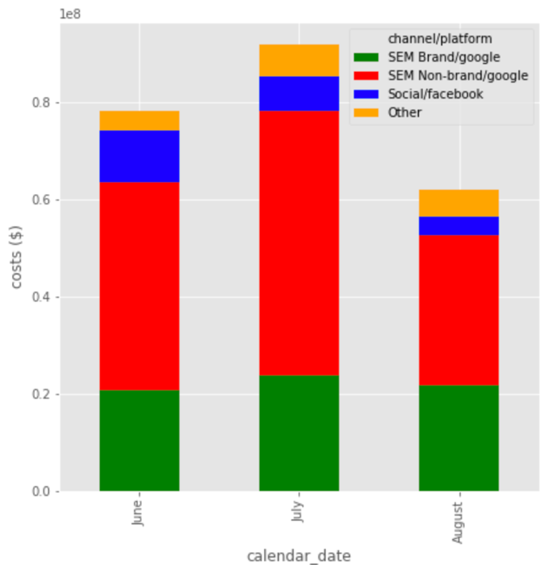 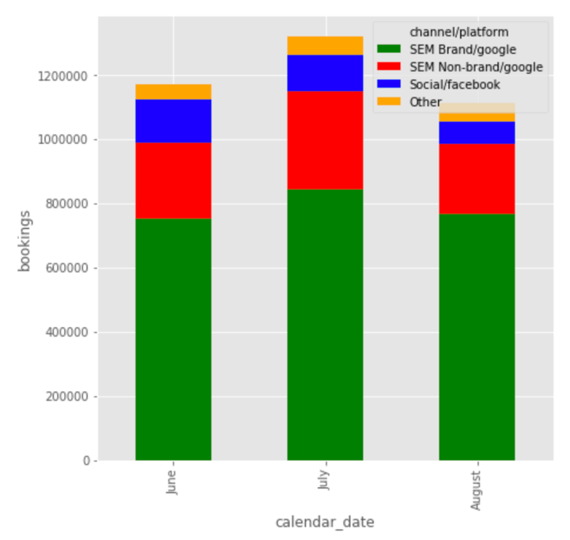

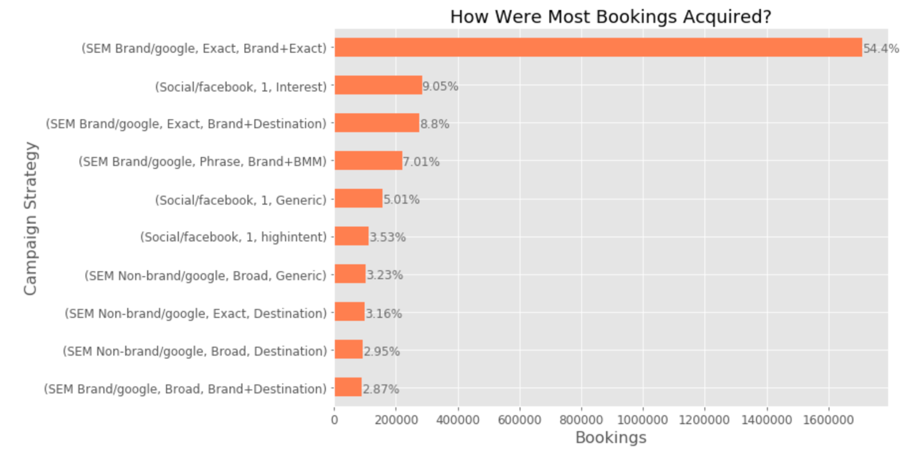

**4. Which areas should we invest an additional $1M in to get the best return?**

The team should invest an additional $1M of ad budget in Facebook ads. SEM Brand ins inherently limited because there are only so many folks searching for your product. SEM Non-brand is highly competitive and has proven to a negative ROI channel for three straight months. Facebook/Instagram has the highest potential to scale of the three channels. As a channel, it has the most precise targeting abilities, which makes it affordable even for Interest-based strategies:

**Top 10 Channels, Campaign Strategies by CPA**

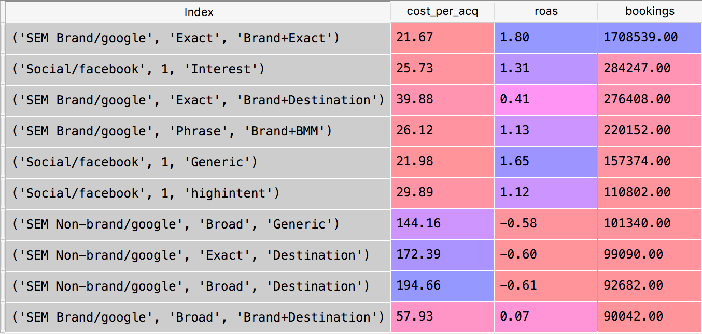

*Three of the top 6 campaign strategies are on Facebook, which makes up only 10% of ad spend and has room to scale.*

Interest, generic, and highintent (remarketing, symbolized by the 1) are all sub-$30 CPA. I would spend the additional $1M evenly across these three channels to continue to learn which strategy is the most effective as the Facebook/Instagram program scales.

I would also dial back SEM Non-brand ad spend up to 30% over the next 12 months and spend that money on continuing to optimize SEM Brand and Facebook ad campaign strategies.

**5.What other research, experiments, or approaches could help the team and the company get more clarity on growth?**

One benefit of scaling up Facebook/Instagram ads is that the team can experiment more than it can on Google with things like creative, audiences, and remarketing. Some experimentation ideas that are uniquely suited to Facebook/Instagram: video advertising, influencer marketing, and profile-based advertising. I would also suggest investing in new kinds landing pages to engage casual 'See' and 'Think' users on Instagram. Content like Top 10 Places to Visit in X can be highly productive at scale and help grow brand awareness and stickiness.

Paid acquisition is tricky to grow, at scale. Everything that goes into your best models is dynamic – per-channel CAC, ad saturation, competitive dynamics, scale effects, etc. But that’s what makes the game of growth fun in the first place. It would be boring if everything was linear and you could figure it out with one magic formula.