1. INTRODUCTION

Wireless body area network (WBAN) is a biomedical sensor network nodes connected wirelessly to the communication on, in and near the area of the body, which monitoring the real data of body to improve health care. The rapid growth in the field of nanotechnology over the last two decades has provided us tools to design and fabricate nanostructured components such as nanosensors, nanoactuators, and nanoprocessors. These devices provide health care monitoring and feedback to external entities. The information of health can be recorded over a longer period of time to improve the measurement quality of data.

Wireless body area network (WBAN) is a body area Nanonetwork where nanosensors are distributed in the human body to measure body parameters such as the presence of glucose and oxygen in blood, cholesterol, infectious agents, body temperature and heart beat. The main theme of nanosensors is health monitoring, disease detection and drug release. Size of Nanosensor in human body is 1-100nm.

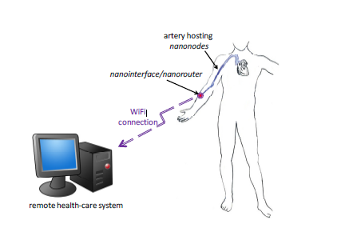 Energy efficiency is key factor in Wireless body area network (WBAN).The design of nanonodes is made to use energy effectively. Taking energy efficiency into consideration Mac protocol for single hop communication is used and Smac Protocol, where most nodes communicate as peer. Here all nodes are free to choose there own listener and sleep schedules.

The scheme involves hierarchical structure which includes nanointerface, nanorouter and nanonodes. The nanointerface is responsible for receiving request from external entities and returning the requested data from nanorouter to these entities. The nanorouter collects the data from nanonodes. The nanonodes are responsible for gathering data from human body.

Figure 1.1

1. LITERATURE SURVEY

Recent years ago medical field has no more development in its medical devices and healthcare systems. Wireless body area network is a kind of wireless sensor network which is wearable or implantable in the human body. WBAN is an emerging technology in the field of healthcare system, which is able to change the landscape of the medical system and its way of delivery. WBAN technology reduces the problem of wires in the healthcare system and increases the comfort of patient and provides the ability for healthcare system to monitor patient remotely.

A goal of body area network is healthcare system that guarantees continuous reliability, gathering of objectives, physiological and behavior aspect of a patient and delivers this information to external entities. In WBAN there are various issues faced like interference and eaves dropping that should be solved in body area network. Energy efficiency related issues resolved by various Mac layer techniques.



Figure 2.1 Applications of BANN

1. SYSTEM DESIGN

3.1 SYSTEM MODEL

In the design section of Body Area Nanonetwork (BANN) the nanointerface and nanorouter are static, where all nanonodes move at a constant speed along the artery with the direction of blood. The network area is assumed to have torus boundaries such that when nanonodes reach a boundary, it will move across the boundary and appear in the opposite side, then they perform various in-body

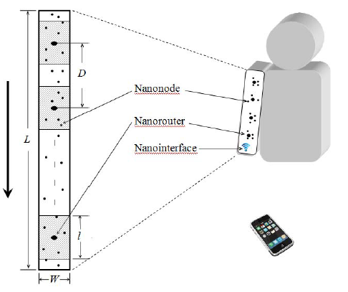 tasks.

In this process BANN is distributed along the artery of a human arm, which is assumed as rectangular area with length **L** and width **W.** Thenetworks consist of 1 nanointerface and **n** nanorouters placed vertically at distance **D** and multiple nanonodes with density **μ.** We denote **λ** for arrival rate of the external requests to nanointerface.

Depending on the amount of available energy, each nanonode can operate in three states, namely, sleep state, active state and invalid state as follows:

Figure 3.1

Illustration of system model

**Sleep state:**The nanonodes will not do any operations in this state.

**Active state:**Energy consumption happens in this state. Whenever the requests from a nanorouter arrive at the nanonode, it will turn into active state from sleep state to perform the related tasks. After completing the task, it will automatically turn back to the sleep state.

**Invalid state:** when the energy level of the nanonode goes below some threshold Eth, it will become invalid and cannot participate in any operation. until its energy exceeds Eth.

3.2 PROPOSED DATA COLLECTION SCHEME

The data collection scheme is based on wake-up mechanism and hierarchical collection process. The data collection process starts when external entity requests it. We define the following messages:

**Request message:**It is forwarded by the nanointerface to all nanorouters to indicate what kind of data the external entity is requesting. **Mr**is used to indicate the size of request message.

**Activation message:**The nanorouter activates sleep nanonodes. The nanonodes outside this region cannot receive the activation message and still remain in the sleep state. **Ma**is used to indicate the size of the activation message.

**Energy feedback message:**It is answer from nanonode for activate message and contain the available energy of the nanonodes.

**Me**is used to indicate the size of the energy feedback message.

**Answer message:**It is the answer generated by the nanonode and sent back to the nanointerface. **Ms**is used to indicate the size of the answer message.

The Process works as follows:

1. The nanointerface sends the **Request message**to all the nanorouters

2. Each nanorouter broadcasts an **Activation message**to the nanonodes

in a rectangle region centered at itself with length **L**and width **W**

3. **if** nanonode in wake-up region **then**

4. Wake-up nanonode and return **Energy feedback message**

5. Each nanorouter selects the one having the largest available

energy as the target nanonode and sends the **Request message**

to this nanonode.

6. The target nanonode starts gathering the requested data and

sends back an **Answer message**

**7. else**

8. nanonode continue keep sleep state

9. **end if**

* 1. EXPERIMENTAL SETUP

Wireless Body Area Nanonetwork (WBAN) can be implemented using NS3 simulator. The setup is made where the patient can carry out diagnose by himself and it is stored into the healthcare database and can be seen by the doctor and take actions on it. The patient can carry out diagnose anywhere and anytime.

3.3.1Parameters values calculated from sensors

* Electromyogram (EMG).
* GSR (Galvanic Skin Reflex).
* ECG signal.
* Blood Pressure (BP).
* Respiratory rate.
* Body Temperature.

3.3.2 Advantages of NS3 Wireless Body area Network Projects

* Location dependent monitoring.
* Cost savings.
* Mobility of the patients.
* Improving quality of lifetime of patients.

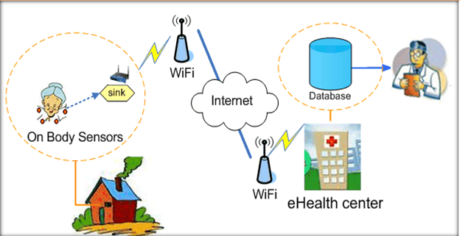

Figure 3.2 Architecture for WBAN

4. PERFORMANCE ANALYSIS

Theperformance of proposed data collection scheme is based on two important sections, namely, Average amount of energy available in each nanonode and average path-loss of selected target nanonode.

A. Average Available Energy

Average amount of energy available in each nanonode used to measure lifetime of BANN. To have a lifetime of network the nanonodes should have minimal power, data storage, processing, and communication capabilities.

Consider Ebtx to transmit a pulse (where Ebtx=1pJ), Ebrx to receive a pulse (where Ebrx=0.1pJ), Etx(x) to transmit a packet of x bits, Erx(x) to receive a packet of x bits.

We adopt the concept of TS-OOK (Time Spread On-Off Keying) where a pulse represents a bit 1otherwise bit 0 during transmission of message. TS-OOK configuration is used with pulse duration, pulse time interarrival and transmission range equal to 100fs, 100ps, and 10mm, respectively.

Lets us consider a packet of x bits, the energy required dealing with its transmission written as

Etx(x) = x **.** α **.** Ebtx  (1)

And reception can be written as

Erx(x) = x **.** Ebrx =0.1 **.** x **.** Ebtx  (2)

Where αis the probability to have a symbol 1 within the stream of *x* bits (generally, αis set to 0.5 because symbols are equiprobable). Thus, during one data collection process, the energy consumed for a general nanonode is

E1=Erx (Ma) + Etx (Me) (3)

And for the target nanonode is

E2=Erx (Mr) + Etx (Ms) (4)

The energy threshold Ethis defined as the amount of energy required to complete the request/response mechanism, that is:

Eth=β [Erx (Ma) + Etx (Me) + Erx (Mr) + Etx (Ms)] (5)

At the initial stage when network is built in human body nanonodes are fully charged (where Efull=800pJ).The available energy for a nanonode after the network runs for T time unit and it is formulated as

Eavailable= Efull – E1 – 1tar **.** E2 + Ecap (6)

where 1taris the indicator variable that equals 1 if the nanonode is selected as the target and 0 otherwise, Ecapis total harvested energy.

Average Available Energy (AAE) is the average amount

**AAE** Algorithm

1. nanorouter send activation message

2. **for** i=1 to sum (nanorouters)

3. **if** nanonode in ith cluster wake-up region **then**

4. nanonode energy-E1and return energy feedback message

5. **if** nanonode energy < Eth**then**

6. nanonode goto invalid state

7. **end if**

8. find the highest energy nanonode in the cluster

9. nanonode energy- E2

10. **else**

11. nanonode continue keep sleep state

12. **end if**

13. **end for**

14. Calculate all the average amount of energy available

15. all nanonodes energy+ Ecap

B. Path-loss

Average Path-loss of selected target nanonode used to measure the reliability of data collection. Path-loss affects the Electromagnetic (EM) waves in Terahertz band. In Path-loss A denotes traveling waves in terahertz band and given in dB, Aspread denotes spreading loss, Aabs denotes molecular absorption loss.

A (f, d) = Aspread (f, d) + Aabs (f, d) = (4πfd/c)2 + ek(f)d

where *d* is the total path length, *f* is frequency of the EM wave, *k* (*f*) is the absorption coefficient and *c* stands for the speed of light in the vacuum.

5. RESULTS

We consider a scenario as following, A length L=300mm, width W=1mm of the rectangular area, one nanointerface, 10 nanorouters positioned along the arm of the patient at a distance D=30mm, and a variable number of nanonodes (i.e., form 0.5 to 4 nanonodes/mm2) in a rectangle. Length of wake-up region Lis the horizontal distance between nanorouter and nanonodes in selection region. Whereas both nanointerface and nanorouters maintain a fixed position during the time, nanonodes move along the artery following the direction of the blood at the speed of 20 cm/s. The length of messages exchanged within the BANNs is set as in the following: Ma= Me= 48 bits; Mr= Ms= 176bits. The scheme has been configured in order to generate requests with parameter λchosen 0.05 request/s. Reported results have been averaged over 100 runs in order to minimize the impact of statistical fluctuations.

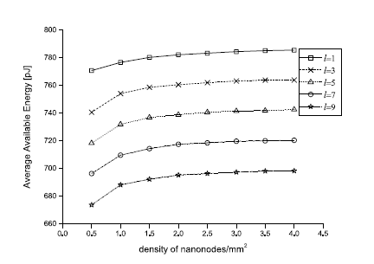

Figure 5.1

Figure 1 illustrate Average amount of energy stored in each nanonode is depends upon the density of nanonode. As the density of nanonode increases the available energy also increases. We adopt the wake-up mechanism so that activation message activates the nanonodes this conserver’s energy within nanonodes. On the other hand as the area of wake-up region increases there is probability of having multiple active nanonodes, thus leads to increase in the range of nanorouter as well. As soon as the number of satisfied requests raises, the available energy is hence reduced by transmission and reception mechanisms.

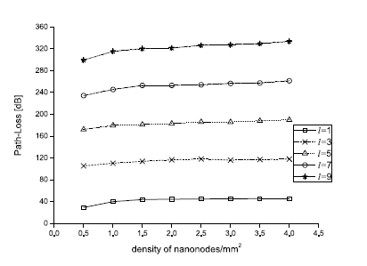Finally, we conclude that the available energy is directly proportional to the density of nanonodes.

Figure 5.2

The impacts on the density of nanonode and the length of the wake-up region L on the path loss are summarized in Figure 2. Due to the blood is mainly made from water, we assume the EM frequency is 300GHz, and the absorption coefficient is 123cm-1. From the results we prove that path loss increases as the length of the wake-up region increases. The quality of communication is increases as the nanorouter and nanonode are at shorter range. It can also be observed that the path-loss increase as the density of nanonode increases, the density of nanonode varies from1.0 to 1.5nanonodes/mm2.

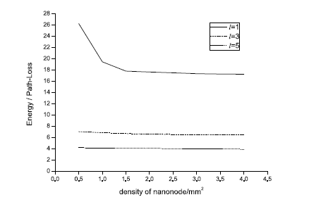

Figure 5.3

In order to illustrate the relationship among the network size, available energy and path-loss, we use the ratio of energy and path-loss as the research object. The results in Figure 3 show that there is also great change in the density of nanonode from1.0-1.5 nanonodes/mm2, which implies that it is a turning point between the network size with available energy and path-loss.

The results from Figure 5.1, Figure 5.2 and Figure 5.3 together show that this scheme can provide a flexible control of the system performances and better performances can be achieved when size of the network (i.e. density of nanonode) is from 1.0 to 1.5 nanonodes/mm2.

6. CONCLUSION & FUTURE SCOPE

This report describe the hierarchical network which has the ability of interaction among the BANN’s (Body Area Nanonetwork) and also communicating it with external monitoring device, to carry out this communication the wake-up mechanism is used. The performance of the network is evaluated through computer simulation. To achieve the proper results wake-up mechanism is used. This mechanism helps in conserving energy within the nanonodes which are not used in the process, the energy consumption and parameters of channel quality are used to carry out different operations when taken in to account.

Although wireless technology in the field of healthcare and medical applications is still nascent Wireless Body Area Network (WBAN) holds the promise to become a key infrastructure element in remotely supervised, home-based patient rehabilitation. As it has the potential to provide better and less expensive healthcare services and provides much benefit to patients, health care staffs, and the society. Already commercial products are being developed by several companies to solve wide range of health care problems. WBAN provides a continuous monitoring of the patient health it will improve the quality of life as it will allow patients to engage in normal activities of daily life, rather than staying at home or close to specialized medical services like hospital clinics etc. Some of the future applications of WBAN include Context-Sensitive Medicine, Patient Homecare and a Pre hospital Mobile Database for Emergency Medical Service.

7. REFERNCES

[1] M. Udin Harun Al Rasyid1, Bih-Hwang Lee2, Amang “Wireless Body Area Network For Monitoring Body Temperature, Heart Beat And Oxygen In Blood”, udinharun@pens.ac.id, bhlee@mail.ntust.edu.tw, amang@pens.ac.id.

[2] <https://en.wikipedia.org/wiki/Body_area_network>

[3] Ali, Najah Abu, and M. Abu-Elkheir. "Internet of nano-things healthcare applications: Requirements, opportunities, and challenges." 2015 IEEE 11th International Conference on Wireless and Mobile Computing, Networking and Communications (WiMob) IEEE Computer Society, 2015:9-14.

[4] <https://ieeexplore.ieee.org/document/7564185>

[5] G. Piro, L.A. Grieco, G. Boggia, and P. Camarda, “Simulating Wireless Nano Sensor Networks in the NS-3 platform”, {fg.piro,a.grieco,g.boggia,camardag} @poliba.it.

[6] <https://jneuroengrehab.biomedcentral.com/articles/10.1186/1743-0003-9-21>

[7] Bo Liu∗†, Yuanyu Zhang, Xiaohong Jiang and Zhenqiang Wu, “An Energy-Efficient Data Collection Scheme in Body Area Nanonetworks”,liubojsj@snnu.edu.cn,yy90zhag@gmail.com,jing@fun.ac.jp,zqangwu@snu.edu.cn

[8] <http://ns3-code.com/ns3-wireless-body-area-network-projects/>