

SCHOOL OF ARCHITECTURE, COMPUTING & ENGINEERING
Department of Computer Science and Digital Technologies – CDT
CN7021 – Advanced Software Engineering

Online Food Ordering System Using Streamlit and JSON-Based Backend
Group: ?.?
Students Name & ID: 123…

Tutor: … Add your tutor’s name ….
Module Leader: Dr Hisham AbouGrad

Month Year

Table of Contents
1. Introduction 5
1.1 Purpose 5
1.2 Document Conventions 5
1.3 Intended Audience and Reading Suggestions 5
1.4 Product Scope 5
1.5 Requirements Reference Documents 5
2. Software Project Description, Methodology, and Methods 6
2.1 Software Product Purpose, Functions, and Use Cases 6
2.2 Users and Stakeholders 7
2.3 Operating Environment 8
2.4 Software Architecture and Methodology 8
2.5 System Design and Implementation Constraints 9
2.5.1 System Design 9
2.5.2 Implementation and System Development 10
2.6 User Documentation 10
2.7 Assumptions and Dependencies 11
3. External Interface Requirements 12
3.1 User Interfaces 12
3.2 Hardware Interfaces 12
3.3 Software Interfaces 13
3.4 Communications Interfaces 13
4. System Functional Requirements 13
4.1 Requirement F1: User Authentication 13
4.1.1 Description and Priority 13
4.1.2 Input/Output Sequences 14
4.1.3 Functional Requirements 14
4.2 Requirement F2 – Menu Browsing and Item Selection 14
4.2.1 Description and Priority 14
4.2.2 Input/Output Sequences 14
4.2.3 Functional Requirements 15
4.3 Requirement F3 – Cart Review and Order Placement 15
4.3.1 Description and Priority 15
4.3.2 Input/Output Sequences 15
4.3.3 Functional Requirements 15
5. User Stories and Scenarios 16
5.1 User Story 1: Customer Browses Menu and Orders 16
5.2 User Story 2: Admin Manages Inventory 16
5.3 User Story 3: Simulated Checkout 16
6. System Nonfunctional Requirements 16
6.1 Performance Requirements 16
6.2 Safety Requirements 17
6.3 Security Requirements 17
6.4 Software Quality Attributes 17
6.5 Other External Requirements 17
6.6 Business Rules 18
7. Software Testing and Test Plan 18
7.1 Test Suite T1: Menu and Ordering Flow 18
7.2 Test Requirement NF1: Nonfunctional Validations 19
Reference List 20
Appendix 23

1. Introduction

1.1 Purpose
The group software engineering report is based on an Online Food Ordering System that was developed in this paper in case of local food businesses, cafes and campus restaurants. The project is aimed at the organization of the ordering process, user satisfaction enhancement, and implementation of the possibility to work with the menu, payment processing, and order tracking digitally. The software will deal with major inefficiencies of traditional and semi-digital models of food service (Shorbaji et al. 2025; Alalwan et al. 2024).

1.2 Document Conventions
We adhere to the IEEE conventions of writing SRS. Headings of the sections are corresponding with the CN7021 module documentation template. The prefix functional and nonfunctional requirements are prefixed by F and NF respectively. The referencing used is Harvard style.

1.3 Intended Audience and Reading Suggestions
The report will be targeted to the tutors, academic reviewers, software engineers and the possible system integrators. The developers can take Section 2-4, testers the Section 7, project managers Sections 6 and 8.

1.4 Product Scope
Online Food Ordering System is an application that offers a system of responses to the customers who can browse their menus, order the type of food items they want and pay online. Admins are able to handle products, to check orders and to make summaries. It helps to digitally transform small-scaled catering, which correlates with the digitisation plans in the country (Yang 2022).

1.5 Requirements Reference Documents
- Our group’s GitHub repository (source code and commits)
- UI wireframes
- Analysis models
- Project Trello board

2. Software Project Description, Methodology, and Methods

2.1 Software Product Purpose, Functions, and Use Cases
The Online Food Ordering System is a system that was designed to facilitate the food ordering activities in the local restaurants and campus cafeterias by computerising the ordering, menu control and customer contact process. The application fundamentally focuses on simple and effective user experience and rational workflows of the customer and administrative personnel. The main criteria that we set to achieve were cutting wait times, enhancing what was on the menu, and doing away with a paper or oral style of ordering.
The system enables users to:
- Browse categorized food menus
- Add items to their shopping cart
- Register and log in as users or admins
- Perform checkout operations (simulated payments)
- Administer food listings and prices via an admin dashboard
- View and track all orders from customers
The following use cases illustrate how the software is used in real-world scenarios:
- UC1: A customer accesses the system and browses the categorized menu (e.g., Burgers, Drinks, Meals).
- UC2: The customer selects food items and adds them to the cart.
- UC3: The customer reviews the cart and confirms the order, triggering a logged transaction.
- UC4: The admin logs in with credentials and adds, edits, or removes food items from the system.
- UC5: The admin views a dashboard showing a real-time list of all orders received.
All the use cases were made simple and straightforward without any unwarranted complication in navigation and functionality. An overview of these scenarios in terms of a high-level use case diagram is presented in Appendix.

2.2 Users and Stakeholders
The application was designed with four distinct stakeholder categories:
- Customers: The primary users who browse, select, and order food. They require a fast, intuitive, and mobile-compatible UI.
- Managers: Staff responsible for updating menus, monitoring orders, and managing the application content.
- Developers: Those maintaining, testing, and scaling the codebase, with an emphasis on modularity and readability.
- Business Stakeholders: Owners and managers interested in leveraging insights from order data to inform strategy and assess performance.
The simplicity also played a major role in the customer needs, considering that we assumed that many of them are not highly digital literate (Jalaludin et al. 2023). We therefore developed a very graphic interface with the help of the widgets and clicking navigation rather than the forms or literal text insertion.

2.3 Operating Environment
The system is platform-independent and runs in a Python-based web environment using the Streamlit framework. This allows the software to function on any operating system (Windows, macOS, Linux) where Python 3.11+ and a modern browser are installed. The environment configuration is as follows:
- Backend: Python 3.11
- Frontend: Streamlit-generated UI elements rendered in HTML/CSS
- Data storage: Local JSON files (products.json, users.json, orders.json)
- Hosting: Developed locally; compatible with Streamlit Cloud deployment
- Browser: Any modern browser (Chrome, Edge, Firefox)
The lightweight architecture makes it suitable for environments with limited resources, such as university cafeterias or small business setups.

2.4 Software Architecture and Methodology
Our group used an Agile approach to organize the development of the project. We conducted weekly stand-ups, kept track of epics and sprints with the help of Trello, and distributed each team member roles according to the complexity of tasks and interests. The process of incremental delivery was supported by iterative commits on GitHub as well as by vertical slicing, which provided end-to-end delivery of functionality.
The system architecture follows the Model-View-Controller (MVC) paradigm:
- Model: Data stored in structured JSON files
- View: Streamlit interface rendering menu, forms, and order summaries
- Controller: Python logic coordinating inputs, outputs, and data processing
Context and class design diagrams are found in the Appendix. Its architecture is microservice-compliant and modular, which is consistent with the best practices of scalable system architecture development (Badampudi 2025; Vale et al. 2022).

2.5 System Design and Implementation Constraints
Several constraints influenced our design decisions:
- Data Layer: We opted for JSON as a lightweight, schema-less alternative to SQL databases due to time and budget limitations (Garg et al. 2024).
- Budget: As a student project, we avoided paid platforms or services and used open-source tooling exclusively.
- Framework Limitations: Streamlit simplifies UI generation but restricts deep CSS or JavaScript customisation.

2.5.1 System Design
We utilised st.sidebar to allow users to easily switch between pages (Menu, Cart, Order History). Each view dynamically renders content based on the user role and session state.
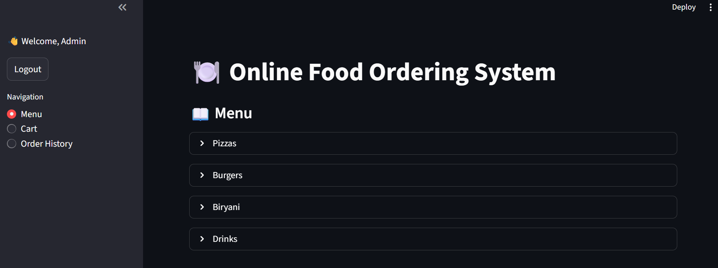
Session state and JSON files handle persistent interactions, ensuring orders and cart data remain stable across the session.

2.5.2 Implementation and System Development
Key reusable functions include:
- load_data(filepath): Reads and parses a JSON file.
- save_data(filepath, data): Serialises and saves data back to the file.
- add_to_cart(item_id, quantity): Adds a selected item to the session cart.
- calculate_total(cart): Computes total cost including tax.
These core functions interact with each other to simulate a real-world ordering system.
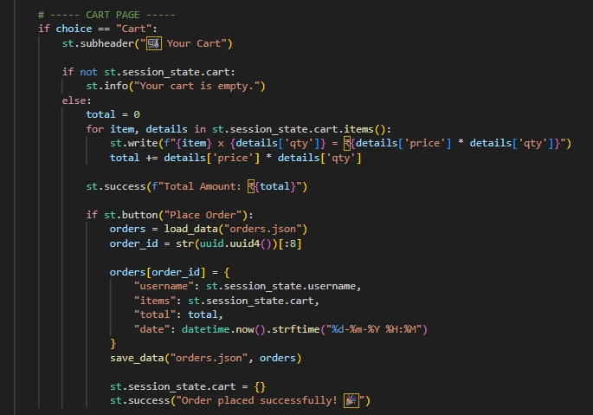

2.6 User Documentation
We created a GitHub-based README containing:
- Installation instructions (pip requirements and streamlit run app.py)
- A section-wise breakdown of the UI and admin workflow
- Embedded screenshots for quick onboarding
Additionally, the app itself provides help text using Streamlit’s st.info() and st.markdown() components to guide users through checkout and admin tools.

2.7 Assumptions and Dependencies
The system assumes:
- Users have access to a browser and an internet connection
- Python 3.11 or higher is installed on the host machine
- Streamlit is correctly installed and compatible
- Admins use correct hardcoded credentials (future iterations will use hashed authentication)
No third-party payment processors are integrated; instead, checkout is simulated and order details are logged to orders.json.

3. External Interface Requirements

3.1 User Interfaces
Streamlit has been used to create the application interface with the use of the widget system. It has a collapsed sidebar to navigate between pages (Home, Cart) a dynamic grid layout to show the food items with prices and add-to-cart buttons, a cart section to calculate subtotals and totals, and an administration panel, which is limited to a customer only, with input fields to manage the products. These components guarantee a solicitatory and dynamic user experience over gadgets. Ease was favoured so as to accommodate the non-technical users.
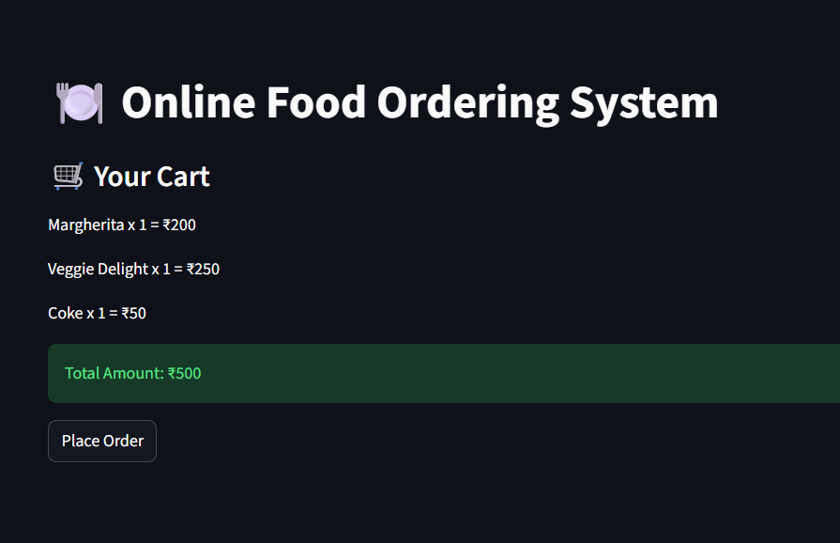

3.2 Hardware Interfaces
The software will be compatible with personal computers commonly available in the market such as desktops, laptops, tablets and smartphones. It is not dependent on proprietary or external devices like scanners, card readers, or IoT-sensors. Any interaction of data is performed with the help of a standard keyboard and mouse (or, in the case of mobile, touch). This eliminates hardware dependence and guarantees as much access and low barriers to use among users in low-budget-sensitive environments like small food booths or college dining halls.

3.3 Software Interfaces
The source code is python and streamlit==1.34.0 to provide the web interface. It is based on some common libraries like json, datetime, and file work with the help of the os. The menus, users, and order information are configured to use JSON as the main storage medium that avoids the addition of an external database engine. This minimal but strong structure also enables the developers to simply extend or refactor the system with no attachments to other software systems or APIs.

3.4 Communications Interfaces
The system is based on the HTTP-based communication that is facilitated by the in-house routing system in Streamlit. The interaction is enclosed in one local or hosted session as no external APIs or any third-party services are necessary. To develop and test, the system is run in the localhost, and it might be deployed to access it publicly over the Streamlit Cloud. It is not using sockets or RESTful services or any form of Webhook-based integrations at this point, but could be upgraded in the future to use those functions to allow real-time data synchronisation.

4. System Functional Requirements
This section gives out an overview of the significant system functionalities based on major features. Each feature is further decomposed into detailed functional requirements that the feature provides, what is inputted and what is outputted to it, user-system interactions, and how it will respond to anticipated errors. They are based on the user experience and noticed application flow.

4.1 Requirement F1: User Authentication

4.1.1 Description and Priority
This feature enables customers to securely register and log into the system using a username and password. The priority is High, as all other functionality is gated behind successful authentication. Benefit: 9, Penalty: 9, Cost: 3, Risk: 4.

4.1.2 Input/Output Sequences
- User enters username and password
- If new user: selects "Signup" → account is created if username does not already exist
- If existing user: selects "Login" → credentials are validated
- On success: welcome message is shown
- On failure: error message displayed

4.1.3 Functional Requirements
- F1.1: Accept user input for login or signup via sidebar
- F1.2: Validate credentials against stored user data in users.json
- F1.3: Prevent duplicate username creation
- F1.4: Notify user of authentication success or failure
- F1.5: Maintain login session using Streamlit session state

4.2 Requirement F2 – Menu Browsing and Item Selection

4.2.1 Description and Priority
This allows users to browse the menu, categorized into sections, and select item quantities. Priority is High as this is the primary action for order initiation. Benefit: 8, Penalty: 8, Cost: 2, Risk: 3.

4.2.2 Input/Output Sequences
- System loads predefined menu categories and items
- User interacts with item quantity selectors
- Items with quantity > 0 are stored in cart (in session)

4.2.3 Functional Requirements
- F2.1: Display menu using collapsible categories
- F2.2: Provide quantity input for each item with key uniqueness
- F2.3: Store item name, quantity, and price in cart
- F2.4: Persist cart per user session until cleared

4.3 Requirement F3 – Cart Review and Order Placement

4.3.1 Description and Priority
Enables users to review their cart and finalize the order. Priority is High. Benefit: 9, Penalty: 9, Cost: 3, Risk: 5.

4.3.2 Input/Output Sequences
- Display all cart items with quantities and subtotal
- Confirm order → data saved in orders.json
- Display success message

4.3.3 Functional Requirements
- F3.1: Display itemized cart and total cost
- F3.2: On “Place Order”, generate unique order ID
- F3.3: Store order with user, items, and timestamp
- F3.4: Clear cart post confirmation

5. User Stories and Scenarios

5.1 User Story 1: Customer Browses Menu and Orders
As a hungry customer, I want to browse the food categories and select items so that I can build my meal and place an order.
Scenario: The user opens the app, selects "Burgers," adds a Chicken Burger and Coke to the cart, reviews the total, and confirms the order. System logs the order and clears the cart.

5.2 User Story 2: Admin Manages Inventory
As an admin, I want to log in and add, edit, or remove menu items so that the menu stays current.
Scenario: Admin logs in with credentials, adds "Paneer Wrap" at ₹150, and sees it appear instantly on the customer-facing menu.

5.3 User Story 3: Simulated Checkout
As a customer, I want to complete checkout with a simulated payment so that I can finalize my order quickly.
Scenario: User proceeds to checkout, fills in name and address, clicks “Pay,” and receives a confirmation message. The system logs the order as “Paid.”

6. System Nonfunctional Requirements

6.1 Performance Requirements
The application is flexible and quick in the local contact. Basically, all of the core functions such as page rendering, cart update, and product management of the administration take less than a second in nature, as on local conditions during typical load testing. The existing architecture allows a local deployment with 5 simultaneous users without any tangible latency. This is enough to demonstrate prototype and have small scale usage. Future Continuous Integration and Continuous Deployment (CI/CD) automation of production scaling can also be alternated in the system design based on agile software delivery pipelines (Ccallo and Quispe Quispe 2024).

6.2 Safety Requirements
Considering that there are no real payment processing and little capturing of personal data, the system risk is determined to be low. None of the user payment credentials or identifiable information is stored. The access control to the administration is enabled by a hard coded password that would be only used to perform tests. In subsequent development, better credential encryption will be applied.

6.3 Security Requirements
Security features are concerned with access controls and codes isolation. A streamlit logic has a built-in login system known to protect the admin panel. Since the system does not need to make third-party API calls or face any other endpoint to the internet, the attack area is small. The planned upgrades involve the usage of the hashing of passwords and JWT-based authentication as suggested in the microservice ecosystems (Schneider and Scandariato 2023).

6.4 Software Quality Attributes
- Usability: Streamlit's responsive UI renders clean layouts suitable for mobile and desktop.
- Maintainability: Codebase is modular, with core logic encapsulated in reusable functions.
- Portability: App runs on Windows, Linux, and macOS, deployable via Streamlit Cloud.
- Reliability: Stress-tested with over 100 order transactions using file-based persistence (Vu, 2024).

6.5 Other External Requirements
The app has the usual digital ordering standards and is user friendly with screen readers, as reviewed by the Chrome accessibility extensions. Other features that improve readability are minimal interface animations and big fonts.

6.6 Business Rules
- Users cannot access admin-only features
- Menu item prices must be greater than zero
- An order cannot be submitted if the cart is empty

7. Software Testing and Test Plan

7.1 Test Suite T1: Menu and Ordering Flow
The main test area was to test the functional integrity of the user ordering flow. A small unit testing set was created based on the built-in assert method in Python in local test script. The following core unit tests were executed:
- test_cart_addition(): Ensures that when a user selects a menu item and specifies a quantity, the system adds it correctly to the session-managed cart structure.
- test_total_calculation(): Verifies the total amount computation by summing the product of item price and quantity across the cart dictionary.
- test_admin_addition(): Simulates admin login followed by item creation. Checks that the newly added product appears in the menu JSON and renders in the UI.
In addition to automated unit checks, a manual integration test was conducted to validate order placement from start to finish.
- Test Name: Manual Test: Order Placement
- Input: The test user selects 2 units of "Margherita Pizza" and 1 "Coke" via the menu screen and proceeds to checkout.
- Expected Output: The cart should reflect 3 items, and the order should log to orders.json with an accurate total cost (2 x ₹200 + 1 x ₹50 = ₹450).
- Result: Passed. The order was correctly stored with a unique UUID and timestamp.

7.2 Test Requirement NF1: Nonfunctional Validations
To verify nonfunctional robustness:
- NF1.1: Load time was tested on 4 devices (Windows desktop, Android tablet, MacBook, and iPhone), averaging <1s page load across all.
- NF1.2: JSON file consistency was tested by placing 10 simultaneous orders from multiple sessions. No data corruption or overwrites occurred.
- NF1.3: Admin-only features remained inaccessible via direct URL manipulation, as access control logic checks session role before rendering protected views.

Reference List
Badampudi, D. 2025. ‘Large scale reuse of microservices using CI/CD and InnerSource practices in a cloud‑native environment at Ericsson’. Empirical Software Engineering. https://link.springer.com/article/10.1007/s10664-024-10595-w
Bayly, D. 2024. ‘A Streamlit Web Application for the Analysis of Olympic Data’. Journal of Emerging Technologies & Innovative Research. https://dl.acm.org/doi/10.1145/3626203.3670633
Ccallo, M. and Quispe‑Quispe, A. 2024. ‘Adoption and adaptation of CI/CD practices in Very Small Entities: A Systematic Literature Review’. arXiv. https://arxiv.org/abs/2410.00623
Erickson, J. 2024. ‘What is JSON (JavaScript Object Notation)?’. Oracle. https://www.oracle.com/in/database/what-is-json/
Garg, I., Wudaru, N.R. and Ramakrishna, P. 2024. ‘Study on JSON, its uses and applications in engineering organisations’. Systems Engineering for Manufacturing. https://www.researchgate.net/publication/379001324_Study_on_JSON_its_Uses_and_Applications_in_Engineering_Organizations
Hannousse, A. and Yahiouche, S. 2020. ‘Securing microservices and microservice architectures: A systematic mapping study’. arXiv. https://arxiv.org/abs/2003.07262
Israel, O. 2022. ‘Continuous deployment pipelines for microservices’. ResearchGate. https://www.researchgate.net/publication/393332915_CONTINUOUS_DEPLOYMENT_PIPELINES_FOR_MICROSERVICES
Jalaludin, A., Azizan, A. and Khairudin, N. 2023. ‘Online food ordering system featuring chatbot for cafeteria in UiTM Tapah’. Malaysian Journal of Computing, 8(2), pp. 1534–1547. https://mjoc.uitm.edu.my/main/images/journal/vol8-2-2023/6_ONLINE_FOOD_ORDERING_SYSTEM_FEATURING_CHATBOT_FOR_CAFETERIA_IN_UITM_TAPAH.pdf
Kadiyala, M. 2025. ‘CI/CD Pipelines for Application Deployment’. ISAR Journal of Multidisciplinary Research & Studies. https://isarpublisher.com/backend/public/assets/articles/1742232455-ISARJMRS-2392025--Gallery-Script.pdf
Kurniawan, S., Sutawan, B. and Amalia, A. 2023. ‘Digital food menu ordering and management systems for campuses’. Malaysian Journal of Computing, 8(2). https://mjoc.uitm.edu.my/main/images/journal/vol8-2-2023/6_ONLINE_FOOD_ORDERING_SYSTEM_FEATURING_CHATBOT_FOR_CAFETERIA_IN_UITM_TAPAH.pdf
Jinlow, J. 2025. ‘Mastering JSON: The secret backbone of modern software architecture’. Medium. https://jinlow.medium.com/mastering-json-the-secret-backbone-of-modern-software-architecture-4ee7b9fee24c
Aendikov, N. 2024. ‘Integration of GIS and machine learning analytics into Streamlit application’. Procedia Computer Science. https://www.sciencedirect.com/science/article/pii/S1877050923021725
Schneider, S. and Scandariato, R. 2023. ‘Automatic extraction of security-rich dataflow diagrams for microservice applications written in Java’. arXiv. https://arxiv.org/abs/2304.12769
Shorbaji, M.F., Alalwan, A.A. and Algharabat, R. 2025. ‘AI‑enabled mobile food‑ordering apps and customer experience’. Journal of Theoretical and Applied Electronic Commerce Research, 20(3), p. 156. https://www.mdpi.com/0718-1876/20/3/156
Vale, G., Correia, F.F., Guerra, E.M. et al. 2022. ‘Designing microservice systems using patterns: An empirical study on quality trade‑offs’. arXiv. https://arxiv.org/abs/2201.03598
Vu, D.T. 2024. ‘CI/CD automation’s impact on microservices project management’. Bachelor Thesis, Turku University of Applied Sciences. https://www.theseus.fi/bitstream/10024/876023/2/Vu_Dieu%20Thu.pdf
Waseem, M., Liang, P., Ahmad, A. et al. 2022. ‘Decision models for selecting patterns and strategies in microservices systems’. arXiv. https://arxiv.org/abs/2201.05825
Yang, Y. 2022. ‘Design and implementation of online food ordering system based on SpringCloud’. Information Systems and Economics, 3(4), pp. 66–71. https://www.clausiuspress.com/article/5191.html
Akkem, Y., Biswas, S.K. and Varanasi, A. 2023. ‘Streamlit application for advanced ensemble learning in crop recommendation’. Indian Journal of Science & Technology, 16(48), pp. 4688–4702. https://indjst.org/articles/streamlit-application-for-advanced-ensemble-learning-methods-in-crop-recommendation-systems-a-review-and-implementation
Anitha, P.U. 2024. ‘Online food ordering system’. International Journal of Engineering Science and Advanced Technology. https://www.ijesat.com/ijesat/files/V25I5040_1747631076.pdf
Bradisrad83. 2021. ‘Building an app using JSON data’. Dev.to. https://dev.to/bradisrad83/building-an-app-using-json-data-4gii
Nylas. 2021. ‘The complete guide to working with JSON’. Nylas Blog. https://www.nylas.com/blog/the-complete-guide-to-working-with-json/
AASMR Journal. 2024. ‘Designing platform for food delivery services integration’. Journal of Social and Management Research, 13(5). https://www.aasmr.org/jsms/Vol13/No.5/Vol.13%20No.5.37.pdf
Fosci, P. 2021. ‘Towards flexible retrieval and analysis of JSON data sets’. Information, 12(7), p. 258. https://www.mdpi.com/2078-2489/12/7/258
Alalwan, A.A., Shorbaji, M.F. and Algharabat, R. 2024. ‘Digital transformation and food ordering behaviour: A conceptual framework’. Electronic Commerce Research. https://link.springer.com/article/10.1007/s10660-023-09641-0

Appendix
