IBM SkillsBuild Cyber Security Bootcamp 2026
Conducted by BharatCares
Network Intrusion Detection
Using Machine Learning
Project Report
Submitted by: Deeksha S
Dataset: KDD Cup 1999 (via scikit-learn)
Tools: Python, scikit-learn, Google Colab

Table of Contents

1. Abstract
2. Introduction
3. Problem Statement and Objectives
4. Dataset Description
5. Tools and Technologies
6. Methodology
7. Implementation
8. Results and Analysis
9. Discussion
10. Limitations
11. Conclusion
12. Future Scope
13. References

1. Abstract
Network intrusion detection is a core task in cyber security: identifying malicious connections among the large volume of normal traffic that flows through a network. This project builds a machine learning based intrusion detector that classifies each network connection as either normal or attack.
The KDD Cup 1999 network intrusion dataset was loaded directly from scikit-learn (100,655 connections with 41 features). The labels were converted to a binary form, the three categorical features were label encoded, the data was split 80/20 with stratification and the features were standardized. Three classifiers were trained and compared: Logistic Regression, Decision Tree and Random Forest.
On a test set of 20,131 connections the models achieved accuracies of 99.94%, 99.98% and 99.99% respectively. The Random Forest performed best and correctly detected 672 of the 675 attack connections in the test set (an Attack recall of about 99.6%) with no false alarms. Because the dataset is heavily imbalanced (about 97% normal traffic), recall on the Attack class was treated as the most meaningful measure alongside accuracy.

2. Introduction
As organisations and individuals depend more on networked systems, attacks such as denial of service, port scanning, probing and unauthorised access have become more frequent. An Intrusion Detection System (IDS) monitors network traffic and raises an alert when it sees activity that looks malicious.
Traditional signature based systems detect only attacks they already know. Machine learning offers a data driven alternative: a model learns the statistical patterns that separate normal connections from attacks, and can then flag new connections automatically. This project applies supervised machine learning to that problem using a well known public benchmark.

3. Problem Statement and Objectives
Problem statement: Given the recorded features of a network connection (protocol, service, bytes transferred, connection counts, error rates and similar), predict whether the connection is normal or an attack.
Objectives:
- Load and prepare a public network intrusion dataset without any manual download or external account.
- Convert the problem to binary classification (normal vs attack).
- Train and compare three machine learning models.
- Evaluate the models using accuracy, precision, recall, F1-score and a confusion matrix.
- Identify which network features contribute most to detecting attacks.

4. Dataset Description
The project uses the KDD Cup 1999 network intrusion dataset, one of the most widely used benchmarks for intrusion detection research. It was created from simulated network traffic captured for the 1999 KDD Cup competition. It is loaded in the notebook with the scikit-learn function fetch_kddcup99, using the 10% subset and the "SA" variant, so it is downloaded automatically the first time the notebook runs.
Property | Value
Source | scikit-learn: sklearn.datasets.fetch_kddcup99
Subset used | 10% subset, "SA" variant
Total records | 100,655
Number of features | 41
Normal connections | 97,278
Attack connections | 3,377
Target label | Binary: 0 = normal, 1 = attack

Dataset link:
https://scikit-learn.org/stable/modules/generated/sklearn.datasets.fetch_kddcup99.html

4.1 Features
Each record describes one network connection with 41 features. They include basic connection attributes (duration, protocol_type, service, flag, src_bytes, dst_bytes), content features (such as num_failed_logins, logged_in and num_compromised), and traffic features computed over a time window (such as count, srv_count, serror_rate and same_srv_rate), plus host based statistics (the dst_host_* features).
Three features are categorical text values: protocol_type, service and flag. All other features are numeric.

4.2 Class imbalance
The dataset is strongly imbalanced. Only about 3% of the records are attacks, as shown in Figure 1. This matters for evaluation: a model that predicted every connection as normal would already reach about 97% accuracy while detecting no attacks at all. For this reason the report places special attention on precision, recall and F1-score for the Attack class and not on accuracy alone.
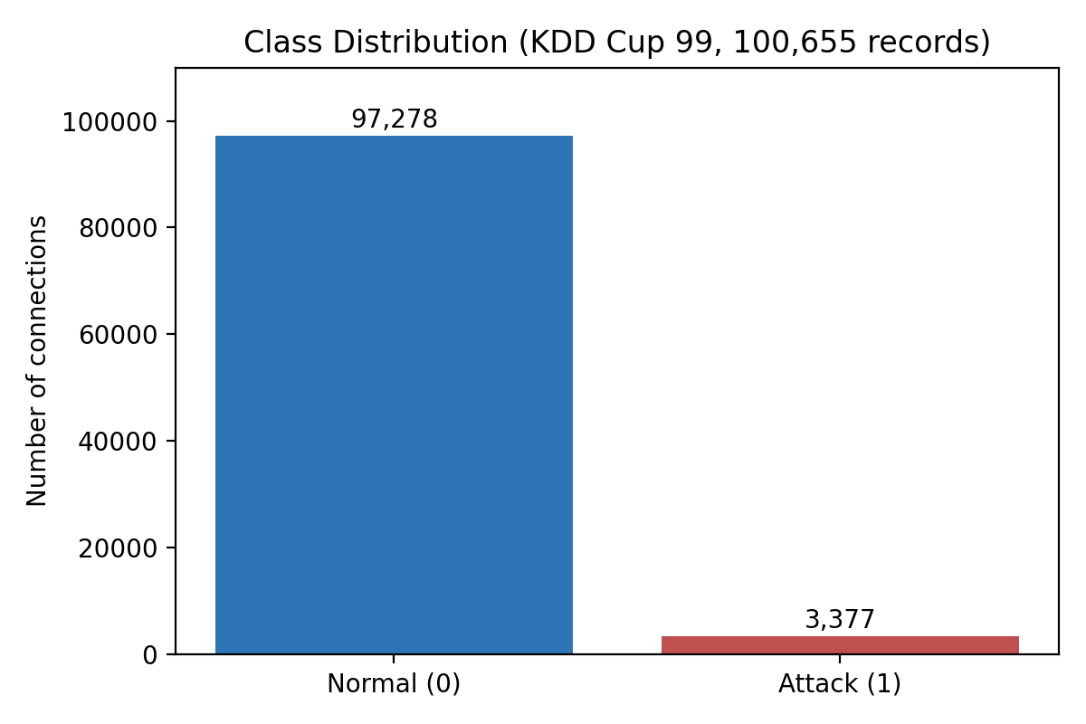
Figure 1: Class distribution of the dataset (normal vs attack).

5. Tools and Technologies
Tool | Purpose
Python 3 | Programming language for the whole project
Google Colab | Cloud notebook environment used to write and run the code
pandas, NumPy | Data loading, cleaning and numerical operations
scikit-learn | Dataset loader, preprocessing, model training and evaluation metrics
matplotlib, seaborn | Charts: class distribution, accuracy comparison, confusion matrix, feature importance

6. Methodology
The project follows a standard supervised machine learning workflow. Each step is described below and implemented in the notebook.
- Data loading: the KDD Cup 99 data is fetched from scikit-learn as a pandas DataFrame.
- Decoding: text columns arrive as bytes, so they are decoded to normal strings.
- Label conversion: the original attack names are collapsed into a single binary label (0 = normal, 1 = attack).
- Exploration: data types, shape and class balance are checked.
- Encoding: the categorical columns protocol_type, service and flag are converted to integers with label encoding.
- Splitting: the data is split into 80% training and 20% test sets, using stratification so both sets keep the same normal/attack ratio.
- Scaling: features are standardized with StandardScaler, fitted on the training data only to avoid data leakage.
- Training: Logistic Regression, Decision Tree and Random Forest classifiers are trained on the scaled training set.
- Evaluation: each model is tested on the unseen test set and compared with accuracy, precision, recall and F1-score; the best model is analysed with a confusion matrix and feature importance.

7. Implementation
The full code is in the notebook Deeksha_NetworkIntrusionDetector.ipynb. The main steps are shown below.

7.1 Loading the dataset
The dataset is fetched from scikit-learn. A helper function decodes bytes values, and the label is converted to binary form.
X, y = fetch_kddcup99(subset="SA", percent10=True, as_frame=True, return_X_y=True)

def to_text(v):
return v.decode("utf-8") if isinstance(v, bytes) else str(v)

for c in X.select_dtypes(include="object").columns:
X[c] = X[c].apply(to_text)
y = y.apply(to_text).str.rstrip(".")
y = (y != "normal").astype(int) # 0 = normal, 1 = attack

Output: the data has shape (100,655, 41), with 97,278 normal connections and 3,377 attacks.

7.2 Encoding categorical features
for c in ["protocol_type", "service", "flag"]:
X[c] = LabelEncoder().fit_transform(X[c])

7.3 Train/test split and scaling
X_train, X_test, y_train, y_test = train_test_split(
X, y, test_size=0.2, random_state=42, stratify=y)

scaler = StandardScaler()
X_train_s = scaler.fit_transform(X_train)
X_test_s = scaler.transform(X_test)

The test set contains 20,131 connections: 19,456 normal and 675 attacks.

7.4 Model training
models = {
"Logistic Regression": LogisticRegression(max_iter=1000),
"Decision Tree": DecisionTreeClassifier(random_state=42),
"Random Forest": RandomForestClassifier(n_estimators=100,
random_state=42, n_jobs=-1),
}
for name, model in models.items():
model.fit(X_train_s, y_train)
pred = model.predict(X_test_s)
print(classification_report(y_test, pred,
target_names=["Normal", "Attack"]))

7.5 Models used
- Logistic Regression: a linear model that estimates the probability that a connection is an attack. It is fast and simple and serves as a baseline.
- Decision Tree: learns a series of if/else rules on the features. It captures non-linear patterns and is easy to interpret.
- Random Forest: an ensemble of 100 decision trees whose votes are combined. It is usually more accurate and more stable than a single tree and gives feature importance scores.

8. Results and Analysis

8.1 Accuracy comparison
All three models were evaluated on the same unseen test set of 20,131 connections. Table 1 and Figure 2 summarise the results.
Model | Accuracy | Attack recall | Attack F1
Logistic Regression | 99.94% | 0.99 | 0.99
Decision Tree | 99.98% | 1.00 | 1.00
Random Forest | 99.99% | 1.00 | 1.00
Table 1: Test set results. Precision and recall values are rounded to two decimals, as printed by scikit-learn's classification report.
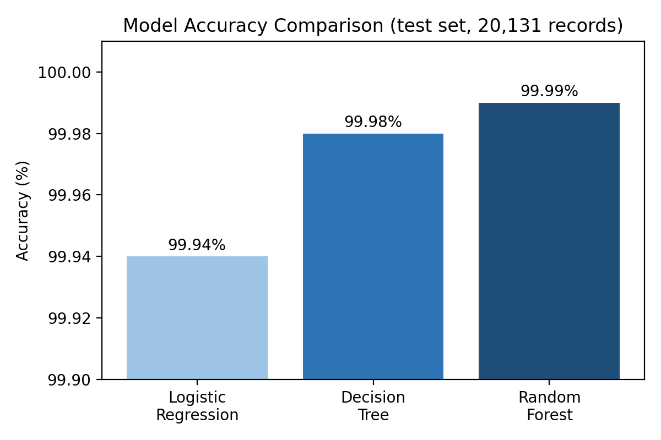
Figure 2: Accuracy of the three models on the test set.
The Random Forest achieved the highest accuracy (99.99%), followed by the Decision Tree (99.98%) and Logistic Regression (99.94%). The differences are very small, which reflects how separable this dataset is. In the classification reports, the precision, recall and F1-score for the Normal class were 1.00 for all three models. For the Attack class, precision was 1.00 for all models, and recall was 0.99 for Logistic Regression and 1.00 for the Decision Tree and Random Forest.

8.2 Confusion matrix (Random Forest)
The confusion matrix of the best model is shown in Figure 3. All 19,456 normal connections were classified correctly, so there were no false alarms (0 normal connections were flagged as attacks). Of the 675 attack connections, 672 were detected and 3 were missed (classified as normal). This gives an Attack precision of 100% and an Attack recall of about 99.6% (672 / 675). Only 3 of the 20,131 test connections were misclassified.
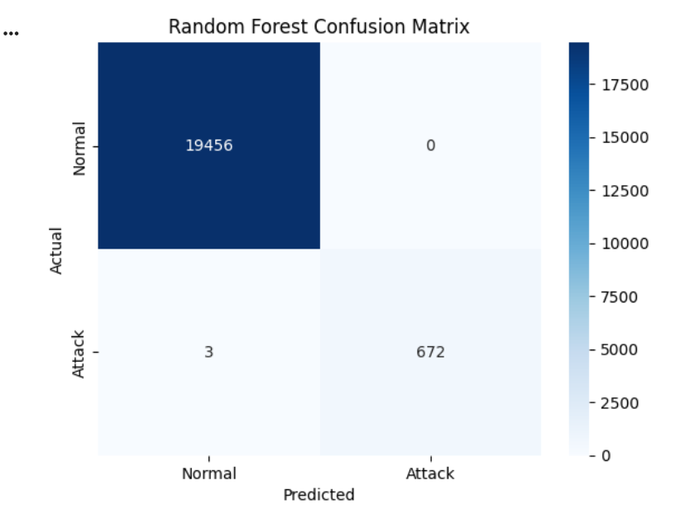
Figure 3: Confusion matrix of the Random Forest on the test set.

8.3 Feature importance
The Random Forest also reports how much each feature contributed to its decisions. The ten most important features are shown in Figure 4.
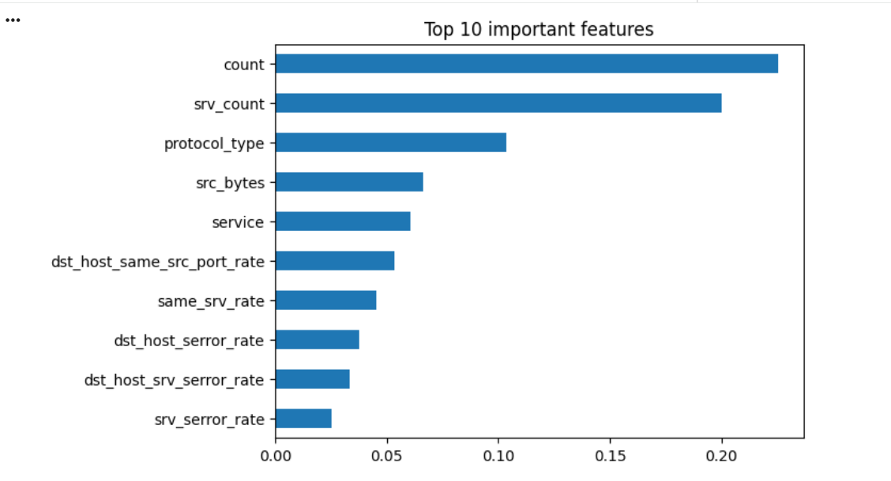
Figure 4: Top 10 most important features according to the Random Forest.
The two most important features were count (importance of about 0.22) and srv_count (about 0.20), followed by protocol_type (about 0.10) and src_bytes. The next most important features were service, dst_host_same_src_port_rate, same_srv_rate, dst_host_serror_rate, dst_host_srv_serror_rate and srv_serror_rate.
count and srv_count measure how many connections were made to the same host or the same service within a short time window. This suggests that bursts of connections are a strong indicator of attacks, which is consistent with how flooding and scanning attacks behave.

9. Discussion
- All models performed very well. Even the simple Logistic Regression baseline reached 99.94% accuracy, which shows that normal and attack connections in this dataset are highly separable.
- Random Forest was the best model, but its advantage over the Decision Tree is only a few connections out of 20,131.
- Accuracy alone is misleading here. With about 97% of records being normal, a high accuracy is easy to reach. Attack recall is the more useful measure, because a missed attack is far more costly than a false alarm in a security setting.
- Traffic-pattern features matter most. Features that count recent connections to the same host or service dominated the importance ranking.

10. Limitations
- KDD Cup 99 is an old dataset (1999) and its traffic does not reflect modern networks, protocols or attack techniques.
- The dataset is known to be easy, with many repeated and similar records, so near-perfect scores are expected and will not carry over to real-world traffic.
- Only the binary problem (normal vs attack) was studied. The specific attack types (for example DoS or probing) were not classified separately.
- A single 80/20 split was used, without cross-validation or hyperparameter tuning.

11. Conclusion
This project built and compared three machine learning models for network intrusion detection on the KDD Cup 99 dataset. The Random Forest performed best with an accuracy of 99.99%, followed by the Decision Tree (99.98%) and Logistic Regression (99.94%), and it detected 672 of the 675 attacks in the test set with no false alarms.
The project also showed the importance of looking beyond accuracy on imbalanced data, and identified connection-count features as the strongest signals of attacks. Although the results are near perfect, they should be read with care because of the age and simplicity of the dataset.

12. Future Scope
- Test on a modern dataset such as NSL-KDD or CIC-IDS2017 that better reflects current traffic.
- Extend to multi-class classification to identify the type of attack.
- Apply cross-validation and hyperparameter tuning, and try other models such as gradient boosting.
- Handle the class imbalance explicitly, for example with class weights or resampling.
- Evaluate the model on live or streaming network data.

13. References
- scikit-learn documentation: sklearn.datasets.fetch_kddcup99. https://scikit-learn.org/stable/modules/generated/sklearn.datasets.fetch_kddcup99.html
- KDD Cup 1999 Data, UCI Machine Learning Repository / University of California, Irvine.
- Pedregosa et al., "Scikit-learn: Machine Learning in Python", Journal of Machine Learning Research, 12, 2011.
- pandas, NumPy, matplotlib and seaborn official documentation.

