Theme:A

Theme

Main Theme = Sitting Golden Retriever

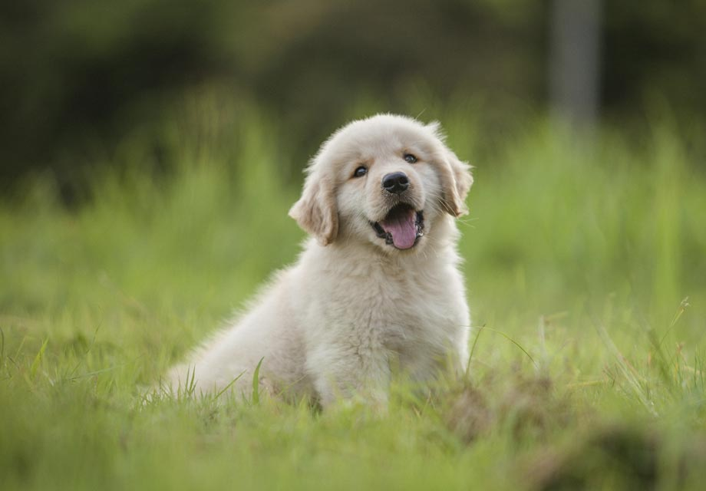

B

Contrasting

Contrasting Theme = Standing Kitten

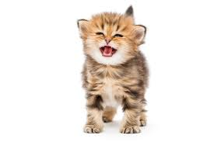

A2

Variation of A

Back to the main first thing with a bit of a variation to it, giving us a golden retriever puppy standing



B2

Variation of contrasting sound

Still a similar kitten, but it’s now sitting.

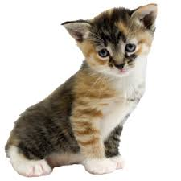

A3

A, but with a trumpet in the background

Gives an older golden retriever sitting



B3

B, but with a trumpet involved

Gives an older cat standing

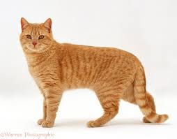

C

Gives a section contrasting to everything that happened earlier to head toward the end of the section.

Gives us a Goldfish, because it is another common household pet

