WIREFRAME & UI/UX BEHAVIOR
SALARY GRADE PROMOTION

1. Screen 2 - Review Period List
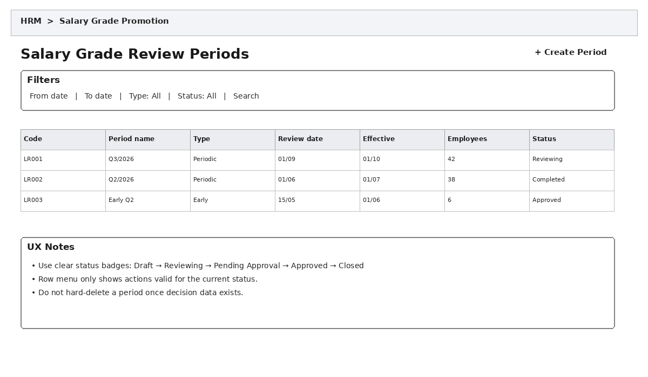

Main Behavior
- Allows searching/filtering by date range, review type, and status.
- The Create Review Period button opens a form for Code, Name, ReviewType, ReviewDate, EffectiveDate, and Description.
- Row menu actions vary by Status. For example, a CLOSED period is view-only and cannot be edited.
- Do not hard-delete a review period once review or decision data exists; use business status/cancellation instead.
- Click View to navigate to the Review Period Details screen.

Related Data/Tables
HrSalaryReviewPeriod, HrSalaryReviewEmployee

2. Screen 3 - Review Period Details
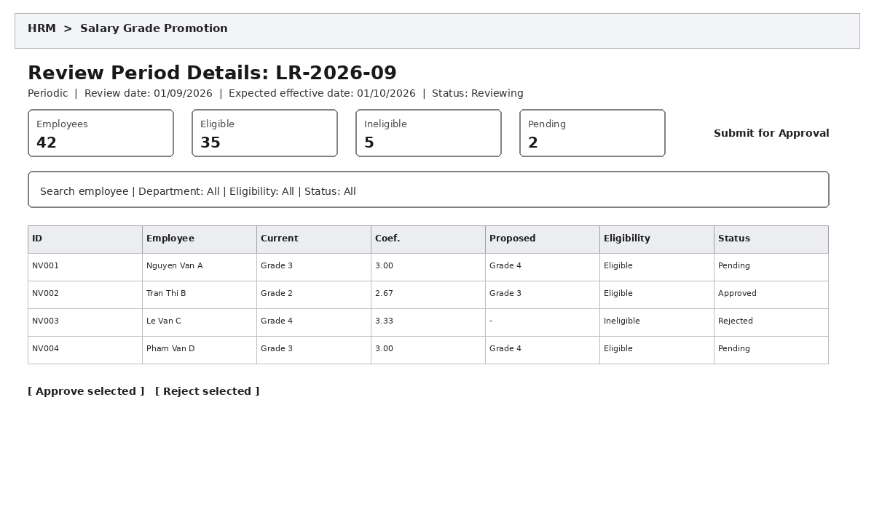

Main Behavior
- This is the main HR working screen, optimized for processing a large number of employees.
- The system loads the period's HrSalaryReviewEmployee records and displays the current grade/coefficient together with the proposed grade.
- Allows filtering by department, eligibility, and status to reduce the number of rows requiring review.
- Checkboxes support bulk actions, but the system must validate each employee before bulk approval.
- Clicking a row opens the employee detail screen/panel.
- Submit for Approval is available only after the required records have been processed; confirmation is required.

Related Data/Tables
HrSalaryReviewPeriod, HrSalaryReviewEmployee, HrEmployee, HrEmployeeSalary, HrSalaryGrade

3. Screen 4 - Employee Review Details
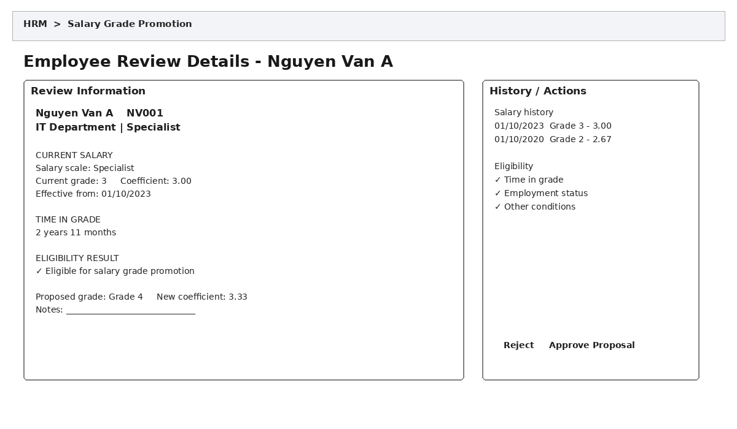

Main Behavior
- Displays the salary snapshot at the review time rather than only the current salary when the user opens the screen.
- Proposed grades should be limited to the employee's valid salary scale.
- If EligibilityStatus = INELIGIBLE, the system must clearly display the reason and may disable the Approve button depending on business rules.
- Approving a proposal updates the review status and does not immediately create a new HrEmployeeSalary record.
- Rejection should require a reason when the business process requires traceability.
- The adjacent salary history gives the approver enough context without leaving the screen.

Related Data/Tables
HrSalaryReviewEmployee, HrEmployeeSalary, HrSalaryGrade, HrEmployee

4. Screen 5 - Create/Issue Salary Decision
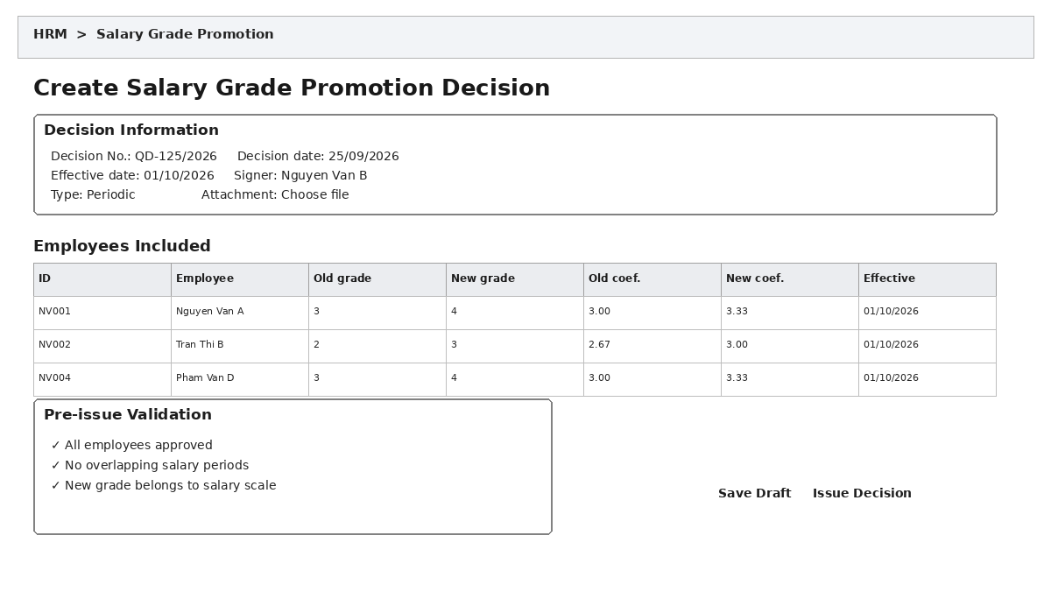

Main Behavior
- Only approved employees are included in the decision list.
- Before issuing, validate the decision number, effective date, new grade, and salary-history conflicts.
- Save Draft only creates/updates HrSalaryDecision and HrSalaryDecisionDetail in DRAFT status.
- Issuing a decision is a sensitive action: show a confirmation dialog and an impact summary.
- When the decision becomes effective, the system closes the previous HrEmployeeSalary record and creates a new one; this should be performed in a transaction.
- An effective decision should not be hard-deleted; use a cancellation/revocation process if available.

Related Data/Tables
HrSalaryDecision, HrSalaryDecisionDetail, HrEmployeeSalary, HrSalaryGrade, HrEmployee

5. Screen 6 - Employee Salary History
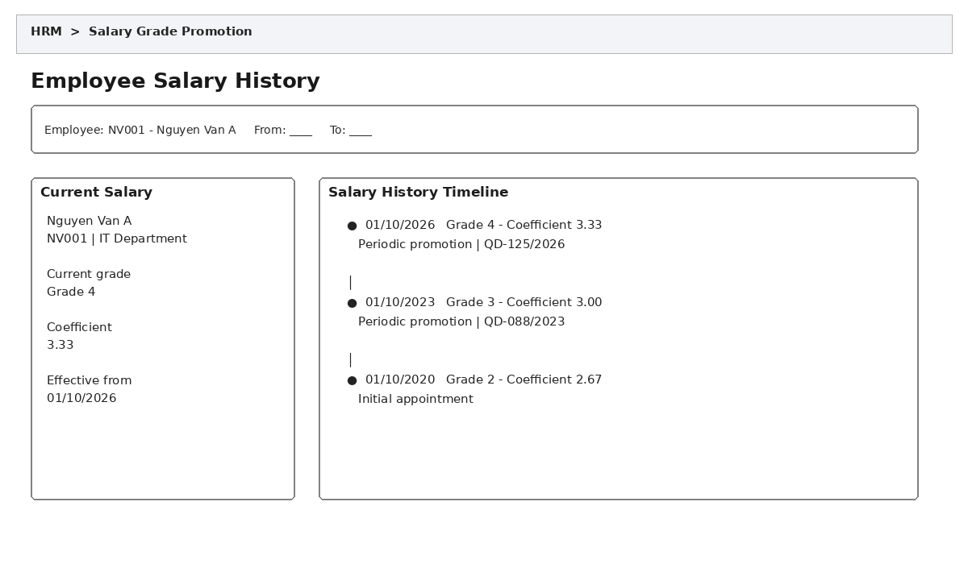

Main Behavior
- Allows selecting an employee and date range for lookup.
- The current salary is highlighted; history is displayed on a newest-to-oldest timeline.
- Each timeline entry should show grade, coefficient, effective date, reason, and decision number when available.
- The decision number can be clicked to open decision details in read-only mode.
- This screen is primarily read-only for lookup and audit; salary-history changes must go through a separate adjustment process.

Related Data/Tables
HrEmployee, HrEmployeeSalary, HrSalaryDecision, HrSalaryGrade, HrSalaryScale

6. Recommended Navigation Flow
Dashboard → Review Period List → Review Period Details → Employee Details → Submit/approve results → Create Decision → Issue Decision → Update Salary History.

7. Common UX Rules
- Use consistent status badges throughout the module.
- Important data-changing actions must require confirmation and provide clear result feedback.
- Do not use modals for very large data tables; prefer a full page or side drawer.
- Forms must clearly identify required fields, validate at field level, and show understandable error messages.
- Bulk actions must show the number of selected records and the number of successful/failed records.
- Historical/issued data should be read-only by default to preserve the audit trail.
- Do not expose database column names directly to users; use clear business terminology.
- Large lists require pagination or server-side filtering.

8. Mapping the 8 Database Tables to the UI
Table | UI Role
HrEmployee | Employee information on detail, history, and review-list screens.
HrSalaryScale | Salary scale master data source; usually not edited directly in the review workflow.
HrSalaryGrade | Source of current and proposed grades/coefficients.
HrEmployeeSalary | Current salary and salary-history timeline.
HrSalaryReviewPeriod | Review period list/details.
HrSalaryReviewEmployee | Employee list and review results for each period.
HrSalaryDecision | Decision header/general information.
HrSalaryDecisionDetail | Employee list and old/new changes included in the decision.

