WIREFRAME & UI/UX BEHAVIOR
SALARY GRADE PROMOTION

1. Screen 1 - Review Period List (HR Staff)
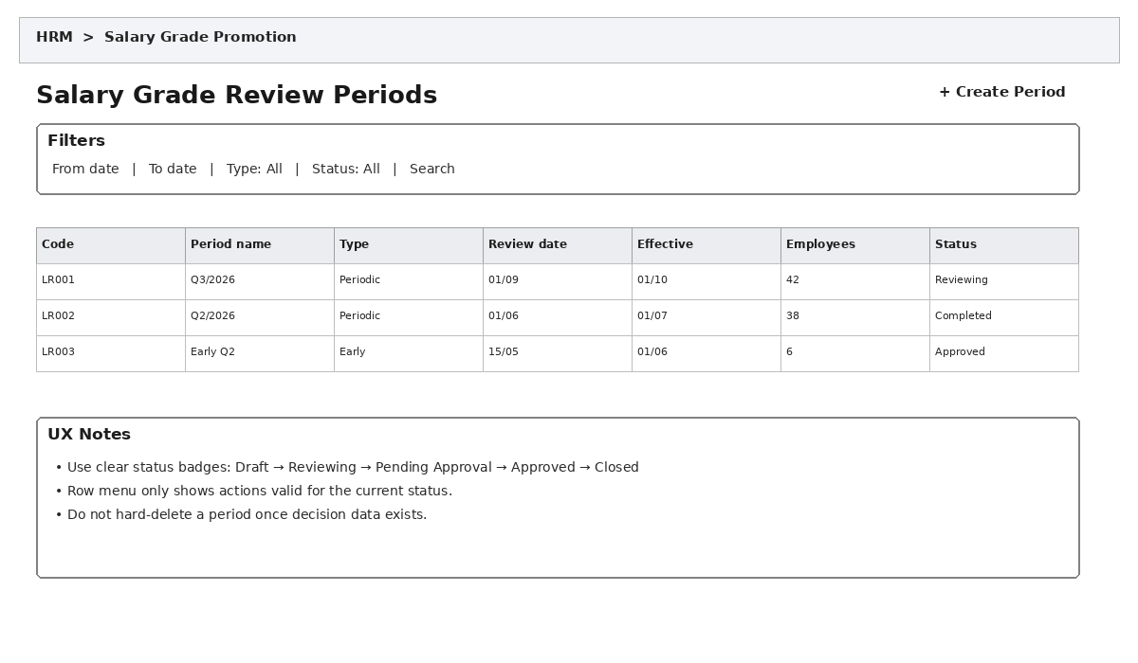

Main Behavior
- Allows searching/filtering by date range, review type, and status.
- The Create Review Period button opens a form for Code, Name, ReviewType, ReviewDate, EffectiveDate, and Description.
- Row menu actions vary by Status. For example, a CLOSED period is view-only and cannot be edited.
- Do not hard-delete a review period once review or decision data exists; use business status/cancellation instead.
- Click View to navigate to the Review Period Details screen.

Related Data/Tables
HrSalaryReviewPeriod, HrSalaryReviewEmployee

2. Screen 2 - Review Period Details (HR Staff)
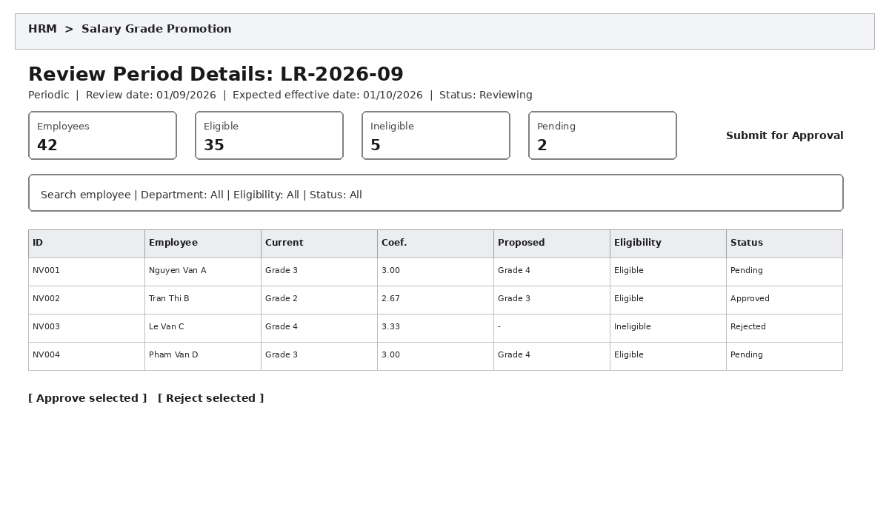

Main Behavior
- This is the main HR working screen, optimized for processing a large number of employees.
- The system loads the period's HrSalaryReviewEmployee records and displays the current grade/coefficient together with the proposed grade.
- Allows filtering by department, eligibility, and status to reduce the number of rows requiring review.
- Checkboxes support bulk actions, but the system must validate each employee before bulk approval.
- Clicking a row opens the employee detail screen/panel.
Once the period's Status is Submitted, a "Create Decision" button appears; it opens the Create/Edit Salary Decision screen (Screen 5) with this review period already selected. If a non-cancelled decision already exists for this period, the button instead says "View Decision" and opens that decision.
- Submit for Approval is available only after the required records have been processed; confirmation is required.

Related Data/Tables
HrSalaryReviewPeriod, HrSalaryReviewEmployee, HrEmployee, HrEmployeeSalary, HrSalaryGrade

3. Screen 3 - Employee Review Details (HR Staff)
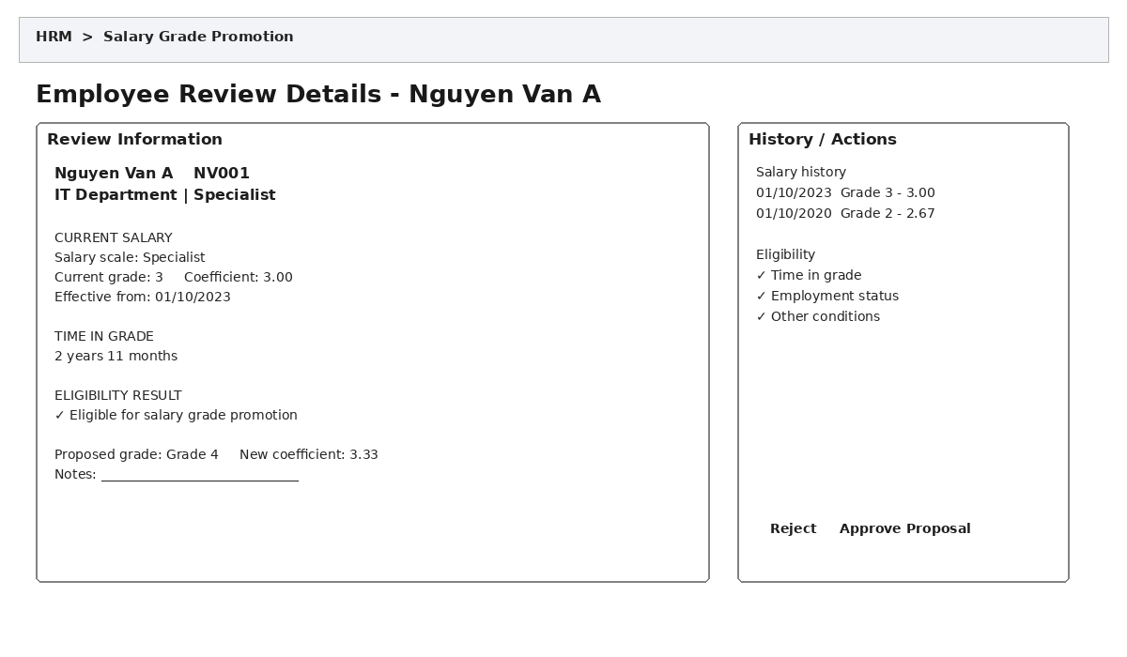

Main Behavior
- Displays the salary snapshot at the review time rather than only the current salary when the user opens the screen.
- The system automatically calculates the proposed grade and coefficient for each eligible employee, limited to their valid salary scale; HR Staff reviews this system-calculated value rather than entering it manually.
- If EligibilityStatus = INELIGIBLE, the system must clearly display the reason and may disable the Approve button depending on business rules.
- Approving a proposal updates the review status and does not immediately create a new HrEmployeeSalary record.
- Rejection should require a reason when the business process requires traceability.
- The adjacent salary history gives HR Staff enough context without leaving the screen.

Related Data/Tables
HrSalaryReviewEmployee, HrEmployeeSalary, HrSalaryGrade, HrEmployee
4. Screen 4 - Salary Decision List (Approver)

Main Behavior
This is the landing page when the Approver opens "Salary Decisions" from the menu. Lists every salary decision, whatever its status.
Each row shows Decision Number, Review Period, Status (Draft, Applied, Cancelled), and Effective Date.
Clicking a Draft row reopens it on the Create/Edit Salary Decision screen (Screen 5) with everything previously added still there.
Clicking an Applied or Cancelled row opens it in read-only mode; it cannot be edited from here.
The "Create New" button requires picking a submitted review period first; only periods without an existing non-cancelled decision are offered.
Allows filtering by status and searching by decision number or review period.
Related Data/Tables
HrSalaryDecision, HrSalaryReviewPeriod

5. Screen 5 - Create/Edit Salary Decision (Approver)
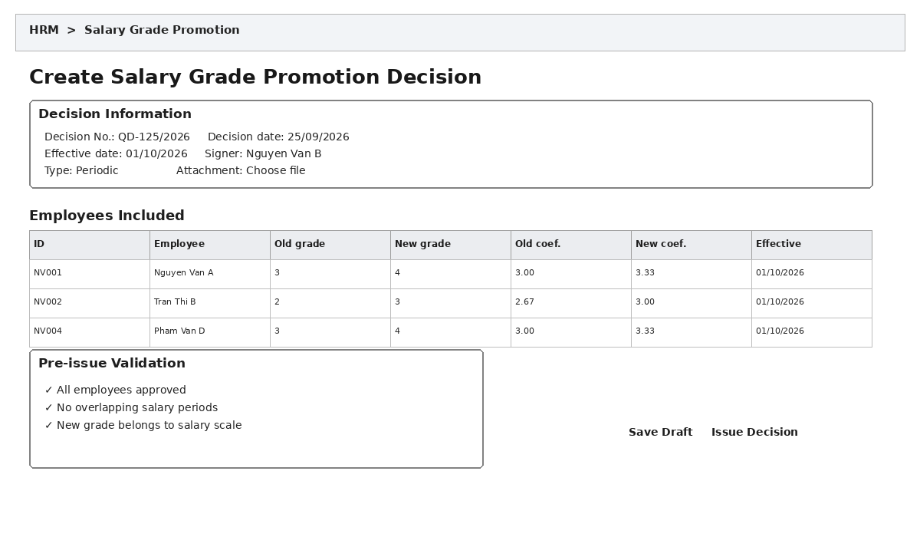

Main Behavior
Reached two ways: (1) from Review Period Detail via "Create Decision" once the period is Submitted — the period is already selected; (2) from the Salary Decision List (Screen 4) via "Create New" — the Approver must first pick a submitted review period without an existing non-cancelled decision. Either way, the Approved Employees list already reflects HR Staff's screening, so no separate review screen is required before drafting the decision.
Save Draft corresponds to preparing the decision; Issue Decision corresponds to making it official (see User Stories US-06 and US-07).
- Only approved employees are included in the decision list.
- Before issuing, validate the decision number, effective date, new grade, and salary-history conflicts.
- Save Draft only creates/updates HrSalaryDecision and HrSalaryDecisionDetail in DRAFT status.
- Issuing a decision is a sensitive action: show a confirmation dialog and an impact summary.
- When the decision becomes effective, the system closes the previous HrEmployeeSalary record and creates a new one; this should be performed in a transaction.
- An effective decision should not be hard-deleted; use a cancellation/revocation process if available.

Related Data/Tables
HrSalaryDecision, HrSalaryDecisionDetail, HrEmployeeSalary, HrSalaryGrade, HrEmployee

6. Screen 6 - Employee Salary History (HR Staff / Approver)
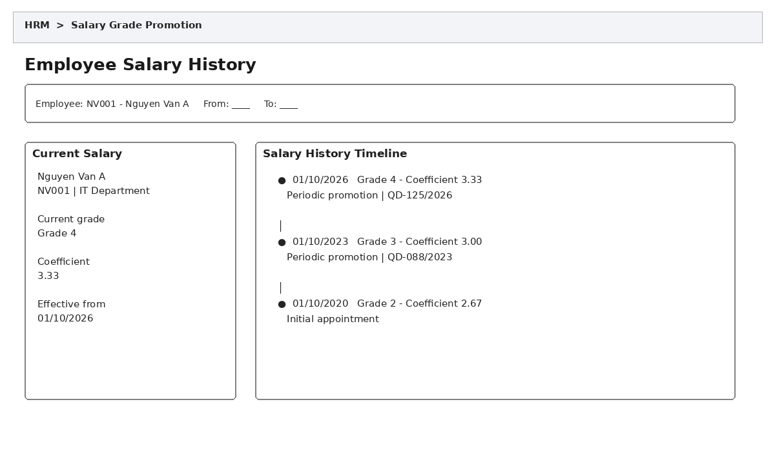

Main Behavior
- Allows selecting an employee and date range for lookup.
- The current salary is highlighted; history is displayed on a newest-to-oldest timeline.
- Each timeline entry should show grade, coefficient, effective date, reason, and decision number when available.
- The decision number can be clicked to open decision details in read-only mode.
- This screen is primarily read-only for lookup and audit; salary-history changes must go through a separate adjustment process.

Related Data/Tables
HrEmployee, HrEmployeeSalary, HrSalaryDecision, HrSalaryGrade, HrSalaryScale

7. Recommended Navigation Flow
HR Staff flow: Dashboard → Review Period List → Review Period Details → Employee Details → Approve/Reject Employees → Submit Review Period.
Approver flow (after the review period is submitted): Review Period Details → Create Decision (or Salary Decision List → Create New, picking the period) → Issue Decision → Update Salary History.

8. Common UX Rules
- Use consistent status badges throughout the module.
- Important data-changing actions must require confirmation and provide clear result feedback.
- Do not use modals for very large data tables; prefer a full page or side drawer.
- Forms must clearly identify required fields, validate at field level, and show understandable error messages.
- Bulk actions must show the number of selected records and the number of successful/failed records.
- Historical/issued data should be read-only by default to preserve the audit trail.
- Do not expose database column names directly to users; use clear business terminology.
- Large lists require pagination or server-side filtering.

9. Mapping the 8 Database Tables to the UI
Table | UI Role
HrEmployee | Employee information on detail, history, and review-list screens.
HrSalaryScale | Salary scale master data source; usually not edited directly in the review workflow.
HrSalaryGrade | Source of current and proposed grades/coefficients.
HrEmployeeSalary | Current salary and salary-history timeline.
HrSalaryReviewPeriod | Review period list/details.
HrSalaryReviewEmployee | Employee list and review results for each period.
HrSalaryDecision | Decision header/general information.
HrSalaryDecisionDetail | Employee list and old/new changes included in the decision.

