My application:

Home:

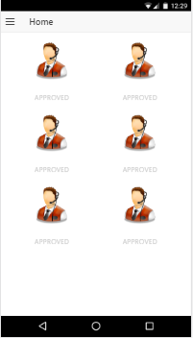

Login:

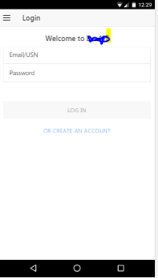

Regis:

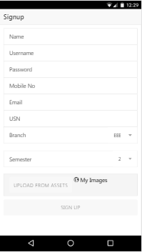

SideMenu:

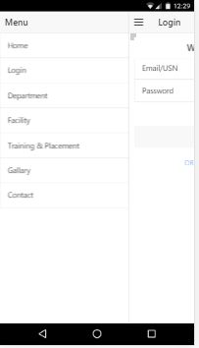

Note: No platform are being included in git. You have to add it all by yourself.

I wil share the steps once I am done.