**i) Overlap Save Method**

close all;

clear all;

x=input('Enter First Sequence x[n]= ');

h=input('Enter Second Sequence h[n]= ');

N=input('Enter length of each block N = ');

%Ploting the Input Sequences

subplot (2,2,1);

stem(x);

title('First Sequence x[n]');

xlabel ('Samples');

ylabel ('Amplitude');

subplot (2,2,2);

stem(h);

title('Second Sequence h[n]');

xlabel ('Samples');

ylabel ('Amplitude');

Lx=length(x);

M=length(h);

L=N-M+1;

K=ceil(Lx/L)+1;

R=rem(Lx,N);

%Padding zeros to input sequences to make length equal to N

x=[x zeros(1,L)]

h=[h zeros(1,N-M)]

%To pad zeros to Input sequence at the end of the sequence

z=zeros(1,M-1);

for i=1:K

X(i,:)=x(((i-1)*L+1):i*L);

if i==1

Xi(i,:)=[zeros(1,M-1) X(i,:)];

else

Xi(i,:)=[X(i-1,(L-M+2):L) X(i,:)];

end

Yi(i,:)=cconv(Xi(i,:),h,N); Yi(i,:)=C_Conv(Xi(i,:),h);

end

U=Yi(:,M:N);

y1=U';

y=y1(:)'

%Plotting of the Convoled Signal

subplot (2,2,3:4);

stem(y);

title ('Convolved Signal');

xlabel ('Samples');

ylabel ('Amplitude');

**Result:**

Enter First Sequence x[n]= [1 2 -1 2 3 -2 -3 -1 1 1 2 -1]

Enter Second Sequence h[n]= [1 2 3]

Enter length of each block N = 4

x = 1 2 -1 2 3 -2 -3 -1 1 1 2 -1 0 0

h = 1 2 3 0

y = 1 4 6 6 4 10 2 -13 -10 0 7 6 4 -3

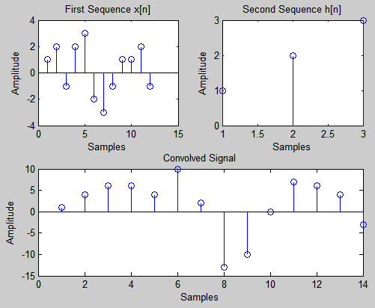

**ii) Overlap Add Method**

close all;

clear all;

x=input('Enter First Sequence x[n]= ');

h=input('Enter Second Sequence h[n]= ');

N=input('Enter length of each block N = ');

Lx=length(x);

M=length(h);

L=N-M+1;

K=ceil(Lx/L);

R=rem(Lx,L);

%Padding zeros to input sequences to make length equal to N

if R>0

x=[x zeros(1,L-R)]

end

h=[h zeros(1,N-M)]

%Initialising the Output

y=zeros(N,K);

%Padding zeros to Input sequence at the end of the sequence

z=zeros(1,M-1);

%To perform Circular Convolution of two input sequences

for i=0:K-1

Xn=x(L*i+1:L*i+L);

Xi=[Xn z];

u(i+1,:)=cconv(Xi,h,N); u(i+1,:)=C_Conv(Xi(i,:),h);

end

Y=u';

for i=1:K-1

u(i+1,1:M-1)= u(i,M:N)+u(i+1,1:M-1);

end

z1=u(:,1:L)';

y1=(z1(:))';

y=[y1 u(K,(M:N))]

%Ploting the Input Sequences

subplot (2,2,1);

stem(x);

title('First Sequence x[n]');

xlabel ('Samples');

ylabel ('Amplitude');

subplot (2,2,2);

stem(h);

title('Second Sequence h[n]');

xlabel ('Samples');

ylabel ('Amplitude');

%Plotting of the Convoled Signal

subplot (2,2,3:4);

stem(y);

title ('Convolved Signal');

xlabel ('Samples');

ylabel ('Amplitude');

**Result:**

Enter First Sequence x[n]= [1 2 -1 2 3 -2 -3 -1 1 1 2 -1]

Enter Second Sequence h[n]= [1 2 3]

Enter length of each block N = 4

h = 1 2 3 0

y = 1 4 6 6 4 10 2 -13 -10 0 7 6 4 -3

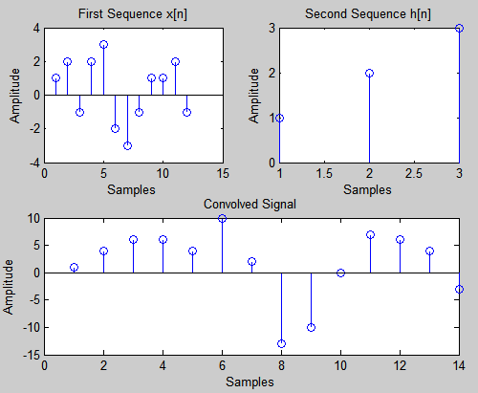

**Note:**

C_Conv : Name of the file containing Circular Convolution

Circular COnvolution Altered Program for Overlap Add and Save Method saved as C_Conv.m

function y=C_Conv1(x1,x2)

Lx1=length(x1);

Lx2=length(x2);

len=max(Lx1,Lx2);

if Lx1<len

x1=[x1,zeros(len-Lx1)];

else

x2=[x2,zeros(len-Lx2)];

end

for n=1:len

y(n)=0;

for k=1:len

i=n-k+1;

if(i<=0)

i=i+len;

end

y(n)=y(n)+x2(k)*x1(i);

end

end

disp('Circular Convolution of x1[n] & x2[n] is ')

disp(y)