**WEEK 2- PL/SQL PROGRAMMING**

1. Control Statements

Code:

CREATE TABLE Customers (

  CustomerID    NUMBER,

  CustomerName  VARCHAR2(100),

  Balance       NUMBER,

  IsVIP         VARCHAR2(5)

);

INSERT INTO Customers VALUES (1, 'Alice', 5000, 'FALSE');

INSERT INTO Customers VALUES (2, 'Bob', 15000, 'FALSE');

INSERT INTO Customers VALUES (3, 'Charlie', 12000, 'FALSE');

INSERT INTO Customers VALUES (4, 'Diana', 8000, 'FALSE');

COMMIT;

BEGIN

  FOR cust IN (SELECT CustomerID, Balance FROM Customers) LOOP

    IF cust.Balance > 10000 THEN

      UPDATE Customers

      SET IsVIP = 'TRUE'

      WHERE CustomerID = cust.CustomerID;

    ELSE

      UPDATE Customers

      SET IsVIP = 'FALSE'

      WHERE CustomerID = cust.CustomerID;

    END IF;

  END LOOP;

  DBMS_OUTPUT.PUT_LINE('VIP status updated.');

END;

/

SET SERVEROUTPUT ON;

Output:

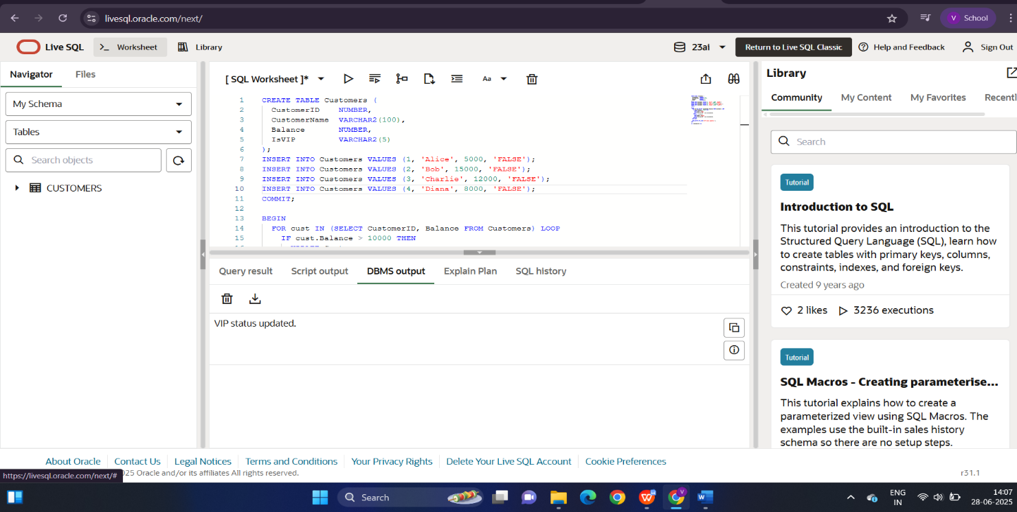

1. Stored Procedures

Code:

CREATE TABLE Accounts (

  AccountID   NUMBER PRIMARY KEY,

  AccountName VARCHAR2(100),

  Balance     NUMBER

);

INSERT INTO Accounts VALUES (101, 'Alice', 5000);

INSERT INTO Accounts VALUES (102, 'Bob', 8000);

INSERT INTO Accounts VALUES (103, 'Charlie', 3000);

COMMIT;

CREATE OR REPLACE PROCEDURE TransferFunds (

  p_from_acc   IN NUMBER,

  p_to_acc     IN NUMBER,

  p_amount     IN NUMBER

) AS

  v_balance NUMBER;

BEGIN

  -- Step 1: Check if source account exists and has enough balance

  SELECT Balance INTO v_balance

  FROM Accounts

  WHERE AccountID = p_from_acc;

  IF v_balance < p_amount THEN

    RAISE_APPLICATION_ERROR(-20001, 'Insufficient funds in source account.');

  END IF;

  UPDATE Accounts

  SET Balance = Balance - p_amount

  WHERE AccountID = p_from_acc;

  UPDATE Accounts

  SET Balance = Balance + p_amount

  WHERE AccountID = p_to_acc;

  COMMIT;

  DBMS_OUTPUT.PUT_LINE('Transfer successful.');

EXCEPTION

  WHEN NO_DATA_FOUND THEN

    RAISE_APPLICATION_ERROR(-20002, 'Account not found.');

  WHEN OTHERS THEN

    ROLLBACK;

    DBMS_OUTPUT.PUT_LINE('Error: ' || SQLERRM);

END;

/

BEGIN

  TransferFunds(101, 102, 2000);

END;

/

SELECT * FROM Accounts;

Output:

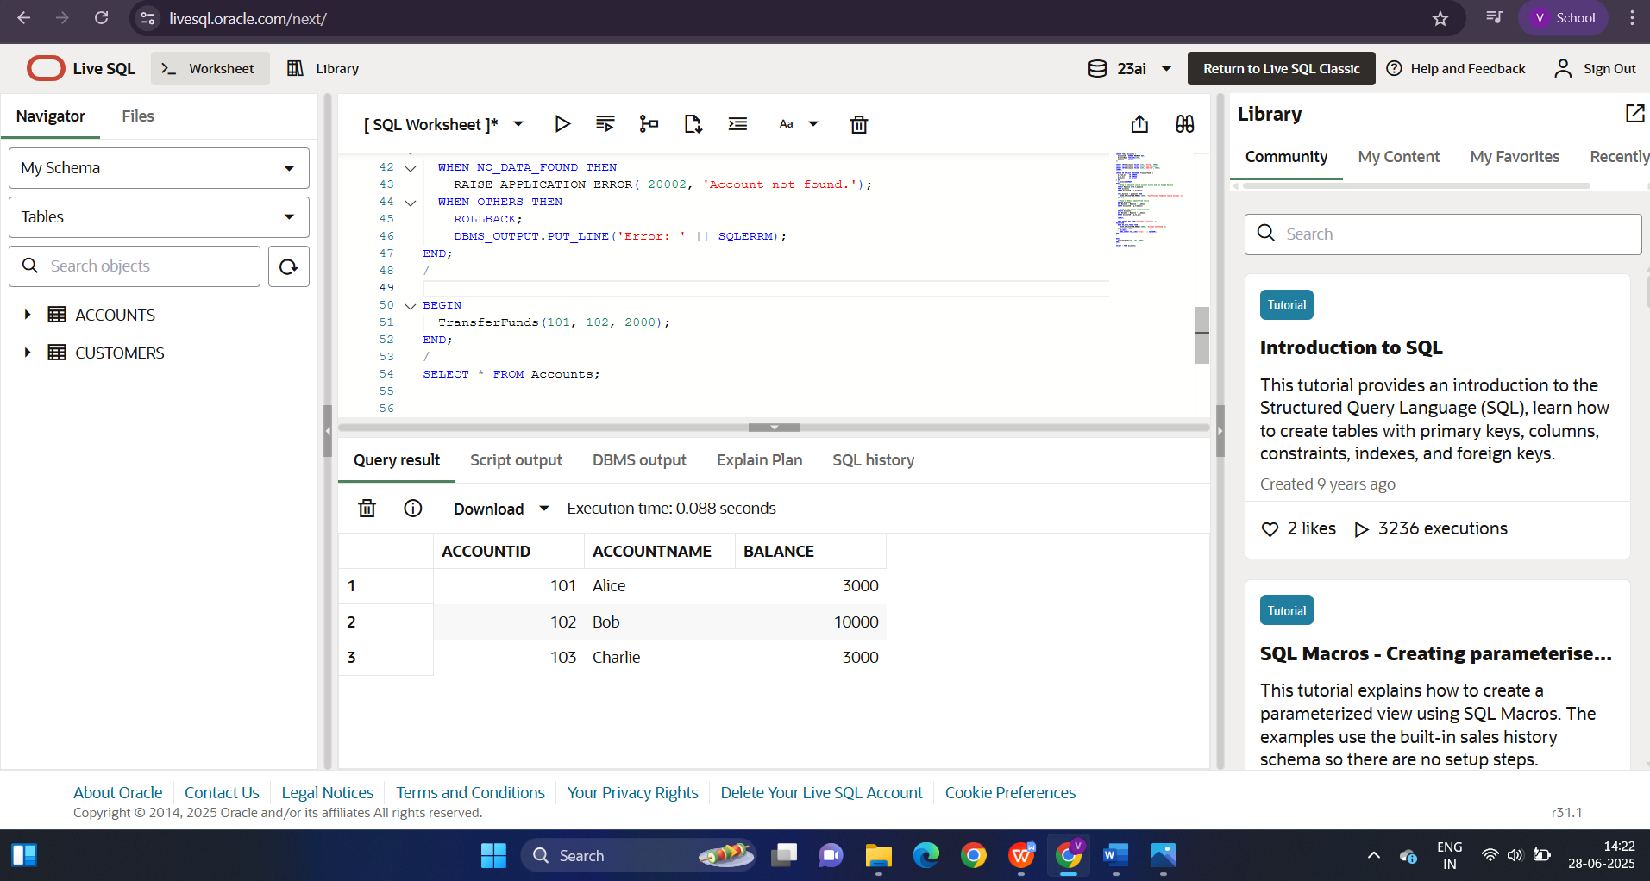

3-