Comparison of the Base Model and the BananaVLM Model

Sample 1

Ground Truth: sigatoka
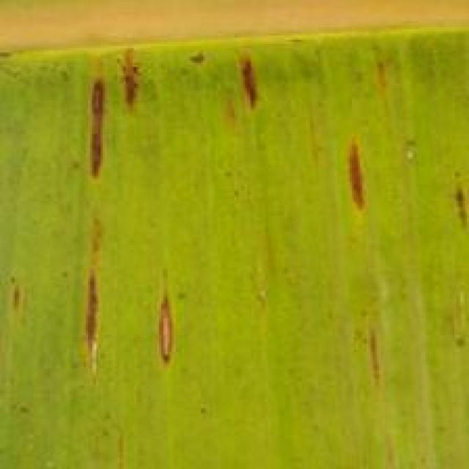
Option 1:
The image shows a leaf with a yellowish-brown color, which could indicate a disease or a nutrient deficiency. The leaf appears to be affected by a fungal infection, as it has a brown spot on it. This type of infection can be caused by various factors, such as overwatering, poor drainage, or excessive fertilizer.
To address this issue, it is essential to identify the cause of the infection and take appropriate measures to prevent it from spreading. This may include adjusting the watering schedule, ensuring proper drainage, and using a balanced fertilizer that does not over-promote the growth of fungi. Additionally, pruning away infected leaves and maintaining a healthy environment for the plant can help prevent further damage and promote the plant's overall health.
Option 2:
The image shows a banana plant with several visible symptoms indicative of a disease called Sigatoka. These symptoms include:
1. Brown spots or lesions on the leaves, which are characteristic of this fungal disease.
2. Yellowing of the leaf edges and veins, which is also a common sign of Sigatoka infection.
3. Curling or distortion of the leaf edges, which can be due to the presence of the fungus.
The possible solution for this plant would involve proper identification by an expert, followed by treatment with fungicides specifically designed to combat Sigatoka. It's important to follow recommended guidelines for application and timing of these treatments to minimize the risk of resistance developing. Additionally, good plant hygiene, including removing infected leaves and maintaining proper drainage, can help prevent the spread of the disease.

Which answer do you prefer:

Sample 2

Ground Truth: sigatoka
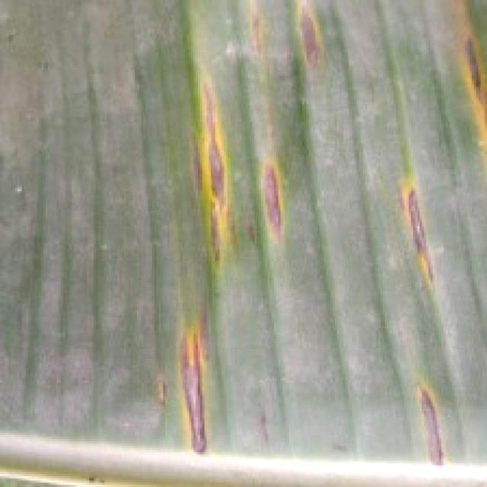
Option 1:
The image shows a leaf with a hole in it, which could be a sign of a disease or pest infestation. The hole appears to be a small, round, and clean-cut opening, which might be the result of a pest or insect feeding on the leaf.
The possible solution to this issue would be to identify the pest or insect responsible for the damage and take appropriate measures to control or eliminate it. This could involve using pesticides, insecticides, or other methods to protect the plant and prevent further damage. Additionally, it is essential to maintain proper plant care, such as regular watering, sunlight exposure, and nutrient intake, to promote healthy growth and reduce the risk of pest infestations.
Option 2:
Based on the image provided, it appears that the banana plant is affected by a disease known as Sigatoka. The visible symptoms include yellowing of the leaves with brown spots and lesions. These spots are often accompanied by purple or black discoloration around the edges of the affected areas.
The possible solution for this disease would involve the use of fungicides specifically designed to combat Sigatoka. It's important to follow proper application and safety guidelines when using these chemicals, as well as considering organic alternatives if desired. Additionally, good plant hygiene practices such as removing infected leaves and maintaining proper drainage can help prevent the spread of the disease.

Which answer do you prefer:

Sample 3

Ground Truth: sigatoka
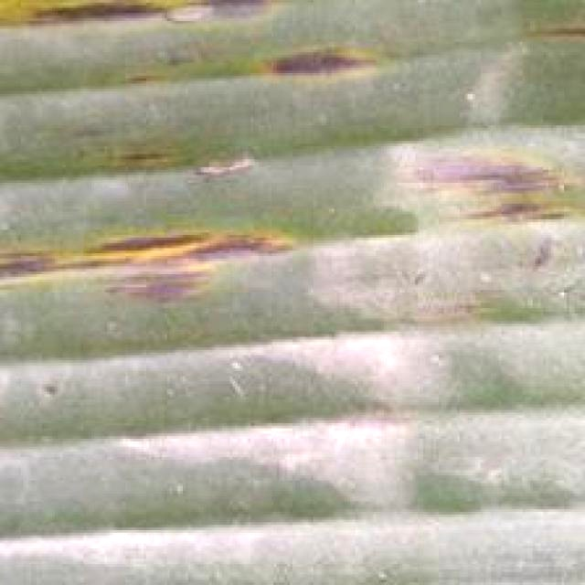
Option 1:
The image shows a leaf with yellow and green stripes, which appears to be affected by a disease. The yellow and green stripes suggest that the leaf is experiencing a fungal infection, possibly caused by a fungus such as Fusarium oxysporum. The visible symptoms include the yellow and green stripes, which are the result of the fungus's growth on the leaf.
A possible solution to this problem is to practice good gardening practices, such as regular pruning, removing infected leaves, and ensuring proper drainage to prevent the growth of fungi. Additionally, using organic or fungicidal treatments can help control the spread of the fungus and prevent further damage to the plant. It is essential to identify the specific type of fungus causing the infection and use appropriate treatments to manage the disease effectively.
Option 2:
The visible symptoms in the image include discoloration and yellowing of the leaves, which are characteristic signs of a disease called Sigatoka. This is a fungal disease that affects banana plants, causing brown spots on the leaves and eventually leading to leaf drop and reduced fruit production.
To address this issue, an agricultural assistant would recommend the following solutions:
1. Implement proper crop management practices such as regular pruning of infected leaves, removing and destroying affected plant material, and maintaining good drainage in the growing area.
2. Use fungicides that are registered for use on bananas and have been proven effective against Sigatoka. It's important to follow the recommended dosages and application instructions provided by the manufacturer.
3. Consider using organic alternatives if available, such as copper-based fungicides or biological control agents like Bacillus subtilis.
4. Monitor the plant regularly for any further signs of disease and adjust management practices accordingly.
5. Ensure proper irrigation and fertilization to support the health of the plant.

Which answer do you prefer:

Sample 4

Ground Truth: sigatoka
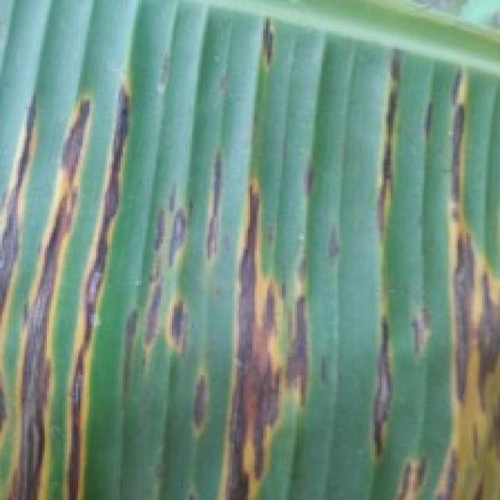
Option 1:
The image shows a leaf with yellow spots, which could be a sign of a fungal infection or a bacterial disease. The yellow spots are spread across the leaf, indicating that the plant is affected by the disease.
To address this issue, it is essential to identify the specific type of disease causing the yellow spots. Once the disease is diagnosed, appropriate treatment measures can be taken. For fungal infections, it is crucial to remove infected leaves and branches, and apply fungicides to prevent the spread of the disease. For bacterial diseases, it is important to practice proper plant care, such as regular watering, pruning, and ensuring adequate nutrient intake. Additionally, using organic or chemical-free fertilizers can help maintain the health of the plant and prevent the development of diseases.
Option 2:
The visible symptoms in the image include yellowing leaves with brown spots, which are characteristic signs of a disease called Sigatoka. This is a fungal disease that affects banana plants and can cause significant damage if left untreated.
To address this issue, an agricultural assistant would recommend the following solutions:
1. Implement proper crop management practices such as regular pruning, removing infected leaves, and maintaining good drainage to prevent waterlogging.
2. Use fungicides that are effective against Sigatoka, such as Mancozeb or Copper Oxychloride. It's important to follow label instructions when applying these chemicals.
3. Consider using biological control methods like beneficial nematodes or parasitic nematodes to help manage the disease.
4. Monitor the plant regularly for any signs of improvement and adjust treatment accordingly.
5. Maintain good sanitation practices around the banana plant to prevent the spread of the fungus.

Which answer do you prefer:

Sample 5

Ground Truth: sigatoka
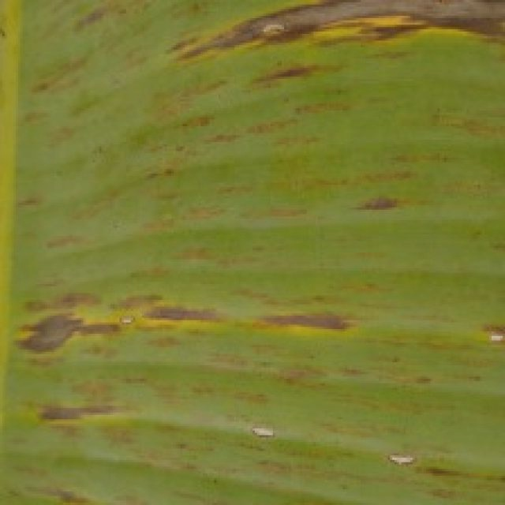
Option 1:
The image shows a leaf with a brown spot, which could be a sign of a disease or infection affecting the plant. The brown spot may indicate that the plant is experiencing stress or damage due to various factors such as overwatering, underwatering, nutrient deficiencies, or exposure to pests or diseases.
To address this issue, it is essential to identify the cause of the brown spot and take appropriate measures to address it. If the brown spot is caused by overwatering, it is crucial to ensure that the plant receives adequate drainage and does not sit in standing water. If underwatering is the issue, it is necessary to provide the plant with sufficient water to prevent dehydration.
If the brown spot is due to nutrient deficiencies, it is important to provide the plant with the necessary nutrients through proper soil amendment or supplementation. If the brown spot is caused by pests or diseases, it is necessary to identify the specific pest or disease and take appropriate measures to control or eradicate it. This may involve using pesticides, fungicides, or other treatments, depending on the cause of the brown spot.
In conclusion, it is essential to identify the cause of the brown spot on the leaf and take appropriate measures to address it, which may involve adjusting watering habits, providing adequate nutrients, or controlling pests or diseases.
Option 2:
The image shows a close-up view of a banana leaf with signs of Sigatoka disease, which is a fungal infection caused by Mycosphaerella fijiensis. Visible symptoms include yellowing or browning of the leaf tissue, often accompanied by small brown spots that can merge into larger lesions. The veins may also become discolored and darken.
The Sigatoka disease is a common problem for banana plants, particularly in humid and warm conditions. Possible solutions include:
1. Proper drainage: Ensure that the soil has good drainage to prevent waterlogging, which can exacerbate the disease.
2. Fungicide application: Use fungicides registered for banana cultivation to control the spread of the disease. It's important to follow label instructions and rotate fungicides to prevent resistance.
3. Pruning and removal of infected leaves: Regularly prune affected leaves to reduce the amount of plant material available for fungal growth.
4. Improved air circulation: Ensure adequate airflow around the plants to reduce humidity levels, which can help prevent the spread of the disease.
5. Sanitation and cleaning: Keep equipment clean and free from fungal spores to minimize the risk of infection.
6. Proper watering: Avoid over-watering as it can lead to root rot, a condition that can exacerbate Sigatoka disease.
7. Fertilization: Appropriate fertilization practices should be followed to ensure the plant has adequate nutrients without causing excessive moisture levels.

Which answer do you prefer:

Sample 6

Ground Truth: sigatoka
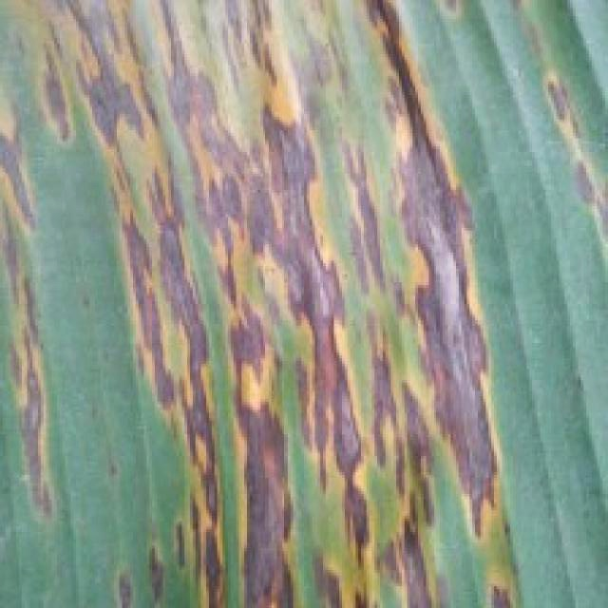
Option 1:
The image shows a banana plant with a large, curved, and brown stem, which appears to be infected with a disease. The banana plant is surrounded by other plants, and the banana bunches are visible in the background. The brown stem suggests that the plant is affected by a fungal infection, which can cause the stem to turn brown and eventually die.
To address this issue, it is essential to identify the specific type of fungal infection and take appropriate measures to prevent its spread. This may involve removing infected parts of the plant, ensuring proper drainage and air circulation, and using organic or chemical fungicides to control the infection. Additionally, maintaining a healthy plant by providing adequate nutrients, water, and sunlight can help prevent the development of diseases and promote overall plant health.
Option 2:
The banana plant in the image appears to be affected by Sigatoka, which is a fungal disease that affects bananas and other plants in the Musa genus. Visible symptoms include yellowing or browning of leaves, which can be seen on the edges of the leaf blades. There may also be small brown spots or lesions on the leaves.
The possible solution for this disease is to use fungicides that are effective against Sigatoka, such as copper-based fungicides like Bordeaux mixture or other organic alternatives like neem oil. It's important to follow proper application and timing guidelines for these treatments to minimize the risk of resistance developing. Additionally, good plant hygiene, including removing infected leaves and maintaining proper drainage, can help prevent the spread of the disease within a plantation.

Which answer do you prefer:

Sample 7

Ground Truth: sigatoka
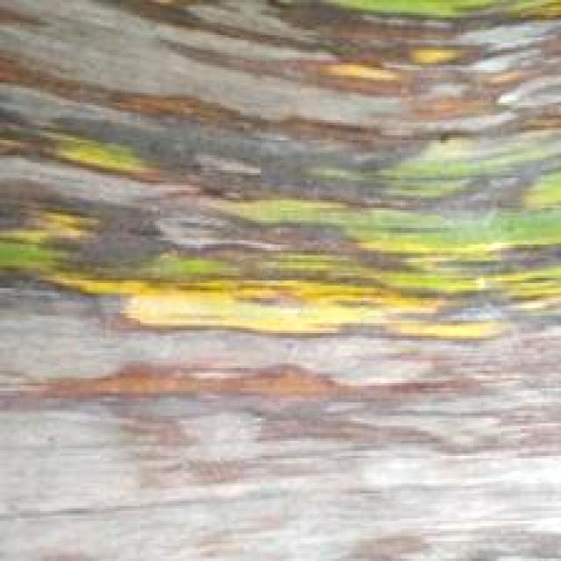
Option 1:
The image shows a banana tree with a large, brown, and yellow leaf, which appears to be infected with a fungal disease. The leaf is covered in brown spots and has a yellowish hue, indicating that the tree is experiencing some form of decay or damage.
The presence of this disease can negatively impact the tree's health and overall growth. To address this issue, it is essential to identify the specific type of fungal disease affecting the banana tree and take appropriate measures to manage it. This may include applying fungicides, pruning infected leaves, and ensuring proper drainage and air circulation around the tree to prevent the spread of the disease. Additionally, regular monitoring of the tree's health and timely intervention can help minimize the impact of the disease on the tree's overall well-being.
Option 2:
The visible symptoms in the image include yellowing leaves with brown spots, which are characteristic of a disease called Sigatoka. This is a fungal disease that affects banana plants. Possible solutions include using fungicides and maintaining proper drainage to prevent waterlogging, which can exacerbate the problem. Additionally, removing infected leaves and practicing good hygiene can help prevent the spread of the disease.

Which answer do you prefer:

Sample 8

Ground Truth: sigatoka
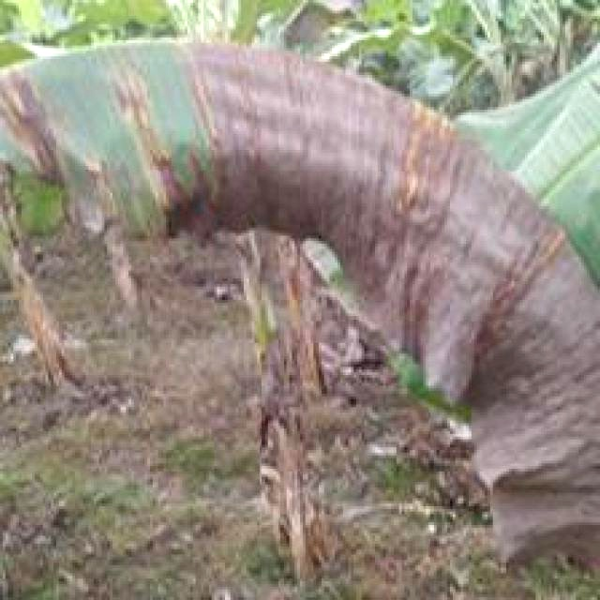
Option 1:
The image shows a leaf with yellow and green stripes, which could be indicative of a disease or a natural variation in the leaf's coloration. The yellow and green stripes might be a result of a fungal infection, such as powdery mildew or a bacterial infection, like bacterial leaf spot.
To identify the specific disease, it would be necessary to examine the leaf more closely and possibly take a sample for laboratory testing. Once the disease is identified, the appropriate treatment can be applied to manage the symptoms and prevent further damage to the plant.
For fungal infections, the use of fungicides can help control the spread of the disease and protect the plant. For bacterial infections, applying a suitable bactericide or using a copper-based fungicide can help manage the symptoms. It is essential to follow the recommended treatment guidelines for the specific disease to ensure the health and longevity of the plant.
Option 2:
The visible symptoms in the image include discoloration and spots on the leaves of the banana plant. These are indicative of a disease called Sigatoka, which is caused by a fungus. The yellowing and brown spots suggest that the plant has been affected by this disease.
To address this issue, it would be advisable to follow proper crop management practices such as:
1. Regularly inspecting plants for early signs of disease.
2. Removing and destroying infected leaves to prevent further spread.
3. Applying fungicides specifically designed to combat Sigatoka, following the recommended dosage and application schedule as per the product label.
4. Maintaining proper drainage and air circulation around the plant to reduce humidity levels that can exacerbate the disease.
5. Ensuring adequate nutrient intake for the plant to support its immune system.
6. Practicing crop rotation to minimize the risk of disease outbreaks in the same area.

Which answer do you prefer:

Sample 9

Ground Truth: sigatoka
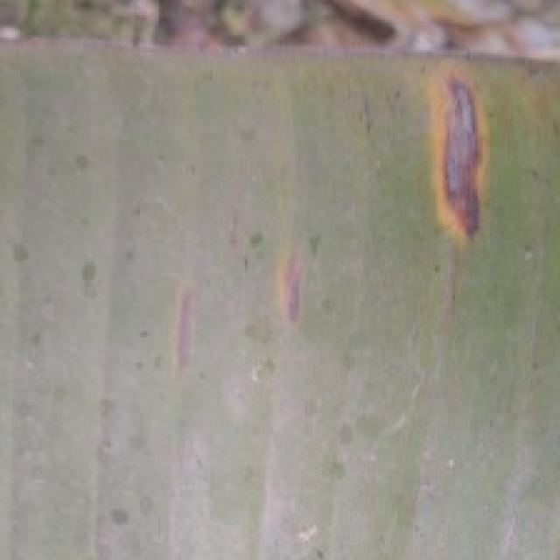
Option 1:
The image shows a plant with purple spots on its leaves, which could indicate a disease or infection. The presence of these spots suggests that the plant might be experiencing some form of stress or illness. Possible solutions for this issue could include:
1. Identifying the specific type of disease or infection causing the purple spots and consulting with a plant expert or a local nursery to determine the appropriate treatment.
2. Implementing proper care practices, such as regular watering, fertilizing, and pest control, to maintain the health of the plant and prevent further damage.
3. Ensuring that the plant is receiving adequate sunlight, as insufficient light can cause stress and weaken the plant's immune system, making it more susceptible to diseases.
4. Regularly inspecting the plant for any signs of pests or other issues that could be causing the purple spots and addressing them promptly.
It is essential to monitor the plant's health and take appropriate action to ensure its well-being and prevent any further damage.
Option 2:
The visible symptoms in the image include yellowing leaves with purple or red spots, which are characteristic of a disease called Sigatoka. This is a fungal disease that affects banana plants and can cause significant damage if left untreated.
Possible solutions include:
1. Removing infected leaves to prevent further spread of the disease.
2. Applying fungicides specifically designed for controlling Sigatoka, such as copper or sulfur-based products.
3. Implementing good plant hygiene practices to prevent the entry of pathogens into the plant.
4. Ensuring proper drainage and air circulation around the plant to reduce humidity levels, which can exacerbate the disease.

Which answer do you prefer:

Sample 10

Ground Truth: sigatoka
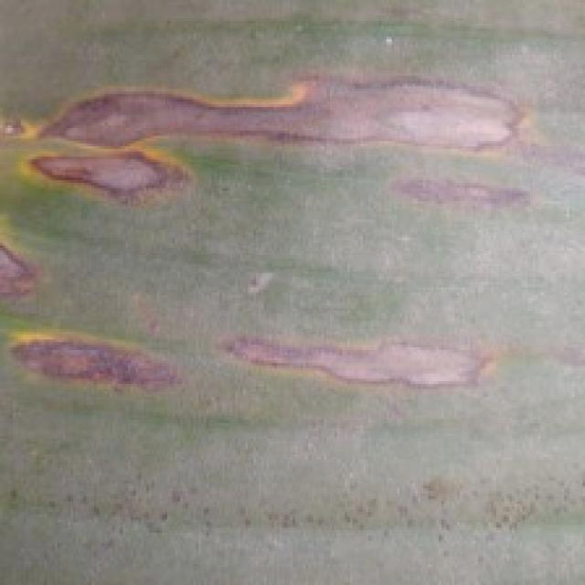
Option 1:
The image shows a leaf with a purple and yellow striped pattern, which could be indicative of a disease or a natural phenomenon. The purple and yellow stripes might be a result of a fungal infection or a nutrient deficiency in the plant.
To identify the specific disease or issue, it would be necessary to examine the leaf more closely and possibly take a sample for further testing. If the stripes are due to a fungal infection, the plant may require treatment with fungicides or other remedies to prevent the spread of the disease and promote healthy growth. If the stripes are a result of a nutrient deficiency, the plant may need to be fertilized with the appropriate nutrients to address the issue.
In either case, it is essential to monitor the plant's health and take appropriate action to maintain its well-being.
Option 2:
The visible symptoms in the image include discoloration and lesions on the leaves of the banana plant. There are purple and yellow areas interspersed with green, which indicates a fungal infection, likely caused by Sigatoka.
To address this issue, it is recommended to follow these steps:
1. Remove infected leaves to prevent further spread of the disease.
2. Apply fungicides specifically designed for banana plants, such as copper or Bordeaux mixture.
3. Implement good plant hygiene practices, including regular pruning and sanitizing tools.
4. Ensure proper drainage and avoid waterlogging, which can exacerbate the issue.
5. Consider using resistant varieties if available in your region.
6. Monitor the plant regularly for any signs of improvement or worsening of the disease.

Which answer do you prefer:

Sample 11

Ground Truth: sigatoka
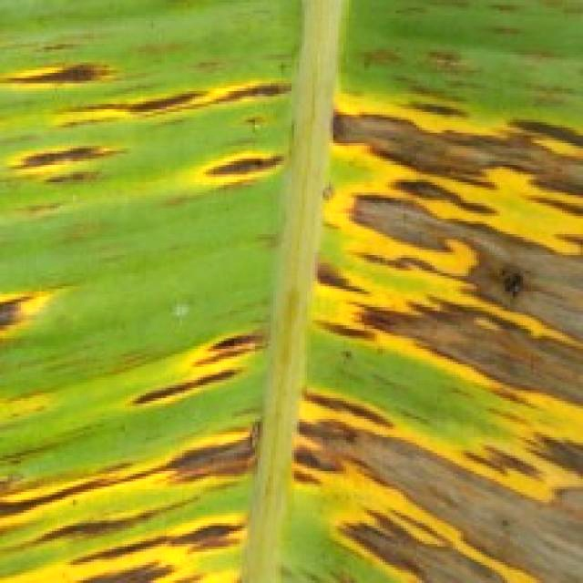
Option 1:
The image shows a leaf with a yellowish-brown color, which indicates that it might be affected by a fungal disease. The leaf has a spotted pattern, which is a common symptom of fungal infections. The presence of spots on the leaf suggests that the fungus is spreading and causing damage to the plant.
To address this issue, it is essential to identify the specific type of fungus causing the infection and apply appropriate treatment methods. This may involve using fungicides, pruning infected parts of the plant, and ensuring proper drainage and air circulation to prevent the spread of the fungus. Additionally, maintaining a healthy plant by providing adequate nutrients, water, and sunlight can help prevent the development of fungal diseases.
Option 2:
The visible symptoms in the image include yellowing and browning of the leaves, which are characteristic signs of a disease called Sigatoka. This is a fungal disease that affects banana plants, causing discoloration and necrosis on the leaf surfaces. Possible solutions include using fungicides specifically designed for controlling Sigatoka, as well as implementing cultural practices such as removing infected leaves and maintaining proper drainage to prevent the spread of the fungus.

Which answer do you prefer:

Sample 12

Ground Truth: sigatoka
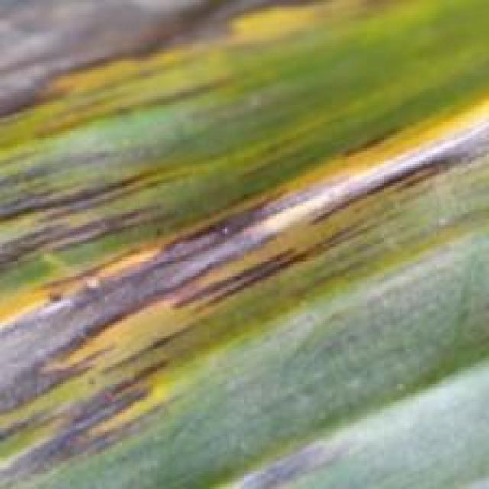
Option 1:
The image shows a leaf with a purple spot, which could be a sign of a disease or infection affecting the plant. The purple spot might indicate that the plant is experiencing a bacterial or fungal infection, which can cause damage to the plant's tissues and negatively impact its overall health.
To address this issue, it is essential to identify the specific type of disease causing the purple spot and take appropriate measures to treat it. This may involve using organic or chemical treatments, depending on the cause of the infection. In some cases, it may be necessary to remove the affected leaves or branches to prevent the spread of the disease. Additionally, maintaining proper plant care, such as regular watering, pest control, and ensuring adequate sunlight and nutrients, can help prevent the development of diseases and promote overall plant health.
Option 2:
The visible symptoms in the image include yellowing and browning of the leaves, which are characteristic signs of a disease called Sigatoka. This is a fungal disease that affects banana plants, causing leaf spots and necrosis.
To manage this disease, it's important to practice good horticultural practices such as proper drainage, avoiding waterlogging, and maintaining adequate spacing between plants. Additionally, regular pruning of infected leaves can help prevent the spread of the fungus. Fungicides may also be used in conjunction with these measures to control the disease. It's important to follow label instructions when applying any pesticides or fungicides and consider the environmental impact of these treatments.

Which answer do you prefer:

Sample 13

Ground Truth: sigatoka
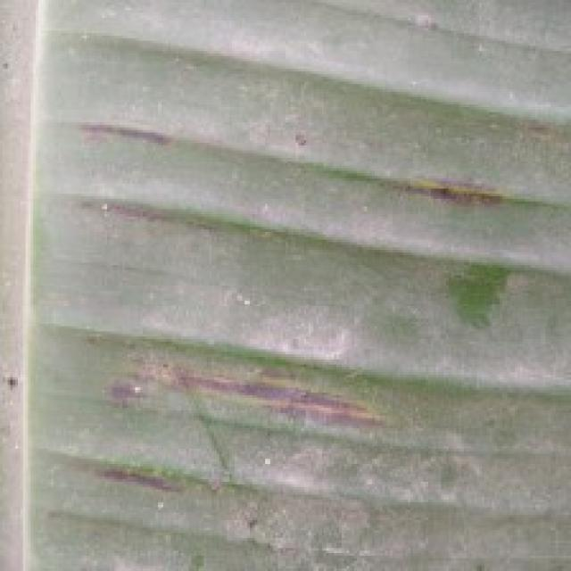
Option 1:
The image shows a leaf with a yellowish-brown color, which indicates that it might be affected by a disease or a nutrient deficiency. The leaf appears to be curled and has a brownish-yellow color, which could be a sign of a fungal infection or nutrient deficiency.
To address this issue, it is essential to identify the specific cause of the leaf's condition. If it is a fungal infection, it is crucial to remove the affected leaves and practice proper plant care, such as regular watering, good drainage, and proper spacing to prevent overcrowding. If it is a nutrient deficiency, it is necessary to provide the plant with the necessary nutrients through fertilization or soil amendment.
In either case, it is important to monitor the plant's health and take appropriate action to prevent further damage or spread of the disease.
Option 2:
The visible symptoms in the image include yellowing and browning of the leaves, which are characteristic signs of a fungal disease called Panama Disease or Sigatoka. This disease affects banana plants and is caused by the fungus Mycosphaerella fijiensis.
The possible solution for this disease would involve preventive measures such as growing varieties that are less susceptible to the disease, maintaining proper drainage in the soil, avoiding waterlogging, and pruning infected leaves regularly. Additionally, fungicides can be used to control the spread of the disease, but it's important to follow recommended guidelines for their use in agriculture to minimize any potential harm to the environment or other plants.

Which answer do you prefer:

Sample 14

Ground Truth: sigatoka
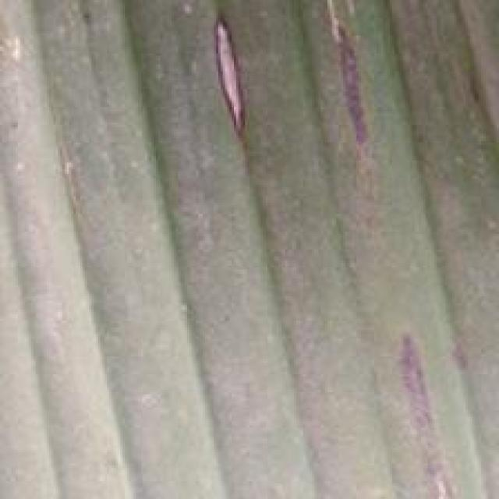
Option 1:
The image shows a leaf with a yellow and brown color pattern, which could be indicative of a disease or a natural aging process. The leaf appears to be affected by a fungal infection, as it has a brown spot on it. This type of infection can be treated with fungicides, which can help prevent the spread of the disease and protect the plant from further damage. It is essential to identify the specific type of fungus causing the infection and apply the appropriate fungicide to ensure effective treatment. Additionally, proper care, such as regular watering, sunlight exposure, and pest control, can help prevent the occurrence of such diseases in the future.
Option 2:
The visible symptoms on the banana plant include yellowing leaves with brown spots, which are characteristic of a disease known as Panama disease or sigatoka. This is a fungal disease caused by Mycosphaerella fijiensis, which affects bananas and other plants in the Musa genus.
The possible solution for this disease would involve the use of fungicides that are effective against sigatoka, such as copper-based fungicides or organic alternatives like neem oil. It's also important to maintain proper drainage, avoid waterlogging, and ensure adequate sunlight exposure to reduce the risk of infection. Additionally, pruning infected leaves and practicing good hygiene can help prevent the spread of the disease within a plantation.

Which answer do you prefer:

Sample 15

Ground Truth: sigatoka
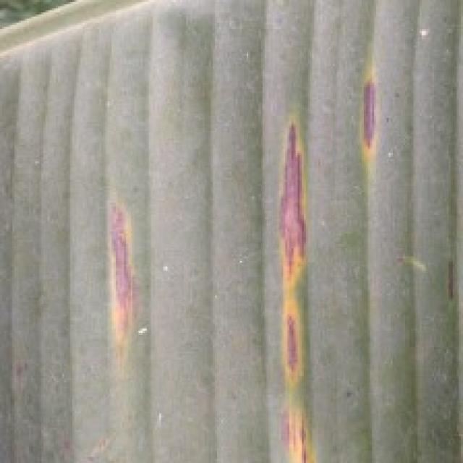
Option 1:
The image shows a leaf with a purple or greenish-purple color, which could indicate a disease or a natural pigmentation. The leaf appears to be affected by a fungal infection, as it has a brown spot on it. This could be a sign of a fungal disease, such as powdery mildew or a bacterial infection.
To address this issue, it is essential to identify the specific type of infection and take appropriate measures to treat it. For fungal infections, it is recommended to remove infected leaves and branches, and apply a fungicide to prevent the spread of the disease. For bacterial infections, it is crucial to remove the affected leaves and branches, and ensure proper hygiene and sanitation practices are followed to prevent the spread of the infection. Additionally, it is important to maintain a healthy plant by providing adequate nutrients, water, and sunlight, and by ensuring proper spacing and air circulation.
Option 2:
The image shows a close-up view of a banana plant leaf with visible signs of a disease known as Panama disease or Sigatoka, which is caused by the fungus Mycosphaerella fijiensis. The symptoms include yellowing and browning of the leaf tissue, often accompanied by small, dark spots that can enlarge over time.
The visible symptoms include:
- Yellowing and browning of the leaf tissue, which is a sign of chlorosis caused by the fungus.
- Small, dark spots on the leaf surface which are characteristic of Sigatoka disease.
The possible solution for this disease would involve the use of fungicides specifically designed to combat Panama disease or Sigatoka. It's important to follow label instructions and recommendations from a plant pathologist when applying these chemicals, as well as considering organic alternatives if desired. Additionally, good sanitation practices, such as removing infected leaves and maintaining proper drainage, can help prevent the spread of the disease.

Which answer do you prefer:

Sample 16

Ground Truth: sigatoka
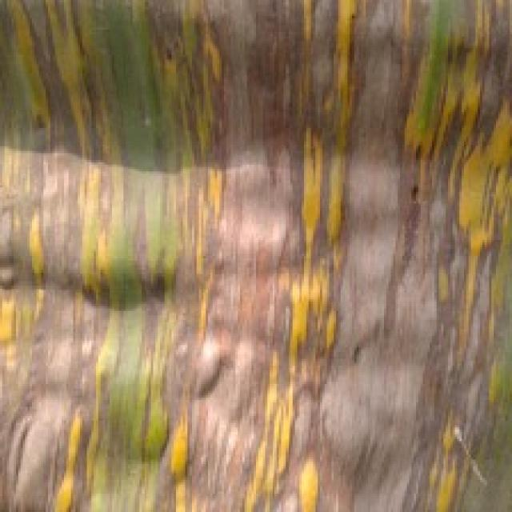
Option 1:
The image shows a leaf with yellow and brown spots, which indicates that the plant is suffering from a disease. The disease appears to be affecting the leaf's color and texture, causing it to become discolored and possibly damaged.
The visible symptoms of the disease include the yellow and brown spots on the leaf, which are indicative of the infection. The leaf may also show signs of wilting or discoloration, depending on the severity of the disease.
To address this issue, it is essential to identify the specific disease causing the symptoms and take appropriate measures to treat it. This may involve using fungicides or other chemical treatments to combat the infection, or applying organic solutions such as neem oil or compost tea to promote plant health and prevent the disease from spreading. Additionally, proper care and maintenance, such as regular watering, pest control, and ensuring adequate sunlight and nutrients, can help prevent the disease from occurring in the first place.
Option 2:
The visible symptoms on the banana plant in the image include yellowing and browning of the leaves, which are characteristic signs of a disease called Sigatoka. This is a fungal disease that affects bananas and other plants in the family Musa.
The possible solution for this disease would involve preventive measures such as growing varieties that are less susceptible to the disease, maintaining proper drainage to avoid waterlogging, and avoiding overcrowding of plants. Additionally, regular inspection for early signs of infection can help in timely treatment with fungicides. It's important to follow recommended guidelines for the use of pesticides in agriculture to minimize environmental impact and ensure effective control of the disease.

Which answer do you prefer:

Sample 17

Ground Truth: sigatoka
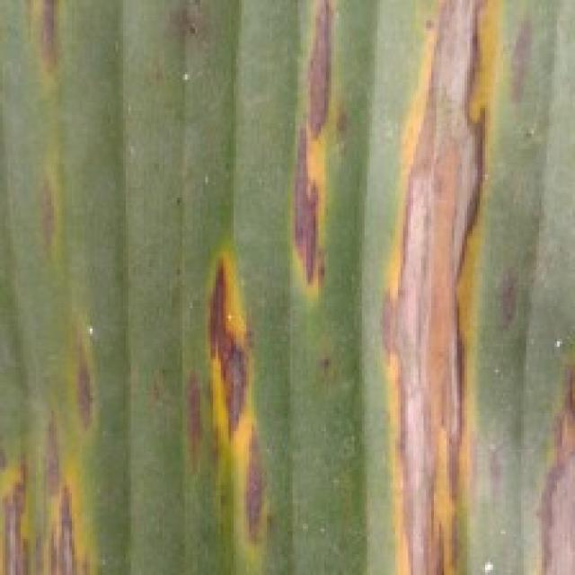
Option 1:
The image shows a leaf with a yellowish-brown color, which could indicate a disease or a nutrient deficiency. The leaf appears to be affected by a fungal infection, as it has a brown spot on it. This type of infection can be caused by various fungi, such as Rhizoctonia, Fusarium, or Botrytis.
To address this issue, it is essential to identify the specific type of fungus causing the infection and apply the appropriate treatment. This may involve using fungicides, applying a preventative spray, or removing and disposing of infected leaves to prevent the spread of the disease. Additionally, ensuring proper plant care, such as regular watering, adequate nutrient supply, and proper drainage, can help prevent the development of fungal infections in the future.
Option 2:
The image shows a close-up view of a banana plant leaf with visible signs of a disease known as Sigatoka. Symptoms include yellowing or browning of the leaf tissue, which can be accompanied by small, dark spots that are characteristic of this fungal infection.
Sigatoka is caused by the fungus Mycosphaerella fijiensis and affects banana plants worldwide. The visible symptoms include yellowing or browning of the leaves, which can progress to necrosis (death) of the leaf tissue. In severe cases, entire leaves may turn brown and die.
To manage this disease, it is important to practice good horticultural practices such as proper spacing between plants, regular pruning, and removal of infected leaves. Additionally, using fungicides can help control the spread of the fungus. It's also crucial to maintain proper drainage and avoid waterlogging, as these conditions can exacerbate the issue.

Which answer do you prefer:

Sample 18

Ground Truth: sigatoka
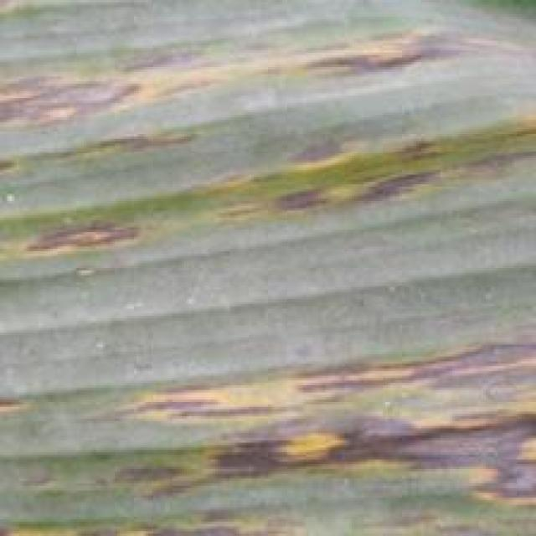
Option 1:
The image shows a leaf with yellow and brown spots, which indicates that the plant is suffering from a disease. The yellow and brown spots are visible symptoms of the disease, and the leaf appears to be infected.
The possible solution to this problem is to identify the specific disease causing the spots and take appropriate measures to treat it. This may involve using fungicides, applying a suitable pesticide, or removing the affected leaves to prevent the spread of the disease. It is essential to consult with a plant expert or a local nursery to determine the best course of action for treating the disease and preventing further damage to the plant.
Option 2:
The visible symptoms in the image include yellowing leaves with brown spots, which are characteristic of a disease called Sigatoka. This is a fungal disease that affects banana plants. Possible solutions include using fungicides and maintaining proper drainage to prevent waterlogging, which can exacerbate the problem. Additionally, removing infected leaves and ensuring adequate sunlight exposure can help in controlling the spread of the disease.

Which answer do you prefer:

Sample 19

Ground Truth: sigatoka
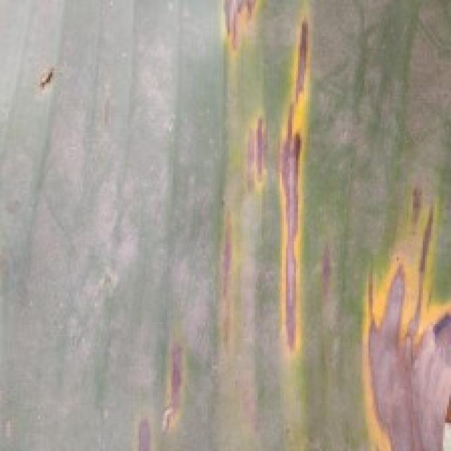
Option 1:
The image shows a leaf with yellow and brown spots, which indicates that the plant is suffering from a disease called bacterial leaf spot. This disease is caused by bacteria that infect the plant's leaves, leading to the formation of spots and potentially causing the leaves to turn yellow and brown.
The visible symptoms of bacterial leaf spot include the yellow and brown spots on the leaves, which can spread and cause the leaves to wither and die. The disease can affect various plant species, including palm trees, and can be caused by different bacteria species.
To manage this disease, it is essential to practice proper plant care, such as regular watering, ensuring adequate nutrient intake, and maintaining a healthy plant environment. Additionally, it is crucial to identify the specific bacteria causing the disease and use appropriate fungicides to treat the affected plants. In some cases, removing and destroying infected leaves can help prevent the spread of the disease.
Option 2:
The visible symptoms in the image include yellowing and browning of the banana leaves, which are characteristic signs of a disease called Sigatoka. This is a fungal disease that affects bananas and other plants in the Musa genus.
The possible solutions include:
1. Proper identification by an expert to confirm the presence of Sigatoka.
2. Implementing cultural practices such as removing infected leaves, maintaining good air circulation, and avoiding waterlogging.
3. Using fungicides if necessary, but always following recommended guidelines for their use in agriculture.
4. Regular monitoring to detect early stages of the disease and prevent its spread.

Which answer do you prefer:

Sample 20

Ground Truth: sigatoka
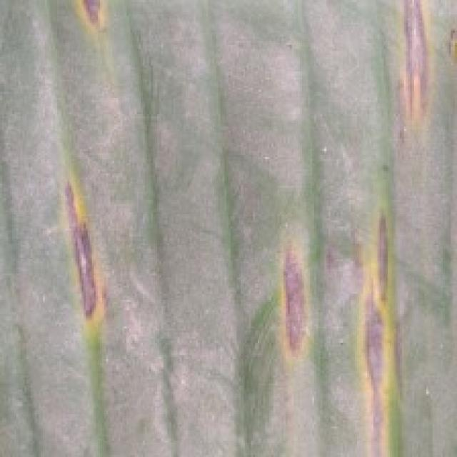
Option 1:
The image shows a leaf with yellow and brown spots, which indicates that the plant is suffering from a disease. The disease appears to be affecting the plant's ability to photosynthesize, as the leaf is described as "dead" and "dying."
The visible symptoms of the disease include the yellow and brown spots, which are indicative of a fungal infection or bacterial disease. The leaf's discoloration and wilting suggest that the plant is experiencing stress and is unable to recover from the infection.
A possible solution to this problem would be to identify the specific type of disease and apply appropriate treatment methods. This may involve using fungicides or bactericides to combat the infection, as well as providing the plant with proper care, such as ensuring adequate watering, sunlight, and nutrient intake. Additionally, it is essential to maintain a healthy plant environment by removing any infected leaves and practicing good hygiene to prevent the spread of the disease.
Option 2:
The image shows a banana plant with yellowing leaves, which is indicative of a disease called Sigatoka. This disease affects bananas and other plants in the family Musa. The symptoms include chlorotic (yellowing) spots on the leaves, which can eventually coalesce into larger lesions. These lesions are often accompanied by a yellow halo around the edges of the affected areas.
The solution for this disease would typically involve fungicide treatments to control the spread of the pathogen. It's important to follow recommended application rates and follow all label instructions when applying these chemicals. Additionally, good plant nutrition, proper drainage, and avoiding waterlogging can help prevent the development of Sigatoka and other similar diseases.

Which answer do you prefer:

Sample 21

Ground Truth: sigatoka
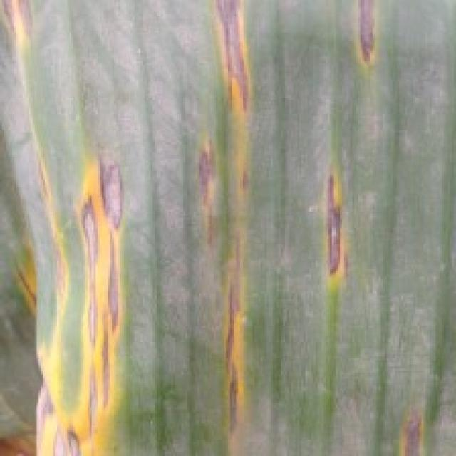
Option 1:
The image shows a leaf with yellow and brown spots, which indicates that the plant is suffering from a fungal infection. The spots are likely caused by a fungus that has infected the plant, leading to the yellowing and browning of the leaves.
To address this issue, it is essential to identify the specific type of fungus causing the infection and apply appropriate fungicides to the affected plant. Additionally, it is crucial to maintain proper plant care, such as regular watering, ensuring adequate sunlight, and providing proper nutrients to promote healthy growth and prevent future infections. It is also important to practice good garden hygiene, such as removing infected leaves and avoiding overcrowding plants, to minimize the risk of fungal infections spreading to other plants in the garden.
Option 2:
The visible symptoms in the image include yellowing leaves with brown spots, which are characteristic of a disease called Sigatoka. This is a fungal disease that affects banana plants and can cause significant damage if not treated.
To address this issue, it's important to follow proper horticultural practices such as:
1. Regularly inspecting plants for early signs of infection.
2. Removing infected leaves to prevent further spread of the disease.
3. Applying fungicides specifically designed for banana plants, following the recommended dosage and application frequency as per the product label.
4. Maintaining good plant nutrition and water management to promote healthy growth and reduce stress on the plant.
5. Implementing cultural practices such as spacing plants properly to allow adequate air circulation and sunlight exposure.
6. Removing debris from around the base of the plant where fungal spores can accumulate.
7. Practicing crop rotation to minimize the risk of disease spreading between plants.

Which answer do you prefer:

Sample 22

Ground Truth: sigatoka
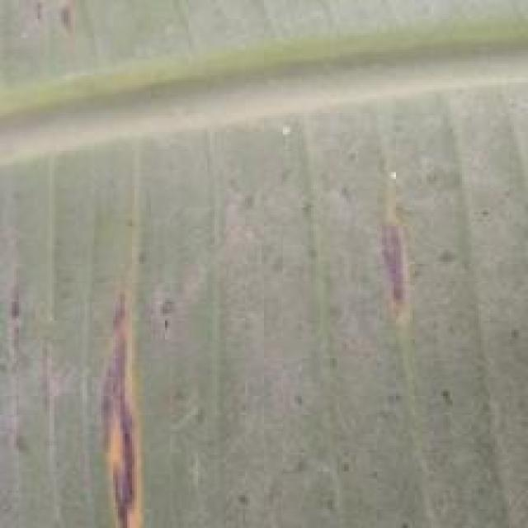
Option 1:
The image shows a tree with a yellow and green striped bark, which could be indicative of a disease or a natural phenomenon. The yellow and green stripes might be a result of a fungal infection or a nutrient deficiency in the tree.
To identify the specific disease or cause of the yellow and green striped bark, a thorough examination of the tree and its surrounding environment would be necessary. If the bark is indeed affected by a fungal infection, the tree may require treatment with fungicides to prevent the spread of the disease and protect the tree's health. If the bark is due to nutrient deficiency, the tree may require supplementation with essential nutrients to promote healthy growth and prevent further damage.
It is important to consult with a tree care professional or a local agricultural extension service to determine the best course of action for the tree's health and well-being.
Option 2:
The visible symptoms in the image include discoloration and possibly some lesions or spots on the banana plant's leaf. These could be indicative of a disease caused by a fungus such as Sigatoka, which is common in bananas.
To address this issue, it would be advisable to follow best practices for disease management in bananas. This includes:
1. Regularly inspecting plants for early signs of disease and taking action promptly.
2. Maintaining proper drainage around the base of the plant to prevent waterlogging, which can exacerbate fungal growth.
3. Removing and destroying infected leaves to prevent further spread of the disease.
4. Applying fungicides as recommended by a local agricultural extension service or professional.
5. Ensuring proper nutrition and irrigation to support the plant's health.
6. Implementing cultural practices such as removing weeds and debris around the base of the plant to reduce the risk of disease spread.

Which answer do you prefer:

Sample 23

Ground Truth: yellow black sigatoka
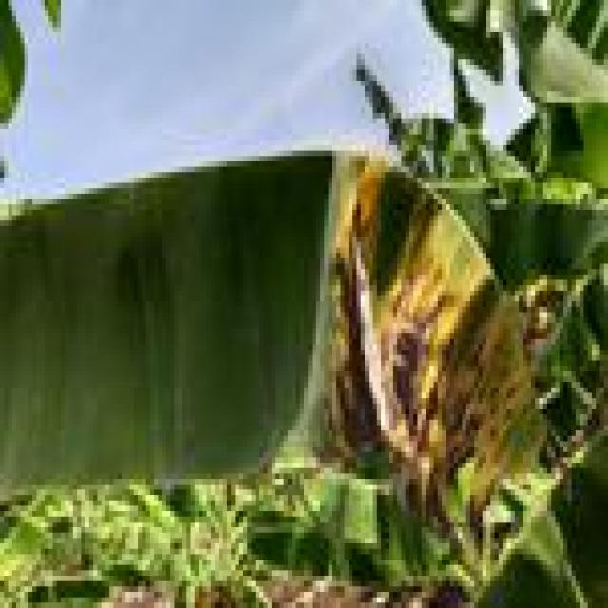
Option 1:
The image shows a banana plant with yellow leaves, which indicates that the plant is experiencing a disease called "yellowing" or "chlorosis." This disease is caused by a lack of nutrients, particularly iron, in the soil. The yellowing of the leaves can be a sign of iron deficiency in the soil, which can lead to reduced plant growth and yield.
To address this issue, it is essential to provide the plant with adequate amounts of iron-rich soil or fertilizers. This can be achieved by adding organic matter, such as compost or well-rotted manure, to the soil to improve its structure and nutrient content. Additionally, regular soil testing and monitoring of the plant's health can help identify any other nutrient deficiencies and ensure that the plant receives the necessary nutrients for optimal growth and health.
Option 2:
The visible symptoms in the image include yellowing leaves with brown spots, which are characteristic of a disease called Yellow Sigatoka (Yb_sigatoka). This disease affects banana plants and is caused by a fungus.
The possible solutions include:
1. Proper identification of the disease by an expert in plant pathology or a local agricultural extension service.
2. Implementing cultural practices such as removing infected leaves, maintaining good drainage, and avoiding waterlogging.
3. Using fungicides if necessary, following all label instructions and recommended dosages. It's important to consult with a plant pathologist or extension service before applying any chemical treatments.
4. Monitoring the plant regularly for signs of improvement or worsening of the disease and adjusting management practices accordingly.

Which answer do you prefer:

Sample 24

Ground Truth: yellow black sigatoka
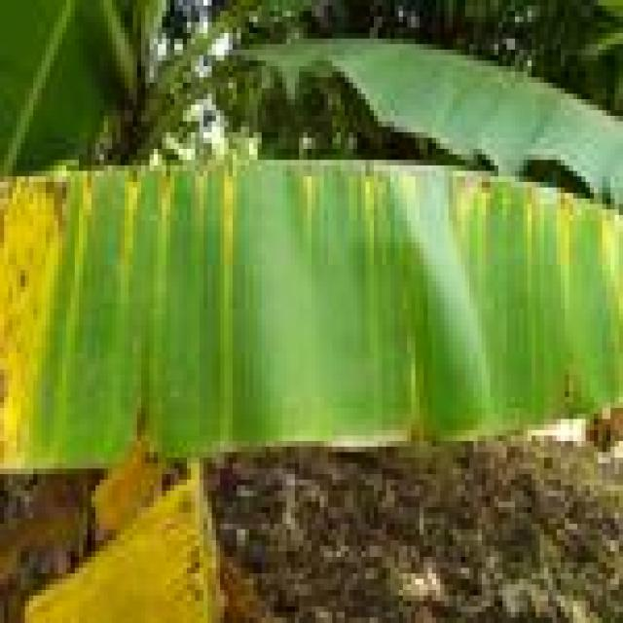
Option 1:
The image shows a banana leaf with brown spots and yellow patches, indicating that it is affected by a disease. The brown spots and yellow patches suggest that the banana leaf is experiencing a fungal infection, which can be caused by various factors such as overwatering, nutrient deficiencies, or poor soil quality.
To address this issue, it is essential to identify the underlying cause of the infection and take appropriate measures to prevent further damage. This may include:
1. Ensuring proper drainage and watering: Overwatering can lead to root rot, which can cause the banana leaf to turn brown and yellow. Ensuring that the soil is well-drained and watered appropriately can help prevent this issue.
2. Providing adequate nutrients: A lack of essential nutrients can weaken the plant and make it more susceptible to diseases. Adding organic matter to the soil, such as compost or aged manure, can help improve soil quality and provide the necessary nutrients.
3. Regularly inspecting the plant: Keeping an eye on the plant's health and looking for any signs of infection or damage can help identify and address issues early on.
4. Practicing good hygiene: Removing any infected leaves or parts of the plant and disposing of them properly can help prevent the spread of the disease.
By addressing these factors, it is possible to improve the health of the banana plant and prevent further damage from the fungal infection.
Option 2:
The visible symptoms on the banana plant in the image include yellowing and browning of the leaves, which are indicative of a disease known as Yellow Sigatoka (Yb_sigatoka). This disease is caused by the fungus Mycosphaerella fijiensis.
The affected areas on the leaves show signs of necrosis, where tissue has died and turned brown or black. There may also be small, water-soaked spots that are characteristic of Yellow Sigatoka infection. These spots can eventually coalesce into larger lesions if left untreated.
A possible solution for this disease would involve the use of fungicides specifically designed to combat Yellow Sigatoka. It's important to follow recommended application rates and guidelines provided by the manufacturer when using these chemicals. Additionally, good plant hygiene practices, such as removing infected leaves and maintaining proper drainage, can help prevent the spread of the disease.

Which answer do you prefer:

Sample 25

Ground Truth: yellow black sigatoka
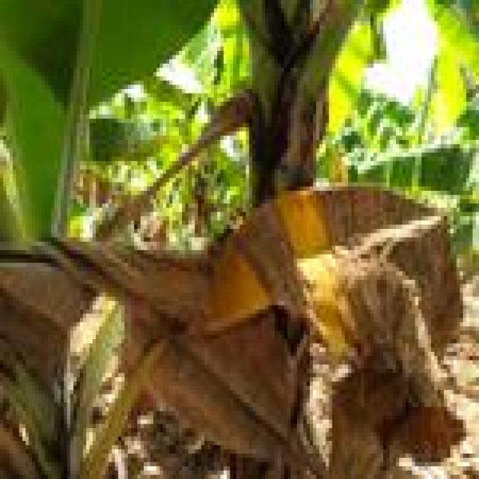
Option 1:
The image shows a leaf with yellow and brown spots, which indicates that the plant is suffering from a disease. The disease appears to be affecting the leaf's health and causing it to lose its vibrant green color.
The visible symptoms of the disease include the yellow and brown spots, which are indicative of a fungal infection or bacterial infection. The leaf may also show signs of wilting or drooping, further suggesting that the plant is affected by the disease.
To address this issue, it is essential to identify the specific type of disease affecting the plant and take appropriate measures to treat it. This may involve using fungicides or bactericides to combat the infection, as well as ensuring proper care and maintenance of the plant, such as regular watering, adequate sunlight, and proper soil conditions. Additionally, it is important to practice good garden hygiene, such as removing infected leaves and avoiding overcrowding plants, to prevent the spread of the disease.
Option 2:
The visible symptoms on the banana plant in this image include yellowing and browning of the leaves, which are indicative of a disease known as Panama disease or Yellow Sigatoka. This disease is caused by a fungus and can affect bananas and other plants in the Musa genus.
The possible solution for this disease would involve the following steps:
1. Proper identification of the disease by an expert to confirm its presence.
2. Implementing good agricultural practices such as proper drainage, avoiding overcrowding of plants, and maintaining a clean environment to prevent the spread of the fungus.
3. Using resistant varieties of bananas if available in the region where Panama disease is prevalent.
4. Applying fungicides as recommended by an agricultural professional to control the spread of the disease.
5. Regular monitoring and removal of affected leaves to prevent further damage to the plant.

Which answer do you prefer:

Sample 26

Ground Truth: yellow black sigatoka
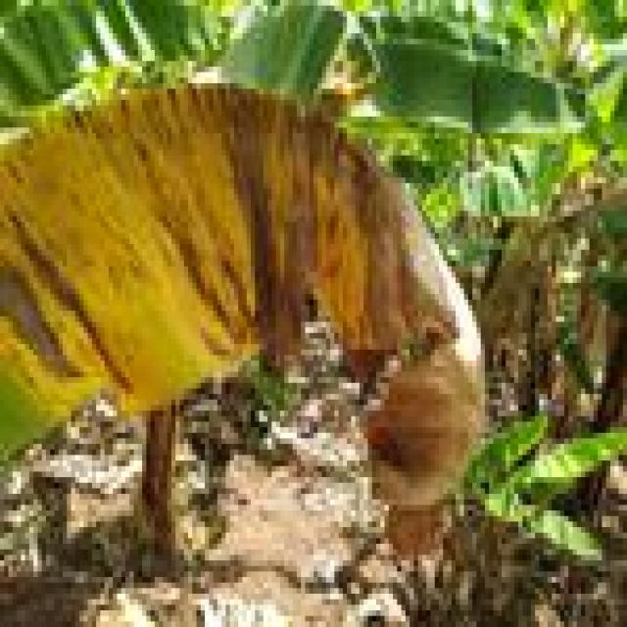
Option 1:
The image shows a banana plant with a large, yellow, and brown leaf, which appears to be infected with a disease. The leaf has visible spots and is starting to wilt. This could be a sign of a fungal infection or a bacterial disease affecting the banana plant.
To address this issue, it is essential to identify the specific disease causing the symptoms and take appropriate measures to treat or prevent its spread. Some possible solutions include:
1. Removing infected leaves and branches to prevent the disease from spreading to healthy parts of the plant.
2. Applying a suitable fungicide or bactericide to the plant to kill the pathogens causing the infection.
3. Practicing good plant hygiene, such as removing any debris or pests that may be attracting the disease-causing organisms.
4. Ensuring proper drainage and air circulation around the plant to reduce the risk of fungal growth.
5. Monitoring the plant's health and taking preventive measures, such as applying a protective coating or using resistant varieties, to minimize the risk of future infections.
It is crucial to consult with a local agricultural expert or a plant pathologist to determine the best course of action for treating and preventing the disease in the banana plant.
Option 2:
The visible symptoms in the image include discoloration and spots on the leaves of the banana plant. These are indicative of a disease called Yellow Sigatoka, which is caused by the fungus Mycosphaerella fijiensis.
The affected leaves show yellowing, browning, and blackening with small, irregularly shaped spots that can coalesce into larger lesions. This disease can lead to significant yield loss if not managed properly.
A possible solution for this disease would include the use of fungicides, such as those containing copper or other organic compounds, and good plant nutrition management to improve the plant's overall health and resistance to infection. Additionally, proper drainage, spacing, and removal of infected leaves can help prevent the spread of the disease within the plantation.

Which answer do you prefer:

Sample 27

Ground Truth: yellow black sigatoka
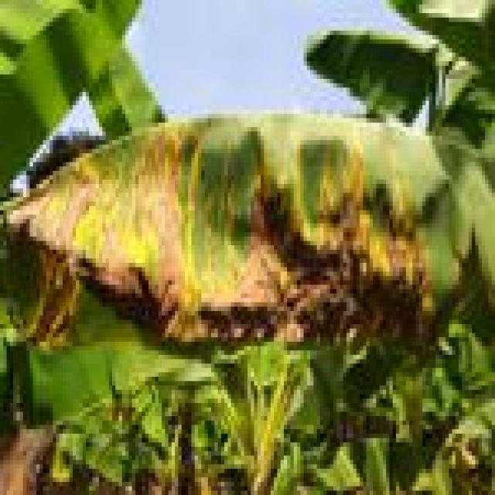
Option 1:
The image shows a banana tree with yellow leaves, which indicates that the tree is suffering from a disease called "Panama disease." This disease is caused by the fungus Fusarium oxysporum f. sp. cubense, which affects the tree's vascular system, causing it to wilt and die.
The visible symptoms of Panama disease include yellowing of the leaves, wilting, and eventual death of the tree. The disease can spread rapidly and is highly contagious, making it difficult to control and eradicate.
A possible solution to prevent the spread of Panama disease is to practice good agricultural practices, such as regular pruning, proper irrigation, and maintaining a healthy soil environment. Additionally, using resistant varieties of banana trees can help reduce the risk of infection. It is also essential to monitor the health of the tree and take appropriate action if any signs of disease are detected early on.
Option 2:
The visible symptoms in the image include yellowing leaves with brown spots, which are characteristic of a disease called Panama Disease or Yellow Sigatoka. This disease affects banana plants and is caused by the fungus Mycosphaerella fijiensis.
The possible solution for this disease would involve the following steps:
1. Early detection: Regularly inspect the plant for signs of Panama Disease, such as yellowing leaves with brown spots.
2. Proper identification: Confirm the presence of the disease by sending samples to a laboratory for diagnosis.
3. Sanitation and water management: Ensure that the banana plant is growing in clean soil and has adequate drainage to prevent the spread of the fungus.
4. Fungicide application: Use registered fungicides to control the disease. It's important to follow label instructions and rotate fungicides to prevent resistance.
5. Removal and destruction of infected plants: Remove affected plants promptly to prevent further spread of the disease.
6. Crop rotation: Rotate banana crops with other plants that are not susceptible to Panama Disease to reduce the risk of infection.
7. Good field sanitation: Keep fields free from weeds and debris that can harbor the fungus.
8. Proper water management: Avoid waterlogging, which can exacerbate the disease.
9. Use resistant varieties: If available, consider planting varieties that are known to be resistant to Panama Disease.
10. Monitoring and adjustment: Regularly monitor the health of the plant and adjust management practices as needed.

Which answer do you prefer:

Sample 28

Ground Truth: yellow black sigatoka
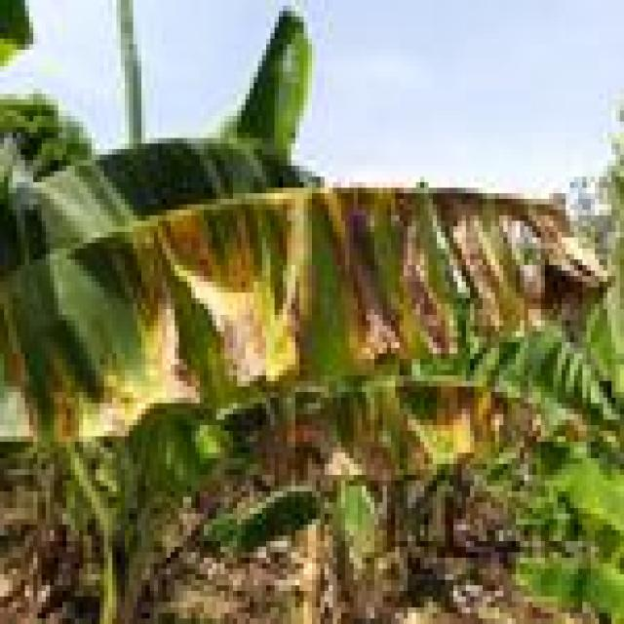
Option 1:
The image shows a leaf with yellow spots and brown patches, which could be indicative of a fungal infection or a bacterial disease. The spots and patches are irregularly shaped and appear to be spreading across the leaf.
To address this issue, it is essential to identify the specific type of disease causing the symptoms. Once the disease is diagnosed, appropriate treatment measures can be taken. For fungal infections, applying a fungicide specifically designed for the disease can help control the spread and prevent further damage. For bacterial diseases, it is crucial to remove any infected parts of the plant and practice proper plant care, such as regular watering, pruning, and ensuring adequate sunlight and nutrients. Additionally, maintaining a healthy plant environment by avoiding overcrowding and ensuring proper air circulation can help prevent the spread of diseases.
Option 2:
The image shows a banana leaf with yellow spots and lesions, which are characteristic signs of Yellow Sigatoka disease (Yb_sigatoka). This is a fungal disease that affects banana plants. Visible symptoms include yellowing of the leaves, followed by the formation of brown or black spots and lesions on the leaf surface.
The possible solution for this disease would involve the use of fungicides specifically designed to combat Yellow Sigatoka. It's important to follow recommended application rates and guidelines provided by the manufacturer when using these chemicals. Additionally, good plant hygiene practices such as removing infected leaves and maintaining proper drainage can help prevent the spread of the disease.

Which answer do you prefer:

Sample 29

Ground Truth: yellow black sigatoka
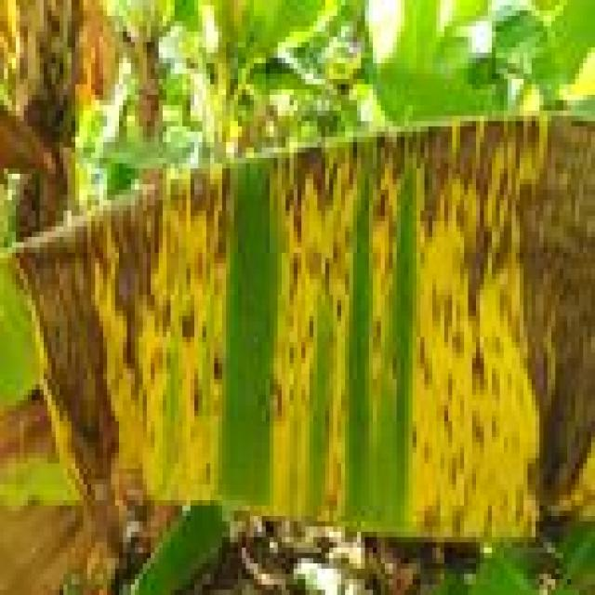
Option 1:
The image shows a yellow and green leaf with brown spots, which indicates that the leaf is affected by a fungal disease. The brown spots are a visible symptom of the disease, and the leaf appears to be dying.
To solve this issue, it is essential to identify the specific type of fungal disease affecting the leaf and take appropriate measures to prevent its spread. This may involve removing infected leaves, pruning affected branches, and applying fungicides to the plant to prevent further damage. Additionally, ensuring proper care, such as regular watering, adequate sunlight, and well-draining soil, can help maintain the health of the plant and reduce the risk of fungal diseases.
Option 2:
The visible symptoms in the image include yellowing leaves with brown spots, which are characteristic of a disease called Yellow Sigatoka (Yb). This disease affects banana plants and is caused by the fungus Mycosphaerella fijiensis.
The possible solutions for this disease include:
1. Proper sanitation: Ensure that the plant is free from infected leaves and debris.
2. Fungicide application: Use registered fungicides such as Luna Experience, Serenade Prime, Routine, Scala, or Scala CSD to control the disease.
3. Resistance management: If necessary, consider removing diseased plants and replacing them with healthy ones to prevent further spread of the disease.
4. Water management: Avoid waterlogging, which can exacerbate the problem by creating a favorable environment for fungal growth.
5. Nutrient management: Ensure that the plant is receiving adequate nutrients, especially potassium, as deficiencies can increase susceptibility to Yb_sigatoka.
6. Cultural practices: Remove and destroy infected leaves to prevent further spread of the disease.

Which answer do you prefer:

Sample 30

Ground Truth: yellow black sigatoka
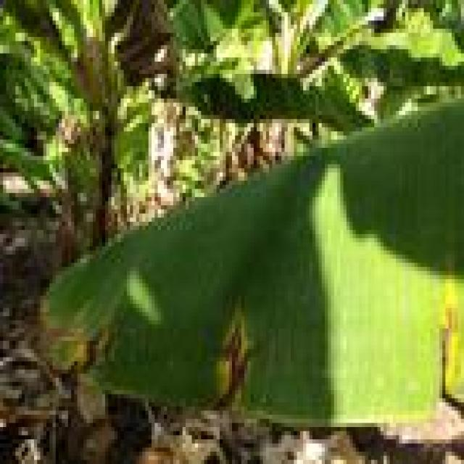
Option 1:
The image shows a banana tree with yellow leaves, which indicates that it is suffering from a disease called "Banana Bunch Disease." This disease is caused by a fungus called Fusarium oxysporum f. sp. cubense, which affects the tree's growth and fruit production.
The visible symptoms of Banana Bunch Disease include yellowing of the leaves, chlorosis (yellowing of the leaf veins), and the formation of brown spots on the leaves. The disease can also cause the banana bunches to become deformed or unhealthy, leading to a reduced yield.
A possible solution to this problem is to practice good agricultural practices, such as proper irrigation, pest and disease management, and timely pruning of infected parts of the tree. Additionally, using resistant varieties of banana trees can help minimize the impact of the disease. It is also essential to maintain a healthy soil and a balanced nutrient supply to support the tree's overall health and prevent the disease from spreading.
Option 2:
The image shows a banana plant with several yellowed leaves, which could be indicative of a disease known as Panama disease or Fusarium wilt, also referred to as "Yellow Sigatoka." This disease is caused by the fungus Fusarium oxysporum f. sp. cubense and affects banana plants.
Visible symptoms include:
- Yellowing of leaves, which can progress to brown or black discoloration.
- Leaf necrosis (death) at the edges or tips.
- Wilting and eventual death of the plant if not treated.
The possible solution for this disease is the use of fungicides that are effective against Fusarium oxysporum f. sp. cubense, such as Luna Experience, Scala, Serenade Prime, and Routine. It's important to follow proper application and rotation guidelines to minimize the risk of developing resistance to these chemicals. Additionally, good plant hygiene, including removing infected plants and sanitizing tools, can help prevent the spread of the disease.

Which answer do you prefer:

Sample 31

Ground Truth: yellow black sigatoka
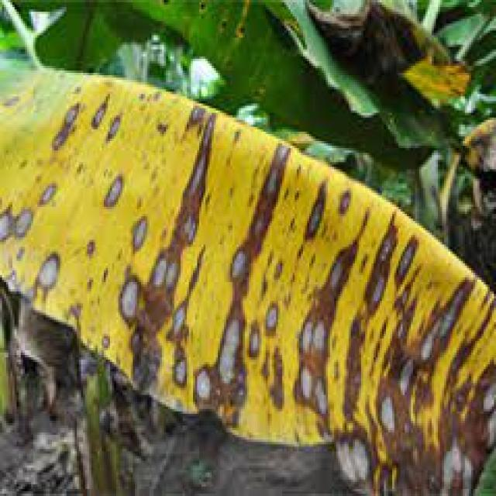
Option 1:
The image shows a piece of wood with a yellowish-brown color and a few black spots. The black spots are likely the result of a fungal infection, which can cause the wood to rot and decay. The presence of mold and mildew on the wood indicates that the wood has been exposed to moisture and has not been properly dried or treated.
To prevent further decay and damage, it is essential to address the underlying issues that caused the wood to become infected. This may involve removing the affected wood, treating the wood with a fungicide or preservative, and ensuring proper ventilation and moisture control in the area where the wood is stored or used. Additionally, regular inspections and maintenance can help prevent the spread of the fungal infection and prolong the life of the wood.
Option 2:
The image shows a close-up view of a banana plant affected by Yellow Sigatoka disease (Yb_sigatoka). Visible symptoms include yellowing of the leaves, which is characteristic of this fungal infection. The affected areas have a yellow hue with brown spots and lesions, indicating damage to the tissue caused by the pathogen.
A possible solution for managing Yellow Sigatoka disease would involve cultural practices such as removing infected leaves, maintaining good air circulation around the plant, and using fungicides when necessary. It's important to follow recommended guidelines for the use of pesticides in agriculture and consider the environmental impact of these treatments. Additionally, monitoring the health of the plant regularly and implementing preventive measures like proper irrigation and fertilization can help minimize the risk of disease spread.

Which answer do you prefer:

Sample 32

Ground Truth: yellow black sigatoka
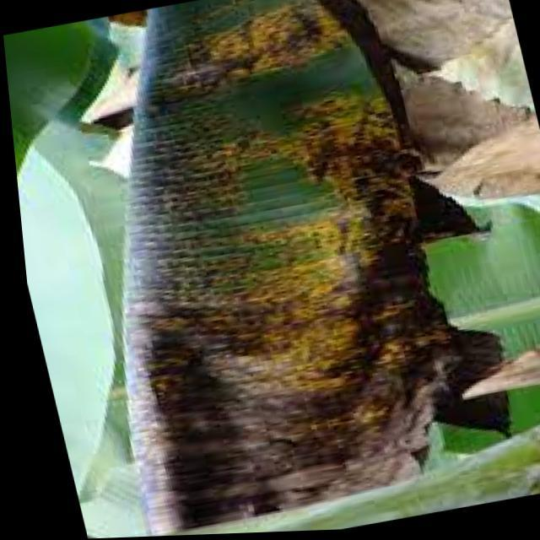
Option 1:
The image shows a leaf with brown spots and yellow patches, which indicates that the plant is suffering from a disease. The disease could be a fungal infection or a bacterial infection, as both can cause similar symptoms. To address this issue, it is essential to identify the specific type of disease and take appropriate measures to treat it.
For fungal infections, it is crucial to remove any infected leaves and branches, and then apply a fungicide to the affected plant. It is also important to maintain proper plant hygiene, such as regular pruning and cleaning of the plant, to prevent the spread of the disease.
For bacterial infections, it is necessary to remove the infected leaves and branches, and then apply a bactericide to the affected plant. Additionally, it is important to maintain proper plant hygiene, such as regular pruning and cleaning of the plant, to prevent the spread of the disease.
In both cases, it is essential to consult with a plant expert or a local nursery to identify the specific disease and receive guidance on the appropriate treatment and prevention measures.
Option 2:
The visible symptoms on the banana plant in the image include discoloration and spots. There are brown and yellow areas on the leaves, which could indicate a fungal disease such as Panama disease (Fusarium oxysporum f. sp. cubense), also known as Panama wilt or Foc. This disease affects banana plants by causing vascular tissue to become blocked, leading to wilting and death of the plant.
The possible solution for this disease would involve preventive measures such as proper drainage, avoiding overcrowding in the soil, and using resistant varieties of banana plants. Additionally, fungicides can be applied to control the spread of the disease, but it's important to follow recommended guidelines for their use in agriculture to minimize any potential harm to the environment or other plants.

Which answer do you prefer:

Sample 33

Ground Truth: yellow black sigatoka
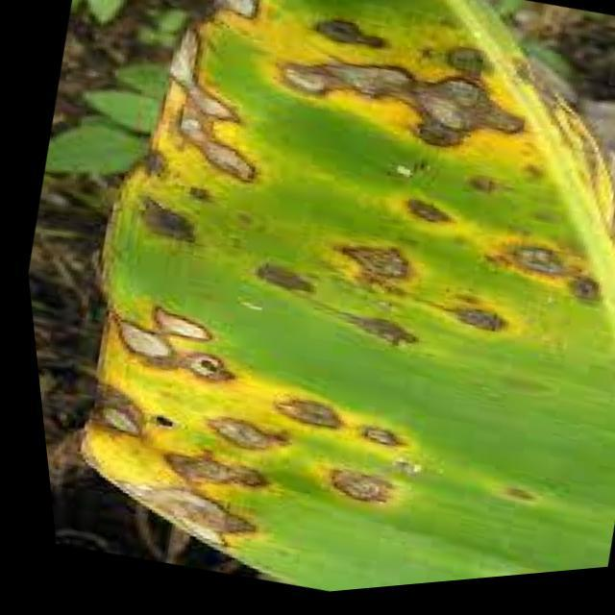
Option 1:
The image shows a banana tree with yellow and brown spots on its leaves, indicating that it is suffering from a disease. The disease appears to be affecting the tree's overall health and growth.
The visible symptoms of the disease include the yellow and brown spots on the leaves, which could be a sign of fungal infection or bacterial disease. The tree's leaves may also be drooping or wilting, further indicating the presence of a disease.
To address this issue, it is essential to identify the specific disease causing the symptoms and take appropriate measures to treat it. This may involve applying fungicides or bactericides to the affected tree, ensuring proper irrigation and drainage, and maintaining a healthy environment for the tree by removing any dead or diseased parts. Additionally, regular monitoring of the tree's health and early detection of any signs of disease can help prevent further damage and promote the tree's overall well-being.
Option 2:
The visible symptoms in the image include yellowing leaves with brown spots, which are characteristic of a disease called Yellow Sigatoka (Yb). This disease affects banana plants and is caused by the fungus Mycosphaerella fijiensis.
To manage this disease, growers can implement several strategies:
1. Proper drainage: Ensure that the soil has good drainage to prevent waterlogging, which can exacerbate the problem.
2. Pruning and de-suckering: Regularly prune infected leaves and de-sucker to reduce the amount of plant material available for fungal growth.
3. Fungicide application: Use systemic fungicides such as Luna Experience, Scala, Serenade Prime, Routine, and Scala C. These can help control the disease by preventing spore germination and spread.
4. Crop rotation: Rotate affected plants with healthy ones to avoid the buildup of fungal spores in the soil.
5. Sanitation and water management: Keep banana plants away from areas with high humidity and poor drainage, as these conditions can contribute to the development of Yellow Sigatoka.
6. Improved plant nutrition: Ensure that the plants receive adequate nutrients, especially potassium, which can help improve their overall health and resistance to diseases.
7. Monitoring and early detection: Regularly inspect plants for signs of disease and treat affected areas as soon as possible to prevent further spread.

Which answer do you prefer:

Sample 34

Ground Truth: yellow black sigatoka
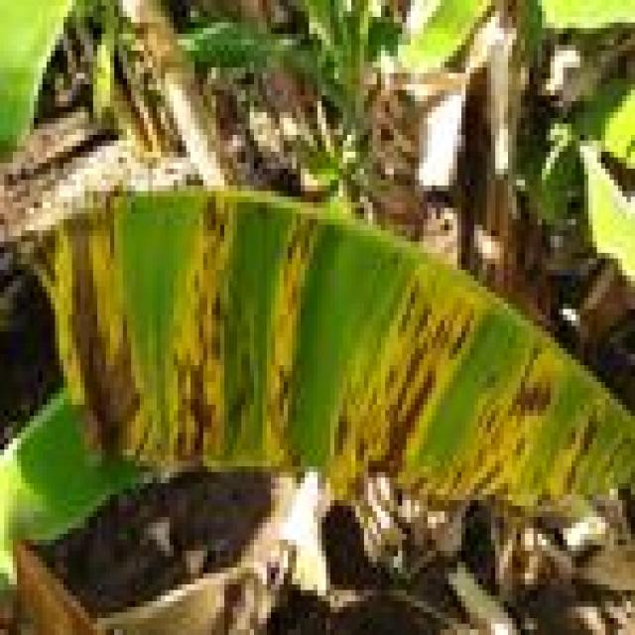
Option 1:
The image shows a banana leaf with yellow spots and brown patches, which indicates that the banana tree is suffering from a disease called Panama disease. This disease is caused by the fungus Fusarium oxysporum f. sp. cubense, which affects the banana tree's vascular system, causing it to wilt and die.
The visible symptoms of Panama disease include yellow spots and brown patches on the banana leaves, as well as wilting and yellowing of the tree's foliage. The disease can spread rapidly and is difficult to control once it has taken hold.
A possible solution to prevent the spread of Panama disease is to practice good agricultural practices, such as proper irrigation, pest and disease management, and regular monitoring of the banana tree's health. Additionally, using resistant varieties of banana trees can help reduce the risk of infection. In cases where the disease has already spread, it may be necessary to remove affected trees and replace them with healthy ones to prevent further spread of the disease.
Option 2:
The image shows a banana leaf with yellow and brown spots, which are characteristic of a disease known as Yellow Sigatoka (Yb_sigatoka). This disease affects bananas and is caused by the fungus Mycosphaerella fijiensis.
Visible symptoms include:
- Yellow or yellowish-brown spots on the leaves, which can be irregularly shaped or elongated.
- The spots may have a yellow halo around them.
- The edges of the spots are often sharply defined.
- The spots can coalesce to form larger lesions.
A possible solution for this disease is the use of fungicides that are registered for controlling Yellow Sigatoka in bananas. These fungicides can help prevent the spread of the disease and protect healthy tissue from further damage. It's important to follow label instructions when applying these chemicals, as well as adhere to any recommended application rates or restrictions. Additionally, good plant nutrition, water management, and proper sanitation practices can help maintain overall plant health and reduce the risk of disease development.

Which answer do you prefer:

Sample 35

Ground Truth: yellow black sigatoka
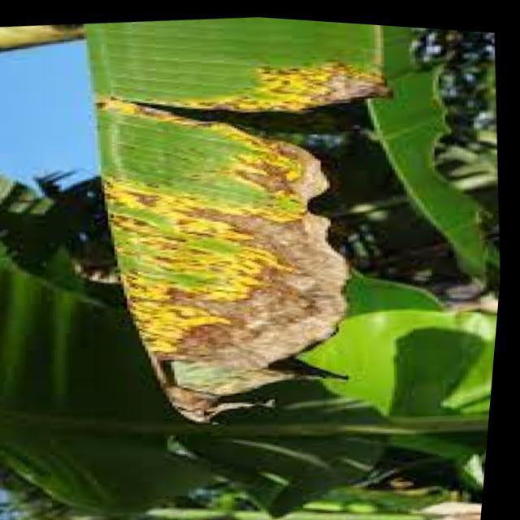
Option 1:
The image shows a banana leaf with yellow spots and brown patches, indicating that it is affected by a fungal disease called Panama disease. This disease is caused by the fungus Fusarium oxysporum f. sp. cubense, which attacks the banana plant's roots and vascular system, leading to the yellowing and browning of the leaves.
The visible symptoms of Panama disease include yellow spots and brown patches on the banana leaf, as well as wilting and yellowing of the plant's leaves. The disease can also cause the plant to produce small, deformed fruits or no fruit at all.
A possible solution to combat Panama disease is to practice good agricultural practices, such as proper soil management, regular irrigation, and the use of resistant varieties of banana plants. Additionally, using fungicides can help prevent the spread of the disease and protect the plant from further damage. It is essential to identify and manage the disease early to minimize its impact on the banana plant and the yield of the fruit.
Option 2:
The visible symptoms on the banana leaf include yellowing with brown spots, which are characteristic of a disease known as Yellow Sigatoka (Yb_sigatoka). This disease affects bananas and is caused by the fungus Mycosphaerella fijiensis.
The possible solution for this disease would involve the following steps:
1. Remove infected leaves to prevent further spread of the fungus.
2. Apply a fungicide that is effective against Yellow Sigatoka, such as Luna Experience, Serenade Prime, Routine, Scala, or Scala Copper. It's important to follow the recommended application rates and follow all label instructions for safe use.
3. Maintain proper drainage and avoid waterlogging, as this can exacerbate the disease.
4. Ensure adequate sunlight exposure, as this helps in the prevention of fungal growth.
5. Keep the plant well-ventilated to reduce humidity levels.
6. Consider using resistant varieties if available in your region.
7. Regularly inspect plants for early signs of disease and treat as needed.

Which answer do you prefer:

Sample 36

Ground Truth: yellow black sigatoka
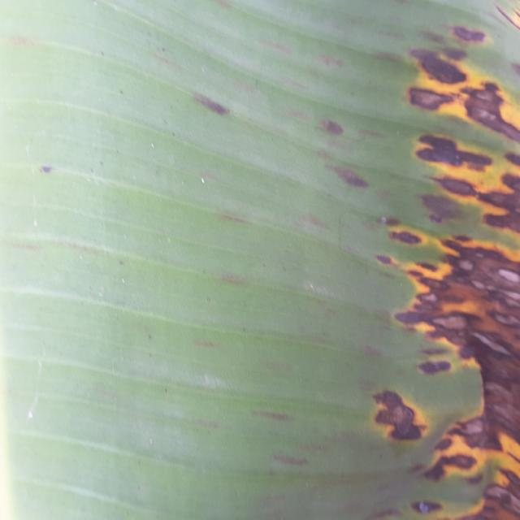
Option 1:
The image shows a leaf with brown spots and yellow streaks, which indicates that the plant is suffering from a disease. The disease appears to be affecting the plant's growth and overall health.
The visible symptoms of the disease include brown spots and yellow streaks on the leaf, which are indicative of a fungal infection or bacterial disease. The presence of these spots and streaks suggests that the plant is experiencing stress or damage, which can be caused by various factors such as overwatering, underwatering, nutrient deficiencies, or exposure to extreme temperatures.
To address this issue, it is essential to identify the cause of the disease and take appropriate measures to prevent further damage. This may include adjusting the plant's watering schedule, ensuring proper nutrient intake, and providing adequate sunlight or shade, depending on the plant's specific requirements. Additionally, if the disease is caused by a fungal infection, it may be necessary to use fungicides to control the spread of the disease and promote the plant's recovery.
Option 2:
The image shows a banana leaf with several visible symptoms indicative of Yellow Sigatoka disease (Yb_sigatoka). These symptoms include:
1. Brown spots: There are brown spots scattered across the leaf, which is characteristic of the fungal infection.
2. Yellowing: The edges of the leaf appear to be yellowed, which could indicate chlorosis due to nutrient deficiency or stress from the disease.
3. Discoloration: There are areas where the color has changed from green to brown, indicating necrosis caused by the fungus.
4. Leaf deformation: The leaf appears slightly curled at the edges, which could be a result of the fungal infection affecting the plant's ability to transport water and nutrients properly.
To manage this disease, it is important to follow best practices for banana cultivation, such as proper drainage, avoiding overcrowding in planting, and maintaining good soil fertility. Additionally, using fungicides specifically designed for Yellow Sigatoka can help control the spread of the disease and prevent further damage to the plant.

Which answer do you prefer:

Sample 37

Ground Truth: yellow black sigatoka
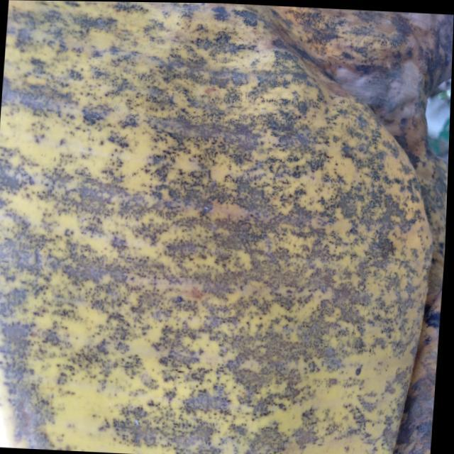
Option 1:
The image shows a banana tree with yellow leaves, which indicates that it is suffering from a disease called "Panama disease." This disease is caused by the fungus Fusarium oxysporum f. sp. cubense, which affects the tree's roots and eventually leads to the yellowing and wilting of the leaves.
The visible symptoms of Panama disease include yellowing leaves, stunted growth, and a general decline in the tree's health. The disease can be fatal to the tree if not treated in time.
A possible solution to combat Panama disease is to practice good agricultural practices, such as proper irrigation, regular pruning, and the use of resistant varieties of banana trees. Additionally, the use of fungicides and other chemical treatments can help control the spread of the disease and protect the tree from further damage. It is essential to identify the disease early and take appropriate measures to prevent its spread and minimize the impact on the banana tree and the overall crop.
Option 2:
The visible symptoms in the image include yellowing of the leaves, which is a common sign of diseases like Yellow Sigatoka (YB) in banana plants. This disease is caused by the fungus Mycosphaerella fijiensis and can lead to significant yield loss if not managed properly.
The possible solutions include:
1. Proper identification of the disease by a qualified agronomist or plant pathologist to confirm the diagnosis.
2. Implementing cultural practices such as removing infected leaves, maintaining good drainage, and avoiding waterlogging.
3. Using fungicides that are registered for use in bananas and following all label recommendations for application rates and timing. Some examples include Luna Experience, Scala, and Serenade Prime.
4. Rotating the use of fungicides to prevent resistance development.
5. Monitoring plants regularly for signs of disease progression and adjusting management practices accordingly.

Which answer do you prefer:

Sample 38

Ground Truth: yellow black sigatoka
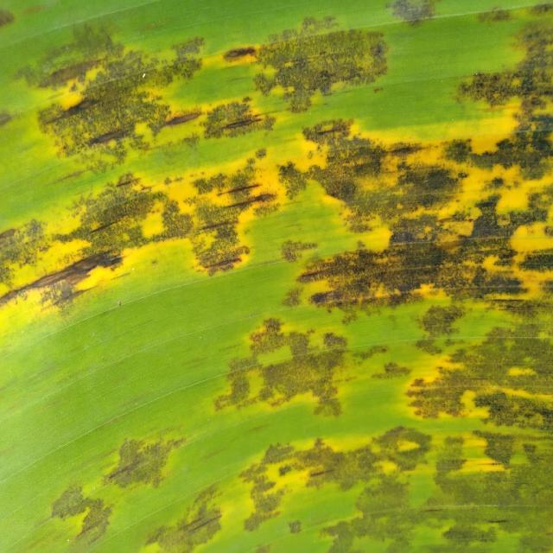
Option 1:
The image shows a large green leaf with yellow spots, which could be a symptom of a disease affecting the plant. The yellow spots are likely a result of a fungal infection or a bacterial disease. The presence of these spots on the leaf indicates that the plant is experiencing stress or damage, which can affect its overall health and growth.
To address this issue, it is essential to identify the specific type of disease causing the yellow spots and take appropriate measures to treat it. This may involve using fungicides or bactericides to combat the infection, as well as ensuring proper care and maintenance of the plant, such as regular watering, adequate sunlight, and proper soil conditions. Additionally, it is important to monitor the plant's health and take preventive measures to avoid further damage or infections.
Option 2:
The visible symptoms on the banana plant include yellowing leaves with brown spots, which are characteristic of a disease known as Yellow Sigatoka (Yb). This disease is caused by the fungus Mycosphaerella fijiensis and affects bananas worldwide.
The possible solutions include:
1. Proper identification of the disease by an expert in plant pathology.
2. Implementing cultural practices such as removing infected leaves to prevent further spread of the disease.
3. Using fungicides that are registered for use on bananas and have been proven effective against Yellow Sigatoka. It's important to follow label instructions when applying these chemicals.
4. Monitoring the plant regularly for any signs of improvement or worsening of the disease.
5. Practicing good hygiene, such as cleaning tools and equipment used on the plant, to prevent the spread of the fungus.

Which answer do you prefer:

Sample 39

Ground Truth: yellow black sigatoka
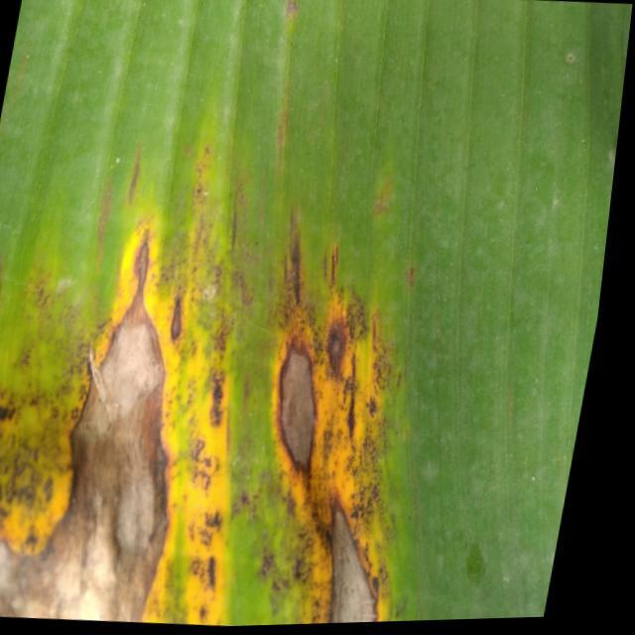
Option 1:
The image shows a banana plant with yellow leaves and brown spots, indicating that it is suffering from a disease. The disease appears to be affecting the plant's growth and overall health.
The visible symptoms include yellow leaves with brown spots, which are indicative of a fungal infection or bacterial disease. The plant's growth is stunted, and the leaves are starting to wilt.
To address this issue, it is essential to identify the specific disease causing the symptoms and take appropriate measures to treat it. This may involve using fungicides or bactericides to combat the infection, as well as ensuring proper care and maintenance of the plant, such as regular watering, adequate sunlight, and proper soil conditions. Additionally, it is crucial to monitor the plant's health and take preventive measures to avoid further damage or infection.
Option 2:
The visible symptoms in the image include yellowing and browning of the leaves, which are characteristic signs of a disease called Yellow Sigatoka (Yb_sigatoka). This disease affects banana plants and is caused by a fungus.
The affected leaves show a pattern of yellowing at the edges, followed by browning as the infection progresses. The veins may also become more prominent due to the discoloration. The solution for this disease would typically involve fungicide treatments to prevent the spread of the fungus and potentially improve the plant's health. It's important to follow recommended guidelines for application and timing when applying fungicides to minimize any negative effects on the environment or other plants in the area.

Which answer do you prefer:

Sample 40

Ground Truth: yellow black sigatoka

Option 1:
The image shows a banana tree with yellow leaves, which indicates that it might be suffering from a disease called "Panama disease." This disease is caused by the fungus Fusarium oxysporum f. sp. cubense, which affects the tree's roots and eventually leads to the yellowing of leaves and the tree's decline.
The visible symptoms of Panama disease include yellowing of leaves, wilting of the tree, and a general decline in the tree's health. The disease can be spread through the soil, water, and insects, making it difficult to control.
A possible solution to combat Panama disease is to practice good agricultural practices, such as proper irrigation, soil management, and pest control. Additionally, using resistant varieties of banana trees can help reduce the risk of infection. It is also essential to maintain a healthy environment for the tree, including regular pruning and removal of dead or infected parts.
Option 2:
The visible symptoms in the image include discoloration and spots on the leaves of the banana plant. These are indicative of a disease known as Yellow Sigatoka, which is caused by the fungus Mycosphaerella fijiensis.
The possible solutions include:
1. Proper sanitation: Ensure that the field is free from debris and other sources of infection.
2. Crop rotation: Rotate the crops grown in the field to avoid the spread of the disease.
3. Fungicide application: Use registered fungicides to control the disease. It's important to follow label instructions and recommendations from a certified agricultural professional.
4. Leaf removal: Remove infected leaves promptly to prevent further spread of the disease.
5. Good drainage: Ensure that the soil is well-drained to reduce the risk of waterlogging, which can exacerbate the problem.
6. Proper nutrition: Provide adequate nutrients to the plant to support its immune system.
7. Monitoring: Regularly inspect the plants for any signs of disease and take action as needed.

Which answer do you prefer:

Sample 41

Ground Truth: yellow black sigatoka
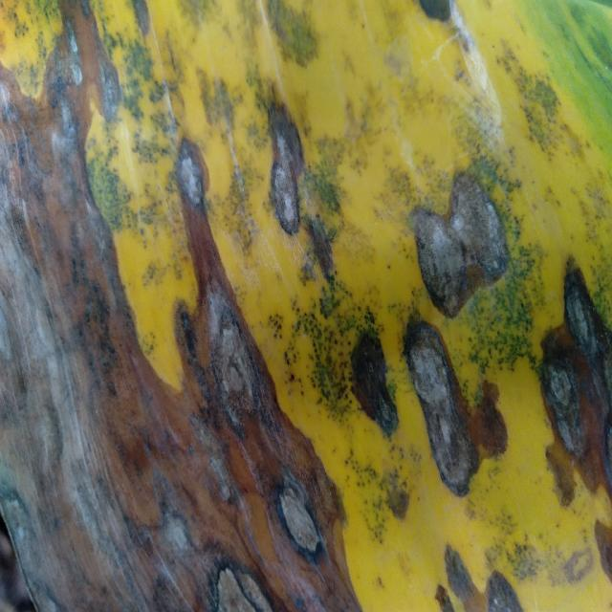
Option 1:
The image shows a leaf with yellow spots and a brownish-yellow color, which indicates that the leaf is affected by a fungal disease. The disease appears to be spreading, as the spots are growing larger and more numerous.
The visible symptoms of the disease include the yellow spots on the leaf, which are likely caused by the fungus's growth and spread. The brownish-yellow color of the leaf is another sign of the disease's progression.
A possible solution to this problem is to remove the affected leaves and dispose of them properly to prevent the spread of the disease. Additionally, it is essential to maintain proper plant hygiene and practice good gardening practices, such as regular pruning, watering, and pest control, to prevent the disease from spreading to other plants in the area. If the disease is severe, it may be necessary to consult a professional to identify the specific fungus and recommend appropriate treatment methods.
Option 2:
The image shows a banana plant with yellowing leaves, which could be indicative of a disease known as Yellow Sigatoka (Yb_sigatoka). This disease is caused by the fungus Mycosphaerella fijiensis and affects bananas worldwide.
Visible symptoms include:
- Yellowing of leaves, often starting at the edges and progressing towards the center.
- Brown spots or lesions on the leaves.
- Leaf drop or wilting.
Possible solutions include:
- Removal and destruction of infected plants to prevent further spread.
- Use of fungicides registered for banana diseases, such as Luna Experience, Serenade Prime, Routine, Scala, and others.
- Implementing cultural practices like proper drainage, avoiding waterlogging, and maintaining adequate spacing between plants to reduce infection rates.

Which answer do you prefer:

Sample 42

Ground Truth: yellow black sigatoka
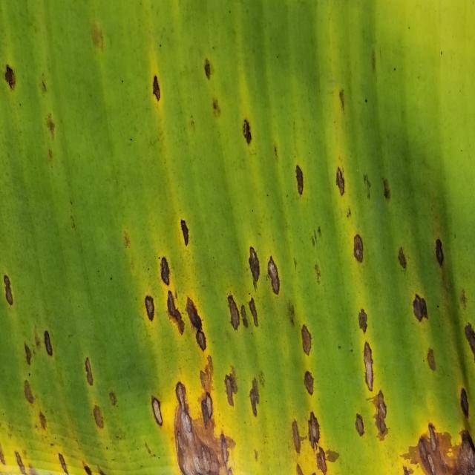
Option 1:
The image shows a banana leaf with yellow spots, which indicates that the banana tree is suffering from a disease called Panama disease. This disease is caused by the fungus Fusarium oxysporum f. sp. cubense, which affects the banana tree's roots and vascular system, leading to yellowing and wilting of the leaves.
The visible symptoms of Panama disease include yellow spots on the leaves, chlorosis (yellowing of the leaves), and wilting of the plant. The disease can lead to the death of the banana tree if not treated properly.
A possible solution to combat Panama disease is to practice good agricultural practices, such as proper irrigation, pest and disease management, and regular monitoring of the plant's health. Additionally, using resistant varieties of banana trees can help reduce the risk of infection and improve the overall health of the plant.
Option 2:
The visible symptoms in the image include yellowing and discoloration of the banana leaves, which are characteristic of a disease called Yellow Sigatoka (Yb_sigatoka). This disease affects banana plants by causing yellow spots on the leaves that can eventually lead to leaf drop and reduced fruit production.
A possible solution for this issue would be to implement an integrated pest management approach that includes regular monitoring, removal of infected leaves, and the use of fungicides if necessary. It's also important to maintain proper drainage, avoid waterlogging, and ensure adequate sunlight exposure to promote healthy plant growth. Additionally, using resistant varieties of bananas can help reduce the impact of Yellow Sigatoka on the crop.

Which answer do you prefer:

Sample 43

Ground Truth: yellow black sigatoka
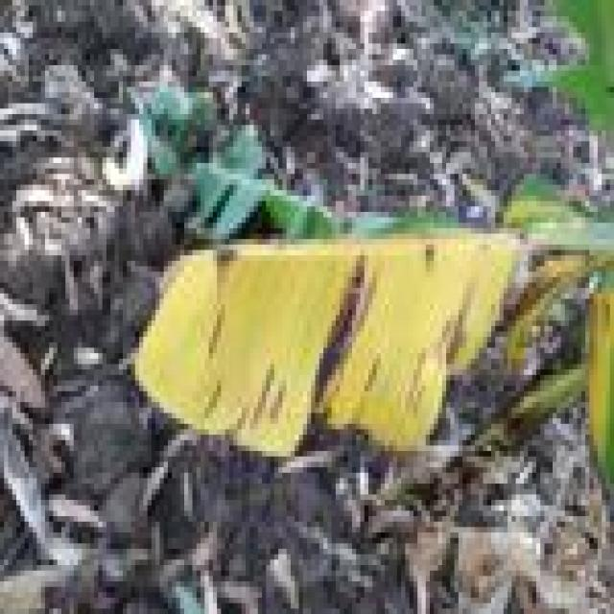
Option 1:
The image shows a leaf with a yellowish-brown color, which could indicate a disease or a natural aging process. The leaf appears to be affected by a fungal infection, as it has a brown spot on it. This type of infection can be caused by various fungi, such as fungal pathogens or bacteria.
To address this issue, it is essential to identify the specific type of fungus causing the infection and apply appropriate treatment methods. This may involve using fungicides, pruning the affected parts of the plant, or providing proper care and nutrients to help the plant recover from the infection. It is also important to maintain a healthy environment for the plant, including regular watering, proper drainage, and adequate sunlight, to prevent the growth of harmful fungi and promote overall plant health.
Option 2:
The visible symptoms in the image include discoloration and spots on the leaves of the banana plant. These are indicative of a disease known as Yellow Sigatoka, which affects bananas and other plants in the family Musa.
The yellowing and brown spots are characteristic signs of this disease. The affected areas may also have a thin, yellowish border around the spots. In severe cases, the entire leaf can turn yellow and die.
To manage this disease, it is important to remove infected leaves promptly, maintain good air circulation around the plant, and avoid overcrowding plants in the field. Fungicides may also be used as part of an integrated pest management strategy. It's crucial to follow label instructions when applying fungicides and consider cultural practices such as proper drainage and sanitation to minimize the risk of disease development.

Which answer do you prefer:

Sample 44

Ground Truth: yellow black sigatoka
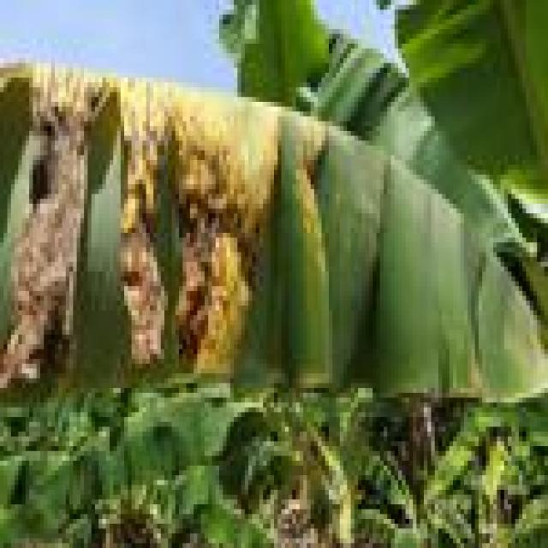
Option 1:
The image shows a banana tree with yellow leaves, which indicates that the tree is suffering from a disease called "Panama disease." This disease is caused by the fungus Fusarium oxysporum f. sp. cubense, which affects the tree's roots and eventually leads to the yellowing and wilting of the leaves.
The visible symptoms of Panama disease include yellowing leaves, stunted growth, and a general decline in the tree's health. The disease can be fatal to the tree, and there is no known cure for it.
To prevent the spread of the disease and protect the banana tree, it is essential to practice proper hygiene and sanitation, remove infected plants, and maintain a healthy environment for the tree. Additionally, using resistant varieties of banana trees can help reduce the risk of infection.
Option 2:
The visible symptoms in the image include yellowing leaves with brown spots, which are characteristic of a disease called Yellow Sigatoka (Yb_sigatoka). This disease affects banana plants and is caused by a fungus.
The possible solutions include:
1. Proper identification of the disease by an expert in plant pathology or a local agricultural extension service.
2. Implementing cultural practices such as removing infected leaves to reduce the spread of the disease.
3. Using fungicides registered for use against Yellow Sigatoka, following all label instructions and recommended application rates.
4. Rotating out of the affected plants and using clean tools when working with healthy plants to prevent further spread of the fungus.
5. Monitoring the plant regularly to ensure that the disease does not progress to a more severe stage.

Which answer do you prefer:

Sample 45

Ground Truth: insectpest
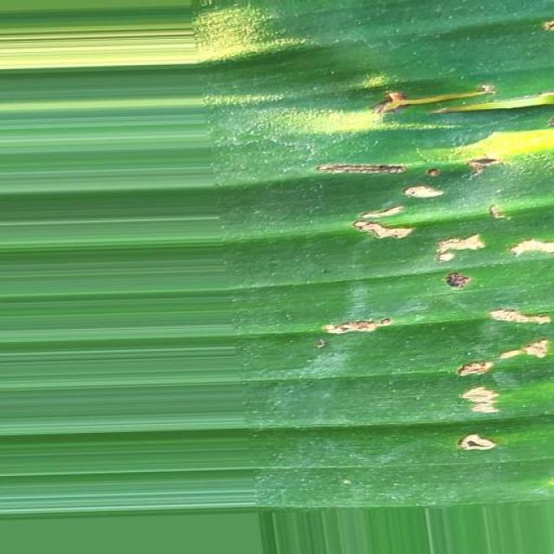
Option 1:
The image shows a leaf with a green stem and a large number of holes in it. This suggests that the leaf is affected by a disease, possibly a fungal infection or a bacterial disease. The holes in the leaf indicate that the plant is under attack and is experiencing damage.
To address this issue, it is essential to identify the specific type of disease causing the holes in the leaf. Once the disease is identified, appropriate treatment measures can be taken. For fungal infections, applying a fungicide specifically designed for the disease can help control its spread and prevent further damage. For bacterial infections, it is crucial to remove any infected leaves and maintain proper plant hygiene to prevent the disease from spreading to other parts of the plant. Additionally, ensuring proper care, such as regular watering, adequate sunlight, and proper nutrient intake, can help the plant recover from the disease and prevent future infections.
Option 2:
The image shows a close-up view of a banana plant leaf with several visible symptoms that could be indicative of an insect pest infestation or other issues affecting the plant's health. Here are the observations:
1. Discoloration: There is a yellowing and browning on the edges of the leaf, which might suggest nutrient deficiency, water stress, or disease.
2. Spots and Mottling: The leaf has several spots that vary in color from green to brown. These could be indicative of fungal infections, bacterial diseases, or pest-related damage.
3. Holes and Damage: There are holes and damage on the surface of the leaf, which might be caused by insects such as caterpillars or borers.
4. Soil Attachment: The edges of the leaf appear to have soil attached to them, which could indicate poor drainage conditions or a recent transplant.
5. Stem Rot: There is a dark spot on the stem that might be indicative of stem rot caused by fungi.
To address these issues, it would be advisable to conduct a thorough inspection of the plant for signs of pests and diseases, and consider implementing integrated pest management practices such as using biological controls, chemical treatments if necessary, and ensuring proper drainage in the soil. Additionally, monitoring the health of the plant over time can help identify any changes in symptoms that may require further intervention.

Which answer do you prefer:

Sample 46

Ground Truth: insectpest
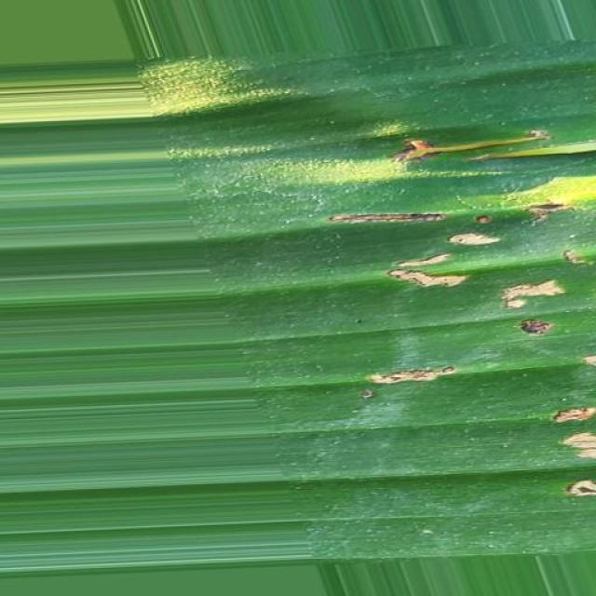
Option 1:
The image shows a leaf with brown spots and holes, which indicates that the plant is suffering from a disease. The disease could be a fungal infection, as the spots and holes are commonly associated with fungal diseases. To address this issue, it is essential to identify the specific type of fungal infection and take appropriate measures to treat it. This may involve using fungicides, removing infected leaves, and ensuring proper drainage and air circulation around the plant to prevent the spread of the disease. Additionally, maintaining a healthy plant by providing adequate nutrients, water, and sunlight can help prevent the development of diseases in the future.
Option 2:
The image shows a banana leaf with several visible symptoms that could be indicative of an insect pest infestation or disease. Here are the observations:
1. Patches of discoloration: There are areas on the leaf where the color is different from the rest, which could indicate damage or stress caused by pests or diseases.
2. Small holes and punctures: There are small holes and punctures visible on the surface of the leaf, which might be caused by insects feeding on the plant.
3. Drying or wilting: Some parts of the leaf appear dry or wilted, which could be a sign of disease or pest damage affecting the plant's ability to photosynthesize and transport water efficiently.
Possible solutions for these symptoms might include:
- Insect pest management: If the damage is caused by insects, using pesticides or biological control methods can help manage the infestation.
- Disease diagnosis and treatment: If the symptoms are due to a disease, identifying the specific pathogen and applying appropriate fungicides or other treatments can help manage the disease.
- Improved plant care: Ensuring proper drainage, fertilization, and watering practices can help prevent future infestations and diseases by maintaining the overall health of the banana plant.

Which answer do you prefer:

Sample 47

Ground Truth: insectpest
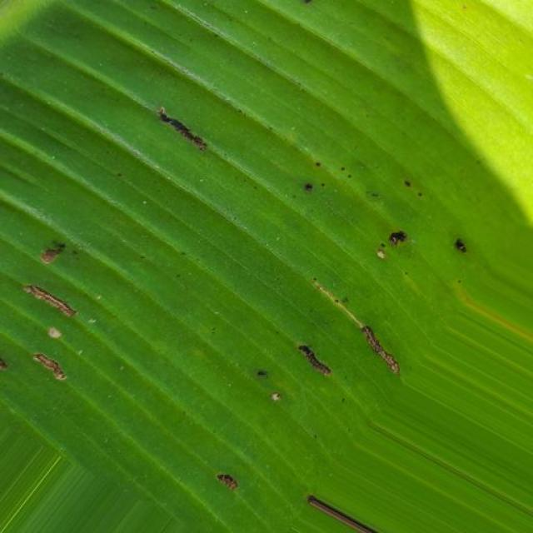
Option 1:
The image shows a leaf with brown spots and a yellowish-green color, which indicates that it might be affected by a fungal disease. The leaf appears to be infected with a fungus, which can cause the spots and discoloration.
To address this issue, it is essential to identify the specific type of fungus causing the infection and apply appropriate treatment methods. This may involve using fungicides, pruning infected parts of the plant, or ensuring proper drainage and air circulation to prevent the spread of the fungus. Additionally, maintaining a healthy plant by providing adequate nutrients, water, and sunlight can help prevent the development of fungal diseases.
Option 2:
The visible symptoms in the image include yellowing leaves with brown spots, which could indicate a fungal or bacterial disease affecting the banana plant. Possible solutions might include removing and destroying infected leaves to prevent further spread of the pathogen, applying appropriate fungicides or biological controls, and ensuring proper drainage and sunlight exposure to promote healthy growth. It's also important to monitor the plant for any additional signs of disease and consult with a local agricultural expert for specific recommendations based on the local environment and pathogens present in that area.

Which answer do you prefer:

Sample 48

Ground Truth: insectpest
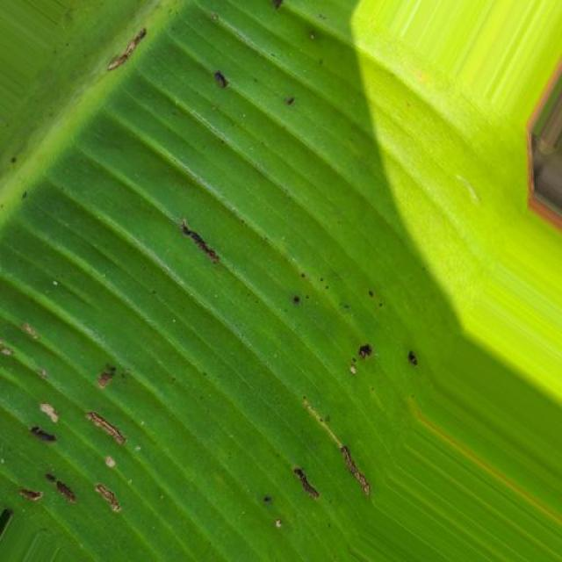
Option 1:
The image shows a green leaf with brown spots, which could indicate a disease or infection affecting the plant. The brown spots might be a sign of fungal or bacterial infections, or it could be a nutrient deficiency. To address this issue, it is essential to identify the specific cause of the brown spots and take appropriate measures to treat the plant.
If the brown spots are caused by a fungal infection, it is crucial to remove any infected leaves and apply a fungicide to prevent the spread of the disease. If the brown spots are due to a nutrient deficiency, it is necessary to provide the plant with the necessary nutrients through proper soil amendment or supplementation.
In any case, it is important to monitor the plant's health and take preventive measures to ensure its well-being. Regularly inspecting the plant for any signs of disease or infection and addressing the issue promptly can help maintain the plant's health and prevent further damage.
Option 2:
The visible symptoms in the image include discoloration, with a yellowish hue on some parts of the banana plant leaf. This could be indicative of nutrient deficiency or other environmental stressors affecting the plant's health. To address this issue, it would be advisable to conduct a soil test to determine if there are any nutrient imbalances that need correction. Additionally, ensuring proper drainage and avoiding overwatering can help prevent root rot and other water-related problems. If pests are suspected, an assessment of the plant for signs of infestation such as holes or damage to the leaves would be necessary to identify the type of pest and recommend appropriate control measures.

Which answer do you prefer:

Sample 49

Ground Truth: insectpest
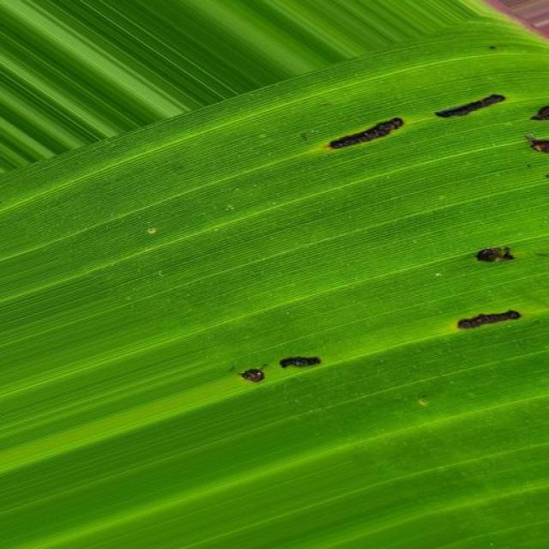
Option 1:
The image shows a close-up of a leaf with brown spots and holes, indicating that the plant is affected by a disease. The disease appears to be affecting the plant's growth and overall health.
The visible symptoms of the disease include brown spots and holes on the leaf, which could be caused by various factors such as fungal infections, bacterial infections, or insect infestations. To address this issue, it is essential to identify the specific cause of the disease and take appropriate measures to treat it.
For fungal infections, applying a fungicide specifically designed for the type of fungus causing the disease can help control its spread and prevent further damage to the plant. For bacterial infections, using a bactericide or applying a copper-based solution can help kill the bacteria. In the case of insect infestations, using insecticides or employing natural methods like neem oil can help protect the plant from further damage.
It is also important to practice good gardening practices, such as regular pruning, proper watering, and ensuring adequate sunlight, to maintain the health of the plant and prevent diseases from occurring.
Option 2:
The visible symptoms in the image include numerous small holes or punctures on the leaves, which are indicative of a type of insect pest infestation. The damage appears to be caused by some type of sucking insects, such as thrips or banana weevils.
The possible solutions for this issue include:
1. Insecticide application: Depending on the severity and type of pest, an appropriate insecticide can be used to control the infestation. It's important to follow label instructions and consider the environmental impact when selecting a pesticide.
2. Biological control: Introducing beneficial insects or predators that feed on the pests can help reduce their population. This method is often more sustainable and environmentally friendly compared to chemical treatments.
3. Cultural practices: Removing and destroying infested leaves, pruning plants regularly, and maintaining clean growing areas can help prevent the spread of pests.
4. Fungicide application (if the damage is caused by a fungal pathogen): If the damage is due to a fungal infection, applying a fungicide may be necessary to control the disease.
It's important to consult with an agricultural expert or extension service for specific recommendations based on the location, climate, and type of pest affecting the plant.

Which answer do you prefer:

Sample 50

Ground Truth: insectpest
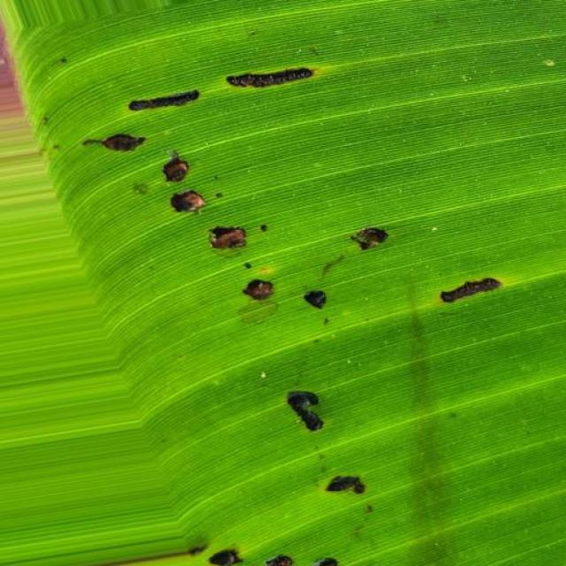
Option 1:
The image shows a close-up of a leaf with a green stem, which appears to be infected with a disease. The leaf is covered in black spots, indicating that it is affected by a fungal infection. The presence of these black spots suggests that the plant is experiencing a disease called black spot, which is caused by the fungus Cercospora.
To manage this disease, it is essential to practice proper plant care, including regular watering, ensuring adequate sunlight, and maintaining a clean and healthy environment. Additionally, it is crucial to remove any infected leaves and stems to prevent the spread of the disease. If the infection is severe, it may be necessary to consult a plant specialist or use fungicides to control the disease and protect the plant from further damage.
Option 2:
The image shows a close-up view of a banana leaf with several small, round holes or punctures scattered across its surface. These holes are indicative of insect pests feeding on the plant. The most likely culprits are insects such as thrips, which can cause damage to the leaves by feeding on them and leaving behind droppings that can lead to discoloration or disease.
To address this issue, an agricultural assistant might recommend the following solutions:
1. Inspection: Regularly inspect plants for signs of pests and diseases.
2. Pest identification: If possible, identify the specific type of pest causing damage to the plant.
3. Integrated pest management: Implement a holistic approach to pest control that includes cultural practices (such as removing weeds), biological control methods (using beneficial insects), and chemical treatments (using appropriate pesticides).
4. Monitoring: Keep track of the progress of the pest problem and adjust management strategies accordingly.
5. Clean-up: Remove affected leaves and debris from the plant to prevent further spread of disease.
6. Sanitation: Maintain clean growing areas to minimize the risk of pests entering the farm.
7. Rotation: Implement a rotation system for chemical pesticides to prevent resistance development.
8. Fertilization: Ensure proper nutrition of the plant by providing adequate fertilizers as needed.

Which answer do you prefer:

Sample 51

Ground Truth: insectpest
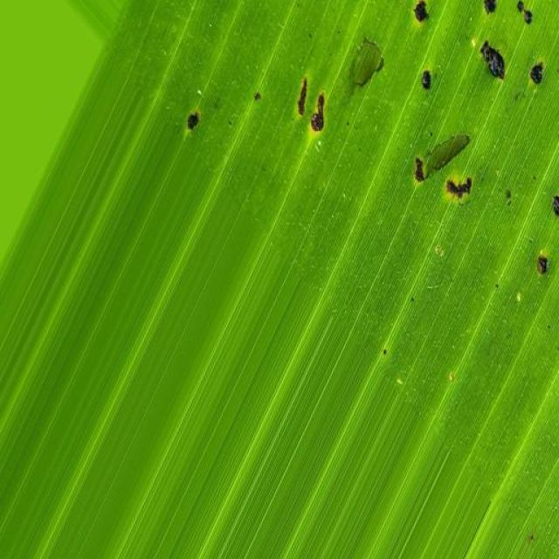
Option 1:
The image shows a leaf with brown spots and holes, which indicates that the plant is suffering from a disease. The disease appears to be affecting the leaf's health and causing it to deteriorate.
The visible symptoms of the disease include brown spots and holes on the leaf, which are signs of damage or decay. These symptoms suggest that the plant is under stress and may not be receiving adequate nutrients or water.
To address this issue, it is essential to identify the specific disease affecting the plant and take appropriate measures to treat it. This may involve using fungicides, applying organic compost, or adjusting the plant's watering schedule to ensure it receives the necessary nutrients. Additionally, regular monitoring of the plant's health and early detection of any signs of disease can help prevent further damage and promote the plant's overall well-being.
Option 2:
The image shows several small, dark-colored spots scattered across the surface of a banana leaf. These spots could be indicative of a fungal infection or a bacterial disease affecting the plant. To address this issue, an agricultural assistant might recommend the following steps:
1. Identify the type of disease or pest causing the damage. This can often be done through laboratory testing or by comparing visible symptoms with those of known pathogens or pests.
2. Implement preventive measures such as crop rotation, proper irrigation practices, and removal of affected plants to reduce the spread of disease.
3. Use fungicides or pesticides specifically designed for bananas if a fungal infection is confirmed. It's important to follow label instructions and recommendations from an agricultural extension service when selecting and applying these chemicals.
4. Monitor the plant regularly to ensure that the issue is being effectively managed and to identify any new symptoms early on.
5. Consider organic alternatives if available, as they can be more environmentally friendly and may not require a license for use in certain areas.
It's important to consult with an agricultural professional for accurate diagnosis and appropriate treatment recommendations.

Which answer do you prefer:

Sample 52

Ground Truth: insectpest
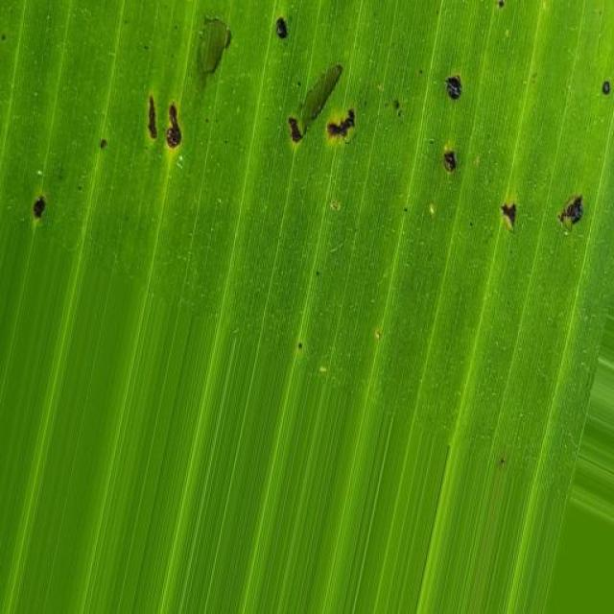
Option 1:
The image shows a leaf with brown spots and blackened areas, which indicates that the leaf is affected by a disease. The disease appears to be spreading, as the spots are growing larger and more numerous. The presence of these spots and blackened areas suggests that the leaf is experiencing a fungal infection or a bacterial disease.
To address this issue, it is essential to identify the specific type of disease affecting the leaf and take appropriate measures to prevent its spread. This may involve removing infected leaves, practicing proper plant care, and using organic or chemical treatments to control the disease. It is also important to maintain a healthy environment for the plant by providing adequate sunlight, water, and nutrients. Regular monitoring of the plant's health and timely intervention can help minimize the impact of the disease and promote the plant's overall well-being.
Option 2:
The visible symptoms in the image include brown spots and black specks on the leaves of the banana plant. These are indicative of a disease caused by a fungus or bacteria, which can lead to leaf necrosis and reduced photosynthetic capacity.
To address this issue, an agricultural assistant might recommend the following solutions:
1. Monitor the plant for signs of disease progression and consider removing affected leaves to prevent further spread of the pathogen.
2. Implement good hygiene practices, such as sanitizing tools and equipment that have come into contact with the plant, to prevent the spread of the disease.
3. Consider using fungicides or bactericides if the disease is severe or if there is a risk of it spreading to other plants in the area. However, it's important to follow label instructions and recommendations from a qualified agronomist when using these chemicals.
4. Improve drainage and air circulation around the plant to reduce humidity levels, which can help prevent the growth of fungi.
5. Consider using resistant varieties if available or breeding for resistance if possible.
6. Regularly inspect plants for early signs of disease and take action promptly to prevent further damage.

Which answer do you prefer:

Sample 53

Ground Truth: insectpest
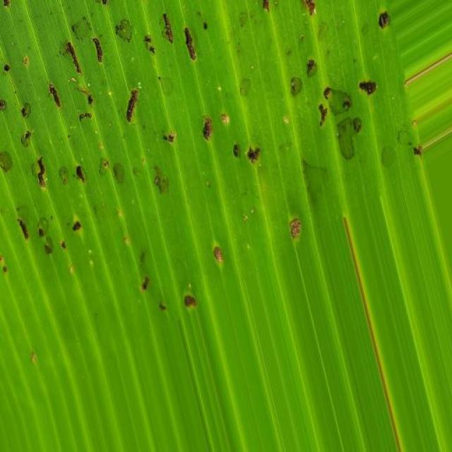
Option 1:
The image shows a leaf with a green stem and a large number of small holes or bumps on it. These holes or bumps are likely the result of a fungal infection, which can cause the leaf to become discolored and deformed. The presence of these holes indicates that the plant is experiencing a disease called powdery mildew.
Powdery mildew is a common fungal disease that affects a wide range of plants, including trees, shrubs, and vegetables. It is characterized by the growth of white, powdery spores on the surface of the plant, which can cause damage to the plant's tissues and lead to reduced growth, discoloration, and even death in severe cases.
To manage powdery mildew, it is essential to practice good garden hygiene, such as removing infected leaves and pruning affected branches. Additionally, it is important to maintain proper plant spacing, ensure adequate air circulation, and avoid overcrowding plants. If the infection is severe, it may be necessary to use fungicides to control the disease and prevent further damage to the plant.
Option 2:
The visible symptoms on the banana plant include yellowing leaves with brown spots, which could indicate a fungal or bacterial infection. Additionally, there are holes in the leaves and some discoloration, suggesting possible damage from insects or pests.
To address these issues, it would be advisable to conduct a thorough inspection of the plant for any signs of infestation or disease, such as fungal growth or bacterial infections. If an insect pest is identified, appropriate measures can be taken to control their population, such as using biological pesticides or physical barriers. If a fungal infection is suspected, appropriate fungicides should be applied according to the specific type of disease and the plant's condition.
It's also important to maintain good plant hygiene by removing affected leaves and ensuring proper drainage to prevent the spread of diseases or pests. Regular monitoring of the plant's health is crucial for early detection and timely treatment of any issues that may arise.

Which answer do you prefer:

Sample 54

Ground Truth: insectpest
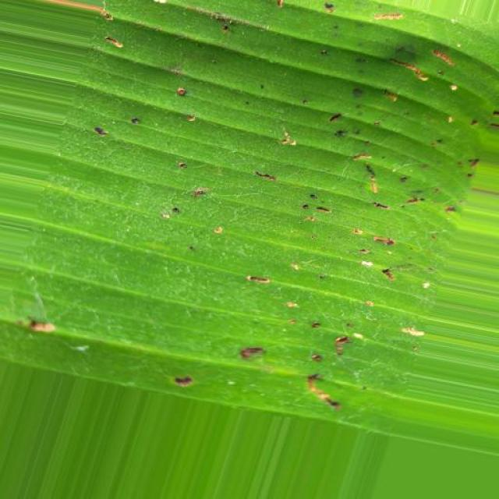
Option 1:
The image shows a leaf with a green stem and a brown spot on it. The brown spot appears to be a fungal infection, which can be identified by the presence of black spots on the leaf. This type of infection is commonly caused by fungi, such as the fungus Rhizoctonia solani.
The visible symptoms of the infection include the brown spots on the leaf, which can spread and cause the leaf to wither and die. The infection can also affect the stem, leading to a weakened plant and reduced growth.
To solve this issue, it is essential to identify the type of fungal infection and take appropriate measures to prevent its spread. This may include removing infected leaves and stems, ensuring proper drainage and air circulation, and using organic or chemical fungicides to control the infection. Additionally, maintaining a healthy plant by providing adequate nutrients, water, and sunlight can help prevent the development of fungal infections.
Option 2:
Based on the image provided, it appears that the banana plant is affected by a disease or infestation that has caused damage to its leaves. The most visible symptoms include:
1. Black spots: There are several black spots scattered across the surface of the leaf. These could be indicative of fungal infection, bacterial disease, or insect damage.
2. Discoloration: The edges of the leaf appear to be discolored with a yellowish hue, which might suggest nutrient deficiency or stress from pests or diseases.
3. Holes and damage: There are holes in the leaves that could be caused by insects such as caterpillars or borers. These holes can lead to further damage and disease progression if not addressed.
4. Moss growth: There is a small amount of moss visible on the surface of the leaf, which might indicate poor drainage or excessive moisture in the soil.
To address these symptoms, it would be advisable to conduct a thorough inspection of the plant for signs of infestation or disease, and consider implementing measures such as:
- Removing and destroying affected leaves to prevent further spread of disease.
- Applying fungicides if a fungal infection is suspected.
- Implementing integrated pest management strategies to control insect infestations.
- Addressing soil drainage issues with proper irrigation practices.
- Monitoring the plant for any additional symptoms and adjusting care accordingly.

Which answer do you prefer:

Sample 55

Ground Truth: insectpest
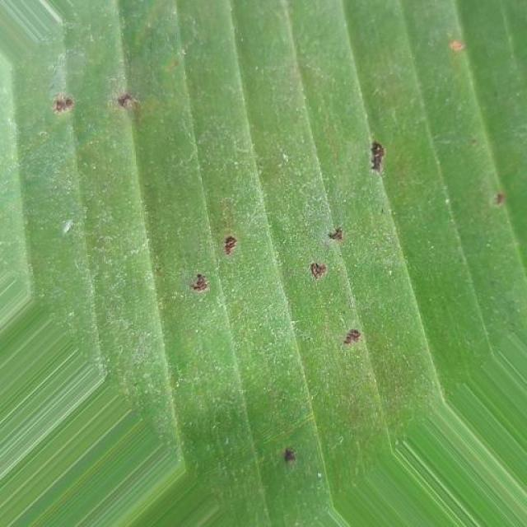
Option 1:
The image shows a leaf with yellow spots and a yellowish-green color, which indicates that it might be affected by a fungal disease. The presence of these spots and the yellowish-green color suggest that the leaf is experiencing a condition called "downy mildew," which is caused by various fungal pathogens.
Downy mildew can affect a wide range of plants, including cucumbers, tomatoes, and peppers. The symptoms may include yellow or brown spots on leaves, stems, or fruits, and the leaves may become distorted or deformed.
To manage downy mildew, it is essential to practice good garden hygiene, such as removing infected plants and keeping the area clean. Additionally, using resistant varieties of the affected plant species can help prevent the disease from spreading. It is also important to maintain proper spacing between plants, as overcrowding can lead to increased humidity and promote the growth of fungal pathogens.
If the disease is severe, it may be necessary to use fungicides to control the spread of the pathogen. However, it is always recommended to consult with a local agricultural extension service or a plant pathologist to determine the best course of action for managing downy mildew in your specific situation.
Option 2:
The image shows a close-up view of a banana plant leaf with several visible symptoms that could be indicative of an insect pest infestation or disease. Here are the observations:
1. Discoloration: There is yellowing and browning on the leaf, which could indicate chlorosis due to nutrient deficiency or iron deficiency. This can happen when the soil pH is too high, preventing the uptake of essential nutrients by the plant.
2. Holes and damage: There are holes in the leaf tissue, which could be caused by insects such as banana weevils or nematodes. These holes can lead to a reduction in photosynthesis and overall health of the plant.
3. Mottling: The discoloration is not uniform; there are patches of yellow and green on the leaf, which could be indicative of mottling caused by nutrient deficiency or disease.
4. Curling edges: The edges of the leaf appear to be curling upwards, which might be a sign of water stress or nutrient deficiency.
Possible solutions for this plant would include:
- Assessing soil pH and nutrient levels to ensure they are within optimal ranges for banana growth.
- Implementing integrated pest management strategies such as using biological controls, traps, and chemical treatments if necessary.
- Monitoring the plant regularly for signs of recovery or worsening conditions.
- Ensuring proper drainage and water management to prevent overwatering or underwatering.

Which answer do you prefer:

Sample 56

Ground Truth: insectpest
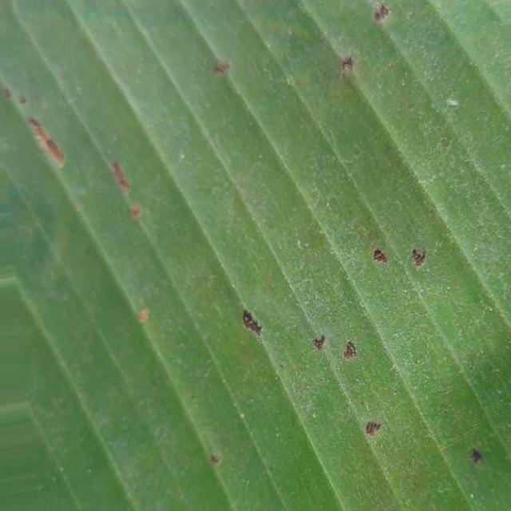
Option 1:
The image shows a leaf with a green stem and a large number of holes or bumps on it. This could be a symptom of a disease or infestation, such as a fungal infection or an insect infestation. The holes or bumps on the leaf may indicate that the plant is under stress or experiencing some form of damage.
To address this issue, it is essential to identify the cause of the damage. If it is a fungal infection, it may be necessary to remove the affected leaves and apply a fungicide to prevent the spread of the disease. If it is an insect infestation, it may be helpful to remove the affected leaves and use insecticides or other control methods to manage the infestation. Additionally, ensuring proper care and maintenance of the plant, such as providing adequate water, sunlight, and nutrients, can help prevent future damage and promote healthy growth.
Option 2:
The image shows a banana plant with several visible symptoms that suggest it may be affected by an insect pest. Here are the observations:
1. Leaf damage: There are holes in the leaves, which could indicate feeding activity from insects such as caterpillars or borers.
2. Discoloration: Some areas of the leaf appear discolored with yellowing and browning, which might be due to the pests' feeding activity or a response to stress caused by their presence.
3. Mite infestation: There are small, round spots on the leaves that could indicate an infestation of mites or other small insects.
To address these issues, a solution might include:
- Identifying the specific type of pest causing the damage and selecting appropriate pesticides or biological controls for that species.
- Implementing integrated pest management practices to minimize the use of chemicals and reduce the risk of pesticide resistance.
- Regularly inspecting plants for signs of infestation and promptly addressing any issues found.
- Ensuring proper drainage, sunlight exposure, and good plant health to help reduce the impact of pests on the plant.

Which answer do you prefer:

Sample 57

Ground Truth: insectpest
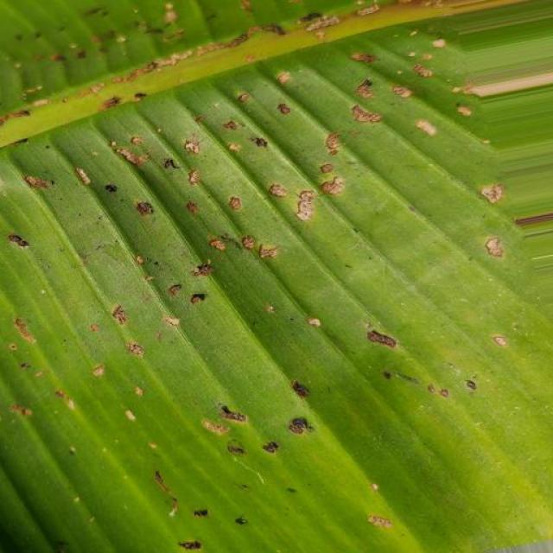
Option 1:
The image shows a leaf with yellow spots, which could be a sign of a fungal infection or a bacterial disease. The yellow spots are likely the result of the growth of fungi or bacteria on the leaf.
To address this issue, it is essential to identify the specific type of disease causing the yellow spots. Once the disease is identified, appropriate treatment methods can be applied. For fungal infections, it is crucial to remove infected leaves and branches, and apply fungicides to prevent the spread of the disease. For bacterial infections, it is important to remove the affected leaves and branches, and apply antibiotics to kill the bacteria.
In addition to these treatments, it is also essential to maintain proper plant care, such as regular watering, proper drainage, and adequate sunlight, to prevent the growth of diseases and promote overall plant health.
Option 2:
The image shows a close-up view of a banana plant with several visible symptoms that could be indicative of an insect pest infestation or a disease affecting the plant. Here are the observations:
1. Discoloration: There are areas on the leaves where the color is not uniform, with yellowing and browning visible. This could be due to nutrient deficiency, water stress, or pest damage.
2. Holes and Tunnels: The plant has several holes and tunnels in its leaves, which could indicate feeding activity by insects such as aphids, caterpillars, or other pests.
3. Softening and Decay: There are areas where the leaf tissue appears soft and decayed, which might be due to fungal infection or bacterial disease.
4. Necrotic Spots: Some spots on the leaves are necrotic (dead), which could be a sign of a bacterial or fungal infection.
5. Yellowing: There are yellow areas on the leaves that could indicate nutrient deficiency, particularly if there's a lack of nitrogen.
6. Pest Droppings: There are small yellow spots scattered across the leaves, which might be droppings from insects feeding on the plant.
To address these symptoms, it would be advisable to conduct a thorough inspection of the plant for pests and diseases, and then implement appropriate measures such as using pesticides or fungicides if necessary, pruning infected parts, and ensuring proper nutrient management to prevent further damage.

Which answer do you prefer:

Sample 58

Ground Truth: insectpest
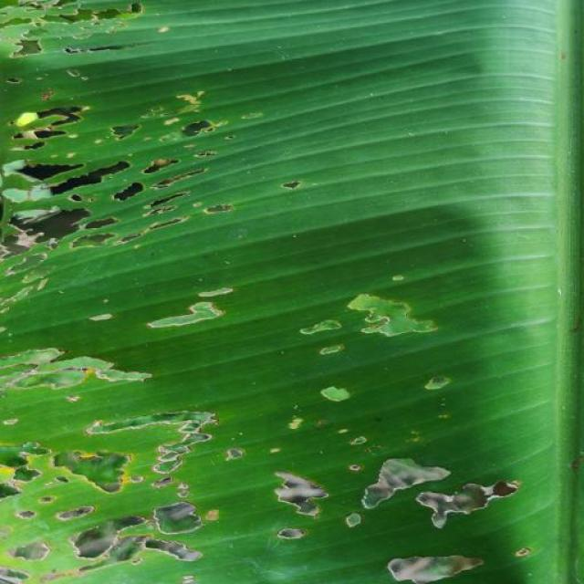
Option 1:
The image shows a green leaf with brown spots, which indicates that the leaf is affected by a disease. The brown spots are a visible symptom of the disease, and it is likely that the leaf is experiencing a fungal infection or a bacterial disease.
To solve this issue, it is essential to identify the specific type of disease affecting the leaf and take appropriate measures to treat it. For fungal infections, applying a fungicide specifically designed for the type of fungus causing the infection can help prevent the disease from spreading and reduce the severity of the symptoms. For bacterial diseases, it is crucial to remove the affected leaves and practice proper plant care, such as regular pruning, watering, and pest control, to prevent the disease from spreading to other parts of the plant.
Option 2:
Based on the image provided, it appears that the banana plant is affected by a disease or pest infestation. The most visible symptoms include:
1. Brown spots and holes on the leaves.
2. Discoloration of the leaf tissue, with yellowing and browning.
3. Curling and distortion of the leaf edges.
4. A general decline in the health of the plant, as evidenced by the overall wilted appearance.
The possible solutions for this issue would include:
1. Identifying the specific type of disease or pest causing the damage to the plant. This may require a closer examination of the leaves and possibly laboratory testing to determine the pathogen or pest responsible.
2. Implementing preventive measures such as using organic or chemical pesticides depending on the diagnosis, pruning infected parts, and ensuring proper drainage and nutrient management in the soil.
3. Monitoring the plant regularly for any further signs of disease or pest infestation and taking appropriate action as needed.

Which answer do you prefer:

Sample 59

Ground Truth: insectpest
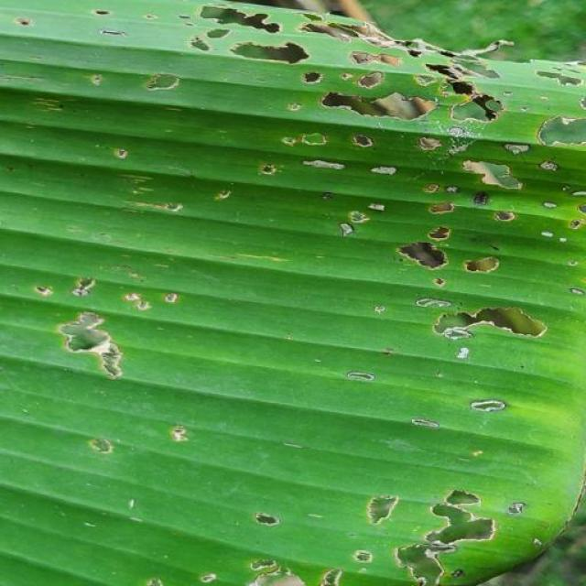
Option 1:
The image shows a close-up of a leaf with a green background, which appears to be affected by a disease. The leaf has brown spots and is covered in small holes, indicating that it is infected with a fungus or bacteria.
To address this issue, it is essential to identify the specific type of disease affecting the leaf and take appropriate measures to prevent its spread. This may involve removing infected leaves, pruning affected branches, and applying appropriate fungicides or bactericides to the plant. Additionally, ensuring proper care, such as regular watering, adequate sunlight, and well-draining soil, can help maintain the health of the plant and prevent future infections.
Option 2:
The visible symptoms in the image include several small, round holes or punctures on the leaves of the banana plant. These could be indicative of a pest infestation, such as aphids or other insects that feed on the plant's tissue. The solution to this issue would typically involve identifying the type of pest and using appropriate pesticides or biological control methods to manage the infestation. Additionally, ensuring proper hygiene and monitoring for early signs of infestation can help prevent further damage.

Which answer do you prefer:

Sample 60

Ground Truth: insectpest
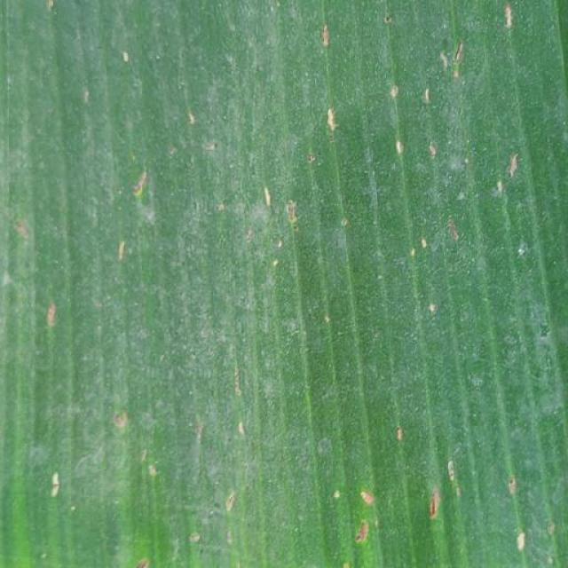
Option 1:
The image shows a close-up of a leaf with a yellowish-brown spot on it. This spot could be a sign of a disease or infection affecting the leaf. Possible solutions to address this issue include:
1. Identifying the specific disease or infection causing the spot, which may require consultation with a plant expert or a local nursery.
2. Implementing proper care and maintenance practices, such as regular watering, fertilizing, and pest control, to prevent the spread of the disease or infection.
3. If the disease or infection is severe, it may be necessary to remove the affected leaves or the entire plant to prevent the spread of the problem to other plants in the area.
It is essential to monitor the plant's health and take appropriate action to address any issues that may arise to ensure the plant's well-being and longevity.
Option 2:
The visible symptoms in the image of the banana plant include yellowing leaves with small brown spots, which could indicate a fungal or bacterial disease. Possible solutions might include treating the plant with appropriate pesticides to control insect infestations, applying fungicides to combat fungal diseases, and ensuring proper drainage and sunlight exposure for the plant to promote healthy growth. It's also important to monitor the plant regularly for any signs of improvement or worsening of the symptoms.

Which answer do you prefer:

Sample 61

Ground Truth: insectpest
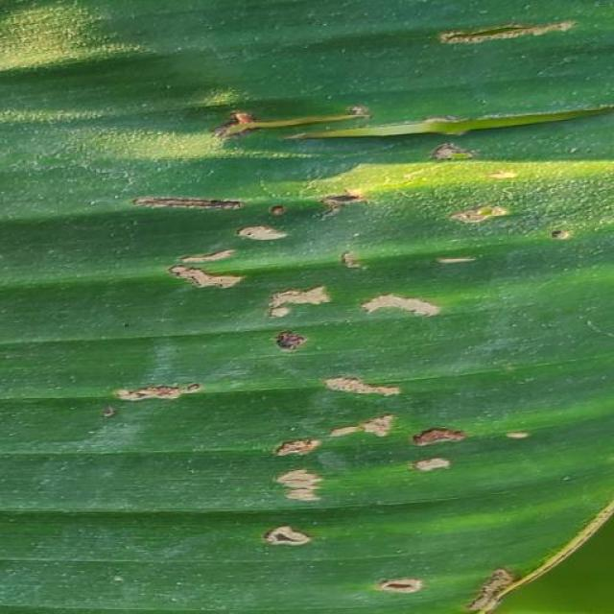
Option 1:
The image shows a close-up of a leaf with brown spots, which could be indicative of a fungal infection or a bacterial disease. The brown spots are spread across the leaf, and the overall appearance of the leaf is discolored.
To address this issue, it is essential to identify the specific type of disease causing the brown spots. Once the disease is diagnosed, appropriate treatment measures can be taken. For fungal infections, applying a fungicide specifically designed for the type of fungus causing the disease can help control its spread and prevent further damage to the plant. For bacterial diseases, it is crucial to practice proper plant care, such as regular pruning, ensuring proper drainage, and maintaining a healthy soil pH. Additionally, using organic or chemical-free fertilizers can help strengthen the plant's immune system and promote overall health.
Option 2:
The image shows a banana plant with several visible symptoms indicative of a disease affecting it. The most prominent symptom is the presence of dark brown or black spots on the leaves, which could be indicative of a fungal infection such as Panama disease (Fusarium oxysporum f. sp. cubense), also known as Panama disease tropical race 4 (TR4).
Other visible symptoms include:
- Discoloration: The affected areas on the leaves show discoloration with yellowing and browning, which is characteristic of many plant diseases.
- Leaf necrosis: There are areas where the tissue has died, leading to a dry, brittle appearance.
- Curling or wilting: Some leaves may appear curled or wilted, which could be due to the disease affecting the plant's ability to transport water and nutrients.
A possible solution for this disease would involve implementing preventive measures such as proper drainage, avoiding overcrowding in the field, and using resistant varieties of banana plants. Additionally, fungicides can be applied to control the spread of the disease, but it is important to follow recommended guidelines for their use and to consider their potential impact on the environment and other organisms.

Which answer do you prefer:

Sample 62

Ground Truth: insectpest
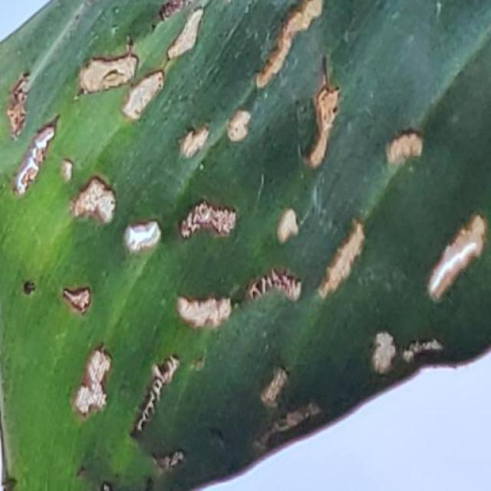
Option 1:
The image shows a close-up of a leaf with yellow spots, which could indicate a disease or infection affecting the plant. The yellow spots might be a sign of bacterial or fungal infections, which can cause damage to the plant's tissues and negatively impact its overall health.
To address this issue, it is essential to identify the specific type of disease causing the yellow spots and take appropriate measures to treat it. This may involve using organic or chemical-based treatments, depending on the cause of the infection. In some cases, it may be necessary to remove the affected leaves and prune the plant to prevent the spread of the disease. Additionally, maintaining proper plant care, such as regular watering, sunlight exposure, and pest control, can help prevent the development of diseases and promote overall plant health.
Option 2:
The visible symptoms in the image include yellowing leaves with numerous small, round holes. This pattern suggests that the banana plant may be affected by a disease caused by insect pests such as nematodes or thrips.
To address this issue, an agricultural assistant could recommend the following solutions:
1. Identification of the specific pest causing the damage.
2. Implementing integrated pest management strategies, which may include cultural practices like crop rotation and removal of infested plants, as well as chemical treatments such as insecticides or biological control agents.
3. Regular monitoring for signs of infestation and prompt action to prevent further damage.
4. Improving soil quality and drainage to reduce the risk of pest infestations.
5. Using organic or low-toxicity pesticides when possible to minimize environmental impact.

Which answer do you prefer:

Sample 63

Ground Truth: insectpest
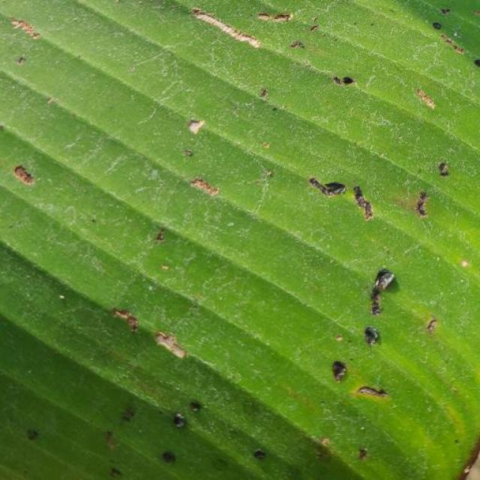
Option 1:
The image shows a close-up of a leaf with brown spots, which could indicate a disease or infection affecting the plant. The brown spots might be a sign of fungal infections, bacterial diseases, or other plant-related issues. To address this issue, it is essential to identify the specific type of disease causing the brown spots and take appropriate measures to treat or prevent it.
For fungal infections, it is crucial to practice proper plant care, such as regular watering, ensuring adequate drainage, and avoiding overcrowding. Additionally, using organic mulch and compost can help improve soil quality and promote healthy plant growth.
For bacterial diseases, it is important to maintain a clean and healthy environment, including regular pruning, removing infected leaves, and using clean tools and equipment. It is also essential to practice crop rotation and avoid over-fertilizing, as excessive nutrients can sometimes lead to bacterial diseases.
In any case, it is advisable to consult with a local nursery or agricultural expert to identify the specific disease and receive guidance on the best course of action to address the issue and maintain the health of the plant.
Option 2:
The image shows a close-up view of a banana leaf with several small, dark spots scattered across its surface. These spots could be indicative of several types of diseases or pests affecting the plant.
From the visible symptoms, it appears that the plant might have been affected by a disease such as Panama disease or black sigatoka, which are common diseases in banana plants caused by fungi. The dark spots could be indicative of the presence of these pathogens on the leaf.
To address this issue, an agricultural assistant would likely recommend a thorough inspection of the plant for signs of disease and pests, followed by appropriate treatment measures. This may include removing infected leaves, applying fungicides or other chemical treatments, and possibly using biological controls to manage the problem. It's also important to monitor the plant regularly to ensure that the issue is being effectively managed and to prevent further spread of the disease or pest infestation.

Which answer do you prefer:

Sample 64

Ground Truth: insectpest
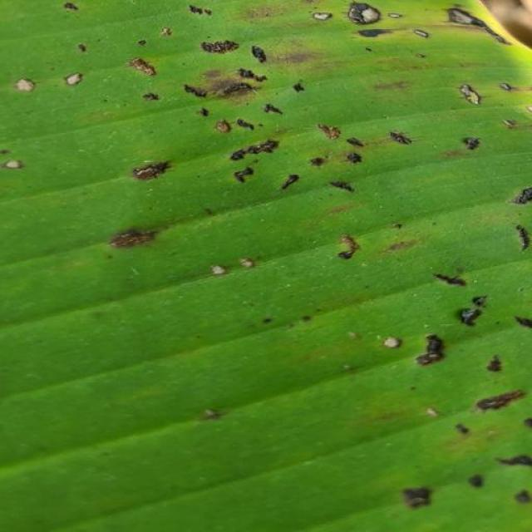
Option 1:
The image shows a close-up of a leaf with a green stem, which appears to be affected by a disease. The leaf has a yellowish-green color, and there are spots and bumps on its surface. This could be a sign of a fungal infection or a bacterial disease.
To address this issue, it is essential to identify the specific type of disease affecting the plant. Once the disease is diagnosed, appropriate treatment methods can be applied, such as using fungicides or bactericides to combat the pathogens. Additionally, proper care and maintenance of the plant, including regular watering, pest control, and ensuring adequate sunlight and nutrient availability, can help prevent the disease from spreading and causing further damage to the plant.
Option 2:
The image shows a banana plant with several visible symptoms that indicate it may be affected by an insect pest. Here are the observations:
1. Leaf Discoloration: There are areas on the leaves where the color has changed from green to yellow or brown, which could be indicative of damage caused by insects.
2. Holes and Tunnels: The leaves show holes and tunnels that could be a result of feeding activity from insects such as caterpillars or borers.
3. Soil Attachment: There are patches where soil appears to be attached to the leaf surface, which might suggest that the plant has been affected by an insect that burrows into the ground and then emerges onto the leaves.
4. Leaf Curling: Some leaves show signs of curling or rolling, which could be a defense mechanism by the plant against insects or other environmental stressors.
To address these symptoms, it would be advisable to conduct an insect identification and diagnosis to determine the specific pest causing the damage. Treatment options may include chemical pesticides, biological control methods, or organic alternatives such as neem oil or other natural repellents. It's important to follow proper guidelines for pesticide application and follow-up monitoring to ensure the health of the plant and the environment.

Which answer do you prefer:

Sample 65

Ground Truth: insectpest
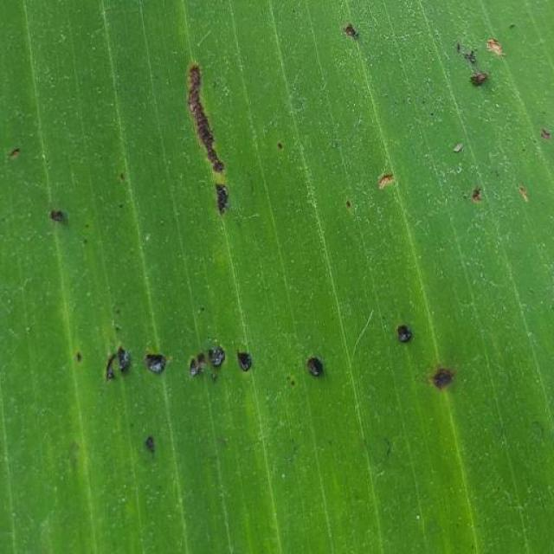
Option 1:
The image shows a leaf with a lot of holes and spots, which indicates that it is affected by a disease. The holes and spots are likely caused by insects or fungi, which have penetrated the leaf and caused damage.
To address this issue, it is essential to identify the specific type of disease or pest causing the damage. Once the cause is determined, appropriate measures can be taken to prevent further damage or loss of the plant. This may include using pesticides or fungicides to kill the insects or fungi, applying appropriate fertilizers to promote healthy growth, and ensuring proper irrigation and drainage to maintain a healthy environment for the plant. Additionally, regular monitoring of the plant's health and early detection of any signs of disease or pest infestation can help prevent further damage and ensure the plant's overall well-being.
Option 2:
The image shows a banana leaf with several visible symptoms indicative of an insect pest infestation. There are black spots scattered across the surface of the leaf, which could be caused by feeding or excreting from the pests. Additionally, there appears to be some discoloration and possibly necrosis around these spots, suggesting that the plant has been affected by a disease or pest infestation.
The visible symptoms include:
- Black spots on the leaf surface
- Discoloration and necrosis around these spots
- Possible damage to the tissue of the leaf
Possible solutions for this issue could include:
- Identifying the specific type of pest causing the damage (e.g., aphids, thrips, or other insects) through observation or laboratory testing.
- Implementing integrated pest management practices to control and prevent further infestations.
- Applying appropriate pesticides or biological control agents as recommended by an agricultural expert.
- Ensuring proper sanitation practices are followed to minimize the risk of pest infestations.
- Monitoring the plant regularly for signs of recovery and continued health.

Which answer do you prefer:

Sample 66

Ground Truth: insectpest
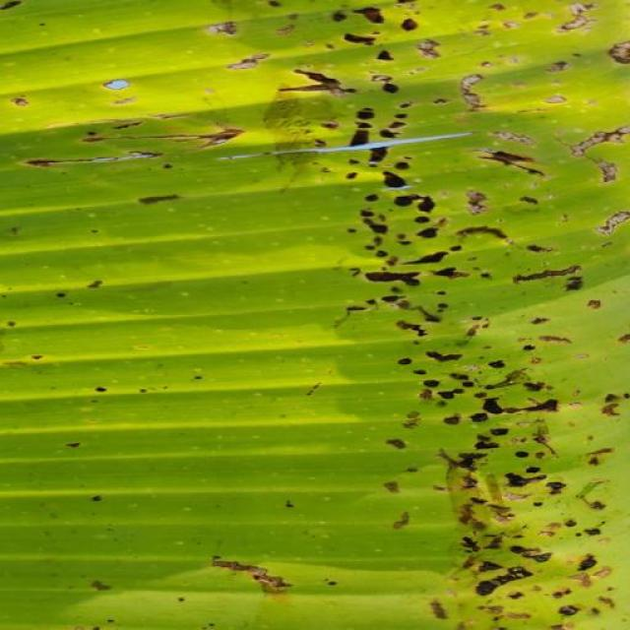
Option 1:
The image shows a close-up of a leaf with brown spots, indicating that the plant is affected by a disease. The brown spots are a visible symptom of the disease, which could be a fungal infection or a bacterial infection.
To address this issue, it is essential to identify the specific type of disease affecting the plant and take appropriate measures to treat it. For fungal infections, applying a fungicide specifically designed for the disease can help control its spread and prevent further damage. For bacterial infections, it is crucial to remove any infected leaves and maintain proper plant hygiene to prevent the disease from spreading. Additionally, ensuring proper drainage and aeration of the soil can help prevent root rot and other bacterial infections. Regularly monitoring the plant's health and addressing any signs of disease promptly can help maintain a healthy and thriving plant.
Option 2:
The image shows a banana plant with several visible symptoms indicative of an insect pest infestation. There are small holes in the leaves, which could be caused by feeding insects such as thrips or caterpillars. Additionally, there is yellowing and browning on some parts of the leaf, which might be due to nutrient deficiency or damage from the pests.
To address these issues, a possible solution would include:
1. Identifying the specific type of pest causing the damage and selecting appropriate pesticides or biological control methods accordingly.
2. Implementing integrated pest management practices to minimize the use of chemicals and reduce the risk of pest resistance.
3. Ensuring proper nutrient management through soil testing and fertilization to maintain healthy plant growth.
4. Regularly inspecting the plants for signs of infestation and taking action promptly to prevent further damage.

Which answer do you prefer:

Sample 67

Ground Truth: panama
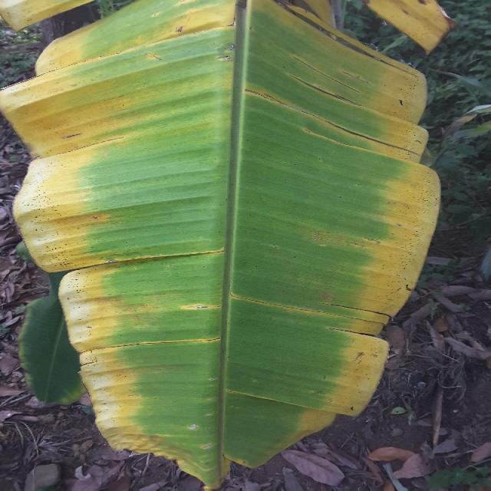
Option 1:
The image shows a yellow plant with brown spots, which could indicate a disease or infection affecting the plant. The brown spots may be a sign of fungal infections, bacterial diseases, or other plant-related issues. To identify the specific disease, it would be necessary to examine the plant more closely and possibly take a sample for further testing.
To address the issue, the plant owner should consider the following steps:
1. Remove any infected or affected leaves and branches to prevent the spread of the disease.
2. Improve the plant's overall health by providing proper care, such as adequate watering, sunlight, and nutrients.
3. Consider using organic or chemical-free pest control methods to prevent the spread of diseases and pests.
4. If the disease is severe, consult a local nursery or gardening expert for advice on the best course of action to save the plant.
It is essential to identify the disease and take appropriate measures to prevent further damage and ensure the plant's health and longevity.
Option 2:
The image shows a banana plant with several visible symptoms that could be indicative of Panama disease, also known as Fusarium wilt. Symptoms include:
1. Discoloration: There are yellowing and browning of the leaves, which is characteristic of the disease.
2. Wilted leaves: The leaves at the top of the plant appear to be wilted or dying, a common sign of Panama disease.
3. Stem lesions: There may be visible lesions on the stem, which can be an early sign of the disease.
4. Reduced vigor: The overall health and growth of the plant may appear reduced compared to healthy plants.
The possible solution for this plant would involve proper identification by a professional, followed by measures such as removing infected plants from the field, improving drainage, and applying fungicides if necessary. It's important to note that Panama disease is caused by a soil-borne fungus and can be devastating to banana crops if not managed properly.

Which answer do you prefer:

Sample 68

Ground Truth: panama
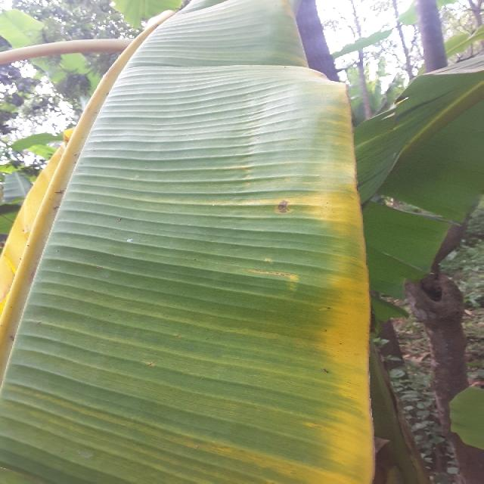
Option 1:
The image shows a leaf with yellow and brown spots, which could indicate a disease or infection affecting the plant. The presence of these spots suggests that the plant might be experiencing stress or damage due to various factors such as pests, nutrient deficiencies, or exposure to extreme weather conditions.
To address this issue, it is essential to identify the cause of the problem and take appropriate measures to treat or prevent it. If the spots are caused by pests, it is crucial to remove the affected leaves and use organic or chemical pest control methods to protect the plant. If the spots are due to nutrient deficiencies, it is necessary to provide the plant with the necessary nutrients through proper soil amendment or supplementation. If the spots are a result of extreme weather conditions, it is important to provide the plant with adequate shade, water, and protection from the elements.
In addition to these measures, regular monitoring of the plant's health and timely intervention can help prevent further damage and promote the plant's overall well-being.
Option 2:
The visible symptoms on the banana plant include yellowing leaves with brown spots, which are indicative of Panama disease. This is a serious fungal disease caused by Fusarium oxysporum f. sp. cubense tropical race 4 (Foc TR4).
The possible solution for this disease would involve implementing a comprehensive management strategy that includes:
1. Proper soil management: Ensure that the soil has good drainage and does not become waterlogged, which can exacerbate the disease.
2. Crop rotation: Rotate the banana plant with other crops to reduce the risk of Foc TR4 spreading.
3. Proper irrigation: Avoid over-watering as it can lead to root rot and increase the risk of Panama disease.
4. Fungicide application: Use registered fungicides that are effective against Panama disease, such as Luna Experience, Scala, and Serenade Prime.
5. Soil testing: Regularly test the soil for pH levels and nutrient deficiencies to ensure optimal growing conditions.
6. Proper pruning: Prune infected leaves to prevent further spread of the disease.
7. Sanitation: Maintain clean fields by removing and destroying infected plant material.
8. Monitoring: Regularly inspect plants for signs of disease and take action as needed.

Which answer do you prefer:

Sample 69

Ground Truth: panama
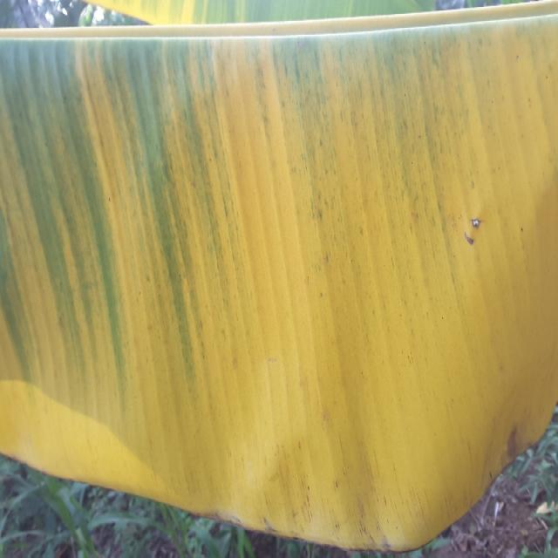
Option 1:
The image shows a banana tree with yellow leaves, which indicates that the tree is suffering from a disease called "Panama disease." This disease is caused by the fungus Fusarium oxysporum f. sp. cubense, which affects the tree's roots and eventually leads to the yellowing and wilting of the leaves.
The visible symptoms of Panama disease include yellowing leaves, stunted growth, and a general decline in the tree's health. The disease can be fatal to the tree if not treated in time.
A possible solution to combat Panama disease is to practice good agricultural practices, such as regular pruning, proper irrigation, and maintaining a healthy soil environment. Additionally, using resistant varieties of banana trees can help prevent the spread of the disease. If the disease has already taken hold, it may be necessary to remove the affected parts of the tree and replace it with a healthy plant.
Option 2:
The visible symptoms in the image include the yellowing of the leaves, which is a characteristic sign of Panama disease in banana plants. This disease is caused by the fungus Fusarium oxysporum f. sp. cubense (Foc) and can lead to severe damage to the plant's vascular system, resulting in wilting and death of the leaves.
A possible solution for this issue would be to implement a comprehensive disease management strategy that includes:
1. Proper identification of the disease by an expert in banana diseases.
2. Implementing good agricultural practices such as maintaining clean fields, removing infected plants, and using resistant varieties if available.
3. Using fungicides that are registered for use against Panama disease, although these should be used with caution and according to label instructions.
4. Implementing cultural practices like proper drainage, avoiding waterlogging, and avoiding close spacing between plants to reduce the risk of infection.
5. Regular monitoring of the plant's health and prompt action if any signs of disease are detected.

Which answer do you prefer:

Sample 70

Ground Truth: panama
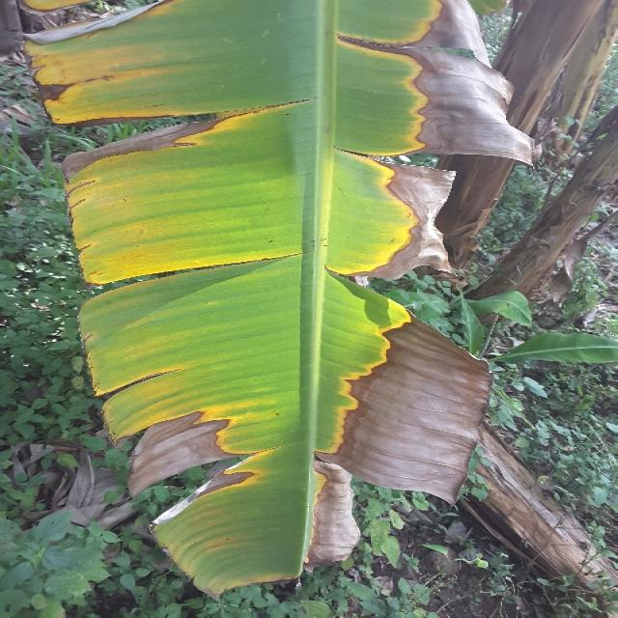
Option 1:
The image shows a bunch of bananas with yellow and brown spots, indicating that they are affected by a disease called Panama disease. This disease is caused by the fungus Fusarium oxysporum f. sp. cubense, which attacks the banana plant and causes the fruit to turn yellow and brown.
The visible symptoms of Panama disease include yellowing and browning of the banana fruit, wilting of the plant, and a general decline in the plant's health. The disease can lead to the death of the plant and the loss of the entire crop.
A possible solution to prevent the spread of Panama disease is to practice good agricultural practices, such as proper planting techniques, regular monitoring of the plant's health, and early detection and removal of infected plants. Additionally, using resistant varieties of banana plants can help reduce the risk of infection and improve the overall health of the plantation.
Option 2:
The visible symptoms in the image include discoloration and browning of the banana leaves, which are indicative of Panama disease. This is a serious fungal disease that affects banana plants, causing significant damage to the leaves and potentially leading to the death of the plant if left untreated.
A possible solution for this disease would involve the use of fungicides specifically designed to combat Panama disease. These fungicides can help prevent the spread of the disease and protect healthy tissue from further damage. Additionally, proper irrigation practices, such as avoiding waterlogging, can help maintain good plant health and reduce the risk of infection. It's also important to monitor the plant regularly for any signs of new infections and treat them promptly with appropriate fungicides.

Which answer do you prefer:

Sample 71

Ground Truth: panama
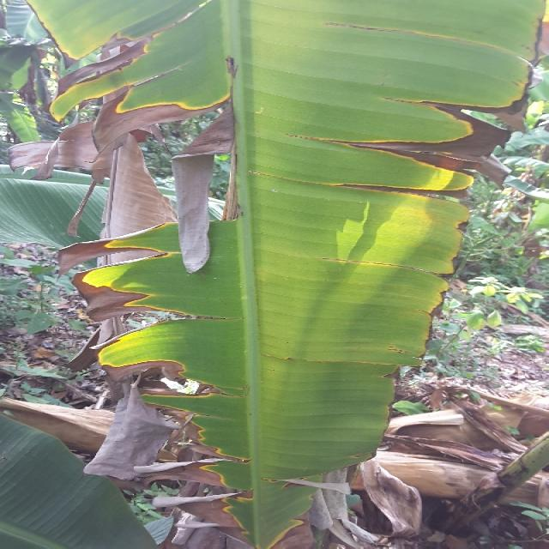
Option 1:
The image shows a banana with a yellowish-brown color, which indicates that it is affected by a disease called Panama disease. This disease is caused by the fungus Fusarium oxysporum f. sp. cubense, which attacks the banana plant and causes the fruit to turn yellow and eventually die.
The visible symptoms of Panama disease include yellowing and browning of the banana fruit, wilting of the plant, and a general decline in the plant's health. The disease can lead to significant crop losses for banana growers.
A possible solution to combat Panama disease is the use of resistant varieties of banana plants. These varieties have been bred to be more resistant to the fungus and can help prevent the spread of the disease. Additionally, proper planting practices, such as spacing the plants adequately and ensuring proper drainage, can also help reduce the risk of the disease. Proper management of the soil and regular monitoring of the plant's health can also aid in early detection and treatment of the disease.
Option 2:
The image shows a banana plant with several visible symptoms indicative of Panama disease, also known as Fusarium wilt. Symptoms include:
1. Yellowing of leaves: The leaves are turning yellow and may have brown spots or lesions.
2. Wilting: The plant appears to be wilting, with drooping stems and leaves that are not upright.
3. Discoloration: There is a discoloration pattern on the stem, which is characteristic of Panama disease.
4. Stem decay: The stem may show signs of decay or rot, which is a common symptom in plants affected by Fusarium wilt.
The possible solution for this plant would be to implement measures to prevent further spread of the disease and to manage the existing damage. These may include:
1. Proper drainage: Ensuring that the soil has good drainage is crucial in preventing the spread of Fusarium wilt.
2. Avoid waterlogging: Waterlogging can exacerbate the problem by creating an environment where the fungus thrives.
3. Use resistant varieties: Selecting banana varieties that are resistant to Panama disease can help mitigate the impact of the disease.
4. Proper pruning and removal of infected plants: Removing affected plants and pruning them properly can help prevent the spread of the fungus.
5. Fungicides: In some cases, fungicides may be used to control the disease, but it's important to follow recommended guidelines for their use in agriculture.

Which answer do you prefer:

Sample 72

Ground Truth: panama
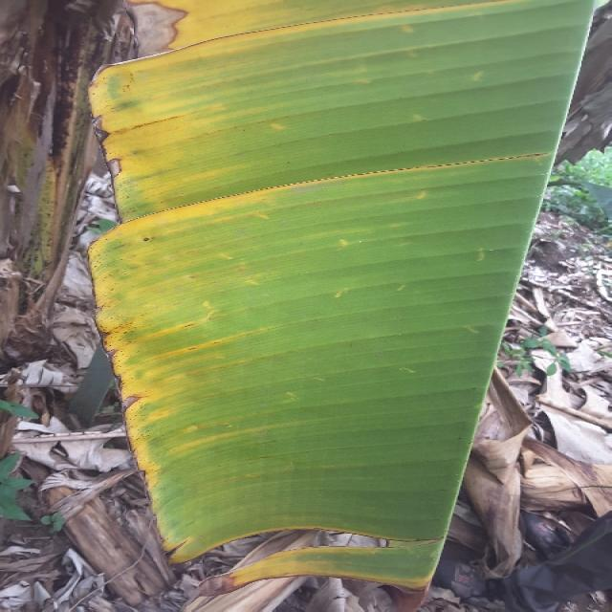
Option 1:
The image shows a banana tree with yellow leaves, which indicates that it is suffering from a disease called "Panama disease." This disease is caused by the fungus Fusarium oxysporum f. sp. cubense, which affects the tree's roots and eventually leads to the yellowing and wilting of the leaves.
The visible symptoms of Panama disease include yellowing leaves, stunted growth, and a general decline in the tree's health. The disease can be fatal to the tree if not treated in time.
A possible solution to combat Panama disease is to practice good agricultural practices, such as proper irrigation, regular pruning, and the use of resistant varieties of banana trees. Additionally, the use of fungicides and other chemical treatments can help control the spread of the disease and protect the tree from further damage. It is essential to identify the disease early and take appropriate measures to prevent its spread and minimize the impact on the banana tree and the overall crop.
Option 2:
The visible symptoms in the image include discoloration and browning of the leaves, which are characteristic signs of Panama disease affecting banana plants. This disease is caused by a fungus that infects the plant through its roots or stem.
The visible symptoms include:
- Yellowing and browning of the leaf edges and tips, which can progress to the entire leaf becoming discolored and eventually dying.
- Leaf spots that are oval or irregularly shaped, which can be brown, black, or yellow in color.
- Stem lesions that are often circular and may have a yellow halo around them.
The possible solution for this disease includes:
- Proper identification of the disease by an expert to confirm its presence.
- Implementing cultural practices such as removing infected plants, maintaining clean fields, and avoiding overcrowding of banana plants.
- Using fungicides that are registered for use in bananas and following all label instructions carefully. It's important to rotate fungicides to prevent resistance development.
- Practicing good hygiene by removing contaminated soil, tools, and equipment from the field.
It's also important to note that Panama disease can be devastating for banana crops, so early detection and management are crucial to minimize its impact on production.

Which answer do you prefer:

Sample 73

Ground Truth: panama
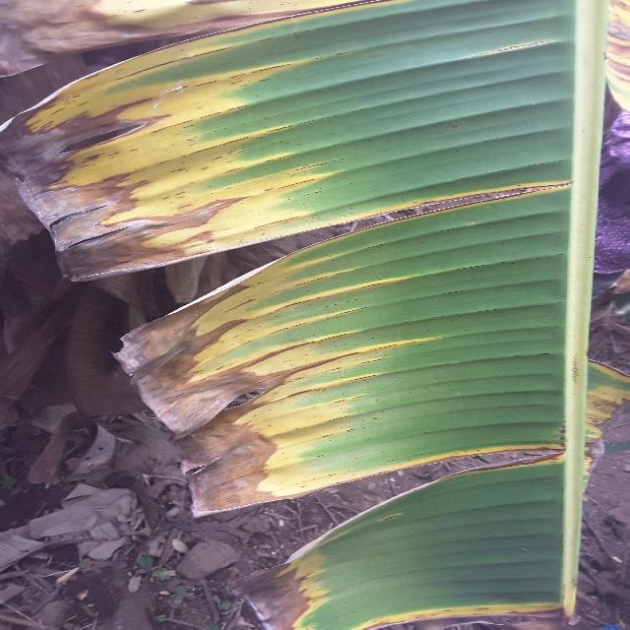
Option 1:
The image shows a leaf with yellow and green stripes, which appears to be affected by a disease. The yellow stripes on the leaf suggest that it might be infected with a fungal disease, such as fusarium wilt or bacterial wilt. These diseases can cause the yellowing of leaves and stems, as well as the eventual death of the plant.
To address this issue, it is essential to identify the specific disease causing the yellowing and take appropriate measures to prevent its spread. This may involve removing infected plants, practicing proper plant care, and using fungicides or other treatments to manage the disease. Additionally, it is important to maintain a healthy plant environment by providing adequate water, nutrients, and sunlight, as well as ensuring proper spacing and air circulation to minimize the risk of disease infection.
Option 2:
The visible symptoms in the image include discoloration and browning of the leaves, which are characteristic signs of Panama disease in banana plants. This disease is caused by a fungus that infects the plant through its roots or stem.
The possible solutions for managing Panama disease include:
1. Proper drainage: Ensuring that the soil has good drainage helps prevent the fungus from spreading.
2. Fungicides: Applying fungicides can help control the spread of the disease and protect healthy tissue.
3. Crop rotation: Rotating banana crops with other plants can help reduce the risk of infection.
4. Soil management: Regularly testing soil for pH levels and applying lime as needed to maintain a proper pH balance.
5. Proper watering: Avoid over-watering, which can lead to root rot and increase the risk of disease.
6. Pruning infected plants: Removing affected plants helps prevent further spread of the fungus.
7. Sanitation: Keeping the area around banana plants free from debris and weeds can help reduce the risk of infection.

Which answer do you prefer:

Sample 74

Ground Truth: panama
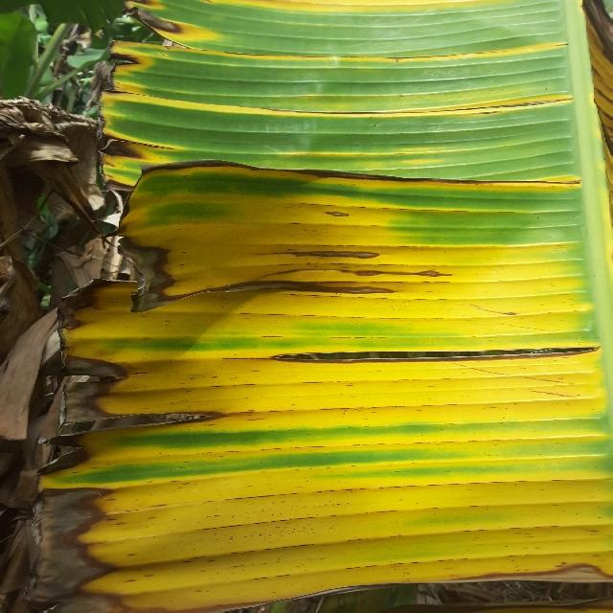
Option 1:
The image shows a banana tree with yellow leaves, which indicates that the tree is suffering from a disease called "Panama disease." This disease is caused by the fungus Fusarium oxysporum f. sp. cubense, which affects the tree's roots and eventually leads to the yellowing and wilting of the leaves.
The visible symptoms of Panama disease include yellowing leaves, stunted growth, and a general decline in the tree's health. The disease can be fatal to the tree if not treated in time.
A possible solution to combat Panama disease is to practice good agricultural practices, such as regular pruning, proper irrigation, and maintaining a healthy soil environment. Additionally, using resistant varieties of banana trees can help reduce the risk of infection. In severe cases, chemical treatments may be necessary to control the disease and prevent its spread.
Option 2:
The image shows a banana plant with several visible symptoms that could be indicative of Panama disease, which is caused by the fungus Fusarium oxysporum f. sp. cubense (Foc). Here are the visible symptoms:
1. **Dark Brown Leaf Tips**: The tips of the leaves are turning dark brown and may eventually die off. This is a common symptom in Panama disease.
2. **Yellowing of Leaves**: The leaves appear to be yellowing, which could be due to nutrient deficiency or water stress, but it's also a sign of Panama disease.
3. **Discoloration and Spotting**: There are discolored areas on the leaves that may have a reddish-brown color with darker spots. This is characteristic of Panama disease.
4. **Withering and Death of Leaves**: Some leaves are visibly wilted and dying, which is consistent with the effects of Panama disease on banana plants.
5. **Stem Rot**: There may be signs of stem rot, which is a common symptom in Panama disease.
6. **General Decline in Plant Health**: The overall health of the plant appears to be declining, with leaves drooping and not fully opening up.
To address Panama disease, it's important to implement preventive measures such as proper drainage, avoiding overcrowding of plants, and using resistant varieties of banana plants. Additionally, fungicides can be used to control the spread of the disease, but it's crucial to follow recommended guidelines for their use in agriculture.

Which answer do you prefer:

Sample 75

Ground Truth: panama
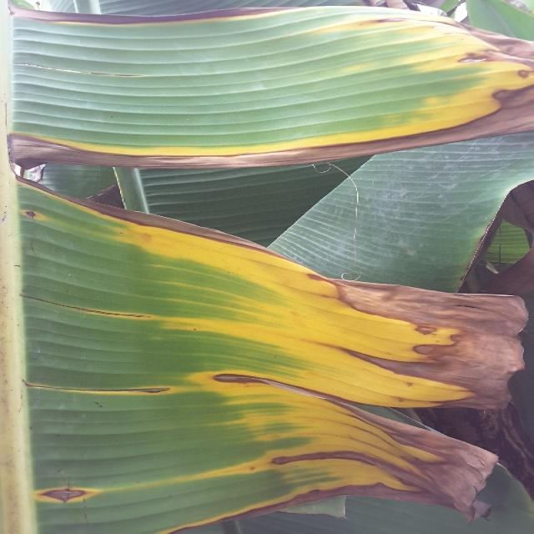
Option 1:
The image shows a banana tree with yellow and brown leaves, indicating that it is suffering from a disease called "Panama disease." This disease is caused by the fungus Fusarium oxysporum f. sp. cubense, which affects the tree's vascular system, causing it to wilt and die.
The visible symptoms of Panama disease include yellowing and browning of the leaves, wilting of the tree, and a general decline in the tree's health. The disease can spread rapidly and is difficult to control once it has taken hold.
A possible solution to prevent the spread of Panama disease is to practice good agricultural practices, such as proper irrigation, pest management, and regular monitoring of the tree's health. Additionally, using resistant varieties of banana trees can help reduce the risk of infection. In cases where the disease has already spread, it may be necessary to remove infected trees and replace them with healthy ones to prevent further spread of the disease.
Option 2:
The visible symptoms in the image include discoloration and browning of the banana leaves, which are characteristic of Panama disease. This disease affects bananas by causing a yellowing of the leaves from the edges towards the center, followed by browning and eventual death of the leaf tissue.
The possible solution for this disease would involve preventive measures such as using resistant varieties of bananas, maintaining proper drainage in the soil, avoiding overcrowding in planting, and ensuring adequate nutrient availability. Additionally, controlling weeds and other weeds that can harbor the Panama disease fungus can help reduce the risk of infection. If the disease has already been detected, fungicides may be applied to manage the outbreak. It's important to follow recommended guidelines for the use of pesticides and to rotate the application of fungicides to prevent resistance development.

Which answer do you prefer:

Sample 76

Ground Truth: panama
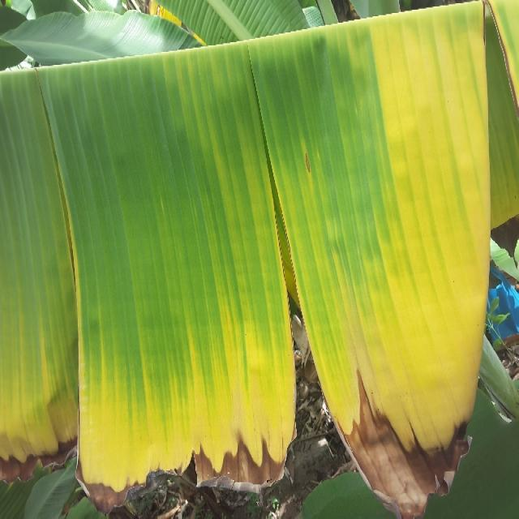
Option 1:
The image shows a banana tree with yellow leaves, which indicates that the tree is suffering from a disease called "Banana Bunch Disease." This disease is caused by a fungus called Fusarium oxysporum f. sp. cubense, which affects the tree's growth and fruit production.
The visible symptoms of Banana Bunch Disease include yellowing of the leaves, chlorosis (yellowing of the leaf veins), and the formation of brown spots on the leaves. The tree may also produce small, deformed, or unripe fruits.
A possible solution to this disease is to practice good agricultural practices, such as proper irrigation, pest and disease management, and timely pruning of infected parts of the tree. Additionally, using resistant varieties of banana plants can help reduce the risk of infection and improve the overall health of the tree.
Option 2:
The visible symptoms in the image include yellowing leaves with brown edges, which is indicative of a disease called Panama disease or Fusarium wilt. This disease affects banana plants and can cause significant damage to the plant.
The solution for this disease would typically involve removing infected plants from the field, sanitizing tools used for planting or pruning, and implementing good crop management practices such as proper drainage, avoiding overcrowding, and maintaining a balanced fertilizer program. Additionally, using resistant varieties of banana plants can help reduce the risk of infection.

Which answer do you prefer:

Sample 77

Ground Truth: panama
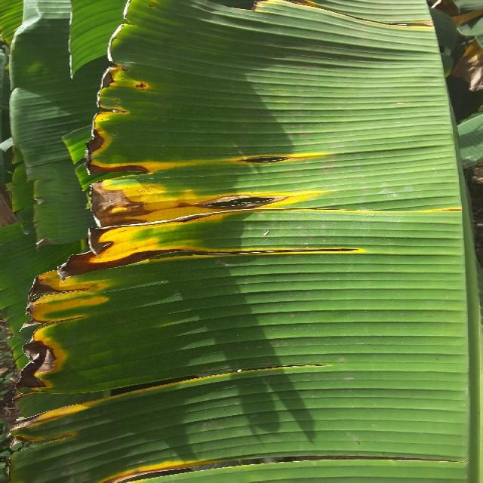
Option 1:
The image shows a close-up of a banana with a green and yellow color, which indicates that it is ripe. There are no visible symptoms of disease or any other health issues in the banana. To maintain the quality and taste of the banana, it is essential to store it properly, away from direct sunlight and heat, and consume it before it becomes overripe.
Option 2:
The image provided appears to be distorted or corrupted, making it difficult to discern the details clearly. However, I can attempt to describe some common symptoms of Panama disease in bananas based on typical visual cues:
1. Leaf Discoloration: Affected leaves may show yellowing, browning, or blackening at the edges and tips.
2. Stem Rot: The stem of the plant can become rotted and discolored, often starting at the base and spreading upwards.
3. Flower Blight: Flowers on affected plants may wilt or die prematurely.
4. Fruit Decay: Infected fruits may develop brown spots or rot, which can lead to a loss of quality and taste.
To address these symptoms, it's important to practice good horticultural practices such as proper drainage, avoidance of overcrowding, and regular monitoring for signs of disease. If Panama disease is confirmed, fungicides may be applied according to label recommendations and local regulations.

Which answer do you prefer:

Sample 78

Ground Truth: panama
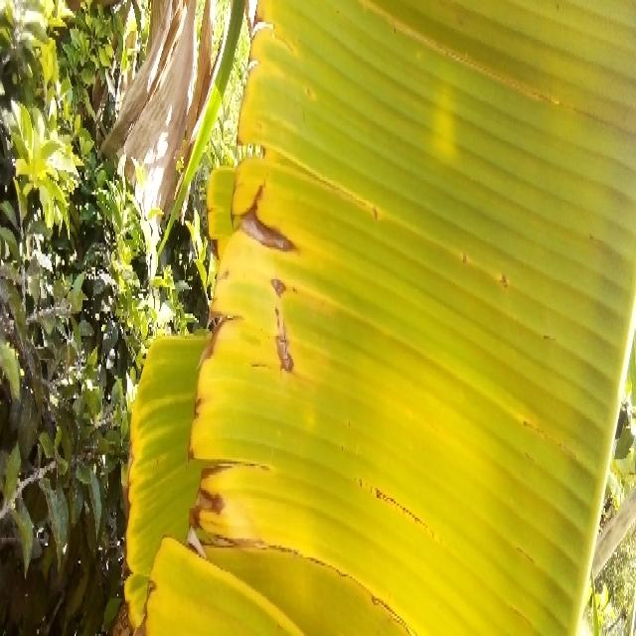
Option 1:
The image shows a leaf with a yellowish-brown color, which could indicate a disease or a sign of aging. The leaf appears to be a banana leaf, and the yellowish-brown color might be due to a fungal infection or a nutrient deficiency.
To address the issue, it is essential to identify the specific cause of the yellowish-brown color. If it is a fungal infection, it is crucial to remove the affected parts of the plant and apply a fungicide to prevent the spread of the disease. If it is a nutrient deficiency, it may be necessary to provide the plant with the necessary nutrients through fertilization or soil amendment.
In either case, it is important to monitor the plant's health and take appropriate action to maintain its well-being and prevent further damage.
Option 2:
The visible symptoms in the image include yellowing leaves with brown spots, which are indicative of Panama disease. This is a serious fungal disease that affects banana plants and can cause significant damage to the plant.
To address this issue, it's important to practice good horticultural practices such as proper drainage, avoiding overcrowding in the soil, and maintaining a balanced fertilizer schedule. Additionally, regular monitoring for signs of disease and prompt removal of affected plants can help prevent the spread of the disease within the plantation. If Panama disease is detected early, fungicides may be applied to control its spread. However, it's crucial to follow recommended dosages and application methods as per the manufacturer's instructions to minimize any potential harm to the plant.

Which answer do you prefer:

Sample 79

Ground Truth: panama
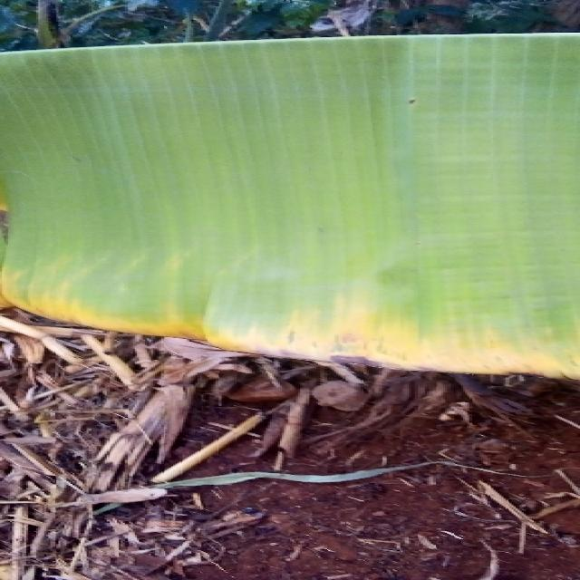
Option 1:
The image shows a banana tree with a yellow and brown leaf, which indicates that the tree is suffering from a disease called "Panama disease." This disease is caused by the fungus Fusarium oxysporum f. sp. cubense, which affects the tree's roots and eventually leads to the yellowing and browning of the leaves.
The visible symptoms of Panama disease include yellowing and browning of the leaves, wilting of the tree, and a general decline in the tree's health. The disease can be fatal to the tree if not treated in time.
A possible solution to combat Panama disease is to practice good agricultural practices, such as proper irrigation, regular pruning, and the use of resistant varieties of banana trees. Additionally, the use of fungicides and other chemical treatments can help control the spread of the disease and protect the tree from further damage. It is essential to identify the disease early and take appropriate measures to prevent its spread and minimize the impact on the banana tree and the overall crop.
Option 2:
The visible symptoms in the image include discoloration and browning of the banana leaves, which are indicative of a disease known as Panama disease or Fusarium wilt. This disease affects bananas and other plants in the Musa genus.
The affected leaves show signs of necrosis (death) at the edges, with a yellowing or browning of the tissue, which is characteristic of the disease. The veins may also appear darker due to the presence of the pathogen.
A possible solution for this disease would involve proper crop management practices such as selecting resistant varieties, maintaining good drainage and soil fertility, and implementing a program to control the spread of the disease through regular monitoring and removal of infected plants. Additionally, using fungicides may be necessary in some cases, but it's important to follow recommended guidelines for their use to minimize environmental impact.

Which answer do you prefer:

Sample 80

Ground Truth: panama
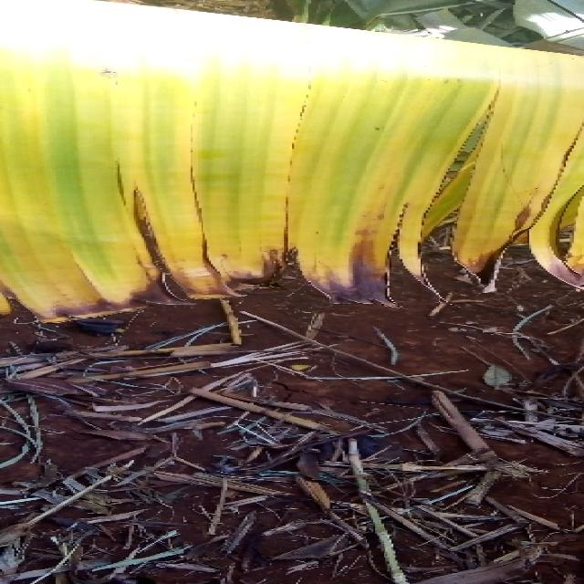
Option 1:
The image shows a banana with brown spots and a yellow peel, which indicates that it is rotting. This could be due to a disease called Panama disease, which affects banana plants and causes them to produce fruit with brown spots and a rotting peel.
The visible symptoms of Panama disease include brown spots on the banana peel, yellowing of the banana, and the fruit becoming soft and mushy. The disease is caused by the fungus Fusarium oxysporum f. sp. cubense, which enters the plant through the roots and spreads through the plant's vascular system.
A possible solution to prevent the spread of Panama disease is to practice good agricultural practices, such as proper irrigation, pest management, and regular monitoring of the plant's health. Additionally, using resistant varieties of banana plants can help reduce the risk of infection.
Option 2:
The image shows a banana plant with several yellowing leaves, which is indicative of Panama disease. This disease affects bananas and is caused by the fungus Fusarium oxysporum f. sp. cubense tropical race 4 (Foc TR4).
Visible symptoms include:
- Yellowing of leaves, starting from the edges and progressing towards the center.
- Leaf necrosis (death) with a dark brown or black coloration.
- Wilting of affected leaves.
- Stem lesions that can be seen as dark, water-soaked areas on the stem.
The possible solution for this disease is to implement integrated pest management practices such as:
- Proper drainage and soil management to prevent waterlogging, which can exacerbate the disease.
- Use of resistant varieties of bananas.
- Implementing cultural practices like removing infected plants promptly and maintaining clean tools to prevent cross-contamination.
- Applying fungicides when necessary, but it's important to follow label instructions and use only registered products for Panama disease.
- Regular monitoring of plant health and prompt action if symptoms are observed.

Which answer do you prefer:

Sample 81

Ground Truth: panama
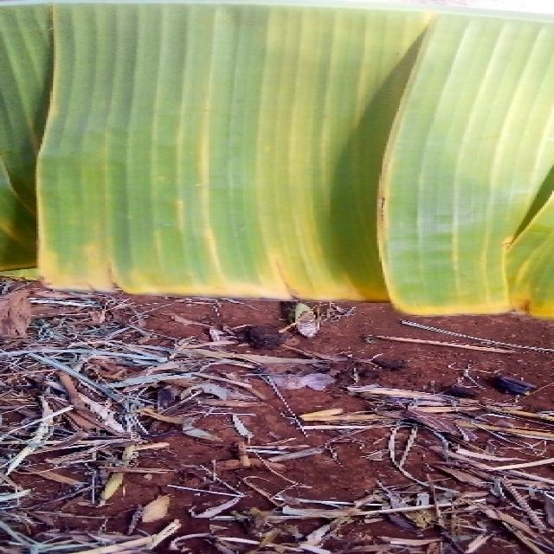
Option 1:
The image shows a leaf with yellow and brown spots, which indicates that the plant is suffering from a disease. The yellow and brown spots are a result of the plant's immune system trying to fight off the infection. The possible solution to this problem is to identify the specific disease and apply appropriate treatment methods. This may involve using fungicides, applying organic compounds, or removing infected parts of the plant to prevent the disease from spreading further. It is essential to consult with a plant expert or a local nursery to determine the best course of action for treating the disease and ensuring the health of the plant.
Option 2:
The visible symptoms in the image include yellowing of the leaf edges, which is characteristic of Panama disease (Fusarium wilt). This disease affects banana plants and can lead to severe damage if not treated. Possible solutions include using resistant varieties, proper drainage, and regular monitoring for early signs of infection. Additionally, proper irrigation practices and removal of infected plant material can help prevent the spread of the disease.

Which answer do you prefer:

Sample 82

Ground Truth: panama
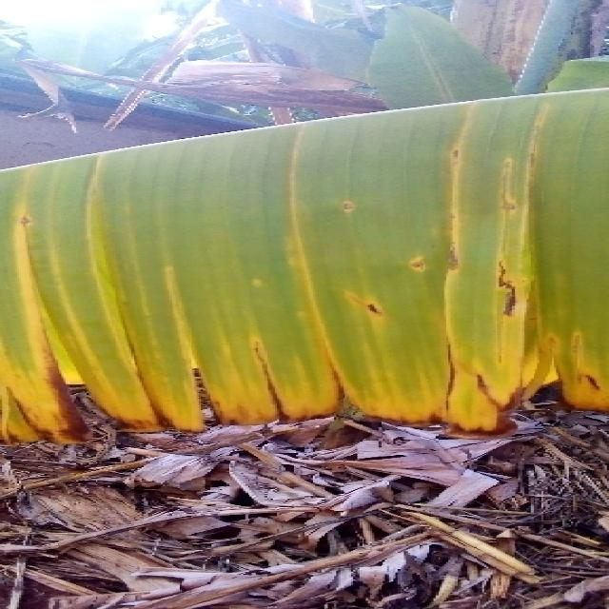
Option 1:
The image shows a leaf with yellow and green stripes, which could be indicative of a disease or a natural variation in the leaf's coloration. The yellow and green stripes might be a natural occurrence, such as a variation in the leaf's pigmentation or a response to environmental factors. However, if the yellow and green stripes are a result of a disease, it could be a fungal infection or a bacterial infection.
To identify the specific disease, one would need to observe the leaf's overall appearance, including the size, shape, and texture of the leaf, as well as any visible signs of discoloration or damage. If the yellow and green stripes are a result of a disease, it would be important to consult a plant pathologist or a horticulturist to determine the cause and appropriate treatment.
In general, preventive measures such as proper watering, pest control, and regular maintenance can help minimize the risk of diseases affecting plants. Additionally, early detection and treatment of any signs of disease can help prevent further damage and promote the health of the plant.
Option 2:
Based on the image provided, it appears that the banana plant may be affected by Panama disease. This is indicated by the yellowing of the leaves and the overall unhealthy appearance of the plant. The yellowing could be due to a lack of nutrients or water stress, but in the context of Panama disease, it is often accompanied by a vascular browning that can be seen as dark streaks or discoloration within the stems and leaves.
A possible solution for this issue would involve soil testing to ensure proper nutrient levels, as well as monitoring the plant for any signs of waterlogging or root rot, which can exacerbate the symptoms of Panama disease. Proper drainage and irrigation practices should also be considered to prevent these issues from occurring. If a diagnosis of Panama disease is confirmed, then fungicides may be necessary to control the spread of the disease within the plant and prevent further damage.

Which answer do you prefer:

Sample 83

Ground Truth: panama
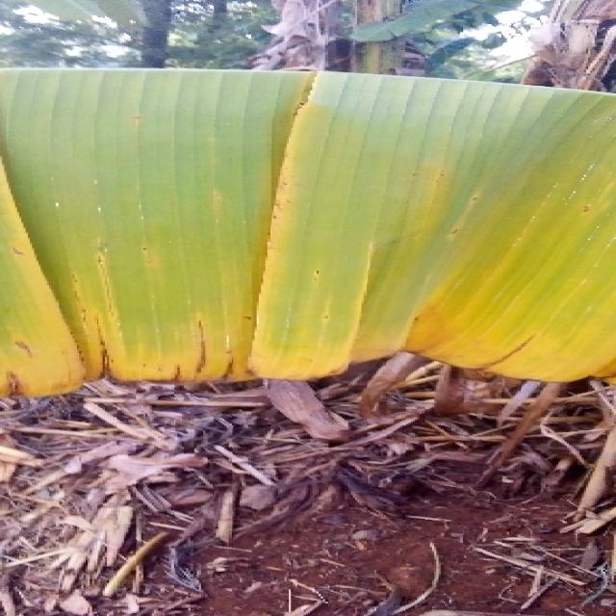
Option 1:
The image shows a leaf with yellow spots, which could indicate a disease or infection affecting the plant. The yellow spots might be a sign of fungal infection, bacterial infection, or nutrient deficiency. To address this issue, it is essential to identify the specific cause of the yellow spots and take appropriate measures to treat the plant.
If the yellow spots are due to a fungal infection, it is crucial to remove any infected leaves and apply a fungicide to prevent the spread of the disease. If it is a bacterial infection, it may require the application of a bactericide or a change in the plant's care routine, such as improving drainage or watering practices.
If the yellow spots are due to nutrient deficiency, it is essential to provide the plant with the necessary nutrients through proper soil amendment or supplementation. Regularly monitoring the plant's health and addressing any issues promptly can help maintain the plant's overall health and prevent further damage.
Option 2:
The image shows a banana plant with several visible symptoms that could be indicative of Panama disease, which is caused by the fungus Fusarium oxysporum f. sp. cubense (Foc). Here are the visible symptoms:
1. Yellowing of leaves: The most noticeable symptom is the yellowing of the leaves, which is a characteristic sign of Panama disease in banana plants.
2. Brown spots and lesions: There are brown spots and lesions on the leaves, which are typical for the fungal infection.
3. Leaf necrosis: The edges of the leaves appear to be dying back, which is another sign of Panama disease.
4. Stem rot: Although not visible in this image, stem rot is a common symptom of Panama disease and can lead to the death of the plant if left untreated.
The possible solution for managing Panama disease in banana plants includes proper drainage, avoiding waterlogging, using resistant varieties, and applying fungicides as recommended by local agricultural authorities or extension services. It's important to consult with a professional before applying any chemical treatments.

Which answer do you prefer:

Sample 84

Ground Truth: panama
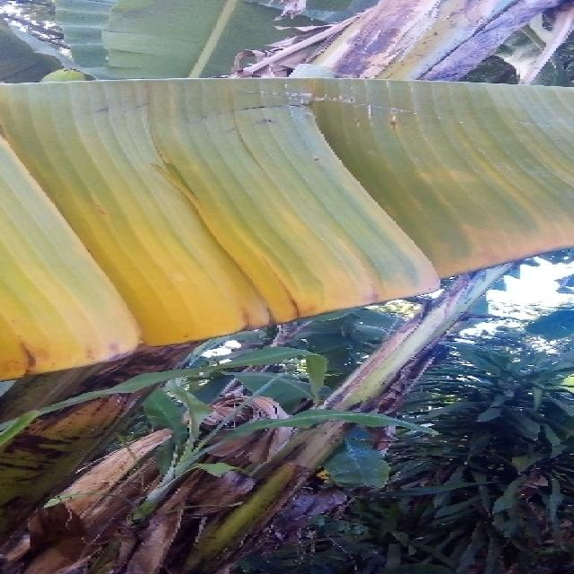
Option 1:
The image shows a banana plant with yellow and green leaves, indicating that it is affected by a disease. The yellowing of the leaves suggests that the plant is experiencing a condition called "yellow leaf disease," which can be caused by various factors such as nutrient deficiencies, overwatering, or pests and diseases.
To address this issue, it is essential to identify the underlying cause of the yellowing leaves. If it is due to nutrient deficiencies, the plant may require additional nutrients, such as potassium, to help it recover. If overwatering is the issue, the plant may benefit from better drainage or reduced watering frequency. If pests or diseases are the cause, it is crucial to identify the specific pest or disease and take appropriate measures to control or eradicate it. This may involve using pesticides, applying fungicides, or removing affected leaves and stems to prevent the spread of the disease. Regular monitoring and timely intervention can help the plant recover and maintain its health.
Option 2:
The visible symptoms in the image include discoloration and browning of the leaves, which are characteristic signs of Panama disease. This is a serious banana disease caused by the fungus Fusarium oxysporum f. sp. cubense tropical race 4 (Foc TR4).
The possible solution for this disease includes:
1. Proper crop management practices such as selecting healthy suckers from disease-free fields and planting them in clean soil.
2. Regular monitoring of the plant for early signs of infection.
3. Implementing good sanitation practices to prevent the spread of the fungus.
4. Using resistant varieties of bananas where available.
5. Applying fungicides as recommended by a plant pathologist or extension service.
6. Implementing integrated pest management strategies to minimize the risk of disease outbreaks.

Which answer do you prefer:

Sample 85

Ground Truth: panama
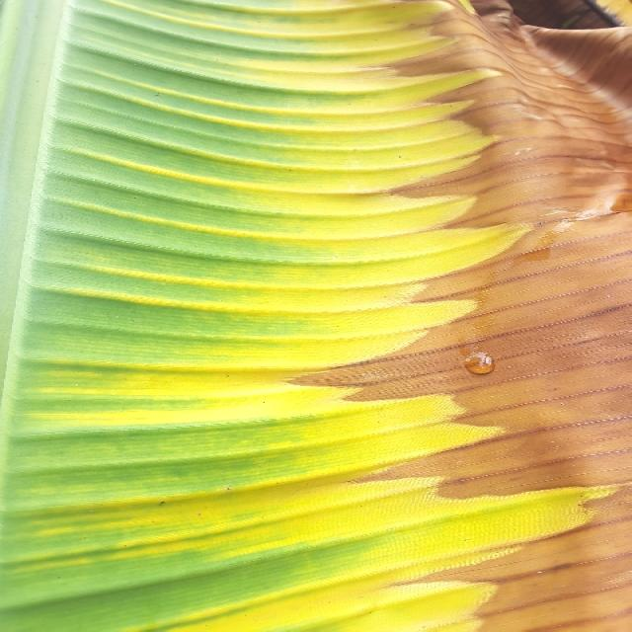
Option 1:
The image shows a banana leaf with yellow spots and streaks, which indicates that the banana tree is suffering from a disease called Panama disease. This disease is caused by the fungus Fusarium oxysporum f. sp. cubense, which affects the banana tree's roots and vascular system, leading to yellowing and wilting of the leaves.
The visible symptoms of Panama disease include yellowing and browning of the leaves, wilting, and eventual death of the tree. The disease can spread rapidly and cause significant damage to the banana crop.
A possible solution to combat Panama disease is to practice good agricultural practices, such as proper irrigation, pest and disease management, and regular monitoring of the banana tree's health. Additionally, using resistant varieties of banana plants can help reduce the risk of infection and disease spread.
Option 2:
The visible symptoms in the image include yellowing leaves with brown spots, which are characteristic of Panama disease. This is a serious fungal disease that affects banana plants and can cause significant damage to the plant.
The solution for this disease would typically involve removing infected plants from the field, sanitizing tools used for planting or pruning, and applying fungicides to prevent the spread of the disease. It's also important to monitor the health of other banana plants in the area and take preventive measures such as maintaining good drainage, avoiding overcrowding, and ensuring proper nutrient management.

Which answer do you prefer:

Sample 86

Ground Truth: panama
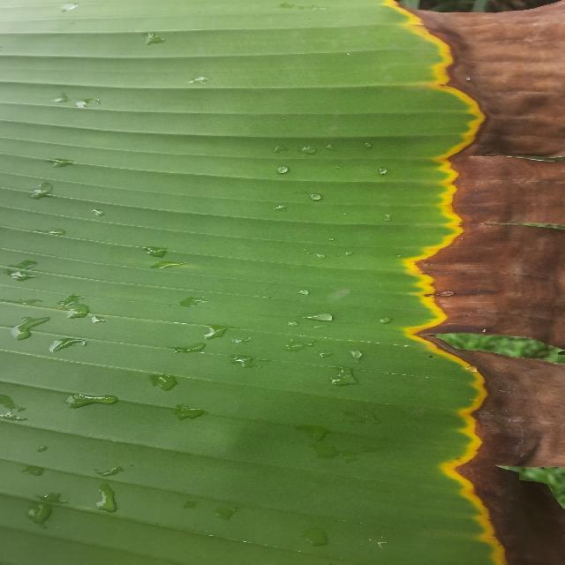
Option 1:
The image shows a plant with brown, yellow, and green leaves, which indicates that it is suffering from a disease. The leaves are withered and have brown spots, which are visible symptoms of the disease. The plant appears to be a palm tree, as suggested by the presence of a palm tree leaf.
The disease could be a fungal infection, as indicated by the brown spots on the leaves. To address this issue, it is essential to identify the specific type of fungus causing the infection and apply appropriate fungicides to treat the plant. Additionally, proper care, such as regular watering, sunlight exposure, and maintaining a healthy soil pH, can help prevent the spread of the disease and promote the plant's overall health.
Option 2:
The image shows a banana plant with several visible symptoms indicative of Panama disease, also known as Fusarium wilt. These symptoms include:
1. Yellowing of leaves: The leaves at the top of the plant are turning yellow and appear to be dying. This is a common sign of Panama disease in banana plants.
2. Discoloration: There is discoloration on the stems, which can range from brown to black, indicating necrosis (death of tissue).
3. Wilted leaves: The leaves at the top of the plant are wilted and appear to be dying. This is a characteristic symptom of Panama disease in banana plants.
4. Stem discoloration: There is discoloration on the stems, which can range from brown to black, indicating necrosis (death of tissue).
The possible solution for this plant would be to remove and destroy infected parts of the plant, including leaves and stems, to prevent further spread of the disease. Additionally, proper sanitation practices should be followed to prevent the spread of the disease from one plant to another. If the disease is severe, chemical treatments may also be considered by a professional in accordance with local regulations.

Which answer do you prefer:

Sample 87

Ground Truth: panama
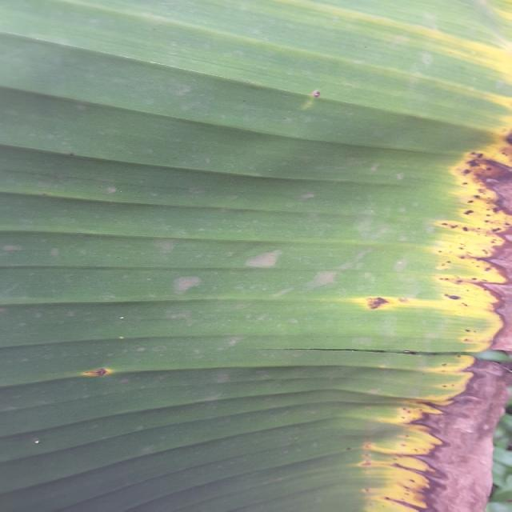
Option 1:
The image shows a banana tree with yellow leaves, which indicates that the tree is suffering from a disease called "Banana Bunch Disease." This disease is caused by a fungus called Fusarium oxysporum f. sp. cubense, which affects the banana plant's growth and fruit production.
The visible symptoms of Banana Bunch Disease include yellowing of the leaves, chlorosis (yellowing of the leaf veins), and the formation of brown spots on the leaves. The disease can also lead to the formation of small, deformed, or unripe fruits.
A possible solution to this problem is to practice good agricultural practices, such as proper irrigation, pest and disease management, and timely pruning of infected parts of the plant. Additionally, using resistant varieties of banana plants can help reduce the risk of infection and improve overall plant health.
Option 2:
The visible symptoms in the image include yellowing leaves with brown edges, which are characteristic of Panama disease (Fusarium wilt) affecting banana plants. This disease is caused by a fungus and can lead to severe damage to the plant if left untreated. Possible solutions include proper drainage, removal of infected plants, and the use of resistant varieties or fungicides when necessary. It's also important to maintain good hygiene practices in the field to prevent the spread of the disease.

Which answer do you prefer:

Sample 88

Ground Truth: panama

Option 1:
The image shows a banana plant with a yellowish-brown leaf, which indicates that the plant is suffering from a disease called Panama disease. This disease is caused by the fungus Fusarium oxysporum f. sp. cubense, which affects the plant's vascular system, causing it to wilt and die.
The visible symptoms of Panama disease include yellowing and browning of the leaves, wilting, and eventual death of the plant. The disease can spread rapidly and is difficult to control once it has taken hold.
A possible solution to prevent the spread of Panama disease is to practice good agricultural practices, such as proper planting techniques, regular monitoring of the plant's health, and early detection and removal of infected plants. Additionally, using resistant varieties of banana plants can help reduce the risk of infection.
Option 2:
The visible symptoms in the image include discoloration and damage to the leaves of the banana plant. There are yellowing areas on the leaves, which could indicate a nutrient deficiency or a disease such as Panama disease.
To address this issue, it would be important to conduct a thorough inspection of the plant for any signs of pests or diseases that might be contributing to the symptoms. If Panama disease is suspected, soil testing can help determine if there are any nutrient deficiencies that could be causing the discoloration.
If Panama disease is confirmed, a solution might involve removing and destroying infected plants to prevent further spread of the disease, as well as applying fungicides if necessary. It's also important to maintain proper drainage and avoid waterlogging in the soil, which can exacerbate the issue.
In addition, good crop rotation practices should be followed to minimize the risk of disease outbreaks. Regular monitoring of the plant's health and prompt action when symptoms are detected can help prevent the spread of diseases and maintain a healthy banana crop.

Which answer do you prefer:

Sample 89

Ground Truth: healthy

Option 1:
The image shows a leaf with a brown spot, which could be a sign of a disease or infection affecting the plant. The brown spot might indicate that the plant is suffering from a fungal infection, bacterial infection, or a nutrient deficiency. To address this issue, it is essential to identify the cause of the brown spot and take appropriate measures to treat the plant.
If the brown spot is caused by a fungal infection, it is crucial to remove any infected leaves and apply a fungicide to prevent the spread of the disease. If the brown spot is due to a bacterial infection, it may require a different treatment approach, such as using a bactericide or applying a copper-based fungicide.
If the brown spot is a result of nutrient deficiency, it is important to provide the plant with the necessary nutrients, such as fertilizers, to help it recover and grow healthy. Regularly monitoring the plant's health and addressing any issues promptly can help prevent further damage and ensure the plant's well-being.
Option 2:
The visible symptoms in the image include a yellowing of the leaves, which could indicate several issues such as nutrient deficiency (particularly nitrogen), water stress, or disease. To address these issues, it would be necessary to assess the plant's overall health and conditions, including soil pH, moisture levels, and potential pests or diseases. If a specific issue is identified, appropriate measures can be taken such as applying fertilizers if necessary, adjusting irrigation practices, or treating for any identified diseases or pests.

Which answer do you prefer:

Sample 90

Ground Truth: healthy
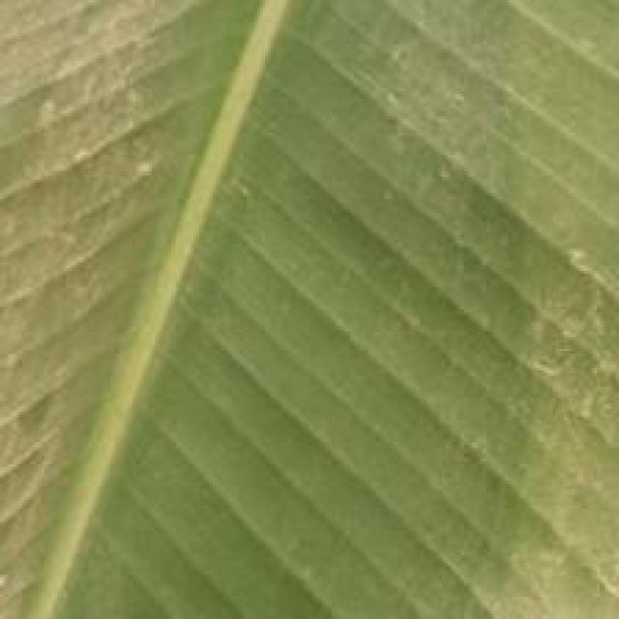
Option 1:
The image shows a leaf with a brown spot on it, which could indicate a disease or infection affecting the plant. The brown spot might be a sign of fungal infection, bacterial infection, or a nutrient deficiency. To address this issue, it is essential to identify the specific cause of the brown spot and take appropriate measures to treat or prevent the disease.
For fungal infections, it is crucial to practice proper plant care, such as regular watering, ensuring adequate drainage, and avoiding overcrowding. Additionally, using organic mulch and compost can help improve soil quality and promote healthy plant growth.
For bacterial infections, it is important to maintain proper hygiene and sanitation practices, such as washing hands and tools before and after handling plants, and using clean water for irrigation.
For nutrient deficiencies, it is necessary to provide the plant with the appropriate nutrients through fertilization or soil amendment. This can be achieved by using a balanced fertilizer or adding organic matter like compost or aged manure to the soil.
In conclusion, identifying the cause of the brown spot on the leaf is essential to address the issue effectively. Proper plant care, hygiene, and nutrient management can help prevent or treat the disease and promote healthy plant growth.
Option 2:
The image shows a close-up view of a banana plant leaf. From the visible symptoms, it appears to be healthy with no signs of disease or pests. The leaf has a vibrant green color and exhibits a natural pattern of veins that are characteristic of banana leaves. There are no spots, discolorations, holes, or other abnormalities that would indicate the presence of diseases or infestations visible in this image.
To maintain the health of a banana plant, it's important to provide proper care, including adequate water and nutrients, protection from extreme temperatures, and regular inspection for any signs of pests or diseases that may require treatment. In general, healthy plants are less likely to be affected by diseases or infestations, so ensuring proper care is key to maintaining the plant's overall health.

Which answer do you prefer:

Sample 91

Ground Truth: healthy
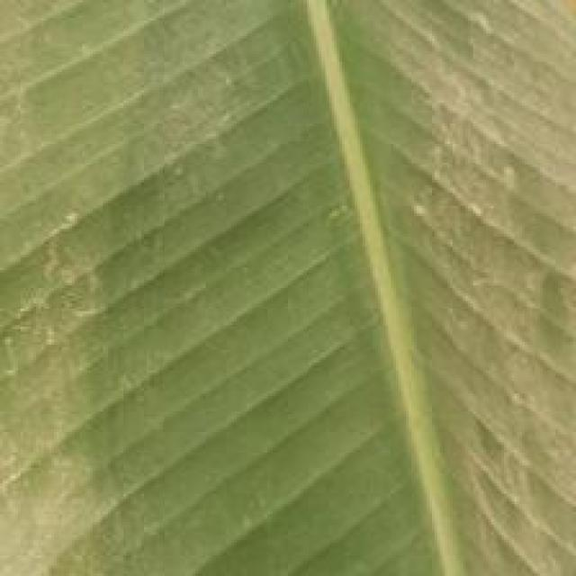
Option 1:
The image shows a large green banana leaf with a yellowish-green stem, which could indicate a disease or a natural aging process. The yellowing of the stem might be due to a natural aging process, or it could be a sign of a disease affecting the banana plant.
If the yellowing is due to a disease, it could be a fungal infection, bacterial infection, or a viral infection. To identify the specific disease, a closer examination of the plant and the leaf would be necessary.
To address the issue, proper care and maintenance of the banana plant are essential. This includes regular watering, ensuring adequate sunlight, and providing proper nutrients. Additionally, monitoring the plant for any signs of disease and taking appropriate action, such as removing infected leaves or applying appropriate fungicides, can help prevent the spread of the disease and maintain the health of the plant.
Option 2:
The visible symptoms in the image include discoloration and possibly some spots or lesions on the leaves. These could be indicative of a fungal disease such as black leaf spot (Mycosphaerella fijiensis) or a bacterial disease like Panama disease (Fusarium oxysporum f. sp. cubense).
To address these issues, it would be important to inspect the plant regularly for signs of infection and treat with appropriate fungicides or bactericides as recommended by an agricultural expert. Additionally, proper drainage, sanitation, and crop rotation can help prevent the spread of such diseases.

Which answer do you prefer:

Sample 92

Ground Truth: healthy

Option 1:
The image shows a close-up of a leaf with a yellowish tint, which could indicate a disease or a nutrient deficiency. The yellowing of the leaf might be due to a lack of nutrients, such as iron or magnesium, or it could be a sign of a fungal infection or bacterial disease.
To identify the specific disease or nutrient deficiency, it would be necessary to examine the leaf more closely and possibly take a sample for further testing. If the issue is a nutrient deficiency, it can be addressed by providing the necessary nutrients through fertilizers or soil amendments. If it is a disease, the appropriate treatment would depend on the specific pathogen causing the issue. In some cases, this may involve removing affected leaves, applying fungicides or bactericides, or providing the plant with a more suitable environment to help it recover.
Option 2:
The image shows a close-up view of a banana plant leaf. From this perspective, it's difficult to definitively identify any specific diseases or symptoms without additional context. However, I can provide some general observations that might be indicative of healthy growth in a banana plant:
1. Leaf color: A healthy banana plant typically has green leaves with no signs of discoloration or yellowing, which could indicate nutrient deficiency or disease.
2. Leaf texture: The surface of the leaf should appear smooth without any significant bumps, holes, or discoloration that might suggest pests or diseases.
3. Stem and petiole: The stem and petiole (the part connecting the leaf to the plant) should be firm and free from signs of decay or infection.
4. Leaf edges: The edges of the leaves should not show signs of browning or curling, which could indicate water stress or nutrient deficiency.
5. Overall plant health: A healthy banana plant appears robust with no significant wilting, drooping, or discoloration that might suggest disease or pest infestation.
If you have concerns about the health of this plant, it would be best to consult a local agricultural expert for a thorough assessment and advice on care and treatment.

Which answer do you prefer:

Sample 93

Ground Truth: healthy

Option 1:
The image shows a leaf with a yellowish-green color, which could indicate a disease or a nutrient deficiency. The yellowing of the leaf might be due to a nutrient deficiency, such as a lack of iron, which is essential for the proper functioning of the plant. To address this issue, it is important to provide the plant with the necessary nutrients, such as iron, through proper soil amendment or supplementation. Additionally, it is crucial to monitor the plant's health and address any other symptoms that may arise to ensure its overall well-being.
Option 2:
The image shows a close-up view of a banana plant leaf. From the visible symptoms, it appears to be healthy with no signs of disease or pests. The color is vibrant green, indicating proper nutrition and growth conditions. There are no spots, discolorations, holes, or other abnormalities that would suggest a disease or infestation.
To maintain the health of the plant, it is important to provide adequate water, sunlight, and fertilizer as needed. Regular inspection for any unusual growths, discolorations, or pests can also help identify potential issues early on. If the plant is part of an orchard, proper spacing between plants and regular pruning can help prevent overcrowding and promote healthy growth.

Which answer do you prefer:

Sample 94

Ground Truth: healthy

Option 1:
The image shows a close-up of a leaf with a brown spot on it. This brown spot could be a sign of a disease or infection affecting the leaf. Possible solutions to address this issue include:
1. Identifying the type of disease: It is essential to determine the specific disease causing the brown spot. This can be done by consulting a plant pathologist or conducting a laboratory test.
2. Applying appropriate treatment: Depending on the disease, a suitable treatment method should be applied. This may involve using fungicides, bactericides, or other chemical treatments to combat the disease. Alternatively, organic methods such as using neem oil or copper-based products can be used to control the disease.
3. Practicing good gardening habits: To prevent diseases and infections, it is crucial to maintain proper gardening practices, such as regular pruning, removing infected leaves, and ensuring proper drainage and air circulation around the plant.
4. Monitoring the plant: Regularly inspecting the plant for any signs of disease or infection can help in early detection and treatment, ensuring the health and longevity of the plant.
Option 2:
The image shows a close-up view of a banana leaf with a pattern that resembles a star or hexagonal shape, which is characteristic of the disease known as Panama disease or Fusarium wilt. This disease affects bananas and other plants in the Musa genus.
Visible symptoms include:
- Discoloration: The affected leaves may show yellowing, browning, or blackening at the edges and/or along the veins.
- Wilted appearance: The leaf may appear wilted or droopy compared to healthy leaves.
- Vascular discoloration: There could be a darkening of the vascular tissue visible on the underside of the affected leaves.
The possible solution for this disease is preventive measures such as using resistant varieties, maintaining proper drainage, avoiding overwatering, and implementing good crop management practices to minimize the risk of infection. If the disease has already been detected, it may require removal of infected plants and treatment with fungicides recommended for bananas.

Which answer do you prefer:

Sample 95

Ground Truth: healthy

Option 1:
The image shows a leaf with a brown spot on it, which could indicate a disease or infection affecting the plant. The brown spot might be a sign of fungal infection, bacterial infection, or a nutrient deficiency. To identify the specific disease, it would be necessary to examine the leaf more closely and possibly take a sample for further testing.
To address the issue, the following steps can be taken:
1. Remove the affected leaf and any surrounding leaves that show signs of infection or damage.
2. Inspect the plant for any other symptoms, such as wilting, discoloration, or unusual growth patterns.
3. If the disease is identified, consult a plant expert or a local nursery for advice on the appropriate treatment or preventive measures.
4. Ensure proper care, such as regular watering, adequate sunlight, and well-draining soil, to maintain the health of the plant.
5. If the disease is severe or persistent, consider relocating the plant to a different area with better growing conditions or removing it entirely to prevent the spread of the disease.
Option 2:
The image shows a close-up view of a banana plant leaf. From the visible symptoms, it appears to be affected by a healthy condition known as "ribbing." Ribbing is a natural growth pattern in which the leaf's veins become more prominent and pronounced, giving the leaf a distinctive texture. This is normal for banana plants and does not indicate any disease or unhealthy condition.

Which answer do you prefer:

Sample 96

Ground Truth: healthy

Option 1:
The image shows a large, lush green field with a few brown spots. These brown spots could be indicative of a disease affecting the grass, such as a fungal infection or a nutrient deficiency. The presence of brown spots suggests that the grass is not healthy and may require treatment or intervention to restore its health.
To address this issue, the following steps could be taken:
1. Identify the cause of the brown spots, which could be a fungal infection, nutrient deficiency, or overgrazing.
2. Implement a proper treatment plan, which may involve using fungicides, applying organic fertilizers, or adjusting grazing patterns to prevent further damage.
3. Monitor the grass's health and take preventive measures to ensure that the field remains healthy and green.
By addressing the issue early on, the field can be restored to its original lush green state, and the grass can continue to grow and thrive.
Option 2:
Based on the image provided, it appears that there are some yellowing leaves and a few brown spots scattered throughout the plant. These symptoms could indicate several issues such as nutrient deficiency, water stress, or disease.
To address these visible symptoms, an agricultural assistant might recommend:
1. Soil testing to ensure proper nutrient levels are maintained.
2. Monitoring water usage and ensuring adequate irrigation.
3. Inspecting the plant for any signs of pests or diseases that could be causing the yellowing and browning.
4. Implementing a preventative spray program if necessary to protect against common banana diseases such as Panama disease or Black Sigatoka.
5. Considering organic or biological alternatives to chemical treatments if desired.
It's important to note that without more detailed information and knowledge of the specific growing conditions and history of the plant, a precise diagnosis and solution cannot be provided.

Which answer do you prefer:

Sample 97

Ground Truth: healthy
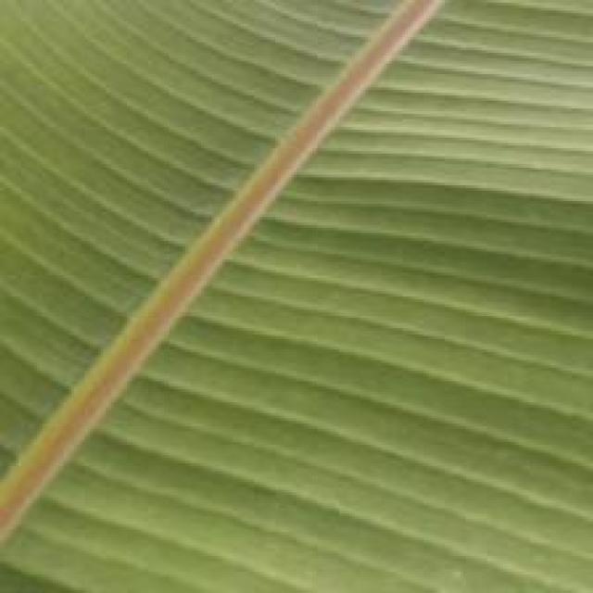
Option 1:
The image shows a leaf with a brown spot on it, which could indicate a disease or infection affecting the plant. The brown spot might be a sign of fungal infection, bacterial infection, or a nutrient deficiency. To address this issue, it is essential to identify the specific cause of the brown spot and take appropriate measures to treat or prevent the disease.
If the brown spot is caused by a fungal infection, it is crucial to remove any infected leaves and apply a fungicide to the plant to prevent the spread of the disease. If it is a bacterial infection, it may require a different treatment approach, such as using a bactericide or applying a copper-based fungicide.
If the brown spot is due to a nutrient deficiency, it is important to address the nutrient imbalance by providing the necessary nutrients through proper soil amendment or supplementation. Regularly monitoring the plant's health and addressing any issues promptly can help maintain the plant's overall health and prevent further damage.
Option 2:
The visible symptoms in the image include discoloration and possibly some damage to the leaf. The leaf appears to be a healthy green color with natural veins, but there are areas where the color has changed to a yellowish hue, which could indicate nutrient deficiency or water stress. Additionally, there might be small holes or punctures on the surface of the leaf, which could suggest pests or diseases affecting the plant.
To address these symptoms, it would be advisable to assess the soil conditions for proper drainage and nutrient levels, as well as check for any signs of pests or diseases that might be causing damage to the leaf. If necessary, apply appropriate fertilizers or pesticides according to the diagnosis. Proper irrigation and monitoring of the plant's health would also be important steps in maintaining its overall health and productivity.

Which answer do you prefer:

Sample 98

Ground Truth: healthy

Option 1:
The image shows a leaf with a brown spot on it, which could be a sign of a disease or infection. The brown spot is located on the green leaf, and it appears to be a small area of discoloration.
There are several possible solutions to address this issue, depending on the type of disease or infection affecting the leaf. If it is a fungal infection, applying a fungicide specifically designed for the type of fungus causing the problem can help prevent the spread of the disease and protect the plant. If it is a bacterial infection, using a bactericide or applying a copper-based solution can help control the bacteria and protect the plant.
It is essential to identify the specific type of disease or infection affecting the leaf to provide the most effective treatment. Regularly inspecting the plant and addressing any signs of disease promptly can help prevent further damage and maintain the health of the plant.
Option 2:
The visible symptoms in the image include a yellowing of the leaves, which could indicate several issues such as nutrient deficiency (especially potassium), water stress, or disease. To address these symptoms, it would be necessary to assess the soil pH and nutrient levels, ensure proper drainage, and possibly apply fertilizers if needed. Additionally, monitoring for any signs of pests or diseases and treating them accordingly would be important steps in maintaining the health of the banana plant.

Which answer do you prefer:

Sample 99

Ground Truth: healthy
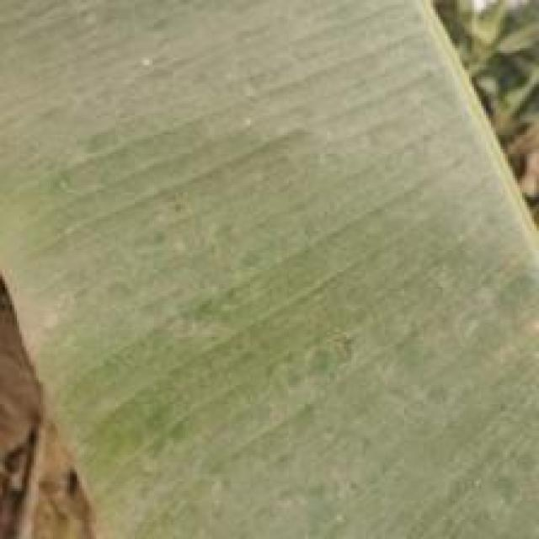
Option 1:
The image shows a leaf with a brown spot, which could be a sign of a disease or infection affecting the plant. The brown spot might be a symptom of a fungal infection, bacterial infection, or a nutrient deficiency. To address this issue, it is essential to identify the cause of the brown spot and take appropriate measures to treat the plant.
If the brown spot is caused by a fungal infection, it is crucial to remove any infected leaves and apply a fungicide to prevent the spread of the disease. If it is a bacterial infection, it may require the application of a bactericide or a change in the plant's care routine, such as improving drainage or watering practices.
If the brown spot is due to a nutrient deficiency, it is necessary to provide the plant with the necessary nutrients through fertilization or soil amendment. Regularly monitoring the plant's health and addressing any issues promptly can help prevent further damage and promote the plant's overall well-being.
Option 2:
The image shows a close-up view of a banana leaf, which appears to be healthy with no obvious signs of disease or damage. However, I can describe some general symptoms that might indicate issues in a banana plant:
1. Discoloration: A yellowing of the leaves could indicate nutrient deficiency, especially if the edges are brown and the veins remain green.
2. Spots or lesions: Dark spots on the leaves can be indicative of fungal infections like black leaf streak or Panama disease.
3. Curling or wilting: Leaves that curl upward and die can be a sign of several issues such as nutrient deficiency, water stress, or pests.
4. Stem lesions: Dark spots on the stem could be an early sign of Panama disease.
5. Flower or fruit damage: Discoloration or wilting of flowers or fruits can indicate a variety of issues like nutrient deficiency, water stress, or pests.
In this image, there are no visible symptoms that would indicate any disease or issue with the banana plant. It appears to be healthy and well-nourished. If there were concerns about the plant's health, a closer examination for signs of pests, diseases, nutrient deficiencies, or water stress would be necessary to diagnose and address any issues.

Which answer do you prefer:

Sample 100

Ground Truth: healthy

Option 1:
The image shows a leaf with brown spots, which could indicate a disease or infection affecting the plant. The brown spots might be a sign of fungal infections, bacterial diseases, or other plant pathogens. To address this issue, it is essential to identify the specific type of disease causing the brown spots and take appropriate measures to treat or prevent it.
For fungal infections, it is crucial to practice good garden hygiene, such as removing infected leaves and pruning affected branches, and ensuring proper spacing between plants to allow for better air circulation. Additionally, using organic mulch and compost can help improve soil health and promote a healthy plant environment.
For bacterial diseases, it is important to practice crop rotation, which involves moving plants to different areas of the garden to prevent the spread of diseases. Regularly inspecting plants for signs of disease and removing infected plants promptly can also help prevent the spread of bacterial infections.
In the case of viral diseases, it is essential to practice crop rotation, remove infected plants, and use resistant varieties when possible. Additionally, using clean, well-draining soil and avoiding overcrowding can help prevent the spread of viral diseases.
In conclusion, identifying the specific disease causing the brown spots on the leaf is crucial to implementing effective treatment or prevention measures. Good garden hygiene, crop rotation, and using resistant varieties can help minimize the impact of diseases on the plant.
Option 2:
The visible symptoms in the image include discoloration and possible spots or lesions on the leaf. These could be indicative of a fungal infection, such as black leaf spot (Mycosphaerella fijiensis), which is common in banana plants. Other possible symptoms might include yellowing of the leaves, wilting, or signs of pests like nematodes or thrips. To address these issues, it would be advisable to consult with a local agricultural extension service or a plant pathologist for an accurate diagnosis and appropriate treatment recommendations.

Which answer do you prefer:

Sample 101

Ground Truth: healthy
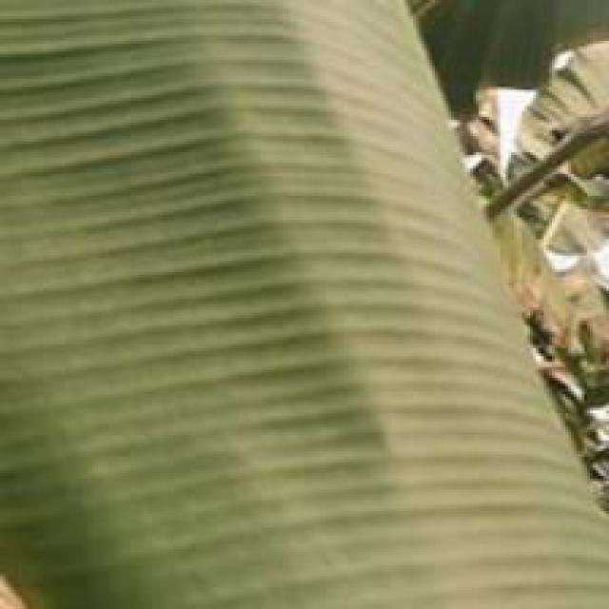
Option 1:
The image shows a leaf with a brown spot on it, which could indicate a disease or infection affecting the plant. The brown spot might be a sign of fungal infection, bacterial infection, or a nutrient deficiency. To address this issue, it is essential to identify the cause of the brown spot and take appropriate measures to treat the plant.
If the brown spot is caused by a fungal infection, it is crucial to remove any infected leaves and apply a fungicide to prevent the spread of the disease. If it is a bacterial infection, it may require the application of a bactericide or a change in the plant's care routine, such as improving drainage or watering practices.
If the brown spot is due to a nutrient deficiency, it is necessary to provide the plant with the necessary nutrients through fertilization or soil amendment. Regularly monitoring the plant's health and addressing any issues promptly can help prevent further damage and promote the plant's overall well-being.
Option 2:
The image shows a close-up view of banana plant leaves, which appear to be healthy and green. There are no visible symptoms of disease or damage on these leaves. If the goal is to ensure the plant remains healthy, it would involve regular monitoring for any signs of pests, diseases, nutrient deficiencies, or environmental stress that could affect the plant's health. Additionally, proper care and maintenance practices should be followed to prevent and address any issues as they arise.

Which answer do you prefer:

Sample 102

Ground Truth: healthy

Option 1:
The image shows a leaf with a yellowish-brown strip running through it, which could indicate a disease or infection. The leaf appears to be affected by a fungal infection, as the yellowish-brown strip is a characteristic symptom of such diseases.
To address this issue, it is essential to identify the specific type of fungal infection affecting the leaf. Once the infection is diagnosed, appropriate measures can be taken to treat the affected plant. These measures may include applying fungicides, pruning infected parts of the plant, and ensuring proper drainage and air circulation to prevent the spread of the infection. Additionally, maintaining a healthy plant by providing adequate nutrients, water, and sunlight can help prevent the development of diseases and promote overall plant health.
Option 2:
Based on the image provided, it appears that the banana plant is affected by a disease or infestation. The most visible symptom is the presence of brown spots on the leaves. These spots can be indicative of several types of diseases or pests, such as bacterial soft rot, Panama disease, or nematode infestations.
To address this issue, a thorough inspection of the plant and its surroundings should be conducted to identify any signs of pests or diseases that may be contributing to the symptoms. If a pest infestation is suspected, appropriate measures such as using pesticides or biological controls can be taken. If it's a disease issue, fungicides may need to be applied depending on the diagnosis.
It's important to note that over-reliance on chemical treatments should be avoided in favor of integrated pest management and organic alternatives whenever possible. Additionally, proper irrigation, fertilization, and sanitation practices can help prevent the spread of diseases and pests.

Which answer do you prefer:

Sample 103

Ground Truth: healthy

Option 1:
The image shows a large green leaf with brown spots, which could indicate a disease or infection affecting the plant. The brown spots might be a sign of fungal infection, bacterial infection, or nutrient deficiency. To identify the specific disease, it would be necessary to examine the leaf more closely and possibly take a sample for further testing.
To address the issue, the following steps can be taken:
1. Remove any infected leaves or parts of the plant to prevent the spread of the disease.
2. Improve the plant's overall health by providing proper nutrients, water, and sunlight.
3. Practice good garden hygiene, such as removing weeds and keeping the area clean, to prevent the spread of diseases.
4. If the disease is identified, consult a local nursery or gardening expert for advice on appropriate treatments or preventive measures.
It is essential to address the issue promptly to prevent further damage to the plant and maintain its health.
Option 2:
The image shows a close-up view of a banana plant's leaf, which appears to be healthy with no visible signs of disease or damage. There are no spots, discoloration, holes, or other abnormalities that would indicate a disease or pest infestation. The veins and ridges on the leaf look normal, and there is no evidence of fungal growth or bacterial infection.
From this image alone, it is not possible to determine if there are any underlying issues that may not be visible from this angle or distance. However, if a problem were to arise later, it would typically present as discoloration, wilting, or signs of pests or diseases on the plant's leaves, stems, or fruits.
To address any potential issues, an agricultural assistant might recommend regular inspections for signs of disease or pest infestations, proper irrigation and fertilization, and monitoring the plant's overall health over time. Additionally, they could provide guidance on proper pruning techniques and other best practices for banana cultivation.

Which answer do you prefer:

Sample 104

Ground Truth: healthy
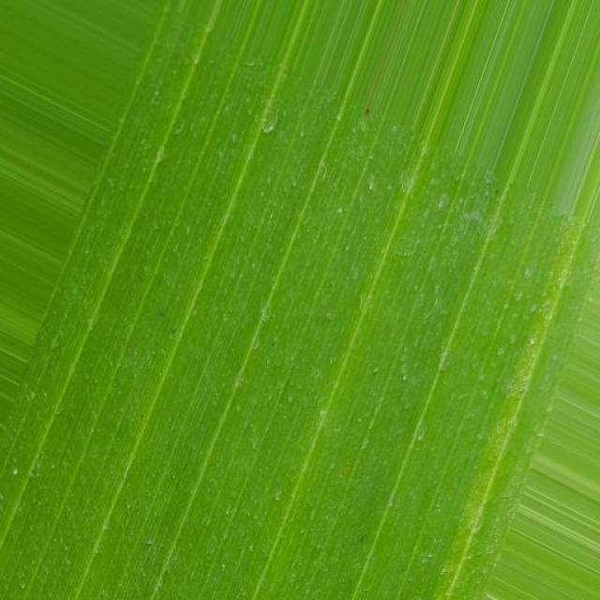
Option 1:
The image shows a leaf with a brown spot on it, which could indicate a disease or infection affecting the plant. The brown spot might be a sign of fungal infection, bacterial infection, or a nutrient deficiency. To address this issue, it is essential to identify the cause of the brown spot and take appropriate measures to treat the plant.
If the brown spot is caused by a fungal infection, it is crucial to remove any infected leaves and apply a fungicide to prevent the spread of the disease. If it is a bacterial infection, it may require the application of a bactericide or a change in the plant's care routine, such as improving drainage or watering practices.
If the brown spot is due to a nutrient deficiency, it is necessary to provide the plant with the necessary nutrients through fertilization or soil amendment. Regularly monitoring the plant's health and addressing any issues promptly can help prevent further damage and promote the plant's overall well-being.
Option 2:
The visible symptom in the image is a single, yellowish leaf with several small brown spots scattered across it. This could indicate a few different issues such as nutrient deficiency (particularly potassium), a fungal infection, or bacterial disease. To address this issue, it would be necessary to perform diagnostic testing on the soil and leaves to determine the exact cause of the symptoms. If it is found that the plant is deficient in potassium, then applying potassium fertilizer could help. If it's a fungal infection, appropriate fungicides could be used. If bacterial disease is suspected, then treatment with antibiotics may be necessary. It's important to consult with a local agricultural extension service or a plant pathologist for specific recommendations based on the location and conditions of the plant.

Which answer do you prefer:

Sample 105

Ground Truth: healthy

Option 1:
The image shows a close-up of a green leaf with a yellowish tint, which could indicate a disease or infection affecting the plant. The yellowing of the leaf might be a sign of a bacterial or fungal infection, or it could be a result of nutrient deficiencies or excessive nutrient levels.
To identify the specific disease or infection, a closer examination of the leaf and any accompanying symptoms would be necessary. If the yellowing is due to a bacterial infection, a suitable antibiotic treatment might be required. If it is a fungal infection, a fungicide treatment could be applied to the plant.
In cases of nutrient deficiencies, it is essential to provide the plant with the necessary nutrients through proper soil amendment or supplementation. Excessive nutrient levels can also cause yellowing, so it is crucial to monitor the plant's growth and adjust the nutrient levels accordingly.
In any case, it is essential to identify the cause of the yellowing and take appropriate action to address the issue and prevent further damage to the plant.
Option 2:
Based on the image provided, it appears that the leaves of the banana plant are exhibiting a healthy green color with some natural curvature and vein patterns. There are no obvious signs of disease or pests such as discoloration, spots, holes, or infestations visible in this image.
From what is visible, it seems that the plant is well-nourished and free from immediate visible issues that would require intervention. If there were any concerns about the health of the plant, they would likely need to be assessed by an agricultural expert who could examine the plant up close for signs of disease or pests not visible in this image.
It's important to note that a single image may not provide a complete picture of the plant's overall health and may only show a snapshot of its condition at that moment. Regular monitoring and consultation with an expert would be necessary to ensure the best care for the banana plant.

Which answer do you prefer:

Sample 106

Ground Truth: healthy
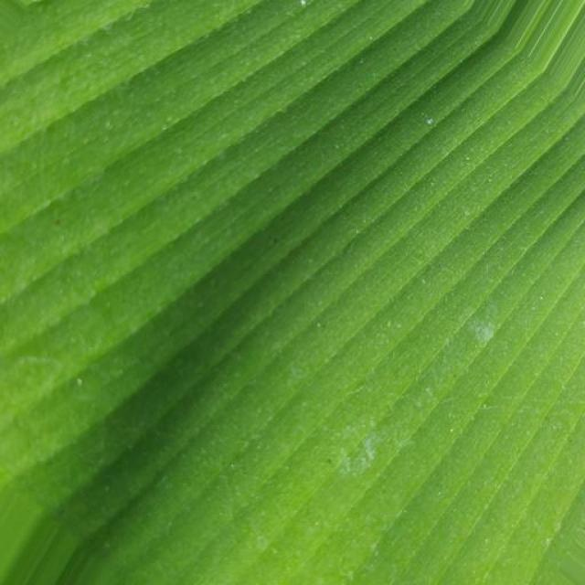
Option 1:
The image shows a large green leaf with a brown spot on it. This brown spot could be a sign of a disease affecting the leaf. The presence of the brown spot indicates that the leaf might be experiencing some form of damage or infection.
To identify the specific disease or infection, a closer examination of the leaf and the surrounding area would be necessary. Possible solutions to address the issue could include:
1. Removing the affected leaf or part of the plant to prevent the spread of the disease.
2. Applying a suitable fungicide or pesticide to treat the infection and prevent further damage.
3. Ensuring proper care and maintenance of the plant, such as regular watering, sunlight exposure, and pest control, to prevent the development of diseases or infections.
It is essential to consult with a plant expert or a local nursery to determine the best course of action for treating the affected plant and preventing further damage.
Option 2:
The visible symptoms in the image include yellowing of the leaves, which could indicate a nutrient deficiency or a disease affecting the plant's ability to photosynthesize. Possible solutions might include testing soil pH levels, ensuring proper drainage, and applying appropriate fertilizers if necessary. It's also important to monitor for any signs of pests or diseases that could be causing the yellowing.

Which answer do you prefer:

Sample 107

Ground Truth: healthy

Option 1:
The image shows a close-up of a green leaf with a brown spot on it. This brown spot could be a sign of a disease or infection affecting the leaf. Possible solutions to address this issue include:
1. Identifying the cause of the brown spot: It could be a fungal infection, bacterial infection, or a nutrient deficiency.
2. Applying appropriate treatment: Depending on the cause, the appropriate treatment can be applied. For fungal infections, using fungicides or applying a preventative spray can help. For bacterial infections, using antibiotics or applying a bactericide can be effective. For nutrient deficiencies, providing the necessary nutrients through fertilizers or soil amendments can help the plant recover.
3. Monitoring the plant's health: Regularly inspecting the plant for any signs of disease or infection and taking appropriate action can help prevent the spread of the problem and maintain the plant's overall health.
It is essential to consult with a plant expert or a local nursery for specific advice on the best course of action for the particular plant and the cause of the brown spot.
Option 2:
The image shows a close-up view of a banana leaf, which appears to be healthy and green. There are no visible symptoms of disease or damage on this leaf. If the goal is to maintain the health of the plant, it would involve providing adequate water, sunlight, and nutrients, as well as protecting it from pests and diseases that could affect its growth.

Which answer do you prefer:

Sample 108

Ground Truth: healthy

Option 1:
The image shows a close-up of a leaf with a brown spot on it. This brown spot could be a sign of a disease or infection affecting the leaf. Possible solutions to address this issue include:
1. Identifying the type of disease: It is essential to determine the specific disease causing the brown spot. This can be done by consulting a plant pathologist or an expert in plant diseases.
2. Appropriate treatment: Depending on the disease, a suitable treatment method should be applied. This may involve using fungicides, bactericides, or other chemical treatments, as well as cultural practices like pruning, removing infected leaves, and improving soil quality.
3. Prevention: To prevent the disease from spreading, it is crucial to maintain proper hygiene and sanitation practices, such as regular pruning, removing dead or infected leaves, and ensuring proper drainage and air circulation around the plant.
4. Monitoring: Regularly inspecting the plant for any signs of disease or infection can help in early detection and treatment, ensuring the health and longevity of the plant.
Option 2:
The image shows a close-up view of a banana plant leaf. From the visible symptoms, it appears to be healthy with no signs of disease or damage. The color is vibrant green, indicating proper nutrition and growth conditions. There are no spots, discolorations, holes, or other abnormalities that would suggest a disease or pest issue.
If the goal is to maintain the health of this plant, it would require regular care such as proper watering, fertilization if needed, and protection from environmental stresses like excessive heat or cold. Additionally, monitoring for any changes in the leaves' color, texture, or appearance could help detect early signs of disease or nutrient deficiency.

Which answer do you prefer:

Sample 109

Ground Truth: healthy
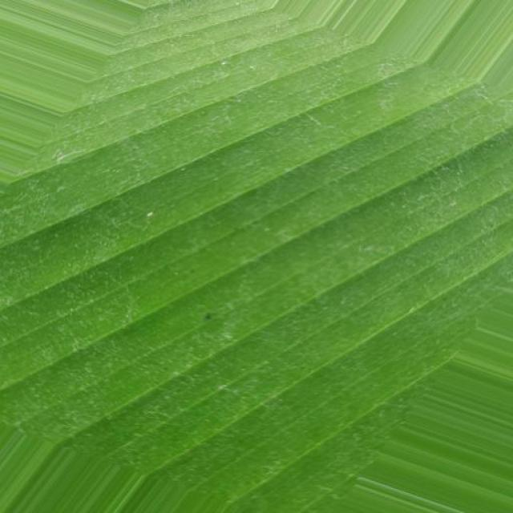
Option 1:
The image shows a close-up of a leaf with a brown spot on it. This brown spot could be a sign of a disease or infection affecting the leaf. Possible solutions to address this issue include:
1. Identifying the cause of the brown spot: It is essential to determine whether the brown spot is caused by a fungal infection, bacterial infection, or a nutrient deficiency. This information will help in choosing the appropriate treatment method.
2. Treating the affected area: Depending on the cause of the brown spot, the appropriate treatment method should be applied. For fungal infections, fungicides can be used to prevent the spread of the disease. For bacterial infections, antibiotics may be necessary. In cases of nutrient deficiencies, providing the necessary nutrients through fertilizers or supplements can help improve the plant's health.
3. Preventing further damage: Once the cause of the brown spot has been identified and treated, it is crucial to take preventive measures to avoid further damage. This may include regular monitoring of the plant's health, proper watering, and maintaining a clean and healthy growing environment.
4. Pest control: If the brown spot is caused by pests, it is essential to identify and treat the pests to prevent further damage to the plant. This may involve using pesticides or other control methods to manage the pest population.
By following these steps, the brown spot on the leaf can be addressed, and the plant's health can be improved.
Option 2:
The image shows a close-up view of several green leaves, which appear to be part of a banana plant. From this perspective, it's difficult to definitively diagnose any diseases or health issues without additional context such as the overall appearance of the plant, the color and texture of the leaves, and any visible signs of pests or fungal growth.
However, I can provide some general observations that might indicate a healthy banana plant:
- The leaves should be vibrant green with no significant discoloration or spots.
- There should be no significant holes, tears, or damage to the leaf edges.
- The veins of the leaves should be clearly visible and not obstructed by any debris or fungal growth.
- The overall plant appearance should be robust and not show signs of wilting or yellowing.
If there are specific symptoms you're concerned about, please provide more details or a different angle of the image for a more accurate assessment.

Which answer do you prefer:

Sample 110

Ground Truth: healthy
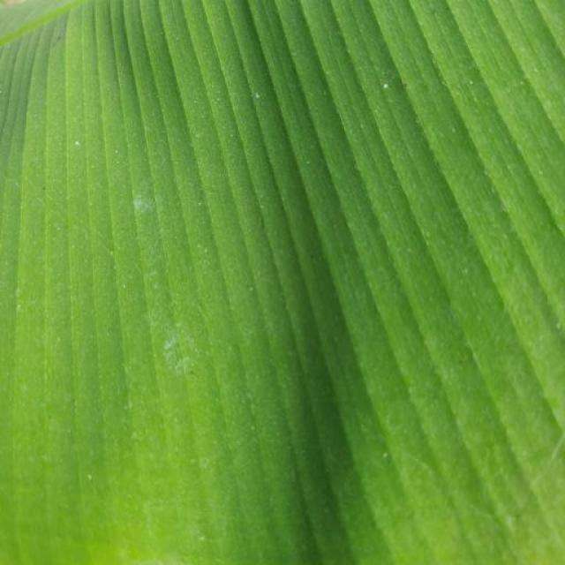
Option 1:
The image shows a banana leaf with brown spots and a yellowish-green color, indicating that it is affected by a disease. The brown spots suggest that the banana leaf is infected with a fungal disease, which can cause the leaf to turn brown and eventually die.
To address this issue, it is essential to identify the specific type of fungal disease affecting the banana plant and take appropriate measures to prevent its spread. This may include removing infected leaves, practicing good hygiene by washing hands and tools before handling healthy plants, and using organic or chemical fungicides to control the disease. Additionally, it is crucial to maintain proper plant care, such as providing adequate sunlight, water, and nutrients, to promote healthy growth and reduce the risk of disease.
Option 2:
The visible symptoms in the image include discoloration, browning, and possible wilting or drooping of the leaves. These could be indicative of a number of issues such as nutrient deficiency, water stress, pests or diseases. To address these issues, it would be necessary to assess the soil conditions, moisture levels, and the presence of any pests or diseases through further inspection and possibly laboratory testing. Proper care and maintenance practices should also be followed to prevent future issues.

Which answer do you prefer:

Sample 111

Ground Truth: cordana
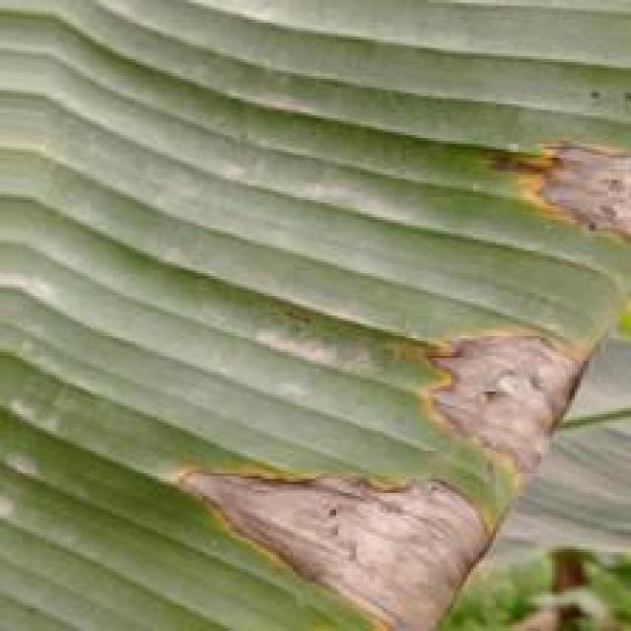
Option 1:
The image shows a leaf with a brown spot, which could be a sign of a fungal infection or a bacterial disease. The brown spot is surrounded by green leaves, indicating that the plant is still healthy in other areas.
To address this issue, it is essential to identify the specific type of disease causing the brown spot. Once the disease is diagnosed, the appropriate treatment or prevention measures can be taken. For fungal infections, it is crucial to remove infected leaves and maintain proper plant hygiene. For bacterial diseases, it is important to practice good gardening practices, such as regular pruning, proper watering, and ensuring adequate sunlight and nutrient availability. Additionally, using organic or chemical-free fertilizers and pest control methods can help prevent the spread of diseases and promote overall plant health.
Option 2:
The visible symptoms in the image include yellowing leaves with brown spots, which are indicative of a disease known as Panama disease or Fusarium wilt (Fusarium oxysporum f. sp. cubense). This is a serious banana disease that affects the plant's vascular system and can lead to significant yield loss.
The possible solution for this disease includes:
- Implementing good agricultural practices such as proper drainage, avoiding overcrowding of plants, and maintaining a clean environment to prevent the spread of the disease.
- Using resistant varieties of bananas if available in the region.
- Implementing fungicide treatments when necessary, but it's important to follow label instructions and use only registered products recommended for use in the area.
- Removing and destroying infected plants promptly to prevent further spread of the disease.

Which answer do you prefer:

Sample 112

Ground Truth: cordana
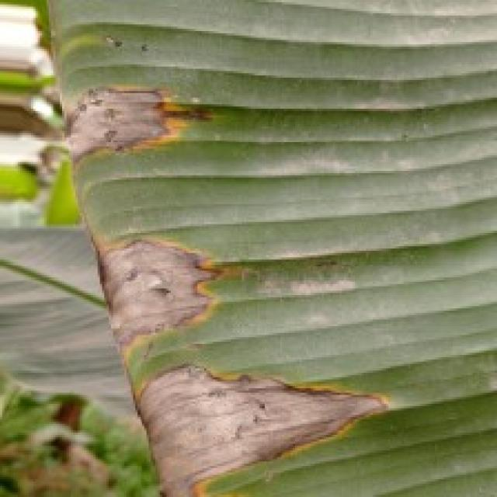
Option 1:
The image shows a leaf with a brown spot, which could be a sign of a fungal infection or a bacterial disease. The brown spot is surrounded by green leaves, indicating that the affected area is still healthy. To address this issue, it is essential to identify the specific type of disease causing the brown spot. If it is a fungal infection, applying a fungicide specifically designed for that type of disease can help prevent its spread and promote the healthy growth of the plant. If it is a bacterial disease, treating the plant with a suitable bactericide can help control the infection and protect the plant from further damage. Regularly inspecting the plant and addressing any signs of disease promptly can help maintain the overall health and appearance of the plant.
Option 2:
The visible symptoms in the image include a large, irregularly shaped lesion with a yellowish-brown discoloration on the leaf of the banana plant. This lesion appears to be rotting and has a distinct border, which is characteristic of the disease known as Panama disease or Fusarium wilt (also referred to as Panama disease tropical race 4, TR4), caused by the fungus Fusarium oxysporum f. sp. cubense.
The visible symptoms include:
- A large, irregularly shaped lesion with a yellowish-brown discoloration on the leaf.
- The lesion appears to be rotting and has a distinct border.
- The affected area may have a dry, brittle texture compared to healthy tissue.
The possible solution for this disease includes:
- Implementing proper crop management practices such as selecting resistant varieties, maintaining good drainage, and avoiding overcrowding in planting.
- Regularly monitoring plants for signs of disease and promptly removing affected plants to prevent further spread.
- Using fungicides when necessary, but it's important to follow recommended guidelines for their use in agriculture.

Which answer do you prefer:

Sample 113

Ground Truth: cordana
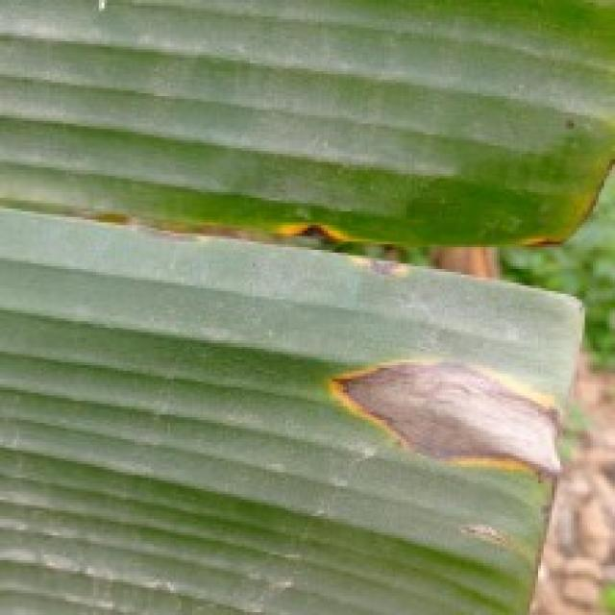
Option 1:
The image shows a leaf with a brown, yellow, and green coloration, which indicates that it is affected by a disease. The leaf appears to be infected with a fungal infection, as evidenced by the brown spots and the yellowing of the leaf.
To address this issue, it is essential to identify the specific type of fungal infection and take appropriate measures to prevent its spread. This may involve removing infected leaves and branches, ensuring proper air circulation, and maintaining a healthy plant by providing adequate nutrients and water. Additionally, using organic or chemical fungicides can help protect the plant from further infections. It is also important to practice good gardening practices, such as regular pruning and removing dead or damaged plant parts, to prevent the spread of fungal diseases.
Option 2:
The visible symptoms in the image include discoloration and browning of the leaf edges, which are indicative of a disease known as "Cordana" affecting banana plants. This disease is caused by a fungus that infects the leaves, causing them to turn yellow and eventually die.
A possible solution for this issue would be to remove affected leaves promptly to prevent further spread of the disease. Additionally, applying fungicides specifically designed for banana plants can help control the growth of the fungus and prevent the disease from spreading to other parts of the plant. It's also important to maintain proper drainage and avoid overcrowding in planting areas to reduce the risk of infection.

Which answer do you prefer:

Sample 114

Ground Truth: cordana
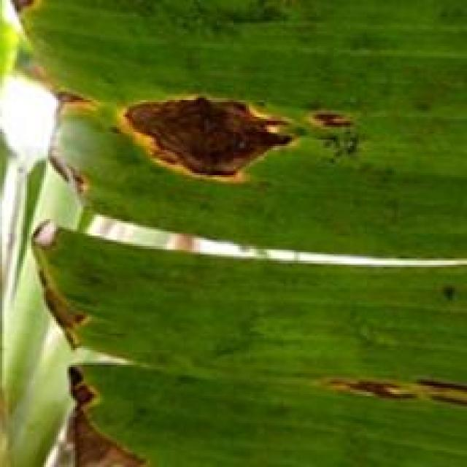
Option 1:
The image shows a tree branch with a brown, yellow, and green coloration, which indicates that the tree is suffering from a disease. The disease appears to be affecting the tree's bark, causing it to peel and turn brown. This could be a sign of bacterial or fungal infections, which can be caused by various factors such as overwatering, nutrient imbalances, or pests.
To address this issue, it is essential to identify the specific cause of the disease and take appropriate measures to treat it. This may involve pruning the affected branches, applying fungicides or bactericides to the tree, or adjusting the tree's watering and nutrient regimen. Additionally, regular monitoring of the tree's health and early detection of any signs of disease can help prevent further damage and promote the tree's overall well-being.
Option 2:
The visible symptoms in the image include discoloration and damage to the leaves of the banana plant. There are yellowish-brown spots on the leaf edges, which could indicate a fungal or bacterial infection. These spots may be indicative of a disease called "Cordana," which is a common name for several types of fungi that can affect banana plants.
To address this issue, it would be advisable to consult with a plant pathologist or an agricultural expert to determine the exact cause of the damage and recommend appropriate treatments or preventive measures. These may include fungicidal sprays, pruning infected leaves, and maintaining proper drainage and sanitation around the plant to prevent further spread of the disease.

Which answer do you prefer:

Sample 115

Ground Truth: cordana
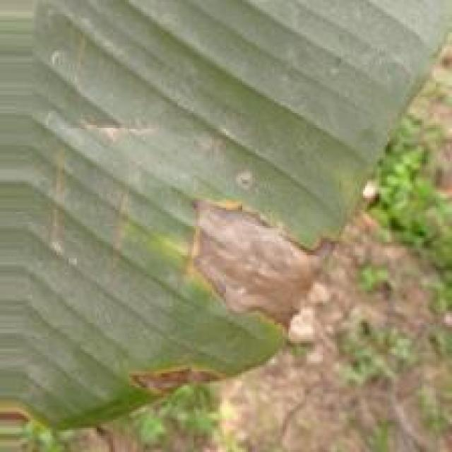
Option 1:
The image shows a banana leaf with brown spots and yellow patches, indicating that it is affected by a disease. The brown spots and yellow patches suggest that the banana plant is experiencing a fungal infection, which can be caused by various factors such as overwatering, nutrient deficiencies, or poor soil quality.
To address this issue, it is essential to identify the specific cause of the disease and take appropriate measures to prevent its spread and promote the health of the plant. Some possible solutions include:
1. Improving soil quality: Ensuring that the soil is well-draining, rich in organic matter, and has the right balance of nutrients can help prevent the growth of harmful fungi.
2. Regular watering: Ensuring that the plant receives adequate water without overwatering can help prevent root rot and other fungal infections.
3. Pest and disease control: Regularly inspecting the plant for signs of pests or diseases and using appropriate pest control methods, such as organic or chemical treatments, can help prevent the spread of the disease.
4. Proper spacing: Ensuring that the banana plant is spaced appropriately can help prevent the overcrowding of the plant, which can lead to the growth of harmful fungi.
By addressing the underlying cause of the disease and implementing these preventive measures, the banana plant can recover and grow healthy, producing high-quality bananas.
Option 2:
The visible symptoms in the image include yellowing and browning of the leaves, which are characteristic signs of Panama disease (also known as Fusarium wilt or Panama disease) affecting banana plants. This disease is caused by a fungus called Fusarium oxysporum f. sp. cubense.
The visible symptoms include:
1. Yellowing and browning of the leaves, which are the most common signs of Panama disease in banana plants.
2. Discoloration of the vascular tissue within the plant's stem, which can be seen as a dark discoloration or blackening of the tissue.
3. Withering and wilting of the leaves, which is a result of the fungus blocking the water transport system within the plant.
The possible solution for this disease includes:
1. Proper crop management practices such as selecting healthy suckers from infected plants for planting.
2. Implementing good drainage and water management to prevent the spread of the fungus.
3. Regularly monitoring the health of banana plants for early detection of Panama disease.
4. Using resistant varieties of bananas if available in the region where the disease is prevalent.
5. Implementing fungicidal treatments when necessary, although these should be used with caution as they can have negative effects on the environment and the plant itself.

Which answer do you prefer:

Sample 116

Ground Truth: cordana
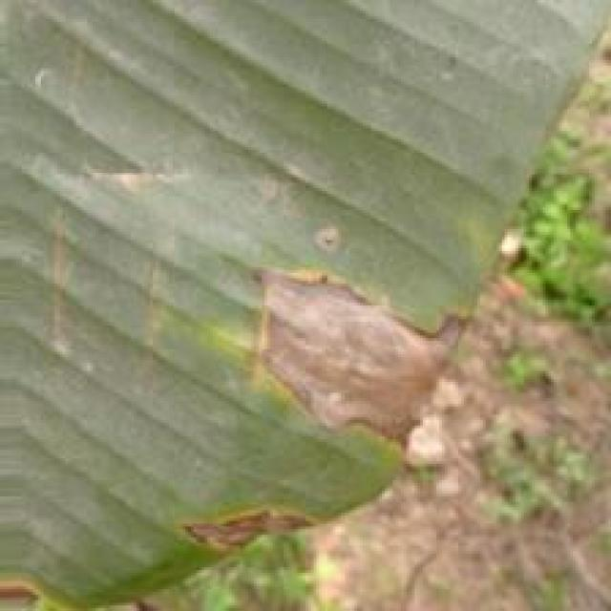
Option 1:
The image shows a leaf with brown spots and yellowish-brown areas, which indicates that the leaf is affected by a fungal disease. The disease appears to be spreading, as the spots are growing larger and more numerous.
The visible symptoms of the disease include brown spots and yellowish-brown areas on the leaf, which are caused by the fungus invading the plant's tissues. The fungus can cause the leaf to become weak and eventually die, which can negatively impact the overall health of the plant.
A possible solution to this problem is to practice good gardening practices, such as regular pruning, removing infected leaves, and ensuring proper drainage and air circulation around the plant. Additionally, using organic or fungicidal treatments can help prevent the spread of the disease and protect the plant from further damage. It is essential to identify the specific type of fungus causing the disease and use appropriate treatments to manage it effectively.
Option 2:
The visible symptoms in the image include brown spots and discoloration on the leaves of the banana plant. These are indicative of a disease known as Panama Disease, also known as Fusarium Wilt or Panama Root Rot, which affects bananas and other plants.
The possible solution for this disease would involve preventive measures such as proper drainage, avoiding overcrowding in planting, and using resistant varieties of banana plants. Additionally, if the disease has already been detected, it is important to remove infected plants promptly to prevent further spreading. Fungicides may also be used in some cases, but it's crucial to follow recommended guidelines for their use and follow up with appropriate measures to prevent resistance development.

Which answer do you prefer:

Sample 117

Ground Truth: cordana
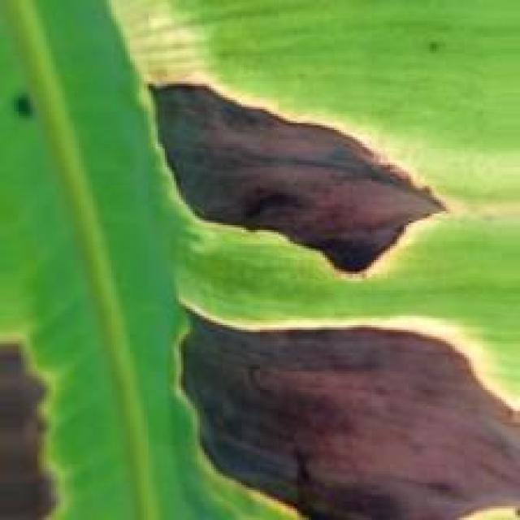
Option 1:
The image shows a leaf with a brown spot, which could be a sign of a fungal infection or a bacterial disease. The leaf appears to be affected by a disease, possibly a fungal infection, as the brown spot is spreading across the leaf.
To address this issue, it is essential to identify the specific type of disease causing the brown spot. Once the disease is identified, appropriate measures can be taken to prevent its spread and manage the affected plant. These measures may include removing infected leaves, applying fungicides or bactericides, and ensuring proper care and maintenance of the plant. It is also important to practice good gardening practices, such as regular pruning, proper watering, and providing adequate sunlight, to promote healthy plant growth and reduce the risk of diseases.
Option 2:
The image shows a banana leaf with several visible symptoms that could be indicative of a disease affecting the plant. Specifically, the symptoms include:
1. Discoloration: There are areas where the color of the leaf has changed from green to yellow or brown, which can be an early sign of disease or nutrient deficiency.
2. Spots and lesions: There are spots and lesions on the leaf that could be indicative of a fungal infection, bacterial disease, or other pathogens.
3. Curling edges: The edges of the leaf appear to be curling upwards, which might suggest water stress or nutrient deficiency.
4. Missing tissue: There is a noticeable area where the tissue of the leaf has been removed, leaving behind a hollowed-out section. This could be due to insect feeding, bacterial infection, or other pathogens.
To address these symptoms, it would be necessary to perform a thorough inspection of the plant and its environment for signs of pests, diseases, or nutrient deficiencies. If any issues are identified, appropriate treatments can be applied, such as fungicides for fungal infections, pesticides for insect infestations, or fertilizers to address nutrient deficiencies. It's also important to maintain proper plant hygiene and monitor the health of the plant regularly to prevent further damage.

Which answer do you prefer:

Sample 118

Ground Truth: cordana
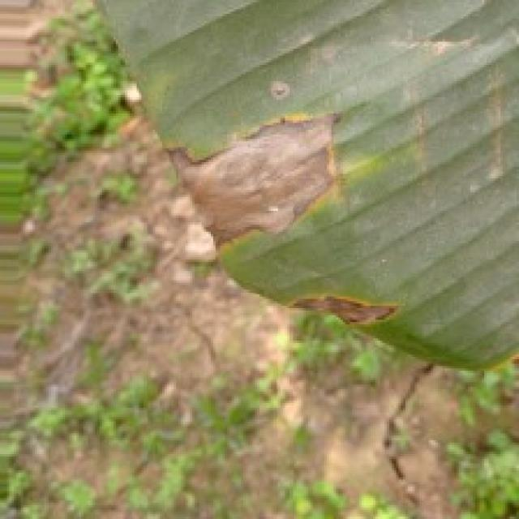
Option 1:
The image shows a leaf with a brown spot, which appears to be a fungal infection. The leaf is green and has a yellowish-brown spot on it. This type of infection is commonly caused by fungi, such as the fungus Rhizoctonia solani, which can affect various plants, including bananas.
The visible symptoms of the infection include the brown spot on the leaf, which is a sign of the fungus's growth and spread. The infection can lead to the decay of the leaf and, in severe cases, the death of the plant.
To prevent or manage this infection, it is essential to practice proper plant care, such as regular pruning, removing infected leaves, and ensuring proper drainage and air circulation around the plant. Additionally, using organic or chemical fungicides can help control the spread of the fungus and protect the plant from further damage. It is also important to maintain a healthy plant by providing adequate nutrients, water, and sunlight.
Option 2:
The visible symptoms in the image include yellowing leaves with brown spots, which are indicative of a disease known as Panama disease or Fusarium wilt (Fusarium oxysporum f. sp. cubense), commonly referred to as "Cordana" in banana plants. This is a serious fungal disease that affects bananas and other plants in the Musa genus.
The visible symptoms include:
- Yellowing of leaves, which is an early sign of the disease.
- Brown spots on the leaves, which can enlarge and coalesce to form large necrotic areas.
- Wilting or death of affected parts of the plant.
The possible solution for this disease includes:
- Proper identification by a plant pathologist to confirm the presence of the disease.
- Implementing preventive measures such as using resistant varieties, maintaining good drainage, and avoiding overcrowding in planting.
- Applying fungicides when necessary, but it's important to follow recommended guidelines for their use in agriculture.
- Removing and destroying infected plants to prevent further spread of the disease.

Which answer do you prefer:

Sample 119

Ground Truth: cordana
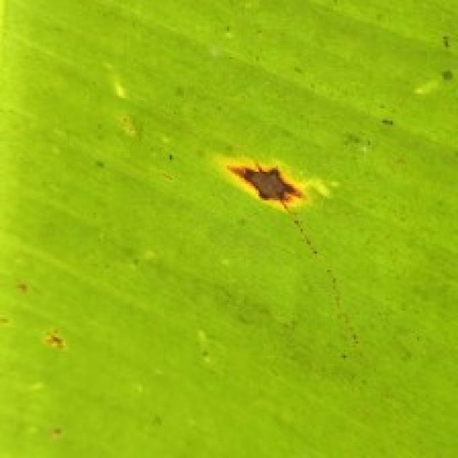
Option 1:
The image shows a banana tree with yellow and brown spots on its leaves, which indicates that the tree is suffering from a disease called Panama disease. This disease is caused by the fungus Fusarium oxysporum f. sp. cubense, which affects the tree's vascular system, causing it to wilt and die.
The visible symptoms of Panama disease include yellowing and browning of the leaves, wilting of the tree, and a general decline in the tree's health. The disease can spread rapidly and is difficult to control once it has taken hold.
A possible solution to prevent the spread of Panama disease is to practice good agricultural practices, such as regular pruning, proper irrigation, and maintaining a healthy soil environment. Additionally, using resistant varieties of banana trees can help reduce the risk of infection. It is also essential to monitor the health of the tree and seek professional help if the disease is detected early on.
Option 2:
The visible symptoms in the image include discoloration and spots on the leaves of the banana plant. These are indicative of a disease called "black leaf streak" or "black sigatoka," which is caused by the fungus Mycosphaerella fijiensis.
The possible solution for this disease would involve:
1. Proper identification of the disease by an expert in plant pathology.
2. Implementing good agricultural practices such as regular inspection of plants for early detection of symptoms, removal and destruction of infected leaves, and maintaining proper drainage to prevent waterlogging which can exacerbate the problem.
3. Using fungicides that are registered for use in bananas and following all label instructions carefully. It's important to rotate fungicides to prevent resistance development.
4. Improving plant nutrition with appropriate fertilizers to boost the plant's immune system.
5. Maintaining proper sanitation around the growing area to minimize the spread of the disease.

Which answer do you prefer:

Sample 120

Ground Truth: cordana
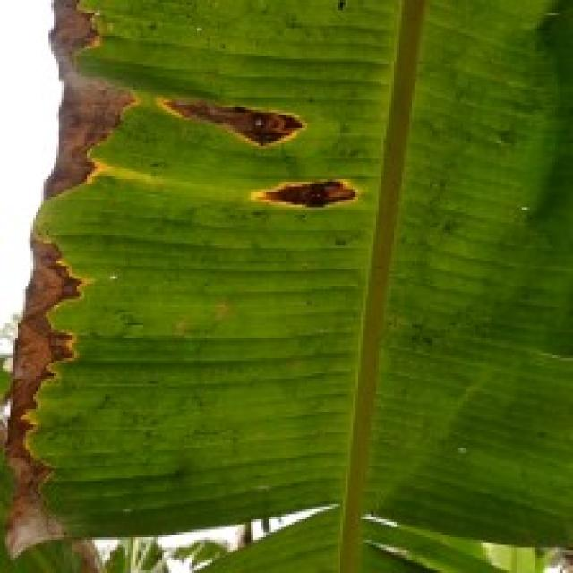
Option 1:
The image shows a leaf with a yellowish-brown spot, which appears to be a fungal infection. The leaf is affected by a disease called "leaf spot," which is caused by fungi that thrive in damp and warm conditions. The visible symptoms include the yellowish-brown spots on the leaf, which are the result of the fungal growth.
To solve this issue, it is essential to maintain proper plant care, including regular watering, ensuring adequate sunlight, and proper spacing between plants to allow for better air circulation. Additionally, it is crucial to remove any infected leaves and avoid overcrowding the plant to prevent the spread of the disease. If the infection is severe, it may be necessary to consult a professional to identify the specific fungus and provide appropriate treatment options.
Option 2:
The visible symptoms in the image include yellowing and discoloration of the banana leaves, which are indicative of a disease known as Panama Disease or Fusarium Wilt (FW), caused by the fungus Fusarium oxysporum f. sp. cubense (Foc). This disease affects bananas and other plants in the Musa genus.
The affected leaves show signs of wilting, browning, and necrosis, which are characteristic of Fusarium Wilt. The yellowing is due to chlorosis caused by the fungus, which blocks the transportation of water and nutrients within the plant.
A possible solution for this disease would involve preventive measures such as using resistant varieties of banana plants, maintaining proper drainage in the soil, avoiding overcrowding in planting, and ensuring adequate fertilization. Additionally, fungicides can be applied to control the spread of the disease, but it's important to follow recommended guidelines for their use in agriculture to minimize any potential harm to the environment or other plants.

Which answer do you prefer:

Sample 121

Ground Truth: cordana
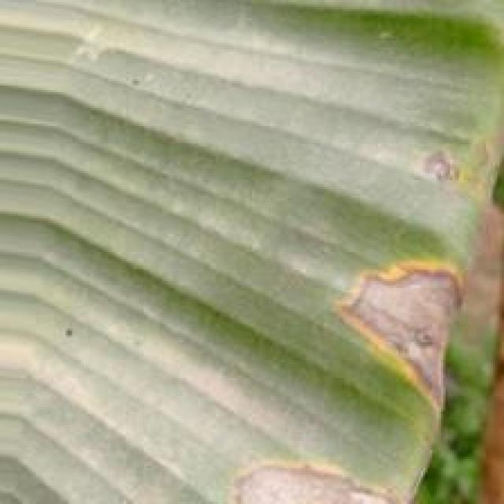
Option 1:
The image shows a leaf with a yellowish-brown color, which indicates that it might be affected by a fungal disease. The leaf appears to be infected with a fungus, causing the discoloration and possibly other visible symptoms such as spots or lesions.
To address this issue, it is essential to identify the specific type of fungus causing the infection and apply appropriate treatment methods. This may involve using fungicides, pruning infected parts of the plant, or ensuring proper drainage and air circulation to prevent the spread of the fungus. Additionally, maintaining a healthy plant by providing adequate nutrients, water, and sunlight can help prevent the development of fungal diseases.
Option 2:
The visible symptoms in the image include discoloration and lesions on the leaves of the banana plant. These are indicative of a disease known as Panama Disease, also known as Fusarium Wilt or Panama Wilt, which is caused by the fungus Fusarium oxysporum f. sp. cubense (Foc).
The visible symptoms include:
- Discoloration: The leaves may show yellowing, browning, or blackening, especially around the edges and along the veins.
- Lesions: There may be small, dark spots on the leaves that can enlarge and become larger, irregularly shaped lesions with a velvety texture.
- Wilting: The plant may show signs of wilting or drooping, especially if the disease progresses to the stem.
The possible solution for this disease includes:
- Proper identification by an expert in plant pathology to confirm the diagnosis.
- Implementing a program of sanitation and crop rotation to reduce the risk of further spread.
- Using resistant varieties if available.
- Applying fungicides, although this should be done with caution as some chemicals can be harmful to the environment and the plant itself.
- Removing infected plants promptly to prevent the spread of the disease.

Which answer do you prefer:

Sample 122

Ground Truth: cordana
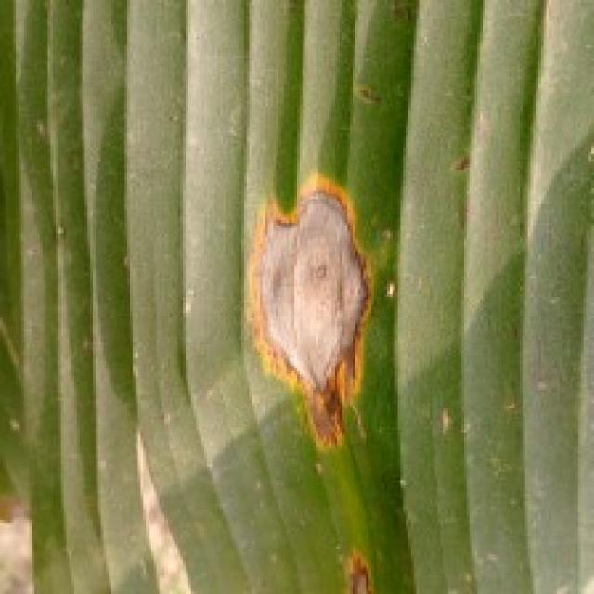
Option 1:
The image shows a leaf with brown spots and a yellowish-green color, which indicates that it might be affected by a fungal disease. The brown spots are a visible symptom of the disease, and the yellowish-green color could be due to the fungus's growth.
A possible solution to this issue is to practice good gardening practices, such as regular pruning, removing infected leaves, and ensuring proper drainage to prevent the growth of fungi. Additionally, using organic or fungicidal treatments can help control the spread of the disease and protect the plant from further damage. It is essential to identify the specific type of fungus causing the issue and use appropriate treatments to address the problem effectively.
Option 2:
The visible symptoms in the image include discoloration and lesions on the leaves of the banana plant. These could be indicative of a disease called "Cordana," which is a fungal infection that affects bananas. The affected areas appear to have a reddish-brown color with yellowing between the veins, which is characteristic of this type of disease.
To address this issue, it would be advisable to remove and destroy infected leaves promptly to prevent further spread of the fungus. Additionally, applying fungicides specifically designed for banana plants can help control the disease. It's also important to maintain good plant hygiene by avoiding waterlogging, pruning regularly, and ensuring proper drainage in the growing medium.

Which answer do you prefer:

Sample 123

Ground Truth: cordana
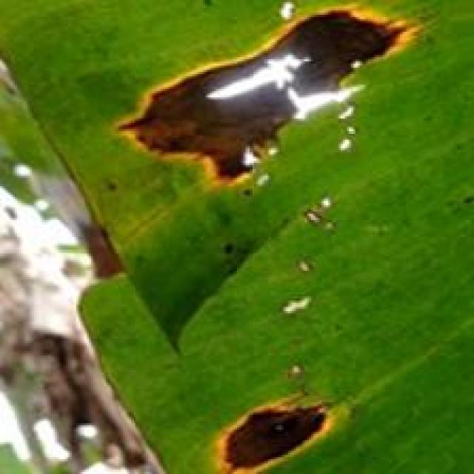
Option 1:
The image shows a leaf with a brown spot, which appears to be a fungal infection. The brown spot is surrounded by green leaves, indicating that the infection is localized. The presence of the fungus on the leaf suggests that the plant may be affected by a fungal disease, such as powdery mildew or leaf spot.
To address this issue, it is essential to identify the specific type of fungal infection and take appropriate measures to prevent its spread. This may involve removing infected leaves, ensuring proper air circulation around the plant, and using organic or chemical fungicides to control the growth of the fungus. Additionally, regular maintenance of the plant, such as pruning and watering, can help prevent the development of fungal infections in the future.
Option 2:
The visible symptoms in the image include a yellowish discoloration and a rotting appearance on the leaf of the banana plant. This could be indicative of a disease known as Panama Disease or Fusarium Wilt, which is caused by the fungus Fusarium oxysporum f. sp. cubense (Foc).
The possible solution for this disease would involve proper crop management practices such as:
1. Proper drainage to prevent waterlogging that can exacerbate the disease.
2. Regular monitoring of plants for early signs of infection and prompt removal of affected plants to prevent further spread.
3. Use of resistant varieties if available.
4. Implementing good sanitation practices to minimize the risk of soil-borne pathogens entering the crop.
5. Proper irrigation management to avoid waterlogging.
6. Fungicides may be used in some cases, but it's important to follow all label recommendations and use them only as directed by a qualified professional.
7. Rotation of crops with other plants that are less susceptible to the disease.

Which answer do you prefer:

Sample 124

Ground Truth: cordana
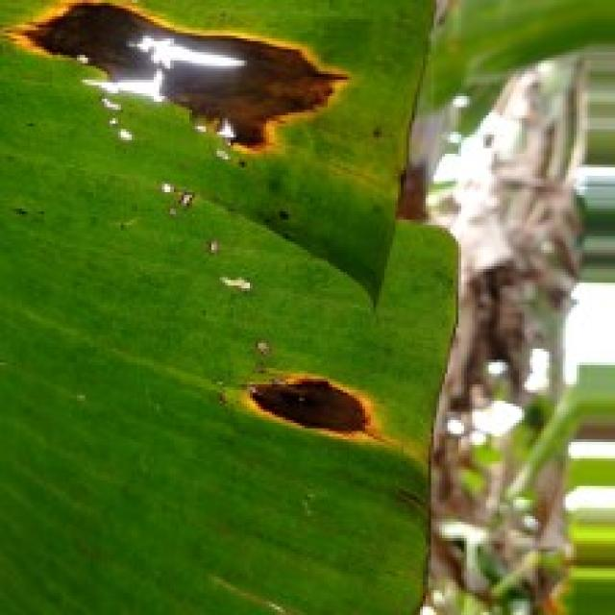
Option 1:
The image shows a leaf with a yellowish-brown color, which indicates that it is affected by a fungal disease. The disease appears to be spreading across the leaf, causing it to become discolored and possibly damaged.
The visible symptoms of the disease include the yellowish-brown coloration and the spreading pattern of the fungus. The affected leaf may also show signs of decay or weakening, which could lead to further damage or even the death of the plant.
To address this issue, it is essential to identify the specific type of fungal disease affecting the plant and take appropriate measures to prevent its spread and manage the damage. This may include removing infected leaves, practicing proper plant care, and using fungicides or other treatments to control the disease. Additionally, it is important to maintain a healthy environment for the plant, ensuring that it receives adequate sunlight, water, and nutrients to support its overall health and prevent future infections.
Option 2:
The visible symptoms in the image include discoloration and spots on the leaves of the banana plant. These could be indicative of a disease called Panama disease, also known as Fusarium wilt or Panama root rot, which is caused by the fungus Fusarium oxysporum f. sp. cubense (Foc).
The visible symptoms include:
- Discoloration: Yellowing and browning of leaves, which can be a sign of stress or disease infection.
- Spots: Brown or black spots on the leaves, which are characteristic of Panama disease.
The possible solution for this disease would involve preventive measures such as proper drainage, avoiding overcrowding of plants, and using resistant varieties of banana plants. Additionally, fungicides can be applied to control the spread of the disease, but it's important to follow recommended guidelines for their use in agriculture to minimize environmental impact.

Which answer do you prefer:

Sample 125

Ground Truth: cordana
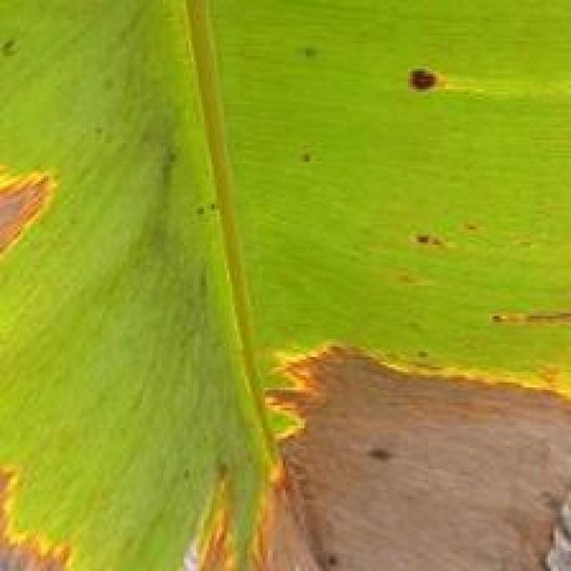
Option 1:
The image shows a leaf with brown spots and holes, which indicates that the plant is suffering from a disease. The disease appears to be affecting the leaf's health and causing it to deteriorate.
The visible symptoms of the disease include brown spots and holes on the leaf, which are signs of damage or decay. These symptoms suggest that the plant is under stress and may not be receiving adequate nutrients or water.
To address this issue, it is essential to identify the specific disease affecting the plant and take appropriate measures to treat it. This may involve using fungicides, applying organic compost, or adjusting the plant's watering schedule to ensure it receives the necessary nutrients. Additionally, regular monitoring of the plant's health and early detection of any signs of disease can help prevent further damage and promote the plant's overall well-being.
Option 2:
The visible symptoms in the image include brown spots and blackened areas on the leaves of the banana plant. These are indicative of a disease known as Panama Disease, also referred to as Fusarium Wilt or Panama Wilt, which is caused by the fungus Fusarium oxysporum f. sp. cubense (Foc).
The possible solution for this disease includes:
1. Proper identification and diagnosis by a plant pathologist to confirm the presence of Panama Disease.
2. Implementing good hygiene practices, such as removing infected plants and de-budding to prevent the spread of the fungus.
3. Using resistant varieties of bananas if available in the region.
4. Implementing cultural practices like proper drainage, avoiding waterlogging, and maintaining a balanced fertilizer program to support the health of the plant.
5. Using fungicides as part of an integrated management strategy to control the disease. However, it's important to follow all label recommendations and use only registered fungicides for bananas.
6. Monitoring the plant regularly for signs of improvement or worsening of the disease.

Which answer do you prefer:

Sample 126

Ground Truth: cordana
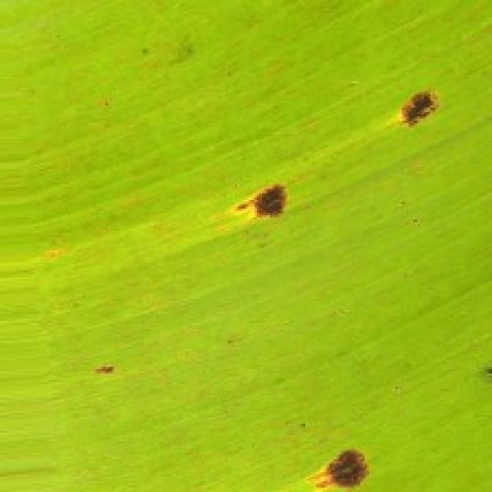
Option 1:
The image shows a leaf with a brown spot, which appears to be a fungal infection. The leaf is attached to a tree branch, and the infection seems to be spreading. The visible symptoms include the brown spot and the surrounding yellowish-green color, which indicates that the leaf is affected by the disease.
A possible solution to this problem is to remove the affected leaf and any other infected leaves from the tree. This can help prevent the spread of the disease and reduce the risk of further damage to the tree. Additionally, it is essential to maintain proper tree care, such as regular pruning, watering, and pest control, to prevent the growth of fungal infections and other diseases.
Option 2:
The visible symptoms in the image include a rotting or decaying area on the leaf, which appears to be infected with a fungal disease. This could be caused by a pathogen such as Panama disease (Fusarium oxysporum f. sp. cubense), also known as "Cordana."
The affected area shows signs of decay and rot, which is characteristic of this type of disease. The rotting tissue may have a fuzzy appearance due to the presence of fungal spores or mycelium. The affected leaf may also show discoloration, with brown or black areas where the pathogen has caused damage.
To manage this disease, it is important to remove and destroy infected leaves and stems, as well as maintain proper drainage and avoid waterlogging in the soil. Fungicides may be used in conjunction with these measures to prevent further spread of the disease. It's also important to monitor the plant for any signs of new infections and treat them promptly.

Which answer do you prefer:

Sample 127

Ground Truth: cordana
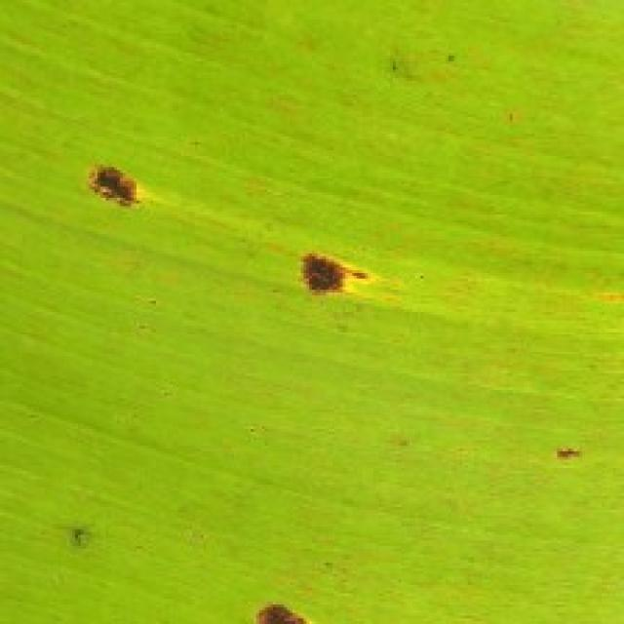
Option 1:
The image shows a leaf with yellow spots and brown patches, which indicates that the leaf is affected by a fungal disease. The disease appears to be spreading, as the spots are growing larger and more numerous.
The visible symptoms of the disease include yellow spots and brown patches on the leaf, which are signs of the fungus's growth and spread. The leaf may also become discolored or wilted as the disease progresses.
To address this issue, it is essential to identify the specific type of fungal disease affecting the plant and take appropriate measures to prevent its spread. This may include removing infected leaves, pruning affected branches, and applying fungicides to the plant to prevent the disease from spreading further. Additionally, ensuring proper care and maintenance of the plant, such as regular watering, adequate sunlight, and well-draining soil, can help prevent the development of fungal diseases in the future.
Option 2:
The visible symptoms in the image include yellowing and discoloration of the leaves, which are indicative of a disease affecting the banana plant. The most likely culprit is Panama disease (Fusarium wilt), also known as Panama disease tropical race 4 (TR4), which is caused by the fungus Fusarium oxysporum f. sp. cubense.
The visible symptoms include:
- Yellowing and browning of leaves, especially at the edges or tips.
- Discoloration with a pattern that resembles a maple leaf shape.
- Leaf wilting and death.
The possible solution for this disease is to implement preventive measures such as using resistant varieties of banana plants, maintaining proper drainage, avoiding waterlogging, and implementing good crop management practices like regular monitoring for signs of disease, removing infected plants promptly, and using fungicides when necessary. It's also important to practice good hygiene in the field to prevent the spread of the disease.

Which answer do you prefer:

Sample 128

Ground Truth: cordana
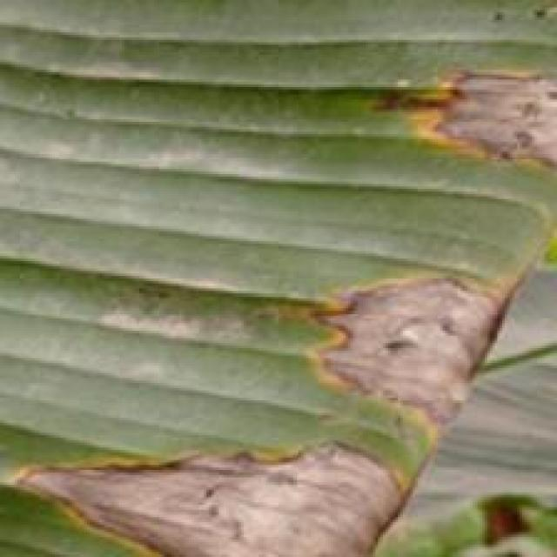
Option 1:
The image shows a leaf with a yellowish-brown spot, which appears to be a disease or infection. The leaf is attached to a tree, and the disease seems to be affecting the tree's health. The yellowish-brown spot indicates that the tree might be experiencing a fungal infection or a bacterial disease.
To address this issue, it is essential to identify the specific type of disease and consult with a local nursery or gardening expert to determine the appropriate treatment. In some cases, pruning the affected area and applying a fungicide or bactericide can help control the spread of the disease. Additionally, maintaining proper tree care, such as regular watering, fertilization, and pest control, can help prevent the development of diseases and promote overall tree health.
Option 2:
The visible symptoms in the image include discoloration, necrosis, and lesions on the leaves of the banana plant. These are indicative of a disease known as Panama disease or Fusarium wilt, which is caused by the fungus Fusarium oxysporum f. sp. cubense (Foc).
The visible symptoms include:
- Discoloration: The leaves may show yellowing, browning, or blackening, especially at the edges and along the veins.
- Necrosis: Dead tissue can be observed as brown or black areas on the leaf surface.
- Lesions: Round, oval, or irregularly shaped spots may appear on the leaves, which are characteristic of Panama disease.
The possible solution for this disease includes:
- Proper identification and diagnosis by a plant pathologist to confirm the presence of Foc.
- Implementing best management practices such as using resistant varieties, maintaining healthy planting material, practicing good hygiene, and controlling weeds that can harbor the fungus.
- Implementing cultural control measures like removing infected plants promptly and maintaining clean fields to prevent the spread of the disease.
- Using fungicides when necessary, but always following label recommendations and practicing integrated pest management to minimize the risk of developing resistance.

Which answer do you prefer:

Sample 129

Ground Truth: cordana
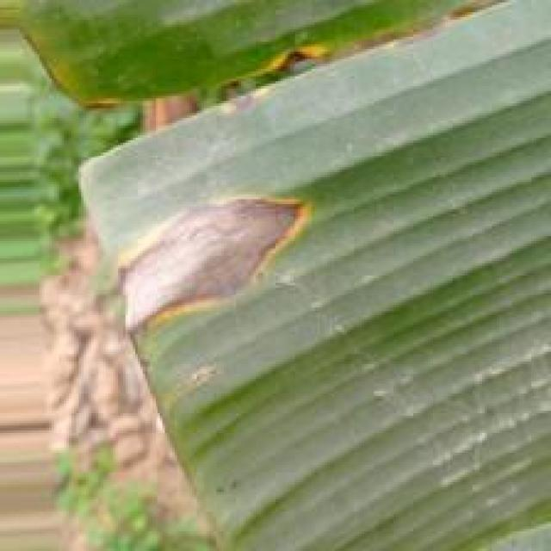
Option 1:
The image shows a leaf with brown spots and holes, which indicates that the plant is suffering from a disease called bacterial soft rot. This disease is caused by bacteria, specifically Xanthomonas campestris, which can infect various plant species, including bananas.
The visible symptoms of bacterial soft rot include brown spots or lesions on the leaves, which eventually turn into holes, and the leaves may become wilted or discolored. The disease can spread rapidly and cause significant damage to the plant.
A possible solution to prevent the spread of the disease and save the plant is to practice proper plant care, such as regular pruning, removing infected leaves, and ensuring proper drainage to prevent the growth of bacteria. Additionally, using organic or bactericidal compounds can help control the bacteria and prevent further damage. It is essential to identify the disease early and take appropriate measures to save the plant and maintain its health.
Option 2:
The visible symptoms in the image include dark, irregularly shaped lesions on the leaves of the banana plant. These lesions are indicative of a disease called "Cordana," which is caused by a fungus that affects bananas and other plants in the family Musa.
The possible solution for this disease would involve removing infected leaves to prevent further spread of the pathogen, applying fungicides specifically designed to combat this type of fungal infection, and ensuring proper drainage and air circulation around the plant to reduce humidity levels that can exacerbate the problem. Additionally, maintaining a healthy plant with good nutrition and proper irrigation can help prevent future outbreaks of Cordana.

Which answer do you prefer:

Sample 130

Ground Truth: cordana
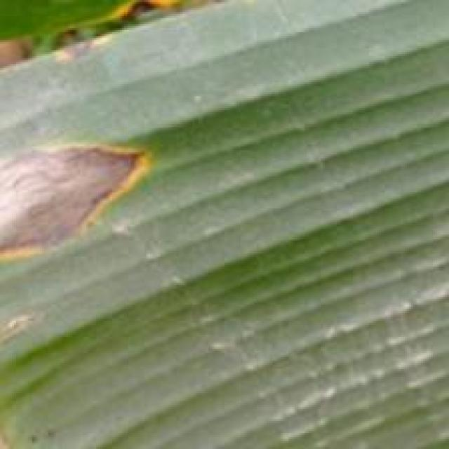
Option 1:
The image shows a leaf with a brown spot, which appears to be a disease or infection. The leaf is green and has a brown spot on it, indicating that it might be affected by a fungal or bacterial infection. The brown spot is surrounded by green tissue, which suggests that the infection is localized and not spreading throughout the entire leaf.
To address this issue, it is essential to identify the specific type of infection and take appropriate measures to treat it. If it is a fungal infection, applying a fungicide specifically designed for the type of fungus causing the infection can help control its spread and prevent further damage to the plant. If it is a bacterial infection, treating the plant with antibiotics or using a bactericidal solution can help combat the infection.
In addition to treating the infection, it is also important to maintain proper plant care, such as providing adequate sunlight, water, and nutrients, to promote overall health and prevent future infections. Regularly inspecting the plant for any signs of infection and addressing them promptly can help ensure the plant's well-being and minimize the impact of the disease.
Option 2:
The visible symptoms in the image include a rotting or decaying area on the leaf, which appears to be caused by a fungal infection. This could be indicative of a disease such as Panama disease (Fusarium oxysporum f. sp. cubense), also known as "Cordana" in bananas.
The possible solution for this type of disease would involve the use of fungicides and proper crop management practices to prevent the spread of the fungus. It's important to monitor the health of the plant regularly and remove affected leaves to minimize further damage. Additionally, maintaining good drainage, avoiding waterlogging, and ensuring proper nutrient availability can help prevent the disease from becoming more severe.

Which answer do you prefer:

Sample 131

Ground Truth: cordana
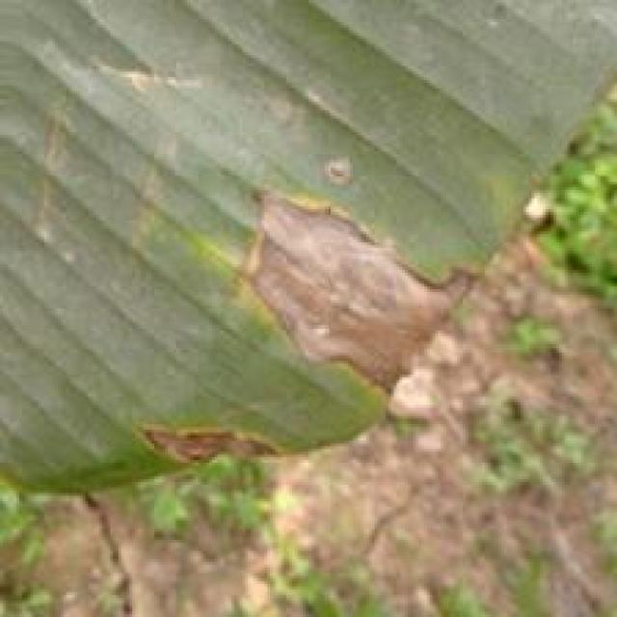
Option 1:
The image shows a leaf with a brown spot, which appears to be a fungal infection. The brown spot is surrounded by a yellow circle, which is a characteristic of the fungus. This type of infection can be caused by various fungi, such as the fungus Rhizoctonia, which can affect the plant's health and growth.
The visible symptoms of this infection include the brown spot on the leaf and the yellow circle surrounding it. The affected leaf may become discolored, wilt, and eventually die. The fungus can spread to other parts of the plant, causing further damage.
To solve this problem, it is essential to identify the specific type of fungus causing the infection and take appropriate measures to prevent its spread. This may include removing infected leaves, practicing proper plant care, and using fungicides to control the growth of the fungus. Additionally, it is crucial to maintain a healthy plant environment by providing adequate sunlight, water, and nutrients to promote plant growth and overall health.
Option 2:
The visible symptom in the image is a yellowish discoloration with a dark center on the leaf, which resembles a star shape. This pattern is characteristic of a disease called Panama disease tropical race 4 (PD-TR4), also known as Panama disease or Fusarium wilt.
The possible solution for this disease includes:
1. Proper identification by an expert in plant pathology to confirm the presence of PD-TR4.
2. Implementing a program to control the spread of the disease within the farm, including removing infected plants and de-budding (removing flower bells) to prevent further spread.
3. Implementing good hygiene practices such as cleaning tools with bleach before using them on healthy plants.
4. Using resistant varieties if available.
5. Considering the use of fungicides, but this should be done under the guidance of a plant pathologist and following all recommended precautions to minimize environmental impact.
6. Monitoring the health of the plant regularly for early detection of any new symptoms.

Which answer do you prefer:

Sample 132

Ground Truth: cordana
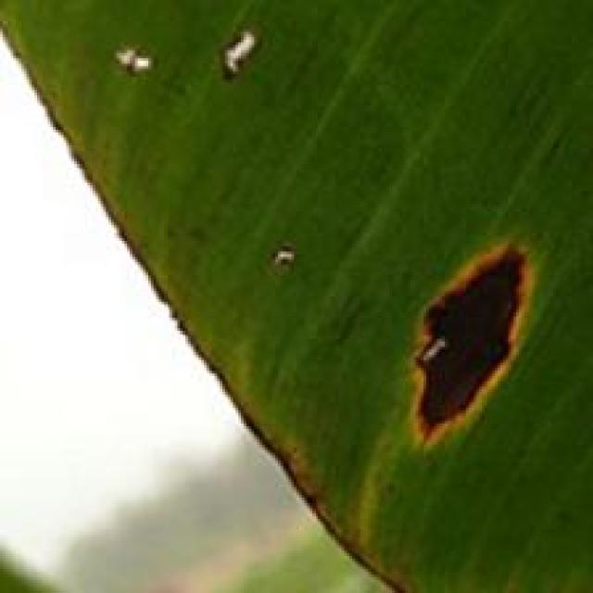
Option 1:
The image shows a banana leaf with yellow spots and brown patches, indicating that it is affected by a fungal disease. The disease appears to be spreading, as the spots are growing larger and more numerous.
The visible symptoms of the disease include yellow spots and brown patches on the banana leaf, which are signs of the fungus's growth and spread. The affected areas may become discolored and eventually die, leading to a decline in the overall health of the banana tree.
A possible solution to this problem is to practice good agricultural practices, such as regular pruning, proper spacing of the banana trees, and ensuring adequate drainage and soil quality. Additionally, using organic or fungicidal treatments can help prevent the spread of the disease and protect the banana tree from further damage. It is essential to identify the specific type of fungus causing the disease and apply the appropriate treatment to minimize the impact on the banana tree and its yield.
Option 2:
The visible symptoms in the image include discoloration, with yellowing and brown spots on the leaves. This could be indicative of a disease called "Banana Bunchy Top Virus" (BBTV), which affects banana plants.
The possible solutions for this disease include:
1. Proper identification by an expert to confirm the presence of BBTV.
2. Implementing preventive measures such as using disease-free planting material and maintaining clean cultivation practices.
3. Removing and destroying infected plants to prevent further spread of the virus.
4. Using resistant varieties if available in the region where the banana plant is grown.
5. Implementing integrated pest management strategies to control other pests that may be associated with BBTV transmission.
6. Regular monitoring for early detection and prompt response to manage the disease effectively.

Which answer do you prefer:

Sample 133

Ground Truth: moko
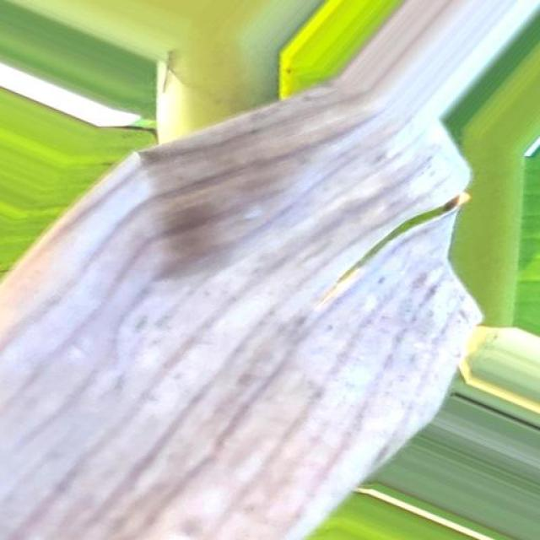
Option 1:
The image shows a tree branch with a visible fungal infection, which appears as a white substance growing on the bark. This infection is likely caused by a fungus, such as the Armillaria fungus, which can cause decay in the tree. The visible symptoms include the white growth on the bark and the decaying appearance of the tree branch.
A possible solution to this problem is to remove the affected branch and the surrounding infected area, as well as any other branches that show signs of decay. This can help prevent the spread of the fungus and reduce the risk of further damage to the tree. Additionally, it is essential to monitor the tree's overall health and take preventive measures, such as regular pruning and maintaining proper tree care, to prevent the development of similar infections in the future.
Option 2:
The image shows a close-up view of a banana plant with several visible symptoms that could be indicative of moko disease. Moko disease is caused by the fungus Mycosphaerella fijiensis, which affects bananas and other plants in the Musa genus.
Visible symptoms include:
1. Brown spots or lesions on the leaves and stems.
2. Discoloration of the plant tissue, often with a yellowish hue.
3. Dead or dying tissue around the affected areas.
4. A general decline in the health of the plant, including wilting and reduced growth.
The possible solution for moko disease is to remove infected plants promptly to prevent further spread of the fungus. Additionally, good sanitation practices should be followed to minimize the risk of new infections, such as regular pruning of dead or diseased tissue, cleaning tools with bleach before using them on healthy plants, and maintaining proper drainage around the base of the plant to prevent waterlogging.

Which answer do you prefer:

Sample 134

Ground Truth: moko

Option 1:
The image shows a close-up of a tree branch with a visible fungus growing on it. The fungus appears to be spreading across the branch, and it is accompanied by a brownish-yellow color. This could indicate a disease affecting the tree, such as a fungal infection or a bacterial disease.
The visible symptoms of the disease include the growth of the fungus on the tree branch and the discoloration of the branch. The possible solution to this issue would be to identify the specific type of disease and consult with a tree care professional or an arborist to determine the best course of action. This may involve pruning the affected branches, applying fungicides or other treatments, or providing the tree with proper care and maintenance to prevent future infections.
Option 2:
The image shows a close-up view of a banana plant that appears to be affected by moko disease. Moko disease is caused by the fungus Mycosphaerella fijiensis, which affects bananas and other plants in the Musa genus.
Visible symptoms include:
- Brown or black spots on the leaves and stems.
- Leaf necrosis (death) with a yellowing or browning of the tissue.
- Stem lesions that can be oval, elongated, or irregular in shape.
- Flower and fruit rot.
The possible solution for moko disease is the use of resistant varieties of bananas, proper drainage, and sanitation practices to reduce the spread of the fungus. Additionally, fungicides can be applied to control the disease if necessary.

Which answer do you prefer:

Sample 135

Ground Truth: moko
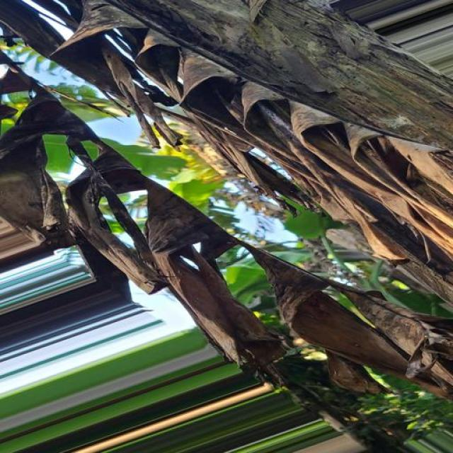
Option 1:
The image shows a leaf with a brown spot, which could be a sign of a disease or infection affecting the plant. The leaf appears to be rotting, and the plant is surrounded by a forest of green leaves.
The visible symptoms of the disease include the brown spot on the leaf and the rotting appearance. This could be caused by various factors such as fungal infections, bacterial infections, or nutrient deficiencies.
To address the issue, it is essential to identify the specific cause of the disease and take appropriate measures to treat or prevent it. This may involve using fungicides or bactericides to combat fungal or bacterial infections, respectively. Additionally, ensuring proper nutrient intake and maintaining a healthy environment for the plant can help prevent further damage and promote its overall health. Regularly inspecting the plant for any signs of disease and addressing them promptly can also contribute to the plant's well-being.
Option 2:
The image shows a banana plant with several visible symptoms that could be indicative of moko disease, which is caused by the fungus Fusarium oxysporum f. sp. cubense (Foc). Here are the visible symptoms:
1. Brown and black discoloration on the leaves: This is a common sign of moko disease in banana plants. The discoloration can range from yellowing to complete browning or blackening of the leaf tissue.
2. Leaf necrosis: There are areas where the leaf tissue has died, which is characteristic of moko disease. This can lead to a loss of photosynthetic capacity and eventually the death of the entire plant if not treated.
3. Stem cankers: The stem may show signs of decay or rotting, which is another symptom of moko disease. This can be seen as dark, rotten areas on the stem where the fungus has entered the plant.
4. Reduced growth and yield: Moko disease can affect the overall health of the banana plant, leading to reduced growth and yield.
The possible solution for this disease is preventive measures such as proper drainage, avoiding waterlogging, and maintaining good soil fertility. Additionally, using resistant varieties of bananas or applying fungicides can help manage the disease if it has already taken hold in the plant.

Which answer do you prefer:

Sample 136

Ground Truth: moko
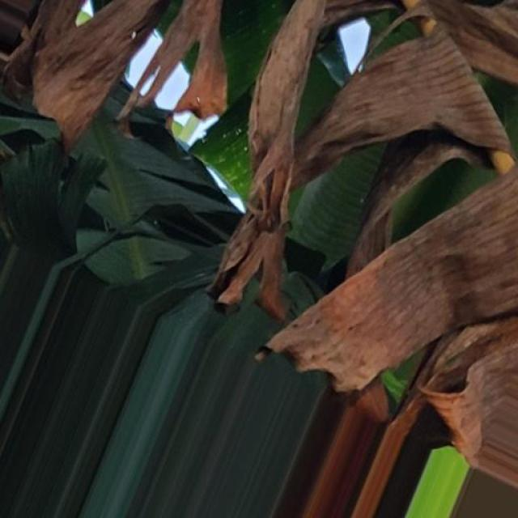
Option 1:
The image shows a tree with brown leaves and branches, indicating that it is suffering from a disease or a lack of proper care. The tree appears to be infected with a fungal disease, which is causing the leaves to turn brown and fall off.
To address this issue, it is essential to identify the specific type of fungal disease affecting the tree and consult with a tree care professional or a local nursery to determine the best course of action. Possible solutions may include applying fungicides, pruning infected branches, and providing proper care and nutrients to the tree to help it recover from the disease. Additionally, regular tree maintenance, such as watering, fertilizing, and pest control, can help prevent the tree from becoming susceptible to diseases in the future.
Option 2:
The visible symptoms in the image include discoloration, browning, and curling of the leaves. These are indicative of a disease called moko, which affects banana plants. Moko is caused by the fungus Mycosphaerella fijiensis.
To address this issue, it's important to remove infected leaves and stems promptly to prevent further spread of the disease. In addition, maintaining good drainage and avoiding waterlogging can help prevent moko from developing. If the plant is severely affected, fungicides may be necessary to control the disease. It's also important to monitor the health of the plant regularly and remove any additional infected leaves as they appear.

Which answer do you prefer:

Sample 137

Ground Truth: moko
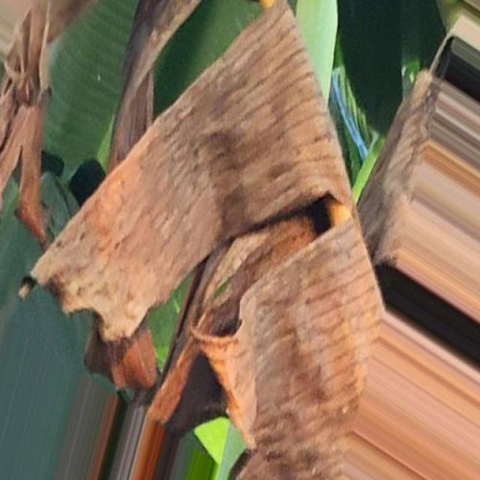
Option 1:
The image shows a banana leaf with yellow spots, which indicates that the banana plant is suffering from a disease called Panama disease. This disease is caused by the fungus Fusarium oxysporum f. sp. cubense, which affects the plant's vascular system, causing yellowing and wilting of the leaves.
The visible symptoms of Panama disease include yellow spots on the leaves, wilting, and a general decline in the plant's health. The disease can lead to the death of the banana plant if not treated properly.
A possible solution to combat Panama disease is to practice good agricultural practices, such as proper irrigation, pest management, and regular monitoring of the plant's health. Additionally, using resistant varieties of banana plants can help reduce the risk of infection. In severe cases, chemical treatments may be necessary to control the disease, but it is essential to use these treatments responsibly and in accordance with local regulations and guidelines.
Option 2:
The visible symptoms in the image include discoloration and potential damage to the leaves of the banana plant. There are yellow and brown spots on the leaves, which could indicate a disease such as Panama disease or another type of fungal infection.
To address this issue, it would be advisable to consult with a local agricultural expert or extension service for an accurate diagnosis and appropriate treatment. Possible solutions may include:
1. Implementing good hygiene practices to prevent the spread of diseases.
2. Using resistant varieties of banana plants if available in the region.
3. Applying fungicides as recommended by a professional, taking into account the specific needs of the plant and local conditions.
4. Ensuring proper drainage and avoiding overwatering, which can exacerbate certain diseases.
5. Regularly monitoring the health of the plant for early detection of any changes in symptoms.

Which answer do you prefer:

Sample 138

Ground Truth: moko

Option 1:
The image shows a tree branch with a brown, rotten, and decaying appearance. This suggests that the tree may be suffering from a disease called "wood decay" or "fungal decay." Wood decay is caused by various fungi and bacteria that feed on the tree's cellulose, leading to the breakdown of the wood.
The visible symptoms of wood decay include discoloration, mushroom-like growths, and the formation of holes or cavities in the wood. The decay can weaken the tree and make it more susceptible to pests and other diseases.
A possible solution to prevent wood decay is to practice proper tree care, such as regular pruning, removing dead or damaged branches, and ensuring that the tree receives adequate nutrients and water. Additionally, it is essential to maintain a healthy environment by controlling pests and preventing the spread of diseases. If the decay is already present, it may be necessary to remove the affected branches and treat the tree with fungicides or other treatments to slow down the decay process and prevent further damage.
Option 2:
The image shows a banana plant with several visible symptoms indicative of moko disease, which is caused by the fungus Mycosphaerella fijiensis. Symptoms include:
1. Brown or black spots on the leaves and stems.
2. Discoloration and necrosis (death) of tissue.
3. Curling and wilting of leaves.
4. Stunted growth or deformation of the plant.
The possible solution for moko disease is to remove infected plants promptly to prevent further spread of the fungus. Additionally, good sanitation practices should be followed, including regular inspection of plants for early detection of infection, and maintaining clean cultivation practices to minimize the risk of new infections. If necessary, fungicides can be applied as part of an integrated management strategy.

Which answer do you prefer:

Sample 139

Ground Truth: moko

Option 1:
The image shows a tree with a large, brown, dead branch. This indicates that the tree is suffering from a disease or infection, which has caused the branch to die and turn brown. The tree may also have other visible symptoms, such as discolored leaves or bark, and the overall health of the tree may be compromised.
A possible solution to this problem is to identify the cause of the disease or infection and take appropriate measures to address it. This may involve consulting with a tree care professional or conducting a soil test to determine if the tree's nutrients are balanced. Additionally, the tree may require pruning or removal of the affected branches to prevent the spread of the disease and maintain the overall health of the tree. It is essential to monitor the tree's condition and take action as needed to ensure its well-being.
Option 2:
The visible symptoms in the image include browning and wilting of the leaves, which are indicative of a disease known as moko or Panama disease. This is caused by the fungus Fusarium oxysporum f. sp. cubense (Foc) and can affect banana plants severely.
The visible symptoms include:
- Brown and black discoloration on the leaves, which is a sign of necrosis caused by the disease.
- Wilting of the leaves, indicating that the plant is unable to photosynthesize effectively due to the infection.
- Possible yellowing or chlorosis of the leaf veins, which can be an early sign of moko disease.
The possible solution for this disease includes:
- Proper identification and diagnosis by a plant pathologist or extension agent to confirm the presence of moko.
- Implementing best management practices such as using resistant varieties, maintaining clean fields, and practicing good sanitation to minimize the risk of disease spread.
- Applying fungicides if necessary, but it's important to follow all label recommendations and use only those registered for use in bananas by the relevant authorities.

Which answer do you prefer:

Sample 140

Ground Truth: moko

Option 1:
The image shows a banana tree with brown, dead leaves and brown, dead bananas hanging from it. This indicates that the tree is suffering from a disease called Panama disease, which is caused by the fungus Fusarium oxysporum f. sp. cubense.
The visible symptoms of Panama disease include brown, dead leaves and fruit, as well as stunted growth and reduced fruit production. The disease can also cause the tree to produce excessive amounts of vegetation, leading to a weakened tree structure.
A possible solution to combat Panama disease is to practice good agricultural practices, such as proper irrigation, pest and disease management, and regular monitoring of the tree's health. Additionally, using resistant varieties of banana trees can help reduce the risk of infection and disease spread. In severe cases, the tree may need to be removed and replaced with a healthy, disease-free plant.
Option 2:
The visible symptoms in the image include discoloration and wilting of the leaves, which are characteristic of moko disease affecting banana plants. Moko is a fungal disease caused by the pathogen Fusarium oxysporum f. sp. cubense (Foc) that affects bananas and other plants in the Musa genus.
The visible symptoms include:
- Discoloration of leaves, often starting at the edges and progressing towards the center.
- Leaf wilting or drooping.
- Brown spots on the leaves.
- Stem rot or decay.
The possible solution for moko disease is to implement preventive measures such as proper drainage, avoiding overcrowding of plants, and using resistant varieties of banana plants. Additionally, fungicides can be applied to control the spread of the disease, although this should be done with caution and in accordance with recommended practices for crop protection.

Which answer do you prefer:

Sample 141

Ground Truth: moko

Option 1:
The image shows a tree with numerous dead branches and leaves, indicating that the tree is suffering from a disease or infection. The dead branches and leaves are a clear sign of the tree's distress, and it is likely that the tree is experiencing a fungal infection or a bacterial disease.
To address this issue, it is essential to identify the specific type of disease affecting the tree and consult with a tree care professional or a local nursery to determine the best course of action. Possible solutions may include pruning away dead branches and leaves, applying fungicides or bactericides to the affected areas, or providing the tree with proper care and nutrients to help it recover from the disease. Regular monitoring of the tree's health and timely intervention can help prevent further damage and promote the tree's overall well-being.
Option 2:
Based on the image provided, it appears that the banana plant is affected by a disease known as moko, which is caused by the fungus Fusarium oxysporum f. sp. cubense (Foc). The visible symptoms include:
1. Brown and black lesions on the stem and leaves.
2. Dead tissue surrounding these lesions.
3. Discoloration of the plant parts affected by the disease.
4. A general decline in the health of the plant, with wilting and reduced growth.
The possible solution for this disease is to remove infected plants promptly to prevent further spread of the fungus. Additionally, good agricultural practices such as proper drainage, avoidance of waterlogging, and regular monitoring for early signs of infection can help prevent the spread of moko and other similar diseases.

Which answer do you prefer:

Sample 142

Ground Truth: moko
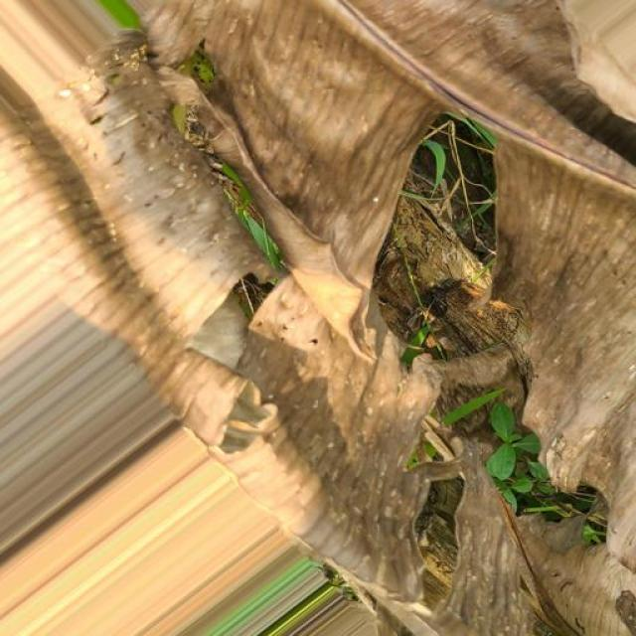
Option 1:
The image shows a tree branch with a brown, rotten, and mushy appearance, indicating that it is affected by a disease. The disease appears to be causing the branch to decay and possibly die.
The visible symptoms of the disease include the brown, rotten, and mushy appearance of the branch, as well as the decaying process that is causing the branch to lose its structural integrity.
A possible solution to this problem would be to remove the affected branch and the surrounding infected tissue, and then apply a fungicide or other treatment to prevent the spread of the disease to other parts of the tree. Additionally, it is essential to monitor the tree's overall health and take preventive measures to avoid further infections or diseases.
Option 2:
Based on the image provided, it appears that the banana plant may be affected by a disease known as Panama disease or Fusarium wilt, which is caused by the fungus Fusarium oxysporum f. sp. cubense (Foc).
The visible symptoms include:
- Discoloration of leaves: The leaves may show yellowing, browning, and eventually die.
- Wilting: The plant may appear weak and wilted, especially at the base of the stem.
- Stem decay: There may be visible signs of rotting or decay on the stem.
Possible solutions include:
- Proper identification by a professional to confirm the disease.
- Implementing best management practices such as using resistant varieties, maintaining good drainage, avoiding waterlogging, and practicing good hygiene in the field.
- Using fungicides if necessary, but always following label instructions and seeking advice from a qualified agronomist or plant pathologist.

Which answer do you prefer:

Sample 143

Ground Truth: moko
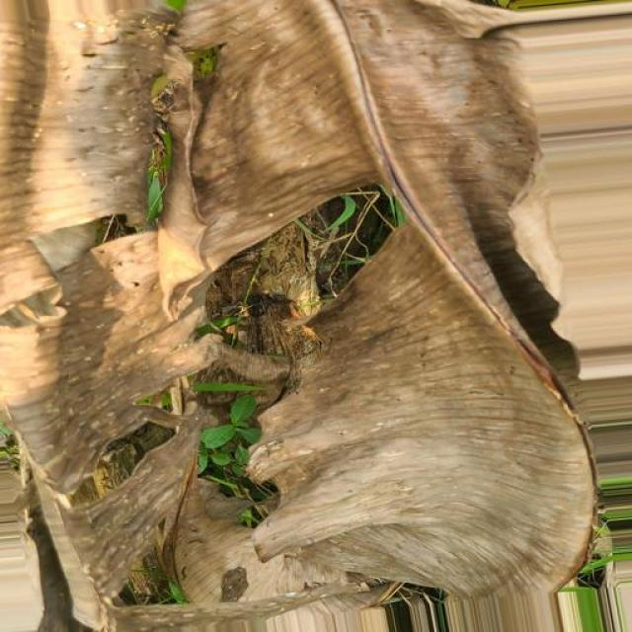
Option 1:
The image shows a tree with a large, rotten, and decaying branch. The branch appears to be infected with a fungus, which is causing the decay. The visible symptoms include the branch's discoloration, mushy texture, and the presence of mold.
A possible solution to this problem is to remove the affected branch and the surrounding infected tissue. This can be done by pruning the branch carefully, ensuring that the cut is clean and sterile to prevent the spread of the fungus. Additionally, it is essential to monitor the tree for any signs of further infection and take appropriate measures to prevent the spread of the disease. This may include regular tree care, such as watering, fertilizing, and pest control, to maintain the overall health of the tree.
Option 2:
The image shows a banana plant with several visible symptoms indicative of moko disease, also known as Panama disease or Fusarium wilt. Symptoms include:
1. Brown and black discoloration on the stem and leaves.
2. Dead tissue at the base of the plant.
3. Wilting of the leaves.
4. Discoloration of the trunk, which can be a sign of internal decay.
The visible symptoms suggest that the banana plant has been affected by a fungal disease caused by Fusarium oxysporum f. sp. cubense (Foc), which is one of the most destructive diseases affecting bananas worldwide.
To manage moko disease, it's important to practice good horticultural practices such as:
- Properly cleaning tools before using them on healthy plants to prevent the spread of the fungus.
- Removing and destroying infected plants promptly.
- Implementing a regular monitoring system for early detection of the disease.
- Using resistant varieties if available.
- Improving drainage and avoiding waterlogging in planting areas.
- Maintaining proper fertilization and pest management practices.

Which answer do you prefer:

Sample 144

Ground Truth: moko

Option 1:
The image shows a tree branch with a brown, dead-looking leaf, which could indicate a disease or a lack of proper nutrients. The brown leaf may be a sign of nutrient deficiency, overwatering, or underwatering. To address this issue, it is essential to identify the cause of the problem and take appropriate measures.
If the issue is due to nutrient deficiency, it is crucial to provide the tree with the necessary nutrients through fertilization or soil amendment. If the problem is caused by overwatering or underwatering, adjusting the watering schedule and ensuring the tree receives the appropriate amount of water can help improve its health.
In some cases, the brown leaf could be a sign of a disease, such as fungal infections or bacterial diseases. In such cases, it is essential to consult a professional arborist or a plant pathologist to identify the disease and provide appropriate treatment or preventive measures.
Option 2:
The image appears to be rotated, making it difficult to provide accurate information about the state of the banana plant. However, I can attempt to describe the visible symptoms if they are not too distorted.
In the case of a banana plant affected by moko disease (also known as Panama disease), you might see signs such as yellowing leaves, wilting, and stunted growth. The disease is caused by a soil-borne fungus and can lead to significant crop loss if not managed properly.
A possible solution for moko disease would involve implementing best management practices, including proper drainage, avoiding planting susceptible varieties, using resistant varieties, and maintaining clean fields free from weeds and other pathogens. Additionally, regular monitoring of the plant's health and prompt removal of infected plants can help prevent further spread of the disease.

Which answer do you prefer:

Sample 145

Ground Truth: moko
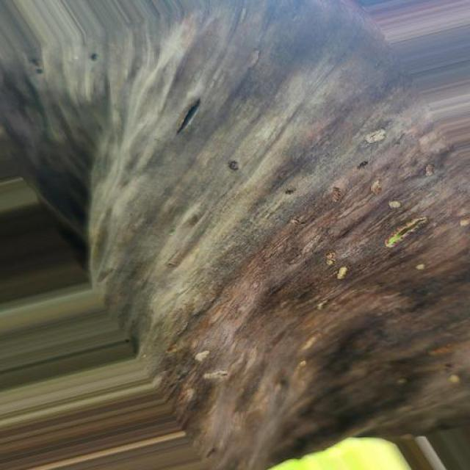
Option 1:
The image shows a tree stump with a large number of holes in it, which indicates that it is infested with termites. The termites have caused significant damage to the tree, leaving it with a hollowed-out appearance.
The visible symptoms of termite infestation include the presence of numerous holes in the tree stump, as well as the overall weakened and damaged state of the tree. The termites have likely caused the tree to lose its structural integrity, making it unstable and potentially dangerous.
A possible solution to this problem is to remove the infested tree stump and replace it with a new, healthy tree. This can be done by cutting the tree down and removing the stump, or by using a specialized tool to remove the stump without damaging the surrounding area. Additionally, it is important to take preventive measures to avoid future infestations, such as regular inspections of the property, proper tree care, and the use of termite-resistant materials in construction.
Option 2:
The image shows a banana plant with several visible symptoms that could be indicative of moko disease, which is caused by the fungus Mycosphaerella fijiensis. Here are the visible symptoms:
1. Brown spots on the leaves: These are characteristic of moko disease and can vary in size and shape.
2. Leaf necrosis: The edges of the leaves appear to be dying or dead, which is a common symptom of moko disease.
3. Stem lesions: There may be visible lesions on the stem, which are typical for moko disease.
To manage moko disease, it's important to remove infected plants and debris from the field, maintain clean tools, and consider using resistant varieties or fungicides if necessary. It's also important to monitor the health of the plant regularly and take action as needed to prevent further spread of the disease.

Which answer do you prefer:

Sample 146

Ground Truth: moko
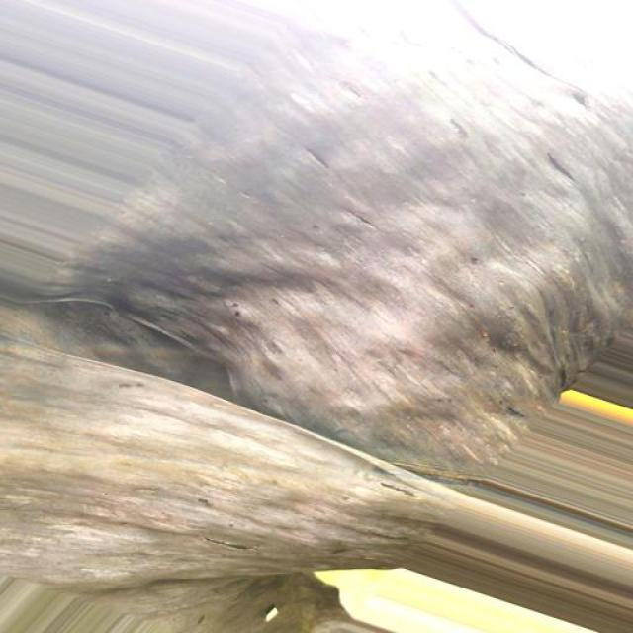
Option 1:
The image shows a close-up of a green and yellow striped object, which appears to be a piece of broccoli. Broccoli is a cruciferous vegetable known for its numerous health benefits. It is rich in vitamins, minerals, and antioxidants, and is a good source of dietary fiber.
One of the visible symptoms of broccoli is its green and yellow color, which indicates that it is fresh and ripe. The green color is due to the presence of chlorophyll, while the yellow color is a result of the breakdown of carotenoids.
A possible solution to the issue of the broccoli being green and yellow is to consume it as part of a healthy diet. Broccoli is a nutritious vegetable that can help improve overall health, boost the immune system, and reduce the risk of chronic diseases.
Option 2:
I'm unable to view images, but I can provide information on mokena banana diseases based on the text description provided. Mokena bananas are a variety of bananas that grow in tropical regions. Common diseases affecting mokena bananas include Panama disease (Fusarium wilt), Black Sigatoka (Mycosphaerella fijiensis), and Bunchy Top Virus.
Visible symptoms of these diseases may include:
- Yellowing or browning of leaves, which could indicate a nutrient deficiency or disease infection.
- Withering and wilting of leaves, which is characteristic of Panama disease.
- Dark spots on the stem, often associated with Bunchy Top Virus.
- Curling and distortion of leaves, which can be a sign of Black Sigatoka infection.
To address these diseases, it's important to practice good agricultural practices such as proper drainage, avoidance of waterlogging, and regular monitoring for signs of disease. Additionally, using disease-free planting material and following recommended crop management techniques can help prevent and control these diseases.

Which answer do you prefer:

Sample 147

Ground Truth: moko
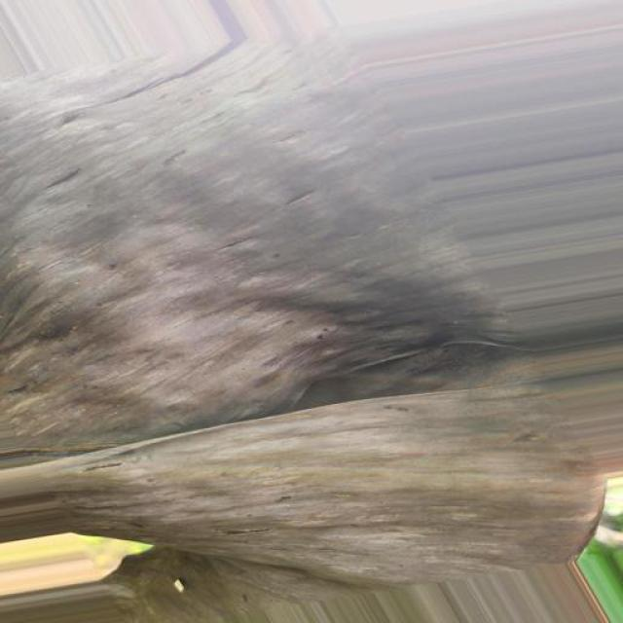
Option 1:
The image shows a tree branch with a large, brown, and rotten area on it. This indicates that the tree is suffering from a disease called "wood decay" or "rot." Wood decay is caused by fungi or bacteria that break down the cell walls of the tree, leading to the decay of the wood.
The visible symptoms of wood decay include discoloration, mushy or spongy texture, and a general weakening of the wood. The rotten area in the image is a clear example of this.
A possible solution to prevent wood decay is to remove the affected area and replace it with healthy wood. This can be done by pruning the tree, removing the rotten branch, and replacing it with a new, healthy branch. Additionally, maintaining the overall health of the tree by providing proper care, such as regular watering, fertilization, and pest control, can help prevent wood decay and other diseases.
Option 2:
The image shows a banana plant with several visible symptoms indicative of a disease known as Panama disease or Moko, which is caused by the fungus Fusarium oxysporum f. sp. cubense (FOC). The visible symptoms include:
1. Brown discoloration on the leaves and stems.
2. Wilting or drooping of the leaves.
3. Dead tissue or necrosis on the plant parts.
4. A general decline in the health of the plant.
The possible solution for this disease is to remove infected plants from the field and replace them with healthy ones. Additionally, proper sanitation practices should be followed to prevent the spread of the fungus, such as removing and destroying affected plants, cleaning tools regularly, and maintaining good drainage in the growing area.

Which answer do you prefer:

Sample 148

Ground Truth: moko

Option 1:
The image shows a close-up of a green field with a yellowish tint, possibly indicating a disease or a change in the field's condition. The yellowish tint could be due to a lack of nutrients, overgrazing, or a fungal infection.
To address this issue, the following steps can be taken:
1. Identify the cause: Determine the reason behind the yellowish tint in the field. This could be due to overgrazing, nutrient deficiency, or a fungal infection.
2. Assess the field: Evaluate the field's condition and determine the extent of the problem.
3. Implement a solution: Depending on the cause, implement a solution to address the issue. For example, if it's due to overgrazing, reduce the number of animals grazing in the field. If it's due to nutrient deficiency, add fertilizers to the soil. If it's a fungal infection, consider using fungicides to control the spread of the disease.
4. Monitor and maintain: Regularly monitor the field's condition and make adjustments as needed to ensure the health of the field and prevent future issues.
It's essential to consult with a local agricultural expert or a specialist in the field to determine the best course of action based on the specific situation.
Option 2:
The image you've provided appears to be rotated, but I'll try to describe the visible symptoms of a banana plant affected by Panama disease.
Panama disease is caused by the fungus Fusarium oxysporum f. sp. cubense, which affects the roots of banana plants. The visible symptoms include:
1. Discoloration of the stem: The stem may turn yellow or brown and eventually die.
2. Wilting of leaves: The leaves may wilt, turn brown, and fall off.
3. Stunted growth: Affected plants may grow poorly with stunted growth.
4. Reduced fruit production: Infected plants may produce fewer fruits or none at all.
5. Soil-splashing symptoms: The fungus can be spread through soil splashes from infected plants.
The possible solution for managing Panama disease includes proper drainage, avoiding planting near infected areas, using resistant varieties, and maintaining good hygiene practices in banana cultivation.

Which answer do you prefer:

Sample 149

Ground Truth: moko
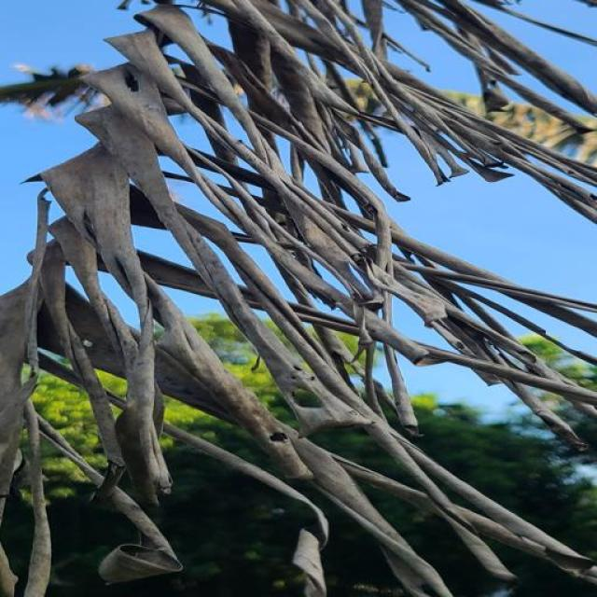
Option 1:
The image shows a tree with brown leaves, which indicates that it might be suffering from a disease or experiencing stress. Brown leaves can be a sign of nutrient deficiencies, overwatering, underwatering, or excessive fertilizer. To address this issue, it is essential to identify the cause of the brown leaves and take appropriate measures to improve the tree's health.
1. If the tree is underwatered, ensure that it receives adequate watering to maintain its health.
2. If the tree is overwatered, reduce the amount of water it receives to prevent root rot.
3. If the tree is experiencing nutrient deficiencies, provide it with the necessary nutrients through fertilization or soil amendment.
4. If the tree is experiencing excessive fertilizer, reduce the amount of fertilizer applied to avoid overloading the tree.
By addressing the underlying cause, the tree's health can be improved, and the brown leaves may turn green and healthy again.
Option 2:
The image shows a banana plant with several visible symptoms that could be indicative of a disease or pest infestation. Specifically, the most prominent feature is the presence of brown, dead leaves at the top of the tree. This is often a sign of moko disease, which is caused by the fungus Mycosphaerella fijiensis.
The visible symptoms include:
1. Dead or dying leaves at the top of the plant.
2. Discoloration and browning of the leaf tissue.
3. A general decline in the health of the plant, with wilting and reduced growth.
The possible solution for this issue would involve identifying the disease and applying appropriate fungicides as recommended by a professional in the field of agriculture or horticulture. Additionally, proper care practices such as pruning infected leaves, maintaining good drainage, and ensuring adequate sunlight exposure can help prevent the spread of the disease.

Which answer do you prefer:

Sample 150

Ground Truth: moko
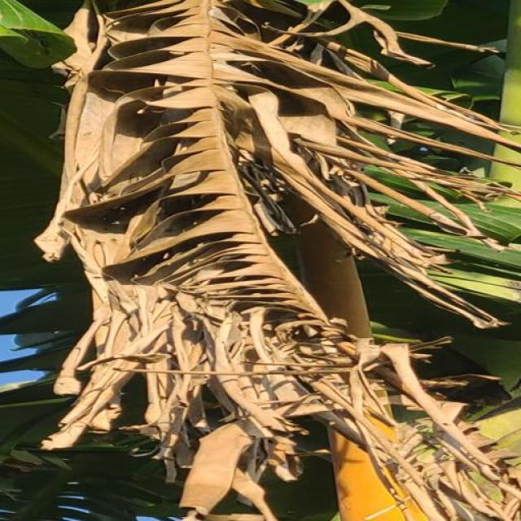
Option 1:
The image shows a banana plant with brown, rotten, and decaying bananas. This indicates that the plant is affected by a disease called Panama disease, which is caused by the fungus Fusarium oxysporum f. sp. cubense. The visible symptoms include brown spots, rotting, and decaying of the bananas, as well as the plant's overall decline in health.
The possible solution to this problem is to practice good agricultural practices, such as proper irrigation, pest management, and soil fertility management. Additionally, using resistant varieties of banana plants can help prevent the spread of the disease and reduce the impact on the plantation. It is also essential to monitor the health of the plant regularly and take appropriate action if the disease is detected early to minimize its impact on the plantation.
Option 2:
The visible symptoms in the image include browning and wilting of the leaves, which are characteristic signs of moko disease affecting banana plants. Moko is a fungal disease caused by the pathogen Fusarium oxysporum f. sp. cubense (Foc) that affects bananas and other plants in the Musa genus.
The visible symptoms include:
- Brown or black spots on the leaves, which can be indicative of the fungal infection.
- Leaf discoloration, with yellowing or browning of the leaf tissue.
- Wilted and drooping leaves.
- Stunted growth and reduced fruit production.
The possible solution for moko disease is to use resistant varieties of banana plants, maintain proper drainage, avoid waterlogging, and practice good hygiene by removing infected plant material promptly. Additionally, fungicides can be applied to control the spread of the disease if necessary.

Which answer do you prefer:

Sample 151

Ground Truth: moko
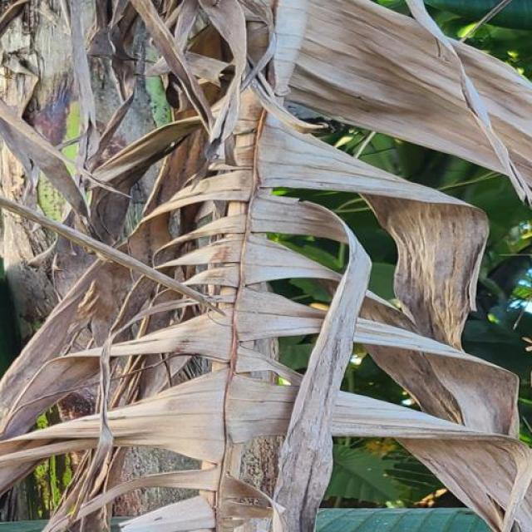
Option 1:
The image shows a tree branch with a brown, rotten, and decaying appearance. This suggests that the tree may be suffering from a disease called "wood decay" or "fungal infection." Wood decay is caused by various fungi that feed on the tree's cellulose, leading to the breakdown of the wood and the formation of mushrooms or other fungal structures.
The visible symptoms of wood decay include the brown, rotten, and decaying appearance of the tree branch, as well as the presence of mushrooms or other fungal structures. The decay can weaken the tree and make it more susceptible to pests and other diseases.
A possible solution to prevent wood decay is to practice proper tree care, such as regular pruning, removing dead or damaged branches, and ensuring that the tree has adequate nutrients and water. Additionally, using fungicides or other treatments to prevent or control the growth of fungi can help protect the tree from further damage.
Option 2:
The image shows a close-up view of a plant with some visible signs that could be indicative of moko disease, which affects banana plants. The symptoms include:
1. Discoloration: There are areas on the plant where the color appears to be altered, possibly due to the presence of the moko bacterium. These discolored areas might have a yellowish or brownish hue compared to healthy tissue.
2. Lesions and necrosis: The affected tissue may show signs of lesions and necrotic (dead) tissue, which is characteristic of moko disease. This can be seen as dark spots or patches on the plant's surface.
3. Softening or decay: There might be a soft, rotten appearance to the affected tissue, indicating that the plant has been infected by the moko bacterium.
The possible solution for this disease would involve proper identification and diagnosis by an expert in plant pathology, followed by removal of infected parts of the plant and possibly applying fungicides or other treatments recommended for banana plants affected by moko disease. It's important to consult with a local agricultural extension service or a plant pathologist for specific recommendations tailored to the region and conditions where the plant is grown.

Which answer do you prefer:

Sample 152

Ground Truth: moko
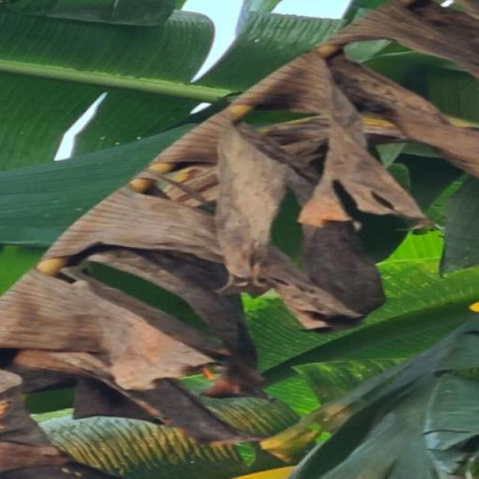
Option 1:
The image shows a tree branch with a brown, dead-looking end. This could indicate that the tree is suffering from a disease or infection, such as bacterial or fungal infections, which can cause the branch to lose its healthy appearance and eventually die.
To address this issue, it is essential to identify the specific cause of the disease and take appropriate measures to treat or prevent it. This may involve pruning the affected branches, applying appropriate fungicides or bactericides, or even removing the entire tree if the disease is too widespread or severe. Additionally, maintaining the overall health of the tree by providing proper care, such as regular watering, fertilization, and pest control, can help prevent the spread of diseases and promote the tree's overall well-being.
Option 2:
The visible symptoms in the image include discoloration and possibly some mottling or spots on the leaves. These could be indicative of a disease such as Panama disease, also known as Fusarium wilt, which affects banana plants.
A possible solution for this disease would involve proper crop management practices like selecting healthy suckers for planting instead of infected plants, maintaining good drainage and avoiding waterlogging, and using resistant varieties if available. Additionally, regular monitoring of the plant's health, prompt removal of affected parts, and proper sanitation are essential to prevent the spread of the disease within a farm or garden.

Which answer do you prefer:

Sample 153

Ground Truth: moko
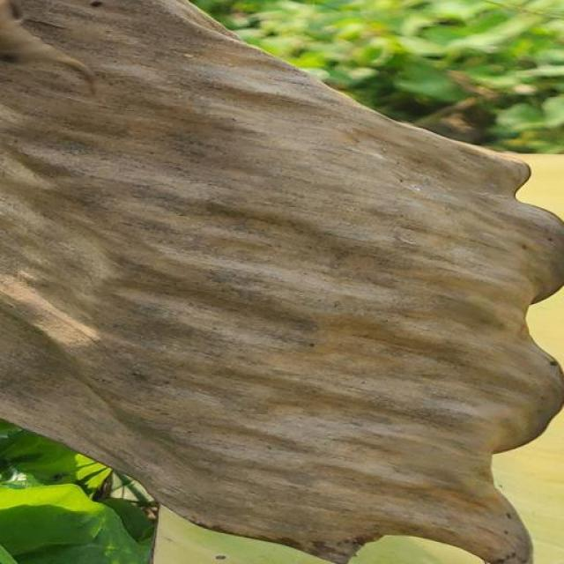
Option 1:
The image shows a wooden structure with a greenish-brown color, possibly due to a fungal infection or rot. The wooden structure appears to be rotting, and there is a green moss growing on it. This indicates that the structure is affected by a disease, which could be caused by fungi or bacteria.
The visible symptoms include the rotting wood and the green moss growing on the surface. The possible solution to this problem would be to remove the affected wood and replace it with new, treated wood to prevent further decay. Additionally, treating the wood with a fungicide or a bactericide can help prevent the growth of the disease-causing organisms and slow down the rotting process. It is also essential to maintain proper ventilation and drainage around the structure to prevent the accumulation of moisture, which can contribute to the growth of mold and mildew.
Option 2:
The image shows a banana plant with several visible symptoms indicative of moko disease, which is caused by the fungus Mycosphaerella fijiensis. The most prominent symptom is the presence of dark brown or black lesions on the leaves and stems. These lesions can be seen in various stages of development, from small spots to large, irregularly shaped areas of necrosis.
The affected plant parts appear to be dry and brittle, which is characteristic of moko disease. Additionally, there may be a general decline in the health of the plant, with reduced vigor and growth.
The solution for managing moko disease would involve proper sanitation practices to prevent the spread of the fungus, such as removing infected plants and de-leafing to reduce humidity levels. Fungicides can also be used to control the disease, but it's important to follow recommended guidelines for their use in agriculture.
In addition to these measures, proper irrigation and fertilization practices should be maintained to support the health of the plant and prevent further damage from moko disease.

Which answer do you prefer:

Sample 154

Ground Truth: moko
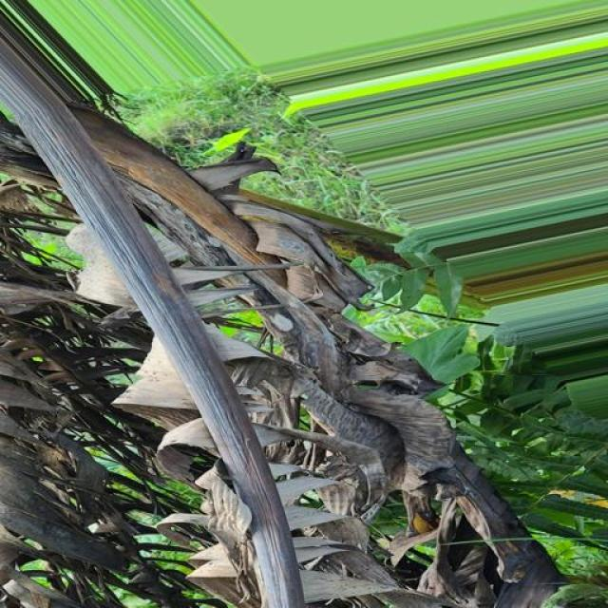
Option 1:
The image shows a plant with a brown leaf, which could indicate a disease or a nutrient deficiency. The brown leaf may be a sign of a fungal infection, bacterial infection, or nutrient deficiency. To identify the specific disease, it would be necessary to examine the plant more closely and possibly take a sample for further testing.
To address the issue, the plant owner should consider the following steps:
1. Remove any infected leaves or parts of the plant to prevent the spread of the disease.
2. Ensure proper drainage and watering to prevent root rot caused by overwatering or poor drainage.
3. Apply a balanced fertilizer to provide the necessary nutrients for the plant's health.
4. Practice good garden hygiene, such as removing weeds and keeping the area clean, to prevent the spread of diseases.
5. If the disease is severe or persistent, consult a local nursery or gardening expert for advice on the best course of action.
Option 2:
The image shows a close-up view of a banana plant leaf that appears to be affected by a disease known as Moko, which is a fungal infection caused by Mycosphaerella fijiensis. Visible symptoms include discoloration and lesions on the leaves, which can range from yellowing to brown or black spots. The edges of the leaves may also be curled upwards.
The possible solution for this disease is to remove infected leaves and plant parts promptly, as well as maintain good drainage and avoid waterlogging in the growing area. Additionally, it's important to practice good hygiene by cleaning tools with bleach before using them on healthy plants. If the disease is severe or persistent, fungicides may be necessary to control the spread of the fungus. However, it's important to follow all label instructions when applying any pesticides or fungicides and consult a professional for advice tailored to specific conditions and treatments.

Which answer do you prefer:

Sample 155

Ground Truth: pestalotiopsis
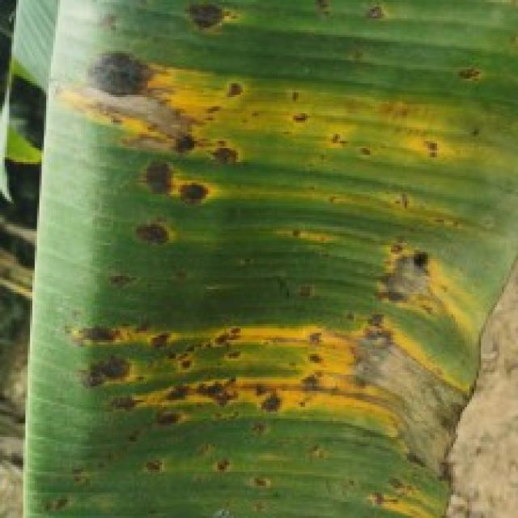
Option 1:
The image shows a leaf with yellow spots and a brownish-yellow color, which indicates that it is affected by a fungal disease. The leaf is attached to a tree branch, and the tree appears to be dead. The visible symptoms of the disease include the yellow spots and the overall brownish-yellow color of the leaf.
A possible solution to this problem is to remove the affected leaves and branches from the tree to prevent the spread of the disease. Additionally, it is essential to practice proper tree care, such as regular pruning, watering, and pest control, to prevent the tree from becoming susceptible to diseases in the future. If the disease is severe, it may be necessary to consult a professional arborist or a local agricultural extension service for further guidance and treatment options.
Option 2:
The visible symptoms in the image include yellowing leaves with brown spots, which are indicative of a disease caused by Pestalotiopsis. This is a fungal pathogen that affects banana plants. Possible solutions include using resistant varieties of bananas, maintaining proper drainage and soil aeration, pruning infected leaves, and applying fungicides as recommended by an agricultural professional.

Which answer do you prefer:

Sample 156

Ground Truth: pestalotiopsis
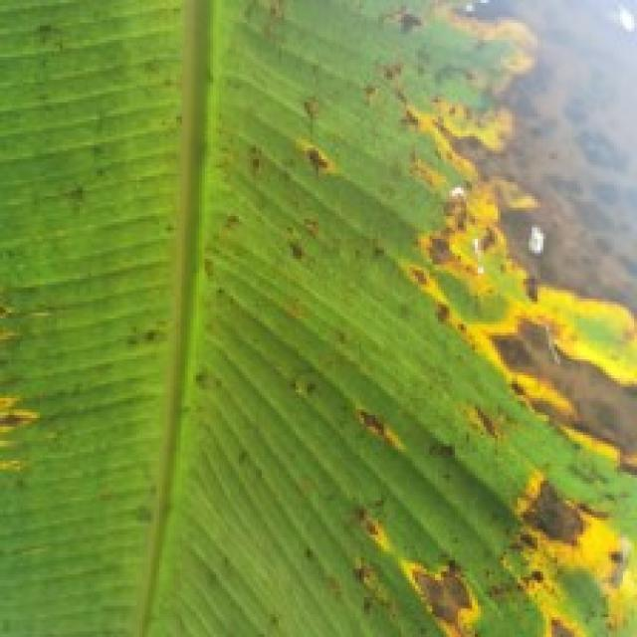
Option 1:
The image shows a tree branch with a yellowish-brown color, which indicates that the tree is suffering from a disease called "Canker" or "Botryosphaeria canker." This disease is caused by the fungus Botryosphaeria diplodia, which affects the tree's vascular system, causing it to lose water and nutrients.
The visible symptoms of this disease include the yellowing and browning of the tree's leaves, branches, and bark. The tree may also exhibit signs of wilting, drying, and eventual death.
A possible solution to this problem is to remove the affected branches and the infected bark, and then apply a fungicide to the tree to prevent the spread of the disease. It is essential to monitor the tree's health and take appropriate measures to prevent the disease from spreading further. Additionally, proper care and maintenance of the tree, such as regular pruning and watering, can help prevent the development of canker and other diseases.
Option 2:
The image shows a close-up view of a banana plant with several visible symptoms indicative of a disease affecting it. The most prominent symptom is the presence of yellowing leaves, which could be due to several factors such as nutrient deficiency, water stress, or disease.
Based on the image provided, it appears that the banana plant is affected by Sigatoka, a fungal disease commonly found in bananas and other plants. The symptoms include yellowing leaves with brown spots and lesions, which are characteristic of this type of disease.
The possible solution for this condition would involve proper identification of the disease by an expert, followed by the application of appropriate fungicides or chemical treatments as recommended by a plant pathologist. Additionally, good plant hygiene practices should be followed to prevent further spread of the disease within the plantation.

Which answer do you prefer:

Sample 157

Ground Truth: pestalotiopsis
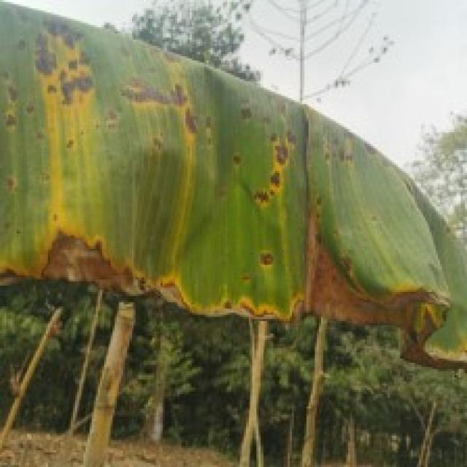
Option 1:
The image shows a leaf with yellow spots and brown patches, which indicates that the plant is suffering from a disease. The disease appears to be affecting the plant's growth and overall health.
The visible symptoms of the disease include yellow spots and brown patches on the leaf, which are indicative of a fungal infection or bacterial disease. The presence of these spots and patches suggests that the plant is experiencing stress or damage due to the disease.
To address this issue, it is essential to identify the specific type of disease affecting the plant and take appropriate measures to treat it. This may involve using fungicides or bactericides to combat the infection, as well as providing proper care and nutrients to help the plant recover and grow healthily. Additionally, it is important to maintain a clean and healthy environment for the plant to prevent the disease from spreading and causing further damage.
Option 2:
The visible symptoms in the image include yellowing leaves with dark spots, which are indicative of a disease affecting the banana plant. The most likely culprit is Pestalotiopsis, a fungus that causes diseases such as Panama disease and Fusarium wilt.
To address this issue, it's important to practice good agricultural practices like proper irrigation, fertilization, and pest management. Additionally, the affected plants should be removed from the field to prevent further spread of the disease. If the damage is severe, chemical treatments may be necessary to control the fungus. It's also important to monitor the health of other plants in the area and take preventive measures to avoid future outbreaks.

Which answer do you prefer:

Sample 158

Ground Truth: pestalotiopsis
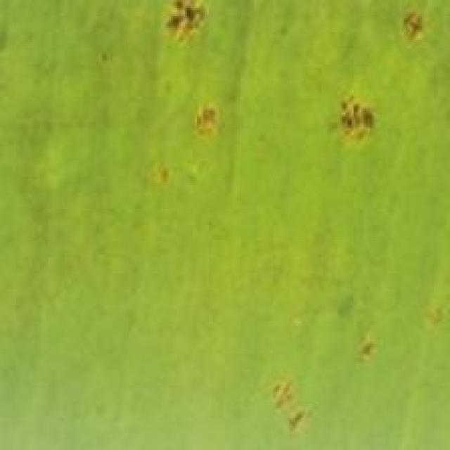
Option 1:
The image shows a leaf with yellow spots and brown patches, which indicates that the plant is suffering from a disease. The disease appears to be affecting the plant's growth and overall health.
The visible symptoms of the disease include yellow spots and brown patches on the leaf, which are indicative of a fungal infection or bacterial disease. The yellow spots may be due to a bacterial infection, while the brown patches could be a result of a fungal infection.
To address this issue, it is essential to identify the specific type of disease causing the symptoms. Once the disease is diagnosed, appropriate treatment measures can be taken to manage the infection and prevent further damage to the plant. This may involve using fungicides or bactericides, as well as practicing good gardening habits such as regular pruning, proper watering, and ensuring adequate sunlight exposure. Additionally, maintaining a healthy plant by providing proper nutrients and pest control measures can help prevent the development of diseases in the future.
Option 2:
The visible symptoms in the image include yellowing leaves with brown spots, which are indicative of a disease caused by the fungus Pestalotiopsis. This disease can affect banana plants and is commonly known as Panama disease or Fusarium wilt.
A possible solution for managing this disease would involve implementing integrated pest management practices such as:
1. Regularly inspecting plants for early signs of infection.
2. Removing infected leaves to prevent further spread of the fungus.
3. Implementing cultural practices like proper drainage, avoiding overcrowding, and maintaining a balanced fertilizer program.
4. Using resistant varieties if available.
5. Applying fungicides when necessary, but always following label recommendations and rotating fungicides to prevent resistance development.
6. Practicing good hygiene in the field, such as keeping tools clean and free of disease-causing organisms.

Which answer do you prefer:

Sample 159

Ground Truth: pestalotiopsis
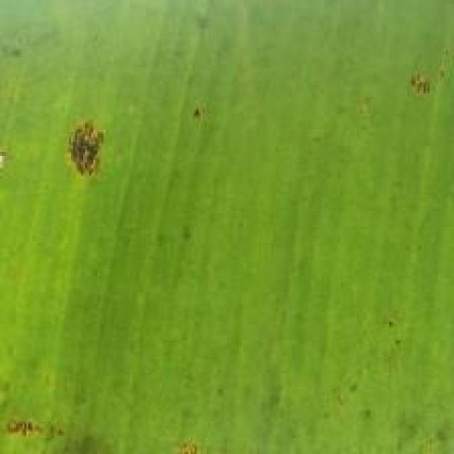
Option 1:
The image shows a banana tree with yellow and green stripes, indicating that it is affected by a disease. The yellow and green stripes are a result of the banana tree being infected by a fungus called Fusarium oxysporum f.sp. cubense, which causes Panama disease. This disease affects the banana tree's growth, fruit production, and overall health.
The visible symptoms of Panama disease include yellowing of the leaves, chlorosis (yellowing of the leaves due to a lack of chlorophyll), and the formation of brown streaks on the leaves. The disease can also lead to the death of the tree.
A possible solution to combat Panama disease is the use of resistant varieties of banana trees, which are less susceptible to the disease. Additionally, proper management practices, such as regular pruning, maintaining adequate spacing between trees, and ensuring proper drainage, can help prevent the spread of the disease. In some cases, fungicides may also be used to control the spread of the fungus.
Option 2:
The visible symptoms on the banana plant include yellowing and discoloration of the leaves, which are indicative of a disease caused by Pestalotiopsis. This disease affects the leaves by causing them to turn yellow with brown spots or lesions. The affected areas may also become necrotic.
A possible solution for this issue would be to treat the plant with fungicides specifically designed to combat Pestalotiopsis. It's important to follow the recommended dosage and application instructions provided by the manufacturer of the fungicide. Additionally, good plant hygiene practices such as removing infected leaves and maintaining proper drainage can help prevent the spread of the disease.

Which answer do you prefer:

Sample 160

Ground Truth: pestalotiopsis
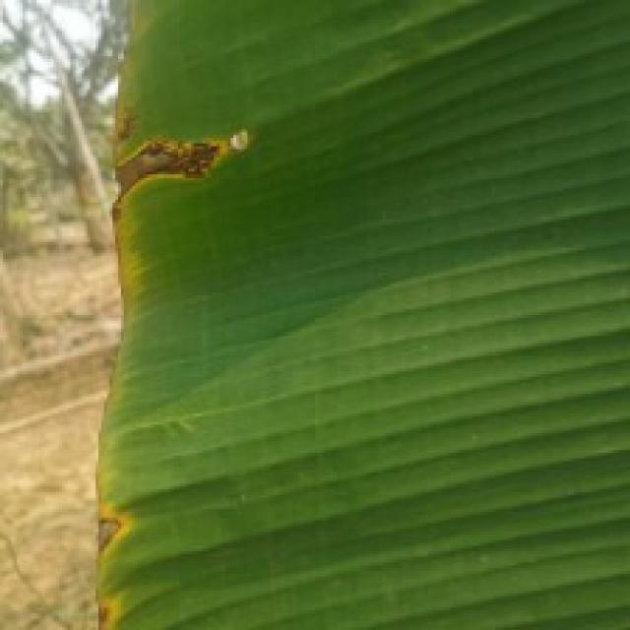
Option 1:
The image shows a leaf with a green stem and a yellowish-green color, which appears to be infected with a disease. The leaf has spots and bumps on it, indicating that it is affected by a fungal infection. The presence of these spots and bumps suggests that the leaf is experiencing a condition called powdery mildew.
Powdery mildew is a common fungal disease that affects various plants, including leafy greens. It is characterized by the growth of white, powdery spores on the leaves, stems, and other parts of the plant. The disease can cause the leaves to become discolored, deformed, and eventually die.
To manage powdery mildew, it is essential to practice good garden hygiene and preventive measures. This includes removing infected leaves and stems, ensuring proper air circulation, and maintaining a healthy balance of nutrients in the soil. Additionally, using organic mulch and avoiding overcrowding plants can help prevent the spread of the disease. If the infection is severe, it may be necessary to use fungicides to control the disease and protect the plant.
Option 2:
The visible symptoms in the image include yellowing of the leaves, which is a common sign of nutrient deficiency or disease. Additionally, there are small, round spots on the leaves that could indicate the presence of pests such as Pestalotiopsis. This type of disease can be identified by the distinctive pattern of spots and discoloration.
A possible solution for this issue would involve a combination of cultural practices, such as removing affected plants from the field to prevent further spread, and chemical treatments to control the pests or diseases. It's important to consult with a plant pathologist or agronomist for an accurate diagnosis and appropriate management strategies tailored to the specific conditions of the plant and the environment.

Which answer do you prefer:

Sample 161

Ground Truth: pestalotiopsis
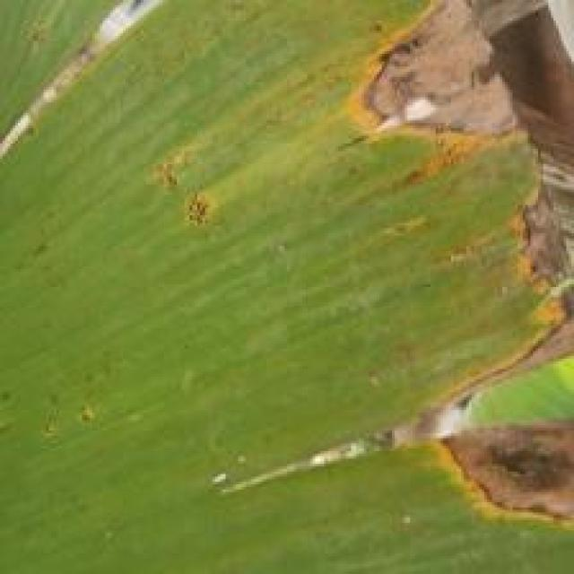
Option 1:
The image shows a leaf with yellow spots and brown patches, which indicates that it is affected by a fungal disease. The leaf appears to be infected with a fungus, causing the yellow spots and brown patches.
To solve this issue, it is essential to identify the specific type of fungus causing the infection and apply appropriate treatment methods. This may involve using fungicides, pruning the affected branches, or removing the infected leaves to prevent the spread of the disease. Additionally, maintaining proper plant care, such as regular watering, ensuring adequate sunlight, and providing proper nutrients, can help prevent the growth of fungi and promote overall plant health.
Option 2:
The banana plant in the image appears to be affected by a disease known as Pestalotiopsis, which is a fungal pathogen that can cause significant damage to banana plants. Visible symptoms include brown spots on the leaves and stems, which are indicative of the fungal infection.
The possible solution for this disease would involve the following steps:
1. Remove infected leaves and stems to prevent further spread of the pathogen.
2. Treat the plant with fungicides specifically designed to combat Pestalotiopsis, such as copper or bordeaux mixture.
3. Implement good hygiene practices in the growing area, including regular cleaning and removal of debris to prevent the build-up of fungal spores.
4. Consider using resistant varieties of banana plants if available, as they are less susceptible to Pestalotiopsis infection.
5. Monitor the plant regularly for any signs of new infections and treat accordingly.

Which answer do you prefer:

Sample 162

Ground Truth: pestalotiopsis
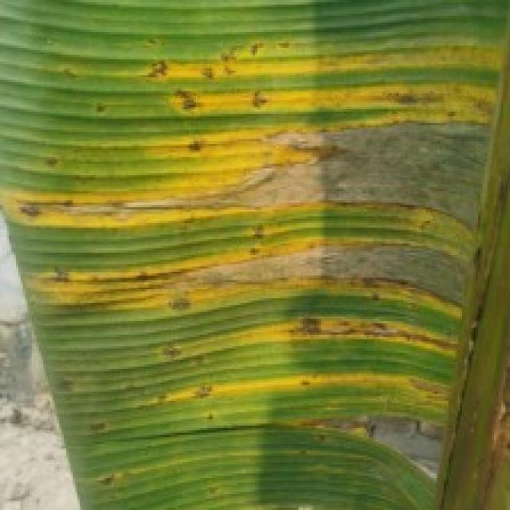
Option 1:
The image shows a banana leaf with yellow spots and brown patches, indicating that it is affected by a disease. The disease appears to be a fungal infection, as the spots and patches are spreading across the leaf. This could be a sign of a bacterial or fungal infection, which can affect the overall health and productivity of the banana plant.
To address this issue, it is essential to identify the specific type of disease and take appropriate measures to prevent its spread. This may involve removing infected leaves, practicing good hygiene, and using organic or chemical-free treatments to control the disease. Additionally, it is crucial to monitor the plant's health regularly and address any signs of infection promptly to minimize the impact on the plant's growth and yield.
Option 2:
The visible symptoms in the image include discoloration, yellowing, and brown spots on the leaves of the banana plant. These are indicative of a disease caused by Pestalotiopsis, which is a fungus that affects bananas.
The possible solutions include:
1. Proper identification of the disease by an expert in plant pathology or a local agricultural extension service.
2. Implementing cultural practices such as removing infected leaves and maintaining good drainage to prevent waterlogging, which can exacerbate the problem.
3. Using fungicides specifically labeled for bananas if necessary, following all recommended application guidelines provided by the manufacturer or a certified pesticide applicator.
4. Monitoring the plant regularly and removing any additional infected leaves as they appear to prevent further spread of the disease.
5. Considering the use of resistant varieties if available in your region, as well as proper sanitation practices to minimize the risk of new infections.

Which answer do you prefer:

Sample 163

Ground Truth: pestalotiopsis
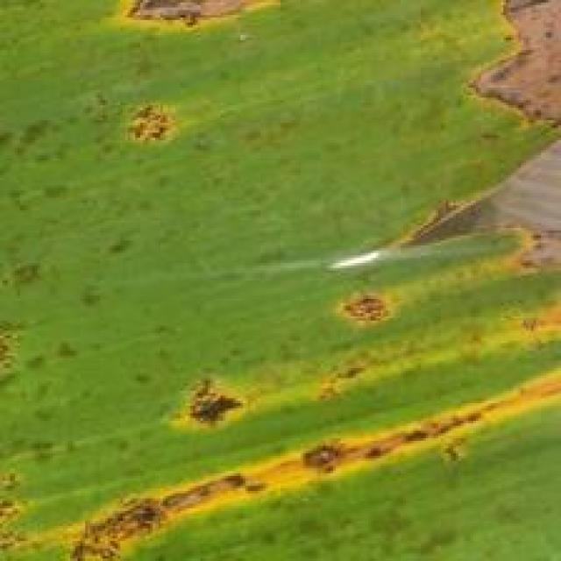
Option 1:
The image shows a banana plant with yellow leaves, which indicates that the plant is suffering from a disease called "Panama disease." This disease is caused by the fungus Fusarium oxysporum f. sp. cubense, which affects the plant's vascular system, causing it to wilt and die.
The visible symptoms of Panama disease include yellowing of the leaves, wilting, and a general decline in the plant's health. The disease can spread rapidly and is difficult to control once it has taken hold.
A possible solution to prevent the spread of Panama disease is to practice good agricultural practices, such as proper irrigation, pest management, and regular monitoring of the plant's health. Additionally, using resistant varieties of banana plants can help reduce the risk of infection. It is also essential to maintain a clean and healthy environment for the plant to thrive.
Option 2:
The visible symptoms in the image include discoloration and damage to the leaves of the banana plant. There are yellowish spots with brown edges, which could indicate a fungal or bacterial infection. Additionally, there appears to be some wilting or drooping of the leaves, which might suggest nutrient deficiency or water stress.
To address these issues, it would be advisable to conduct a thorough inspection of the plant for any signs of pests or diseases that could be causing the damage. If a fungal infection is suspected, appropriate fungicides should be applied according to label instructions. If nutrient deficiency is suspected, soil testing and fertilization may be necessary. Water stress can also cause similar symptoms; therefore, ensuring proper irrigation practices are followed is essential.
It's important to note that a thorough diagnosis by an expert in plant pathology or agronomy would be necessary to determine the exact cause of the damage and provide the most effective solution.

Which answer do you prefer:

Sample 164

Ground Truth: pestalotiopsis
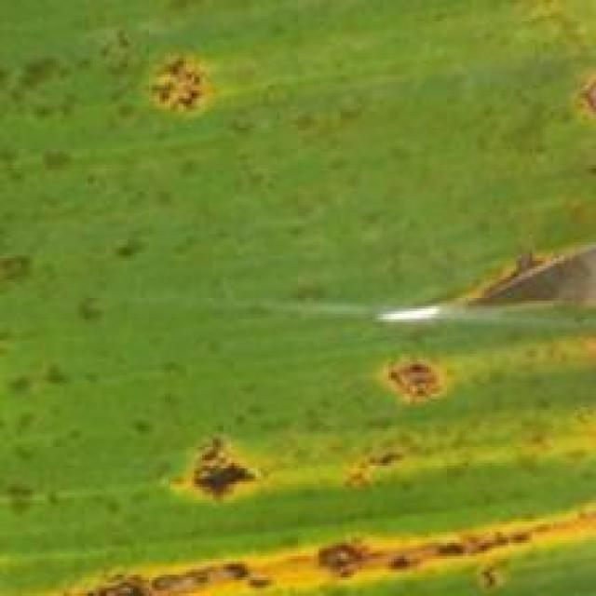
Option 1:
The image shows a close-up of a green leaf with brown spots, which indicates that the leaf is affected by a disease. The brown spots suggest that the leaf is infected with a fungus or bacteria, which can cause the leaf to lose its green color and eventually die.
To address this issue, it is essential to identify the specific type of disease affecting the leaf and take appropriate measures to prevent its spread. This may involve removing infected leaves, practicing proper plant care, and using organic or chemical treatments to control the disease. It is also important to maintain a healthy environment for the plant by providing adequate sunlight, water, and nutrients.
Option 2:
The visible symptoms on the banana plant include yellowing of the leaves, which could indicate a nutrient deficiency or a disease such as Pestalotiopsis. Other signs might include discoloration, spots, or lesions on the leaves. To address this issue, it would be advisable to conduct a thorough inspection of the plant for any signs of pests or diseases, and consider soil testing to ensure proper nutrient levels are maintained. If Pestalotiopsis is identified, appropriate measures such as pruning infected parts, applying fungicides, and improving drainage can be taken to manage the issue.

Which answer do you prefer:

Sample 165

Ground Truth: pestalotiopsis
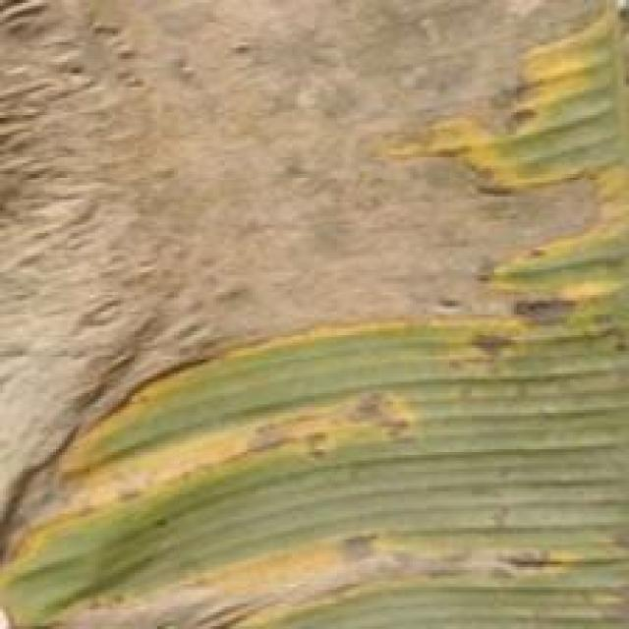
Option 1:
The image shows a banana plant with yellow and green spots on its leaves, which indicates that the plant is suffering from a disease called Panama disease. This disease is caused by the fungus Fusarium oxysporum f. sp. cubense, which affects the plant's vascular system, causing it to wilt and die.
The visible symptoms of Panama disease include yellowing and browning of the leaves, wilting, and eventual death of the plant. The disease can spread rapidly and is difficult to control once it has taken hold.
A possible solution to prevent the spread of Panama disease is to practice good agricultural practices, such as proper planting techniques, regular monitoring of the plant's health, and early detection and removal of infected plants. Additionally, using resistant varieties of banana plants can help reduce the risk of infection.
Option 2:
The visible symptoms in the image include yellowing and discoloration of the leaves, which are indicative of a disease called Sigatoka. This is a fungal disease that affects banana plants. Possible solutions include using fungicides to control the spread of the fungus, as well as practicing good plant hygiene by removing infected leaves and maintaining proper drainage around the plant to prevent waterlogging, which can exacerbate the problem.

Which answer do you prefer:

Sample 166

Ground Truth: pestalotiopsis
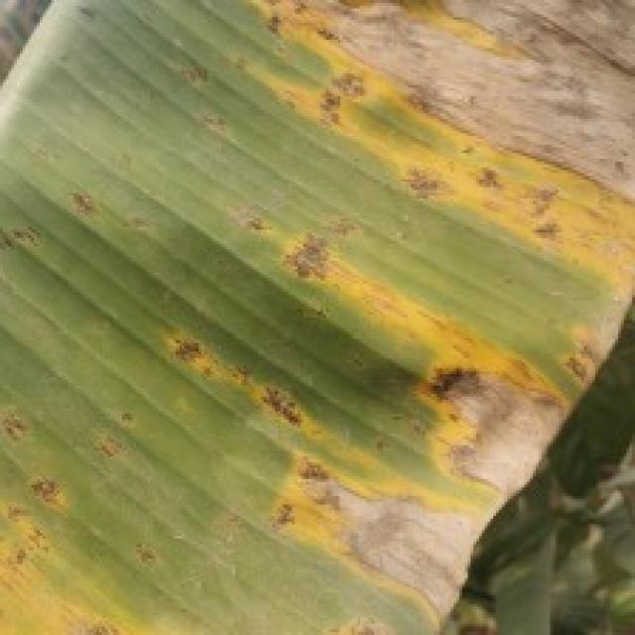
Option 1:
The image shows a leaf with yellow spots, which could be a sign of a disease or a nutrient deficiency. The yellow spots on the leaf are a symptom of the disease, and it is important to identify the specific type of disease to provide an accurate solution.
There are several possible solutions depending on the type of disease:
1. Fungal diseases: If the yellow spots are caused by a fungal infection, the leaf may need to be removed and discarded to prevent the spread of the disease. In addition, applying a fungicide to the plant can help prevent further infections.
2. Bacterial diseases: If the yellow spots are caused by a bacterial infection, the plant may need to be treated with antibiotics or bactericides to combat the disease.
3. Nutrient deficiencies: If the yellow spots are a result of nutrient deficiencies, the plant may need to be fertilized with the appropriate nutrients to help it recover.
It is essential to identify the specific disease or nutrient deficiency to provide the most effective solution for the plant's health.
Option 2:
The visible symptoms on the banana plant in the image include yellowing leaves with brown spots, which are indicative of a disease known as Pestalotiopsis. This disease affects bananas and other plants in the family Musa.
The possible solutions include:
1. Removal of infected leaves to prevent further spread of the disease.
2. Treatment with fungicides specifically designed for controlling Pestalotiopsis, such as Luna Experience or Scala.
3. Implementing cultural practices like proper drainage, avoiding waterlogging, and maintaining adequate spacing between plants to reduce the risk of infection.
4. Regular monitoring of the plant for any signs of new infections and prompt treatment if necessary.

Which answer do you prefer:

Sample 167

Ground Truth: pestalotiopsis
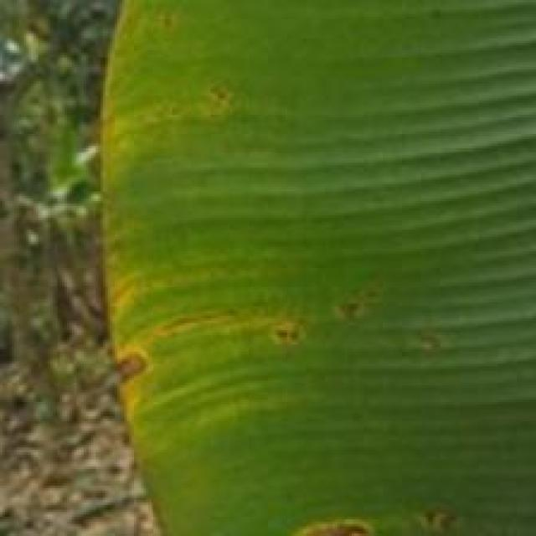
Option 1:
The image shows a leaf with yellow spots and a brownish-yellow color, which indicates that it is affected by a fungal disease. The leaf appears to be infected with a fungus, which is causing the yellow spots and discoloration.
To address this issue, it is essential to identify the specific type of fungus causing the infection and apply appropriate treatment methods. This may involve using fungicides, pruning the affected branches, or removing the infected leaves to prevent the spread of the disease. Additionally, maintaining proper plant care, such as regular watering, ensuring adequate sunlight, and providing proper nutrients, can help prevent the growth of fungi and promote healthy plant growth.
Option 2:
The visible symptoms in the image include discoloration and yellowing of the leaves, which are indicative of a disease affecting the banana plant. The most likely culprit here is Pestalotiopsis, a fungal pathogen that can cause diseases such as Panama disease or Fusarium wilt in bananas.
To address this issue, it would be necessary to conduct a thorough inspection of the plant for any signs of infection, including lesions on the leaves and stems, and the presence of spores or mycelium. If Pestalotiopsis is confirmed, then appropriate fungicidal treatments can be applied as recommended by an agricultural expert. These treatments may include both chemical and biological options, depending on the severity of the infection and the specific needs of the plant.
It's also important to consider cultural practices such as proper drainage, avoiding waterlogging, and maintaining good plant health through regular monitoring and timely intervention to prevent the spread of disease.

Which answer do you prefer:

Sample 168

Ground Truth: pestalotiopsis
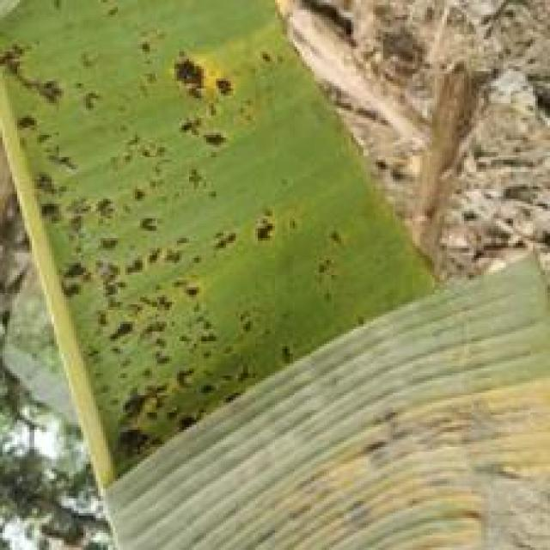
Option 1:
The image shows a leaf with yellow spots and a brownish-yellow color, which indicates that it is affected by a fungal disease. The leaf appears to be infected with a fungus, which is causing the yellow spots and discoloration.
To address this issue, it is essential to identify the specific type of fungus causing the infection and apply appropriate treatment methods. This may involve using fungicides, pruning the affected branches, or removing the infected leaves to prevent the spread of the disease. Additionally, maintaining proper plant care, such as regular watering, ensuring adequate sunlight, and providing proper nutrients, can help prevent the growth of fungi and promote overall plant health.
Option 2:
The visible symptoms in the image include discoloration and yellowing of the leaves, which are indicative of a disease affecting the banana plant. The most likely culprit is Pestalotiopsis, also known as Panama disease tropical race 4 (TR4), which is a fungal disease that affects bananas and other plants in the Musa genus.
The visible symptoms include:
- Yellowing of the leaves, starting from the edges and progressing towards the center.
- Discoloration with brown or black spots on the leaves.
- Leaf necrosis (death) at the tips or margins of the leaves.
- Stunted growth and reduced fruit production.
The possible solution for this disease includes:
- Proper identification of the disease by a plant pathologist or agronomist.
- Implementing cultural practices such as removing infected plants, sanitizing tools, and maintaining clean fields to prevent the spread of the disease.
- Using fungicides that are registered for use in bananas and other crops affected by Pestalotiopsis. It's important to follow label instructions and recommendations from a plant pathologist or agronomist when applying these chemicals.
- Monitoring the plant regularly for any signs of improvement or worsening of the disease.

Which answer do you prefer:

Sample 169

Ground Truth: pestalotiopsis
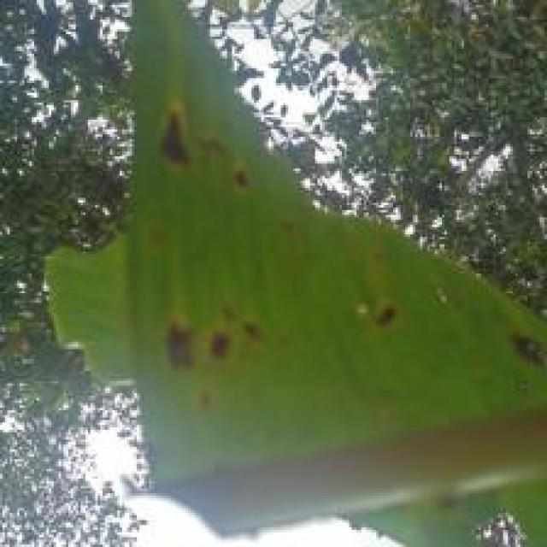
Option 1:
The image shows a leaf with yellow spots and brown patches, which indicates that the leaf is affected by a disease. The disease appears to be spreading, as the spots are growing larger and more numerous.
The visible symptoms of the disease include yellow spots and brown patches on the leaf, which can be indicative of a fungal infection or bacterial disease. The presence of these spots and patches suggests that the plant is under stress, and the disease may be affecting its overall health and growth.
To address this issue, it is essential to identify the specific type of disease affecting the plant and take appropriate measures to treat it. This may involve using fungicides or bactericides to combat the disease, as well as providing the plant with proper care, such as ensuring adequate watering, sunlight, and nutrient intake. Additionally, maintaining a healthy plant environment by removing any infected leaves and practicing good hygiene can help prevent the spread of the disease.
Option 2:
The visible symptoms in the image include discoloration, yellowing, and brown spots on the leaves of the banana plant. These are indicative of a disease caused by Pestalotiopsis, which is a fungus that affects bananas.
The possible solutions include:
1. Removal of infected leaves to prevent further spread of the disease.
2. Use of fungicides specifically designed to combat Pestalotiopsis infections.
3. Improved drainage and air circulation around the plant to reduce humidity levels, which can help prevent the growth of the fungus.
4. Regular monitoring for early detection and treatment of any new infections.

Which answer do you prefer:

Sample 170

Ground Truth: pestalotiopsis
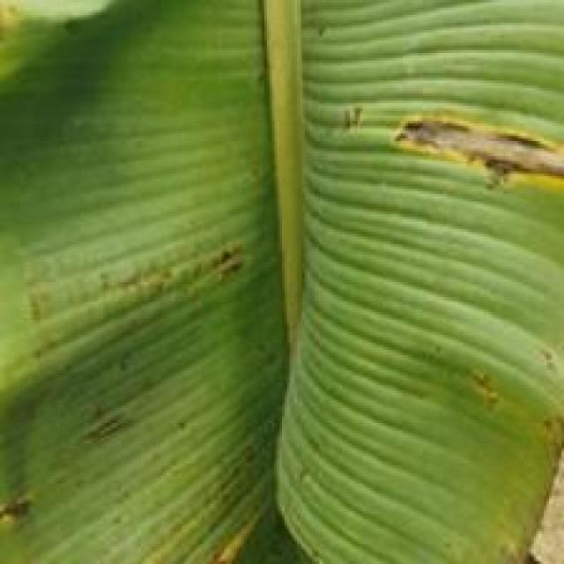
Option 1:
The image shows a leaf with yellow and brown spots, which indicates that it is affected by a fungal disease. The spots are likely caused by a fungus that has infected the leaf, leading to the discoloration and potential damage to the plant.
To address this issue, it is essential to identify the specific type of fungus causing the disease and take appropriate measures to prevent its spread. This may involve removing infected leaves, practicing proper plant care, and using fungicides to treat the affected plant. Additionally, it is important to maintain a healthy environment for the plant by ensuring proper drainage, adequate sunlight, and well-draining soil to minimize the risk of fungal infections in the future.
Option 2:
The visible symptoms in the image include yellowing and discoloration of the leaves, which are indicative of a disease affecting the banana plant. The most likely culprit is Pestalotiopsis, a fungus that can cause diseases such as Panama disease or Fusarium wilt in bananas.
To address this issue, it would be advisable to implement integrated pest management practices including:
1. Regular inspection of plants for early detection of symptoms.
2. Removal and destruction of infected plant material to prevent further spread of the disease.
3. Implementing cultural practices such as proper drainage, avoiding overcrowding, and maintaining a balanced fertilizer program to reduce stress on the plants.
4. Using fungicides when necessary, but always following label recommendations and rotating chemicals to prevent resistance development.
5. Considering biological control methods like using beneficial nematodes or other organisms that can help manage pests and diseases.
6. Monitoring for other signs of disease or pest infestations and addressing them promptly to prevent further damage to the plant.

Which answer do you prefer:

Sample 171

Ground Truth: pestalotiopsis
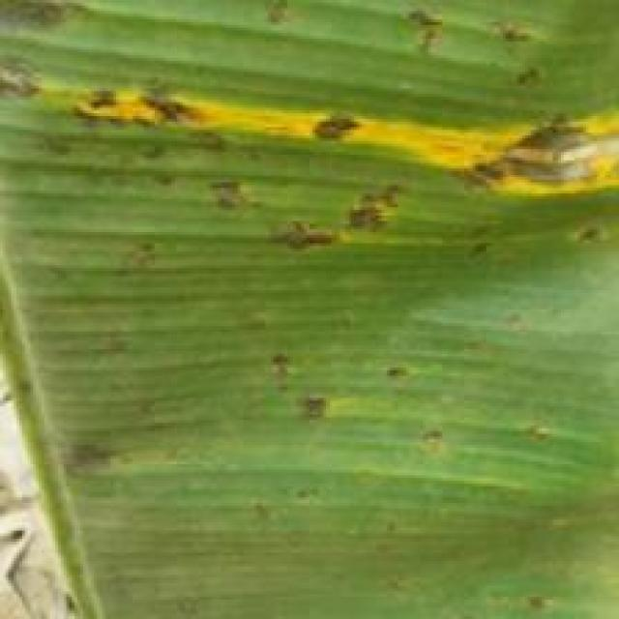
Option 1:
The image shows a leaf with yellow and green spots, which could be a sign of a fungal infection or a bacterial disease. The yellow spots are likely the result of a fungal infection, while the green spots might be a result of a bacterial infection.
To address this issue, it is essential to identify the specific type of infection and the cause of the spots. Once the cause is determined, appropriate treatment can be applied. For fungal infections, it is crucial to remove any infected leaves and branches, and then apply a fungicide to prevent the spread of the disease. For bacterial infections, it is necessary to remove the affected leaves and branches, and then apply a bactericide to kill the bacteria.
In addition to these treatments, it is also important to maintain proper plant care, such as regular pruning, watering, and pest control, to prevent the development of diseases and maintain the health of the plant.
Option 2:
The visible symptoms in the image include yellowing and browning of the leaf, which are indicative of a disease affecting the banana plant. The pattern of discoloration suggests that it could be caused by a fungal or bacterial pathogen.
To address this issue, an agricultural assistant might recommend:
1. Monitoring the health of the plant regularly to identify any further signs of infection or disease progression.
2. Removing and destroying affected leaves to prevent the spread of the pathogen.
3. Implementing good hygiene practices, such as sanitizing tools and equipment that have come into contact with the plant.
4. Considering the use of fungicides or bactericides if the disease is severe or persistent. However, this should be done with caution and in accordance with recommended dosages and application methods to minimize potential harm to the environment and other plants.
5. Assessing the overall health of the plant and considering any other diseases or pests that may be affecting it, as well as providing appropriate nutrients and care to support its recovery.

Which answer do you prefer:

Sample 172

Ground Truth: pestalotiopsis
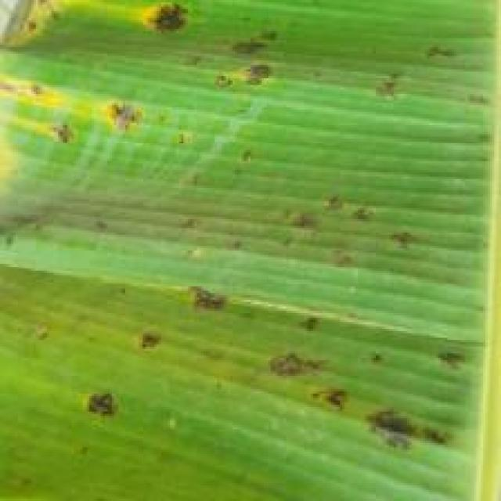
Option 1:
The image shows a banana tree with a brown spot on its leaves, which could indicate a disease or infection. The brown spot is a visible symptom of the problem, and it is essential to identify the cause to address the issue effectively.
There are several possible solutions to address the brown spot on the banana tree. One solution could be to remove the affected leaves and branches, ensuring that the healthy parts of the tree remain untouched. Another solution could be to apply a fungicide or a pesticide to the tree to prevent the spread of the disease or infection. It is also important to monitor the tree's health and take preventive measures, such as regular pruning and maintaining proper drainage, to prevent the recurrence of the problem.
In addition, it is crucial to identify the specific cause of the brown spot, as different diseases or infections may require different treatments. Consulting with a local agricultural expert or a nursery professional can help in identifying the cause and providing appropriate solutions.
Option 2:
The visible symptoms in the image include discoloration, spots, and possibly some damage to the leaves of the banana plant. These could be indicative of a disease caused by Pestalotiopsis, which is a fungus that affects bananas.
The possible solutions include:
1. Proper identification of the disease by an expert in plant pathology or a local agricultural extension service.
2. Implementing cultural practices such as removing infected leaves and maintaining good drainage to prevent waterlogging, which can exacerbate the problem.
3. Using fungicides if necessary, but always following label instructions and seeking advice from a qualified professional to ensure safe and effective use of these chemicals.
4. Monitoring the plant regularly for any further signs of disease and taking appropriate action as needed.

Which answer do you prefer:

Sample 173

Ground Truth: pestalotiopsis
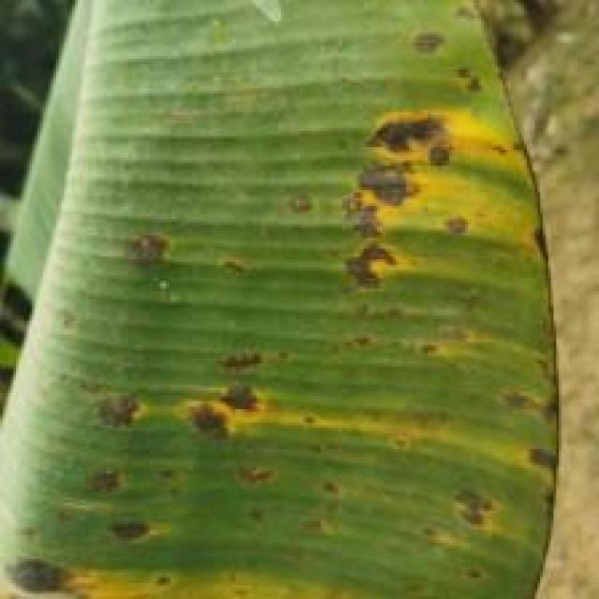
Option 1:
The image shows a leaf with a yellowish-green color, which could be indicative of a disease or a natural aging process. The leaf appears to be infected with a fungus, as it has a brown spot on it. This infection could be caused by various factors, such as overwatering, nutrient imbalances, or poor drainage in the soil.
To address this issue, it is essential to identify the cause of the infection and take appropriate measures to prevent it from spreading to other plants. This may involve adjusting the watering schedule, ensuring proper drainage, and providing the plant with the right balance of nutrients. Additionally, it is crucial to remove any infected leaves and maintain a healthy environment for the plant to recover and grow.
Option 2:
The visible symptoms in the image include discoloration, yellowing, and possibly some spots or lesions on the leaves of the banana plant. These are indicative of a disease called Pestalotiopsis, which is caused by a fungus that affects plants in the family Musa (bananas and plantains).
The possible solution for this disease would involve removing infected leaves and stems, as well as applying fungicides to prevent further spread of the disease. It's also important to maintain good plant hygiene by avoiding waterlogging and ensuring proper drainage. If the plant is severely affected, it may require pruning back to healthy tissue and possibly using resistant varieties of bananas that are less susceptible to this disease.

Which answer do you prefer:

Sample 174

Ground Truth: pestalotiopsis
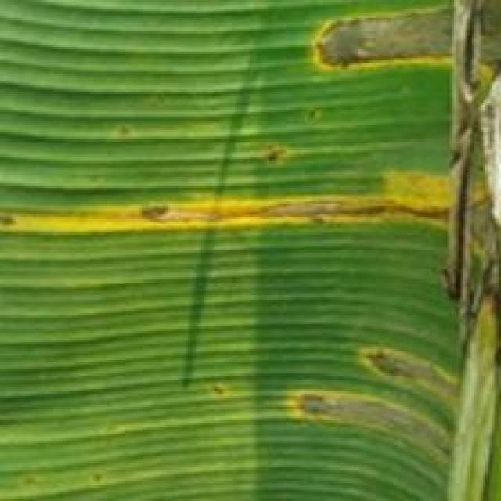
Option 1:
The image shows a leaf with brown spots and holes, which indicates that the plant is suffering from a disease. The disease could be a fungal infection or a bacterial infection, as the spots and holes are characteristic of both types of diseases.
To address this issue, it is essential to identify the specific type of disease causing the symptoms. Once the disease is diagnosed, appropriate treatment measures can be taken. For fungal infections, applying fungicides or using organic methods like neem oil or copper-based products can help control the disease. For bacterial infections, using antibiotics or applying a bactericide can help manage the symptoms.
In addition to treating the disease, it is also important to maintain proper plant care, such as regular watering, pest control, and ensuring adequate nutrient intake, to prevent the disease from recurring.
Option 2:
The visible symptoms in the image include numerous small, round, yellowish spots scattered across the leaves of the banana plant. These spots are indicative of a disease caused by Pestalotiopsis, which is a fungus that affects bananas and other plants in the family Musa.
The possible solution for this disease would involve removing infected leaves to prevent further spread of the fungus, applying fungicides specifically designed to combat Pestalotiopsis, and ensuring proper drainage and air circulation around the plant to reduce humidity levels that can exacerbate the problem. Additionally, maintaining a healthy plant with adequate nutrients and water can help prevent future infections.

Which answer do you prefer:

Sample 175

Ground Truth: pestalotiopsis
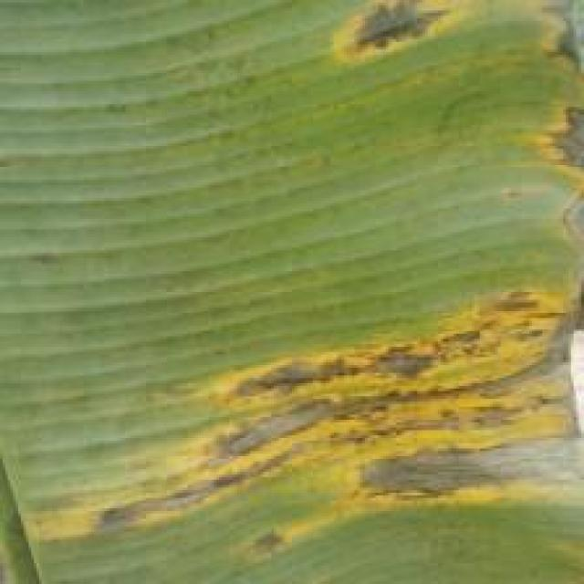
Option 1:
The image shows a leaf with a brown spot, which could be a sign of a fungal infection or a bacterial disease. The brown spot is surrounded by green leaves, indicating that the plant is still healthy in other areas.
To address this issue, it is essential to identify the specific type of disease causing the brown spot. Once the disease is diagnosed, appropriate treatment measures can be taken. For fungal infections, it is crucial to remove the affected leaves and apply a fungicide to prevent the spread of the disease. For bacterial diseases, it is necessary to remove the affected leaves and apply a suitable bactericide to kill the bacteria.
In addition to these treatments, it is also important to maintain proper plant care, such as regular watering, adequate sunlight, and proper nutrient intake, to prevent the development of diseases in the future.
Option 2:
The visible symptoms in the image include yellowing of the leaves, which could indicate a nutrient deficiency or a disease such as Pestalotiopsis. To address this issue, it would be advisable to conduct a thorough inspection of the plant for any signs of pests or diseases, and if found, take appropriate measures such as using organic pesticides, applying fungicides, or pruning infected parts to prevent further spread. Additionally, ensuring proper nutrient management through soil testing and fertilization can help maintain the health of the plant.

Which answer do you prefer:

Sample 176

Ground Truth: pestalotiopsis
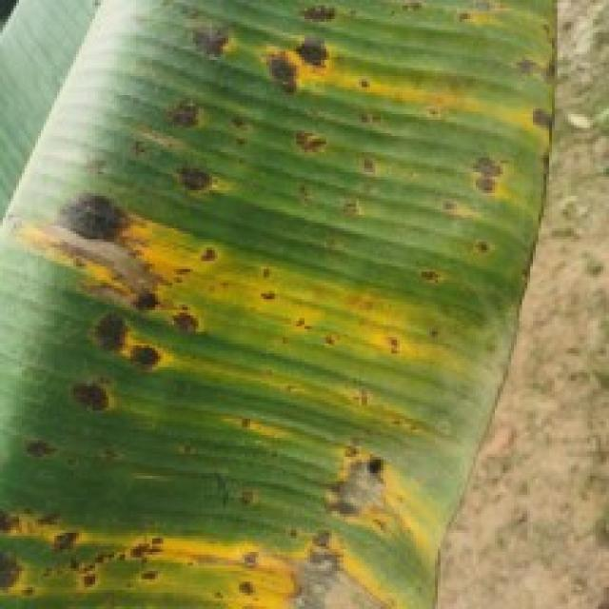
Option 1:
The image shows a banana tree with a large, yellow, and brown leaf, which appears to be infected with a fungal disease. The leaf is covered in spots and has a rotten appearance. This disease can be identified as Fusarium wilt, which is caused by the fungus Fusarium oxysporum.
The visible symptoms of Fusarium wilt include yellowing and browning of the leaves, wilting, and eventual death of the affected parts. The disease can spread rapidly and affect the entire tree if not treated promptly.
A possible solution to this problem is to remove the infected leaves and branches, and then apply a fungicide to the tree to prevent the spread of the disease. It is also essential to practice proper plant care, such as regular watering, adequate sunlight, and well-draining soil, to maintain the health of the tree and prevent the development of diseases.
Option 2:
The visible symptoms in the image include yellowing leaves with brown spots, which are indicative of a disease affecting the banana plant. This could be Pestalotiopsis, also known as Panama disease or Fusarium wilt, which is caused by the fungus Pestalotiopsis.
The possible solution for this disease would involve proper crop management practices such as:
1. Proper drainage and water management to prevent root rot.
2. Regular monitoring of the plant for signs of infection and prompt removal of infected plants to prevent further spread.
3. Use of resistant varieties if available.
4. Implementing fungicide treatments when necessary, although these should be used with caution as they can have negative effects on the environment.
5. Improving soil quality with organic matter and maintaining a balanced fertilization program to support the plant's immune system.

Which answer do you prefer:

Sample 177

Ground Truth: Bract Mosaic Virus

Option 1:
The image shows a banana with brown spots and a greenish-yellow color, which indicates that it is rotting. This could be due to a disease called Panama disease, which affects banana plants and causes the fruit to develop brown spots and eventually die. The visible symptoms of Panama disease include the browning of the fruit, wilting of the plant, and the presence of blackened, shriveled leaves.
A possible solution to prevent the spread of Panama disease is to practice good agricultural practices, such as proper irrigation, pest management, and regular monitoring of the plant's health. Additionally, using resistant varieties of banana plants can help reduce the risk of infection and improve the overall health of the plantation.
Option 2:
The visible symptoms in the image include discoloration, spots, and possibly some wilting or browning on the leaves of the banana plant. These are indicative of a disease caused by the bract mosaic virus (BMV).
The possible solutions for this disease include:
1. Removal of infected plants to prevent further spread of the virus.
2. Implementing good hygiene practices in the growing area to minimize the risk of new infections.
3. Using disease-free planting material for replacement crops.
4. Implementing integrated pest management strategies to control insect vectors that may transmit the virus.
5. Monitoring the health of the plant regularly and removing any additional symptoms as they appear.
6. Considering the use of resistant varieties if available in the region.
7. If the disease is severe, consider chemical treatments under a professional's guidance to manage the outbreak effectively.

Which answer do you prefer:

Sample 178

Ground Truth: Bract Mosaic Virus
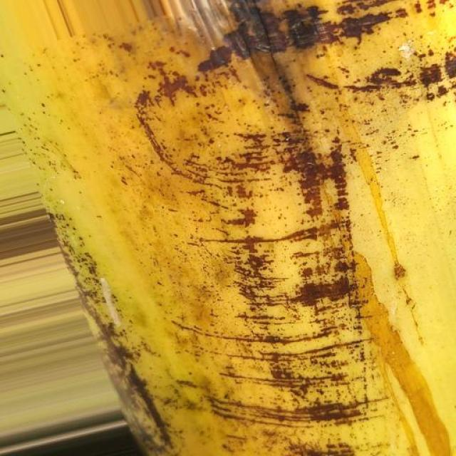
Option 1:
The image shows a banana with brown spots, which indicates that it is rotting or affected by a disease. The brown spots are a visible symptom of the disease, and the banana appears to be overripe.
The possible solution to this problem is to remove the affected parts of the banana and discard them, as the rotting process can spread to other parts of the fruit. It is essential to store the remaining bananas properly to prevent further spoilage. To do this, store the bananas in a cool, dry place, away from direct sunlight and heat sources. Additionally, it is a good idea to consume the bananas before they become overly ripe, as they may become inedible or unappetizing when they are too ripe.
Option 2:
The image shows a close-up view of a banana plant leaf that appears to be affected by a disease, which could be bract mosaic virus. Visible symptoms include discoloration, with yellowing and brown spots on the leaf. These spots are irregularly shaped and may have a mottled appearance. The veins of the leaf may also show signs of discoloration or distortion.
The possible solution for this type of disease would depend on the specific virus causing it. In general, infected plants should be removed from the field to prevent further spread of the disease. If the plant is a commercial crop, it may be necessary to destroy affected plants to prevent the spread of the virus to other plants in the area.
For treatment, if the disease is caused by a bacterial or fungal pathogen, antibiotics or fungicides may be applied. However, if it's a viral disease like bract mosaic virus, there is no known cure and treatment focuses on managing symptoms with appropriate fungicides and pesticides to prevent further spread within the plant or to other plants in the area.

Which answer do you prefer:

Sample 179

Ground Truth: Bract Mosaic Virus
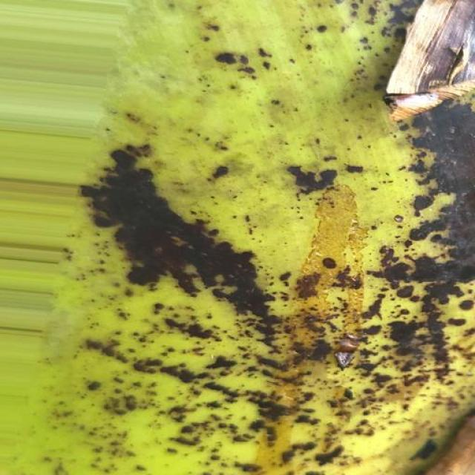
Option 1:
The image shows a banana with brown spots and a yellowish-green color, indicating that it is rotting. This could be due to a disease called Panama disease, which affects banana plants and causes the fruit to develop brown spots and eventually die.
The visible symptoms of Panama disease include brown spots on the banana peel, yellowing of the fruit, and wilting of the plant. The disease is caused by the fungus Fusarium oxysporum f. sp. cubense, which enters the plant through the roots and spreads through the vascular system, causing the plant to become infected and eventually die.
A possible solution to prevent the spread of Panama disease is to practice good agricultural practices, such as proper irrigation, pest management, and regular monitoring of the plant's health. Additionally, using resistant varieties of banana plants can help reduce the risk of infection.
Option 2:
The image shows a banana plant with several visible symptoms indicative of bract mosaic virus infection. These symptoms include:
1. Discoloration: There are yellow spots on the leaves, which is characteristic of the disease.
2. Mosaic pattern: The pattern of discoloration resembles a mosaic pattern, hence the name "mosaic."
3. Leaf deformation: Some leaves appear to be curled or distorted in shape.
4. Reduced vigor: The overall health and growth of the plant seem to be affected, with less vibrant green coloration compared to healthy banana plants.
The possible solution for this disease would involve proper identification by a plant pathologist, followed by removal of infected leaves and possibly treating the plant with fungicides or other recommended treatments to manage the virus. It's also important to maintain good hygiene practices in the growing area to prevent further spread of the disease.

Which answer do you prefer:

Sample 180

Ground Truth: Bract Mosaic Virus
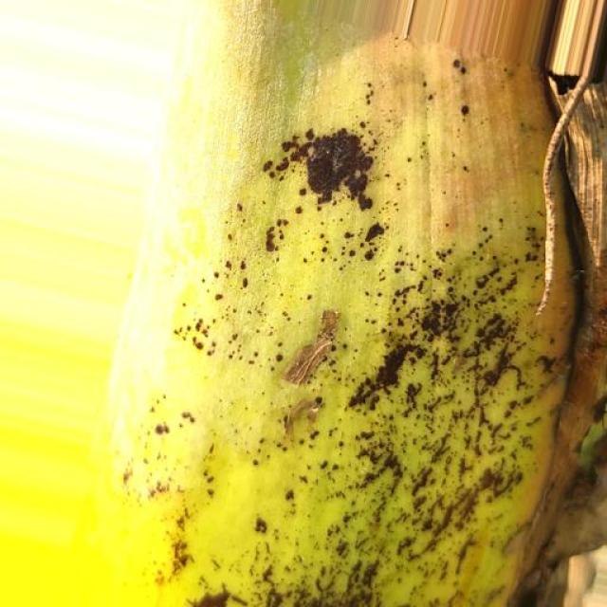
Option 1:
The image shows a banana with brown spots and a black mark on it, which indicates that it is affected by a disease called Panama disease. This disease is caused by the fungus Fusarium oxysporum f. sp. cubense, which attacks the banana plant and causes the fruit to become infected.
The visible symptoms of Panama disease include brown spots on the banana peel, black marks, and a general decline in the plant's health. The disease can lead to the death of the plant and the loss of the fruit production.
A possible solution to prevent the spread of Panama disease is to practice good agricultural practices, such as proper planting techniques, regular monitoring of the plant's health, and early detection and removal of infected plants. Additionally, using resistant varieties of banana plants can help reduce the risk of infection and improve the overall health of the plantation.
Option 2:
The image shows a banana plant with several visible symptoms indicative of a disease affecting the leaves. The most prominent feature is the presence of dark spots or lesions on the surface of the leaves, which could be indicative of a fungal infection such as bract mosaic virus. This type of disease can cause discoloration and deformities in the plant's growth patterns.
To address this issue, it would be advisable to consult with a local agricultural extension service or a plant pathologist for an accurate diagnosis of the disease. If the disease is confirmed as bract mosaic virus, then preventive measures such as removing and destroying infected plants, maintaining clean tools and equipment, and practicing good hygiene can help minimize the spread of the disease. Additionally, applying fungicides may be necessary to control the spread of the fungus causing the infection. It's important to follow all recommended guidelines for the use of pesticides and herbicides to ensure the safety of both the plant and the environment.

Which answer do you prefer:

Sample 181

Ground Truth: Bract Mosaic Virus
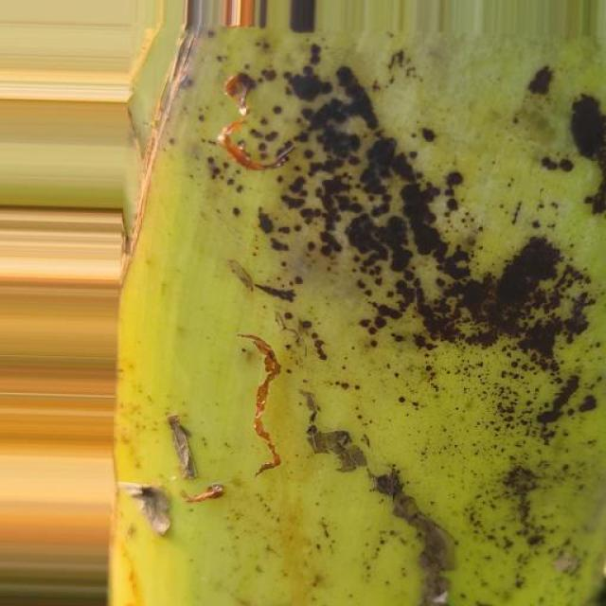
Option 1:
The image shows a banana with brown spots and a blackened stem, which indicates that it is affected by a disease called Panama disease. This disease is caused by the fungus Fusarium oxysporum f. sp. cubense, which attacks the banana plant and causes the fruit to become infected.
The visible symptoms of Panama disease include brown spots on the banana peel, blackened stem, and yellowing of the banana fruit. The disease can lead to the death of the plant and the loss of the entire crop.
A possible solution to prevent the spread of Panama disease is to practice good agricultural practices, such as proper planting techniques, regular monitoring of the plant's health, and early detection and removal of infected plants. Additionally, using resistant varieties of banana plants can help reduce the risk of infection.
Option 2:
The image shows a banana plant with several visible symptoms indicative of bract mosaic virus (BMV). These symptoms include:
1. Discoloration: There are yellowish or brown spots on the leaves, which is characteristic of BMV infection.
2. Mosaic pattern: The pattern of discoloration resembles a mosaic pattern, hence the name "mosaic." This pattern can be seen as irregularly shaped patches of different colors on the leaves.
3. Stunted growth: The plant appears to have stunted growth, with smaller leaves and possibly less vigorous overall appearance compared to healthy banana plants.
4. Reduced vigor: The plant looks weaker and less robust than a healthy banana plant, which could be due to the viral infection affecting its vitality.
A possible solution for this plant would involve proper identification by an expert, followed by removal of infected leaves and possibly treating the plant with appropriate fungicides or other treatments recommended for BMV-affected plants. It's important to note that a diagnosis from a qualified professional is necessary before implementing any treatment plan.

Which answer do you prefer:

Sample 182

Ground Truth: Bract Mosaic Virus
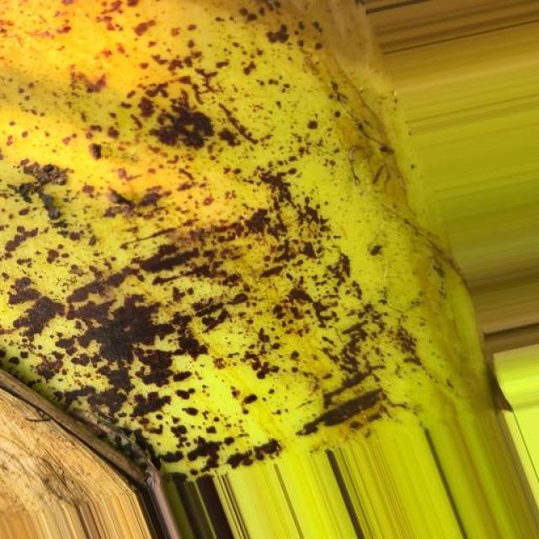
Option 1:
The image shows a banana with brown spots and a yellowish-green color, indicating that it is rotting. This could be due to a disease called Panama disease, which affects banana plants and causes the fruit to become infected and rotten. The visible symptoms include brown spots and a yellowish-green color, which are indicative of the disease's progression.
A possible solution to prevent the spread of the disease and save the banana plant is to practice proper plant care, such as regular pruning, removing infected parts, and ensuring proper drainage and nutrient supply. Additionally, using resistant varieties of banana plants can help protect the plant from the disease. It is also essential to maintain a healthy environment for the plant, including regular watering, pest control, and monitoring for any signs of disease.
Option 2:
The image shows a banana plant with several visible symptoms indicative of a disease known as Bract Mosaic Virus (BMV). Here are the details based on what I can see:
1. **Discoloration**: There is yellowing and discoloration of the leaves, which is characteristic of BMV infection. The affected areas may have a mottled appearance with patches of green, brown, or black.
2. **Mosaic Pattern**: The most distinctive symptom is the presence of a mosaic pattern on the leaves. This pattern consists of irregularly shaped, yellowish-brown spots that can merge into larger areas of discoloration.
3. **Stunted Growth**: Affected plants may show stunted growth due to the infection. The leaves may be smaller than normal and may not develop properly.
4. **Premature Browning**: There is premature browning of the leaf margins, which is another characteristic symptom of BMV infection.
5. **Potato-like Appearance**: The affected areas can have a potato-like appearance with dark brown or black spots surrounded by yellow haloes.
6. **Diseased Tissue**: There may be necrotic tissue visible on the leaves, which is a sign of severe infection.
7. **Disease Progression**: The disease progresses from the tips of the leaves to the entire leaf surface and eventually spreads to the stem.
8. **Disease Spread**: BMV can spread through insects visiting infected plants or by windborne spores.
The solution for this disease would typically involve removing affected leaves, sanitizing tools used for pruning, and ensuring proper drainage to prevent waterlogging, which can exacerbate the problem. In some cases, chemical treatments may be necessary to control the virus. It's also important to monitor the plant regularly for any signs of improvement or worsening and adjust management practices accordingly.

Which answer do you prefer:

Sample 183

Ground Truth: Bract Mosaic Virus
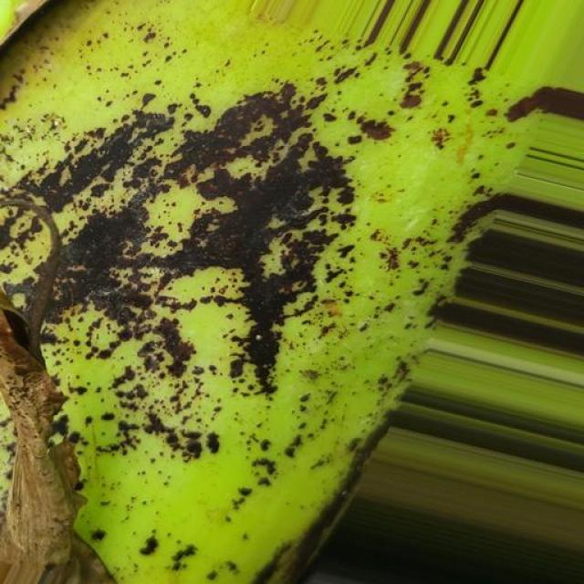
Option 1:
The image shows a banana with brown spots, which indicates that it is affected by a disease called Panama disease. This disease is caused by the fungus Fusarium oxysporum f. sp. cubense, which attacks the banana plant and causes the fruit to develop brown spots and eventually die.
The visible symptoms of Panama disease include brown spots on the banana peel, wilting of the plant, and a general decline in the plant's health. The disease can spread rapidly and affect the entire plant, leading to a significant loss of yield and potentially the death of the plant.
A possible solution to prevent the spread of Panama disease is to practice good agricultural practices, such as proper planting techniques, regular monitoring of the plant's health, and early detection and removal of infected plants. Additionally, using resistant varieties of banana plants can help reduce the risk of infection and improve the overall health of the plant.
Option 2:
The image shows a banana plant with several visible symptoms indicative of a bract mosaic virus infection. These symptoms include:
1. Discoloration: There are yellowing and browning areas on the leaves, which is characteristic of the disease.
2. Mosaic pattern: The most distinctive feature is the mosaic pattern on the leaves, where they appear to be a mix of green and brown patches.
3. Stunted growth: The plant's growth appears stunted, with smaller leaves and possibly less vigorous overall appearance compared to healthy banana plants.
The possible solution for this disease would involve proper identification by an expert in plant pathology or a diagnostic lab, followed by implementing measures such as removing infected plants, sanitizing tools and equipment, and possibly using resistant varieties if available. Additionally, good hygiene practices should be maintained to prevent the spread of the virus within the farm or garden.

Which answer do you prefer:

Sample 184

Ground Truth: Bract Mosaic Virus
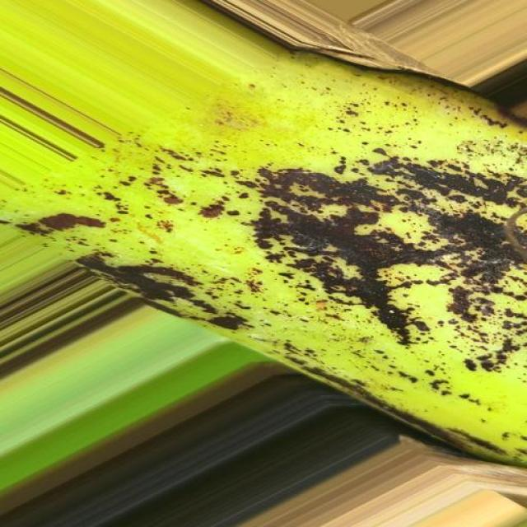
Option 1:
The image shows a banana with brown spots and a hole in it, which indicates that it is affected by a disease called Panama disease. This disease is caused by the fungus Fusarium oxysporum f. sp. cubense, which attacks the banana plant and causes the fruit to become infected.
The visible symptoms of Panama disease include brown spots on the banana peel, which are caused by the fungus's growth and spread. The fruit may also become deformed, and the peel may become soft and mushy.
A possible solution to prevent the spread of Panama disease is to practice good agricultural practices, such as proper soil management, crop rotation, and the use of resistant varieties of banana plants. Additionally, regular monitoring of the plant's health and early detection of the disease can help in controlling its spread and minimizing the impact on the banana crop.
Option 2:
The image shows a banana plant with several visible symptoms indicative of a bract mosaic virus infection. These symptoms include:
1. Discoloration: There are areas on the leaves where the color is distorted, with yellowing and browning. This is characteristic of the discoloration caused by the virus.
2. Mosaic pattern: The most distinctive feature is the mosaic pattern on the leaves, which consists of irregularly shaped patches of different colors (yellow, green, brown). This pattern is a result of the virus affecting the plant's ability to produce normal pigmentation.
3. Leaf deformation: Some leaves appear to be curled or distorted in shape, which can be a sign of viral infection.
4. Stunted growth: The overall appearance of the plant suggests that it may not be growing as healthily as it would without the virus.
The possible solution for this plant would involve removing infected leaves and implementing measures to prevent the spread of the virus within the plantation. This may include using disease-free plants for propagation, maintaining clean cultivation practices, and possibly using chemical treatments if recommended by a professional in the context of organic or integrated pest management.

Which answer do you prefer:

Sample 185

Ground Truth: Bract Mosaic Virus
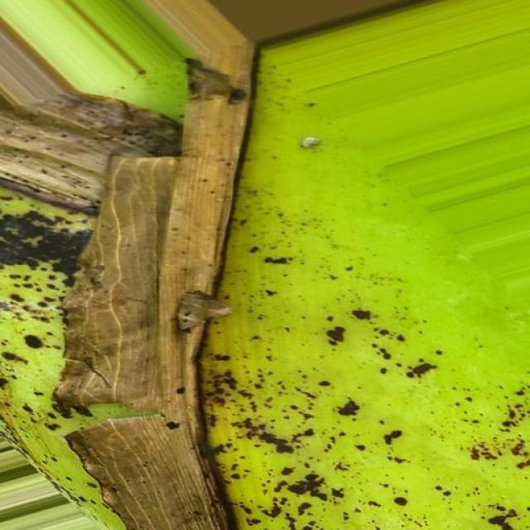
Option 1:
The image shows a banana tree with a large, brown, and rotten banana hanging from it. The banana appears to be infected with a fungal disease, which is indicated by the brown spots and the overall rotten appearance. This disease can be caused by various factors, such as overwatering, underwatering, or poor soil quality.
To address this issue, it is essential to identify the cause of the disease and take appropriate measures to prevent further damage. This may include adjusting the watering schedule, ensuring proper drainage, and providing the banana tree with well-draining soil. Additionally, it is crucial to remove any infected or rotten parts of the banana tree to prevent the spread of the disease. If the disease is severe, it may be necessary to consult a professional to determine the best course of action for treating and preventing further damage to the banana tree.
Option 2:
The visible symptoms in the image include discoloration and spots on the leaves, which are characteristic of a disease known as Banana Bract Mosaic Virus (BBMV). This virus affects bananas and other plants in the Musa genus.
The possible solutions for this disease include:
1. Proper identification by an expert to confirm the presence of BBMV.
2. Implementing a preventive measure such as removing infected plants from the field to prevent further spread of the virus.
3. Using disease-free planting material for new plantings.
4. Implementing good hygiene practices in the growing area, including regular cleaning and sanitizing tools and equipment.
5. Monitoring the health of the plants regularly for early detection of any signs of the disease.
6. If necessary, applying fungicides or other chemical treatments as recommended by a plant pathologist.
7. Practicing crop rotation to reduce the risk of virus transmission from one plant to another.

Which answer do you prefer:

Sample 186

Ground Truth: Bract Mosaic Virus
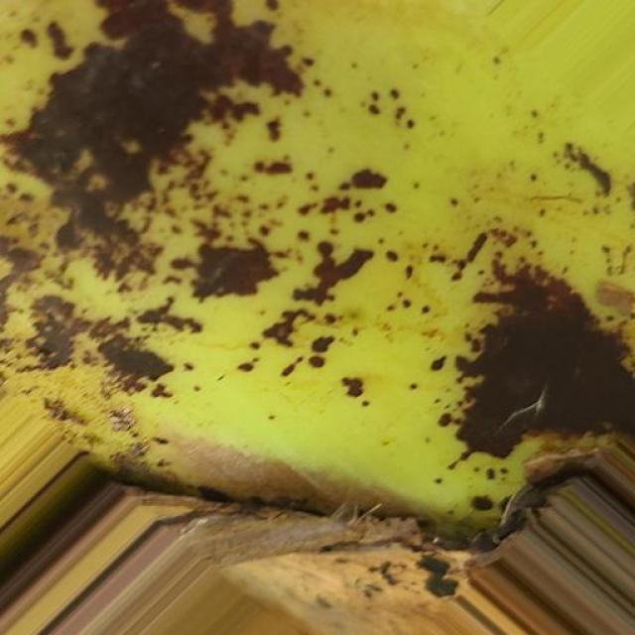
Option 1:
The image shows a large green plant with brown spots and a brown leaf. The brown spots on the plant could be a sign of a disease or infection, which may affect the plant's health and growth. Possible solutions to address this issue include:
1. Identifying the specific disease or infection causing the brown spots and consulting with a plant expert or a local nursery to determine the appropriate treatment.
2. Implementing proper care practices, such as regular watering, sunlight exposure, and pest control, to maintain the plant's health and prevent further damage.
3. If the disease is severe, it may be necessary to remove the affected parts of the plant and replace them with healthy, disease-free cuttings or plants to prevent the spread of the disease.
It is essential to monitor the plant's health and take appropriate action to ensure its well-being and prevent any further damage.
Option 2:
The visible symptoms in the image include brown spots and discoloration on the leaves of the banana plant. These are indicative of a disease caused by the bract mosaic virus (BMV). This virus affects bananas and other plants in the Musa genus.
The possible solution for this disease would involve:
1. Removal of infected leaves to prevent further spread of the virus.
2. Implementing good hygiene practices to prevent the entry of the virus into healthy plants.
3. Using disease-free planting material when propagating new plants.
4. Monitoring the plant for any signs of improvement or worsening and adjusting management practices accordingly.
5. If necessary, consider using chemical treatments such as fungicides to control the spread of the virus within the plant. However, this should be done with caution and in accordance with local regulations and guidelines.

Which answer do you prefer:

Sample 187

Ground Truth: Bract Mosaic Virus
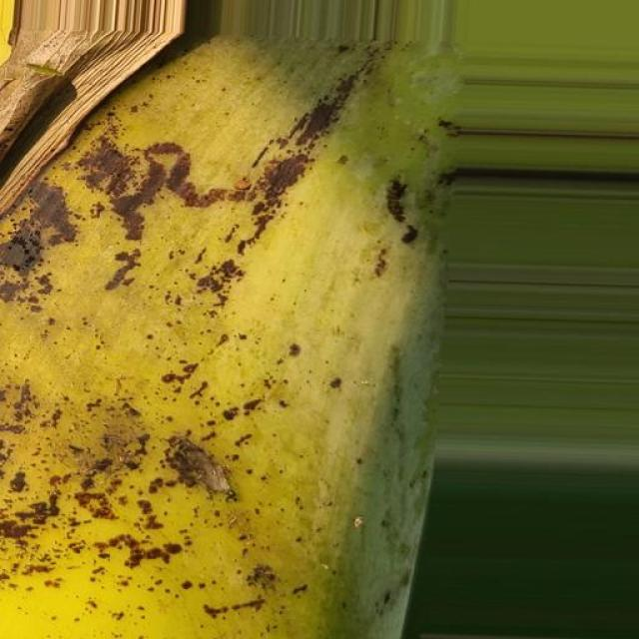
Option 1:
The image shows a banana with brown spots and a small insect, possibly a fruit fly, resting on it. The brown spots on the banana indicate that it is overripe and may have a disease called Panama disease, which is caused by the fungus Fusarium oxysporum f. sp. cubense. This disease affects banana plants and can lead to the death of the plant if not treated.
The visible symptoms of Panama disease include brown spots on the banana, yellowing of the leaves, and stunted growth. The fruit itself may become deformed and develop a blackened core.
To prevent the spread of Panama disease and protect the banana plant, it is essential to practice proper hygiene and sanitation, remove infected plants, and use resistant varieties of banana plants. Additionally, regular monitoring of the plant's health and early detection of any signs of disease can help in controlling the spread of the disease.
Option 2:
The image shows a banana plant with several visible symptoms indicative of bract mosaic virus infection. These symptoms include:
1. Discoloration: There are patches on the leaves that appear to be yellow or brown, which is not typical for healthy banana plants.
2. Mosaic pattern: The most striking feature is the mosaic pattern on the leaves. This pattern consists of irregularly shaped areas where the coloration is different from the rest of the leaf.
3. Stunted growth: The plant appears to have stunted growth, with smaller leaves and possibly a reduced number of fruiting clusters (bananas).
4. Deformed fruit: If there are any visible fruit in the image, they might also show signs of deformation or abnormal coloration due to the virus infection.
The solution for this disease would typically involve removing infected plants from the field and destroying them to prevent further spread of the virus. Additionally, good hygiene practices should be followed to prevent the introduction of the virus into healthy plants. If a banana plant is found to be infected with bract mosaic virus, it is important to isolate it from other plants and monitor its condition closely for any changes that might indicate a worsening of the infection.

Which answer do you prefer:

Sample 188

Ground Truth: Bract Mosaic Virus

Option 1:
The image shows a large, brown, and rotten banana tree with a large, brown, and rotten banana. The tree appears to be infected with a fungal disease, which is causing the rotting and decay of the banana. The visible symptoms include the brown and rotten appearance of the banana and the overall decay of the tree.
A possible solution to this problem is to remove the affected parts of the tree and the rotten banana, and then apply a fungicide to the tree to prevent the spread of the disease. Additionally, proper care and maintenance of the tree, such as regular pruning and ensuring proper drainage, can help prevent the growth of fungi and other pathogens that can cause similar issues in the future.
Option 2:
The visible symptoms in the image include discoloration, with yellowing and brown spots on the leaves. This could be indicative of a bract mosaic virus infection. Possible solutions include removing affected plants from the field to prevent further spread of the disease, using clean tools when working with healthy plants, and considering the use of resistant varieties if available. It's also important to monitor for any signs of the disease in other plants and take appropriate measures to prevent its spread.

Which answer do you prefer:

Sample 189

Ground Truth: Bract Mosaic Virus
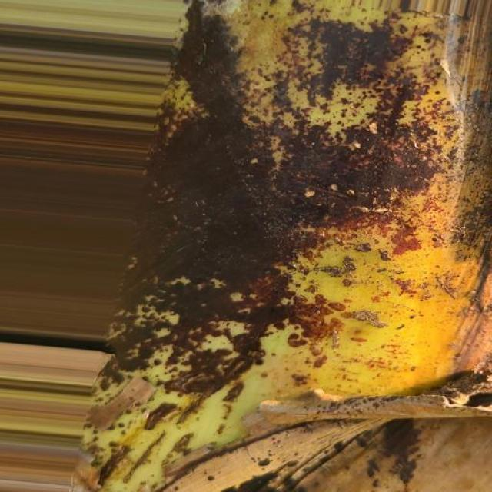
Option 1:
The image shows a green and yellow object with a hole in it, possibly a piece of wood or a metal pipe. The hole appears to be rusty, which suggests that the object has been exposed to moisture and has experienced corrosion. This could be a sign of a disease called "rust" or "corrosion" that affects the metal or wood.
The visible symptoms of rust or corrosion include the formation of rusty or brown spots on the surface of the object, which can lead to the weakening and eventual breakdown of the material. The hole in the object is a clear indication of the damage caused by the rust or corrosion.
A possible solution to prevent further damage and restore the object's functionality is to clean and treat the affected area with a rust-removing or corrosion-inhibiting solution. This may involve sanding, priming, and painting the surface to protect it from future damage. Additionally, it is essential to address the source of the moisture that caused the rust or corrosion, such as fixing any leaks or ensuring proper ventilation, to prevent future damage.
Option 2:
The image shows a banana plant with several visible symptoms that could be indicative of bract mosaic virus infection. These symptoms include:
1. Discoloration: There are areas on the leaves where the color is not uniform, with patches that appear yellow, green, or red. This discoloration is a characteristic feature of many viruses affecting plants.
2. Mosaic pattern: The term "mosaic" refers to the irregular and interspersed patterns of coloration on the leaves. In this case, there are areas where the colors are not uniform, creating a mosaic-like appearance.
3. Leaf deformation: Some of the leaves show signs of distortion or curling, which can be a result of viral infection affecting the plant's ability to photosynthesize normally.
4. Stunted growth: The overall appearance of the plant suggests that it may be experiencing stunted growth due to the virus.
To address this issue, it would be advisable for an agricultural assistant to perform a diagnosis by examining the plant closely and possibly collecting samples for laboratory testing to confirm the presence of bract mosaic virus. If the virus is confirmed, then appropriate measures can be taken such as removing infected plants, sanitizing tools and equipment, and possibly using resistant varieties or chemical treatments if necessary.

Which answer do you prefer:

Sample 190

Ground Truth: Bract Mosaic Virus
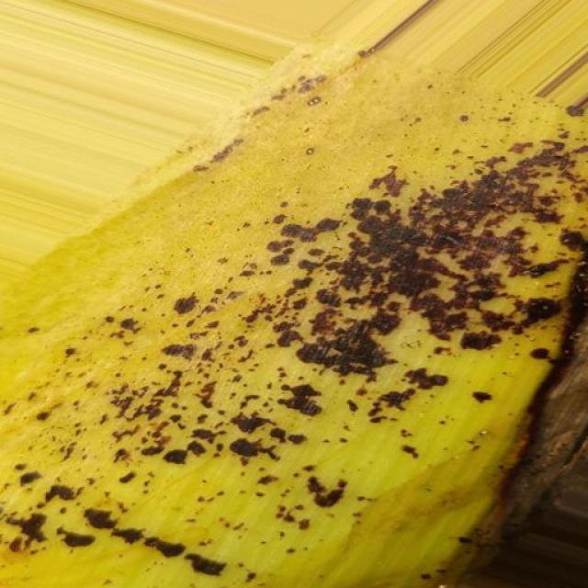
Option 1:
The image shows a banana with brown spots and a yellowish-green color, indicating that it is rotting. This could be due to a disease called Panama disease, which affects banana plants and causes the fruit to develop brown spots and eventually die. The disease is caused by the fungus Fusarium oxysporum f. sp. cubense, which enters the plant through the roots and spreads through the plant's vascular system.
The visible symptoms of Panama disease include brown spots on the banana fruit, wilting of the plant, and a general decline in the plant's health. The disease can lead to significant crop losses for farmers.
A possible solution to prevent the spread of Panama disease is to practice good agricultural practices, such as proper soil management, regular irrigation, and the use of resistant varieties of banana plants. Additionally, regular monitoring of the plant's health and early detection of the disease can help in controlling its spread and minimizing crop losses.
Option 2:
The visible symptoms in the image include discoloration and spots on the leaves of the banana plant. These spots are a characteristic sign of bract mosaic virus infection in bananas. The affected leaves may appear yellowed or have brown or black spots, which can be indicative of the disease.
A possible solution for this disease would involve proper sanitation practices to prevent the spread of the virus, such as removing infected plants and de-budding (removing the flower clusters) to prevent the spread of the virus through insects visiting the flowers. Additionally, using clean tools when pruning or removing diseased tissue can help minimize the risk of transmission.
In terms of treatment, there is no cure for bract mosaic virus infections. However, infected plants can still produce fruit, and the disease does not necessarily mean that the entire plant will be affected or die. If the disease is severe enough to impact yield or quality, then it might be beneficial to consider removing affected plants and replacing them with healthy ones.

Which answer do you prefer:

Sample 191

Ground Truth: Bract Mosaic Virus
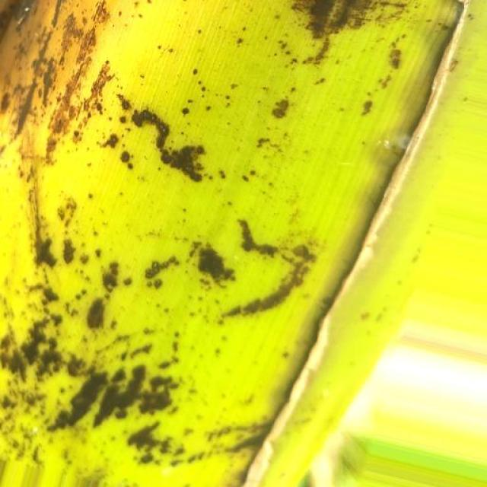
Option 1:
The image shows a banana with brown spots and a white spot, which indicates that it is affected by a fungal disease called "Panama disease." This disease is caused by the fungus Fusarium oxysporum f. sp. cubense, which can cause significant damage to banana plants and reduce their productivity.
The visible symptoms of Panama disease include brown spots on the banana peel, which are caused by the fungus invading the plant's tissues and disrupting the normal growth process. The white spot on the banana peel is a result of the fungus producing a toxin that affects the plant's ability to produce chlorophyll, leading to the discoloration.
A possible solution to prevent the spread of Panama disease is to practice good agricultural practices, such as proper planting techniques, regular monitoring of the plant's health, and timely removal of infected plants. Additionally, using resistant varieties of banana plants can help reduce the risk of infection and improve the overall health of the plantation.
Option 2:
The image shows a banana plant with several visible symptoms indicative of bract mosaic virus infection. These symptoms include:
1. Discoloration: There are brown or black spots on the leaves, which is characteristic of the disease.
2. Deformation: The leaves appear to be curled and distorted, which is another common sign of bract mosaic virus infection.
3. Stunting: The plant's growth appears stunted compared to healthy plants.
4. Reduced fruit production: There may be a reduction in the number of bananas produced on the plant due to the disease.
The possible solution for this plant would involve removing infected leaves and implementing measures to prevent further spread of the virus, such as using clean tools and maintaining good hygiene practices when working with plants. Additionally, if the virus is severe enough, chemical treatments may be necessary to control its spread.

Which answer do you prefer:

Sample 192

Ground Truth: Bract Mosaic Virus
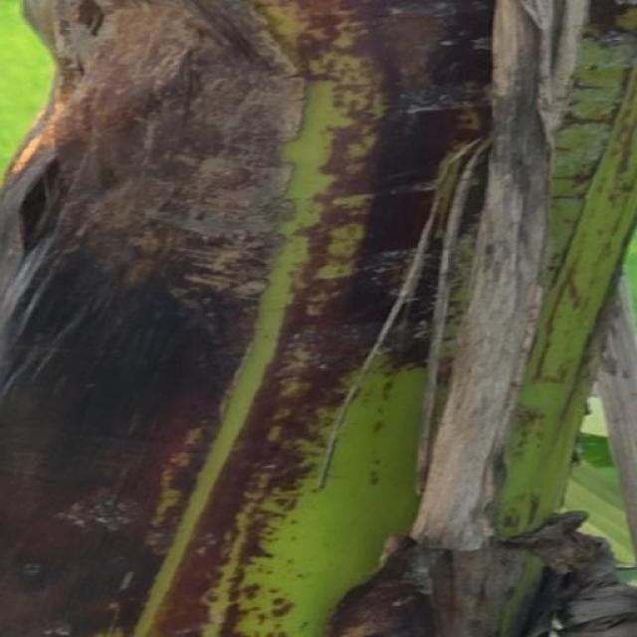
Option 1:
The image shows a banana with brown spots and black marks, which indicates that it is affected by a disease called Panama disease. This disease is caused by the fungus Fusarium oxysporum f. sp. cubense, which attacks the banana plant and causes the fruit to become infected.
The visible symptoms of Panama disease include brown spots and black marks on the banana fruit, as well as yellowing of the leaves and stems. The disease can lead to the death of the plant if not treated properly.
A possible solution to prevent the spread of Panama disease is to practice good agricultural practices, such as proper planting techniques, regular monitoring of the plant's health, and timely removal of infected plants. Additionally, using resistant varieties of banana plants can help reduce the risk of infection. It is also essential to maintain a clean and healthy environment for the plants to minimize the chances of disease transmission.
Option 2:
The visible symptoms in the image include yellowing of the leaves, which is a common sign of bract mosaic virus infection in bananas. The affected areas have dark spots or lesions that are indicative of the disease.
The solution for this type of disease would typically involve removing and destroying infected plants to prevent further spread. Additionally, using disease-free planting material and following good hygiene practices can help prevent the spread of the virus within a farm or garden. It's also important to monitor the health of the plants regularly and treat them with appropriate fungicides if necessary.

Which answer do you prefer:

Sample 193

Ground Truth: Bract Mosaic Virus
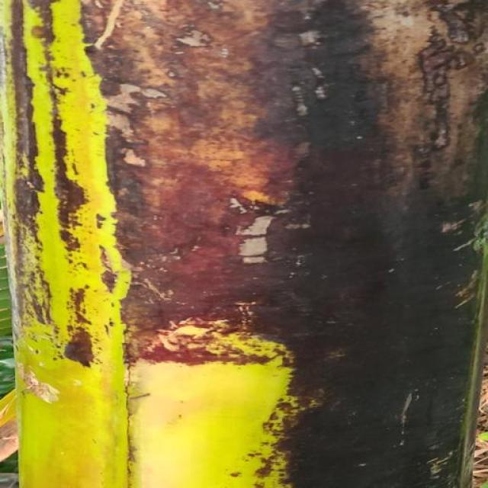
Option 1:
The image shows a banana with brown spots, which indicates that it is affected by a disease called Panama disease. This disease is caused by the fungus Fusarium oxysporum f. sp. cubense, which attacks the banana plant and causes the fruit to develop brown spots and eventually die.
The visible symptoms of Panama disease include brown spots on the banana peel, yellowing of the fruit, and wilting of the plant. The disease can lead to significant yield losses and even the death of the plant if not treated properly.
A possible solution to prevent the spread of Panama disease is to practice good agricultural practices, such as proper planting techniques, regular monitoring of the plant's health, and timely removal of infected plants. Additionally, using resistant varieties of banana plants can help reduce the risk of infection. It is also essential to maintain a clean and healthy environment for the plants to minimize the chances of disease transmission.
Option 2:
The image shows a banana plant with several visible symptoms indicative of bract mosaic virus infection. These symptoms include:
1. Discoloration: There are brown spots on the leaves, which is characteristic of the disease.
2. Mosaic pattern: The leaves exhibit a mottled appearance with yellow and green patches, which is another sign of the virus affecting the plant.
3. Stunted growth: The banana plant appears to have stunted growth compared to healthy plants.
4. Reduced vigor: The overall health of the plant looks compromised, suggesting that it may not be receiving adequate nutrients due to the disease.
A possible solution for this plant would involve removing infected leaves and implementing a comprehensive integrated pest management approach that includes cultural practices such as proper irrigation, fertilization, and pest control measures to minimize the spread of the virus within the plantation. Additionally, using disease-free planting material and maintaining clean cultivation practices can help prevent the further spread of the virus.

Which answer do you prefer:

Sample 194

Ground Truth: Bract Mosaic Virus
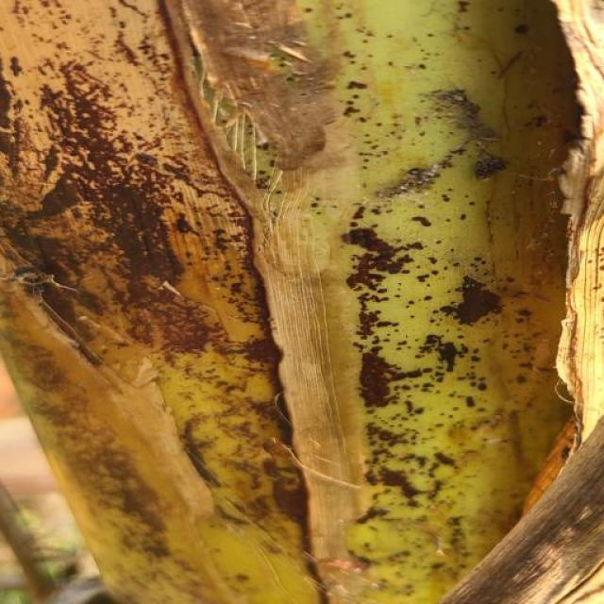
Option 1:
The image shows a banana with brown spots and a rotten appearance. This indicates that the banana is affected by a disease called "Panama disease," which is caused by the fungus Fusarium oxysporum f. sp. cubense. The visible symptoms include brown spots, blackened areas, and a rotten texture.
The possible solution to this problem is to practice good agricultural practices, such as proper soil management, crop rotation, and the use of resistant varieties of banana plants. Additionally, regular monitoring of the banana plants and early detection of the disease can help prevent further spread and damage to the crop.
Option 2:
The image shows a banana plant with several visible symptoms that could be indicative of bract mosaic virus infection. These symptoms include:
1. Discoloration: There are areas on the leaves where the color is not uniform, with patches that appear yellow or brownish. This discoloration is a characteristic feature of the disease.
2. Mosaic pattern: The term "mosaic" refers to the irregular and interspersed patterns of coloration that can be seen on the leaves. In this case, there are areas where the leaf tissue is affected by the virus, resulting in a mottled appearance.
3. Stunted growth: The plant appears to have stunted growth, with smaller leaves and possibly less vigorous overall appearance compared to healthy banana plants.
4. Leaf deformation: Some leaves may show signs of deformation or curling at the edges, which is another common symptom of bract mosaic virus infection.
The possible solution for this plant would involve proper identification and diagnosis by a plant pathologist or agronomist to determine if it is indeed affected by bract mosaic virus. If so, then measures such as removing infected leaves, using clean tools when pruning, and possibly applying fungicides or other treatments recommended for managing this disease could be considered. It's important to follow proper hygiene practices to prevent further spread of the virus.

Which answer do you prefer:

Sample 195

Ground Truth: Bract Mosaic Virus
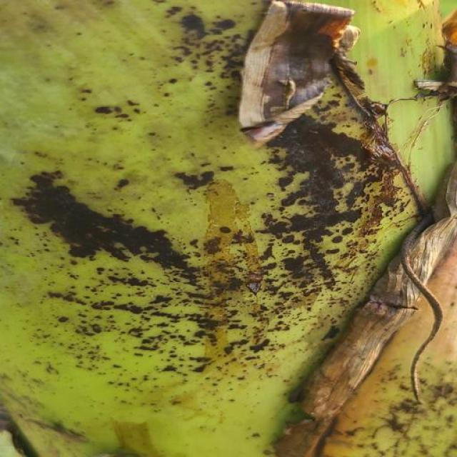
Option 1:
The image shows a banana with brown spots and a yellowish-green color, indicating that it is rotting. This could be due to a disease called Panama disease, which affects banana plants and causes the fruit to develop brown spots and eventually die. The visible symptoms of Panama disease include the browning of the fruit, wilting of the plant, and a yellowing of the leaves.
A possible solution to prevent the spread of Panama disease is to practice good agricultural practices, such as proper irrigation, pest management, and regular monitoring of the plant's health. Additionally, using resistant varieties of banana plants can help reduce the risk of infection and improve the overall health of the plant.
Option 2:
The image shows a banana leaf with several dark spots scattered across it, which are indicative of a disease known as Bract Mosaic Virus (BMV). This virus affects bananas and other plants in the Musa genus. Visible symptoms include discoloration, mottling, and stunting of leaves or fruit.
The possible solution for this disease would involve removing infected plants from the field to prevent further spread of the virus. In addition, good sanitation practices should be followed to minimize the risk of new infections. If the plant is still productive despite the disease, it may still be harvested, but it's important to note that the quality and shelf life of the fruit could be compromised due to the virus.
For treatment, some varieties of bananas are resistant to BMV, so selecting those varieties might help minimize the impact of the disease on the plant's health and productivity. In cases where the plant is still productive despite the disease, it may still be harvested, but it's important to note that the quality and shelf life of the fruit could be compromised due to the virus.

Which answer do you prefer:

Sample 196

Ground Truth: Bract Mosaic Virus
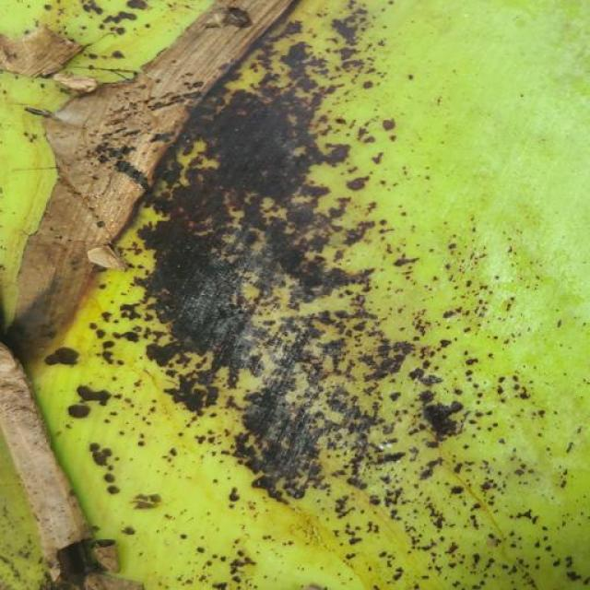
Option 1:
The image shows a banana with brown spots, which indicates that it is affected by a disease called Panama disease. This disease is caused by the fungus Fusarium oxysporum f. sp. cubense, which attacks the banana plant and causes the fruit to develop brown spots and eventually die.
The visible symptoms of Panama disease include brown spots on the banana peel, yellowing of the fruit, and wilting of the plant. The disease can lead to significant yield losses and even the death of the plant if not treated properly.
A possible solution to prevent the spread of Panama disease is to practice good agricultural practices, such as proper planting techniques, regular monitoring of the plant's health, and timely removal of infected plants. Additionally, using resistant varieties of banana plants can help reduce the risk of infection. It is also essential to maintain a clean and well-drained soil to minimize the chances of fungal growth.
Option 2:
The visible symptoms in the image include discoloration, spots, and possibly some wilting or browning of the leaves. These are indicative of a disease affecting the banana plant, which appears to be bract mosaic virus. This type of disease can cause a variety of symptoms depending on the specific strain and stage of infection.
The possible solution for this condition would involve proper identification by an expert in plant pathology or a local agricultural extension service. Once identified, appropriate measures can be taken such as removing infected leaves, pruning affected branches, and applying fungicides or other treatments recommended for bract mosaic virus. It's also important to maintain good hygiene practices to prevent further spread of the disease within the plantation.

Which answer do you prefer:

Sample 197

Ground Truth: Bract Mosaic Virus
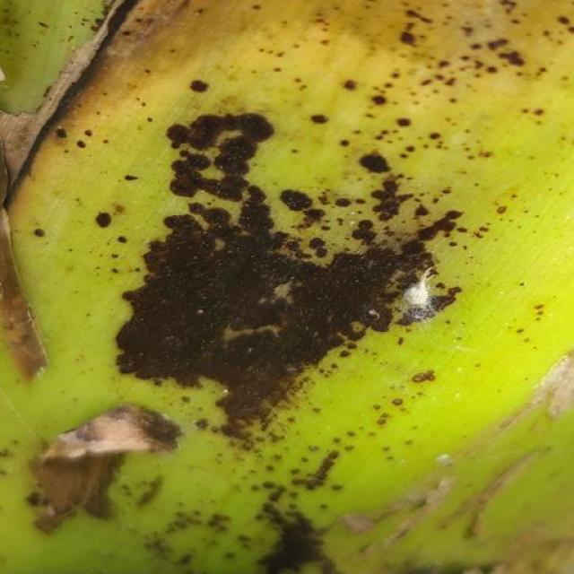
Option 1:
The image shows a wooden surface with a greenish-yellowish hue, which could be indicative of a fungal infection or a bacterial infection. The greenish-yellowish color is often associated with mold or mildew growth, which can cause various health issues if inhaled or if the affected area comes into contact with the skin.
The visible symptoms of the infection include the discoloration of the wooden surface and the presence of mold or mildew. The possible solution to this issue would be to clean the affected area thoroughly using appropriate cleaning agents and tools, such as a mold-killing spray or a scrub brush. Additionally, it is essential to address any underlying issues that may have caused the infection, such as poor ventilation or excessive moisture, to prevent future recurrence. If the infection is severe or widespread, it may be necessary to consult a professional to assess the situation and provide appropriate treatment or remediation.
Option 2:
The image you've provided appears to show a banana plant with several visible symptoms that could be indicative of bract mosaic virus infection. These symptoms include:
1. **Discoloration**: There are areas on the leaves where the color is distorted, with patches that are green, yellow, or a mix of both colors. This discoloration is characteristic of the virus affecting the plant's ability to photosynthesize normally.
2. **Mosaic Pattern**: The term "mosaic" refers to the irregular and interspersed patterns on the leaves, which can be seen as a mix of green and yellow areas. This is another common symptom of bract mosaic virus infection.
3. **Stunted Growth**: There may be signs of stunted growth or abnormal development in the plant's leaves and/or fruit. This could indicate that the virus is affecting the plant's ability to produce healthy tissue.
4. **Yellowing Leaves**: Some leaves appear yellowed, which is a common symptom of viral infections as they disrupt the normal functioning of the plant's photosynthetic system.
The possible solution for this type of disease would involve removing and destroying infected plants to prevent further spread of the virus. Additionally, using disease-free planting material and following good hygiene practices can help prevent the spread of the virus within a garden or farm.

Which answer do you prefer:

Sample 198

Ground Truth: Bract Mosaic Virus
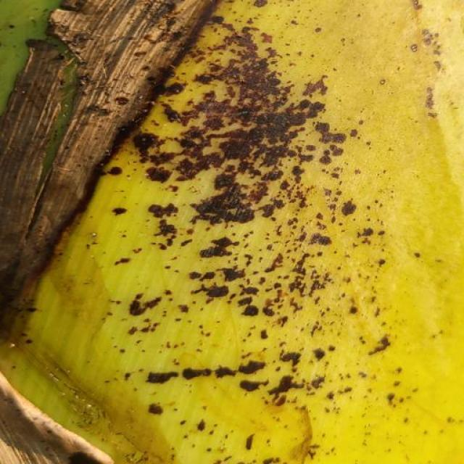
Option 1:
The image shows a banana with a large crack in it, which appears to be rotting. This indicates that the banana is affected by a disease called "Panama disease," which is caused by the fungus Fusarium oxysporum f. sp. cubense. The visible symptoms of Panama disease include brown spots, black streaks, and a general decay of the banana's flesh.
The possible solution to prevent the spread of Panama disease and save the banana tree is to practice good agricultural practices, such as proper irrigation, pest management, and soil fertility management. Additionally, it is essential to maintain a healthy banana tree by regularly inspecting it for any signs of disease and taking appropriate action to address the issue.
Option 2:
The image shows a banana plant with several visible symptoms indicative of bract mosaic virus infection. These symptoms include:
1. Discoloration: There are yellow and brown spots on the leaves, which is characteristic of the disease.
2. Deformation: The edges of the leaves appear to be curling upwards, a common sign of viral infections affecting banana plants.
3. Stunting: The growth of the plant appears stunted compared to healthy plants.
4. Reduced vigor: The overall health and vitality of the plant look compromised, with less vibrant green coloration compared to a healthy banana plant.
A possible solution for this disease would involve proper identification by an expert in plant pathology, followed by removal of infected plants from the field to prevent further spread of the virus. Treatment options may include chemical or biological methods to control the virus, such as using resistant varieties of banana plants or applying fungicides to prevent the spread of the disease. It's important to consult with a local agricultural extension service for specific recommendations tailored to the region and conditions where this plant is grown.

Banana Disease Model Comparison Report

