Groundnut Disease Model Comparison Report

Sample 1

Ground Truth: nutritional deficiency
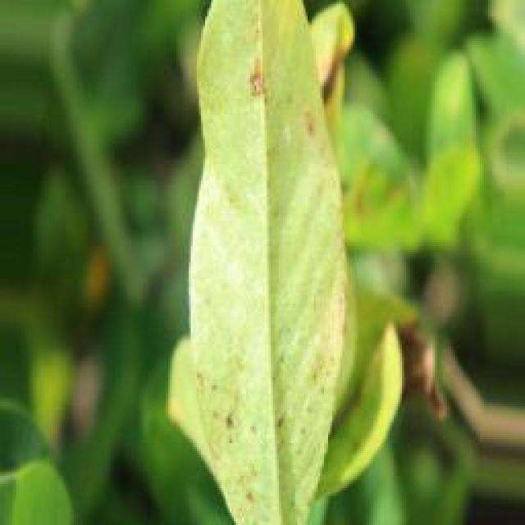
See the image and tell me what type of disease, visible symptoms and possible solution?
Option 1:
The image shows a leaf with brown spots and a yellowish color, which indicates that it is affected by a disease. The leaf appears to be infected with a fungal infection, as suggested by the presence of brown spots and the yellowish color.
To address this issue, it is essential to identify the specific type of fungal infection affecting the leaf and take appropriate measures to prevent its spread. This may involve removing the infected leaves and disposing of them properly, ensuring that the plant is well-drained and has adequate sunlight and nutrients, and using organic or chemical fungicides to control the infection. It is also important to maintain a healthy plant by providing proper care, including regular watering, pruning, and pest control.
Option 2:
The visible symptoms in the image of a groundnut plant affected by nutritional deficiency include yellowing of the leaves, which indicates a lack of chlorophyll due to insufficient nutrients. There may also be interveinal chlorosis, where the veins remain green while the spaces between them turn yellow. This is often indicative of iron deficiency. Other possible symptoms could include stunted growth, pale green foliage, and reduced fruit or pod production.
To address these issues, it would be important to conduct soil tests to determine the specific nutrient deficiencies present in the soil. Based on the results of these tests, appropriate fertilizers can be applied to correct the imbalances. For iron deficiency, a chelated iron product may be recommended as it is more readily available to plants than other forms of iron. Additionally, maintaining proper drainage and avoiding overwatering can help prevent root rot, which can exacerbate nutrient deficiencies.

Which option do you prefer?

Sample 2

Ground Truth: nutritional deficiency
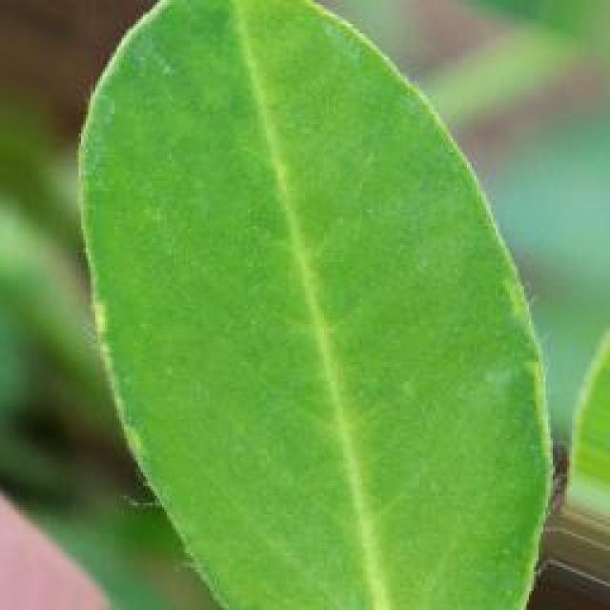
See the image and tell me what type of disease, visible symptoms and possible solution?
Option 1:
The image shows a plant with yellow leaves, which could indicate a disease or nutrient deficiency. The yellowing of the leaves might be due to a nutrient deficiency, such as a lack of nitrogen, or it could be a sign of a disease, like bacterial or fungal infections.
To address the issue, it is essential to identify the cause of the yellowing leaves. If it is a nutrient deficiency, it is crucial to provide the plant with the necessary nutrients, such as nitrogen, through organic or chemical fertilizers. If it is a disease, it is important to identify the specific pathogen causing the problem and apply appropriate treatments, such as fungicides or bactericides, to prevent further damage and promote the plant's recovery.
In addition, proper care, such as regular watering, pest control, and maintaining a healthy soil, can help prevent diseases and nutrient deficiencies in the plant.
Option 2:
The visible symptoms in the image show that the groundnut plant is affected by nutritional deficiency, specifically a lack of nitrogen. The leaves appear yellowish and have some brown spots, which is indicative of chlorosis. This condition occurs when there is not enough nitrogen available to the plant for proper growth and development.
A possible solution for this issue would be to apply urea fertilizer or a foliar spray of urea, as it contains high levels of nitrogen that can be quickly absorbed by the plant. Additionally, soil testing can help determine if there are other nutrient deficiencies present and appropriate adjustments to the fertilization program can be made based on the results.

Which option do you prefer?

Sample 3

Ground Truth: nutritional deficiency
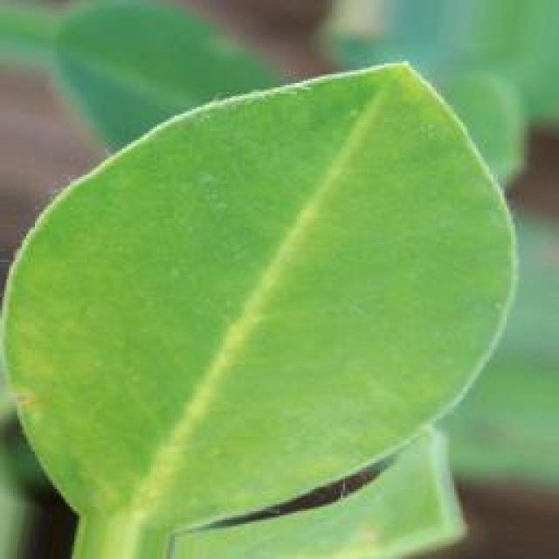
See the image and tell me what type of disease, visible symptoms and possible solution?
Option 1:
The image shows a leaf with a yellowish-green color and a brown spot on it, growing in a dirt field. The brown spot appears to be a fungal infection, which can be identified as a disease. The possible solution to this problem is to practice proper plant care, such as regular watering, pest control, and maintaining a healthy soil environment. Additionally, using organic fertilizers and avoiding overcrowding can help prevent the spread of the disease and promote healthy plant growth. If the infection is severe, it may be necessary to remove the affected leaves and consult a professional for further guidance on treatment and prevention.
Option 2:
The visible symptoms in the image show a groundnut plant with yellowing leaves, which could indicate a nutritional deficiency. Possible solutions for this issue might include soil testing to determine if there are any nutrient imbalances or deficiencies that need to be addressed through fertilization. Additionally, it's important to ensure proper watering and drainage conditions are maintained to support healthy plant growth. If the deficiency is severe, a foliar spray with a balanced fertilizer could also be considered to provide quick relief to the plant.

Which option do you prefer?

Sample 4

Ground Truth: nutritional deficiency
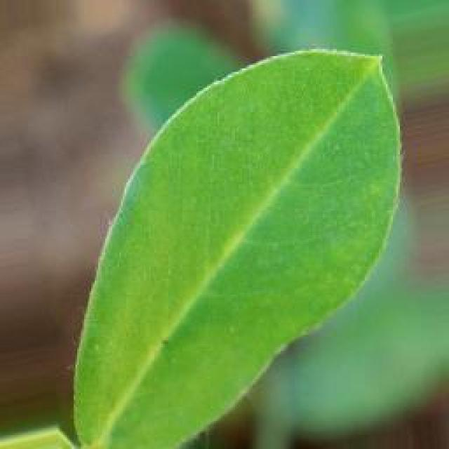
See the image and tell me what type of disease, visible symptoms and possible solution?
Option 1:
The image shows a small green plant with yellow leaves, possibly a tomato plant, growing in a dirt field. The plant appears to be struggling, with some of its leaves turning yellow and drooping. This could be a sign of nutrient deficiency, overwatering, or pests affecting the plant.
To address the issue, it is essential to identify the cause of the plant's distress. If it is due to nutrient deficiency, it is crucial to provide the plant with the necessary nutrients through fertilization. If overwatering is the issue, it is important to ensure that the soil is well-draining and to water the plant only when the soil is dry. If pests are the cause, it is necessary to identify the pests and apply appropriate pest control measures, such as using organic or chemical pest control products, depending on the severity of the infestation.
In addition to these measures, it is also essential to monitor the plant's health and make adjustments as needed to ensure its well-being and growth.
Option 2:
The visible symptoms in the image suggest that the groundnut plant may be affected by a nutritional deficiency, specifically one related to nitrogen. Nitrogen is essential for plant growth and development, and its deficiency can lead to stunted growth, yellowing of leaves, and reduced overall vigor in plants.
The symptoms visible in this image include:
- Yellowing of leaves, which is a common sign of nutrient deficiency.
- Small, deformed leaves that may be less than ideal for photosynthesis due to insufficient nitrogen.
- Slow growth and stunted development compared to healthy plants.
The possible solution for this issue would involve applying appropriate fertilizers or soil amendments containing nitrogen, such as urea or organic matter, to correct the deficiency and support plant growth. It's important to note that the specific nutrient deficiency should be identified through soil testing and a proper diagnosis by an agronomist or plant pathologist.

Which option do you prefer?

Sample 5

Ground Truth: nutritional deficiency
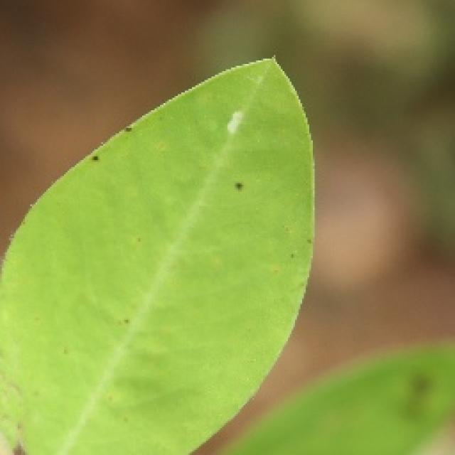
See the image and tell me what type of disease, visible symptoms and possible solution?
Option 1:
The image shows a leaf with yellow spots, which could indicate a disease or infection affecting the plant. The yellow spots might be a sign of bacterial or fungal infections, which can cause damage to the plant's tissues and negatively impact its overall health.
To address this issue, it is essential to identify the specific type of disease causing the yellow spots and take appropriate measures to treat or prevent it. This may involve using organic or chemical pesticides, applying appropriate fungicides, or removing infected leaves and branches to prevent the spread of the disease. Additionally, ensuring proper care, such as regular watering, adequate sunlight, and well-draining soil, can help maintain the plant's overall health and reduce the risk of diseases.
Option 2:
The visible symptom in the image is that the leaf of a groundnut plant appears to be yellowish, which could indicate nutritional deficiency. This could be due to insufficient levels of essential nutrients such as nitrogen, phosphorus, or potassium. A possible solution would be to provide appropriate fertilizers that address these specific nutrient needs and to ensure proper soil management practices are followed to maintain a healthy environment for the plant's growth.

Which option do you prefer?

Sample 6

Ground Truth: nutritional deficiency
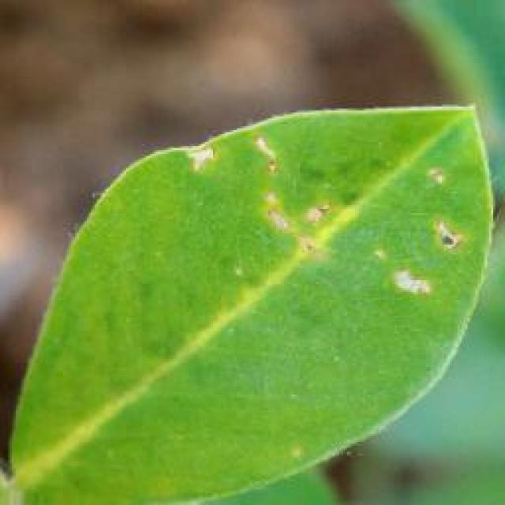
See the image and tell me what type of disease, visible symptoms and possible solution?
Option 1:
The image shows a plant with yellow leaves, possibly a leafy green plant, growing in a dirt field. The leaves appear to be wilted, which could indicate a disease or nutrient deficiency. The possible solution to this issue would be to identify the specific cause of the wilted leaves and take appropriate measures to address it. This could involve providing the plant with proper nutrients, ensuring adequate watering, or treating the plant with a suitable fungicide or pesticide to combat any infections or pests that may be causing the wilted leaves. Additionally, regular monitoring of the plant's health and early detection of any signs of distress can help prevent further damage and promote the plant's overall well-being.
Option 2:
The image shows a young groundnut plant with yellowing leaves, which could indicate a nutritional deficiency. Possible symptoms include chlorosis (yellowing between the veins), interveinal chlorosis (yellowing between the leaf's veins), or necrotic spots.
The visible solution would be to provide the plant with appropriate fertilizers that are lacking, such as nitrogen, phosphorus, potassium, magnesium, sulfur, iron, manganese, or zinc. The specific nutrient deficiency can be identified through soil testing and the application of targeted fertilizers to correct the imbalance. Additionally, proper irrigation practices and maintaining a healthy pH level in the soil can also help support plant growth.

Which option do you prefer?

Sample 7

Ground Truth: nutritional deficiency
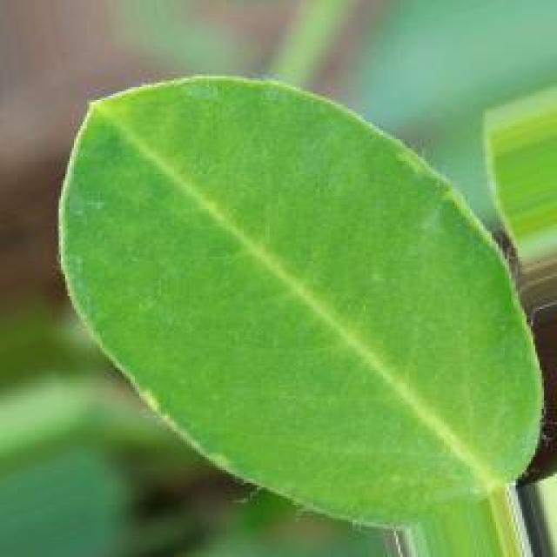
See the image and tell me what type of disease, visible symptoms and possible solution?
Option 1:
The image shows a leaf with a yellowish-green color and a few brown spots on it. This could indicate that the leaf is affected by a disease or a nutrient deficiency. The yellowish-green color might be due to a nutrient deficiency, while the brown spots could be a sign of a fungal infection or bacterial disease.
To address this issue, it is essential to identify the specific cause of the problem. If it is a nutrient deficiency, the plant may require additional nutrients, such as fertilizers, to help it recover. If it is a fungal infection, the plant may need to be treated with fungicides to prevent the spread of the disease and protect the plant from further damage. If it is a bacterial disease, the plant may require antibiotics or other treatments to combat the infection.
It is also important to maintain proper plant care, such as regular watering, pest control, and proper spacing, to prevent the development of diseases and promote healthy growth.
Option 2:
The visible symptoms in the image show yellowing of the leaves, which could indicate a nutrient deficiency or a disease affecting the groundnut plant. Possible solutions for this issue might include soil testing to determine if there are any nutrient imbalances that need correction, and applying appropriate fertilizers based on the results of the soil test. Additionally, if the symptoms are indicative of a disease, it would be important to identify the specific pathogen causing the issue and apply appropriate fungicides or other treatments as recommended by an agricultural expert.

Which option do you prefer?

Sample 8

Ground Truth: nutritional deficiency
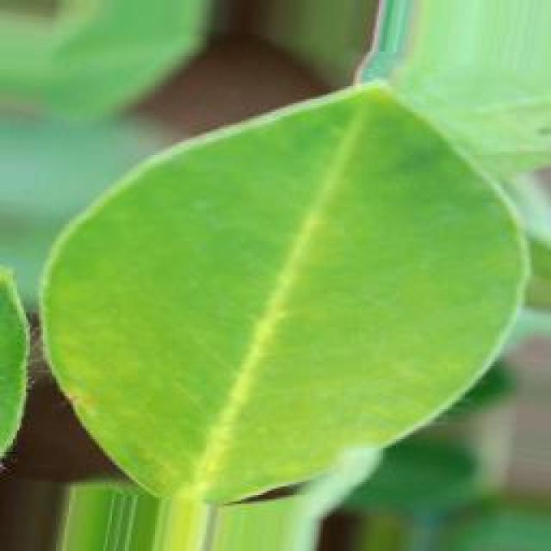
See the image and tell me what type of disease, visible symptoms and possible solution?
Option 1:
The image shows a yellow leaf with brown spots on it, which indicates that the plant is suffering from a disease. The brown spots suggest that the plant is experiencing a fungal infection, which can be caused by various factors such as overwatering, poor soil quality, or exposure to excessive moisture.
To address this issue, it is essential to identify the specific type of fungal infection and take appropriate measures to treat it. This may involve adjusting the watering schedule, improving soil quality, or using fungicides to combat the infection. Additionally, regular monitoring of the plant's health and early detection of any signs of disease can help prevent further damage and promote the plant's overall well-being.
Option 2:
The visible symptoms in the image show a groundnut plant with yellowing leaves, which could indicate nutritional deficiency. This could be due to insufficient levels of essential nutrients such as nitrogen, phosphorus, or potassium. Possible solutions for addressing this issue include soil testing to determine the specific nutrient deficiencies and applying appropriate fertilizers to correct the imbalances. Additionally, proper irrigation practices and maintaining a healthy pH level in the soil can also help in preventing nutritional deficiencies in plants.

Which option do you prefer?

Sample 9

Ground Truth: nutritional deficiency
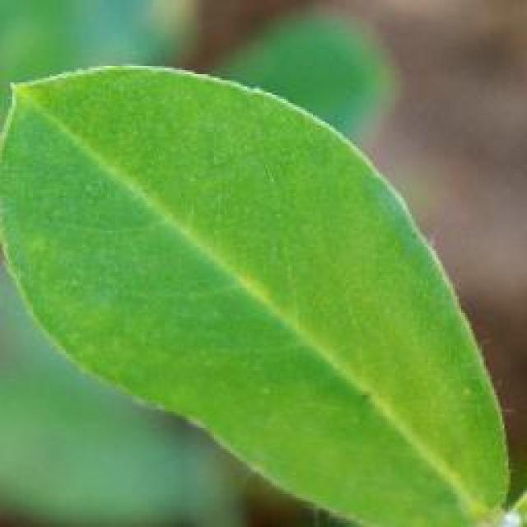
See the image and tell me what type of disease, visible symptoms and possible solution?
Option 1:
The image shows a small yellow plant with brown spots on its leaves, which indicates that it might be affected by a disease. The brown spots could be a sign of fungal infection or bacterial disease. To address this issue, it is essential to identify the specific type of disease and take appropriate measures to treat it.
For fungal infections, it is crucial to remove any infected leaves and branches, and then apply a fungicide specifically designed for the disease. For bacterial infections, it is necessary to remove the affected leaves and branches, and then apply a suitable bactericide to kill the bacteria.
In addition to treating the disease, it is also important to maintain proper plant care, such as providing adequate sunlight, water, and nutrients, to promote healthy growth and prevent future infections. Regularly inspecting the plant for any signs of disease and taking preventive measures can help ensure the plant's health and longevity.
Option 2:
The visible symptoms in the image include yellowing leaves with brown spots, which could indicate a nutrient deficiency such as nitrogen or zinc. This is likely due to the plant not receiving adequate amounts of these essential minerals from the soil.
A possible solution would be to apply a balanced fertilizer that contains all necessary nutrients, including nitrogen, phosphorus, potassium, and micronutrients like zinc. The application of organic matter or compost can also help improve soil quality and increase the availability of these nutrients to the plant. Additionally, maintaining proper drainage and avoiding overwatering can help prevent root rot, which can exacerbate nutrient deficiencies.

Which option do you prefer?

Sample 10

Ground Truth: nutritional deficiency
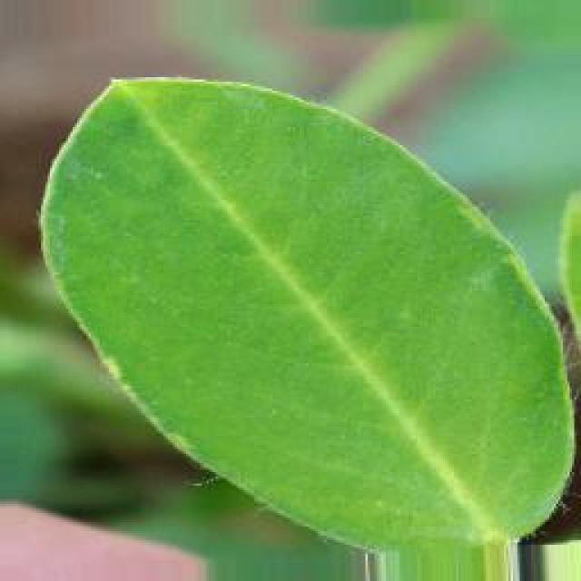
See the image and tell me what type of disease, visible symptoms and possible solution?
Option 1:
The image shows a small green plant with yellow leaves, possibly a leafy vegetable, growing in a pot. The plant appears to be infected with a disease, as indicated by the yellow leaves. The yellowing of the leaves could be due to a variety of factors, such as nutrient deficiencies, overwatering, or exposure to excessive sunlight.
To address the issue, it is essential to identify the cause of the yellowing and take appropriate measures to address it. If the yellowing is due to nutrient deficiencies, it may be necessary to provide the plant with the necessary nutrients through fertilization. If overwatering is the cause, it is crucial to ensure that the plant receives adequate drainage and does not sit in standing water. If the yellowing is due to excessive sunlight, it may be necessary to move the plant to a location with less direct sunlight or provide shade to protect it from the sun's harmful rays.
In addition to these measures, it is also essential to monitor the plant's health and growth to ensure that the disease does not progress and cause further damage to the plant. If the disease is severe or persistent, consulting with a plant expert or a local nursery may be helpful in identifying the specific cause and providing appropriate treatment.
Option 2:
The visible symptoms in the image suggest that the groundnut plant may be suffering from a nutritional deficiency, specifically a lack of nitrogen. Nitrogen is essential for the growth and development of plants, including groundnuts.
The symptoms include:
1. Yellowing of leaves: The leaves appear to be yellowish, which can indicate a lack of chlorophyll due to insufficient nitrogen levels.
2. Stunted growth: The plant's growth appears stunted compared to healthy plants, suggesting that it may not be receiving adequate nutrients for proper development.
3. Reduced leaf size: The leaves are smaller than normal, which can be a sign of nutrient deficiency.
4. Pale green color: The color of the leaves is pale green, which could indicate that the plant is not receiving enough nitrogen to produce healthy chlorophyll.
The possible solution for this issue would be to apply appropriate fertilizers containing nitrogen, such as urea or organic nitrogen-rich compost, to correct the nutritional deficiency and support the growth of the groundnut plant. It's important to monitor the plant's condition and adjust the application frequency or amount based on its response to the treatment.

Which option do you prefer?

Sample 11

Ground Truth: nutritional deficiency
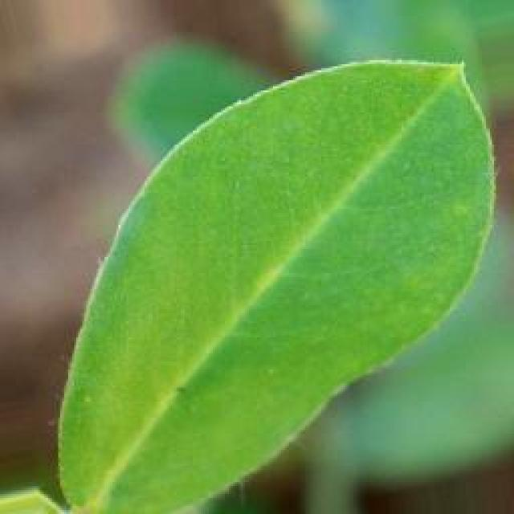
See the image and tell me what type of disease, visible symptoms and possible solution?
Option 1:
The image shows a leaf with brown spots and a few black specks on it. This could indicate that the leaf is affected by a fungal infection or a bacterial disease. The brown spots and black specks are visible symptoms of the disease, which can cause the leaf to lose its health and eventually die.
To solve this issue, it is essential to identify the specific type of disease affecting the plant and take appropriate measures to treat it. This may involve using fungicides or bactericides to combat the infection, as well as practicing good gardening habits such as regular pruning, proper watering, and ensuring adequate sunlight exposure. Additionally, it is important to maintain a healthy plant by providing proper nutrients and ensuring the plant is not overcrowded, which can help prevent the spread of diseases.
Option 2:
The image shows a groundnut plant with several leaves exhibiting the characteristic symptoms of early leaf spot disease. The visible symptoms include small, dark spots or lesions on the leaves, which are indicative of the fungal infection that causes this disease. The affected leaves may also show signs of wilting, yellowing, or curling at the edges.
The possible solution for this issue would be to apply a fungicide specifically designed to treat early leaf spot disease in groundnut plants. It's important to follow the recommended dosage and application schedule as instructed by the manufacturer of the fungicide. Additionally, proper crop rotation and maintaining good field hygiene can help prevent the spread of the disease and reduce its impact on the plant.

Which option do you prefer?

Sample 12

Ground Truth: nutritional deficiency
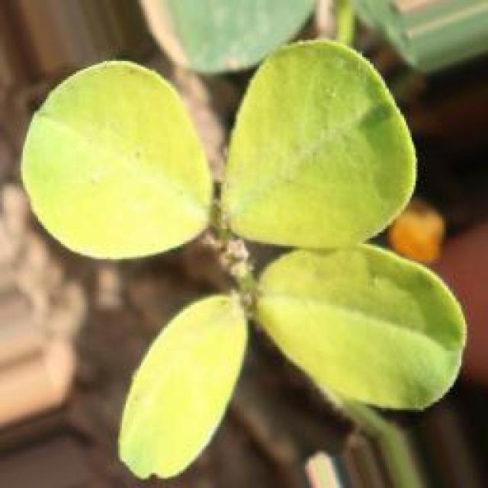
See the image and tell me what type of disease, visible symptoms and possible solution?
Option 1:
The image shows a yellow leaf with a brown spot on it, which could indicate a disease or infection affecting the plant. The brown spot might be a sign of bacterial or fungal infection, or it could be a result of nutrient deficiency or excessive watering.
To address this issue, it is essential to identify the cause of the brown spot and take appropriate measures to treat the plant. If it is a bacterial or fungal infection, it is crucial to remove the affected leaves and apply appropriate fungicides or bactericides to prevent the spread of the disease. If it is a nutrient deficiency, it is necessary to provide the plant with the necessary nutrients through proper soil amendment or supplementation. If the issue is due to excessive watering, it is important to adjust the watering schedule and ensure that the plant receives adequate drainage to prevent root rot or other water-related problems.
Regular monitoring of the plant's health and timely intervention can help prevent further damage and promote the plant's overall well-being.
Option 2:
In the image, there appears to be a single groundnut (also known as pigeon pea) leaf that is exhibiting yellowing and browning at the edges. This could indicate a nutrient deficiency, specifically a lack of nitrogen or sulfur. The possible solution would be to apply appropriate fertilizers to correct the deficiency and ensure proper growth and development of the plant.

Which option do you prefer?

Sample 13

Ground Truth: nutritional deficiency
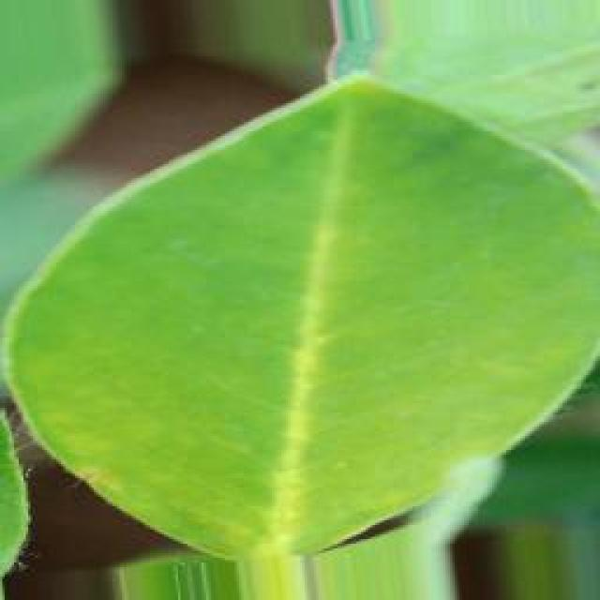
See the image and tell me what type of disease, visible symptoms and possible solution?
Option 1:
The image shows a leaf with a yellowish-green color, which could indicate a disease or a nutrient deficiency. The leaf appears to be drooping, which might be a sign of stress or weakness. To address this issue, it is essential to identify the specific cause of the problem. If it is a disease, it is crucial to consult a plant pathologist or a gardening expert to determine the appropriate treatment or prevention measures. If it is a nutrient deficiency, it may be necessary to provide the plant with the necessary nutrients through proper soil amendment or supplementation. Regular monitoring of the plant's health and addressing any issues promptly can help maintain the plant's overall well-being and prevent further damage.
Option 2:
The visible symptoms in the image suggest that the groundnut plant may be experiencing a nutritional deficiency, specifically related to iron or zinc. The leaves appear yellowish and have a slightly curled edge, which is indicative of iron deficiency in plants. This can occur when the soil pH is too high, preventing the absorption of iron by the plant.
A possible solution for this issue would be to apply iron chelates or other forms of iron fertilizers that are readily available and can help correct the nutrient imbalance. It's important to note that the specific type of deficiency and the appropriate treatment may vary depending on the soil conditions and the plant's requirements. A soil test can provide valuable information about the nutrient levels in the soil, which can guide further action.

Which option do you prefer?

Sample 14

Ground Truth: nutritional deficiency
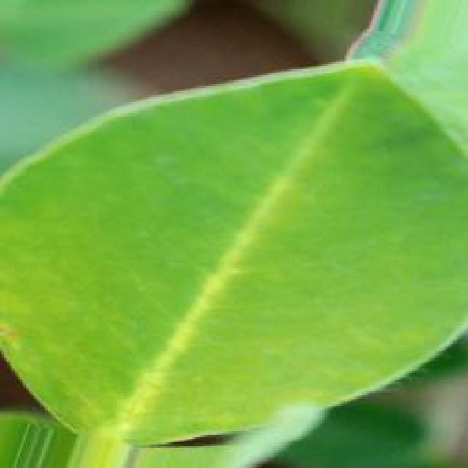
See the image and tell me what type of disease, visible symptoms and possible solution?
Option 1:
The image shows a leaf with a brown spot on it, which could indicate a disease or infection. The leaf appears to be yellow and is growing on a plant. The brown spot might be a sign of bacterial or fungal infection, which can affect the plant's health and growth.
To address this issue, it is essential to identify the specific type of disease causing the brown spot. Once the disease is diagnosed, appropriate treatment measures can be taken. These may include applying fungicides or bactericides to the affected plant, removing infected leaves, and ensuring proper care and maintenance of the plant to prevent future infections. Additionally, it is crucial to practice good gardening practices, such as regular pruning, proper watering, and pest control, to minimize the risk of diseases and infections in the plant.
Option 2:
The visible symptoms in the image suggest that the groundnut plant is experiencing a nutritional deficiency, likely iron or zinc deficiency. The leaves appear yellowish and have a slightly curved shape, which is indicative of chlorosis, a condition where plants do not get enough iron from the soil.
The possible solution for this issue would be to apply iron chelates or other forms of iron fertilizers to correct the nutrient deficiency. These can be applied as foliar sprays or through soil amendments to provide the necessary iron to the plant. It's also important to ensure that the soil pH is within an optimal range for groundnut growth, as high pH can exacerbate iron deficiency symptoms.

Which option do you prefer?

Sample 15

Ground Truth: nutritional deficiency
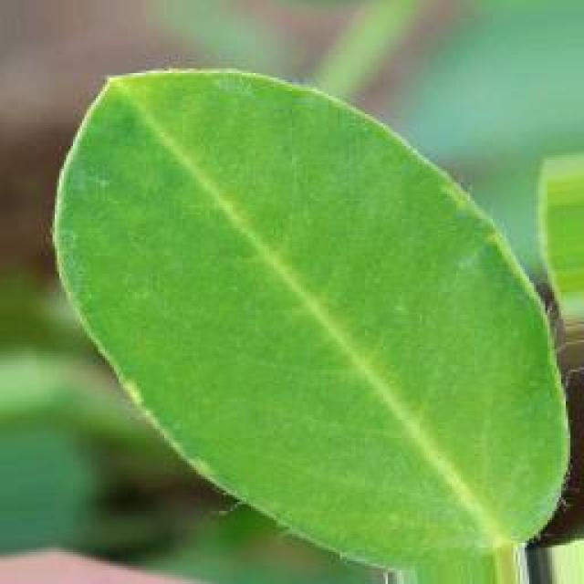
See the image and tell me what type of disease, visible symptoms and possible solution?
Option 1:
The image shows a leaf with a yellowish-green color, which could indicate a disease or a nutrient deficiency. The leaf appears to be slightly wilted, which might suggest that the plant is experiencing stress or is affected by a disease.
To identify the specific disease or nutrient deficiency, it would be necessary to observe the leaf's texture, shape, and any other visible symptoms. If the leaf is affected by a disease, it could be a fungal, bacterial, or viral infection. In such cases, the appropriate solution would depend on the type of disease and the plant species.
For nutrient deficiencies, it is essential to provide the plant with the necessary nutrients through proper soil amendment, fertilization, or supplementation. This can help the plant recover and regain its health.
In general, it is crucial to monitor the plant's health, identify the cause of the issue, and take appropriate action to address the problem. This may involve consulting with a plant expert, conducting soil tests, or using organic or chemical treatments to manage the disease or nutrient deficiency.
Option 2:
The image shows a groundnut plant with yellow leaves, which could indicate a nutritional deficiency. Possible symptoms include chlorosis (yellowing between the veins), necrosis (death of tissue), or stunted growth. The visible symptoms suggest that the plant may be lacking essential nutrients such as nitrogen, iron, or zinc.
To address this issue, a soil test can be conducted to determine the nutrient levels in the soil and identify any imbalances. Based on the results of the soil test, appropriate fertilizers can be applied to correct any deficiencies. For example, if nitrogen levels are low, urea fertilizer can be used as a quick-release source of nitrogen. If iron chlorosis is present, adding iron sulfate or other iron-containing fertilizers can help correct the issue.
It's also important to note that nutritional deficiencies can be caused by poor soil quality, overuse of the land, or waterlogged conditions. Therefore, addressing these underlying issues may also help alleviate the symptoms of nutrient deficiency.

Which option do you prefer?

Sample 16

Ground Truth: nutritional deficiency
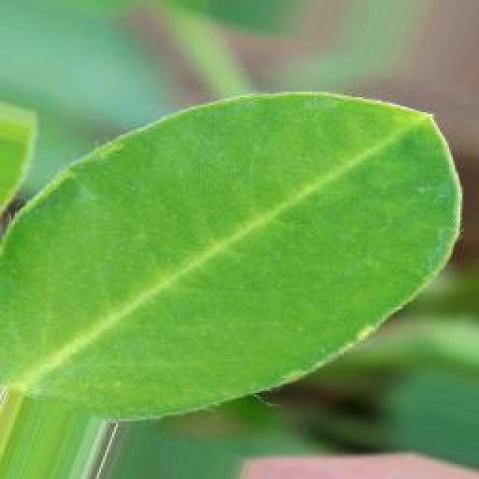
See the image and tell me what type of disease, visible symptoms and possible solution?
Option 1:
The image shows a small yellow leaf with brown spots on it, growing in a dirt field. This could indicate that the plant is suffering from a disease or infection, which is causing the brown spots on the leaf.
The possible solution to this problem would be to identify the specific disease or infection affecting the plant and take appropriate measures to treat it. This may involve using organic or chemical treatments, depending on the type of disease and the plant's health. Additionally, it is essential to maintain proper care for the plant, such as providing adequate water, sunlight, and nutrients, to help it recover and grow healthily.
Option 2:
The image shows a young groundnut plant with yellow leaves, which could indicate a nutritional deficiency. The most common symptoms of nutrient deficiency in plants include discoloration of leaves (yellowing), stunted growth, and reduced vigor.
To address this issue, it would be important to conduct soil tests to determine the specific nutrients that are lacking. Based on the results of the soil test, appropriate fertilizers can be applied to correct the deficiency. For example, if the plant is lacking nitrogen, a nitrogen-rich fertilizer such as urea or ammonium sulfate could be used. If it's a phosphorus deficiency, a phosphorus-rich fertilizer like single superphosphate could be applied.
It's also important to ensure that the plant is receiving adequate water and that there are no pests or diseases affecting its growth. If the deficiency is severe, it may require more frequent application of the corrective fertilizer and possibly additional treatments to address any underlying issues.
In summary, the visible symptoms suggest a nutritional deficiency in the groundnut plant, which would require soil testing and appropriate fertilization to correct the imbalance.

Which option do you prefer?

Sample 17

Ground Truth: nutritional deficiency

See the image and tell me what type of disease, visible symptoms and possible solution?
Option 1:
The image shows a leaf with a yellowish-green color, which could indicate a disease or a nutrient deficiency. The leaf is growing in a dirt field, which might suggest that the soil is not providing the necessary nutrients for the plant's growth.
To address this issue, it is essential to identify the specific cause of the yellowish-green color and consult a plant expert or a local nursery for advice on the appropriate treatment or care. Possible solutions could include adding organic compost or fertilizers to the soil, ensuring proper drainage, or adjusting the watering schedule to provide the plant with the right amount of water. Additionally, monitoring the plant's health and growth over time can help identify any other potential issues and ensure the plant's overall well-being.
Option 2:
The leaf in the image appears to be discolored, with yellowing and browning at the edges, which could indicate a nutrient deficiency or a stress condition affecting the plant. Possible solutions for this issue might include soil testing to determine if there are any nutrient imbalances or deficiencies that need to be addressed through fertilization. Additionally, proper watering and drainage practices can help maintain healthy growth conditions for the plant. It's important to note that without a comprehensive assessment of the entire plant and its growing environment, it's difficult to provide a definitive diagnosis or treatment plan.

Which option do you prefer?

Sample 18

Ground Truth: nutritional deficiency
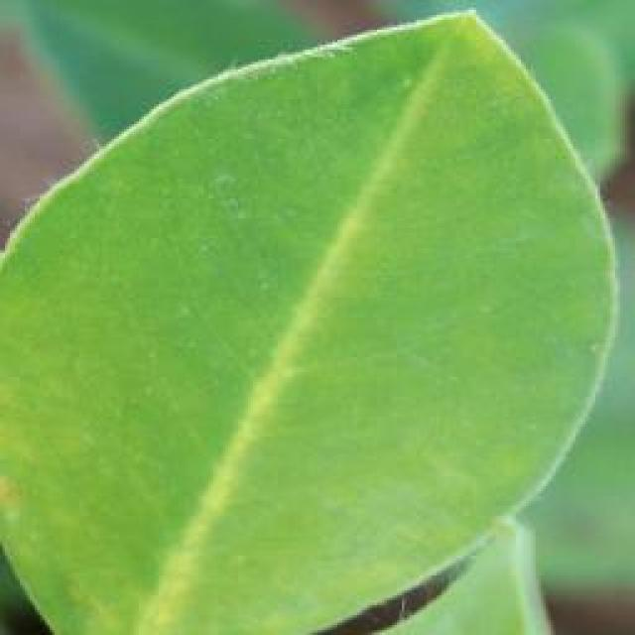
See the image and tell me what type of disease, visible symptoms and possible solution?
Option 1:
The image shows a leaf with a brown spot on it, which could indicate a disease or infection. The brown spot might be a sign of bacterial or fungal infection, or it could be a result of nutrient deficiency or excessive nutrient levels.
To address this issue, it is essential to identify the type of disease or infection affecting the leaf. If it is a bacterial or fungal infection, it is crucial to remove the affected leaves and practice proper plant care, such as regular watering, pest control, and proper spacing to prevent overcrowding. If the issue is due to nutrient deficiency or excessive nutrient levels, it is necessary to adjust the soil's pH and nutrient levels accordingly to provide the plant with the appropriate nutrients.
In any case, it is important to monitor the plant's health and take appropriate action to prevent further damage or spread of the disease.
Option 2:
The leaf in the image appears to be discolored, with yellowing and browning at the edges, which could indicate a nutrient deficiency or a stress condition affecting the plant. Possible solutions for this issue might include soil testing to determine if there is a lack of essential nutrients such as nitrogen, phosphorus, or potassium. Additionally, the plant may require adjustments to its irrigation practices, fertilization, or pruning to address the underlying cause of the discoloration and promote healthy growth. It's important to consult with an agricultural expert for a more accurate diagnosis and appropriate remedial actions.

Which option do you prefer?

Sample 19

Ground Truth: nutritional deficiency
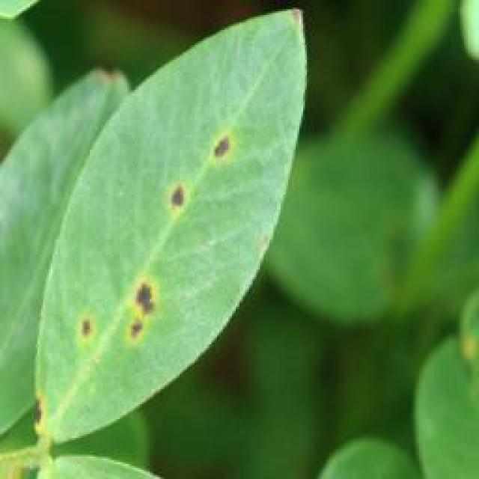
See the image and tell me what type of disease, visible symptoms and possible solution?
Option 1:
The image shows a leaf with a brown spot on it, which could indicate a disease or infection affecting the plant. The brown spot might be a sign of bacterial or fungal infection, or it could be a result of nutrient deficiency or excessive nutrient levels.
To address this issue, it is essential to identify the specific cause of the brown spot and take appropriate measures to treat the plant. If it is a bacterial or fungal infection, it is crucial to remove the affected leaves and apply appropriate fungicides or bactericides to prevent the spread of the disease. If it is a nutrient deficiency, it may be necessary to adjust the plant's nutrient intake to ensure it receives the necessary nutrients.
In addition to these treatments, it is also important to maintain proper plant care, such as regular watering, pest control, and proper sunlight exposure, to prevent the development of diseases and maintain the health of the plant.
Option 2:
In the image provided, there appears to be a groundnut plant with some visible signs of nutritional deficiency. The most noticeable symptom is the yellowing of the leaves, which can indicate a lack of essential nutrients such as nitrogen (N), phosphorus (P), or potassium (K).
The affected leaves show discoloration with green veins and yellow leaf tissue, which is characteristic of nutrient deficiency in plants. This could be due to poor soil quality, insufficient fertilization, or a lack of essential nutrients in the soil.
To address this issue, it would be advisable to conduct a soil test to determine the levels of essential nutrients like nitrogen, phosphorus, and potassium. Based on the results of the soil test, appropriate fertilizers can be applied to correct any deficiencies. Additionally, proper irrigation practices should be followed to ensure that the plant receives adequate water for optimal growth.

Which option do you prefer?

Sample 20

Ground Truth: nutritional deficiency
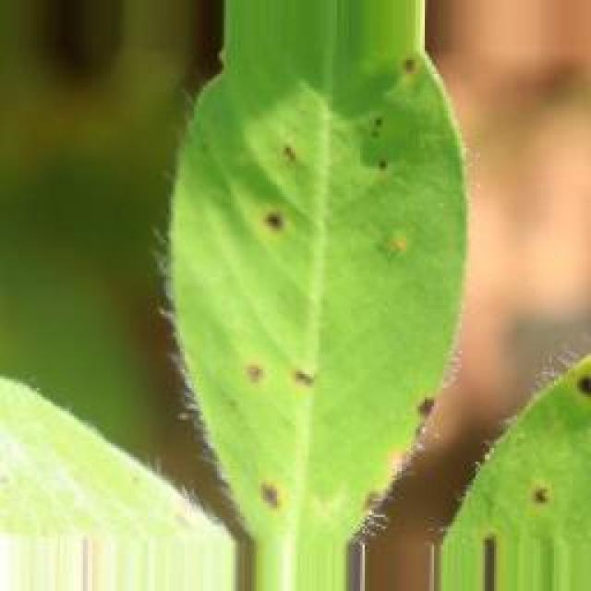
See the image and tell me what type of disease, visible symptoms and possible solution?
Option 1:
The image shows a plant with yellow leaves, which could indicate a disease or nutrient deficiency. The yellowing of the leaves might be due to a nutrient deficiency, such as a lack of nitrogen, or it could be a sign of a disease, like bacterial or fungal infections.
To address the issue, it is essential to identify the cause of the yellowing leaves. If it is a nutrient deficiency, it is crucial to provide the plant with the necessary nutrients, such as nitrogen, through fertilizers or compost. If it is a disease, it is important to identify the specific pathogen and apply appropriate treatments, such as fungicides or bactericides, to prevent further damage and promote the plant's recovery.
In addition, proper care, such as regular watering, pest control, and maintaining a healthy growing environment, can help prevent diseases and nutrient deficiencies in the plant.
Option 2:
The visible symptoms in the image suggest that the groundnut plant may be suffering from nutritional deficiencies, specifically related to nitrogen (N) and possibly other essential nutrients such as phosphorus (P) or potassium (K). The leaves appear yellowish with some brown spots, which could indicate a lack of chlorophyll due to insufficient N. Additionally, the plant's growth appears stunted, which might be related to deficiencies in other nutrients like P and K.
To address these issues, it would be necessary to conduct soil tests to determine the specific nutrient levels and pH of the soil. Based on the results, appropriate fertilizers can be applied to correct any imbalances or deficiencies. For example, if N is lacking, urea or other nitrogen-rich fertilizers can be used. If P and K are also deficient, additional fertilizers containing these nutrients should be added.
It's important to note that these symptoms could also be caused by other factors such as water stress or pests/diseases, so a thorough assessment of the plant's environment and health should be conducted before making any recommendations for treatment.

Which option do you prefer?

Sample 21

Ground Truth: nutritional deficiency
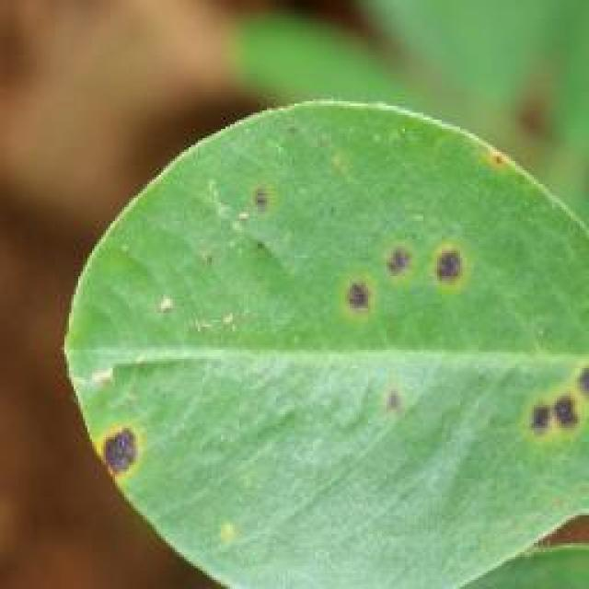
See the image and tell me what type of disease, visible symptoms and possible solution?
Option 1:
The image shows a leaf with brown spots and a hole in the center, which indicates that the plant is affected by a disease called bacterial soft rot. This disease is caused by the bacterium Erwinia tracheiphila and can affect various plants, including tomatoes.
The visible symptoms of bacterial soft rot include brown spots on the leaves, wilting of the plant, and a rotting of the plant tissue. The disease can spread rapidly and cause significant damage to the plant.
To prevent and manage bacterial soft rot, it is essential to practice proper plant care, such as regular watering, ensuring adequate drainage, and maintaining a healthy soil pH. Additionally, it is crucial to remove infected plant parts and dispose of them properly to prevent the spread of the disease. If the disease has already affected the plant, it is best to remove the infected parts and treat the plant with appropriate fungicides to prevent further damage and promote plant recovery.
Option 2:
The visible symptoms in the image suggest that the groundnut plant is affected by a nutrient deficiency, specifically a lack of nitrogen. The leaves appear to be discolored with yellowing between the veins and greening around the edges, which is indicative of chlorosis. This condition occurs when there is not enough nitrogen available for the plant to produce healthy chlorophyll.
A possible solution for this issue would be to apply a balanced fertilizer that contains nitrogen, phosphorus, and potassium in appropriate proportions according to soil test results. Additionally, maintaining proper irrigation practices and ensuring adequate drainage can help prevent further nutrient deficiencies from occurring.

Which option do you prefer?

Sample 22

Ground Truth: nutritional deficiency
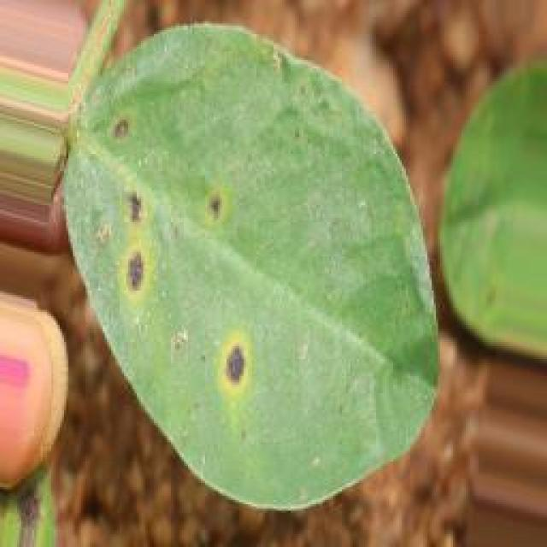
See the image and tell me what type of disease, visible symptoms and possible solution?
Option 1:
The image shows a plant with yellow leaves, which could indicate a disease or nutrient deficiency. The yellowing of leaves is often a sign of nutrient deficiencies, such as a lack of nitrogen, potassium, or magnesium. To address this issue, it is essential to provide the plant with the necessary nutrients through proper soil amendment or supplementation. Additionally, it is important to monitor the plant's overall health, watering, and pest management to ensure a healthy and thriving plant.
Option 2:
The image shows a groundnut plant with yellow leaves, which could indicate a nutritional deficiency. The most common symptoms of nutrient deficiency in plants include discoloration of leaves (yellowing), stunted growth, and reduced overall health.
To address this issue, it would be necessary to perform soil tests to determine the specific nutrients that are lacking. Based on the results of the soil test, appropriate fertilizers can be applied to correct the deficiency. For example, if the plant is lacking nitrogen, a nitrogen-rich fertilizer such as urea or ammonium sulfate could be used. If it's lacking phosphorus, a phosphorus-rich fertilizer like single superphosphate or bone meal could be applied.
It's important to note that nutrient deficiencies can also be caused by poor soil quality, waterlogging, or other environmental factors. Therefore, addressing the issue may require a comprehensive assessment of the plant's growing conditions and any underlying issues that could be contributing to the symptoms observed in the image.

Which option do you prefer?

Sample 23

Ground Truth: nutritional deficiency
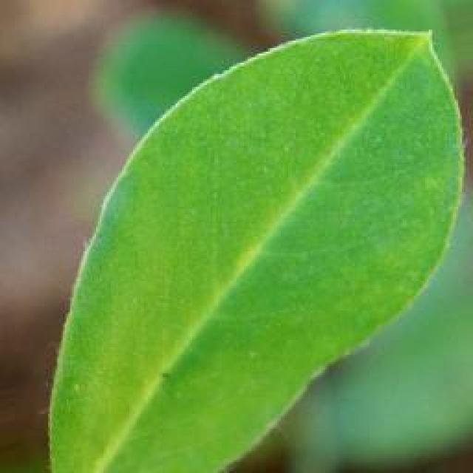
See the image and tell me what type of disease, visible symptoms and possible solution?
Option 1:
The image shows a leaf with a brown spot on it, which could indicate a disease or infection. The brown spot might be a sign of bacterial or fungal infection, or it could be a result of nutrient deficiency or excessive nutrient levels.
To identify the specific disease or infection, it would be necessary to examine the leaf more closely and possibly take a sample for further testing. Once the disease or infection is identified, a suitable solution can be determined. In the case of bacterial or fungal infections, proper treatment with antibiotics or fungicides may be necessary. If the issue is related to nutrient imbalances, adjusting the soil's pH or nutrient levels can help improve the plant's health.
It is essential to monitor the plant's health regularly and address any issues promptly to prevent further damage and ensure the plant's overall well-being.
Option 2:
The image shows a young groundnut plant with a single, large, yellow leaf that appears to be discolored or damaged. This could indicate a nutrient deficiency, such as iron deficiency, which is common in plants grown in alkaline soils. Iron deficiency can cause yellowing of leaves and stunted growth.
To address this issue, the following steps could be taken:
1. Soil analysis: Test the soil to determine if there is an iron deficiency or if other nutrients are also lacking.
2. Foliar application: Apply a foliar spray of iron sulfate (FeSO4) at the recommended rate for groundnuts, which can help correct the deficiency quickly.
3. Soil amendment: If the soil is alkaline, adding organic matter and lime to lower the pH can help improve iron availability.
4. Long-term solution: Ensuring that the plant is receiving a balanced fertilizer program with appropriate amounts of all essential nutrients can help prevent future deficiencies.

Which option do you prefer?

Sample 24

Ground Truth: nutritional deficiency
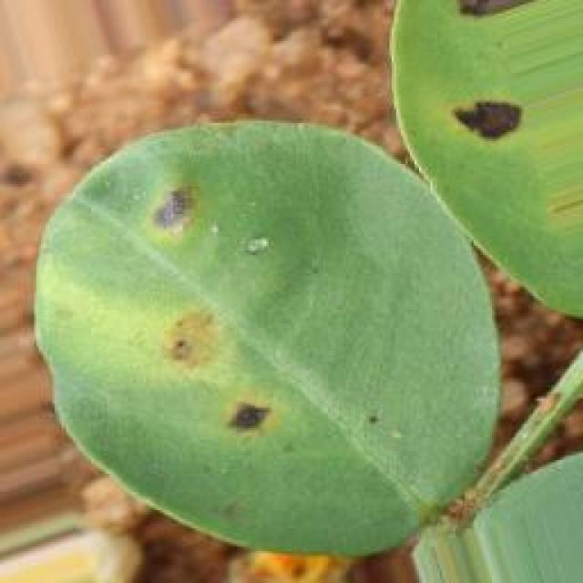
See the image and tell me what type of disease, visible symptoms and possible solution?
Option 1:
The image shows a leaf with brown spots, which indicates that the plant may be suffering from a disease or infection. The brown spots could be a sign of fungal infections, bacterial infections, or nutrient deficiencies. To address this issue, it is essential to identify the specific cause of the brown spots and take appropriate measures to treat the plant.
If the brown spots are caused by a fungal infection, it is crucial to remove any infected leaves and apply a fungicide to prevent the spread of the disease. If the brown spots are due to bacterial infections, it is necessary to remove the affected leaves and apply a bactericide to kill the bacteria.
If the brown spots are a result of nutrient deficiencies, it is important to provide the plant with the necessary nutrients through proper soil amendment or supplementation. Regularly monitoring the plant's health and addressing any issues promptly can help prevent further damage and promote the plant's overall well-being.
Option 2:
The visible symptoms in the image suggest that the groundnut plant is suffering from a nutritional deficiency, specifically a lack of nitrogen. Nitrogen is essential for plant growth and development, including leaf production.
The symptoms include:
- Yellowing of leaves: This is a common sign of nutrient deficiency in plants. In this case, the leaves appear to be yellowed, which could indicate that the plant is not receiving enough nitrogen.
- Leaf discoloration: The edges of the leaves may appear brown or blackened, which can be an indication of a lack of nutrients like nitrogen.
- Stunted growth: Groundnut plants with nutritional deficiencies often show stunted growth compared to healthy plants.
The possible solution for this issue would be to apply a balanced fertilizer that contains nitrogen, such as urea or another nitrogen-rich fertilizer, and possibly additional micronutrients like zinc or iron if they are also deficient. It's important to have soil tests done to determine the exact nutrient levels in the soil and adjust the application accordingly.

Which option do you prefer?

Sample 25

Ground Truth: nutritional deficiency
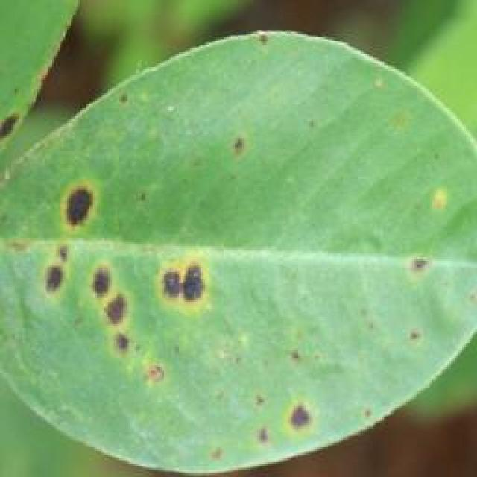
See the image and tell me what type of disease, visible symptoms and possible solution?
Option 1:
The image shows a leaf with a yellowish-green color and a brown spot on it, which could be a sign of a disease or infection. The leaf is growing on a dirt surface, which might indicate that the plant is not receiving adequate nutrients or is exposed to unfavorable growing conditions.
The possible solution to this issue would be to provide the plant with proper care, including regular watering, adequate sunlight, and well-draining soil. Additionally, ensuring that the plant receives the necessary nutrients through fertilization can help improve its overall health and prevent the spread of any diseases or infections. If the issue persists, it might be necessary to consult a plant expert or a local nursery for further guidance on the specific problem and appropriate treatment.
Option 2:
The image shows a groundnut plant with several visible symptoms indicative of nutritional deficiency. The most prominent symptom is the yellowing of the leaves, which can be an early sign of iron deficiency in plants. Iron is essential for chlorophyll synthesis and can cause yellowing when it's not available in sufficient amounts.
Other visible symptoms include stunted growth, thin stems, and possible necrotic spots or lesions on the leaves. These could be indicative of a broader nutrient deficiency or an imbalance in the soil's pH levels.
To address these issues, it would be advisable to conduct soil tests to determine the specific nutrient deficiencies and adjust the fertilization practices accordingly. This may include applying iron chelates, manganese sulfate, or other micronutrients as needed based on the results of the soil test. Additionally, maintaining proper pH levels in the soil can help prevent nutrient deficiencies by providing a more favorable environment for plant growth.

Which option do you prefer?

Sample 26

Ground Truth: nutritional deficiency
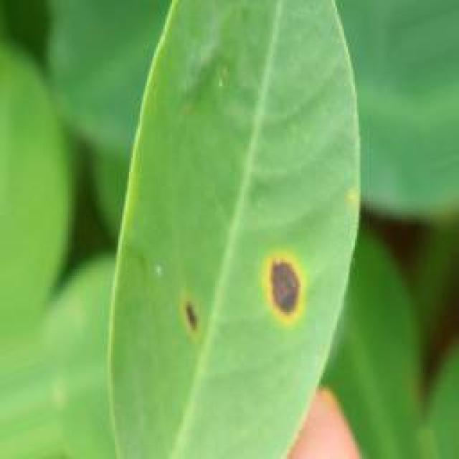
See the image and tell me what type of disease, visible symptoms and possible solution?
Option 1:
The image shows a leaf with a brown spot, which could be a sign of a disease or infection affecting the plant. The leaf appears to be yellow and green, and the brown spot is located in the center of the leaf.
There are several possible solutions to address this issue, depending on the type of disease or infection affecting the plant. Some common solutions include:
1. Regularly inspecting the plant for any signs of disease or pests, and removing any affected leaves or branches promptly.
2. Ensuring proper drainage and watering to prevent over-watering or under-watering, which can lead to root rot or other diseases.
3. Applying a balanced fertilizer to provide the necessary nutrients for the plant's healthy growth.
4. Practicing crop rotation to prevent the build-up of pests or diseases in the soil.
5. Using organic or chemical pesticides or fungicides, depending on the type of disease or pest, to control the problem.
It is essential to identify the specific disease or infection affecting the plant and consult with a plant expert or a local nursery for the most appropriate solution.
Option 2:
Based on the image provided, it appears that there may be a nutrient deficiency affecting the groundnut plant. The most visible symptom is the yellowing of the leaves, which can indicate a lack of essential nutrients such as nitrogen or sulfur. This yellowing could also be due to water stress or other environmental factors.
To address this issue, it would be important to conduct soil tests to determine the specific nutrient deficiencies present in the soil. Once identified, appropriate fertilizers can be applied according to the results of the soil test. In addition, proper irrigation practices and management of water stress should also be considered.
It's important to note that without a closer examination of the plant and its environment, it's difficult to provide a definitive diagnosis or solution. A professional assessment would be necessary for accurate identification and treatment of any issues affecting the groundnut plant.

Which option do you prefer?

Sample 27

Ground Truth: nutritional deficiency
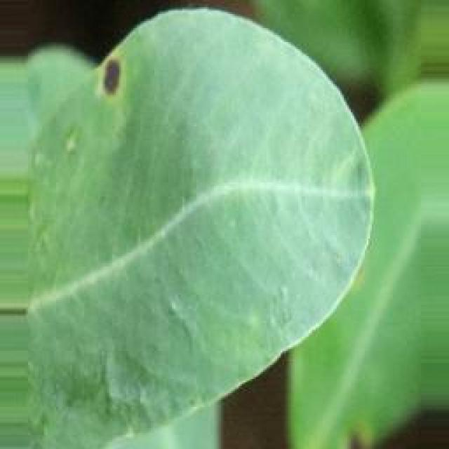
See the image and tell me what type of disease, visible symptoms and possible solution?
Option 1:
The image shows a yellow leaf with a brown spot on it, which could indicate a disease or infection affecting the plant. The brown spot might be a sign of bacterial or fungal infection, or it could be a result of nutrient deficiency or excessive nutrient levels.
To address this issue, it is essential to identify the specific cause of the brown spot. If it is a bacterial or fungal infection, it is crucial to remove the affected leaves and apply appropriate fungicides or bactericides to prevent the spread of the disease. If it is a nutrient deficiency, it may be necessary to adjust the plant's nutrient intake to ensure it receives the necessary nutrients. If the brown spot is a result of excessive nutrient levels, it may be helpful to reduce the amount of nutrients being applied to the plant.
In any case, it is important to monitor the plant's health and take appropriate action to maintain its well-being.
Option 2:
The visible symptoms in the image suggest that the groundnut plant is affected by a nutritional deficiency, specifically iron deficiency. The leaves appear yellowish with green veins, which is characteristic of iron deficiency in plants. This can occur when the soil lacks sufficient iron or if there's an imbalance in the soil's pH levels that hinder the plant's ability to absorb iron.
To address this issue, it would be necessary to perform a soil test to determine the nutrient levels and pH. Based on the results, appropriate fertilizers or amendments can be applied to correct any imbalances or deficiencies. In the case of iron deficiency, adding iron chelates or other forms of iron that are readily available to plants may help correct the issue. Additionally, maintaining proper drainage and avoiding overwatering can also help prevent iron deficiency in groundnut plants.

Which option do you prefer?

Sample 28

Ground Truth: nutritional deficiency
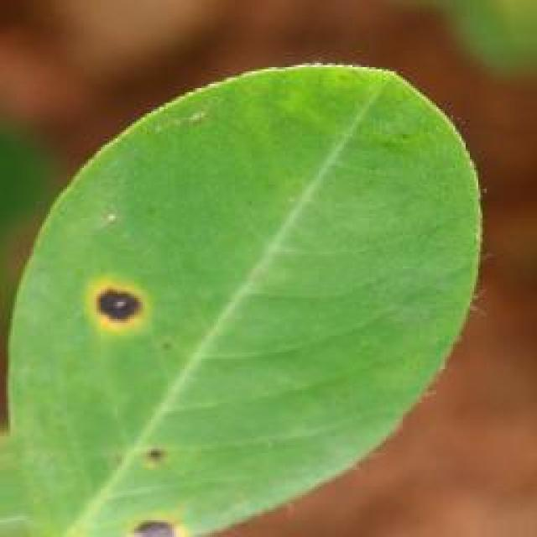
See the image and tell me what type of disease, visible symptoms and possible solution?
Option 1:
The image shows a yellow leaf with brown spots on it, growing in a dirt field. This could indicate that the plant is suffering from a disease or infection, such as bacterial or fungal infections. The brown spots on the leaf are a visible symptom of the disease, which can lead to the plant's decline in health and potentially its death if not treated.
To address this issue, it is essential to identify the specific disease causing the brown spots and take appropriate measures to treat it. This may involve using fungicides or bactericides to combat the infection, as well as ensuring proper care and maintenance of the plant, such as regular watering, adequate sunlight, and proper soil conditions. Additionally, it is crucial to monitor the plant's health and take action if the disease recurs or worsens.
Option 2:
The visible symptoms in the image suggest that the groundnut plant is experiencing nutritional deficiency, specifically a lack of nitrogen. This can be observed from the yellowing of the leaves and the overall pale green coloration compared to healthy plants with vibrant green foliage.
A possible solution for this issue would be to apply appropriate fertilizers that are high in nitrogen content, such as urea or other nitrogen-rich fertilizers. These can be applied as a foliar spray or through soil amendment to help correct the nutritional deficiency and support the growth of the plant. Additionally, it's important to monitor soil pH levels and consider other factors that may contribute to nutrient deficiencies, such as water quality or pest/disease issues.

Which option do you prefer?

Sample 29

Ground Truth: nutritional deficiency
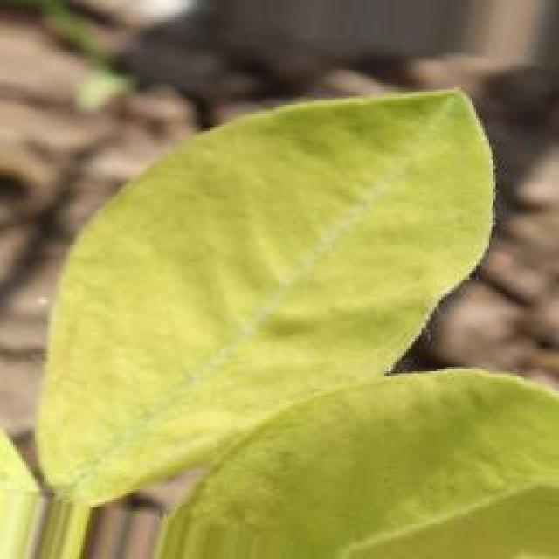
See the image and tell me what type of disease, visible symptoms and possible solution?
Option 1:
The image shows a leaf with a white substance on it, which appears to be a type of fungus or mold. This could be a sign of a disease affecting the plant, such as powdery mildew or downy mildew. The white substance on the leaf is a result of the fungus or mold growing on the surface of the leaf.
To address this issue, it is essential to identify the specific type of fungus or mold causing the problem and take appropriate measures to treat the affected plant. This may involve using fungicides, pruning infected parts of the plant, or ensuring proper drainage and air circulation to prevent the growth of the fungus or mold. Additionally, maintaining a healthy plant by providing adequate nutrients, water, and sunlight can help prevent the development of diseases in the future.
Option 2:
The visible symptoms in the image suggest that the groundnut plant is affected by a nutritional deficiency, specifically a lack of nitrogen. Nitrogen is essential for plant growth and development, including leaf production and chlorophyll synthesis.
The symptoms include:
1. Yellowing of leaves: The leaves appear to be yellowed, which can indicate a lack of nitrogen.
2. Stunted growth: The plant's growth appears stunted compared to healthy plants.
3. Thin stems: The stems look thin and weak, which could be due to insufficient nutrient uptake.
4. Small leaves: The leaves are smaller than normal, which can also indicate a lack of nitrogen.
5. Discoloration: There may be some discoloration on the leaves, which could be an indication of stress or deficiency.
The possible solution for this issue would be to apply a balanced fertilizer that contains nitrogen, such as urea or organic nitrogen sources, to correct the nutritional deficiency and support healthy plant growth. It's important to monitor the soil's nutrient levels and adjust the application frequency based on the plant's needs.

Which option do you prefer?

Sample 30

Ground Truth: nutritional deficiency
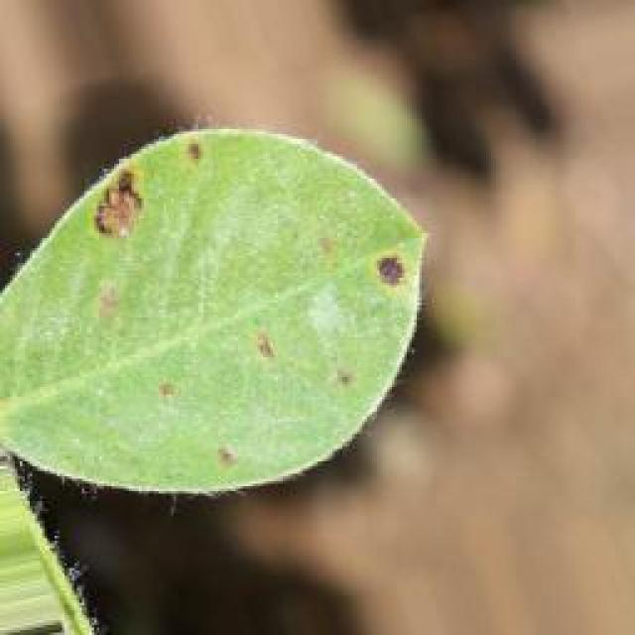
See the image and tell me what type of disease, visible symptoms and possible solution?
Option 1:
The image shows a plant with yellow leaves and brown spots, which indicates that it is affected by a disease. The plant appears to be a leafy green plant, possibly a tomato plant, as suggested by the presence of a tomato in the image. The brown spots on the leaves suggest that the plant is experiencing a fungal infection, which can be caused by various factors such as overwatering, poor soil quality, or exposure to excessive moisture.
To address this issue, it is essential to identify the specific type of fungal infection and take appropriate measures to prevent its spread. This may include:
1. Improving soil quality: Ensuring that the soil is well-draining and rich in organic matter can help prevent the growth of fungi.
2. Regularly watering the plant: Ensuring that the plant receives adequate water without overwatering can help prevent the growth of fungi.
3. Pruning affected leaves: Removing infected leaves and branches can help prevent the spread of the disease.
4. Using organic fungicides: Applying organic fungicides, such as neem oil or sulfur, can help control the growth of fungi and prevent the spread of the disease.
5. Practicing crop rotation: Rotating the planting area can help prevent the build-up of fungal spores and reduce the risk of disease.
By implementing these measures, the plant can recover from the disease and grow healthy leaves.
Option 2:
The image shows a young groundnut plant with yellow leaves, which could indicate a nutritional deficiency. The most common symptoms of nutrient deficiency in plants include discoloration of leaves (yellowing), stunted growth, and reduced vigor.
To address this issue, it would be necessary to perform soil tests to determine the specific nutrients that are lacking. Based on the results of the soil test, appropriate fertilizers can be applied to correct the deficiency. For example, if the plant is lacking nitrogen, a nitrogen-rich fertilizer such as urea or ammonium sulfate could be used. If it's a phosphorus deficiency, phosphorus-rich fertilizers like single superphosphate or bone meal can be applied.
It's important to note that nutrient deficiencies can also be caused by poor soil quality, waterlogging, or other environmental factors. Therefore, a comprehensive assessment of the plant's growing conditions and history should be conducted to identify any underlying issues that may contribute to the nutritional deficiency.

Which option do you prefer?

Sample 31

Ground Truth: nutritional deficiency
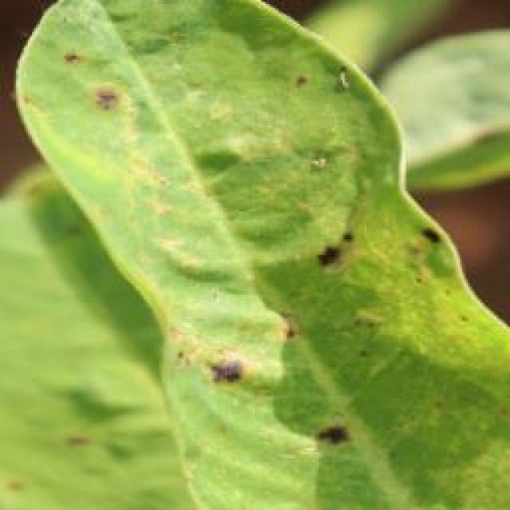
See the image and tell me what type of disease, visible symptoms and possible solution?
Option 1:
The image shows a leaf with a brown spot on it, which could indicate a disease or infection affecting the plant. The brown spot might be a sign of bacterial or fungal infection, or it could be a result of nutrient deficiency or excessive nutrient levels.
To address this issue, it is essential to identify the cause of the brown spot and take appropriate measures to treat the plant. If the brown spot is due to a bacterial or fungal infection, it is crucial to remove the affected leaves and apply appropriate fungicides or bactericides to prevent the spread of the disease. If the brown spot is a result of nutrient deficiency or excessive nutrient levels, it is necessary to adjust the plant's nutrient intake to ensure proper growth and health.
In addition to these measures, it is also important to maintain proper plant care, such as regular watering, adequate sunlight, and proper soil conditions, to prevent the development of diseases and promote healthy growth.
Option 2:
The leaf in the image appears to be discolored, with yellowing and browning at the edges, which could indicate a nutrient deficiency. This could be due to insufficient levels of essential nutrients such as nitrogen, phosphorus, or potassium. A possible solution would be to apply appropriate fertilizers that are tailored to the specific needs of the plant and the soil conditions. It's also important to ensure proper drainage and watering practices are in place to support healthy growth.

Which option do you prefer?

Sample 32

Ground Truth: nutritional deficiency
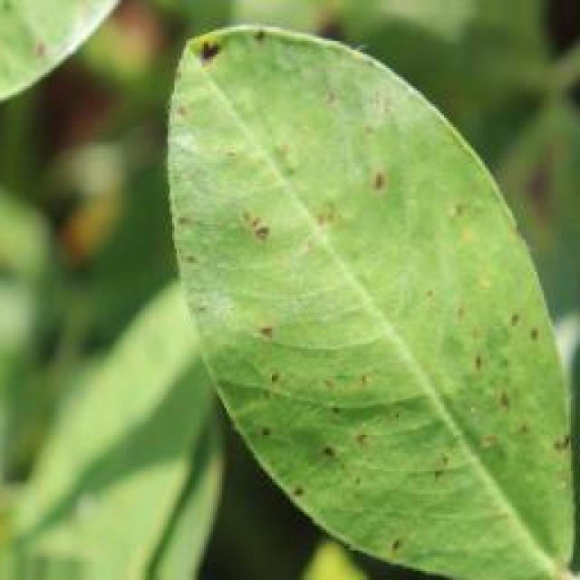
See the image and tell me what type of disease, visible symptoms and possible solution?
Option 1:
The image shows a yellow leaf with brown spots, which could indicate a disease or infection affecting the plant. The brown spots suggest that the plant is experiencing some form of stress or damage, which could be caused by various factors such as overwatering, underwatering, nutrient deficiencies, or exposure to pests or diseases.
To address this issue, it is essential to identify the cause of the problem and take appropriate measures to address it. This may involve adjusting the watering schedule, ensuring proper nutrient intake, or using pest control methods to protect the plant from harmful insects or diseases. Additionally, regular monitoring of the plant's health and appearance can help identify any potential issues early on, allowing for timely intervention and preventing further damage or disease.
Option 2:
The visible symptoms in the image suggest that the groundnut plant is suffering from a nutritional deficiency, specifically a lack of essential nutrients such as nitrogen (N), phosphorus (P), or potassium (K). These deficiencies can cause yellowing of leaves and stunted growth, which are visible in this image.
To address this issue, it is important to conduct soil tests to determine the specific nutrient levels and to apply appropriate fertilizers accordingly. For example, if the soil test indicates a lack of nitrogen, urea or other nitrogen-rich fertilizers can be applied. If the issue is related to phosphorus or potassium deficiency, additional fertilizers containing these nutrients should be added according to the results of the soil test.
It's also important to ensure that the plant is receiving adequate water and that there are no pests or diseases affecting its growth. Proper drainage and aeration in the soil can also help prevent nutrient deficiencies by allowing for better nutrient absorption by the roots.

Which option do you prefer?

Sample 33

Ground Truth: nutritional deficiency
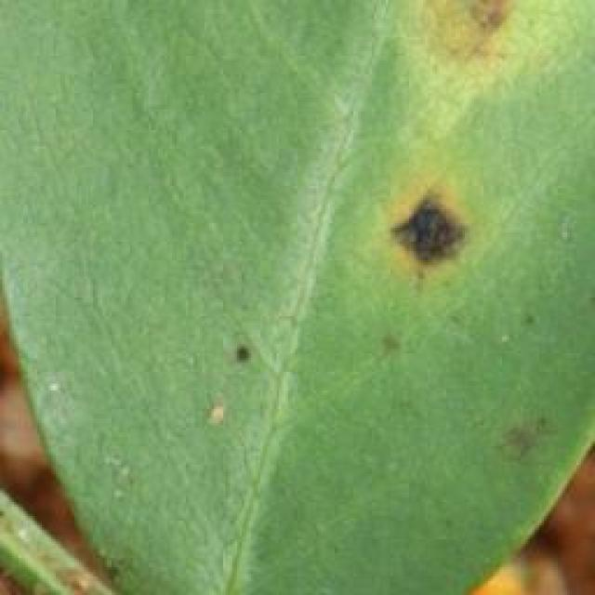
See the image and tell me what type of disease, visible symptoms and possible solution?
Option 1:
The image shows a yellow leaf with brown spots, which could indicate a disease or infection affecting the plant. The brown spots suggest that the plant is experiencing some form of stress or damage, which could be caused by various factors such as overwatering, underwatering, nutrient deficiencies, or exposure to pests or diseases.
To address this issue, it is essential to identify the cause of the problem and take appropriate measures to address it. If the brown spots are due to overwatering, it is crucial to ensure that the plant is not sitting in standing water and to allow the soil to dry out between waterings. If the issue is caused by underwatering, it is necessary to provide adequate water to the plant.
If the brown spots are due to nutrient deficiencies, it is important to provide the plant with the necessary nutrients through fertilization. If the brown spots are caused by pests or diseases, it is essential to identify the specific pest or disease and take appropriate measures to treat or prevent it. This may involve using pesticides, applying fungicides, or removing affected leaves and stems.
In general, it is essential to monitor the plant's health, identify any signs of stress or damage, and take appropriate measures to address the issue to ensure the plant's well-being and prevent further damage.
Option 2:
The leaf in the image appears to be yellowing, which could indicate a nutrient deficiency or an issue with the plant's ability to absorb nutrients from the soil. Possible solutions for this issue might include applying appropriate fertilizers that address the specific nutrient deficiency (such as nitrogen, phosphorus, or potassium), ensuring proper drainage and soil conditions, and monitoring the pH levels to ensure they are within a suitable range for plant growth. It's also important to consider other factors such as water availability and pests/diseases that could be affecting the plant's health.

Which option do you prefer?

Sample 34

Ground Truth: nutritional deficiency
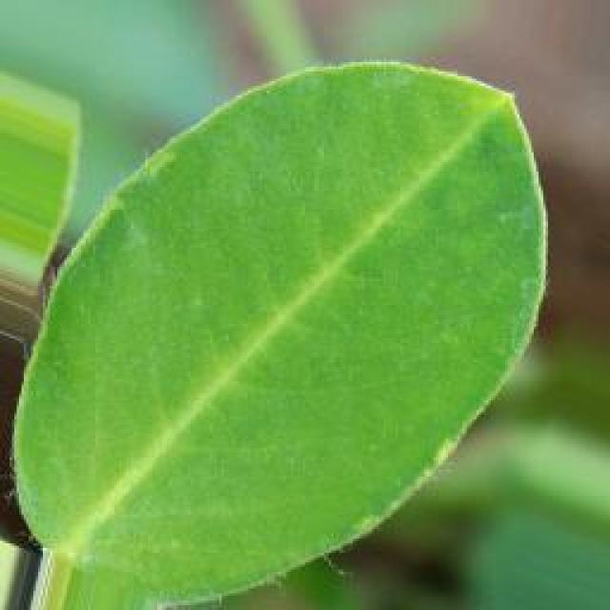
See the image and tell me what type of disease, visible symptoms and possible solution?
Option 1:
The image shows a leaf with a yellowish-green color and a brown spot on it, which appears to be infected with a fungus. The leaf is growing in a dirt field, and the soil appears to be dry.
The visible symptoms of the disease include the yellowish-green color and the brown spot, which are indicative of the fungus's presence. The dry soil and the leaf's location in a dirt field suggest that the plant may be experiencing drought or other environmental stressors.
To address this issue, the plant may require proper irrigation and regular watering to maintain a healthy soil moisture level. Additionally, applying a fungicide to the affected plant and the surrounding soil can help prevent the spread of the fungus and promote the plant's recovery. It is also essential to monitor the plant's health and address any other stressors that may be affecting its growth and overall well-being.
Option 2:
The visible symptoms in the image show a groundnut plant with yellow leaves, which could indicate a nutrient deficiency such as iron or zinc. This can lead to chlorosis, where the leaves turn yellow due to insufficient chlorophyll production. A possible solution for this issue would be to apply appropriate fertilizers that contain these essential minerals to correct the deficiency and promote healthy growth in the plant.

Which option do you prefer?

Sample 35

Ground Truth: nutritional deficiency
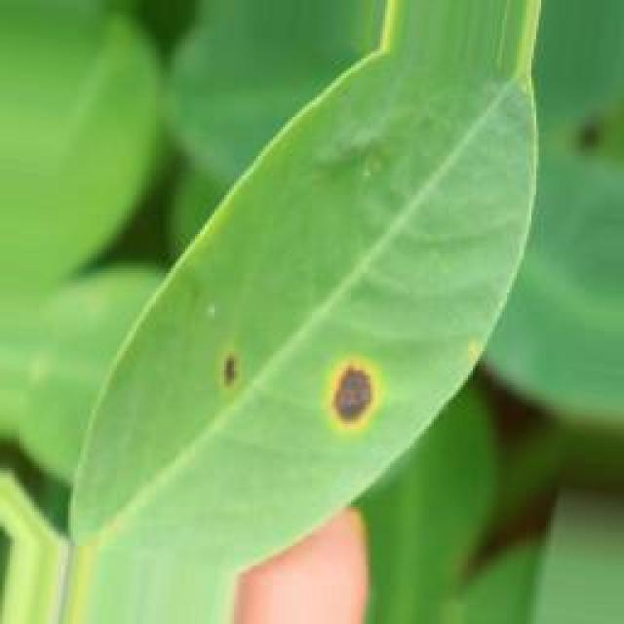
See the image and tell me what type of disease, visible symptoms and possible solution?
Option 1:
The image shows a leaf with yellow spots, which could be a sign of a disease or a nutrient deficiency. The yellow spots on the leaf might indicate a fungal infection, bacterial infection, or nutrient deficiency. To identify the specific disease, it would be necessary to examine the leaf more closely and possibly take a sample to a laboratory for further testing.
To address the issue, the following steps can be taken:
1. Remove any affected leaves or branches to prevent the spread of the disease.
2. Improve the soil quality by adding organic matter, such as compost or aged manure, to provide essential nutrients for the plant.
3. Ensure proper drainage and watering to prevent over-saturation, which can lead to root rot and other diseases.
4. Practice crop rotation to prevent the build-up of pests and diseases in the soil.
5. Use organic or chemical pesticides to control the spread of the disease, depending on the cause and severity of the problem.
It is essential to consult with a plant pathologist or a local agricultural extension service for specific advice on the best course of action for the particular disease or nutrient deficiency.
Option 2:
The visible symptom in the image is a yellowing of the leaves, which indicates a nutrient deficiency. This could be due to a lack of essential nutrients such as nitrogen, potassium, or magnesium. The plant may require soil testing to determine which specific nutrient is lacking and appropriate fertilization practices to address the issue. Additionally, proper irrigation and drainage management can also help maintain healthy growth in plants affected by nutrient deficiencies.

Which option do you prefer?

Sample 36

Ground Truth: nutritional deficiency
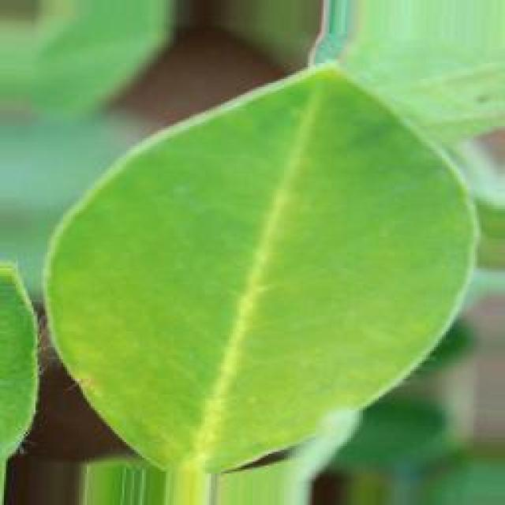
See the image and tell me what type of disease, visible symptoms and possible solution?
Option 1:
The image shows a leaf with a brown spot on it, which could be a sign of a disease or infection. The brown spot might be a result of various factors, such as nutrient deficiencies, overwatering, or exposure to pests or pathogens. To address this issue, it is essential to identify the cause of the brown spot and take appropriate measures to prevent further damage.
If the brown spot is caused by nutrient deficiencies, it is crucial to ensure that the plant receives adequate nutrients through proper soil amendment or fertilization. Overwatering can lead to root rot, so it is important to maintain an appropriate watering schedule and avoid over-saturating the soil.
If the brown spot is caused by pests or pathogens, it is necessary to inspect the plant for any signs of infestation or infection and take appropriate measures to control or eliminate the problem. This may involve using pesticides, fungicides, or other treatments to protect the plant from further damage. Regularly inspecting the plant and addressing any issues promptly can help prevent the spread of diseases and maintain the health of the plant.
Option 2:
The visible symptoms in the image suggest that the groundnut plant may be experiencing nutritional deficiency, specifically a lack of essential nutrients such as nitrogen, phosphorus, or potassium. The leaves appear to be discolored and have yellowing between the veins, which is indicative of iron deficiency. This can occur when the soil pH is too high or if there is an excess of calcium in the soil that competes with iron for uptake by the plant.
A possible solution would be to apply a foliar spray of iron chelates or other iron-containing fertilizers to correct the nutritional deficiency. It's important to note that this is just an observation based on the visible symptoms and further diagnostic testing may be required to confirm the exact cause of the issue and determine the most appropriate course of action.

Which option do you prefer?

Sample 37

Ground Truth: nutritional deficiency
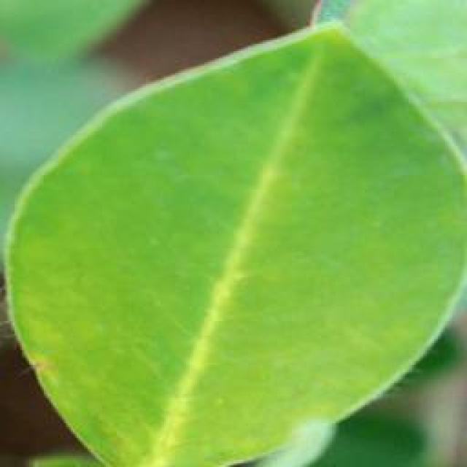
See the image and tell me what type of disease, visible symptoms and possible solution?
Option 1:
The image shows a leaf with a brown spot on it, which could indicate a disease or infection affecting the plant. The brown spot might be a sign of fungal infection, bacterial infection, or nutrient deficiency. To address this issue, it is essential to identify the cause of the brown spot and take appropriate measures to treat the plant.
If the brown spot is caused by a fungal infection, it is crucial to remove any infected leaves and apply a fungicide to prevent the spread of the disease. If it is a bacterial infection, it may require the application of a bactericide or a change in the plant's care routine, such as improving drainage or watering practices.
If the brown spot is due to nutrient deficiency, it is necessary to provide the plant with the necessary nutrients through fertilization or soil amendment. Regularly monitoring the plant's health and addressing any issues promptly can help prevent further damage and promote the plant's overall well-being.
Option 2:
The image shows a single groundnut leaf with visible symptoms that suggest it may be affected by nutritional deficiency. The most noticeable symptom is chlorosis, which appears as yellowing between the veins while the rest of the leaf remains green. This indicates that there may be an iron deficiency in the plant.
To address this issue, a soil test should be conducted to determine the nutrient levels and pH of the soil. If iron deficiency is confirmed, it can be treated with iron chelates or foliar sprays of iron sulfate. Additionally, maintaining proper drainage and avoiding high pH levels in the soil can help prevent further issues with nutrient availability.

Which option do you prefer?

Sample 38

Ground Truth: nutritional deficiency
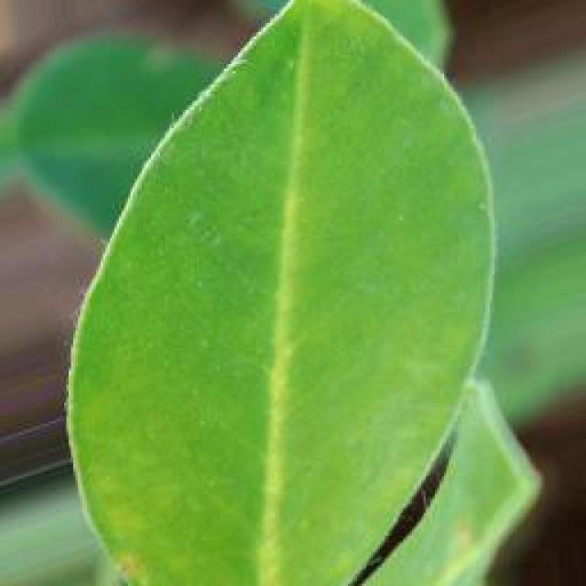
See the image and tell me what type of disease, visible symptoms and possible solution?
Option 1:
The image shows a leaf with a yellowish-green color and a brown spot on it, which could be a sign of a disease or infection. The leaf is laying on the ground, possibly in a dirt field.
The disease or infection could be caused by various factors, such as bacteria, fungi, or viruses. To identify the specific cause, a proper diagnosis would be required. Once the disease or infection is identified, a suitable solution would depend on the cause. For example, if it is a bacterial infection, antibiotics might be prescribed. If it is a fungal infection, fungicides could be used to treat the plant. In the case of a viral infection, the plant might need to be removed and destroyed to prevent the spread of the disease.
It is essential to monitor the plant's health and take appropriate action to prevent further damage or loss of the plant. Regular maintenance, such as proper watering, pest control, and pruning, can help prevent the development of diseases and infections in the plant.
Option 2:
The visible symptom in the image is a yellowing of the leaf, which could indicate a nutrient deficiency. This could be due to insufficient levels of essential minerals such as iron or zinc, or it could be related to a lack of nitrogen. To address this issue, it would be necessary to conduct soil tests to determine the specific nutrient deficiencies and then apply appropriate fertilizers or amendments based on the results of the soil test. Additionally, proper irrigation practices and ensuring that the plant is receiving adequate water can also help alleviate nutrient deficiency symptoms.

Which option do you prefer?

Sample 39

Ground Truth: nutritional deficiency
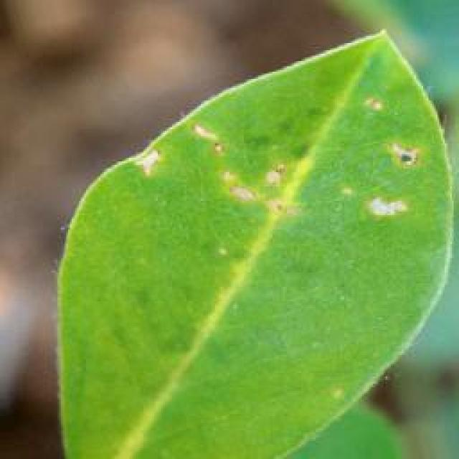
See the image and tell me what type of disease, visible symptoms and possible solution?
Option 1:
The image shows a yellow leaf with brown spots on it, which indicates that the leaf is affected by a disease. The brown spots suggest that the leaf is infected with a fungus or bacteria, which can cause the leaf to turn yellow and eventually die.
To address this issue, it is essential to identify the specific type of disease affecting the plant and take appropriate measures to treat it. Some common solutions include:
1. Pruning infected leaves and branches to prevent the spread of the disease.
2. Applying a fungicide or bactericide to the affected plant to kill the pathogens.
3. Ensuring proper drainage and air circulation around the plant to prevent over-wetting of the soil, which can lead to root rot and other diseases.
4. Regularly inspecting the plant for any signs of disease and taking preventive measures to avoid further infections.
It is important to consult with a plant expert or a local nursery for specific advice on the best course of action for treating the disease and maintaining the health of the plant.
Option 2:
The visible symptom in the image is that the leaves of the groundnut plant are yellowish, which could indicate a nutrient deficiency. Possible solutions for this issue include soil testing to determine if there is a lack of essential nutrients like nitrogen, phosphorus, or potassium. If the soil test confirms a deficiency, appropriate fertilizers can be applied according to the results of the soil test. Additionally, proper irrigation and drainage practices should be maintained to ensure that the plant receives adequate moisture without waterlogging.

Which option do you prefer?

Sample 40

Ground Truth: nutritional deficiency
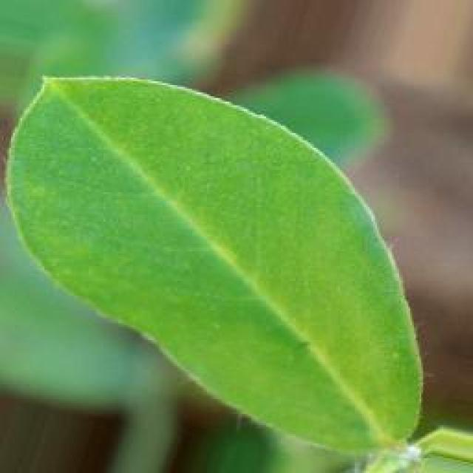
See the image and tell me what type of disease, visible symptoms and possible solution?
Option 1:
The image shows a yellow leaf with brown spots on it, which could indicate a disease or infection affecting the plant. The brown spots might be a sign of bacterial or fungal infections, which can cause damage to the plant's leaves and overall health.
To address this issue, it is essential to identify the specific type of disease causing the brown spots and take appropriate measures to treat it. Some common solutions include:
1. Applying a suitable fungicide or bactericide to the affected plant to kill the pathogens causing the disease.
2. Ensuring proper drainage and aeration of the soil to prevent root rot and other fungal infections.
3. Regularly inspecting the plant for any signs of disease and removing any infected leaves or branches promptly.
4. Practicing good gardening hygiene, such as washing hands and tools before handling the plant, to prevent the spread of diseases.
5. Providing adequate nutrients and water to the plant to support its immune system and overall health.
It is important to consult with a local nursery or gardening expert to determine the best course of action for treating the disease and preventing further damage to the plant.
Option 2:
The visible symptoms in the image suggest that the groundnut plant may be suffering from a nutrient deficiency, specifically a lack of nitrogen. This can be observed as yellowing of the leaves and stunted growth compared to healthy plants.
To address this issue, it would be necessary to perform soil tests to determine the nutrient levels in the soil. If the soil test indicates low levels of nitrogen, then a balanced fertilizer containing nitrogen can be applied according to the recommended dosage for groundnut plants. Additionally, proper irrigation practices and ensuring adequate sunlight are also important for healthy plant growth.

Which option do you prefer?

Sample 41

Ground Truth: late leaf spot
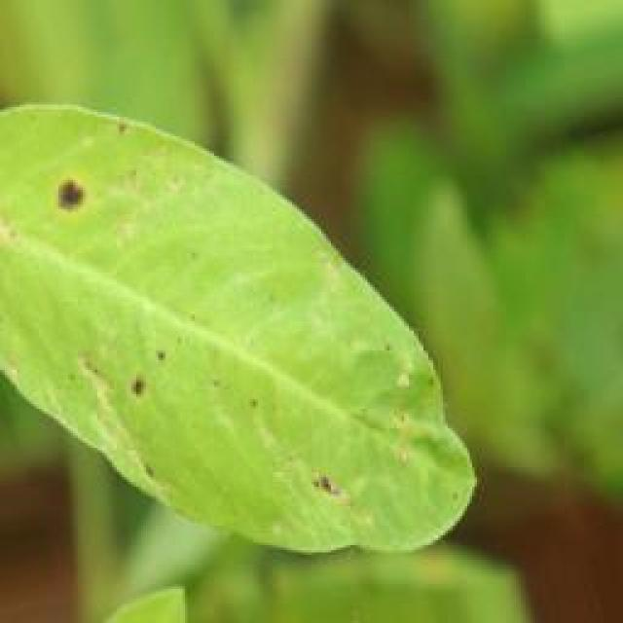
See the image and tell me what type of disease, visible symptoms and possible solution?
Option 1:
The image shows a leaf with spots and bumps, which could be indicative of a disease or a pest infestation. The leaf appears to be affected by a fungal infection, as it has brown spots and bumps on it. This type of infection can be caused by various fungi, such as powdery mildew or rust.
To address this issue, it is essential to identify the specific type of fungal infection affecting the leaf and take appropriate measures to prevent its spread. This may involve removing infected leaves, pruning affected branches, and ensuring proper air circulation around the plant. Additionally, applying a fungicide specifically designed for the identified fungus can help control the infection and protect the plant from further damage. It is also important to maintain the plant's overall health by providing adequate water, sunlight, and nutrients to support its immune system and prevent future infections.
Option 2:
The visible symptoms in the image show a groundnut plant with late leaf spot disease. This disease is characterized by the presence of small, round, yellowish spots on the leaves, which can eventually turn brown and necrotic. The spots are often surrounded by a purple halo.
The possible solution for this disease would be to manage the plant's environment to minimize the risk of infection. This could include proper irrigation, avoiding overhead watering that can splash the fungus onto the leaves, and ensuring good air circulation around the plants to reduce humidity levels. Additionally, if the disease is already present, fungicides may be used to control the spread of the pathogen. It's important to follow recommended practices for groundnut cultivation and to monitor the health of the plant regularly.

Which option do you prefer?

Sample 42

Ground Truth: late leaf spot
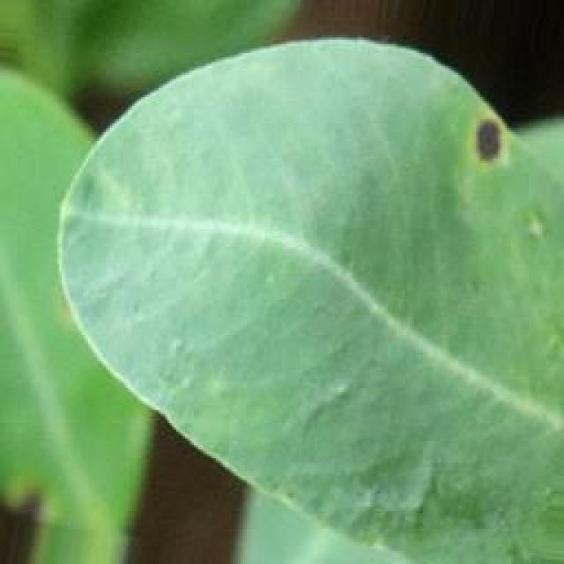
See the image and tell me what type of disease, visible symptoms and possible solution?
Option 1:
The image shows a leaf with spots and brown patches, which indicates that the leaf is affected by a disease. The disease appears to be a fungal infection, as the spots are brown and the leaf is discolored. This type of infection can be caused by various fungi, such as powdery mildew or leaf spot.
To address this issue, it is essential to identify the specific type of fungal infection affecting the leaf and take appropriate measures to prevent its spread. This may include removing infected leaves, pruning affected branches, and applying fungicides to the affected plant. Additionally, maintaining proper plant care, such as regular watering, adequate sunlight, and proper spacing, can help prevent the development of fungal infections in the future.
Option 2:
The visible symptoms in the image include yellowing of the leaves, which is a common sign of late leaf spot disease affecting groundnut plants. Late leaf spot is caused by the fungus Cercospora roxburghii and can lead to significant crop losses if left untreated.
The possible solution for this disease would be to apply fungicides such as thiram, mancozeb, or chlorothalonil at recommended rates, following the guidelines provided by local agricultural extension services. Regular inspections should be conducted to identify and treat infected plants promptly. Additionally, good field hygiene practices can help prevent the spread of the disease, including removing debris after harvest and avoiding planting near older, infected plants.

Which option do you prefer?

Sample 43

Ground Truth: late leaf spot
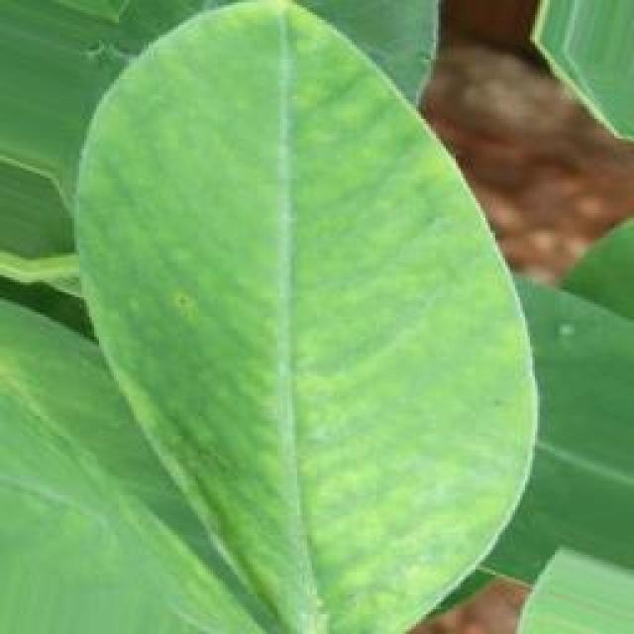
See the image and tell me what type of disease, visible symptoms and possible solution?
Option 1:
The image shows a leaf with a brown spot, which could be a sign of a disease or infection. The leaf appears to be affected by a fungal infection, as indicated by the presence of a brown spot. This type of infection can be caused by various factors, such as overwatering, nutrient imbalances, or poor soil quality.
To address this issue, it is essential to identify the cause of the infection and take appropriate measures to prevent further damage. This may include adjusting the watering schedule, ensuring proper nutrient balance, and improving soil quality. Additionally, it is crucial to monitor the plant's health and remove any infected leaves or parts to prevent the spread of the disease. If the infection is severe, it may be necessary to consult a plant expert or use fungicides to control the disease and protect the plant.
Option 2:
The visible symptoms in the image include yellowing of the leaves with a distinct black or brown spot at the center, which is characteristic of late leaf spot disease affecting groundnut plants. This disease is caused by fungi and can lead to significant crop loss if not managed properly.
The possible solution for this issue would be to implement preventive measures such as using resistant varieties, practicing crop rotation, and maintaining proper field sanitation by removing debris after harvest. Additionally, if the disease has already been identified, fungicides can be applied according to the recommended schedule by an agricultural professional to control the spread of the fungus and minimize damage to the crop.

Which option do you prefer?

Sample 44

Ground Truth: late leaf spot
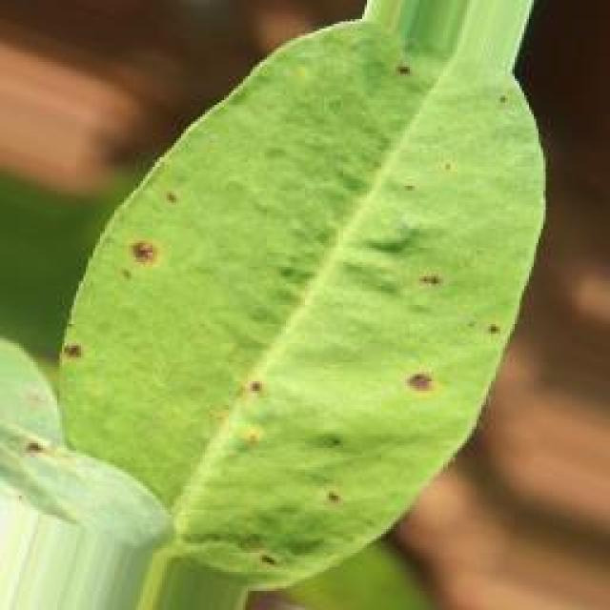
See the image and tell me what type of disease, visible symptoms and possible solution?
Option 1:
The image shows a leaf with a yellowish-green color and numerous black spots, which indicates that the leaf is affected by a disease. The disease appears to be a fungal infection, as the spots are spreading and covering the leaf.
The visible symptoms of the disease include the yellowish-green color and the black spots, which are the result of the fungal growth. The spots are spreading and covering the leaf, which is a sign of the disease's progression.
A possible solution to this problem is to practice good gardening practices, such as regular pruning, removing infected leaves, and ensuring proper drainage to prevent the growth of fungi. Additionally, using organic or chemical fungicides can help control the spread of the disease and protect the plant from further damage. It is essential to identify the specific type of fungus causing the infection and use the appropriate treatment method to prevent the disease from spreading to other plants in the garden.
Option 2:
The visible symptoms in the image include yellowing of the leaves with dark brown or black spots, which are characteristic of a disease called late leaf spot. This disease is caused by fungi and can affect various plants including groundnuts. The spots are irregularly shaped and can vary in size.
The possible solution for this disease would involve preventive measures such as using resistant varieties of the crop, practicing crop rotation to avoid recycling the pathogen, and maintaining good field hygiene by removing debris after harvest. If the disease has already occurred, fungicides can be used for control, but it's important to follow recommended application rates and guidelines to minimize environmental impact. Additionally, proper irrigation management and nutrient deficiency correction may also help in mitigating the effects of this disease.

Which option do you prefer?

Sample 45

Ground Truth: late leaf spot
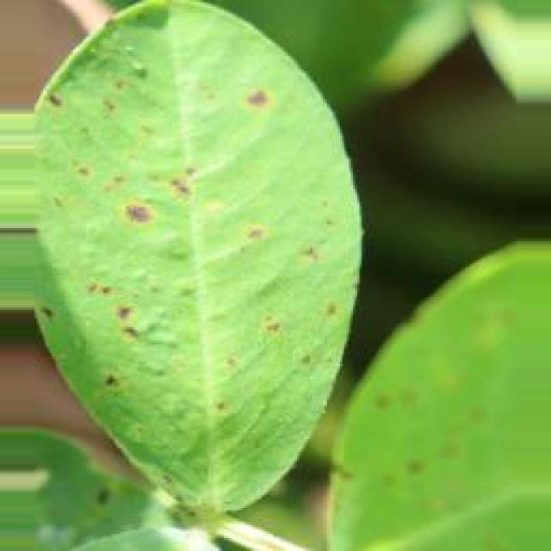
See the image and tell me what type of disease, visible symptoms and possible solution?
Option 1:
The image shows a leaf with brown spots and holes, which indicates that the plant is suffering from a disease called bacterial spot disease. This disease is caused by bacteria that infect the plant's leaves, leading to the formation of brown spots and holes. The symptoms of bacterial spot disease can vary depending on the type of bacteria and the plant species, but they generally involve the formation of lesions or spots on the leaves.
A possible solution to this problem is to practice good gardening practices, such as regular pruning, removing infected leaves, and ensuring proper drainage to prevent the spread of the disease. Additionally, using organic or bactericidal soaps can help to control the bacteria and prevent the disease from spreading further. It is also essential to maintain a healthy plant by providing adequate nutrients, water, and sunlight, which can help the plant to develop a stronger immune system and resist diseases more effectively.
Option 2:
The visible symptoms in the image include yellowing leaves with brown spots, which are indicative of a disease known as late leaf spot. This disease is caused by the fungus Cercospora. The spots are typically round or irregularly shaped and can vary in color from light green to dark brown. The holes in the leaves are also characteristic of this disease.
A possible solution for managing late leaf spot includes proper crop rotation, removing infected plant debris, and applying fungicides such as chlorothalonil or mancozeb. It's important to follow recommended practices and consult with a local agricultural extension service for specific advice tailored to the region and the type of crop.

Which option do you prefer?

Sample 46

Ground Truth: late leaf spot
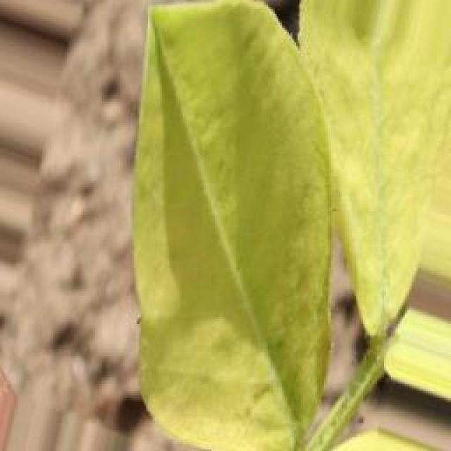
See the image and tell me what type of disease, visible symptoms and possible solution?
Option 1:
The image shows a leaf with brown spots and a yellowish-green color, which indicates that the plant is affected by a disease. The disease appears to be a fungal infection, as the spots are irregularly shaped and the leaf has a yellowish-green color.
To address this issue, it is essential to identify the specific type of fungal infection affecting the plant and take appropriate measures to prevent its spread. This may include removing infected leaves, pruning affected branches, and ensuring proper drainage and air circulation around the plant. Additionally, applying a suitable fungicide can help control the infection and protect the plant from further damage. It is also important to maintain the overall health of the plant by providing adequate water, sunlight, and nutrients to support its immune system and prevent future infections.
Option 2:
The visible symptoms in the image include dark brown or black spots with yellow halos on the leaves of the groundnut plant. These spots are indicative of late leaf spot, a fungal disease that affects plants during warm and humid conditions.
The possible solution for this disease is to apply fungicides such as thiram, mancozeb, or chlorothalonil to control the spread of the fungus. It's important to follow proper application rates and repeat treatments if necessary. Additionally, maintaining good field hygiene by removing debris and practicing crop rotation can help prevent the disease from spreading further.

Which option do you prefer?

Sample 47

Ground Truth: late leaf spot
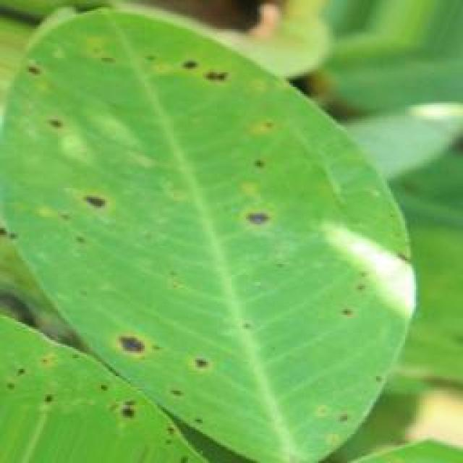
See the image and tell me what type of disease, visible symptoms and possible solution?
Option 1:
The image shows a leaf with brown spots and black dots, which could indicate a disease or infection affecting the plant. The presence of these spots and dots suggests that the plant might be experiencing a fungal or bacterial infection, which can cause damage to the plant's tissues and negatively impact its overall health.
To address this issue, it is essential to identify the specific type of disease causing the spots and dots. Once the disease is diagnosed, appropriate treatment measures can be taken, such as applying fungicides or bactericides to the affected plant, pruning infected parts, and ensuring proper care and maintenance of the plant to prevent future infections. Additionally, it is crucial to practice good gardening practices, such as regular watering, proper spacing, and pest control, to minimize the risk of diseases affecting the plant.
Option 2:
The visible symptoms in the image include brown spots on the leaves, which are characteristic of late leaf spot disease affecting groundnut plants. These spots can vary in size and shape but are typically round or irregularly shaped with a yellowish center surrounded by a purple halo. The spots may coalesce to form larger lesions on the leaves.
The possible solution for this disease is preventative measures such as using resistant varieties of groundnut plants, practicing crop rotation, and maintaining proper field sanitation by removing debris after harvest. If late leaf spot has already occurred, fungicides can be used to control the spread of the disease. It's important to follow recommended application rates and intervals for these treatments, as well as monitoring the plants regularly for signs of infection and treatment effectiveness.

Which option do you prefer?

Sample 48

Ground Truth: late leaf spot
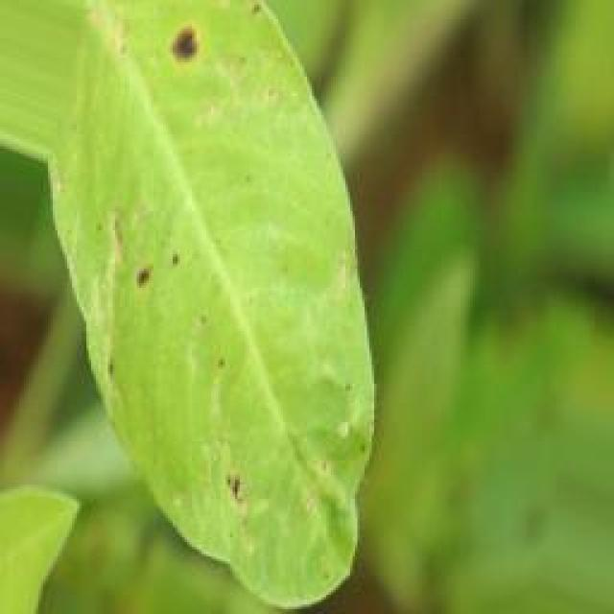
See the image and tell me what type of disease, visible symptoms and possible solution?
Option 1:
The image shows a leaf with yellow spots, which could be a sign of a fungal infection or a bacterial disease. The yellow spots are a visible symptom of the disease, indicating that the plant is affected by a pathogen.
To solve this issue, it is essential to identify the specific type of disease and the pathogen causing it. Once the disease is identified, appropriate treatment methods can be applied, such as using fungicides or bactericides to combat the pathogen. Additionally, proper care and maintenance of the plant, including regular watering, pest control, and ensuring adequate sunlight and nutrients, can help prevent the disease from spreading and reduce the risk of further damage to the plant.
Option 2:
The visible symptoms in the image include yellowing of the leaf, which indicates a nutrient deficiency or stress, and the presence of dark spots or lesions on the leaf, which is indicative of late leaf spot disease. Late leaf spot affects plants by causing brown or black spots to develop on leaves, stems, and pods. The disease is usually caused by fungi and can be identified by the presence of these spots.
A possible solution for this plant would be to treat it with fungicides that are effective against late leaf spot disease, such as thiram or captan. It's important to follow proper application guidelines and repeat the treatment if necessary. Additionally, maintaining good field hygiene and avoiding overcrowding can help prevent the spread of the disease.

Which option do you prefer?

Sample 49

Ground Truth: late leaf spot
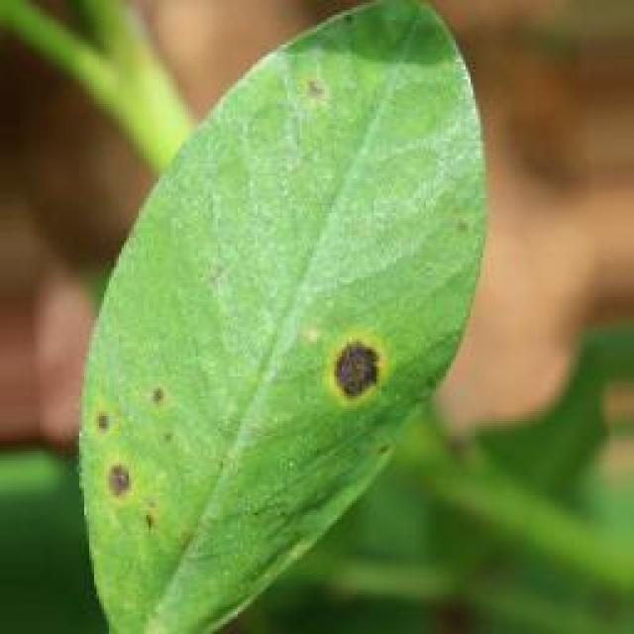
See the image and tell me what type of disease, visible symptoms and possible solution?
Option 1:
The image shows a leaf with a black spot, which could be a sign of a disease or infection. The leaf appears to be affected by a fungal infection, as indicated by the black spot. This type of infection can be caused by various fungi, such as fungal pathogens or bacteria.
To address this issue, it is essential to identify the specific type of fungus or bacteria causing the infection. Once the cause is determined, appropriate treatment measures can be taken, such as using fungicides or bactericides to kill the pathogens, or applying a protective coating to the affected area to prevent further spread. Additionally, proper care and maintenance of the plant, such as regular pruning, watering, and pest control, can help prevent the development of diseases and infections in the future.
Option 2:
The visible symptoms in the image include yellowing leaves with brown spots, which are characteristic of late leaf spot disease affecting groundnut plants. This disease is caused by a fungus and can lead to significant crop loss if not managed properly.
The possible solutions for managing late leaf spot disease include:
1. Early detection: Regularly inspect the plants for signs of the disease, such as yellowing leaves with brown spots, and treat as soon as symptoms are observed.
2. Fungicide application: Use appropriate fungicides like thiram, mancozeb, or chlorothalonil to control the spread of the fungus. Repeat the application if necessary, following the recommended intervals.
3. Crop rotation: Practice crop rotation to avoid re-infection from the soil and reduce the buildup of fungal spores.
4. Proper drainage: Ensure that the soil is well-draining to minimize moisture buildup, which can exacerbate the disease.
5. Resistant varieties: Consider using varieties that are resistant to late leaf spot disease if available in your region.
6. Cultural practices: Remove infected plant debris and maintain a clean environment around the crop to reduce the risk of disease spread.

Which option do you prefer?

Sample 50

Ground Truth: late leaf spot
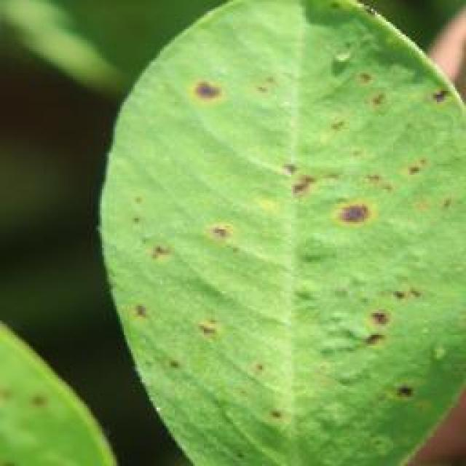
See the image and tell me what type of disease, visible symptoms and possible solution?
Option 1:
The image shows a leaf with brown spots and holes, which indicates that the plant is suffering from a disease called bacterial leaf spot. This disease is caused by bacteria that infect the plant's leaves, leading to the formation of brown spots and holes. The symptoms of bacterial leaf spot include the browning and decay of leaves, which can eventually lead to the death of the affected leaves and, in severe cases, the entire plant.
A possible solution to this problem is to practice good gardening practices, such as regular pruning, removing infected leaves, and ensuring proper drainage to prevent the spread of the disease. Additionally, using organic fertilizers and avoiding the use of excessive nitrogen-rich fertilizers can help in preventing the growth of bacteria that cause the disease. If the disease is severe, it may be necessary to consult a professional to identify the specific bacteria causing the problem and to develop an appropriate treatment plan.
Option 2:
The image shows a groundnut plant with leaves exhibiting symptoms consistent with late leaf spot disease. The visible symptoms include dark brown or black spots on the leaves, which are the result of fungal infection. These spots can vary in size and shape but are typically round to irregularly shaped. The edges of the spots may be sharply defined or blurred, depending on the species of the pathogen causing the disease.
The late leaf spot disease affects the leaves of groundnut plants, causing them to turn brown or black and eventually die. This can lead to reduced photosynthetic capacity, which in turn can impact plant growth and yield. The solution for this disease would typically involve fungicide treatments, such as chlorothalonil, to control the spread of the pathogen and prevent further damage to the plant. It's important to monitor the health of the plants regularly and apply any recommended treatments at the appropriate intervals to manage the disease effectively.

Which option do you prefer?

Sample 51

Ground Truth: late leaf spot
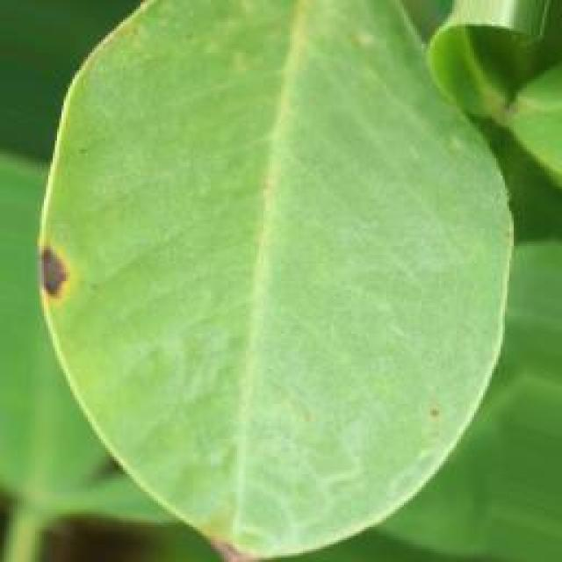
See the image and tell me what type of disease, visible symptoms and possible solution?
Option 1:
The image shows a leaf with brown spots and a yellowish-green color, which indicates that the leaf is affected by a disease. The disease appears to be a fungal infection, as the spots are irregularly shaped and the leaf has a yellowish-green color.
The visible symptoms of the disease include the brown spots on the leaf, which are likely caused by the fungus spreading through the plant's tissues. The yellowish-green color of the leaf could be a result of the fungus affecting the plant's chlorophyll production.
A possible solution to this problem is to practice good gardening practices, such as regular pruning, removing infected leaves, and ensuring proper drainage to prevent the growth of fungi. Additionally, using organic fertilizers and pest control methods can help maintain a healthy plant and prevent the spread of diseases. If the disease is severe, it may be necessary to consult a professional to identify the specific type of fungus and recommend appropriate treatment.
Option 2:
The visible symptoms in the image include dark spots or lesions on the leaves of the groundnut plant. These spots are indicative of a disease called late leaf spot, which is caused by the fungus Cercospora groundsella. The affected leaves may turn yellow, wilt, and eventually die.
The possible solution for this disease would be to apply fungicides such as chlorothalonil or mancozeb to prevent the spread of the disease and protect healthy tissue. It's also important to practice good crop rotation and maintain proper field sanitation to minimize the risk of infection.

Which option do you prefer?

Sample 52

Ground Truth: late leaf spot
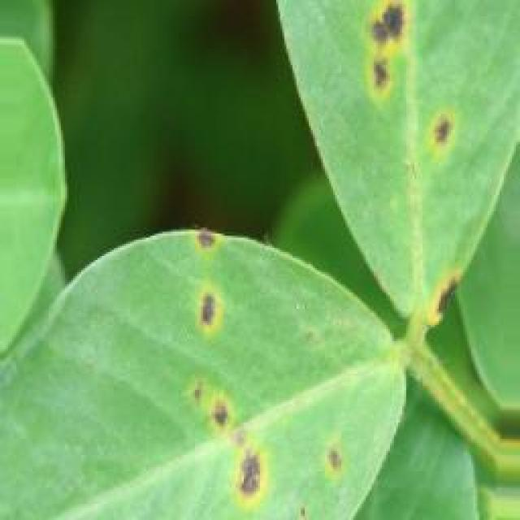
See the image and tell me what type of disease, visible symptoms and possible solution?
Option 1:
The image shows a leaf with a yellow and green color, which appears to be affected by a disease. The leaf has brown spots and is covered in a yellowish substance, indicating that it is infected with a fungus or bacteria. This type of infection can cause the leaf to lose its color and eventually fall off the plant.
To address this issue, it is essential to identify the specific type of disease affecting the plant and take appropriate measures to prevent its spread. This may involve removing infected leaves, practicing proper plant care, and using organic or chemical treatments to control the disease. It is also important to monitor the plant's health regularly to ensure that the disease does not progress and cause further damage.
Option 2:
The visible symptoms in the image show a groundnut plant with late leaf spot disease. This is characterized by the presence of brown or black spots on the leaves, which are often accompanied by yellowing and necrosis around the edges of the spots. The spots can vary in size and shape, and may be circular, irregularly shaped, or elongated.
The possible solution for this disease would involve preventative measures such as using resistant varieties of groundnut plants, practicing crop rotation to avoid re-infection from previous crops, and maintaining proper field sanitation by removing debris and controlling weeds that can harbor the pathogen. If the disease has already been detected, fungicides may be applied according to the recommended schedule for groundnut late leaf spot disease management. It's important to follow local guidelines and use only approved chemicals to minimize environmental impact.

Which option do you prefer?

Sample 53

Ground Truth: late leaf spot
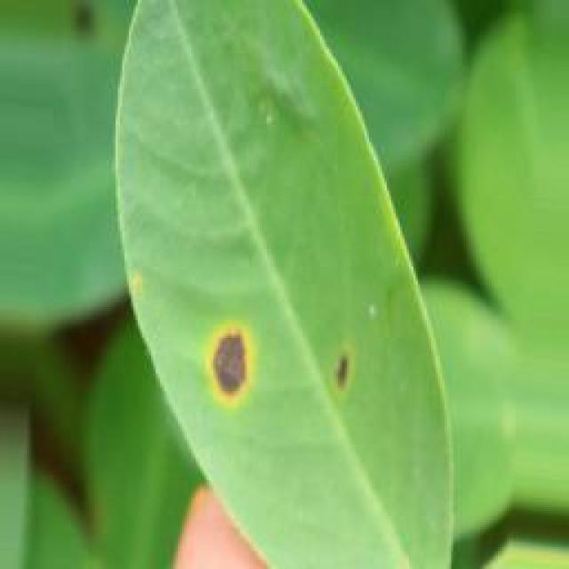
See the image and tell me what type of disease, visible symptoms and possible solution?
Option 1:
The image shows a leaf with brown spots and black dots, which could be indicative of a fungal infection or a bacterial disease. The presence of these spots and dots on the leaf suggests that the plant is experiencing some form of stress or illness.
To address this issue, it is essential to identify the specific type of disease causing the spots and dots. Once the disease is identified, appropriate treatment measures can be taken. For fungal infections, it is crucial to remove infected leaves and branches, and apply fungicides to prevent the spread of the disease. For bacterial diseases, it is important to practice proper plant care, such as regular watering, pest control, and ensuring adequate nutrient intake. Additionally, it is essential to maintain a healthy environment for the plant by providing proper sunlight, temperature, and humidity conditions.
Option 2:
The image shows a groundnut plant with leaves exhibiting symptoms consistent with late leaf spot disease. The visible symptoms include dark brown or black spots on the leaves, which are the result of fungal infection. These spots can vary in size and shape but are typically round to irregularly shaped. The edges of the spots may be sharply defined or blurred.
The late leaf spot disease affects the groundnut plant by causing these dark brown or black spots on the leaves, which can eventually lead to leaf drop and reduced plant vigor. The fungus responsible for this disease is typically spread through splashing water from rain or irrigation systems. To manage this disease, it is important to practice proper crop rotation, remove infected plant debris, and apply fungicides as recommended by a local agricultural extension service.

Which option do you prefer?

Sample 54

Ground Truth: late leaf spot
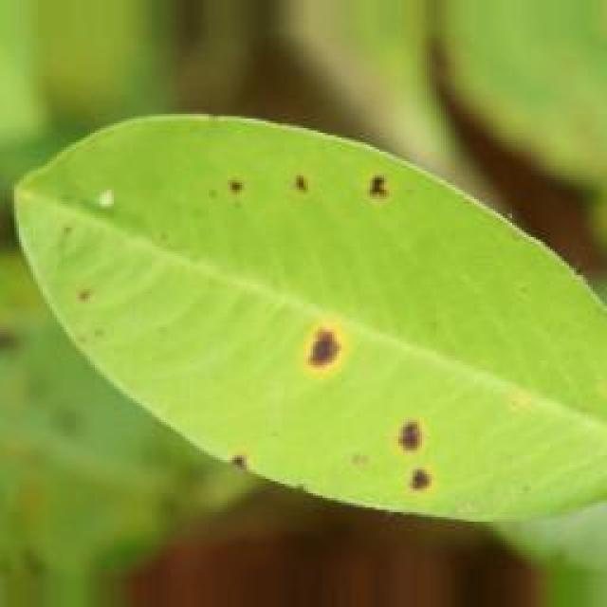
See the image and tell me what type of disease, visible symptoms and possible solution?
Option 1:
The image shows a leaf with brown spots and yellowish-green color, which indicates that the plant is affected by a fungal disease. The spots are likely caused by a fungus that has infected the plant, leading to the discoloration and potential damage to the leaf.
To address this issue, it is essential to identify the specific type of fungal disease affecting the plant and take appropriate measures to prevent its spread. This may include removing infected leaves, practicing proper plant care, and using fungicides if the disease is severe. Additionally, it is important to maintain a healthy plant environment by ensuring adequate sunlight, water, and nutrient availability, as well as proper spacing and air circulation to minimize the risk of fungal infections.
Option 2:
The visible symptoms in the image include yellowing of the leaves, with brown spots and blisters scattered across them. These are indicative of a disease called late leaf spot, which is caused by the fungus Cercospora. The spots can vary in size and color, often starting as small brown or black dots that expand to larger, irregularly shaped areas with yellow halos.
The possible solution for this disease is to manage it through proper crop management practices. This includes removing infected leaves, avoiding overhead irrigation that can spread the fungus, and using fungicides such as chlorothalonil or mancozeb to control the spread of the disease. Additionally, maintaining good field hygiene and practicing crop rotation can help prevent the recurrence of late leaf spot.

Which option do you prefer?

Sample 55

Ground Truth: late leaf spot
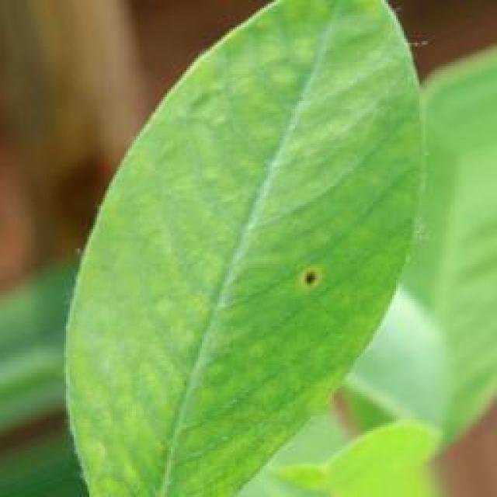
See the image and tell me what type of disease, visible symptoms and possible solution?
Option 1:
The image shows a leaf with brown spots and holes, which indicates that the plant is suffering from a disease called bacterial soft rot. This disease is caused by bacteria, such as Erwinia tracheiphila, which can infect various plant parts, including leaves, stems, and roots.
The visible symptoms of bacterial soft rot include brown spots or lesions on the leaves, which eventually turn into holes, and the leaves may become soft and mushy. The plant may also show signs of wilting, yellowing, or drooping.
A possible solution to this problem is to remove the affected leaves and stems, and then remove the soil from the affected area. It is essential to clean the affected area thoroughly to prevent the spread of the disease. Additionally, it is advisable to practice proper plant care, such as regular watering, proper drainage, and using well-draining soil, to prevent the growth of bacteria and other pathogens. If the disease is severe, it may be necessary to consult a plant pathologist or a gardening expert to identify the specific bacteria causing the problem and to develop an appropriate treatment plan.
Option 2:
The visible symptoms in the image include dark spots or lesions on the leaves, which are indicative of a disease known as late leaf spot. This disease is caused by the fungus Cercospora cruenta. The spots can vary in color from brown to black and may have yellow halos around them. The affected leaves may become deformed or die prematurely.
The possible solution for this disease is to practice crop rotation, removing infected plants, and applying fungicides such as chlorothalonil or mancozeb to prevent the spread of the disease. It's important to monitor the plants regularly and treat them promptly if symptoms appear.

Which option do you prefer?

Sample 56

Ground Truth: late leaf spot
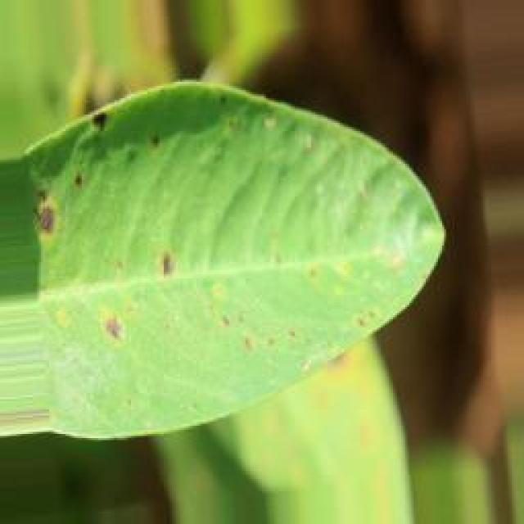
See the image and tell me what type of disease, visible symptoms and possible solution?
Option 1:
The image shows a leaf with a green and brown coloration, which suggests that it might be affected by a disease or a pest infestation. The leaf appears to be infested with small insects, which could be the cause of the discoloration.
The visible symptoms include the leaf's discoloration, which is a mix of green and brown, and the presence of small insects on the leaf. This could indicate that the plant is under stress or experiencing some form of damage.
A possible solution to this issue would be to identify the type of insect causing the damage and take appropriate measures to control or eliminate it. This could involve using insecticides, removing affected leaves, or introducing beneficial insects to help control the pest population. Additionally, ensuring proper care for the plant, such as providing adequate water, sunlight, and nutrients, can help it recover from the damage and prevent future infestations.
Option 2:
The visible symptoms in the image show a groundnut plant with late leaf spot disease. This is characterized by the presence of brown or black spots on the leaves, which are often accompanied by yellowing and necrosis around the edges of the spots. The spots can vary in size and shape, and may be circular, irregularly shaped, or even have a target-like appearance.
The possible solution for this disease would involve preventative measures such as using resistant varieties of groundnut plants, practicing crop rotation to avoid re-infection from previous crops, and maintaining proper field sanitation by removing debris and controlling weeds that can harbor the pathogen causing the late leaf spot disease. If the disease has already been identified, fungicides may be used for control, although their use should be carefully considered due to potential environmental impacts and the development of resistant strains.

Which option do you prefer?

Sample 57

Ground Truth: late leaf spot
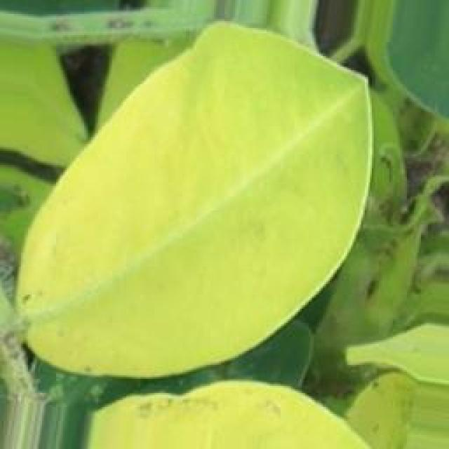
See the image and tell me what type of disease, visible symptoms and possible solution?
Option 1:
The image shows a leaf with brown spots and a yellowish-green color, which indicates that it is affected by a disease. The leaf appears to be infected with a fungal disease, as suggested by the presence of brown spots and the overall yellowish-green color.
To address this issue, it is essential to identify the specific type of fungal disease affecting the leaf and take appropriate measures to prevent its spread. This may involve removing infected leaves, practicing proper plant care, and using fungicides if the disease is severe or widespread. Additionally, it is important to maintain a healthy environment for the plant by providing adequate sunlight, water, and nutrients, as well as ensuring proper spacing between plants to allow for better air circulation and prevent overcrowding.
Option 2:
The visible symptoms in the image include yellowing of the leaves, which is a common sign of late leaf spot disease affecting groundnut plants. Late leaf spot is caused by the fungus Cercospora roxburghii and can lead to significant crop losses if not managed properly.
The visible spots on the leaves are dark brown or black, indicating that the disease has progressed significantly. These spots can vary in size and shape but are typically irregularly shaped with jagged edges. They may be accompanied by a yellow halo around the edges of the spots.
To manage late leaf spot disease, it is important to practice good crop rotation, remove infected plant debris, and apply fungicides such as thiram or mancozeb at recommended rates. Regular inspections should be conducted to catch the disease early and prevent further spread.

Which option do you prefer?

Sample 58

Ground Truth: late leaf spot
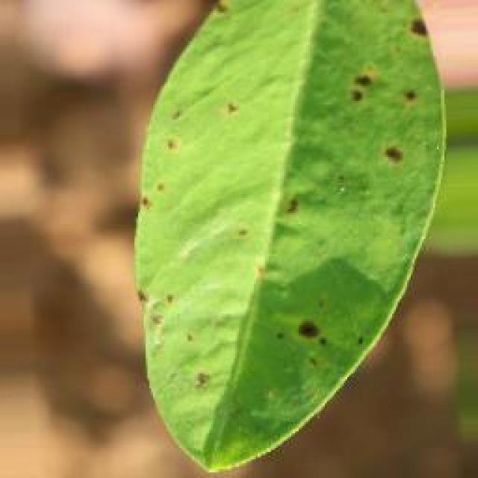
See the image and tell me what type of disease, visible symptoms and possible solution?
Option 1:
The image shows a leaf with spots and blemishes, which could be indicative of a disease or a nutrient deficiency. The leaf appears to be green, but the spots are brown and yellow. The presence of these spots and blemishes might suggest that the plant is experiencing a nutrient deficiency, such as a lack of iron or magnesium.
To address this issue, it is essential to provide the plant with the necessary nutrients through proper soil amendment or supplementation. Ensuring that the soil has adequate levels of essential nutrients, such as iron and magnesium, can help the plant recover from the deficiency and regain its health. Additionally, regular monitoring of the plant's health and addressing any other issues that may arise can help maintain the plant's well-being.
Option 2:
The visible symptoms in the image include dark spots or lesions on the leaves of the groundnut plant, which are indicative of late leaf spot disease. These spots can vary in size and shape, and they often have a yellow halo around them. The affected leaves may also show signs of wilting or drooping.
The possible solution for this disease is to manage it through proper crop management practices. This includes removing infected leaves, avoiding overhead irrigation that can spread the disease, and using fungicides such as thiram or mancozeb to control the spread of the pathogen. It's also important to practice good sanitation and avoid overcrowding in the field to reduce the risk of disease outbreaks.

Which option do you prefer?

Sample 59

Ground Truth: late leaf spot
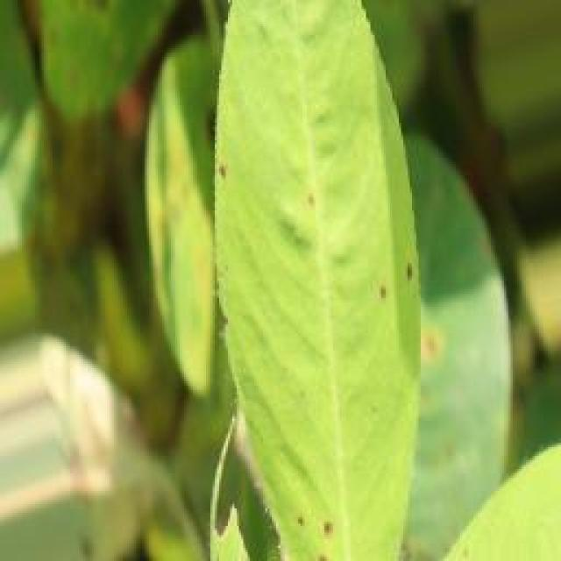
See the image and tell me what type of disease, visible symptoms and possible solution?
Option 1:
The image shows a leaf with spots and brown patches, which indicates that the plant is affected by a fungal disease. The spots and patches are likely caused by a fungus that has infected the plant. To address this issue, it is essential to identify the specific type of fungal disease and take appropriate measures to prevent its spread and manage the affected plant.
Some possible solutions include:
1. Practicing good garden hygiene, such as removing infected leaves and pruning affected branches, to prevent the spread of the disease.
2. Implementing crop rotation, which involves moving the plant to a different area in the garden or yard to reduce the risk of disease transmission.
3. Using organic or chemical fungicides to protect the plant from the fungus, depending on the severity of the disease and the plant's health.
4. Ensuring proper drainage and air circulation around the plant to reduce the risk of fungal growth.
5. Regularly inspecting the plant for signs of disease and taking action promptly to prevent further damage.
It is important to consult with a local nursery or agricultural extension service for specific advice on managing the disease and preventing its recurrence.
Option 2:
The visible symptoms in the image include yellowing leaves with brown spots, which are indicative of a disease affecting the groundnut plant. The most likely diagnosis is late leaf spot, caused by the fungus Cercospora groundsella. This disease affects a wide range of plants and is characterized by the development of small, brown spots on leaves that can eventually lead to necrosis and defoliation.
The possible solution for this disease would involve preventive measures such as crop rotation, removing infected plant debris, and using fungicides like chlorothalonil or mancozeb to control the spread of the fungus. Additionally, maintaining good field hygiene and practicing proper crop management can help minimize the risk of infection.

Which option do you prefer?

Sample 60

Ground Truth: late leaf spot
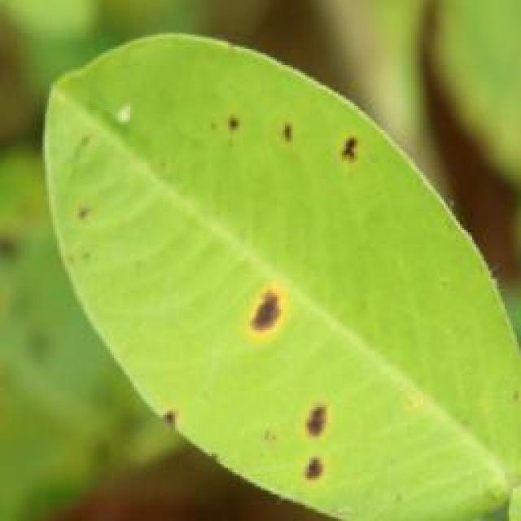
See the image and tell me what type of disease, visible symptoms and possible solution?
Option 1:
The image shows a leaf with brown spots and holes, which indicates that the plant is suffering from a disease called bacterial leaf spot. This disease is caused by bacteria that infect the plant's leaves, leading to the formation of brown spots and holes. The symptoms of bacterial leaf spot include discoloration, wilting, and eventual death of the affected leaves.
A possible solution to this problem is to practice good gardening practices, such as regular pruning, removing infected leaves, and ensuring proper drainage to prevent the spread of the disease. Additionally, using organic fertilizers and avoiding the use of excessive nitrogen-rich fertilizers can help in preventing the growth of bacteria that cause the disease. It is also essential to maintain a healthy plant by providing adequate water, sunlight, and nutrients to support the plant's immune system and prevent the development of diseases.
Option 2:
The visible symptoms in the image include brown spots on the leaves, which are indicative of a fungal disease known as late leaf spot. This disease affects plants by causing brown or black spots to develop on the leaves, eventually leading to necrosis and defoliation if left untreated.
The possible solution for this disease would be to apply fungicides such as thiram, mancozeb, or chlorothalonil, which are commonly used to control late leaf spot in crops like groundnuts. These fungicides can help prevent the spread of the disease and protect the plant from further damage. Additionally, proper crop rotation, maintaining a healthy field environment, and avoiding overcrowding are also important practices to minimize the risk of fungal diseases in plants.

Which option do you prefer?

Sample 61

Ground Truth: late leaf spot
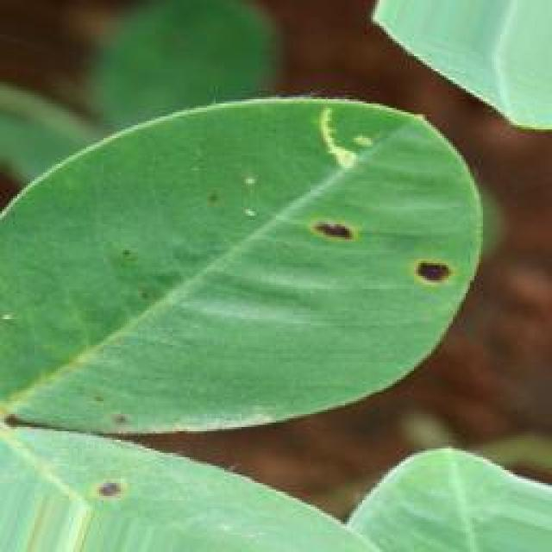
See the image and tell me what type of disease, visible symptoms and possible solution?
Option 1:
The image shows a leaf with brown spots and holes, which indicates that the plant is suffering from a disease called bacterial soft rot. This disease is caused by bacteria, specifically Xanthomonas campestris, which can infect various plant species, including tomatoes, peppers, and eggplants.
The visible symptoms of bacterial soft rot include brown spots or lesions on the leaves, which eventually turn into brown, mushy, and rotten tissue. The affected leaves may also become discolored and wilted.
To manage this disease, it is essential to practice proper crop rotation, remove infected plants, and maintain a clean and healthy growing environment. Additionally, using organic or bactericidal compost can help prevent the spread of the disease and promote healthy plant growth. It is also important to practice good hygiene, such as washing hands and tools before handling plants, to minimize the risk of spreading the disease.
Option 2:
The visible symptoms in the image include dark spots or lesions on the leaves, which are characteristic of late leaf spot disease affecting groundnut plants. These spots can vary in size and shape but are typically round to irregularly shaped with a dark center surrounded by a yellow halo. The spots may coalesce into larger areas of discoloration.
The possible solution for this disease is preventative measures such as using resistant varieties of groundnut plants, practicing crop rotation with other crops to avoid the buildup of fungal spores, and maintaining proper field sanitation by removing debris after harvest. If late leaf spot is already present, fungicides can be used for control, but it's important to follow recommended application rates and guidelines to minimize environmental impact.

Which option do you prefer?

Sample 62

Ground Truth: late leaf spot
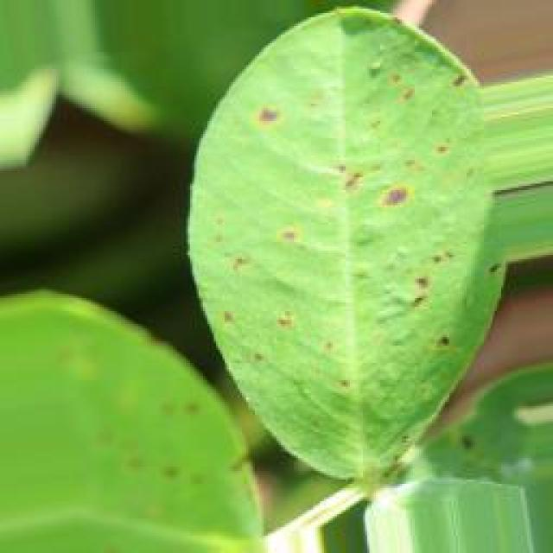
See the image and tell me what type of disease, visible symptoms and possible solution?
Option 1:
The image shows a leaf with brown spots and holes, which indicates that the plant is suffering from a disease called bacterial leaf spot. This disease is caused by bacteria that infect the plant's leaves, leading to the formation of brown spots and holes. The symptoms of bacterial leaf spot include the browning and decay of leaves, which can eventually lead to the death of the affected plant.
A possible solution to this problem is to practice good gardening practices, such as regular pruning, removing infected leaves, and ensuring proper drainage to prevent the spread of the disease. Additionally, using organic fertilizers and avoiding the use of excessive nitrogen-rich fertilizers can help in preventing the growth of bacteria that cause the disease. It is also essential to maintain a healthy plant by providing proper care, including adequate watering, sunlight, and nutrients.
Option 2:
The image shows a groundnut plant with several visible symptoms indicative of late leaf spot disease. The most prominent symptom is the presence of dark brown or black spots on the leaves, which are characteristic of this particular pathogen. These spots can vary in size and shape but are usually circular to irregularly shaped.
The late leaf spot disease affects the groundnut plant by causing necrotic tissue to develop on the leaves, which eventually leads to defoliation and reduced crop yield. The disease is caused by a fungus that thrives in warm and humid conditions.
To manage this disease, it is important to practice proper crop rotation, remove infected plant debris, and apply fungicides such as thiram or mancozeb according to local recommendations. Regular inspections should be conducted to identify and treat the disease early on.

Which option do you prefer?

Sample 63

Ground Truth: late leaf spot
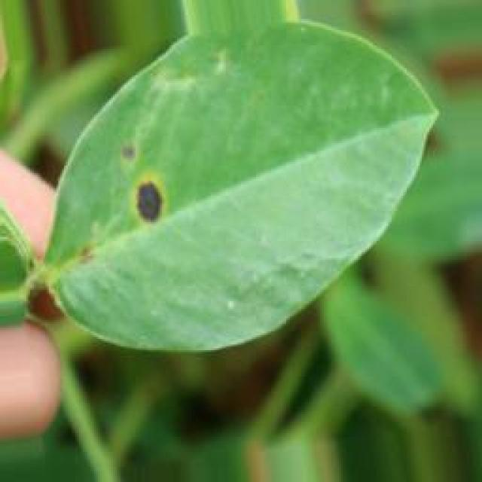
See the image and tell me what type of disease, visible symptoms and possible solution?
Option 1:
The image shows a leaf with yellow spots and black dots, which could be a sign of a fungal infection or a bacterial disease. The spots and dots are spread across the leaf, indicating that the disease has affected a significant portion of the plant.
To address this issue, it is essential to identify the specific type of disease causing the spots and dots. Once the disease is diagnosed, appropriate treatment measures can be taken to prevent further damage to the plant. These measures may include using fungicides or bactericides to kill the pathogens, applying a protective coating to the leaves, or removing and destroying infected leaves to prevent the spread of the disease. Additionally, proper care and maintenance of the plant, such as regular watering, pest control, and providing adequate sunlight, can help prevent the development of diseases and promote overall plant health.
Option 2:
The visible symptoms in the image include yellowing leaves with dark spots, which are characteristic of late leaf spot disease affecting groundnut plants. This disease is caused by a fungus and can lead to significant crop loss if not managed properly.
The possible solutions include:
1. Early detection: Regularly inspect plants for signs of the disease, such as small brown spots on leaves that can grow larger over time.
2. Proper identification: Confirm that the symptoms are indeed caused by late leaf spot disease by examining the spots under a microscope or using a fungal key to identify the specific pathogen involved.
3. Crop rotation: Implement crop rotation practices to reduce the risk of recycling the disease from one crop to another.
4. Fungicide application: If the disease is confirmed, apply fungicides such as thiram or captan at recommended rates and intervals according to local guidelines.
5. Cultural control: Maintain good field hygiene by removing debris after harvest, avoiding overhead irrigation that can spread the disease, and practicing crop rotation with other crops to reduce the risk of disease recycling.
6. Resistant varieties: Consider using varieties that are resistant to late leaf spot disease if available in your region.
It's important to follow local recommendations for specific crops and regions when managing diseases like late leaf spot.

Which option do you prefer?

Sample 64

Ground Truth: late leaf spot
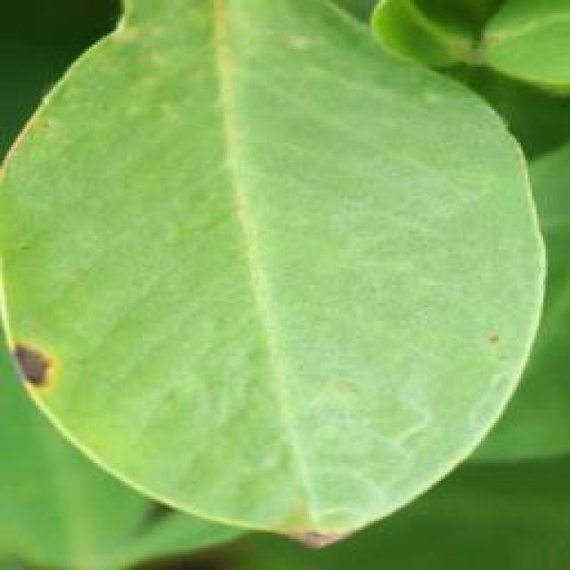
See the image and tell me what type of disease, visible symptoms and possible solution?
Option 1:
The image shows a leaf with brown spots and holes, which indicates that the plant is suffering from a disease called bacterial spot disease. This disease is caused by bacteria that infect the plant's leaves, leading to the formation of brown spots and holes. The symptoms of bacterial spot disease can vary depending on the type of bacteria and the plant species, but they generally involve the formation of lesions or spots on the leaves.
A possible solution to this problem is to practice good gardening practices, such as regular pruning, removing infected leaves, and ensuring proper drainage to prevent the spread of the disease. Additionally, using organic or bactericidal treatments can help control the bacteria and prevent further damage to the plant. It is essential to identify the specific bacteria causing the disease and use appropriate treatments to manage it effectively.
Option 2:
The visible symptoms in the image include yellowing leaves with brown spots and lesions, which are indicative of a disease known as late leaf spot. This disease is caused by the fungus Cercospora. The spots can vary in size and shape, and they often start at the edges of the leaves before spreading to the entire surface.
The possible solution for this disease would be to apply fungicides such as chlorothalonil or mancozeb, which are effective against Cercospora and other similar fungi. It's important to follow proper application rates and repeat the treatment if necessary. Additionally, maintaining good field hygiene, removing debris after harvest, and practicing crop rotation can help prevent the spread of the disease.

Which option do you prefer?

Sample 65

Ground Truth: late leaf spot
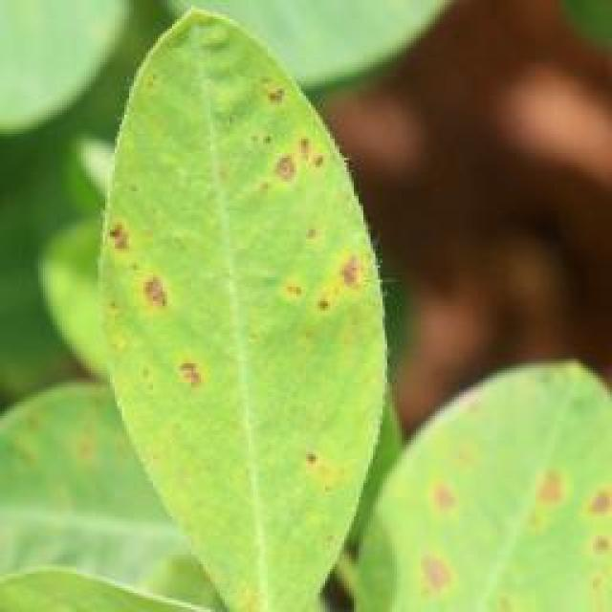
See the image and tell me what type of disease, visible symptoms and possible solution?
Option 1:
The image shows a leaf with a hole in the center, surrounded by spots and blisters. This suggests that the leaf is affected by a disease, possibly a fungal infection or a bacterial disease. The visible symptoms include the hole in the center, spots, and blisters on the leaf.
A possible solution to this problem could be to remove the affected leaves and branches from the plant, and then treat the plant with a suitable fungicide or bactericide to prevent the spread of the disease. Additionally, it is essential to maintain proper plant hygiene and ensure that the plant is not overcrowded, as this can help prevent the growth of pathogens and reduce the risk of infection.
Option 2:
The visible symptoms in the image include discoloration, with yellowing and brown spots on the leaves. These are indicative of a disease known as late leaf spot, which affects plants like groundnuts. The affected leaves show signs of necrosis (death) and can eventually fall off the plant.
A possible solution for this disease would be to implement proper crop management practices such as regular inspections for early detection of the disease, removal of infected leaves, and the use of fungicides if necessary. It's also important to maintain good field hygiene by avoiding overcrowding in the planting area and ensuring proper drainage to minimize moisture buildup that can contribute to the spread of the disease.

Which option do you prefer?

Sample 66

Ground Truth: late leaf spot
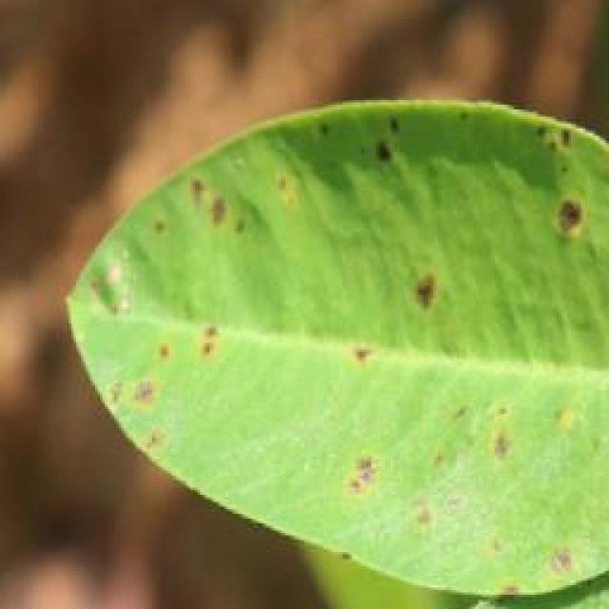
See the image and tell me what type of disease, visible symptoms and possible solution?
Option 1:
The image shows a leaf with brown spots and yellowish-green color, which indicates that the plant is affected by a disease. The spots are likely caused by a fungal infection, which can be identified by the presence of brown or black spots on the leaf.
To address this issue, it is essential to identify the specific type of fungal infection and take appropriate measures to prevent its spread. This may include removing infected leaves, practicing proper plant care, and using fungicides to control the disease. Additionally, it is important to maintain a healthy plant environment by ensuring adequate sunlight, water, and nutrient availability, as well as proper spacing and air circulation.
Option 2:
The visible symptoms in the image include yellowing and brown spots on the leaves of the groundnut plant. These are indicative of a disease called late leaf spot, which is caused by the fungus Cercospora groundsella. The spots can vary in color from yellow to brown and may have a ring-like pattern around the edges.
The possible solution for this disease includes proper crop rotation to avoid re-infection, removal of infected plant debris, and the use of fungicides such as chlorothalonil or mancozeb. It's important to monitor the plants regularly and treat them as soon as symptoms appear to prevent further spread of the disease.

Which option do you prefer?

Sample 67

Ground Truth: late leaf spot
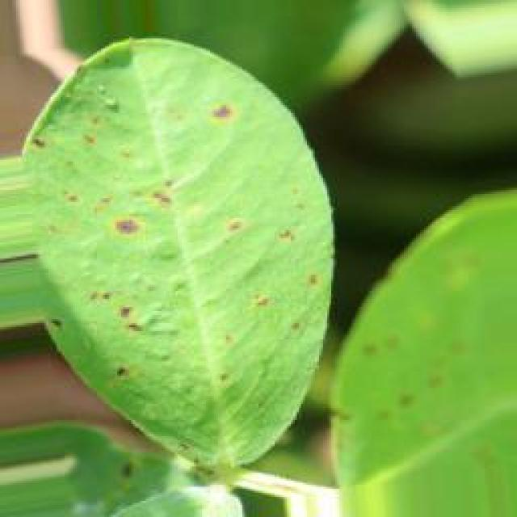
See the image and tell me what type of disease, visible symptoms and possible solution?
Option 1:
The image shows a leaf with brown spots and black dots, which indicates that the plant is affected by a disease. The disease appears to be affecting the leaf's health and causing it to lose its vibrant green color.
The visible symptoms of the disease include brown spots and black dots on the leaf, which are indicative of a fungal infection or bacterial disease. The affected leaf is also starting to wilt, which is another sign of the disease.
To address this issue, it is essential to identify the specific type of disease affecting the plant and take appropriate measures to treat it. This may involve using fungicides or bactericides to combat the infection, as well as ensuring proper care and maintenance of the plant, such as regular watering, adequate sunlight, and proper soil conditions. Additionally, it is important to practice good gardening practices, like removing infected leaves and avoiding overcrowding, to prevent the spread of the disease.
Option 2:
The visible symptoms in the image include yellowing leaves with dark brown spots, which are indicative of a disease known as late leaf spot. This disease is caused by the fungus Cercospora roxburghii and affects various crops including groundnuts.
The possible solution for this disease would involve preventive measures such as using resistant varieties, practicing crop rotation, and maintaining proper field sanitation to reduce the risk of infection. In addition, if the disease has already been identified, fungicides like chlorothalonil can be used for control. It's important to monitor the plants regularly and apply treatments as needed to manage the disease effectively.

Which option do you prefer?

Sample 68

Ground Truth: late leaf spot
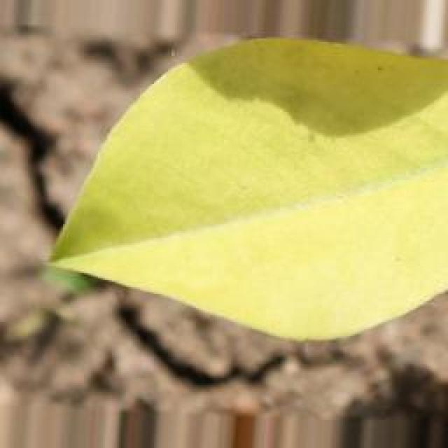
See the image and tell me what type of disease, visible symptoms and possible solution?
Option 1:
The image shows a leaf with brown spots and blemishes, which could be indicative of a disease or a nutrient deficiency. The presence of these spots and blemishes on the leaf suggests that the plant may be experiencing stress or a lack of essential nutrients.
To address this issue, it is important to identify the specific cause of the problem. If it is a disease, it may require the application of fungicides or other treatments to prevent the spread of the disease and protect the plant. If it is a nutrient deficiency, it may be necessary to provide the plant with the necessary nutrients through fertilization or soil amendment.
In either case, it is crucial to monitor the plant's health and take appropriate action to ensure its well-being and prevent further damage.
Option 2:
The visible symptoms in the image include dark spots or lesions on the leaves of the groundnut plant. These spots are indicative of a disease called late leaf spot, which is caused by the fungus Cercospora groundsella. The spots can vary in size and color, ranging from small black dots to larger brown or black lesions.
The possible solution for this disease includes preventive measures such as crop rotation, removing infected plant debris, and using resistant varieties of groundnut plants. If the disease has already occurred, fungicides can be applied according to the recommended schedule by an agricultural professional to manage the outbreak effectively. It's important to monitor the plants closely and follow up with any necessary treatments or adjustments to prevent further spread of the disease.

Which option do you prefer?

Sample 69

Ground Truth: late leaf spot
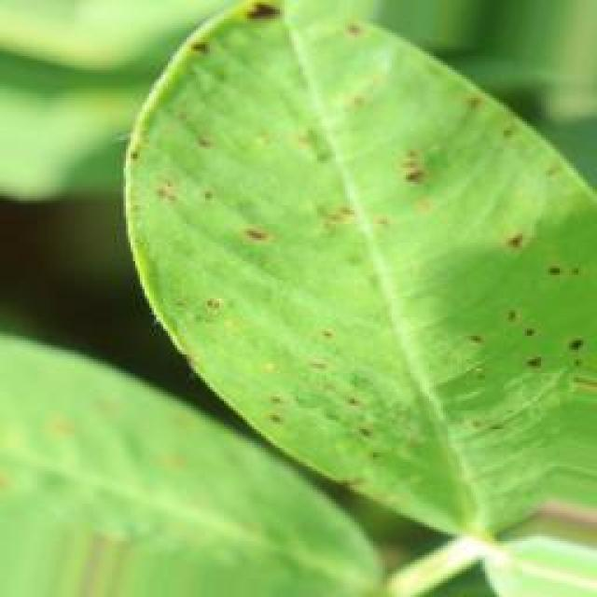
See the image and tell me what type of disease, visible symptoms and possible solution?
Option 1:
The image shows a plant with yellow leaves and brown spots, which indicates that it is suffering from a disease. The plant appears to be infected with a fungal disease, as the brown spots are a common symptom of fungal infections.
To address this issue, it is essential to identify the specific type of fungal disease affecting the plant and take appropriate measures to treat it. Some common solutions include:
1. Remove infected leaves and branches: Cutting off infected leaves and branches can help prevent the spread of the disease to healthy parts of the plant.
2. Practice good garden hygiene: Ensure that the plant is not in contact with other plants or soil that may harbor the fungus.
3. Improve drainage: Ensuring that the soil is well-drained can help prevent the growth of fungi that thrive in damp conditions.
4. Use organic or chemical fungicides: Depending on the type of fungal disease, applying appropriate fungicides can help control the infection and prevent further damage to the plant.
5. Avoid overwatering: Excessive watering can lead to the growth of fungi, so it is essential to maintain an appropriate watering schedule for the plant.
By following these steps, the plant can recover from the disease and regain its health.
Option 2:
The visible symptoms in the image include small, round spots on the leaves of the groundnut plant. These spots are indicative of late leaf spot disease, which affects plants during cooler temperatures and wet conditions. The spots can vary in color from yellow to brown or black, depending on the stage of the disease.
The possible solution for this disease is to manage the moisture levels around the plant to prevent further spread of the pathogen. This may include proper irrigation practices, such as watering only when necessary and avoiding overhead sprinklers that can spread the spores. Additionally, removing infected leaves and debris can help reduce the risk of further infection. If the disease is severe, fungicides may be necessary to control the spread of the pathogen. It's important to follow recommended practices for groundnut cultivation and consult with local agricultural experts for specific advice on managing this disease in your area.

Which option do you prefer?

Sample 70

Ground Truth: late leaf spot
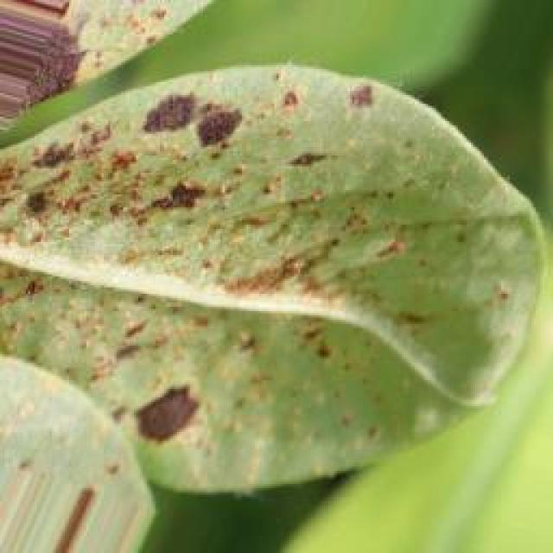
See the image and tell me what type of disease, visible symptoms and possible solution?
Option 1:
The image shows a leaf with brown spots and yellowish-green color, which indicates that the plant is affected by a disease. The disease appears to be a fungal infection, as the spots are irregularly shaped and the leaf has a yellowish-green color.
To address this issue, it is essential to identify the specific type of fungal infection and take appropriate measures to prevent its spread and manage the affected plant. Some possible solutions include:
1. Remove infected leaves and branches to prevent the spread of the disease.
2. Practice proper plant care, such as regular watering, adequate sunlight, and well-draining soil, to promote healthy plant growth and reduce the risk of infection.
3. Use organic or chemical fungicides, depending on the type of infection, to control the disease and protect the plant.
4. Avoid overcrowding plants, as this can lead to increased humidity and promote the growth of fungi.
5. Improve air circulation around the plant to reduce the risk of fungal infections.
It is important to consult with a plant expert or a local nursery to determine the best course of action for managing the disease and ensuring the health of the plant.
Option 2:
The visible symptoms in the image include yellowing leaves with brown spots, which are indicative of a disease known as late leaf spot. This disease is caused by the fungus Cercospora. The spots can vary in color from yellow to brown and may have a ring-like pattern around the edges. The affected leaves may wilt or die prematurely.
A possible solution for this disease is to practice proper crop rotation, removing infected plants, and using fungicides such as chlorothalonil to control the spread of the disease. It's also important to monitor the health of the plants regularly and treat them promptly if any signs of infection are observed.

Which option do you prefer?

Sample 71

Ground Truth: late leaf spot
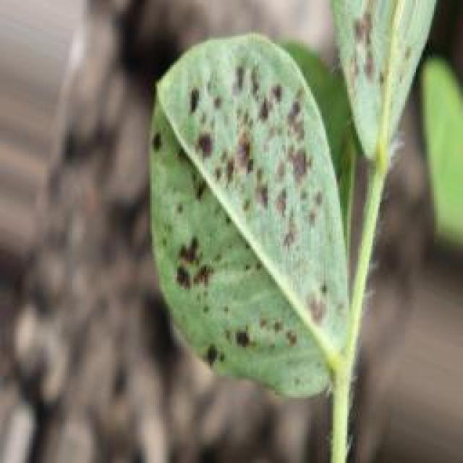
See the image and tell me what type of disease, visible symptoms and possible solution?
Option 1:
The image shows a leaf with brown spots and black dots, which indicates that the plant is suffering from a disease. The disease appears to be affecting the leaf's health and causing it to lose its vibrant green color.
The visible symptoms of the disease include the brown spots and black dots on the leaf, which are indicative of bacterial or fungal infections. These infections can be caused by various factors, such as overwatering, nutrient deficiencies, or exposure to pests or diseases.
To address this issue, it is essential to identify the cause of the disease and take appropriate measures to prevent its spread. This may involve adjusting the plant's watering schedule, ensuring proper nutrient intake, and removing any affected leaves or branches. Additionally, using organic or chemical-free pest control methods can help protect the plant from diseases caused by pests. Regularly inspecting the plant for any signs of disease and addressing them promptly can also help maintain the health of the plant and prevent further damage.
Option 2:
The image shows a close-up view of a groundnut plant with leaves that have yellowish discoloration and numerous small, dark spots scattered across them. These symptoms are indicative of late leaf spot disease, which is caused by the fungus Cercospora groundsella.
The visible symptoms include:
- Yellowing or chlorosis of the leaf tissue.
- Small, dark spots on the leaves.
- Leaf necrosis (death) around these spots.
The possible solution for this disease is to manage it through proper crop rotation, removing infected plants, and applying fungicides such as chlorothalonil or mancozeb to prevent the spread of the disease. It's also important to ensure that the groundnut plants are not overcrowded, as this can exacerbate the disease.

Which option do you prefer?

Sample 72

Ground Truth: late leaf spot
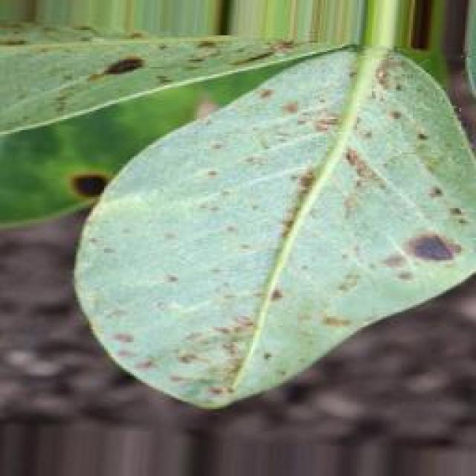
See the image and tell me what type of disease, visible symptoms and possible solution?
Option 1:
The image shows a leaf with brown spots and holes, which indicates that the plant is affected by a disease called bacterial spot disease. This disease is caused by bacteria that infect the plant's leaves, leading to the formation of brown spots and holes. The symptoms of bacterial spot disease can vary depending on the type of bacteria and the plant species, but they generally involve the formation of lesions or spots on the leaves.
A possible solution to this problem is to practice good gardening practices, such as regular pruning, removing infected leaves, and ensuring proper drainage to prevent the spread of the disease. Additionally, using organic or bactericidal soaps can help to control the bacteria and prevent the disease from spreading further. It is also essential to maintain a healthy plant by providing adequate nutrients, water, and sunlight, which can help the plant to resist diseases more effectively.
Option 2:
The visible symptoms in the image include dark spots or lesions on the leaves, which are indicative of a disease known as late leaf spot. This disease is caused by fungi and can affect various plants, including groundnuts. The spots are typically round to irregularly shaped and may have a yellow halo around them.
The possible solution for this disease would involve preventative measures such as proper crop rotation, removing infected leaves, and applying fungicides like thiram or mancozeb according to local recommendations. It's important to monitor the plants regularly and treat the disease as soon as it is detected to prevent further spread and damage.

Which option do you prefer?

Sample 73

Ground Truth: late leaf spot
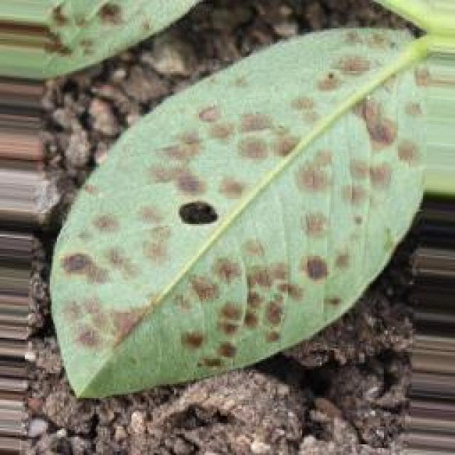
See the image and tell me what type of disease, visible symptoms and possible solution?
Option 1:
The image shows a leaf with brown spots, which could be a sign of a fungal infection or a bacterial disease. The brown spots are spread across the leaf, indicating that the plant is affected by the disease.
To address this issue, it is essential to identify the specific type of disease causing the brown spots. Once the disease is diagnosed, appropriate treatment measures can be taken. For fungal infections, it is crucial to remove infected leaves and branches, and apply fungicides to prevent the spread of the disease. For bacterial diseases, it is important to practice proper plant care, such as regular watering, pest control, and ensuring adequate nutrient intake. Additionally, it is essential to maintain a healthy plant environment by providing proper sunlight, temperature, and humidity conditions.
Option 2:
The image shows a groundnut plant with leaves exhibiting symptoms consistent with late leaf spot disease. This disease is caused by the fungus Cercospora groundsella, which affects a wide range of plants including groundnuts.
Visible symptoms include:
- Brown spots on the leaves
- Yellowing or chlorosis between the veins of the leaf
- Leaf drop
- Reduced plant vigor and growth
The possible solution for this disease is to manage it through cultural practices such as removing infected leaves, avoiding overhead irrigation that can spread the fungus, and maintaining good field hygiene by keeping weeds to a minimum. Additionally, fungicides like thiram or mancozeb can be used for control if necessary. It's important to monitor the plant regularly and apply treatments at the first signs of infection.

Which option do you prefer?

Sample 74

Ground Truth: late leaf spot
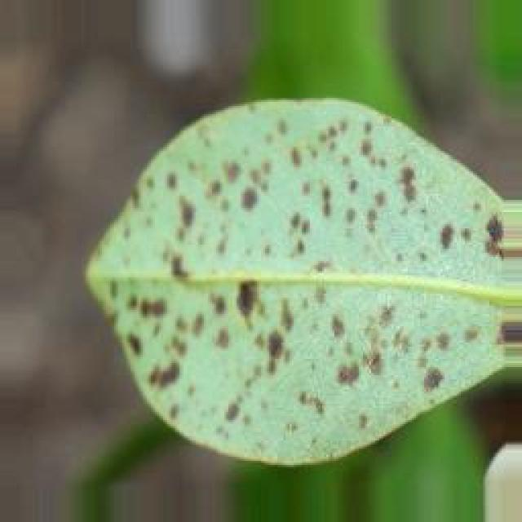
See the image and tell me what type of disease, visible symptoms and possible solution?
Option 1:
The image shows a leaf with brown spots and black dots, which indicates that the plant is affected by a disease. The disease appears to be affecting the leaf's surface, causing it to become discolored and potentially damaging the plant's overall health.
The visible symptoms of the disease include brown spots and black dots on the leaf, which are indicative of bacterial or fungal infections. These infections can be caused by various factors, such as overwatering, nutrient imbalances, or exposure to pests or diseases.
To address this issue, it is essential to identify the specific cause of the disease and take appropriate measures to prevent its spread. This may include adjusting the plant's watering schedule, ensuring proper nutrient balance, and removing any affected leaves or branches to prevent the disease from spreading. Additionally, using organic or chemical-free pest control methods can help protect the plant from potential pest-related infections. Regularly inspecting the plant for any signs of disease and addressing any issues promptly can help maintain the health of the plant and prevent further damage.
Option 2:
The image shows a groundnut plant with several leaves exhibiting symptoms consistent with late leaf spot disease. The visible symptoms include dark brown or black spots on the leaves, which are characteristic of this particular pathogen. Late leaf spot is caused by the fungus Cercospora groundsella and can lead to significant yield loss if not managed properly.
The possible solution for this disease would involve preventative measures such as crop rotation, removing infected plant debris, and applying fungicides like chlorothalonil or mancozeb at recommended rates. Additionally, cultural practices like maintaining good field hygiene and avoiding overcrowding can help reduce the risk of infection.

Which option do you prefer?

Sample 75

Ground Truth: late leaf spot
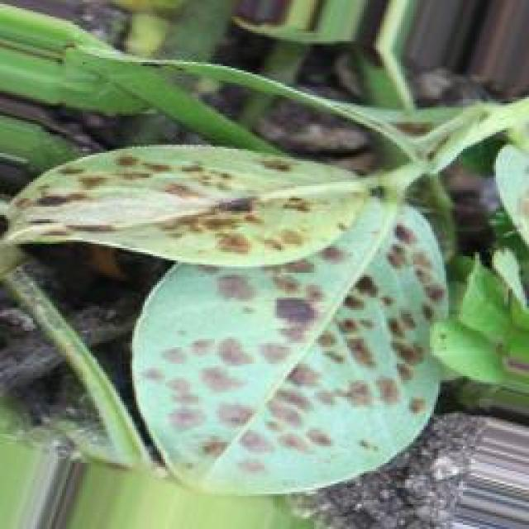
See the image and tell me what type of disease, visible symptoms and possible solution?
Option 1:
The image shows a leaf with brown spots and a yellowish-green color, which indicates that it is affected by a fungal disease. The spots are likely caused by a fungus that has infected the leaf, leading to the discoloration and potential damage to the plant.
To address this issue, it is essential to identify the specific type of fungus causing the disease and take appropriate measures to prevent its spread. This may include removing infected leaves, practicing proper plant care, and using fungicides if the disease is severe. Additionally, it is important to maintain a healthy plant environment by ensuring adequate sunlight, water, and nutrient availability, as well as proper spacing and air circulation to minimize the risk of fungal infections.
Option 2:
The visible symptoms in the image include dark spots or lesions on the leaves, which are indicative of a disease known as late leaf spot. This disease is caused by the fungus Cercospora and affects various crops including groundnuts. The spots can vary in color from black to brown and may have yellow halos around them.
The possible solution for this disease would be to apply fungicides such as thiram or captan, which are effective against Cercospora and other similar fungi. It's important to follow proper crop management practices, including regular inspections and timely application of fungicides, to prevent the spread of the disease and minimize crop losses.

Which option do you prefer?

Sample 76

Ground Truth: late leaf spot
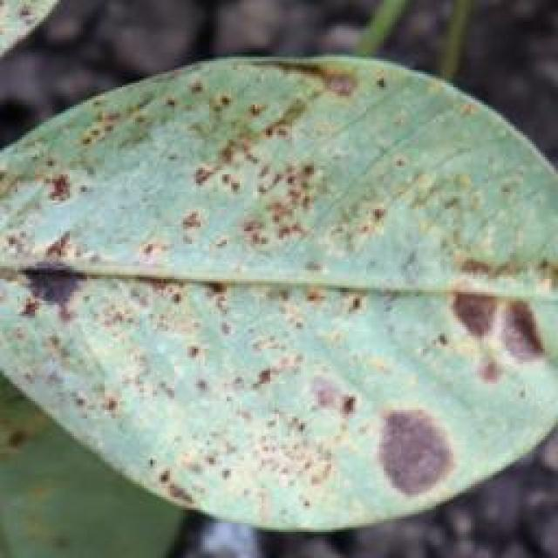
See the image and tell me what type of disease, visible symptoms and possible solution?
Option 1:
The image shows a leaf with yellow spots and black dots, which could be indicative of a fungal infection or a bacterial disease. The yellow spots are likely the result of the fungus or bacteria attacking the leaf, causing it to turn yellow and possibly die.
To address this issue, it is essential to identify the specific type of disease causing the spots and dots on the leaf. Once the disease is identified, appropriate treatment measures can be taken to prevent the spread of the infection and promote the health of the plant. This may involve using fungicides or bactericides, removing infected leaves, and ensuring proper care and maintenance of the plant. Additionally, it is important to practice good gardening practices, such as regular pruning, proper watering, and providing adequate sunlight, to help prevent the development of diseases in the future.
Option 2:
The visible symptoms in the image include yellowing of the leaves with dark spots, which are characteristic of late leaf spot disease affecting groundnut plants. This disease is caused by a fungus and can lead to significant crop loss if not managed properly.
The possible solutions for managing late leaf spot include:
1. Early detection: Regularly inspect plants for signs of the disease and begin treatment as soon as spots are seen.
2. Cultural control: Maintain good field hygiene by removing volunteer plants, debris, and weeds that can harbor the fungus.
3. Rotation: Practice crop rotation with other crops to create a break from recycling the disease.
4. Fungicide application: Use appropriate fungicides such as thiram, mancozeb, or chlorothalonil for control. Repeat the application if necessary, following the recommended schedule.
5. Resistant varieties: Consider using varieties that are resistant to late leaf spot disease.
6. Crop management: Properly manage the crop by controlling weeds, ensuring adequate moisture, and maintaining a healthy soil ecosystem.

Which option do you prefer?

Sample 77

Ground Truth: late leaf spot
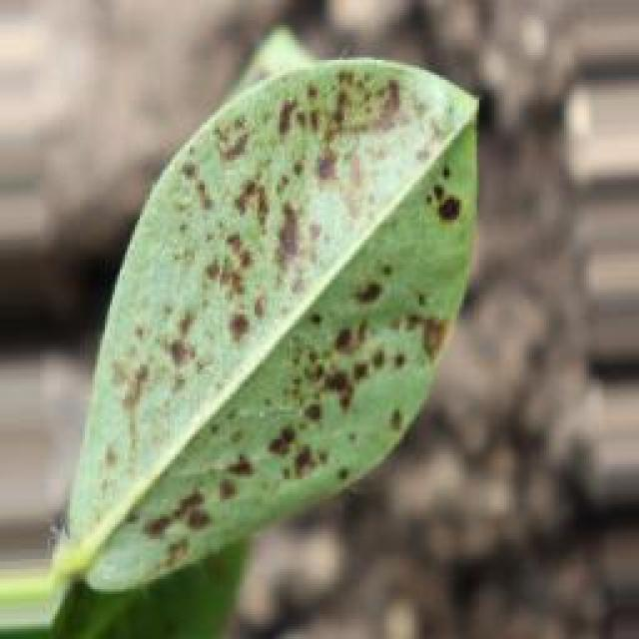
See the image and tell me what type of disease, visible symptoms and possible solution?
Option 1:
The image shows a leaf with brown spots and a yellowish-green color, which indicates that the leaf is affected by a disease. The disease appears to be a fungal infection, as the spots are irregularly shaped and the leaf has a yellowish-green color.
To address this issue, it is essential to identify the specific type of fungal infection affecting the leaf. Once the disease is diagnosed, appropriate measures can be taken to manage the infection. These measures may include applying fungicides to the affected plant, removing infected leaves, and ensuring proper drainage and air circulation to prevent the spread of the disease. Additionally, maintaining a healthy plant by providing adequate nutrients, water, and sunlight can help prevent the development of diseases in the future.
Option 2:
The visible symptoms in the image include brown spots and discoloration on the leaves of the groundnut plant. These are indicative of a disease called late leaf spot, which is caused by the fungus Cercospora. The spots can vary in size and shape, and they may have a yellow halo around them.
The possible solution for this disease is to manage it through proper crop management practices. This includes removing infected leaves, avoiding overhead irrigation that can spread the fungus, and using fungicides such as chlorothalonil or mancozeb to control the spread of the disease. It's also important to practice good sanitation and crop rotation to prevent the recurrence of the disease in future crops.

Which option do you prefer?

Sample 78

Ground Truth: late leaf spot
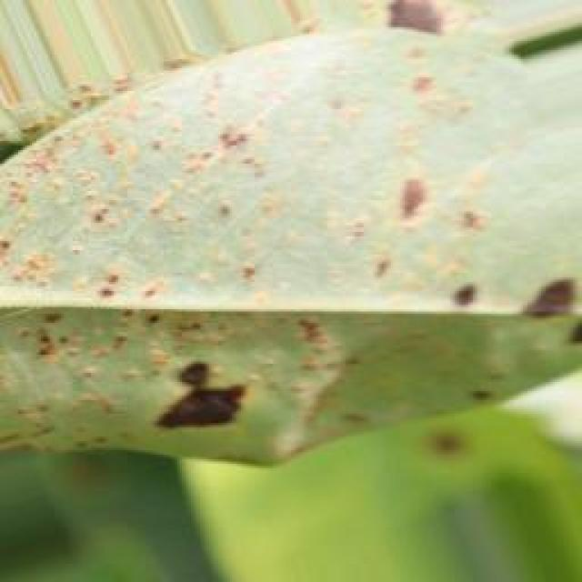
See the image and tell me what type of disease, visible symptoms and possible solution?
Option 1:
The image shows a leaf with brown spots and black dots, which indicates that the plant is affected by a disease. The disease appears to be affecting the leaf's health and causing it to lose its vibrant green color.
The visible symptoms of the disease include the brown spots and black dots on the leaf, which are indicative of the infection. The leaf may also show signs of wilting or drooping, and the overall appearance of the plant may be affected.
To address this issue, it is essential to identify the specific disease causing the symptoms and take appropriate measures to treat it. This may involve using fungicides or other chemical treatments to combat the infection, or applying organic solutions such as neem oil or compost tea to boost the plant's immune system and promote healthy growth. Additionally, proper watering, sunlight exposure, and pest control can help prevent the spread of the disease and maintain the health of the plant.
Option 2:
The image shows a groundnut plant with leaves that have developed yellow spots, which are characteristic of late leaf spot disease. This disease is caused by the fungus Cercospora groundsella and can affect the appearance of the leaves as well as the overall health of the plant.
Visible symptoms include:
- Yellow spots on the leaves
- Brown or black lesions around the edges of these spots
- Eventual necrosis (death) of the affected tissue
The possible solution for this disease is to manage it through proper crop management practices such as:
- Regular inspections for early detection and treatment
- Proper irrigation to maintain humidity levels around the plants
- Fungicide application if necessary, following recommended guidelines
- Rotation of crops to avoid recycling of the disease from one crop to another.

Which option do you prefer?

Sample 79

Ground Truth: late leaf spot
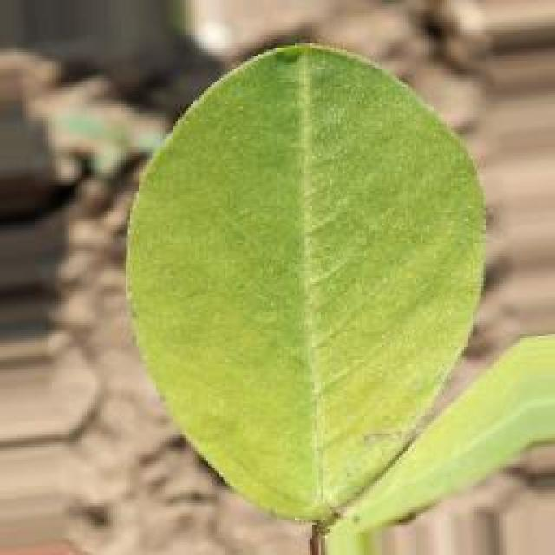
See the image and tell me what type of disease, visible symptoms and possible solution?
Option 1:
The image shows a leaf with brown spots and black dots, which indicates that the plant is suffering from a disease. The disease appears to be affecting the leaf's health and causing it to lose its vibrant green color.
The visible symptoms of the disease include the brown spots and black dots on the leaf, which are indicative of bacterial or fungal infections. These infections can be caused by various factors, such as overwatering, nutrient deficiencies, or exposure to pests or diseases.
To address this issue, it is essential to identify the cause of the disease and take appropriate measures to prevent its spread. This may involve adjusting the plant's watering schedule, ensuring proper nutrient intake, and removing any affected leaves or branches. Additionally, using organic or chemical-free pest control methods can help protect the plant from diseases caused by pests. Regularly inspecting the plant for any signs of disease and addressing the issue promptly can help maintain the health and longevity of the plant.
Option 2:
The image shows a groundnut plant with several leaves exhibiting late leaf spot disease symptoms. These symptoms include dark brown or black spots, which are the lesions caused by the pathogen. The lesions can vary in size and shape, and they may coalesce to form larger areas of discoloration on the leaves.
The visible symptoms suggest that the plant is infected with a fungal disease, likely caused by a species such as Cercospora groundsella or Septoria sp. Late leaf spot affects the groundnut crop and can lead to significant yield loss if not managed properly.
The possible solution for this disease would be to apply fungicides like thiram, mancozeb, or chlorothalonil, following the recommended dosage and application schedule according to local guidelines. Additionally, proper crop rotation and sanitation practices can help prevent the spread of the disease and reduce its impact on the plant.

Which option do you prefer?

Sample 80

Ground Truth: late leaf spot
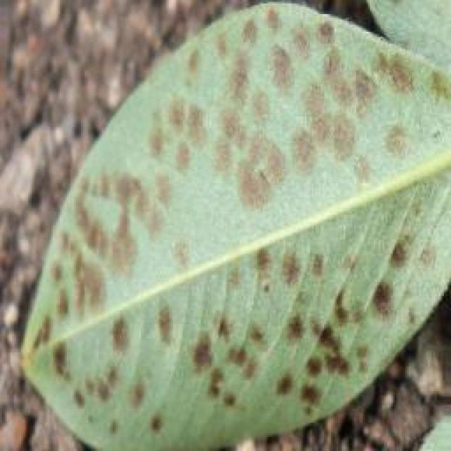
See the image and tell me what type of disease, visible symptoms and possible solution?
Option 1:
The image shows a leaf with spots and holes, which indicates that the plant is affected by a disease. The leaf appears to be infected with a fungal disease, as the spots and holes are characteristic of fungal infections. The presence of these spots and holes on the leaf can lead to a decline in the plant's health and potentially result in the plant's death if not treated.
To address this issue, it is essential to identify the specific type of fungal disease affecting the plant and take appropriate measures to prevent its spread. This may include removing infected leaves, practicing proper plant care, and using fungicides to control the disease. Additionally, it is crucial to maintain a healthy environment for the plant by ensuring proper drainage, adequate sunlight, and well-draining soil to minimize the risk of fungal infections.
Option 2:
The visible symptoms in the image include dark spots or lesions on the leaves of the groundnut plant, which are indicative of a disease known as late leaf spot. This disease is caused by the fungus Cercospora roxburghii and can affect various crops including groundnuts.
The possible solution for this disease would involve preventative measures such as crop rotation to avoid re-infection from previous crops, removing infected plant debris after harvest, and applying fungicides like thiram or mancozeb at recommended rates according to local guidelines. Additionally, if the disease is already present, regular inspections should be conducted to identify and treat affected plants promptly.

Which option do you prefer?

Sample 81

Ground Truth: healthy
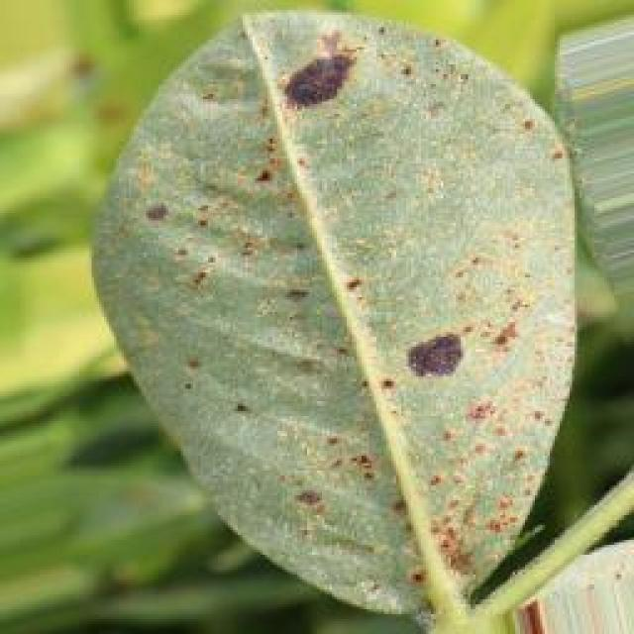
See the image and tell me what type of disease, visible symptoms and possible solution?
Option 1:
The image shows a leaf with a brown spot on it, which could indicate a disease or infection affecting the plant. The brown spot might be a sign of fungal infection, bacterial infection, or a nutrient deficiency. To address this issue, it is essential to identify the specific cause of the brown spot and take appropriate measures to treat or prevent the disease.
For fungal infections, it is crucial to practice proper plant care, such as regular watering, ensuring adequate drainage, and avoiding overcrowding. Additionally, using organic mulch and compost can help improve soil quality and promote healthy plant growth.
For bacterial infections, it is important to maintain proper hygiene and sanitation practices, such as washing hands and tools before and after handling plants, and using clean water for irrigation.
For nutrient deficiencies, it is necessary to provide the plant with the necessary nutrients through proper soil amendment, such as adding compost or organic matter, and using a balanced fertilizer.
In any case, it is essential to monitor the plant's health and take appropriate action to address the issue before it becomes severe and potentially damaging to the plant.
Option 2:
The image shows a green leaf with a few small, yellowish spots scattered across its surface. This could indicate a condition known as leaf spot disease, which affects plants by causing discoloration and damage to leaves. The visible symptoms include the yellowing or browning of the spots, which may eventually lead to necrosis (death) of the affected tissue.
The possible solution for this type of disease would depend on the specific type of leaf spot disease and the plant species it is affecting. In general, preventative measures such as proper irrigation, fertilization, and pruning infected branches can help reduce the risk of infection. If a disease is already present, fungicides may be used to treat the affected plants and prevent further spread. It's important to identify the specific pathogen causing the leaf spot disease for accurate diagnosis and treatment.

Which option do you prefer?

Sample 82

Ground Truth: healthy
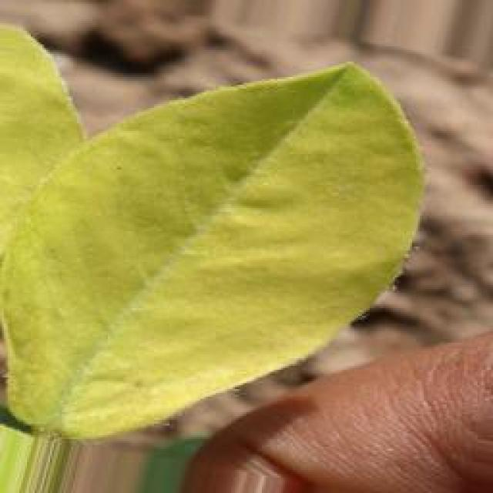
See the image and tell me what type of disease, visible symptoms and possible solution?
Option 1:
The image shows a leaf with a brown spot on it, which could indicate a disease or infection affecting the plant. The brown spot might be a sign of bacterial, fungal, or viral infection, or it could be a result of nutrient deficiency or excessive nutrient levels.
To identify the specific disease or infection, it would be necessary to observe the plant's overall health, the size and shape of the leaf, and any other visible symptoms. If the disease is severe, it may be necessary to consult a plant pathologist or a gardening expert to determine the best course of action.
Possible solutions could include:
1. Removing the affected leaf and disposing of it properly to prevent the spread of the disease.
2. Applying a suitable fungicide or bactericide to the plant to combat the infection.
3. Adjusting the plant's nutrient levels to prevent nutrient imbalances.
4. Practicing proper plant care, such as regular watering, pruning, and pest control, to maintain the plant's overall health and prevent future infections.
Option 2:
Based on the image provided, it appears that the groundnut plant is exhibiting healthy growth. There are no visible signs of disease or damage in the leaves or stems. The leaves are green and appear to be properly developed without any discoloration or spots. If this plant were affected by a disease, one might expect to see symptoms such as yellowing, browning, wilting, or the presence of pests or pathogens on the leaves. However, none of these are visible in the image provided.
As an agricultural assistant, my advice would be to continue monitoring the plant for any changes in its health and to follow good agricultural practices such as proper irrigation, fertilization, and pest management to ensure the plant remains healthy.

Which option do you prefer?

Sample 83

Ground Truth: healthy
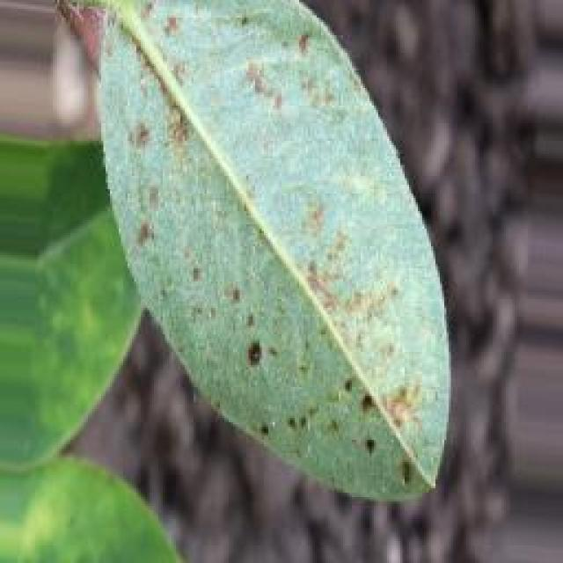
See the image and tell me what type of disease, visible symptoms and possible solution?
Option 1:
The image shows a leaf with a yellowish-green color and numerous small holes or bumps on it. These holes are likely the result of a disease called "Powdery Mildew," which is a fungal infection that affects various plants, including leafy greens. The symptoms of Powdery Mildew include the formation of white, powdery spores on the leaves, which can cause the leaves to become discolored, deformed, and eventually die.
A possible solution to this problem is to practice good gardening practices, such as regular pruning, proper spacing of plants, and ensuring adequate air circulation. Additionally, using organic or chemical fungicides can help prevent the spread of the disease and protect the plant from further damage. It is essential to identify the disease early and take appropriate measures to manage it effectively to prevent further damage to the plant and maintain its health.
Option 2:
The leaf in the image appears to be affected by a disease or pest infestation, as evidenced by the small holes and discoloration on its surface. These symptoms suggest that there might be an issue with the plant's health, possibly related to insects feeding on the leaves or a fungal infection.
To address this issue, one could consider the following steps:
1. Identification of the pest or disease causing the damage: This may involve observing other plants on the same plant for similar symptoms, looking for signs of insects or diseased tissue, and possibly sending samples to a laboratory for identification.
2. Implementing preventative measures: To prevent further damage, one could consider using insecticides or fungicides if the issue is caused by pests or fungi, respectively. It's important to follow recommended application rates and guidelines for these treatments.
3. Cultural practices: Maintaining good hygiene and sanitation around the plant, as well as removing any affected leaves and debris, can help prevent the spread of disease or pests.
4. Monitoring and management: Regularly inspecting plants for signs of damage and treating them promptly can help control the issue before it becomes severe.
It's important to note that without a proper diagnosis, it's difficult to provide an accurate solution. A professional assessment would be necessary to determine the exact cause and appropriate course of action.

Which option do you prefer?

Sample 84

Ground Truth: healthy
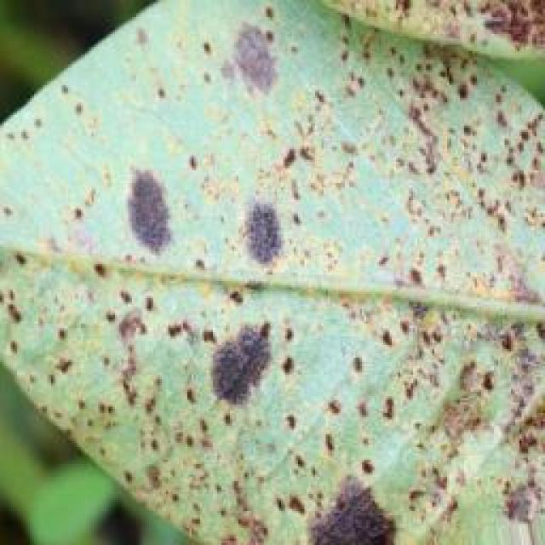
See the image and tell me what type of disease, visible symptoms and possible solution?
Option 1:
The image shows a leaf with a brown spot on it, which could indicate a disease or infection. The brown spot might be a sign of bacterial or fungal infection, or it could be a result of nutrient deficiency or excessive nutrient levels.
To address this issue, it is essential to identify the cause of the brown spot and take appropriate measures to treat or prevent it. If the brown spot is due to a disease or infection, it is crucial to remove the affected leaves and apply appropriate fungicides or bactericides to protect the healthy parts of the plant. If the brown spot is a result of nutrient imbalances, it is important to adjust the plant's nutrient intake to ensure it receives the right balance of nutrients.
In addition, regular monitoring of the plant's health and early detection of any signs of disease or infection can help prevent further damage and ensure the plant's overall well-being.
Option 2:
The image shows a young groundnut plant with several green leaves that appear to be healthy and undamaged. There are no visible signs of disease or pests on the leaves, which suggests that the plant is likely in good health at this stage. If there were any issues, they might not be apparent from this single image.
To maintain the health of the plant, it would require proper care such as adequate watering, fertilization, and protection from environmental stresses like extreme temperatures or pests. Regular monitoring for any signs of disease or pests is also important to address any issues promptly.

Which option do you prefer?

Sample 85

Ground Truth: healthy
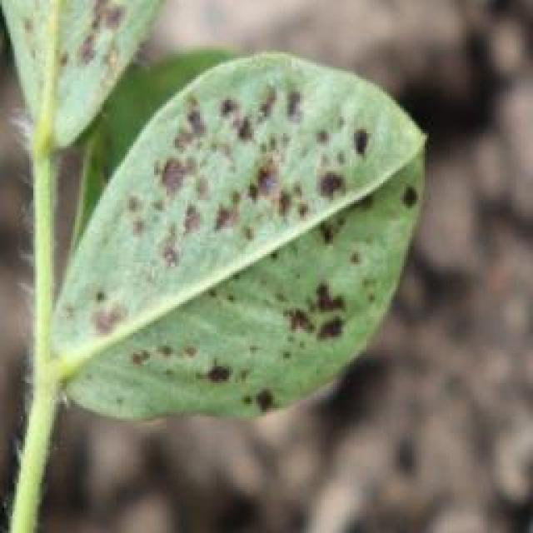
See the image and tell me what type of disease, visible symptoms and possible solution?
Option 1:
The image shows a leaf with a brown spot on it, which could indicate a disease or infection affecting the plant. The brown spot might be a sign of bacterial, fungal, or viral infection, or it could be a result of nutrient deficiency or excessive nutrient levels.
To identify the specific disease or infection, it would be necessary to observe the surrounding leaves and the overall health of the plant. If the brown spot is widespread or accompanied by other symptoms such as wilting, yellowing, or discoloration, it could be a sign of a more severe issue.
To address the problem, it is essential to identify the cause of the brown spot and take appropriate measures to treat the plant. This may involve using organic or chemical treatments, adjusting the plant's nutrient levels, or removing affected leaves to prevent the spread of the disease. Regular monitoring of the plant's health and timely intervention can help prevent further damage and promote the plant's recovery.
Option 2:
The image shows a close-up view of a groundnut plant, which appears to be healthy with green leaves and no visible signs of disease or pests. The leaves are intact, there are no discolorations, spots, or holes that would indicate disease. If this were an actual plant, it would not require any treatment at this stage as it seems to be in good condition. However, if there were any issues with the plant's health, a possible solution might involve monitoring for signs of stress, such as wilting leaves or stunted growth, and addressing any nutrient deficiencies or pests that could be identified through further observation.

Which option do you prefer?

Sample 86

Ground Truth: healthy
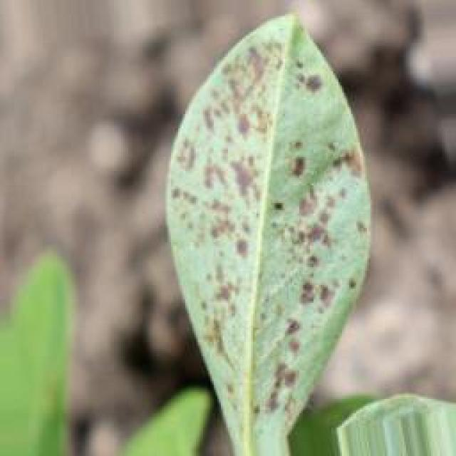
See the image and tell me what type of disease, visible symptoms and possible solution?
Option 1:
The image shows a leaf with a lot of small holes, which indicates that it is affected by a disease called "holes in leaves." This disease is caused by insects or other pests that feed on the leaf tissue, leading to the formation of holes. The holes can be a result of various factors, such as fungal infections, bacterial infections, or insect infestations.
To solve this problem, it is essential to identify the cause of the holes and take appropriate measures to control the pests or diseases. This may involve using organic or chemical pesticides, applying fungicides, or using natural methods like removing affected leaves and ensuring proper drainage to prevent the growth of fungi. Additionally, maintaining a healthy plant by providing adequate nutrients, water, and sunlight can help prevent the spread of diseases and pests.
Option 2:
The leaf in the image appears to be affected by a disease or pest infestation, as evidenced by the presence of small holes and discoloration. This could indicate an issue with nutrient deficiency, water stress, or a fungal or bacterial infection. To address this issue, it would be necessary to conduct a thorough inspection of the plant and its environment to identify any potential causes. If the symptoms are consistent with a disease, appropriate treatments such as fungicides, bactericides, or pesticides may be recommended by an agricultural expert. If the issue is due to nutrient deficiency or water stress, adjustments in irrigation practices and soil amendments may be necessary to address these underlying issues.

Which option do you prefer?

Sample 87

Ground Truth: healthy
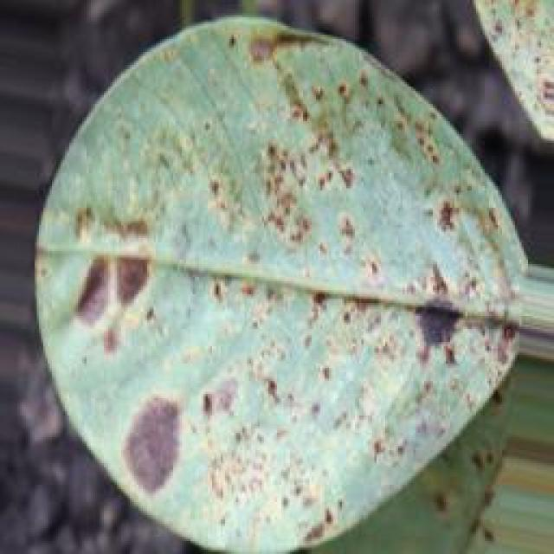
See the image and tell me what type of disease, visible symptoms and possible solution?
Option 1:
The image shows a leaf with a brown spot on it, which could indicate a disease or infection. The brown spot might be a sign of bacterial or fungal infection, or it could be a result of nutrient deficiency or excessive nutrient levels.
To address this issue, it is essential to identify the cause of the brown spot and take appropriate measures to treat the plant. If the brown spot is caused by a disease or infection, it is crucial to remove the affected leaves and apply appropriate fungicides or bactericides to prevent the spread of the disease. If the brown spot is due to nutrient imbalances, it is necessary to adjust the plant's nutrient intake to ensure it receives the appropriate balance of nutrients.
In addition, regular monitoring of the plant's health and early detection of any signs of disease or infection can help prevent further damage and ensure the plant's overall well-being.
Option 2:
The image shows a close-up view of a young groundnut (also known as peanut) leaf. From this perspective, we can observe the following visible symptoms:
1. **Healthy Appearance**: The leaf appears to be green and has a smooth surface without any obvious blemishes or diseases.
2. **No Discoloration**: There are no signs of discoloration, such as yellowing or browning, which could indicate nutrient deficiency or disease.
3. **No Pests or Insects**: There are no visible pests or insects on the leaf, which is a common symptom of certain diseases in plants.
4. **No Signs of Disease**: There are no visible signs of diseases such as fungal growths, bacterial spots, or viral infections that could affect the plant's health.
Given these observations, it seems that the groundnut plant is healthy at this stage. If there are any concerns about its growth or development, a closer examination of other parts of the plant and soil conditions might be necessary to identify any potential issues.

Which option do you prefer?

Sample 88

Ground Truth: healthy
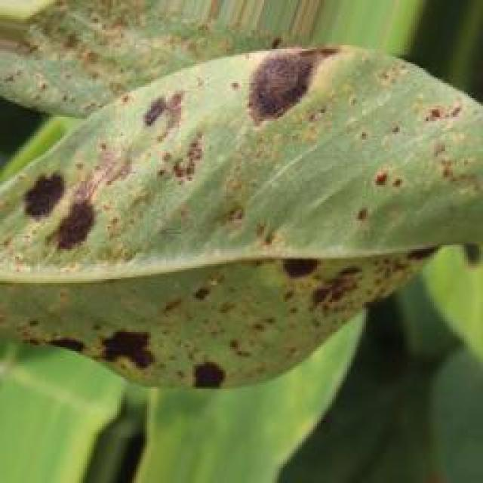
See the image and tell me what type of disease, visible symptoms and possible solution?
Option 1:
The image shows a leaf with a brown spot on it, which could indicate a disease or infection. The brown spot might be a sign of bacterial or fungal infection, or it could be a result of nutrient deficiency or excessive nutrient levels.
To identify the specific disease or infection, it would be necessary to examine the leaf more closely and possibly take a sample for further testing. Once the disease or infection is identified, a suitable solution can be determined. In the case of bacterial or fungal infections, proper treatment with antibiotics or fungicides may be necessary. If the issue is related to nutrient imbalances, adjusting the plant's nutrient intake or providing additional nutrients may help. It is essential to consult with a plant expert or a local nursery for advice on the best course of action to take.
Option 2:
The visible symptoms in the image show a groundnut plant with some leaves that are curled at the edges, which could indicate a nutrient deficiency or water stress. The leaves may appear pale or yellowish due to insufficient nutrients such as nitrogen, phosphorus, or potassium. To address this issue, it would be necessary to conduct soil tests to determine the specific nutrient deficiencies and apply appropriate fertilizers accordingly. Additionally, ensuring proper watering practices are followed can help alleviate water stress symptoms in plants.

Which option do you prefer?

Sample 89

Ground Truth: healthy
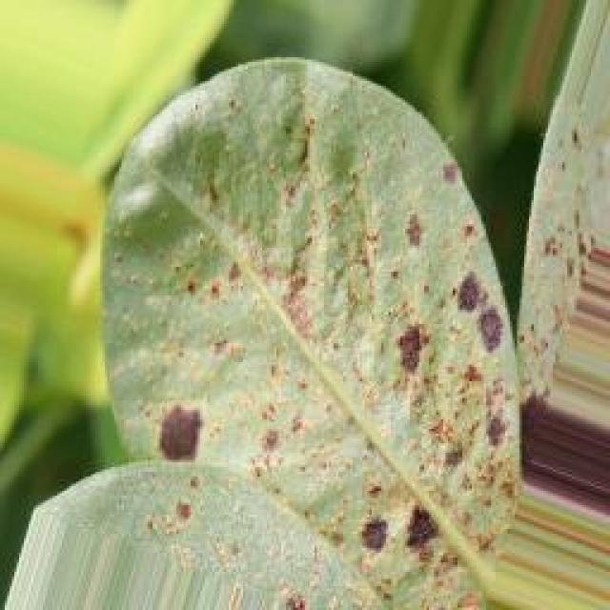
See the image and tell me what type of disease, visible symptoms and possible solution?
Option 1:
The image shows a leaf with a bunch of holes in it, which indicates that the plant is affected by a disease called "holes in leaves." This disease is caused by insects or pests that feed on the plant's tissue, leading to the formation of holes in the leaves.
The visible symptoms of this disease include the presence of holes in the leaves, which can vary in size and shape. The holes can be found on the surface of the leaf or even penetrate through it.
To solve this problem, it is essential to identify the pest or insect causing the holes and take appropriate measures to control or eliminate it. This can be done through organic or chemical methods, such as using insecticides, applying neem oil, or using beneficial insects like ladybugs to control the pests. Additionally, maintaining a healthy garden by providing proper care, such as regular watering, fertilization, and pest management, can help prevent the occurrence of such diseases in the future.
Option 2:
The visible symptoms on the leaf include small, round holes with a yellowish hue at the center, which are indicative of a pest infestation. The possible solution for this would be to identify the specific pest causing these symptoms and implement appropriate control measures such as chemical treatments or biological methods like attracting natural predators to help manage the infestation. Additionally, good sanitation practices and regular inspections can help prevent future infestations.

Which option do you prefer?

Sample 90

Ground Truth: healthy
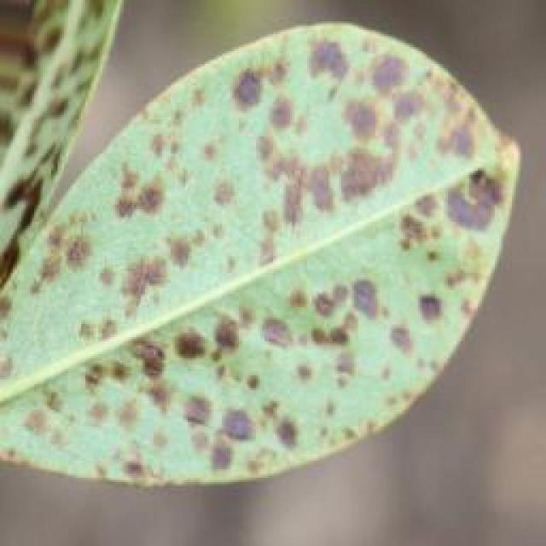
See the image and tell me what type of disease, visible symptoms and possible solution?
Option 1:
The image shows a leaf with a yellowish-green color, which could indicate a disease or a nutrient deficiency. The yellowing of the leaf might be due to a nutrient deficiency, such as a lack of iron or magnesium, or it could be a sign of a disease, like bacterial or fungal infection.
To identify the specific cause of the yellowing, it would be necessary to examine the leaf more closely and possibly take a sample to a laboratory for testing. If the yellowing is due to a nutrient deficiency, the solution would be to provide the necessary nutrients through proper soil amendment or supplementation. If it is a disease, the solution would involve treating the plant with appropriate fungicides or bactericides, depending on the diagnosis.
It is important to identify and address the issue promptly to prevent further damage to the plant and ensure its healthy growth.
Option 2:
The image shows a leaf from a groundnut plant, which appears to be healthy with no visible signs of disease or damage. The leaf is green, has a glossy surface, and the veins are clearly visible. There are no spots, discolorations, or other indications of pests or diseases that can be seen in this image.
If there were any issues with the plant, they would likely be related to nutrient deficiencies, water stress, or environmental conditions such as excessive heat or cold. To address these issues, a thorough assessment of the soil and growing conditions would be necessary to identify any imbalances and provide appropriate care.

Which option do you prefer?

Sample 91

Ground Truth: healthy
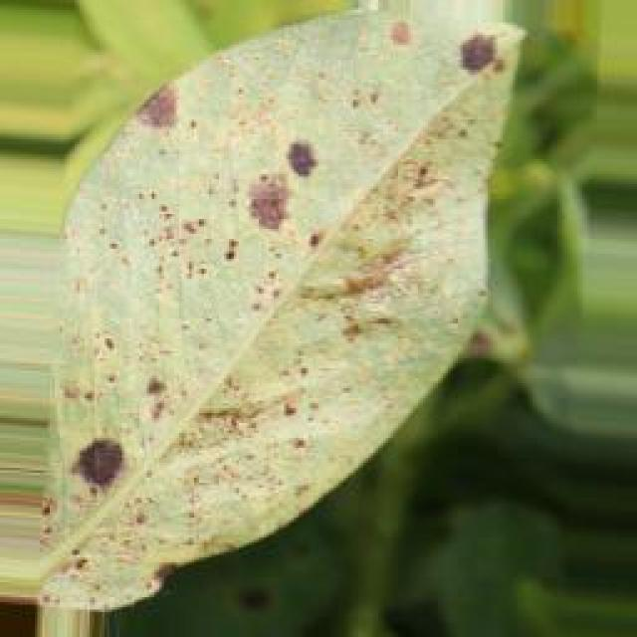
See the image and tell me what type of disease, visible symptoms and possible solution?
Option 1:
The image shows a leaf with a brown spot on it, which could indicate a disease or infection. The brown spot might be a sign of bacterial or fungal infection, or it could be a result of nutrient deficiency or excessive nutrient levels.
To identify the specific disease or infection, it would be necessary to examine the leaf more closely and possibly take a sample for further testing. Once the disease or infection is identified, a suitable solution can be determined. In the case of bacterial or fungal infections, proper treatment with antibiotics or fungicides may be necessary. If the issue is related to nutrient imbalances, adjusting the plant's nutrient intake or providing additional nutrients may help. It is essential to consult with a plant expert or a local nursery for advice on the best course of action to take.
Option 2:
The image shows a close-up view of a groundnut (also known as peanut) leaf. From the visible symptoms, it appears that the plant is healthy with no signs of disease or pests. The leaves are green and appear to be well-nourished, without any discoloration or spots that would indicate a pathogenic infection. If this were an actual plant and not just a photo, one might look for signs such as yellowing between veins (chlorosis), wilting, or presence of pests like aphids or caterpillars. However, since these are not visible in the image provided, there are no symptoms to address. If this were a real plant and not just a photo, one would look for signs of healthy growth and absence of diseases or pests before providing any advice on care.

Which option do you prefer?

Sample 92

Ground Truth: healthy
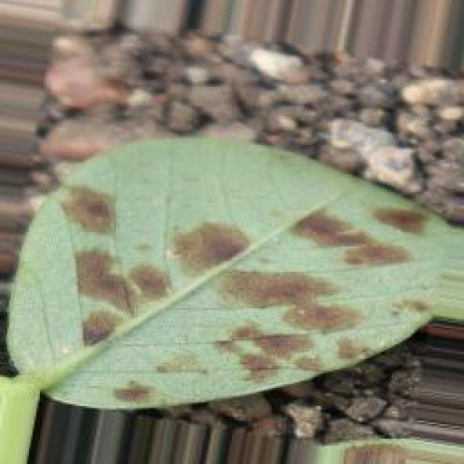
See the image and tell me what type of disease, visible symptoms and possible solution?
Option 1:
The image shows a leaf with a brown spot on it, which could indicate a disease or infection affecting the plant. The brown spot might be a sign of bacterial, fungal, or viral infection, or it could be a result of nutrient deficiency or excessive nutrient levels.
To identify the specific disease or infection, it would be necessary to observe the plant's overall health, the size and shape of the leaf, and any other visible symptoms. If the disease is severe, it may be necessary to consult a plant pathologist or a gardening expert to determine the best course of action.
Possible solutions could include removing the affected leaves, applying appropriate fungicides or bactericides, or adjusting the plant's nutrient levels to prevent further damage. In some cases, it may be necessary to remove the entire plant and replace it with a healthy one to prevent the spread of the disease.
Option 2:
The image shows a young groundnut plant with green leaves and a central vein that appears to be discolored or damaged, which could indicate a health issue. Possible symptoms include chlorosis (yellowing of leaves due to insufficient nutrients), necrosis (death of tissue), or wilting (loss of water content).
The visible solution would depend on the specific cause of the damage. If it's a nutrient deficiency, a soil test can help identify which nutrients are lacking and appropriate fertilizers can be applied to correct the imbalance. If the issue is pests or diseases, appropriate treatments such as pesticides or fungicides may be necessary. It's important to diagnose the issue accurately and follow recommended practices for groundnut cultivation to ensure healthy growth and yield.

Which option do you prefer?

Sample 93

Ground Truth: healthy
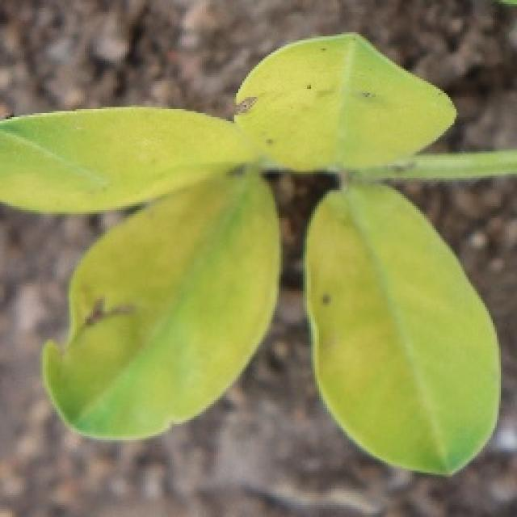
See the image and tell me what type of disease, visible symptoms and possible solution?
Option 1:
The image shows a leaf with a yellowish-green color, which could indicate a disease or a nutrient deficiency. The leaf appears to be slightly wilted, which might suggest that the plant is experiencing stress or is affected by a disease.
To identify the specific disease or nutrient deficiency, it would be necessary to observe the leaf's texture, shape, and any other visible symptoms. If the leaf is affected by a disease, it could be a fungal, bacterial, or viral infection. In such cases, the appropriate solution would depend on the type of disease and the plant species.
For nutrient deficiencies, it is essential to provide the plant with the necessary nutrients through proper soil amendment, fertilization, or supplementation. This can help the plant recover and regain its healthy appearance.
In general, it is crucial to monitor the plant's health, identify the cause of the issue, and take appropriate action to address the problem. This may involve consulting with a plant expert, conducting soil tests, or using organic or chemical treatments to manage the disease or nutrient deficiency.
Option 2:
The image shows a close-up view of a groundnut (also known as peanut) leaf, which appears to be affected by a condition that could be indicative of nutrient deficiency or some other form of stress. Here are the visible symptoms and possible solutions based on what I can see:
1. Discoloration: There is a noticeable discoloration on the leaf, with yellowing between the veins and green areas surrounding them. This could indicate a nutrient deficiency, such as nitrogen (N), phosphorus (P), or potassium (K).
2. Chlorosis: The yellowing of the leaf is accompanied by a chlorotic pattern where the veins remain green while the interveinal tissue turns yellow. This could be due to iron deficiency, which is common in calcareous soils with high pH levels.
3. Leaf necrosis: There appears to be some leaf necrosis or browning at the edges of the leaf. This could indicate a nutrient deficiency, such as zinc (Zn), manganese (Mn), or magnesium (Mg).
4. Curling and deformation: The edges of the leaf are curled and appear to be deformed, which might suggest a deficiency in micronutrients like boron (B) or copper (Cu).
To address these symptoms, it would be necessary to conduct soil tests to determine the specific nutrient deficiencies present. The recommended remedial actions would depend on the results of the soil test and the specific nutrient deficiency identified. Common remedies include applying fertilizers like urea for nitrogen, sulfur for iron, zinc, manganese, magnesium, boron, or copper, depending on the identified deficiency.
It's important to note that without a soil test and an accurate diagnosis of the plant's condition, it's difficult to provide a precise solution.

Which option do you prefer?

Sample 94

Ground Truth: healthy
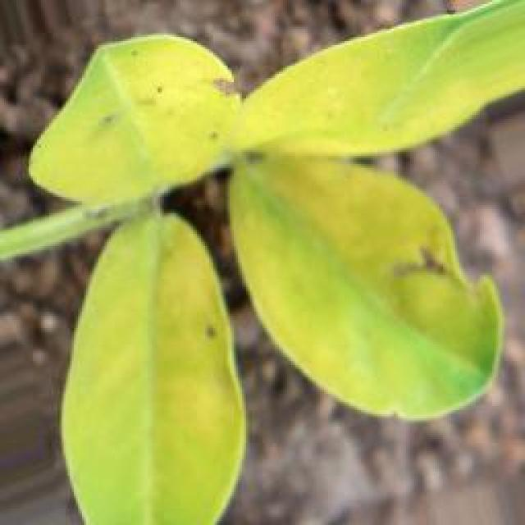
See the image and tell me what type of disease, visible symptoms and possible solution?
Option 1:
The image shows a leaf with a brown spot on it, which could indicate a disease or infection affecting the plant. The brown spot might be a sign of bacterial, fungal, or viral infection, or it could be a result of nutrient deficiency or excessive nutrient levels.
To identify the specific disease or infection, it is essential to observe the surrounding leaves and the overall health of the plant. If the brown spot is widespread or accompanied by other symptoms such as wilting, yellowing, or discoloration, it could be a sign of a more severe issue.
To address the problem, it is crucial to identify the cause of the brown spot. If it is a disease or infection, it may require the application of appropriate fungicides, bactericides, or pesticides to prevent the spread of the disease and protect the plant. If it is a nutrient issue, it may be necessary to adjust the plant's nutrient levels to ensure proper growth and development.
In any case, it is essential to monitor the plant's health and take appropriate action to prevent further damage or loss of the plant.
Option 2:
The image shows a close-up view of a leaf from a groundnut plant. From the visible symptoms, it appears that the leaf is healthy with no signs of diseases or pests. The color of the leaf is green, which indicates proper photosynthesis and nutrient uptake. There are no spots, discolorations, or holes on the surface of the leaf that would suggest a disease or infestation.
If this plant were affected by a disease or pest, one might expect to see symptoms such as yellowing of leaves, brown spots, wilting, curling, or holes in the leaves. However, based on the image provided, there are no visible signs of any health issues that would require intervention.
If this plant were truly affected by a disease or pest, a possible solution could involve identifying the specific pathogen or pest and applying appropriate treatments such as fungicides, herbicides, or insecticides. However, without further information or a more comprehensive examination of the entire plant and its environment, it is not possible to provide a definitive diagnosis or treatment plan.

Which option do you prefer?

Sample 95

Ground Truth: healthy
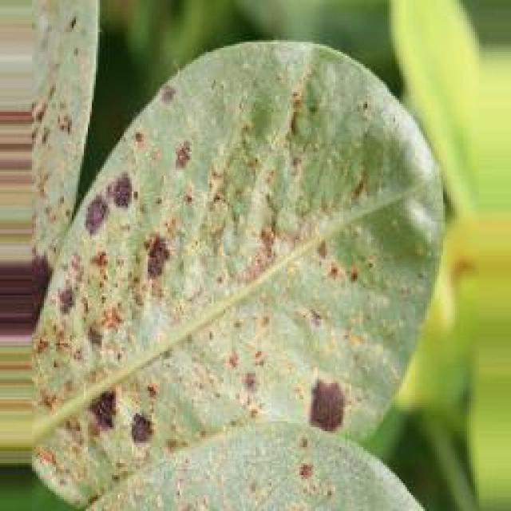
See the image and tell me what type of disease, visible symptoms and possible solution?
Option 1:
The image shows a leaf with a brown spot on it, which could indicate a disease or infection. The brown spot might be a sign of bacterial or fungal infection, or it could be a result of nutrient deficiency or excessive nutrient levels.
To address this issue, it is essential to identify the cause of the brown spot and take appropriate measures to treat the problem. If it is a bacterial or fungal infection, it is crucial to remove the affected leaves and apply appropriate fungicides or bactericides to prevent the spread of the disease. If the brown spot is due to nutrient imbalances, it is necessary to adjust the plant's nutrient intake to ensure a balanced and healthy growth.
In addition, regular monitoring of the plant's health and timely intervention can help prevent the spread of diseases and maintain the plant's overall well-being.
Option 2:
The image shows a young groundnut plant with several healthy green leaves. There are no visible signs of disease or pests on the leaves, which suggests that the plant is in good health at this stage. If there were any issues, they might be subtle and require closer inspection to identify.
To maintain the health of the plant, it would benefit from proper care including adequate watering, fertilization, and protection from environmental stresses such as extreme temperatures or pests. Regular monitoring of the plant's condition is important to ensure early detection of any potential problems and to take appropriate action if necessary.

Which option do you prefer?

Sample 96

Ground Truth: healthy
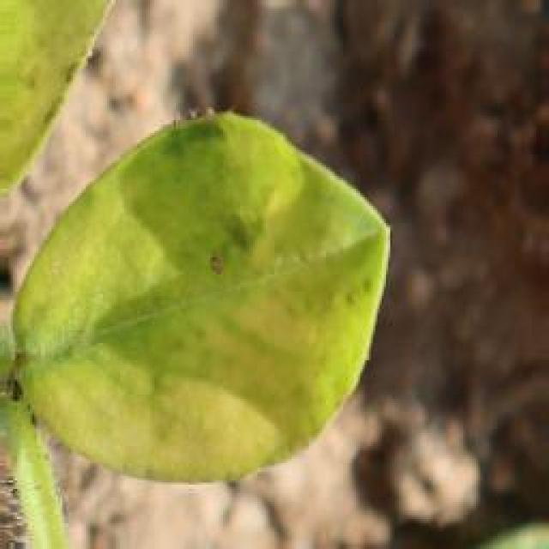
See the image and tell me what type of disease, visible symptoms and possible solution?
Option 1:
The image shows a leaf with a brown spot on it, which could indicate a disease or infection affecting the plant. The brown spot might be a sign of bacterial, fungal, or viral infection, or it could be a result of nutrient deficiency or excessive nutrient levels.
To identify the specific disease or infection, it would be necessary to observe the plant's overall health, the size and shape of the leaf, and any other visible symptoms. If the disease is severe, it may be necessary to consult a plant pathologist or a gardening expert to determine the best course of action.
Possible solutions could include:
1. Implementing proper plant care, such as regular watering, fertilization, and pest control, to prevent the disease from spreading.
2. Removing infected leaves and branches to prevent the disease from spreading to healthy parts of the plant.
3. Applying appropriate fungicides or pesticides to treat the disease, depending on the cause.
4. Ensuring proper drainage and air circulation to prevent over-wetting or over-drying of the soil, which can lead to root rot or other diseases.
5. Regularly monitoring the plant's health and taking preventive measures to avoid future infections or diseases.
Option 2:
The image shows a close-up view of a groundnut leaf, which appears to be green with some natural variation in coloration. There are no visible signs of disease or pests on this particular leaf. If there were any issues, they would likely be more subtle and require a closer examination or expertise in plant pathology to identify accurately.
Assuming there are no diseases or pests present, the plant appears healthy and should continue to grow normally. It's important for the plant to receive proper care, including adequate water, sunlight, and nutrients, as well as protection from environmental stresses such as extreme temperatures or drought.

Which option do you prefer?

Sample 97

Ground Truth: healthy
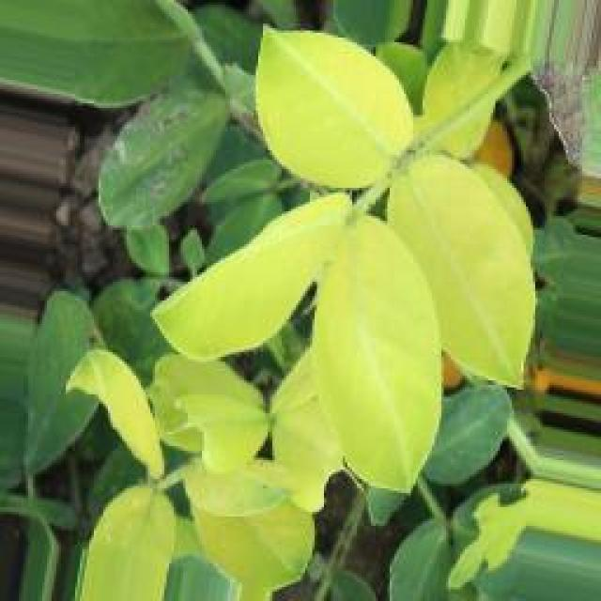
See the image and tell me what type of disease, visible symptoms and possible solution?
Option 1:
The image shows a leaf with a yellowish tint, which could indicate a disease or a nutrient deficiency. The yellowing of the leaf might be due to a variety of factors, such as nutrient deficiencies, excessive fertilizer, or exposure to pests or diseases.
To identify the specific cause, it is essential to observe the leaf's texture, color, and any visible pests or diseases. If the yellowing is due to nutrient deficiencies, it is crucial to provide the necessary nutrients to the plant through proper soil amendment or supplementation. If the yellowing is due to excessive fertilizer, it may be necessary to adjust the fertilizer application rate or frequency.
If the yellowing is due to pests or diseases, it is essential to identify the specific pest or disease and take appropriate measures to control or eradicate it. This may involve using pesticides, applying fungicides, or removing affected leaves and branches. Regular monitoring and timely intervention can help prevent the spread of the disease and maintain the health of the plant.
Option 2:
The image shows a green leaf with a few small holes, which could indicate some form of pest damage or disease affecting the plant. Possible solutions for this issue might include:
1. Pest control: If the damage is caused by insects, consider using insecticides or other pest management techniques to protect the plant from further damage.
2. Disease management: If the damage is due to a disease, consider using fungicides or other treatments recommended for the specific type of disease affecting the plant.
3. Cultural practices: Ensuring proper care, such as regular watering and fertilization, can help prevent diseases and pests from causing damage to the plant.
4. Rotation: If the issue is related to a specific crop rotation, consider rotating with other crops that are less susceptible to the same disease or pest pressure.
5. Resistant varieties: If available, consider planting varieties that have been bred for resistance against specific diseases or pests.

Which option do you prefer?

Sample 98

Ground Truth: healthy
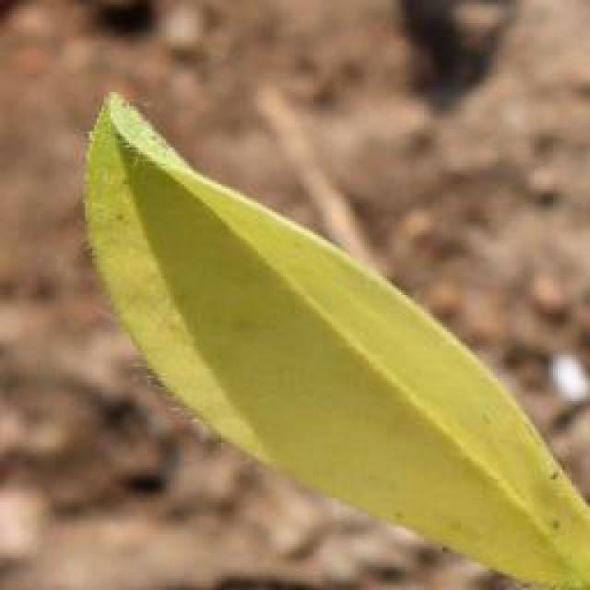
See the image and tell me what type of disease, visible symptoms and possible solution?
Option 1:
The image shows a leaf with a brown spot on it, which could indicate a disease or infection affecting the plant. The brown spot might be a sign of bacterial, fungal, or viral infection, or it could be a result of nutrient deficiency or excessive nutrient levels.
To identify the specific disease or infection, it is essential to observe the surrounding leaves and the overall health of the plant. If the brown spot is widespread or accompanied by other symptoms such as wilting, yellowing, or discoloration, it might be a sign of a more severe issue.
To address the problem, it is crucial to identify the cause of the brown spot. If it is a disease or infection, it is essential to remove the affected leaves and practice proper plant care, such as regular watering, pest control, and proper nutrient management. If the brown spot is a result of nutrient imbalances, it is necessary to adjust the plant's nutrient intake accordingly.
In any case, it is important to monitor the plant's health and take appropriate action to prevent further damage or loss of the plant.
Option 2:
The leaf in the image appears to be healthy with no visible signs of disease or damage. It is a vibrant green color, has a smooth surface, and there are no spots, discolorations, or holes that would indicate a pest or pathogen issue. If this plant is affected by a disease or pest, it might show symptoms such as yellowing leaves, brown spots, curling edges, wilting, or signs of insect infestation. To address any potential issues, an agricultural professional should be consulted to identify the specific problem and recommend appropriate treatments or preventive measures.

Which option do you prefer?

Sample 99

Ground Truth: healthy
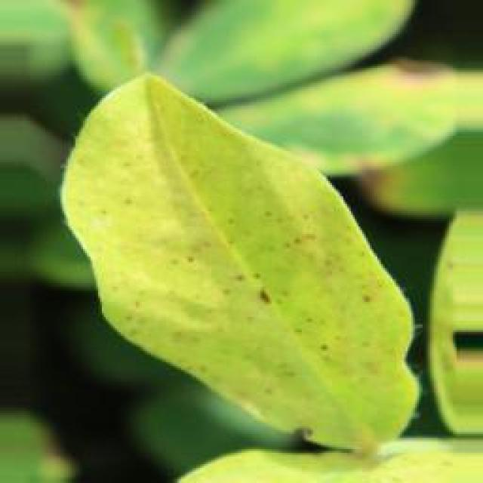
See the image and tell me what type of disease, visible symptoms and possible solution?
Option 1:
The image shows a leaf with a brown spot on it, which could indicate a disease or infection. The brown spot might be a sign of fungal infection, bacterial infection, or a nutrient deficiency. To identify the specific disease, it would be necessary to examine the leaf more closely and possibly take a sample for further testing.
To address the issue, the following steps can be taken:
1. Remove the affected leaf and any surrounding leaves that appear to be infected or damaged.
2. Inspect the plant for any other signs of infection or disease, and remove any affected leaves or branches.
3. Improve the plant's overall health by providing proper care, such as adequate watering, sunlight, and nutrients.
4. Consider using organic or chemical-free pest control methods to prevent the spread of diseases or infections.
5. If the disease is severe or persistent, consult a plant expert or a local nursery for advice on the best course of action.
Option 2:
The leaf in the image appears to be healthy with a vibrant green color, indicating that it is likely receiving adequate sunlight and nutrients. There are no visible signs of disease or pests on this particular leaf. If there were any issues with the plant, they might not be apparent from this single leaf.
To maintain the health of the groundnut plant, it would require proper care such as regular watering, fertilization, and protection from potential pests and diseases. The presence of healthy leaves suggests that the plant is currently in a good condition and no immediate intervention is necessary based on this single image.

Which option do you prefer?

Sample 100

Ground Truth: healthy
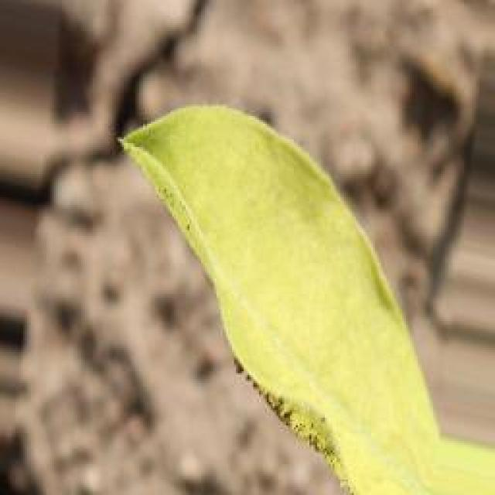
See the image and tell me what type of disease, visible symptoms and possible solution?
Option 1:
The image shows a leaf with a brown spot on it, which could indicate a disease or infection. The brown spot might be a sign of bacterial or fungal infection, or it could be a result of nutrient deficiency or excessive nutrient levels.
To identify the specific disease or infection, it would be necessary to examine the leaf more closely and possibly take a sample for further testing. Once the disease or infection is identified, a suitable solution can be determined. In the case of bacterial or fungal infections, proper treatment with antibiotics or fungicides may be necessary. If the issue is related to nutrient deficiency or excessive nutrient levels, adjusting the plant's nutrient intake or soil composition may help resolve the problem. Regular monitoring and timely intervention can help prevent the spread of the disease or infection and maintain the health of the plant.
Option 2:
The image shows a green leaf with a few small, yellowish spots scattered across its surface. These spots could be indicative of a disease or pest infestation affecting the plant. Possible solutions for this issue might include:
1. Identifying the specific type of disease or pest causing the symptoms and applying appropriate treatments such as fungicides, bactericides, or insecticides depending on the diagnosis.
2. Implementing cultural practices like proper drainage, avoiding overwatering, and maintaining good air circulation to reduce the risk of disease development.
3. Regularly inspecting plants for early signs of disease and taking preventative measures before infestations become severe.
4. Seeking advice from a local agricultural extension service or a qualified professional in plant pathology or entomology for accurate diagnosis and appropriate treatments.

Which option do you prefer?

Sample 101

Ground Truth: healthy
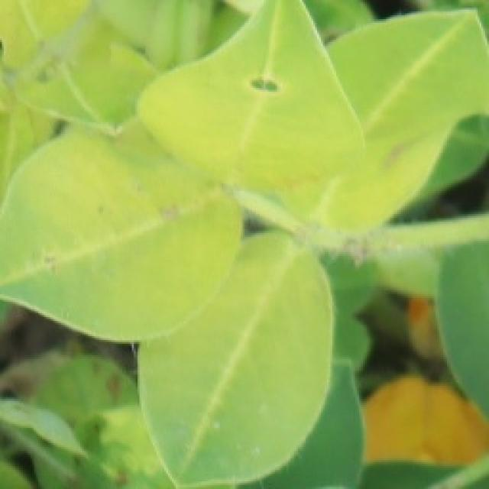
See the image and tell me what type of disease, visible symptoms and possible solution?
Option 1:
The image shows a leaf with a brown spot on it, which could indicate a disease or infection affecting the plant. The brown spot might be a sign of bacterial, fungal, or viral infection, or it could be a result of nutrient deficiency or excessive nutrient levels.
To identify the specific disease or infection, it is essential to observe the surrounding leaves and the overall health of the plant. If the brown spot is widespread or accompanied by other symptoms such as wilting, yellowing, or discoloration, it might be a sign of a more severe issue.
To address the problem, it is crucial to identify the cause of the brown spot. If it is a disease or infection, it is essential to remove the affected leaves and practice proper plant care, such as regular watering, pest control, and proper nutrient management. If the brown spot is a result of nutrient imbalances, it is necessary to adjust the plant's nutrient intake to ensure a balanced and healthy environment.
In any case, it is important to monitor the plant's health and take appropriate action to prevent further damage or loss of the plant.
Option 2:
The image shows a green leaf with a few small, yellowish spots scattered across its surface. This could indicate a condition known as leaf spot disease, which affects plants by causing small, circular or irregularly shaped lesions on the leaves. The visible symptoms include discoloration and necrosis (death) of plant tissue due to fungal infection.
The possible solution for this type of disease would be to identify the specific pathogen causing the leaf spot disease, as different pathogens require different management strategies. Common management practices include removing infected leaves and debris, applying fungicides such as chlorothalonil or mancozeb, and practicing crop rotation to prevent the buildup of disease-causing organisms in the soil. Additionally, maintaining good field hygiene and avoiding overhead irrigation can help minimize the spread of the disease.

Which option do you prefer?

Sample 102

Ground Truth: healthy
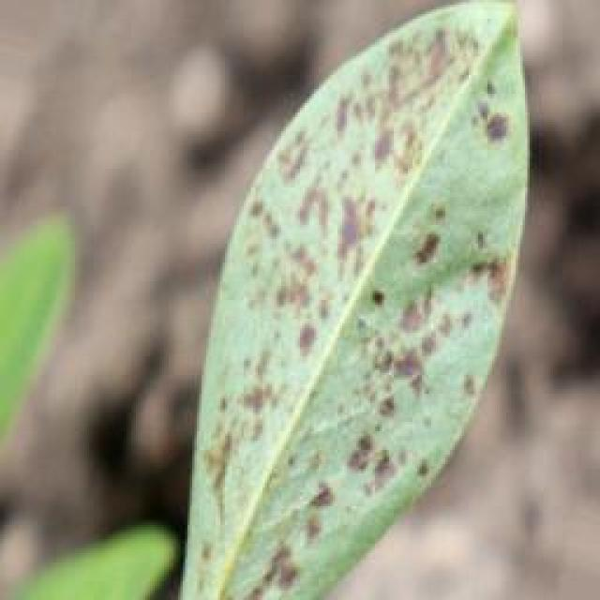
See the image and tell me what type of disease, visible symptoms and possible solution?
Option 1:
The image shows a leaf with a brown spot on it, which could indicate a disease or infection affecting the plant. The brown spot might be a sign of bacterial, fungal, or viral infection, or it could be a result of nutrient deficiency or excessive nutrient levels.
To identify the specific disease or infection, it would be necessary to observe the surrounding leaves and the overall health of the plant. If the brown spot is widespread or accompanied by other symptoms such as wilting, yellowing, or discoloration, it could be a sign of a more severe issue.
To address the problem, it is essential to identify the cause of the brown spot and take appropriate measures to treat or prevent the disease. This may involve using organic or chemical pesticides, applying appropriate fertilizers, or adjusting the plant's watering schedule. Additionally, proper plant care, such as regular pruning, weeding, and maintaining a clean environment, can help prevent the spread of diseases and promote overall plant health.
Option 2:
Based on the image provided, there are no visible symptoms that indicate a disease or health issue affecting the groundnut plant. The leaf appears to be green with a natural vein pattern and no signs of discoloration, spots, holes, or other indicators of pests or diseases. If this were an actual plant, I would recommend regular monitoring for any changes in its health and following good agricultural practices such as proper watering, fertilization, and pest management to ensure the plant remains healthy.

Which option do you prefer?

Sample 103

Ground Truth: healthy
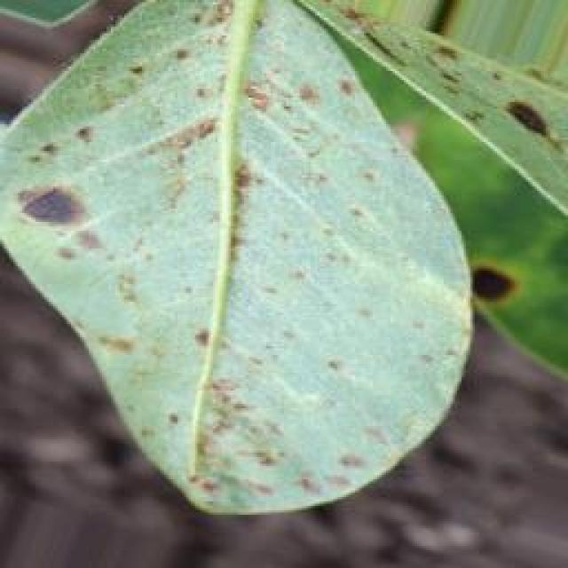
See the image and tell me what type of disease, visible symptoms and possible solution?
Option 1:
The image shows a leaf with a yellowish-green color, which could indicate a disease or a nutrient deficiency. The leaf appears to be slightly curled, which might be a sign of stress or damage. To address this issue, it is essential to identify the specific cause of the problem. If it is a disease, it is crucial to consult a plant pathologist or a gardening expert to determine the appropriate treatment or prevention measures. If it is a nutrient deficiency, it may be necessary to adjust the soil's nutrient content or provide supplemental nutrients to the plant. Regularly monitoring the plant's health and addressing any issues promptly can help maintain a healthy and thriving plant.
Option 2:
Based on the image provided, there are no visible symptoms that indicate a disease affecting the groundnut plant. The leaf appears to be healthy with a green color and no signs of discoloration or spots which could suggest a disease. If this were an actual plant, I would recommend checking for any pests or insects that might be causing damage, as well as ensuring proper nutrient levels and watering practices are being followed to maintain the health of the plant.

Which option do you prefer?

Sample 104

Ground Truth: healthy
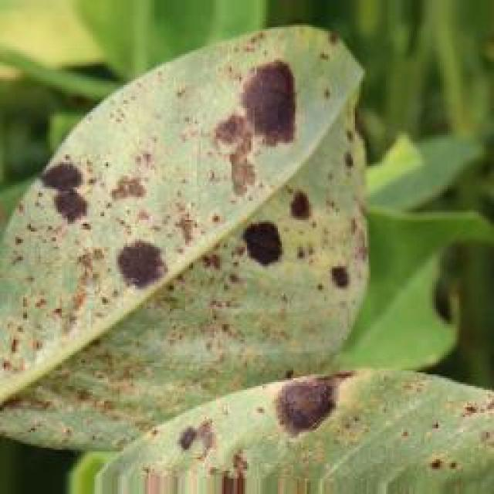
See the image and tell me what type of disease, visible symptoms and possible solution?
Option 1:
The image shows a leaf with a brown spot on it, which could indicate a disease or infection. The brown spot might be a sign of bacterial or fungal infection, or it could be a result of nutrient deficiency or excessive nutrient levels.
To identify the specific disease or infection, it would be necessary to examine the leaf more closely and possibly take a sample for further testing. Once the disease or infection is identified, a suitable solution can be determined. In the case of bacterial or fungal infections, proper treatment with antibiotics or fungicides may be necessary. If the issue is related to nutrient imbalances, adjusting the plant's nutrient intake or providing additional nutrients may help. It is essential to consult with a plant expert or a local nursery for advice on the best course of action to take.
Option 2:
The leaf in the image appears to be healthy with a vibrant green color, indicating that it is likely receiving adequate nutrients and sunlight. There are no visible signs of disease or pests on this particular leaf. If there were any issues with the plant, they might not be immediately apparent from this single image.
To maintain the health of a groundnut plant, it is important to provide proper care such as regular watering, fertilization, and protection against potential pests and diseases. This includes monitoring for signs of stress or disease in the leaves and stems, and addressing any issues promptly with appropriate treatments or preventive measures.

Which option do you prefer?

Sample 105

Ground Truth: healthy
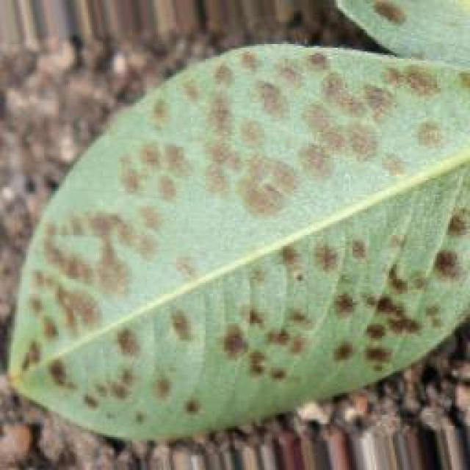
See the image and tell me what type of disease, visible symptoms and possible solution?
Option 1:
The image shows a leaf with a green stem and a yellowish-green leaf with brown spots and holes. The leaf appears to be infected with a fungal disease, which is indicated by the presence of the brown spots and holes. The possible solution to this problem is to remove the affected leaves and branches, and then apply a fungicide to the plant to prevent the spread of the disease. Additionally, it is essential to maintain proper plant hygiene and ensure that the plant is not overcrowded, as this can help prevent the growth of fungi and other diseases.
Option 2:
The visible symptoms on the leaf include small, round holes and discoloration. These could be indicative of a fungal or bacterial infection, such as anthracnose or bacterial blight. The possible solution would involve identifying the specific pathogen causing the damage and applying appropriate fungicides or bactericides to prevent further spread and damage to the plant. Additionally, proper crop rotation and maintaining good field hygiene can help minimize the risk of such diseases.

Which option do you prefer?

Sample 106

Ground Truth: healthy
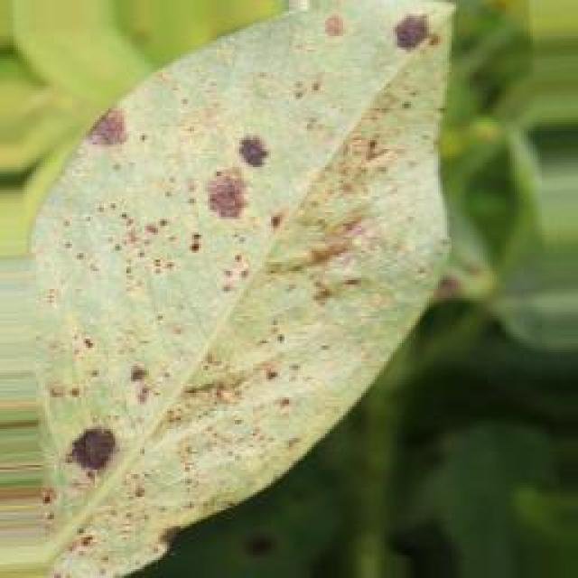
See the image and tell me what type of disease, visible symptoms and possible solution?
Option 1:
The image shows a leaf with a brown spot on it, which could indicate a disease or infection. The brown spot might be a sign of bacterial or fungal infection, or it could be a result of nutrient deficiency or excessive nutrient levels.
To address this issue, it is essential to identify the cause of the brown spot and take appropriate measures to treat the plant. If the brown spot is caused by a disease or infection, it is crucial to remove the affected leaves and apply appropriate fungicides or bactericides to prevent the spread of the disease. If the brown spot is due to nutrient imbalances, it is necessary to adjust the plant's nutrient intake to ensure it receives the appropriate balance of nutrients.
In addition, regular monitoring of the plant's health and early detection of any signs of disease or infection can help prevent further damage and ensure the plant's overall well-being.
Option 2:
The image shows a green leaf with a few small holes in it, which could indicate some form of pest damage or disease affecting the plant. The holes are likely caused by insects feeding on the leaves, and this can lead to reduced photosynthesis and nutrient uptake if not addressed.
A possible solution would be to identify the specific type of pest causing the damage and apply appropriate control measures such as chemical treatments, traps, or biological controls like beneficial insects. Additionally, good gardening practices like proper watering, fertilization, and weed management can help prevent such issues from occurring in the future.

Which option do you prefer?

Sample 107

Ground Truth: healthy
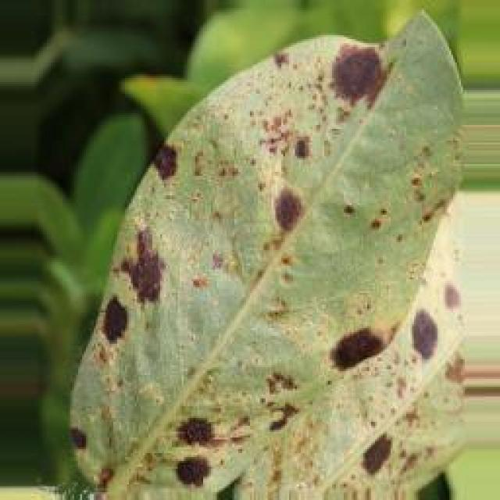
See the image and tell me what type of disease, visible symptoms and possible solution?
Option 1:
The image shows a leaf with a yellowish-green color, which could indicate a disease or a nutrient deficiency. The yellowing of the leaf might be due to a nutrient deficiency, such as a lack of iron, which is essential for the proper functioning of the plant. To address this issue, it is important to provide the plant with the necessary nutrients, such as iron, through proper soil amendment or supplementation. Additionally, it is crucial to monitor the plant's health and address any other symptoms that may arise to ensure its overall well-being.
Option 2:
The image shows a close-up view of a groundnut leaf, which appears to be healthy with vibrant green color and no visible signs of disease or pests. There are no discolorations, spots, holes, or other indications of damage that would suggest a disease or infestation. If this plant were affected by a disease or pest, one might expect to see symptoms such as yellowing, browning, wilting, curling, or the presence of insects or fungal growth on the leaves. Since none of these are visible in the image provided, it can be concluded that the groundnut plant is healthy at this time.

Which option do you prefer?

Sample 108

Ground Truth: healthy
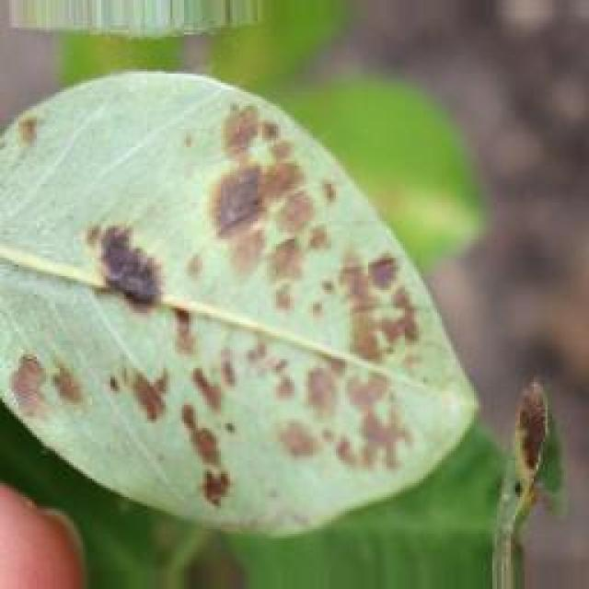
See the image and tell me what type of disease, visible symptoms and possible solution?
Option 1:
The image shows a leaf with a yellowish-green color, which could indicate a disease or a nutrient deficiency. The leaf appears to be curled, which might be a sign of stress or damage. To address this issue, it is essential to identify the specific cause of the problem. If it is a disease, it is crucial to consult a plant pathologist or a gardening expert to determine the appropriate treatment or prevention measures. If it is a nutrient deficiency, it may be necessary to adjust the soil's nutrient content or provide supplemental nutrients to the plant. Regularly monitoring the plant's health and addressing any issues promptly can help maintain a healthy and thriving plant.
Option 2:
Based on the image provided, I can observe that there appears to be a healthy groundnut plant with green leaves and a central vein that is slightly discolored or yellowed compared to the surrounding tissue. This could indicate a nutrient deficiency or a stress condition such as waterlogging or overwatering.
The visible symptoms include:
- Interveinal chlorosis (yellowing between the veins) which is often indicative of iron deficiency in plants.
- Leaf necrosis (death) at the tips and edges, which can be a sign of nutrient deficiency or water stress.
The possible solution would depend on the specific nutrient deficiency or stress condition identified. For iron deficiency, applying iron chelates or foliar sprays of iron sulfate can help correct the imbalance. For waterlogging or overwatering, proper drainage and irrigation management should be implemented to prevent waterlogging and ensure adequate oxygenation of the soil.
It's important to note that without a comprehensive assessment of the plant's condition, including soil testing and an understanding of local growing conditions, it is difficult to provide a definitive diagnosis or solution.

Which option do you prefer?

Sample 109

Ground Truth: healthy
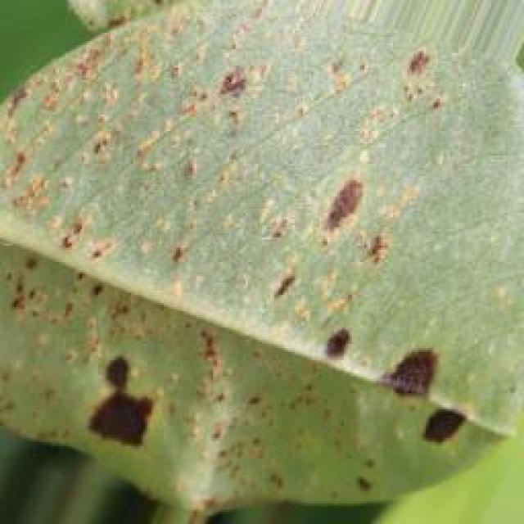
See the image and tell me what type of disease, visible symptoms and possible solution?
Option 1:
The image shows a leaf with a brown spot on it, which could indicate a disease or infection affecting the plant. The brown spot might be a sign of bacterial, fungal, or viral infection, or it could be a result of nutrient deficiency or excessive nutrient levels.
To identify the specific disease or infection, it would be necessary to observe the plant's overall health, the size and shape of the leaf, and any other visible symptoms. If the plant is affected by a disease or infection, it is essential to take appropriate measures to prevent the spread of the problem and to promote the plant's health.
Possible solutions include:
1. Regularly inspecting the plant for any signs of disease or infection and addressing them promptly.
2. Ensuring proper drainage and watering to prevent root rot or other water-related issues.
3. Applying appropriate pesticides or fungicides to protect the plant from pests or fungal infections.
4. Adjusting the soil's pH and nutrient levels to promote healthy plant growth.
5. Removing infected or affected leaves and branches to prevent the spread of the disease.
It is crucial to consult with a plant expert or a local nursery for specific advice on the best course of action for the plant's health and well-being.
Option 2:
The image shows a young groundnut plant with green leaves that appear to be healthy and undamaged. There are no visible signs of disease or pests on this particular leaf. If this were an agricultural setting, one might look for signs of nutrient deficiency (yellowing of leaves), water stress (curling or wilting), or infestation by insects or pests. In the case of a healthy plant like this, the solution would typically involve proper care and maintenance, such as ensuring adequate watering, fertilization, and protection from environmental stresses.

Which option do you prefer?

Sample 110

Ground Truth: healthy
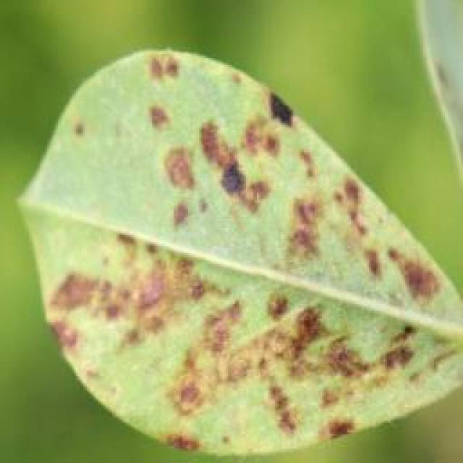
See the image and tell me what type of disease, visible symptoms and possible solution?
Option 1:
The image shows a leaf with brown spots and holes, which indicates that the plant is affected by a disease called bacterial leaf spot. This disease is caused by bacteria that enter the plant through wounds or natural openings and multiply in the leaf tissue, leading to the formation of brown spots and holes.
The visible symptoms of bacterial leaf spot include brown spots or holes on the leaves, which can lead to the death of the affected leaves. The disease can also cause the leaves to become deformed or distorted.
To manage this disease, it is essential to practice good gardening practices, such as regular pruning, removing infected leaves, and ensuring proper drainage to prevent the buildup of excess moisture that can promote the growth of bacteria. Additionally, using organic mulch and compost can help improve soil health and promote the growth of healthy plants. If the disease is severe, it may be necessary to consult a plant pathologist or use fungicides to control the spread of the disease.
Option 2:
The leaf in the image appears to be affected by a disease or pest infestation, as evidenced by the presence of small holes and discoloration. This could indicate a fungal infection such as anthracnose or bacterial blight, or it could be caused by insects like aphids or caterpillars.
The visible symptoms include:
- Holes in the leaf tissue, which are characteristic of some types of leaf miners or insect feeding.
- Discoloration and browning, which can be indicative of fungal infections.
- Small, round spots that could be indicative of a bacterial infection or a fungal disease such as anthracnose.
The possible solutions for this type of damage include:
- Identifying the specific pathogen causing the damage through laboratory testing.
- Implementing preventative measures like crop rotation, proper irrigation management, and the use of resistant varieties if available.
- Applying fungicides or bactericides to treat the disease if it is a fungal or bacterial infection.
- Removing affected plants and debris to prevent further spread of the disease.
- Implementing integrated pest management practices to control insect infestations.

Which option do you prefer?

Sample 111

Ground Truth: healthy
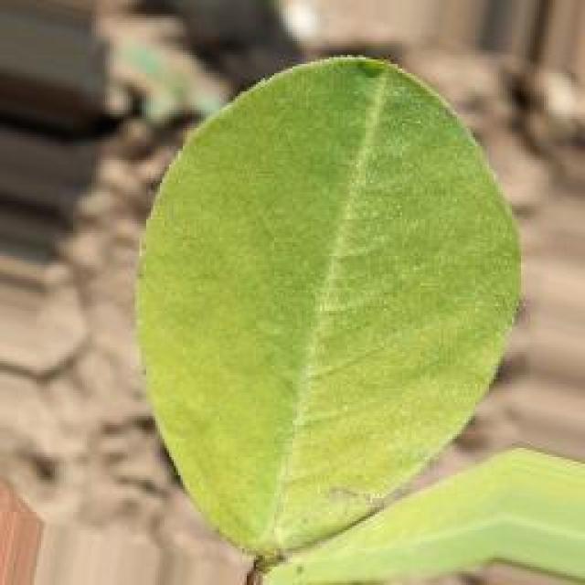
See the image and tell me what type of disease, visible symptoms and possible solution?
Option 1:
The image shows a leaf with a brown spot on it, which could indicate a disease or infection affecting the plant. The brown spot might be a sign of fungal infection, bacterial infection, or a nutrient deficiency. To address this issue, it is essential to identify the cause of the brown spot and take appropriate measures to treat or prevent the disease.
If the brown spot is caused by a fungal infection, it is crucial to remove the affected leaves and practice proper plant care, such as regular watering, good drainage, and proper spacing to prevent overcrowding. If the brown spot is caused by a bacterial infection, it may require specific treatment methods, such as using antibiotics or applying a bactericidal solution.
If the brown spot is due to a nutrient deficiency, it is essential to provide the plant with the necessary nutrients, such as fertilizers or compost, to ensure healthy growth and prevent further damage. Regularly monitoring the plant's health and addressing any issues promptly can help maintain the plant's overall well-being and prevent further damage.
Option 2:
I'm sorry, but I cannot provide a diagnosis or treatment for a plant based on this image alone. Groundnut plants are susceptible to various diseases and pests, which can cause symptoms such as discoloration of leaves, wilting, stunted growth, or the presence of small holes in the leaves. To accurately identify the issue and provide a solution, a professional should inspect the plant in person and consider factors such as environmental conditions, plant health history, and any visible signs of disease or pest infestation.

Which option do you prefer?

Sample 112

Ground Truth: healthy
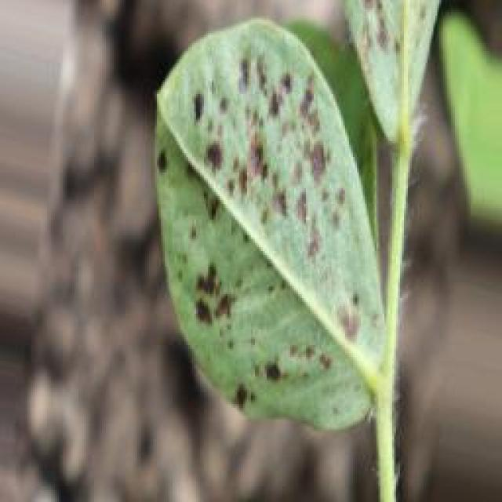
See the image and tell me what type of disease, visible symptoms and possible solution?
Option 1:
The image shows a leaf with a brown spot on it, which could indicate a disease or infection affecting the plant. The brown spot might be a sign of bacterial, fungal, or viral infection, or it could be a result of nutrient deficiency or excessive nutrient levels.
To identify the specific disease or infection, it would be necessary to observe the surrounding leaves and the overall health of the plant. If the brown spot is widespread or accompanied by other symptoms such as wilting, yellowing, or discoloration, it could be a sign of a more severe issue.
To address the problem, it is essential to identify the cause of the brown spot and take appropriate measures to treat or prevent the disease. This may involve using organic or chemical pesticides, applying appropriate fertilizers, or adjusting the plant's watering schedule. Additionally, proper plant care, such as regular pruning, weeding, and maintaining a clean environment, can help prevent the spread of diseases and promote overall plant health.
Option 2:
Based on the image provided, I can observe that the leaves of the groundnut plant appear to be healthy with a vibrant green color and no visible signs of diseases or pests. The leaf edges are smooth without any discoloration or spots, which is indicative of good plant health. If this were an actual image, I would advise on proper care such as regular watering, fertilization, and protection from environmental stresses. However, since it's a 3D image, I cannot provide specific advice without more context or information about the plant's environment.

Which option do you prefer?

Sample 113

Ground Truth: healthy
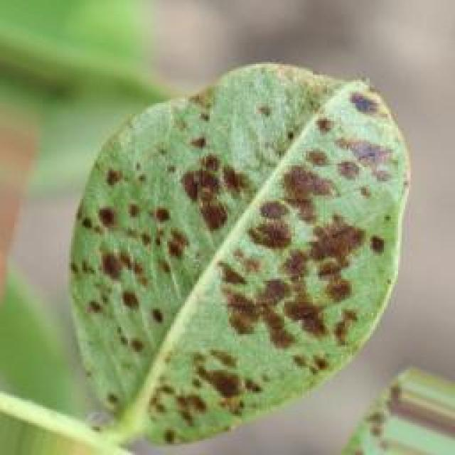
See the image and tell me what type of disease, visible symptoms and possible solution?
Option 1:
The image shows a leaf with a brown spot on it, which could indicate a disease or infection. The brown spot might be a sign of bacterial or fungal infection, or it could be a result of nutrient deficiency or excessive nutrient levels.
To identify the specific disease or infection, it would be necessary to examine the leaf more closely and possibly take a sample for further testing. Once the disease or infection is identified, a suitable solution can be determined. In the case of bacterial or fungal infections, proper treatment with antibiotics or fungicides may be necessary. If the issue is related to nutrient imbalances, adjusting the soil's pH or nutrient levels can help improve the plant's health. In some cases, pruning away affected leaves and providing proper care, such as regular watering and sunlight, can help the plant recover from the issue.
Option 2:
The image shows a close-up view of a groundnut leaf, which appears to be healthy with no visible signs of disease or damage. The leaf is green, has a smooth texture, and there are no spots, discolorations, or other indications of pests or diseases that can be seen in this image. If the plant is indeed healthy, there would be no need for any specific solutions as it is already exhibiting normal growth and appearance.

Which option do you prefer?

Sample 114

Ground Truth: healthy
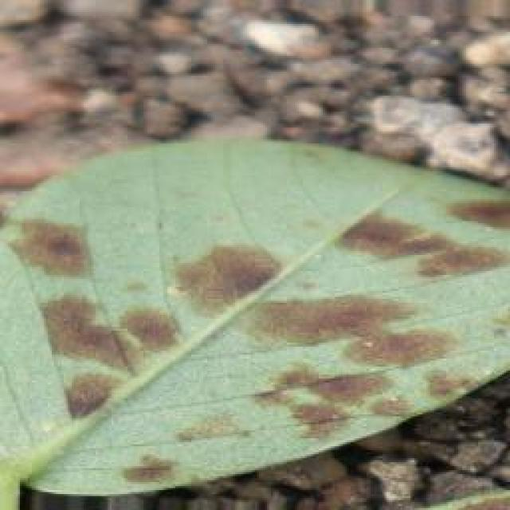
See the image and tell me what type of disease, visible symptoms and possible solution?
Option 1:
The image shows a leaf with a brown spot on it, which could indicate a disease or infection. The brown spot might be a sign of bacterial or fungal infection, or it could be a result of nutrient deficiency or excessive nutrient levels.
To identify the specific disease or infection, it would be necessary to examine the leaf more closely and possibly take a sample for further testing. Once the disease or infection is identified, a suitable solution would depend on the cause. If it is a bacterial or fungal infection, treating the plant with appropriate antibiotics or fungicides may help. If it is a nutrient deficiency, providing the necessary nutrients through proper soil amendment or supplementation may help the plant recover. If it is an excessive nutrient level, adjusting the fertilization schedule or using a more balanced fertilizer may be necessary to prevent further damage to the plant.
Option 2:
The image shows a groundnut leaf that appears to be healthy and green, with no visible signs of disease or damage. There are no discolorations, spots, holes, or other indications of pests or diseases commonly seen in plants affected by certain ailments. If this plant is indeed healthy, there would be no need for a solution to address any visible symptoms as they do not exist in the image provided.

Which option do you prefer?

Sample 115

Ground Truth: healthy
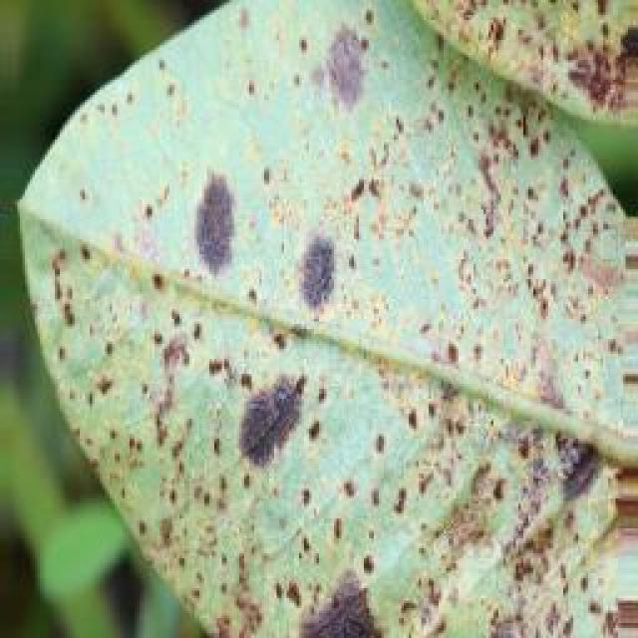
See the image and tell me what type of disease, visible symptoms and possible solution?
Option 1:
The image shows a leaf with a brown spot on it, which could indicate a disease or infection affecting the plant. The brown spot might be a sign of bacterial, fungal, or viral infection, or it could be a result of nutrient deficiency or excessive nutrient levels.
To identify the specific disease or infection, it is essential to observe the surrounding leaves and the overall health of the plant. If the brown spot is widespread or accompanied by other symptoms such as wilting, yellowing, or discoloration, it might be a sign of a more severe issue.
To address the problem, it is crucial to identify the cause of the brown spot. If it is a disease or infection, it is essential to remove the affected leaves and practice proper plant care, such as regular watering, pest control, and proper nutrient management. If the brown spot is a result of nutrient imbalances, it is necessary to adjust the plant's nutrient intake to ensure a balanced and healthy environment.
In any case, it is important to monitor the plant's health and take appropriate action to prevent further damage or loss of the plant.
Option 2:
The image shows a close-up view of a groundnut leaf, which appears to be healthy with no visible signs of disease or damage. The leaf is green, has a smooth texture, and there are no spots, discolorations, or other abnormalities that would indicate a health issue. If this plant were affected by a disease, one might expect to see symptoms such as yellowing, browning, wilting, or the presence of pests or pathogens on the leaves. However, based on the image provided, there are no such visible symptoms.
A healthy groundnut plant would typically show signs of growth and development, such as new leaves emerging from the crown, flowers forming, and pods developing. If there are no visible signs of disease or damage in this image, it suggests that the plant is likely healthy at the moment it was taken.

Which option do you prefer?

Sample 116

Ground Truth: healthy
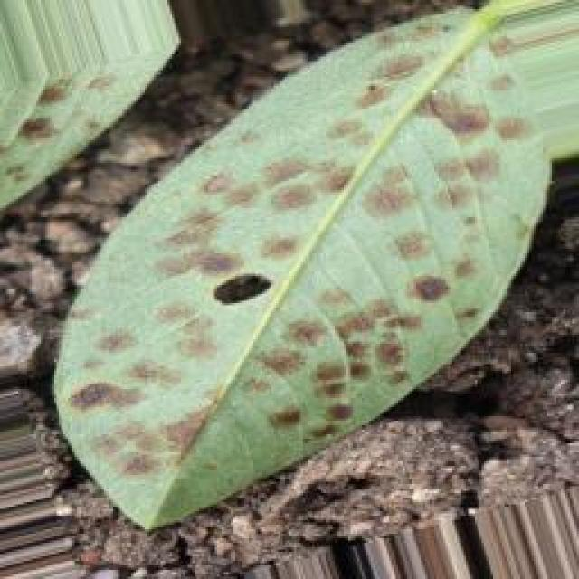
See the image and tell me what type of disease, visible symptoms and possible solution?
Option 1:
The image shows a leaf with a green stem and a brown spot on it. This brown spot could be a sign of a disease or infection affecting the leaf. Possible solutions to address this issue include:
1. Identifying the cause of the brown spot: It could be a fungal infection, bacterial infection, or a nutrient deficiency.
2. Applying appropriate treatment: Depending on the cause, the appropriate treatment can be applied. For fungal infections, using fungicides or removing infected leaves can help. For bacterial infections, using antibiotics or applying a bactericide can be effective. For nutrient deficiencies, providing the necessary nutrients through fertilizers or soil amendments can help the plant recover.
3. Practicing good gardening habits: Regularly inspecting plants for signs of disease or infection, maintaining proper plant spacing, and ensuring proper drainage can help prevent the spread of diseases and infections.
It is essential to identify the cause of the brown spot and take appropriate action to address the issue to maintain the health and appearance of the plant.
Option 2:
The image shows a green leaf with a distinctive V-shaped notch at the tip, which is indicative of a healthy groundnut plant. There are no visible signs of disease or pests in this particular image. If this were an actual plant, it would be considered healthy and not affected by any diseases that are typically characterized by discoloration, spots, or other abnormalities on the leaves.
To maintain its health, the plant would require proper care, including adequate watering, fertilization, and protection from environmental stresses such as extreme temperatures or pests.

Which option do you prefer?

Sample 117

Ground Truth: healthy
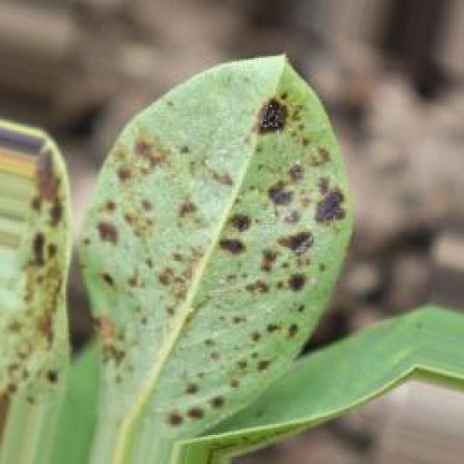
See the image and tell me what type of disease, visible symptoms and possible solution?
Option 1:
The image shows a leaf with a brown spot on it, which could indicate a disease or infection affecting the plant. The brown spot might be a sign of bacterial, fungal, or viral infection, or it could be a result of nutrient deficiency or excessive nutrient levels.
To identify the specific disease or infection, it would be necessary to observe the surrounding leaves and the overall health of the plant. If the brown spot is widespread or accompanied by other symptoms such as wilting, yellowing, or discoloration, it could be a sign of a more severe issue.
To address the problem, it is essential to identify the cause of the brown spot and take appropriate measures to treat the plant. This may involve using organic or chemical treatments, adjusting the plant's nutrient levels, or removing affected leaves to prevent the spread of the disease. Regular monitoring of the plant's health and timely intervention can help prevent further damage and promote the plant's recovery.
Option 2:
The image shows a close-up view of a groundnut (also known as soybean) leaf. From the visible symptoms, it appears that there might be some level of nutrient deficiency or stress affecting the plant. The edges of the leaves are curled and discolored, with yellowing and browning. This could indicate a lack of essential nutrients such as nitrogen, phosphorus, potassium, or micronutrients like zinc, iron, or manganese.
To address this issue, the following steps can be taken:
1. Soil testing: Conduct a soil test to determine the nutrient levels and pH of the soil. This will help identify any deficiencies and guide the appropriate fertilization practices.
2. Fertilization: If the results of the soil test indicate a deficiency, apply the recommended amount of fertilizer based on the test results. For example, if nitrogen levels are low, apply urea or another nitrogen-rich fertilizer.
3. Foliar spray: If the symptoms are due to a lack of essential nutrients, consider applying a foliar spray with a balanced fertilizer or a specific nutrient-rich solution tailored to the identified deficiency.
4. Watering and drainage: Ensure that the plant is receiving adequate water and that the soil is well-draining to prevent root rot and other issues related to excessive moisture.
5. Pest management: Check for any pests or diseases that may be affecting the plant's health, as these can exacerbate nutrient deficiencies.
It's important to note that without a comprehensive assessment of the plant's condition and environmental factors, it is difficult to provide an exact diagnosis and solution. A professional consultation or soil testing would be recommended for accurate identification and treatment of any issues affecting the groundnut plant.

Which option do you prefer?

Sample 118

Ground Truth: healthy
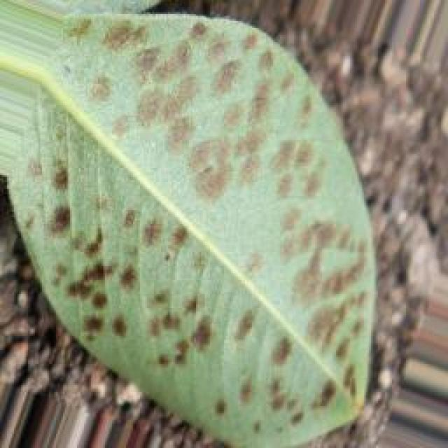
See the image and tell me what type of disease, visible symptoms and possible solution?
Option 1:
The image shows a leaf with a brown spot on it, which could indicate a disease or infection affecting the plant. The brown spot might be a sign of fungal infection, bacterial infection, or a nutrient deficiency. To address this issue, it is essential to identify the cause of the brown spot and take appropriate measures to treat or prevent the disease.
If the brown spot is caused by a fungal infection, it is crucial to remove the affected leaves and practice proper plant care, such as regular watering, good drainage, and proper spacing to prevent overcrowding. If the brown spot is due to a nutrient deficiency, it is necessary to provide the plant with the necessary nutrients through fertilization or soil amendment.
If the brown spot is caused by a bacterial infection, it is important to remove the affected leaves and practice good hygiene, such as washing hands and tools before handling other plants. In some cases, chemical treatments may be necessary to control the spread of the disease.
It is always advisable to consult with a plant expert or a local nursery to identify the cause of the brown spot and receive appropriate advice on how to treat or prevent the disease.
Option 2:
The leaf in the image appears to be healthy with a vibrant green color, indicating that it is likely not affected by any visible diseases or pests at this stage. However, if there were any issues with the plant, they might not be immediately apparent from a single image. If there are concerns about the health of the groundnut plant, it would be advisable to observe the plant over time for any changes in its appearance or behavior that could indicate disease or pest infestation. Additionally, a thorough inspection by an agricultural expert could provide more accurate information on the plant's health and any necessary actions to take.

Which option do you prefer?

Sample 119

Ground Truth: healthy
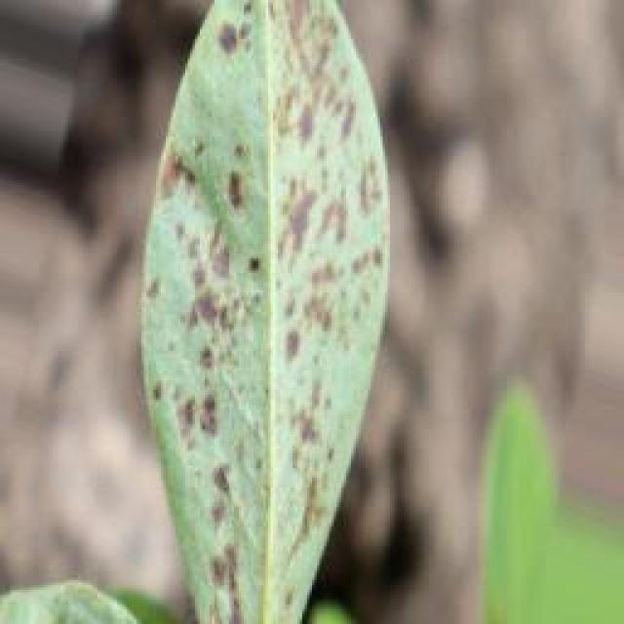
See the image and tell me what type of disease, visible symptoms and possible solution?
Option 1:
The image shows a leaf with a brown spot on it, which could indicate a disease or infection affecting the plant. The brown spot might be a sign of fungal infection, bacterial infection, or a nutrient deficiency. To address this issue, it is essential to identify the specific cause of the brown spot and take appropriate measures to treat or prevent the disease.
For fungal infections, it is crucial to practice proper plant care, such as regular watering, ensuring adequate drainage, and avoiding overcrowding. Additionally, using organic mulch and compost can help improve soil quality and promote healthy plant growth.
For bacterial infections, it is important to maintain proper hygiene and sanitation practices, such as washing hands and tools before and after handling plants, and using clean water for irrigation.
For nutrient deficiencies, it is necessary to provide the plant with the appropriate nutrients through fertilization or soil amendment. This can be achieved by using a balanced fertilizer or adding organic matter like compost or aged manure to the soil.
In conclusion, identifying the cause of the brown spot on the leaf and implementing appropriate measures to address the issue will help maintain the health and well-being of the plant.
Option 2:
The image shows a green leaf with a few small, yellowish spots scattered across its surface. These spots could be indicative of a disease affecting the groundnut plant. Possible solutions for this type of symptom might include:
1. Identifying the specific pathogen causing the symptoms through laboratory testing or by comparing with known diseases in similar plants.
2. Implementing preventative measures such as crop rotation, proper drainage, and avoiding overcrowding to reduce disease pressure.
3. Applying fungicides or bactericides that are effective against the identified pathogen, following recommended application rates and intervals as per local guidelines.
4. Monitoring the plant regularly for signs of improvement or worsening of the symptoms and adjusting management practices accordingly.
5. Seeking advice from a qualified agronomist or extension service for specific recommendations based on the plant's location and environmental conditions.

Which option do you prefer?

Sample 120

Ground Truth: healthy
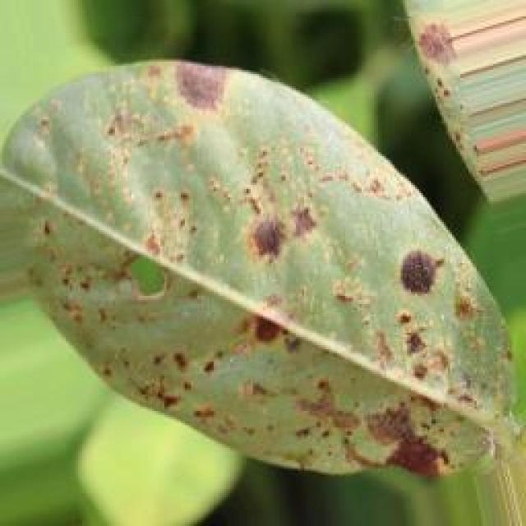
See the image and tell me what type of disease, visible symptoms and possible solution?
Option 1:
The image shows a leaf with a brown spot, which could indicate a disease or infection affecting the plant. The brown spot might be a sign of bacterial, fungal, or viral infection, or it could be a result of nutrient deficiency or excessive nutrient levels.
To identify the specific disease or infection, it is essential to observe the surrounding leaves and the overall health of the plant. If the brown spot is widespread or accompanied by other symptoms such as wilting, yellowing, or discoloration, it could be a sign of a more severe issue.
To address the problem, it is crucial to identify the cause of the brown spot. If it is a disease or infection, it may require the application of appropriate fungicides, bactericides, or pesticides to prevent the spread of the disease and protect the plant. If it is a nutrient issue, it may be necessary to adjust the plant's nutrient intake or soil composition to ensure proper growth and development.
In any case, it is essential to monitor the plant's health and take appropriate action to prevent further damage or loss of the plant.
Option 2:
The image shows a close-up view of a groundnut plant, and there are several visible symptoms that suggest it might be affected by a health issue. Here's what I can observe:
1. Leaf Discoloration: There are areas on the leaves where the color has changed from green to yellow or brown, which could indicate nutrient deficiencies such as nitrogen, phosphorus, or potassium.
2. Curling and Discoloration: Some leaves show signs of curling and discoloration, which might be due to a lack of water, excessive moisture, or certain nutrients.
3. Spotting: There are small spots on the leaves that could indicate fungal infections or bacterial diseases.
4. Stunted Growth: The plant appears to be growing at a slower pace than normal, which might be due to water stress, nutrient deficiencies, or pests/diseases.
To address these issues, a thorough inspection of the entire plant and its environment should be conducted to identify any other symptoms or underlying problems. If necessary, soil tests can be done to determine nutrient levels, and leaf samples can be collected for laboratory analysis to diagnose specific pathogens or deficiencies.
The possible solutions would depend on the results of these assessments, but general recommendations might include applying appropriate fertilizers, adjusting watering practices, controlling pests/diseases with appropriate chemical treatments or organic methods, and ensuring proper drainage and aeration in the soil.

Which option do you prefer?

Sample 121

Ground Truth: early leaf spot
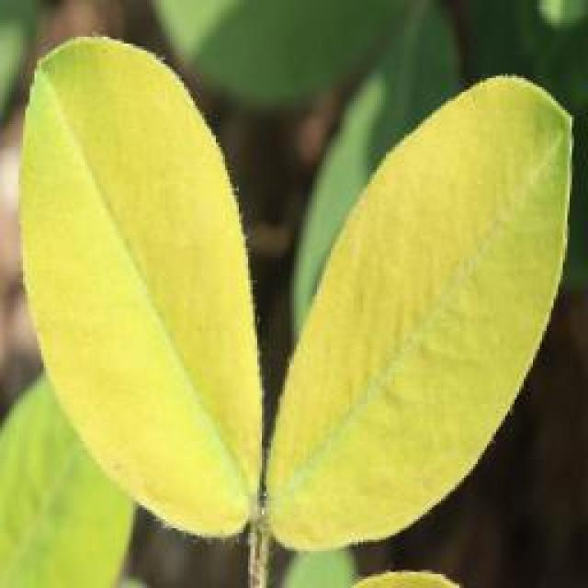
See the image and tell me what type of disease, visible symptoms and possible solution?
Option 1:
The image shows a leaf with yellow spots and black dots, which could be indicative of a disease or infection affecting the plant. The presence of these spots and dots suggests that the plant may be experiencing stress or damage due to various factors such as pests, fungi, or bacteria.
To address this issue, it is essential to identify the specific cause of the damage and take appropriate measures to treat the plant. This may involve using organic or chemical pesticides to control pests, applying fungicides to combat fungal infections, or using bactericides to combat bacterial infections. Additionally, it is important to ensure that the plant is receiving proper care, such as adequate watering, sunlight, and nutrients, to promote its overall health and prevent further damage.
Option 2:
The visible symptoms in the image include yellowing of the leaf with brown spots, which are characteristic of early leaf spot disease affecting the groundnut plant. This disease is caused by a fungus and can be identified by the small, round, black or brown spots on the leaves.
The possible solution for this disease would involve preventative measures such as using resistant varieties of the crop, practicing crop rotation to avoid re-infection from previous crops, and maintaining good field hygiene by removing volunteer plants and debris. If the disease has already occurred, fungicides can be used for control, but it's important to follow recommended application rates and intervals to minimize environmental impact. Additionally, proper irrigation practices should be followed to ensure the plant has adequate water without worsening the condition of the groundnut plant.

Which option do you prefer?

Sample 122

Ground Truth: early leaf spot
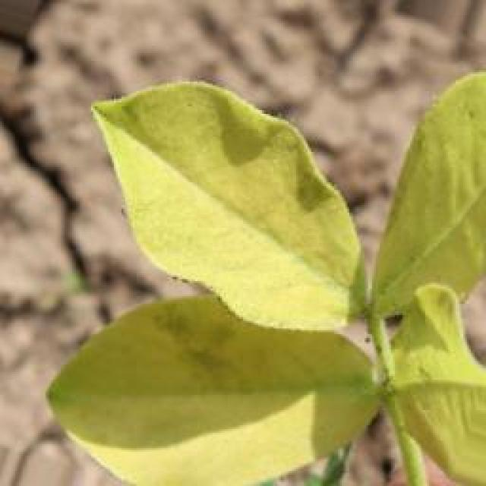
See the image and tell me what type of disease, visible symptoms and possible solution?
Option 1:
The image shows a leaf with numerous small holes, which could be a sign of a disease or pest infestation. The holes are scattered across the leaf, and the leaf appears to be green. The presence of these holes might indicate that the plant is affected by a disease or pest, such as a fungal infection or an insect infestation.
To address this issue, it is essential to identify the specific cause of the holes and take appropriate measures to treat the plant. If the holes are caused by a fungal infection, it is crucial to remove any affected leaves and apply a fungicide to prevent the spread of the disease. If the holes are caused by an insect infestation, it is necessary to identify the type of insect and apply appropriate insecticides or pesticides to control the infestation. Regularly inspecting the plant and taking preventive measures, such as using organic or natural pest control methods, can help minimize the risk of future infestations or diseases.
Option 2:
The visible symptoms in the image include small, round spots on the leaves of the groundnut plant. These spots are indicative of early leaf spot disease, which can affect various plants including groundnuts. The spots may vary in color from yellow to brown and can sometimes have a dark center.
The possible solution for this disease is preventative measures such as using fungicides like thiram or mancozeb, practicing crop rotation, and maintaining proper drainage to reduce moisture levels around the plants. If the disease has already been detected, regular inspections and timely application of fungicides can help control its spread. It's also important to ensure that the plant is not overwatered, as this can exacerbate the issue.

Which option do you prefer?

Sample 123

Ground Truth: early leaf spot
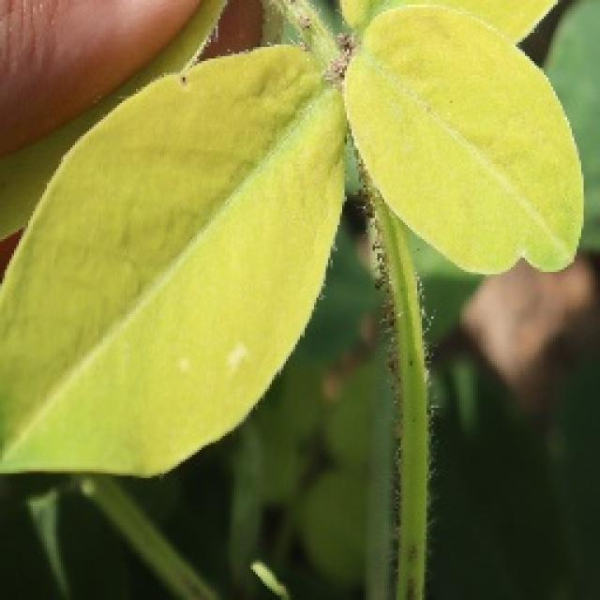
See the image and tell me what type of disease, visible symptoms and possible solution?
Option 1:
The image shows a leaf with brown spots and black dots, which indicates that the plant is affected by a disease. The disease appears to be a fungal infection, as the spots and dots are characteristic of fungal growth.
To address this issue, it is essential to identify the specific type of fungal infection and take appropriate measures to prevent its spread and manage the affected plant. Some possible solutions include:
1. Remove infected leaves and branches to prevent the spread of the disease.
2. Practice proper plant care, such as regular watering, adequate sunlight, and well-draining soil, to promote healthy plant growth and reduce the risk of infection.
3. Use organic or chemical fungicides, depending on the severity of the infection, to control the growth of the fungus and protect the plant.
4. Implement crop rotation and sanitation practices to minimize the risk of fungal infections in the future.
It is crucial to consult with a plant expert or a local agricultural extension service for specific advice on managing the disease and preventing further damage to the plant.
Option 2:
The visible symptoms in the image include small, round, dark brown spots with yellow halos on the leaves of the groundnut plant. These spots are indicative of a disease called early leaf spot, which is caused by fungal pathogens such as Cercospora and Septoria species.
The possible solution for this disease includes proper crop rotation to avoid re-infection from the same family of crops, removal of infected plant debris, and the use of fungicides like chlorothalonil or mancozeb to control the spread of the pathogen. It's important to monitor the condition of the plants regularly and apply any recommended treatments at the appropriate times to minimize damage and maintain crop yield.

Which option do you prefer?

Sample 124

Ground Truth: early leaf spot
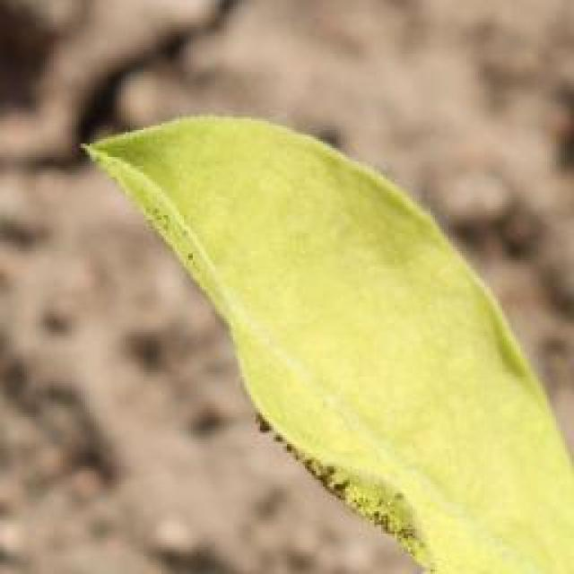
See the image and tell me what type of disease, visible symptoms and possible solution?
Option 1:
The image shows a leaf with yellow spots and holes, which indicates that the plant is affected by a disease called bacterial soft rot. This disease is caused by the bacterium Erwinia tracheiphila and can affect various plants, including tomatoes, peppers, and eggplants. The symptoms include yellowing of the leaves, wilting, and rotting of the plant tissue.
A possible solution to this problem is to practice good garden hygiene, such as removing infected plants and disposing of them properly, and ensuring that the soil is well-drained to prevent the growth of bacteria. Additionally, using organic mulch and compost can help improve soil quality and promote healthy plant growth. It is also essential to maintain a balanced pH in the soil and avoid overwatering, as these factors can contribute to the development of bacterial soft rot.
Option 2:
The visible symptoms in the image include small, yellowish spots on the leaves of the groundnut plant. These spots are indicative of early leaf spot disease, which is a common problem affecting plants like groundnuts. The spots can vary in size and color, often starting as small water-soaked lesions that later turn brown or black and become necrotic.
The possible solution for this disease would involve preventative measures such as using resistant varieties of the plant, practicing crop rotation to avoid re-infection from previous crops, and maintaining proper field sanitation by removing volunteer plants and debris. If the disease has already been detected, fungicides can be used for control, although the use of these chemicals should be done with caution and in accordance with recommended practices to minimize environmental impact.

Which option do you prefer?

Sample 125

Ground Truth: early leaf spot
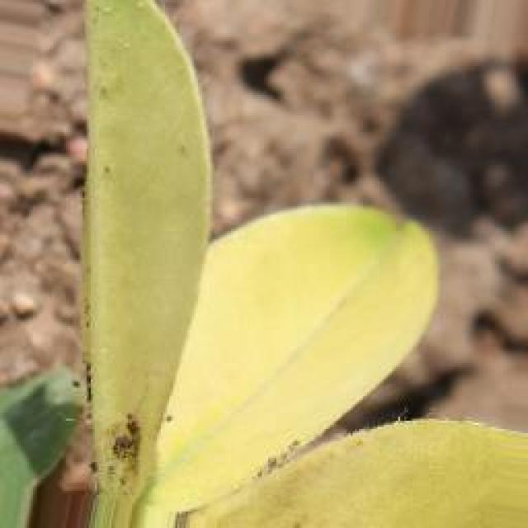
See the image and tell me what type of disease, visible symptoms and possible solution?
Option 1:
The image shows a leaf with brown spots and yellow patches, which indicates that the plant is suffering from a disease. The disease appears to be affecting the plant's growth and overall health.
The visible symptoms of the disease include brown spots and yellow patches on the leaf, which are indicative of a fungal infection or bacterial disease. The presence of these spots and patches suggests that the plant is experiencing stress or damage due to the disease.
To address this issue, it is essential to identify the specific type of disease affecting the plant and take appropriate measures to treat it. This may involve using fungicides or bactericides to combat the infection, as well as providing proper care and nutrients to help the plant recover and grow healthily. Additionally, it is important to maintain a clean and healthy environment for the plant to prevent the disease from spreading and causing further damage.
Option 2:
The visible symptoms in the image include yellowing of the leaves with dark spots, which are characteristic of early leaf spot disease affecting groundnut plants. This disease is caused by a fungus and can lead to significant crop loss if not managed properly.
The possible solutions for managing this disease include:
1. Early detection and removal of infected plant parts to prevent further spread of the fungus.
2. Implementing cultural practices such as crop rotation, maintaining good field hygiene, and avoiding overhead irrigation that can spread the disease.
3. Using fungicides like chlorothalonil or mancozeb for chemical control, following recommended application rates and intervals.
4. Practicing integrated pest management (IPM) to minimize the use of synthetic chemicals and promote a healthy ecosystem around the crop.
5. Monitoring the health of the plants regularly and adjusting management practices as needed based on the severity of the disease outbreak.

Which option do you prefer?

Sample 126

Ground Truth: early leaf spot
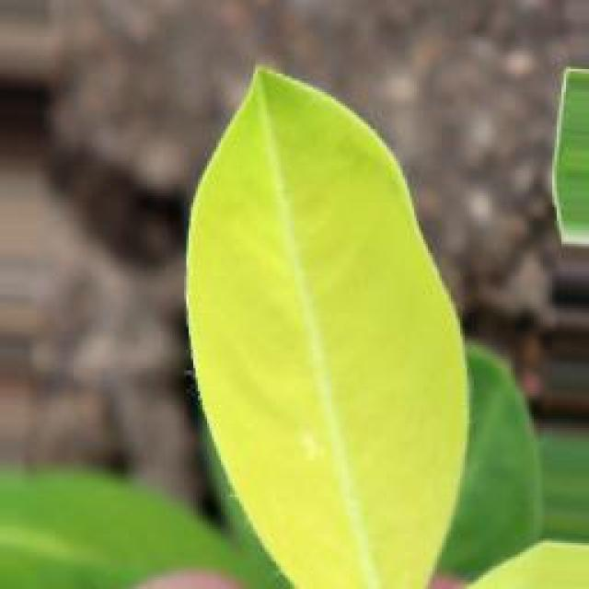
See the image and tell me what type of disease, visible symptoms and possible solution?
Option 1:
The image shows a leaf with yellow spots and black dots, which could be indicative of a disease or infection affecting the plant. The presence of these spots and dots suggests that the plant may be experiencing stress or damage, possibly due to overwatering, nutrient deficiencies, or exposure to pests or pathogens.
To address this issue, it is essential to identify the specific cause of the problem and take appropriate measures to address it. This may involve adjusting the watering schedule, providing adequate nutrients, or using pest control methods to prevent further damage. Additionally, monitoring the plant's health and taking preventive measures can help minimize the risk of further damage and promote the plant's overall well-being.
Option 2:
The visible symptoms in the image include yellowing and discoloration of the leaves, with brown spots that are indicative of a fungal disease known as late leaf spot. This disease affects the groundnut plant and can lead to significant crop loss if not managed properly.
The possible solution for this disease is to implement preventive measures such as using resistant varieties, practicing crop rotation, and maintaining proper field sanitation by removing debris after harvest. In addition, fungicides can be used to control the spread of the disease, but their use should be minimized as much as possible to reduce environmental impact. It's also important to monitor the health of the plants regularly and apply treatments promptly when symptoms appear.

Which option do you prefer?

Sample 127

Ground Truth: early leaf spot

See the image and tell me what type of disease, visible symptoms and possible solution?
Option 1:
The image shows a leaf with a yellow spot, which appears to be a fungal infection. The leaf is green and has a yellow spot on it, indicating that the plant is affected by a disease. The yellow spot is likely a symptom of the infection, and the leaf may be experiencing other symptoms as well.
To address this issue, it is essential to identify the specific type of fungal infection and take appropriate measures to treat it. This may involve using fungicides, removing infected leaves, or practicing good gardening habits such as regular pruning, proper watering, and ensuring adequate air circulation to prevent the spread of the disease. Additionally, it is important to maintain a healthy plant by providing proper nutrition, pest control, and regular monitoring for any signs of infection or disease.
Option 2:
The visible symptoms in the image include yellowing of the leaf with a distinct circular pattern where the color is altered to a lighter shade compared to the rest of the leaf. This pattern is characteristic of the early stage of a disease called yellowing or chlorosis, which can be caused by several factors such as nutrient deficiencies, waterlogging, or in some cases, diseases like bacterial leaf spot.
The circular pattern could indicate that the affected area is necrotic (dead tissue), which is a common symptom of bacterial leaf spot diseases. The presence of dark spots on the leaf might also suggest bacterial infection.
To address this issue, it would be important to identify the specific cause of the yellowing and necrosis by conducting tests for nutrient levels, water quality, and bacterial contamination. If it is indeed a disease issue, appropriate measures such as crop rotation, proper sanitation practices, and the use of fungicides or bactericides may be necessary to manage the problem.

Which option do you prefer?

Sample 128

Ground Truth: early leaf spot
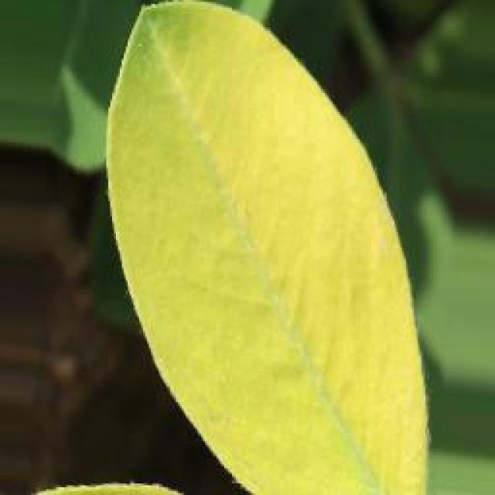
See the image and tell me what type of disease, visible symptoms and possible solution?
Option 1:
The image shows a leaf with a brown spot, which could be a sign of a disease or infection affecting the plant. The brown spot might be a symptom of various diseases, such as bacterial, fungal, or viral infections. To identify the specific disease, a closer examination of the leaf and the surrounding area would be necessary.
To address the issue, it is essential to identify the cause of the brown spot and take appropriate measures to treat the plant. This may involve using fungicides, bactericides, or other treatments to combat the infection, depending on the type of disease. Additionally, proper care, such as regular watering, sunlight exposure, and pest control, can help prevent the spread of the disease and promote the health of the plant.
Option 2:
The visible symptoms on the leaves of the groundnut plant in the image include small, round spots that appear to be dark or black in color, which could indicate a fungal infection such as early leaf spot. These spots are often accompanied by yellowing and curling of the leaf edges.
A possible solution for this disease would be to apply fungicides like mancozeb, chlorothalonil, or wettable sulphur to the plant, following the recommended dosage and frequency according to local agricultural practices. It's important to note that preventive measures such as crop rotation, proper drainage, and avoiding overcrowding can also help reduce the risk of fungal infections in groundnut plants.

Which option do you prefer?

Sample 129

Ground Truth: early leaf spot
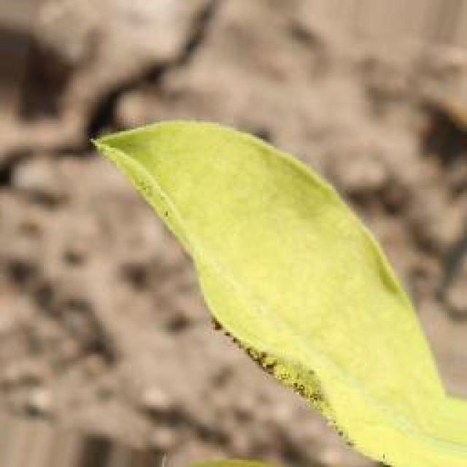
See the image and tell me what type of disease, visible symptoms and possible solution?
Option 1:
The image shows a leaf with brown spots, which could indicate a disease or infection affecting the plant. The presence of these spots suggests that the plant may be experiencing stress or damage due to various factors such as pests, nutrient deficiencies, or exposure to extreme weather conditions.
To address this issue, it is essential to identify the cause of the brown spots and take appropriate measures to treat the plant. If the spots are caused by pests, it is crucial to remove the affected leaves and use organic or chemical pest control methods to prevent further damage. If the spots are due to nutrient deficiencies, it is necessary to provide the plant with the necessary nutrients through proper soil amendment or supplementation.
In some cases, the brown spots could be a result of overwatering or underwatering, so it is important to monitor the plant's watering needs and adjust the watering schedule accordingly. Additionally, if the spots are caused by extreme weather conditions, it is essential to provide the plant with adequate shade or protection to prevent further damage.
In conclusion, the presence of brown spots on the leaf indicates that the plant may be experiencing stress or damage due to various factors. It is crucial to identify the cause of the spots and take appropriate measures to treat the plant, such as pest control, nutrient supplementation, and adjusting watering needs.
Option 2:
The visible symptoms in the image include yellowing of the leaf edges, which is a characteristic sign of early leaf spot disease affecting groundnut plants. This disease is caused by fungi such as Cercospora and can lead to significant crop loss if not managed properly.
The possible solution for this disease includes:
1. Early detection: Regularly inspect plants for signs of the disease, especially during the early stages when it's easier to manage.
2. Crop rotation: Practice crop rotation with other crops to reduce the risk of fungal infection from one year to the next.
3. Resistant varieties: Consider using varieties that have a natural resistance to early leaf spot disease.
4. Fungicide application: If necessary, use fungicides such as thiram or mancozeb for control. Apply at regular intervals and follow the recommended dosage on the label.
5. Proper planting and drainage: Ensure that plants are planted in well-draining soil and avoid overhead watering to minimize humidity around the leaves, which can exacerbate the disease.
6. Crop management: Remove infected plants and debris after harvest to prevent the spread of the disease.

Which option do you prefer?

Sample 130

Ground Truth: early leaf spot
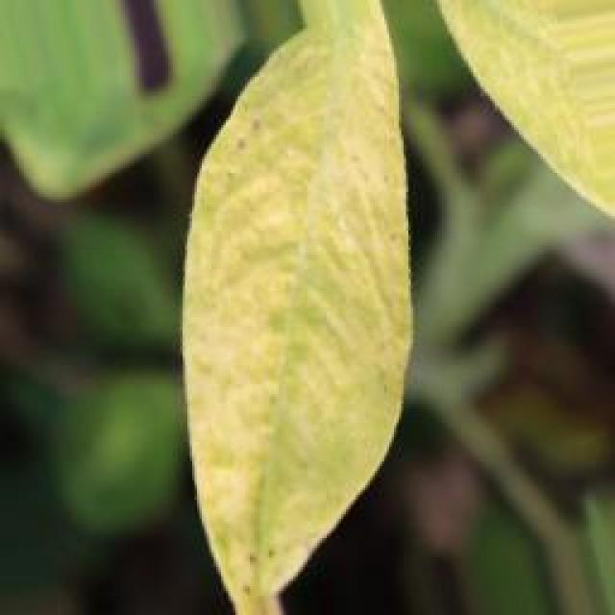
See the image and tell me what type of disease, visible symptoms and possible solution?
Option 1:
The image shows a leaf with brown spots and bumps, which could be indicative of a disease or infection affecting the plant. The presence of these spots and bumps suggests that the plant may be experiencing stress or damage, possibly due to pests, fungi, or other environmental factors.
To address this issue, it is essential to identify the specific cause of the damage and take appropriate measures to treat or prevent it. This may involve using organic or chemical pest control methods, such as applying a suitable fungicide or insecticide, or using beneficial insects to control pests. Additionally, ensuring proper plant care, such as providing adequate water, sunlight, and nutrients, can help the plant recover from the damage and prevent further issues. Regular monitoring of the plant's health and any visible symptoms can also help in early detection and treatment of any potential diseases or infections.
Option 2:
The visible symptoms in the image include small, round, dark spots with a yellow halo on the leaves of the groundnut plant. These are indicative of early leaf spot disease, which is caused by fungal pathogens such as Cercospora and Septoria species.
The possible solution for this disease would be to apply fungicides like chlorothalonil or mancozeb at the recommended dosage and frequency, following the guidelines provided by a local agricultural extension service. Additionally, proper crop rotation, avoiding overhead irrigation, and maintaining good field hygiene can help prevent the spread of the disease and reduce its impact on the plant.

Which option do you prefer?

Sample 131

Ground Truth: early leaf spot
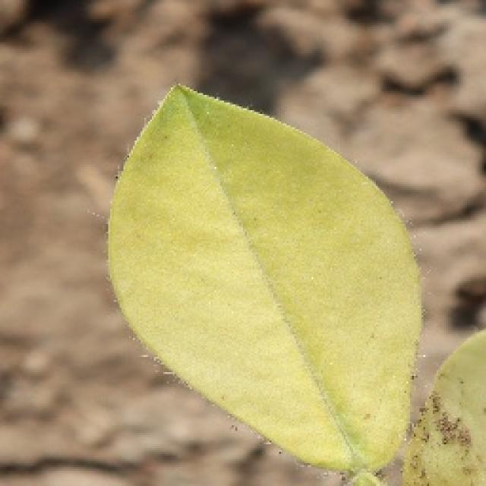
See the image and tell me what type of disease, visible symptoms and possible solution?
Option 1:
The image shows a leaf with brown spots and holes, which indicates that the plant is suffering from a disease called bacterial spot disease. This disease is caused by bacteria that infect the plant's leaves, leading to the formation of brown spots and holes. The symptoms of bacterial spot disease can vary depending on the type of bacteria and the plant species, but they generally involve the formation of lesions or spots on the leaves.
A possible solution to this problem is to practice good gardening practices, such as regular pruning, removing infected leaves, and ensuring proper drainage to prevent the spread of the disease. Additionally, using organic or bactericidal soaps can help to control the bacteria and prevent the disease from spreading further. It is also essential to maintain a healthy plant by providing adequate nutrients, water, and sunlight, which can help the plant to develop a stronger immune system and resist diseases more effectively.
Option 2:
The visible symptoms in the image include dark spots or lesions on the leaves of the groundnut plant. These are indicative of a disease known as early leaf spot, which can be caused by various fungal pathogens such as Cercospora and Septoria species. The spots are typically round and may have a yellow halo around them.
The possible solution for this disease is to apply fungicides like chlorothalonil or mancozeb, which are effective against early leaf spot pathogens. It's important to monitor the plants regularly and treat as soon as symptoms appear to prevent further spread of the disease. Additionally, good field sanitation practices such as removing debris after harvest and avoiding overhead irrigation can help reduce the risk of fungal infection.

Which option do you prefer?

Sample 132

Ground Truth: early leaf spot
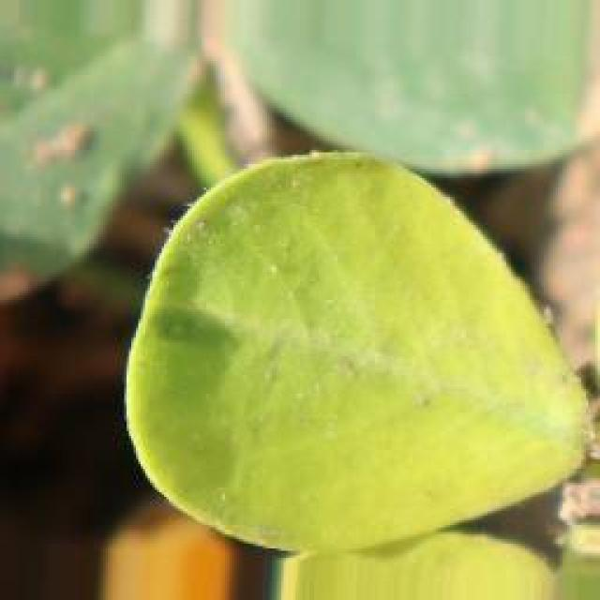
See the image and tell me what type of disease, visible symptoms and possible solution?
Option 1:
The image shows a leaf with spots and bumps, which could be indicative of a disease or infection. The leaf appears to be affected by a fungal infection, as it has white spots and bumps on it. This type of infection can be caused by various fungi, such as powdery mildew or downy mildew.
To address this issue, it is essential to identify the specific type of fungal infection affecting the leaf and take appropriate measures to prevent its spread. This may include removing infected leaves, pruning affected branches, and applying fungicides to the plant to prevent further infection. Additionally, ensuring proper plant care, such as regular watering, adequate sunlight, and proper spacing, can help maintain the health of the plant and reduce the risk of infection.
Option 2:
The visible symptoms in the image include small, round, yellowish spots scattered across the surface of the groundnut leaf. These spots are indicative of a disease called early leaf spot, which is caused by fungal pathogens such as Cercospora species.
The possible solution for this disease would involve preventative measures like crop rotation to avoid re-infection from previous crops, proper irrigation to maintain humidity levels, and the use of fungicides like chlorothalonil or mancozeb to control the spread of the pathogen. Additionally, if the disease is already present, regular inspections should be conducted to identify and treat infected plants promptly.

Which option do you prefer?

Sample 133

Ground Truth: early leaf spot
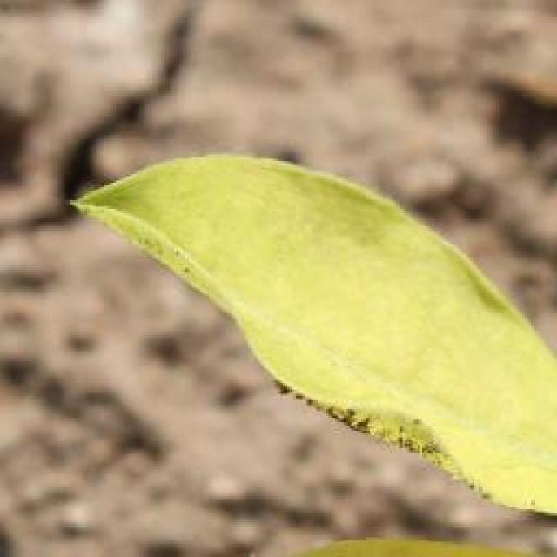
See the image and tell me what type of disease, visible symptoms and possible solution?
Option 1:
The image shows a leaf with brown spots and a black spot, which indicates that the leaf is affected by a disease. The disease could be a fungal infection or a bacterial infection, as the spots are irregularly shaped and the black spot is a darker color than the surrounding area.
To address this issue, it is essential to identify the specific type of disease causing the spots and black spot. Once the disease is identified, appropriate treatment methods can be applied, such as using fungicides or bactericides to control the spread of the disease. Additionally, proper care and maintenance of the plant, including regular pruning, watering, and pest control, can help prevent the disease from spreading and causing further damage to the plant.
Option 2:
The visible symptoms in the image include yellowing leaves with brown spots, which are indicative of a disease known as early leaf spot. This disease is caused by fungi and can affect various plants including groundnuts. The spots are typically round or irregularly shaped and may have a black center.
The possible solution for this disease would involve preventative measures such as using resistant varieties of the plant, practicing crop rotation to avoid re-infection from previous crops, and maintaining proper field sanitation by removing debris after harvest. If the disease has already occurred, fungicides can be used for control, although this should be done with caution as it may affect the environment and the health of the plant. It's important to follow recommended practices by an agricultural professional to ensure the best outcome for the plant.

Which option do you prefer?

Sample 134

Ground Truth: early leaf spot
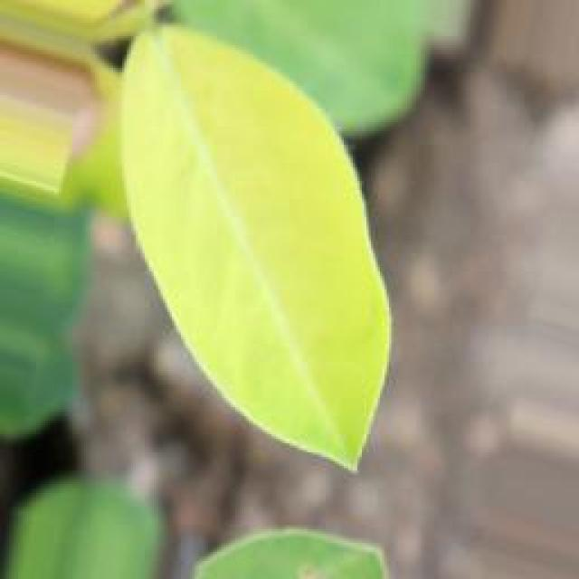
See the image and tell me what type of disease, visible symptoms and possible solution?
Option 1:
The image shows a leaf with a yellow spot, which appears to be a fungal infection. The leaf is green and has a yellow spot on it, indicating that the plant is affected by a disease. The presence of the yellow spot suggests that the plant is experiencing a fungal infection, which can be caused by various factors such as overwatering, poor soil quality, or exposure to excessive moisture.
To address this issue, it is essential to identify the cause of the infection and take appropriate measures to prevent it from spreading. This may include adjusting the watering schedule, ensuring proper drainage, and using well-draining soil. Additionally, it is crucial to remove any infected leaves and maintain a healthy environment for the plant to recover and prevent further damage. If the infection is severe, it may be necessary to consult a professional to determine the best course of action for treating the plant and preventing further damage.
Option 2:
The visible symptoms in the image include yellowing leaves with a distinct circular pattern, which is characteristic of early leaf spot disease affecting groundnuts. This disease is caused by fungi such as Cercospora and Macrophomina. The circular spots are often accompanied by a yellow halo around the edges.
The possible solution for this disease includes proper crop rotation to avoid re-infection from previous crops, maintaining good field drainage to reduce moisture levels that favor fungal growth, and using fungicides like thiram or captan for prevention and control. It's important to monitor the plants regularly and apply treatments as soon as symptoms appear.

Which option do you prefer?

Sample 135

Ground Truth: early leaf spot
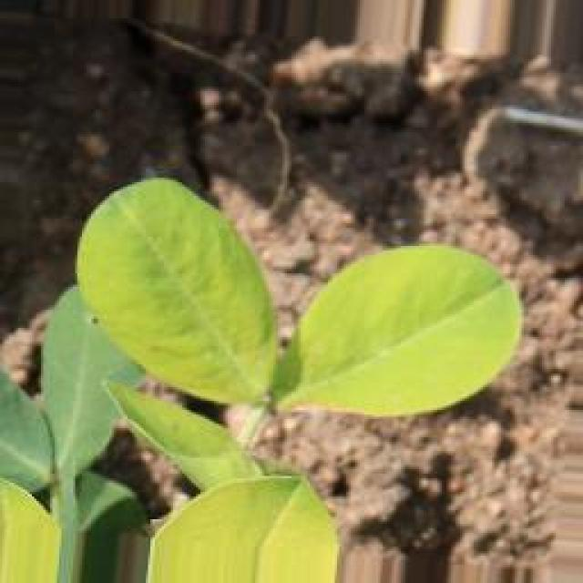
See the image and tell me what type of disease, visible symptoms and possible solution?
Option 1:
The image shows a leaf with brown spots and holes, which indicates that the plant is suffering from a disease called bacterial leaf spot. This disease is caused by bacteria that infect the plant's leaves, leading to the formation of brown spots and holes. The plant's leaves may also turn yellow and drop off.
To address this issue, it is essential to identify the specific bacteria causing the disease and apply appropriate treatments. Some common solutions include using organic or chemical fungicides, improving the plant's overall health through proper care, and ensuring proper drainage and air circulation around the plant. Additionally, it is crucial to practice crop rotation and maintain a healthy plant environment to prevent the spread of the disease.
Option 2:
The visible symptoms in the image include dark spots or lesions on the leaves, which are indicative of early leaf spot disease affecting the groundnut plant. These spots can vary in size and shape, and they may have a yellow halo around them. The affected leaves may also show signs of wilting or chlorosis (yellowing).
The possible solution for this disease is to practice proper crop rotation, removing infected plants, and using fungicides such as mancozeb, chlorothalonil, or wettable sulphur to control the spread of the disease. It's important to follow recommended application rates and repeat treatments if necessary. Additionally, maintaining good field hygiene and avoiding overcrowding in the planting can help prevent the disease from spreading.

Which option do you prefer?

Sample 136

Ground Truth: early leaf spot
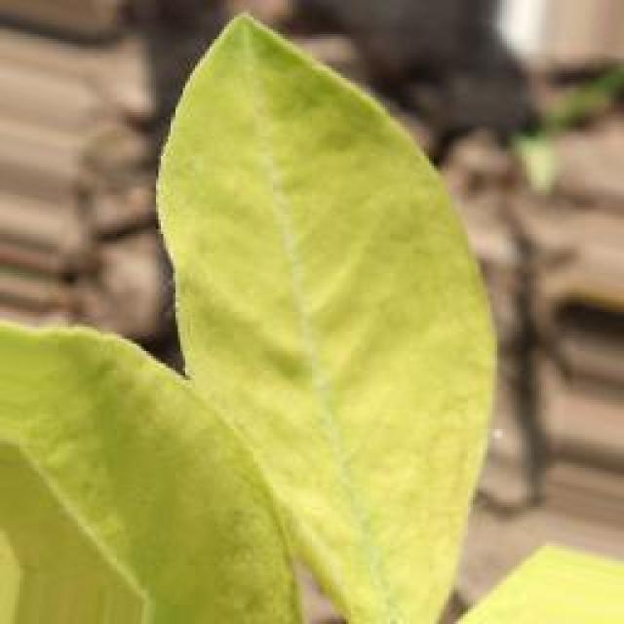
See the image and tell me what type of disease, visible symptoms and possible solution?
Option 1:
The image shows a leaf with a brown spot, which could be a sign of a disease or infection. The leaf appears to be infected with a fungus, as indicated by the brown spot. To address this issue, it is essential to identify the specific type of fungus causing the infection and take appropriate measures to treat it. This may involve using fungicides, pruning infected parts of the plant, or ensuring proper drainage and air circulation to prevent the spread of the fungus. Additionally, maintaining a healthy plant by providing adequate nutrients, water, and sunlight can help prevent the development of diseases and promote overall plant health.
Option 2:
The visible symptoms in the image include dark spots or lesions on the leaves, which are indicative of a disease known as early leaf spot. This disease is caused by fungi and can affect various plants including groundnuts.
The possible solution for this disease would be to apply fungicides such as mancozeb, chlorothalonil, or wettable sulphur to the affected plants. It's important to follow the recommended dosage and frequency of application as per the instructions provided with the fungicide. Additionally, proper crop rotation and maintaining good field hygiene can help prevent the spread of the disease.

Which option do you prefer?

Sample 137

Ground Truth: early leaf spot
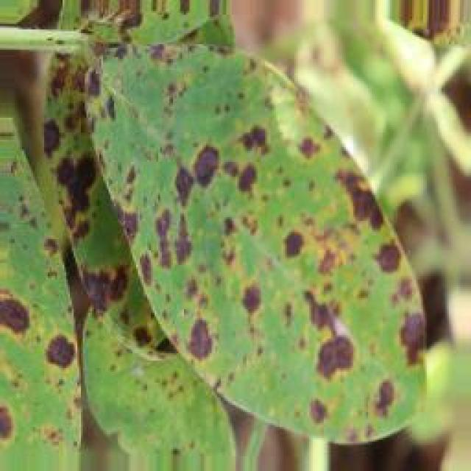
See the image and tell me what type of disease, visible symptoms and possible solution?
Option 1:
The image shows a leaf with yellow spots, which could indicate a disease or infection affecting the plant. The yellow spots might be a sign of bacterial or fungal infections, which can cause damage to the plant's tissues and negatively impact its overall health.
To address this issue, it is essential to identify the specific type of disease causing the yellow spots and take appropriate measures to treat or prevent it. Some common solutions include:
1. Practicing proper plant care, such as regular watering, ensuring adequate sunlight, and maintaining a clean and well-draining soil.
2. Regularly inspecting the plant for any signs of disease or pests and addressing them promptly.
3. Using organic or chemical pesticides or fungicides, depending on the type of disease, to control the spread and protect the plant.
4. Removing infected or affected parts of the plant to prevent the disease from spreading further.
It is crucial to consult with a plant expert or a local nursery for guidance on the best course of action to take based on the specific disease and the plant species.
Option 2:
The visible symptoms in the image include yellowing of the leaves, which is a common sign of nutrient deficiency or stress in plants. The affected plant appears to have a condition known as early leaf spot, characterized by small, dark spots on the leaves. This could be due to various factors such as overwatering, poor drainage, or excessive fertilizer application.
To address this issue, it is important to identify the specific nutrient deficiency or the cause of the early leaf spot. If it's a nutrient deficiency, a soil test can help determine which nutrients are lacking and how much should be applied. If it's due to overwatering or poor drainage, adjusting irrigation practices and ensuring proper drainage can help. If the issue is excessive fertilizer application, reducing the amount of fertilizer and possibly using organic amendments can alleviate the problem.
It's also important to note that early leaf spot can be caused by various fungal pathogens, which may require different treatments such as fungicide application or removal and destruction of affected plant parts to prevent further spread.

Which option do you prefer?

Sample 138

Ground Truth: early leaf spot
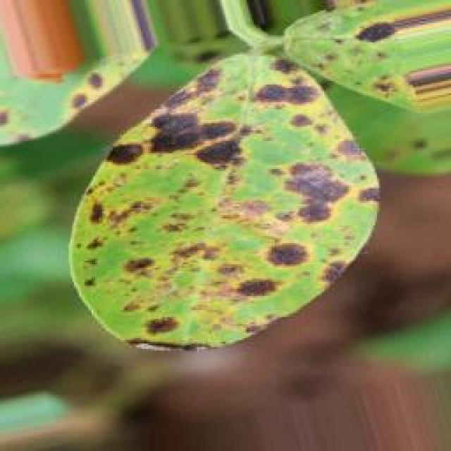
See the image and tell me what type of disease, visible symptoms and possible solution?
Option 1:
The image shows a leaf with brown spots and holes, which indicates that the plant is suffering from a disease called bacterial soft rot. This disease is caused by bacteria, specifically Xanthomonas campestris, which can infect various plant species, including tomatoes.
The visible symptoms of bacterial soft rot include brown spots or lesions on the leaves, which eventually turn into brown, mushy, and rotten tissue. The plant's leaves may also become discolored, wilt, and eventually die.
A possible solution to prevent the spread of the disease and save the plant is to remove the infected leaves and stems, and practice proper crop rotation and sanitation. Additionally, using organic or bactericidal compost can help improve soil health and reduce the risk of bacterial infections in the future. It is also essential to maintain a healthy plant by providing adequate water, nutrients, and sunlight.
Option 2:
The visible symptoms in the image include small, round, yellowish spots on the leaves of the groundnut plant. These spots are indicative of a disease called early leaf spot, which can affect various plants including groundnuts. The disease is caused by fungi and typically starts with small, water-soaked spots that later turn brown and develop into larger, necrotic lesions.
The possible solution for this disease would involve preventative measures such as crop rotation to avoid re-infection from the same family of plants, proper irrigation to maintain a healthy moisture level in the soil, and the use of fungicides if necessary. It's important to identify the specific type of fungus causing the disease and apply the appropriate fungicide for effective control. Additionally, good field sanitation practices can help reduce the risk of disease outbreaks.

Which option do you prefer?

Sample 139

Ground Truth: early leaf spot
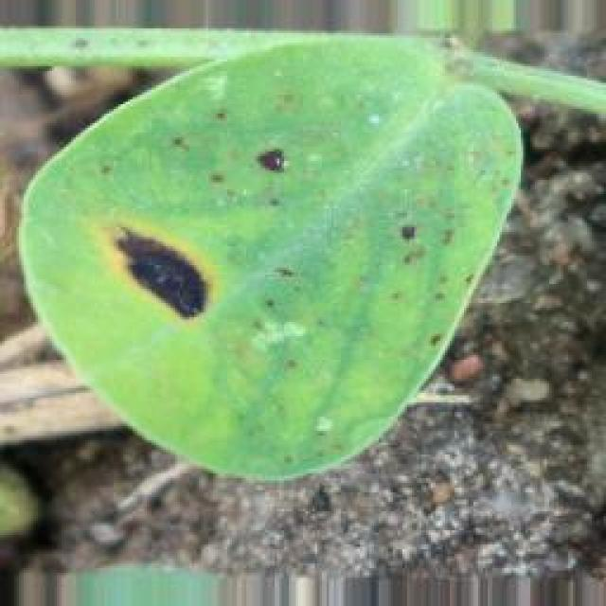
See the image and tell me what type of disease, visible symptoms and possible solution?
Option 1:
The image shows a leaf with spots and bumps, which could be indicative of a disease or a pest infestation. The leaf appears to be green and has a few brown spots. The presence of these spots and bumps suggests that the plant might be affected by a fungal infection or a pest infestation.
To address this issue, it is essential to identify the specific type of disease or pest causing the damage. Once the cause is determined, appropriate measures can be taken to treat or prevent the problem. For fungal infections, it is crucial to practice good garden hygiene, such as removing infected leaves and maintaining proper drainage and air circulation around the plant. For pest infestations, it is important to monitor the plant for signs of pests and take appropriate action, such as using pesticides or removing affected leaves. Regularly inspecting the plant and taking preventive measures can help minimize the risk of further damage and promote healthy growth.
Option 2:
The visible symptoms in the image include small, round spots with a yellow hue on the leaves of the groundnut plant. These spots are indicative of early leaf spot disease. The possible solution for this disease is to apply fungicides such as mancozeb or chlorothalonil to prevent the spread of the pathogen and protect the crop from further damage. Additionally, proper irrigation and fertilization practices can also help maintain the health of the plant.

Which option do you prefer?

Sample 140

Ground Truth: early leaf spot
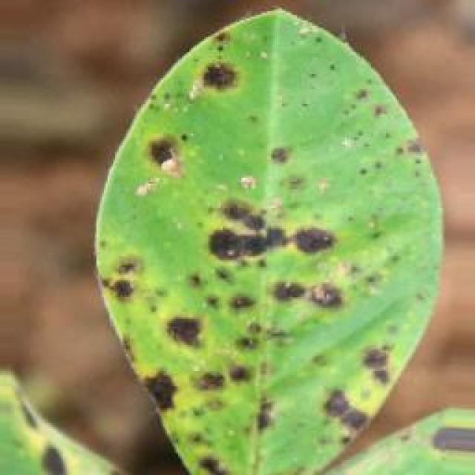
See the image and tell me what type of disease, visible symptoms and possible solution?
Option 1:
The image shows a leaf with brown spots and holes, which indicates that the plant is suffering from a disease called bacterial leaf spot. This disease is caused by bacteria that infect the plant's leaves, leading to the formation of brown spots and holes. The symptoms of bacterial leaf spot include the browning and decay of leaves, which can eventually lead to the death of the affected plant.
A possible solution to this problem is to practice good gardening practices, such as regular pruning, removing infected leaves, and ensuring proper drainage to prevent the spread of the disease. Additionally, using organic fertilizers and avoiding the use of excessive nitrogen-rich fertilizers can help in preventing the growth of bacteria that cause the disease. It is also essential to maintain a healthy plant by providing proper care, including adequate watering, sunlight, and nutrients.
Option 2:
The visible symptoms in the image include yellowing leaves with brown spots, which are indicative of a disease known as early leaf spot. This disease is caused by fungi such as Cercospora and can affect various plants including groundnuts.
The possible solution for this disease is to apply fungicides like mancozeb, chlorothalonil, or wettable sulphur to the affected plants. It's important to spray the fungicides at regular intervals, usually every 10-14 days until 14 days before harvest. Additionally, proper crop rotation and maintaining good field hygiene can help prevent the spread of the disease.

Which option do you prefer?

Sample 141

Ground Truth: early leaf spot
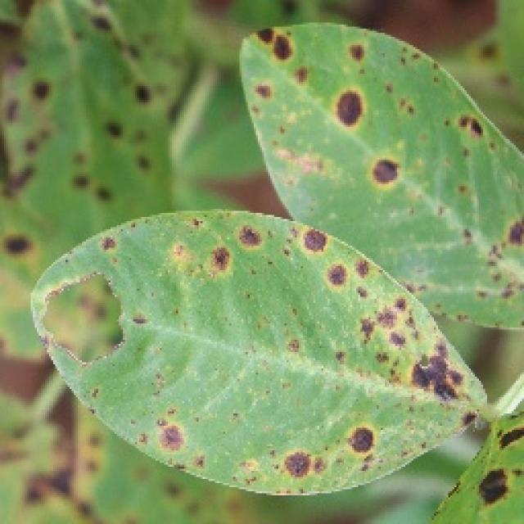
See the image and tell me what type of disease, visible symptoms and possible solution?
Option 1:
The image shows a leaf with brown spots and holes, which indicates that it is affected by a disease. The leaf appears to be infected with a fungal disease, as the spots and holes are characteristic of fungal infections. The visible symptoms include brown spots and holes on the leaf, which can lead to the degradation of the leaf's structure and eventually its death.
A possible solution to this problem is to practice good gardening practices, such as regular pruning, removing infected leaves, and ensuring proper drainage and air circulation around the affected plant. Additionally, using organic fertilizers and pest control methods can help prevent the spread of the disease and promote healthy plant growth. If the disease is severe, it may be necessary to consult a professional to identify the specific type of fungus and recommend appropriate treatment options.
Option 2:
The visible symptoms in the image include dark spots or lesions on the leaves of the groundnut plant. These spots are indicative of a disease known as early leaf spot, which can be caused by various fungal pathogens such as Cercospora and Septoria species.
The possible solution for this disease would involve preventative measures like crop rotation to avoid re-infection from previous crops, proper irrigation to maintain humidity levels, and the use of fungicides like chlorothalonil or mancozeb to control the spread of the pathogen. Additionally, if the disease is severe, it may be necessary to remove and destroy affected plants to prevent further contamination.

Which option do you prefer?

Sample 142

Ground Truth: early leaf spot
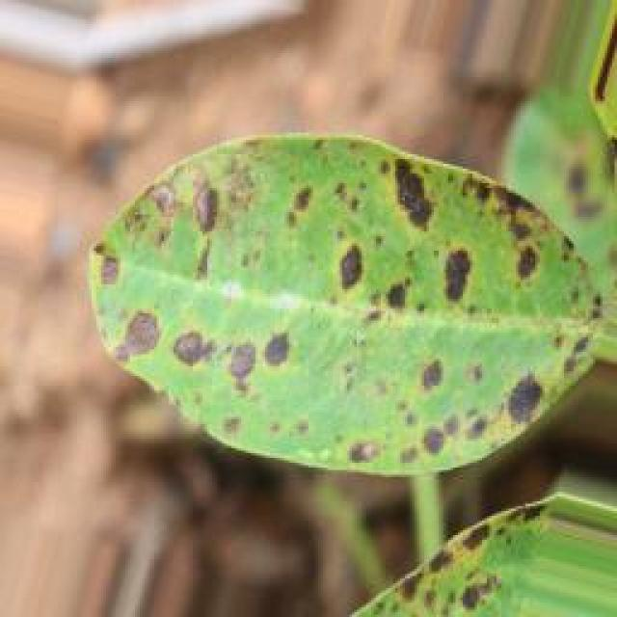
See the image and tell me what type of disease, visible symptoms and possible solution?
Option 1:
The image shows a leaf with a large black spot, which appears to be a fungal infection. The leaf is green and has a yellowish tint, indicating that it is affected by the disease. The black spot is a symptom of the infection, and the yellowish tint could be a result of the infection as well.
To solve this issue, it is essential to identify the type of fungal infection and take appropriate measures to treat it. This may involve using fungicides, pruning the affected plant, or removing the infected leaves to prevent the spread of the disease. Additionally, it is crucial to maintain proper plant care, such as regular watering, sunlight exposure, and pest control, to prevent the growth of fungal infections in the future.
Option 2:
The visible symptoms in the image include yellow spots with dark centers on the leaves of the groundnut plant. These spots are indicative of a disease called early leaf spot, which is caused by fungal pathogens such as Cercospora spp. or Septoria spp. The spots can vary in size and shape but are typically round or oval with a yellow halo surrounding the dark center.
The possible solution for this disease is to apply fungicides like chlorothalonil, mancozeb, or wettable sulphur to control the spread of the fungus. It's important to follow proper crop management practices such as removing infected leaves and avoiding overhead irrigation to prevent the spread of the disease. Additionally, maintaining good field hygiene and rotating crops can help prevent recurrence of the disease.

Which option do you prefer?

Sample 143

Ground Truth: early leaf spot
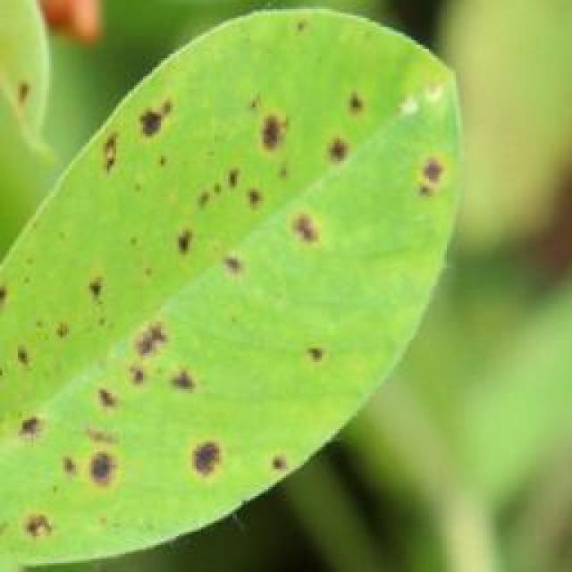
See the image and tell me what type of disease, visible symptoms and possible solution?
Option 1:
The image shows a leaf with a lot of small black spots, which could indicate a disease or infection affecting the plant. The presence of these spots suggests that the plant might be experiencing stress or damage due to various factors such as pests, fungi, or bacteria.
To address this issue, it is essential to identify the specific cause of the spots and take appropriate measures to treat the plant. This may involve using organic or chemical pesticides to control pests, applying fungicides to combat fungal infections, or using bactericides to combat bacterial diseases. Additionally, it is crucial to ensure that the plant receives proper care, including adequate watering, sunlight, and nutrients, to promote its overall health and prevent further damage.
Option 2:
The visible symptoms in the image include yellowish spots with a darker center, which are characteristic of early leaf spot disease affecting the groundnut plant. This disease is caused by fungi and can lead to significant crop loss if not managed properly.
The possible solutions include:
1. Prevention: Implementing good agricultural practices such as proper crop rotation, removing volunteer plants, and maintaining a healthy soil environment can help prevent the disease from occurring.
2. Early detection: Regularly inspecting plants for signs of early leaf spot disease and treating them with fungicides as soon as symptoms are observed is crucial in managing the disease effectively.
3. Cultural control: Removing and destroying infected plant debris, avoiding overhead irrigation that can spread the disease, and practicing good sanitation are important cultural control measures.
4. Chemical control: Using fungicides such as chlorothalonil or mancozeb, following recommended application rates and intervals, can help manage the disease.
5. Resistant varieties: If available, planting resistant varieties of groundnut can help reduce the impact of early leaf spot disease on crops.
It's important to note that these solutions may vary depending on local conditions and regulations, so it's advisable to consult with a plant pathologist or extension service for specific recommendations.

Which option do you prefer?

Sample 144

Ground Truth: early leaf spot
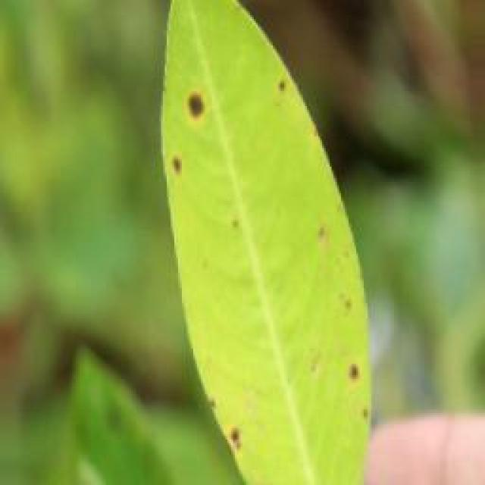
See the image and tell me what type of disease, visible symptoms and possible solution?
Option 1:
The image shows a leaf with brown spots, which could indicate a disease or infection affecting the plant. The brown spots might be a sign of fungal infection, bacterial infection, or nutrient deficiency. To address this issue, it is essential to identify the cause of the brown spots and take appropriate measures to treat the plant.
If the brown spots are caused by a fungal infection, it is crucial to remove any infected leaves and apply a fungicide to prevent the spread of the disease. If the brown spots are due to bacterial infection, it is necessary to remove the affected leaves and apply a bactericide to kill the bacteria.
If the brown spots are a result of nutrient deficiency, it is important to provide the plant with the necessary nutrients through proper soil amendment or supplementation. Regularly monitoring the plant's health and addressing any issues promptly can help maintain the plant's overall health and prevent further damage.
Option 2:
The visible symptoms in the image include yellowing leaves with dark spots, which are indicative of a disease known as early leaf spot. This disease is caused by fungi and can affect various plants, including groundnuts.
The possible solutions for managing this disease include:
1. Prevention: Practicing good agricultural practices such as crop rotation, proper planting times, and avoiding overcrowding in the field to reduce humidity around the plants.
2. Early detection: Regularly inspecting plants for signs of disease and treating them as soon as possible with fungicides like mancozeb, chlorothalonil, or wettable sulphur.
3. Cultural control: Removing infected leaves and debris after harvest to prevent the spread of the disease.
4. Resistant varieties: Selecting varieties that are resistant to early leaf spot and other diseases when available.
5. Integrated pest management: Implementing a holistic approach that includes cultural control measures, crop rotation, and biological control methods like beneficial insects.

Which option do you prefer?

Sample 145

Ground Truth: early leaf spot
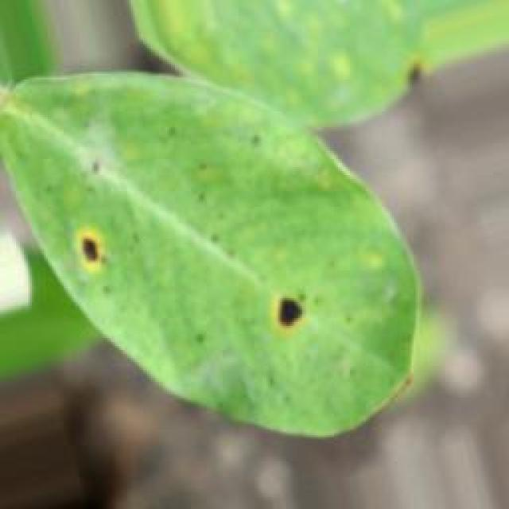
See the image and tell me what type of disease, visible symptoms and possible solution?
Option 1:
The image shows a leaf with yellow spots and bumps, which could be a sign of a disease or infection affecting the plant. The presence of these spots and bumps indicates that the plant is experiencing some form of stress or damage.
One possible solution to address this issue is to provide the plant with proper care, such as regular watering, adequate sunlight, and well-draining soil. Additionally, it is essential to monitor the plant for any signs of further deterioration and consult with a plant expert or a local nursery for advice on the best course of action to take. If the disease is severe, it may be necessary to remove the affected leaves and branches to prevent the spread of the infection and promote the plant's overall health.
Option 2:
The visible symptoms in the image include yellowish spots or lesions on the leaves of the groundnut plant. These spots are indicative of a disease called early leaf spot, which is caused by fungal pathogens such as Cercospora species. The spots can vary in color from yellow to brown and may have a yellow halo around them.
The possible solution for this disease would involve preventative measures like crop rotation, removing infected plant debris, and using resistant varieties of groundnut plants. If the disease has already occurred, fungicides can be used to control the spread of the pathogen and prevent further damage to the crop. It's important to follow recommended practices for the specific region and crop type when dealing with such diseases.

Which option do you prefer?

Sample 146

Ground Truth: early leaf spot
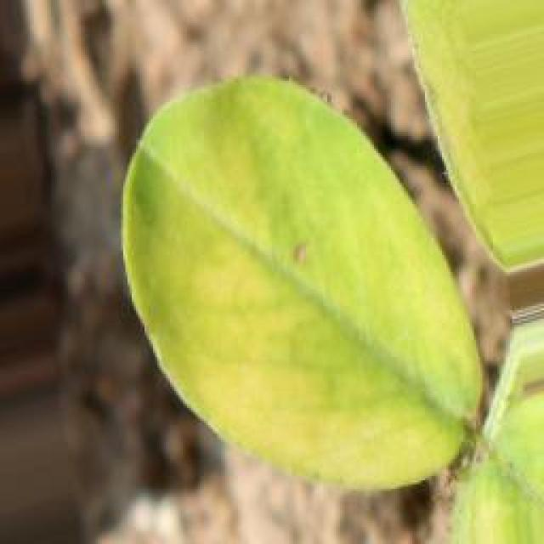
See the image and tell me what type of disease, visible symptoms and possible solution?
Option 1:
The image shows a leaf with a brown spot, which could be a sign of a disease or infection. The brown spot is surrounded by green leaves, indicating that the plant is still healthy in other areas. The presence of the brown spot might be due to various factors, such as fungal infections, bacterial diseases, or nutrient deficiencies.
To address this issue, it is essential to identify the cause of the brown spot and take appropriate measures to treat or prevent the disease. This may involve using organic or chemical pesticides, applying appropriate fungicides or bactericides, or adjusting the plant's nutrient intake to ensure it receives the necessary nutrients. Additionally, proper watering, sunlight exposure, and pest control can help maintain the health of the plant and prevent the spread of the disease.
Option 2:
The visible symptom in the image is a yellowing of the leaf with a distinct circular pattern where the color has turned brownish-black, indicating the presence of a disease or pest infestation. This could be an early sign of a fungal disease such as early leaf spot, which affects plants by causing small, circular spots on leaves that can eventually lead to larger necrotic areas if left untreated.
The possible solution would depend on the specific type of plant and the region it is grown in, but generally speaking, early detection and treatment with appropriate fungicides can help manage this disease. It's important to identify the specific pathogen causing the symptoms and follow recommended practices for crop management to minimize further damage.

Which option do you prefer?

Sample 147

Ground Truth: early leaf spot
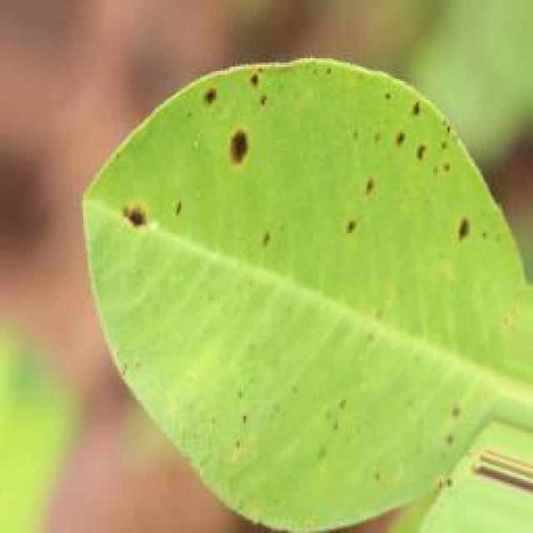
See the image and tell me what type of disease, visible symptoms and possible solution?
Option 1:
The image shows a leaf with brown spots and holes, which indicates that the plant is suffering from a disease called bacterial leaf spot. This disease is caused by bacteria that infect the plant's leaves, leading to the formation of brown spots and holes. The symptoms of bacterial leaf spot include discoloration, wilting, and eventual death of the affected leaves.
A possible solution to this problem is to practice good gardening practices, such as regular pruning, removing infected leaves, and ensuring proper drainage to prevent the spread of the disease. Additionally, using organic fertilizers and avoiding the use of excessive nitrogen-rich fertilizers can help in preventing the growth of bacteria that cause the disease. It is also essential to maintain a healthy plant by providing adequate water, sunlight, and nutrients to support the plant's immune system and prevent the development of diseases.
Option 2:
The visible symptoms in the image include yellowing of the leaves, which is a common sign of early leaf spot disease affecting plants like groundnuts. The spots on the leaves are dark brown or black with a yellow halo around them, indicating that the plant has been infected by a fungal pathogen.
The possible solution for this disease would involve preventive measures such as using resistant varieties of the crop, practicing crop rotation to avoid re-infection from previous crops, and maintaining good field hygiene by removing debris after harvest. If the disease has already occurred, fungicides can be used for control, but it's important to follow recommended application rates and intervals to minimize environmental impact. Additionally, proper irrigation and nutrient management can help maintain plant health and reduce stress that may exacerbate the symptoms of early leaf spot.

Which option do you prefer?

Sample 148

Ground Truth: early leaf spot
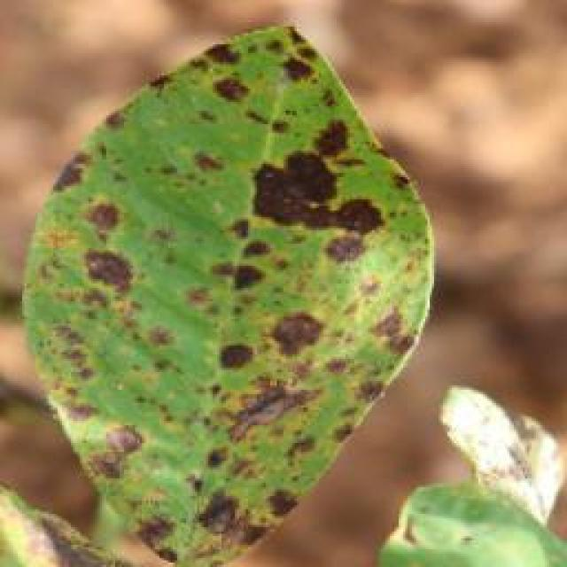
See the image and tell me what type of disease, visible symptoms and possible solution?
Option 1:
The image shows a leaf with a small black spot, which could be a sign of a disease or infection. The leaf appears to be green and has a slightly rough texture. The black spot might be a symptom of a fungal infection, such as powdery mildew or bacterial infection.
To address this issue, it is essential to identify the specific type of disease affecting the plant and take appropriate measures to treat it. For fungal infections, it is crucial to practice good garden hygiene, such as removing infected leaves and pruning affected branches, and applying a suitable fungicide to prevent the spread of the disease. For bacterial infections, it is important to remove the affected leaves and apply a suitable bactericide to kill the bacteria.
In addition to treating the disease, it is also essential to maintain a healthy plant by providing proper care, such as adequate watering, sunlight, and nutrients, to prevent future infections and promote overall plant health.
Option 2:
The visible symptoms in the image include a round, yellowish or brownish discoloration on the leaves of the groundnut plant. This is indicative of early leaf spot disease, which affects plants by causing small, circular spots to develop on the leaves. The spots can vary in color from yellow to brown and may have a ring-like pattern around the edge.
The possible solution for this disease is prevention through proper crop rotation, ensuring that groundnuts are not planted near other susceptible crops. It's also important to practice good sanitation by removing debris after harvest and avoiding overhead irrigation that can spread the fungus. If the disease has already occurred, fungicides can be used for control, but it's crucial to follow recommended application rates and intervals to minimize environmental impact.

Which option do you prefer?

Sample 149

Ground Truth: early leaf spot
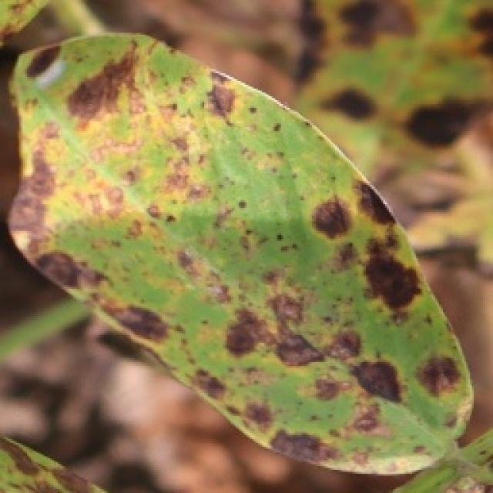
See the image and tell me what type of disease, visible symptoms and possible solution?
Option 1:
The image shows a leaf with brown spots and yellow patches, which indicates that the plant is suffering from a disease. The disease could be a fungal infection or a bacterial infection, as the spots and patches are not consistent with insect damage.
To address this issue, it is essential to identify the specific type of disease causing the symptoms. Once the disease is diagnosed, appropriate treatment measures can be taken. These may include applying fungicides or bactericides to the affected plant, removing infected leaves, and ensuring proper care and maintenance of the plant to prevent future infections. Additionally, it is crucial to practice good gardening practices, such as regular pruning, proper watering, and pest control, to minimize the risk of diseases affecting the plant.
Option 2:
The visible symptoms in the image include yellowing of the leaves, which is a common sign of early leaf spot disease in groundnut plants. The spots on the leaves are dark brown to black and have a yellow halo around them, indicating that the disease has progressed.
The possible solution for this disease would be to apply fungicides such as mancozeb, chlorothalonil, or wettable sulphur to control the spread of the pathogen causing the early leaf spot. It's also important to practice good crop rotation and maintain proper field sanitation to prevent the disease from spreading further.

Which option do you prefer?

Sample 150

Ground Truth: early leaf spot
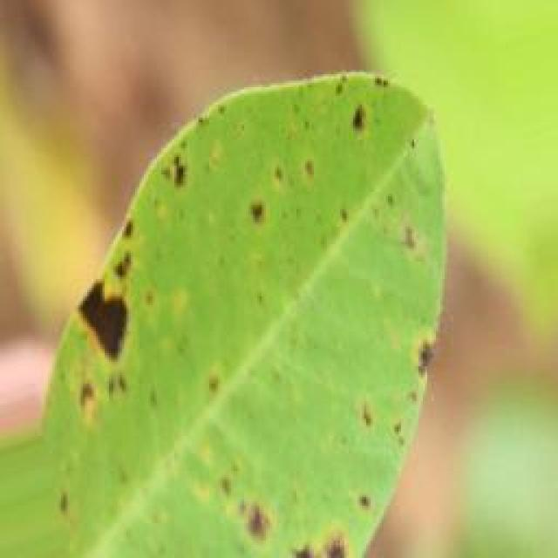
See the image and tell me what type of disease, visible symptoms and possible solution?
Option 1:
The image shows a leaf with brown spots and bumps, which could indicate a disease or infection affecting the plant. The presence of these spots and bumps suggests that the plant may be experiencing stress or damage due to various factors such as pests, fungi, or nutrient deficiencies.
To address this issue, it is essential to identify the specific cause of the damage and take appropriate measures to treat or prevent it. This may involve using pesticides to control pests, applying fungicides to combat fungal infections, or providing the plant with the necessary nutrients to promote healthy growth. Additionally, proper care, such as regular watering, sunlight exposure, and temperature control, can help maintain the plant's overall health and prevent further damage.
Option 2:
The visible symptoms in the image include dark spots or lesions on the leaves, which are indicative of a disease known as early leaf spot. This disease is caused by fungi and can affect various plants, including groundnuts.
The possible solution for this disease would be to apply fungicides such as mancozeb, chlorothalonil, or wettable sulphur to the affected plants. It's important to spray these chemicals at the recommended dosage and frequency, and to repeat the application if necessary. Additionally, proper crop rotation and maintaining good field hygiene can help prevent the spread of the disease.

Which option do you prefer?

Sample 151

Ground Truth: early leaf spot
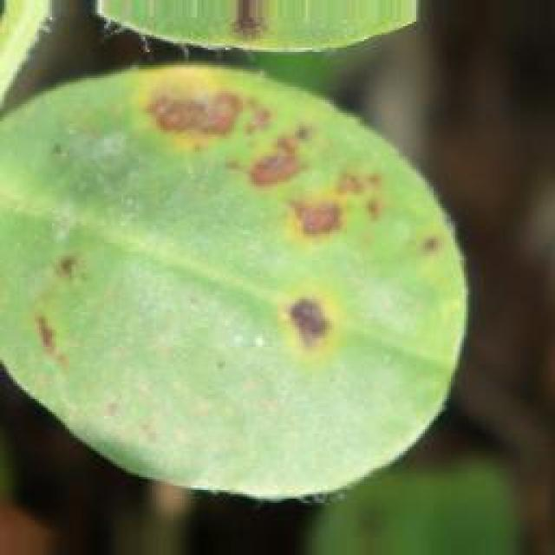
See the image and tell me what type of disease, visible symptoms and possible solution?
Option 1:
The image shows a leaf with brown spots and holes, which indicates that the plant is suffering from a disease called bacterial leaf spot. This disease is caused by bacteria that enter the plant through wounds or natural openings and multiply in the leaf tissue, leading to the formation of brown spots and holes.
The visible symptoms of bacterial leaf spot include brown spots or holes on the leaves, which can lead to the death of the affected leaves. The disease can spread rapidly and affect the overall health of the plant.
To manage this disease, it is essential to practice proper plant care, such as regular watering, ensuring adequate sunlight, and maintaining a clean and healthy growing environment. Additionally, using organic or chemical-free fertilizers and pest control methods can help prevent the spread of the disease. If the disease has already affected the plant, it is crucial to remove the affected leaves and practice crop rotation to prevent the disease from spreading to other plants in the same area.
Option 2:
The visible symptoms in the image include small, round spots on the leaves of the groundnut plant. These spots are indicative of early leaf spot disease, which can affect the health and productivity of the plant.
The possible solution for this disease is to implement preventive measures such as proper crop rotation, removing infected plants, and using fungicides like mancozeb or chlorothalonil to control the spread of the pathogen. Additionally, maintaining good field hygiene and ensuring adequate drainage can also help in preventing the disease from spreading further.

Which option do you prefer?

Sample 152

Ground Truth: early leaf spot
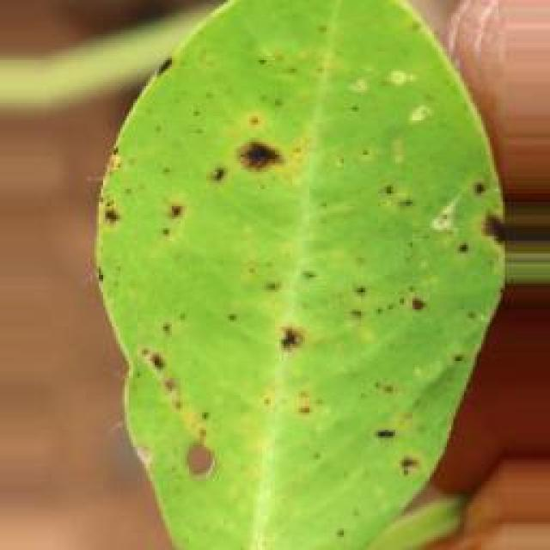
See the image and tell me what type of disease, visible symptoms and possible solution?
Option 1:
The image shows a leaf with brown spots and yellow dots, which could indicate a disease or infection affecting the plant. The presence of these spots and dots suggests that the plant might be experiencing stress or damage due to various factors such as pests, fungi, or nutrient deficiencies.
To address this issue, it is essential to identify the cause of the problem and take appropriate measures to treat or prevent it. If the spots and dots are caused by pests, it is crucial to remove the affected leaves and use organic or chemical pest control methods to protect the plant. If the issue is related to fungi, it is necessary to practice proper plant care, such as regular watering, good drainage, and adequate sunlight, to prevent the growth of fungi.
If the spots and dots are due to nutrient deficiencies, it is important to provide the plant with the necessary nutrients through fertilization or soil amendment. Regularly monitoring the plant's health and taking appropriate measures to address the issue will help maintain the plant's overall health and prevent further damage.
Option 2:
The visible symptoms in the image include yellowing of the leaf, with dark brown spots that are irregularly shaped and have a yellow halo around them. These spots are indicative of late leaf spot disease affecting the groundnut plant.
The possible solution for this disease is to manage it through proper crop management practices. This includes removing infected leaves, avoiding overhead irrigation that can spread the disease, and using fungicides such as thiram or mancozeb to control the spread of the pathogen. Additionally, maintaining good field hygiene and rotating crops can help prevent recurrence of the disease.

Which option do you prefer?

Sample 153

Ground Truth: early leaf spot
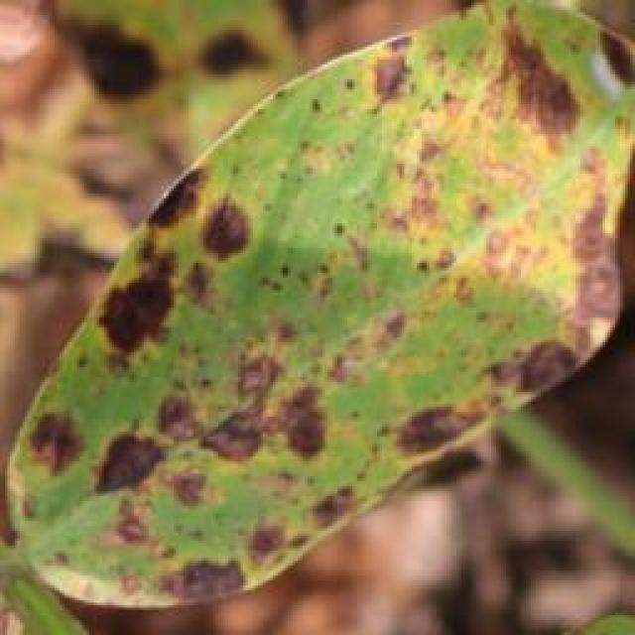
See the image and tell me what type of disease, visible symptoms and possible solution?
Option 1:
The image shows a leaf with brown spots and a yellowish tint, which indicates that the leaf is affected by a disease. The disease appears to be a fungal infection, as the spots are brown and the leaf has a yellowish tint. This could be a result of overwatering, nutrient imbalances, or poor soil quality.
To address this issue, it is essential to identify the specific type of fungal infection and take appropriate measures to prevent its spread. This may include adjusting the watering schedule, ensuring proper nutrient balance, and improving soil quality. Additionally, using organic mulch and maintaining a healthy plant can help prevent the growth of fungi and other pests. If the infection is severe, it may be necessary to remove the affected leaves and prune the plant to prevent the spread of the disease.
Option 2:
The image shows a groundnut plant with several visible symptoms indicative of early leaf spot disease. These symptoms include small, round, yellowish spots on the leaves which are the result of fungal infection. The spots can be seen on both the upper and lower surfaces of the leaves.
The possible solution for this disease would involve preventative measures such as crop rotation to avoid re-infection from previous crops, proper drainage to reduce moisture levels around the plants, and the use of fungicides like thiram or mancozeb to control the spread of the fungus. Additionally, if the disease is already present, regular inspections should be conducted to identify and treat infected areas promptly.

Which option do you prefer?

Sample 154

Ground Truth: early leaf spot
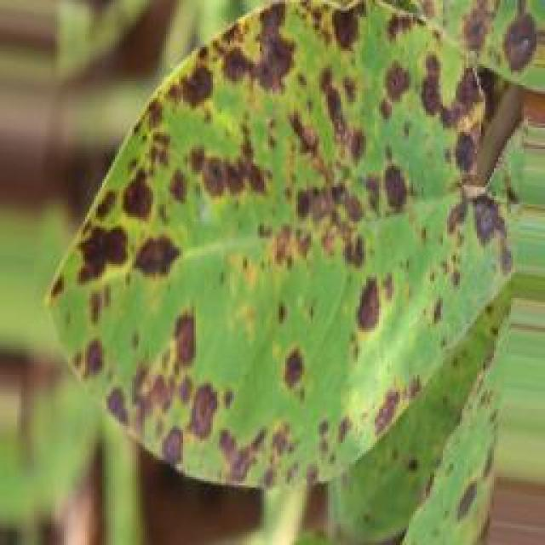
See the image and tell me what type of disease, visible symptoms and possible solution?
Option 1:
The image shows a leaf with numerous small holes, which indicates that it is affected by a disease called "holes in leaves." This disease is caused by insects or fungi that feed on the leaf tissue, leading to the formation of holes. The holes can be circular or irregular in shape, and they can be scattered across the leaf surface.
The visible symptoms of this disease include the presence of small holes in the leaf, which can be brown, black, or yellow, depending on the type of disease. The affected leaves may also become discolored or wilted.
To solve this problem, it is essential to identify the cause of the holes and take appropriate measures to control the disease. If the holes are caused by insects, it is crucial to remove the affected leaves and use insecticides to kill the insects. If the holes are caused by fungi, it is necessary to remove the affected leaves, apply fungicides to the plant, and ensure proper drainage and air circulation to prevent the spread of the fungus. Additionally, maintaining a healthy plant by providing adequate nutrients, water, and sunlight can help prevent the development of diseases and promote overall plant health.
Option 2:
The visible symptoms in the image include small, round spots with a yellow hue and purple or reddish centers on the leaves of the groundnut plant. These spots are indicative of early leaf spot disease, which is caused by fungal pathogens such as Cercospora species.
The possible solution for this disease includes proper crop rotation to avoid re-infection from the same family of plants, and the use of fungicides like chlorothalonil or mancozeb to control the spread of the disease. It's also important to ensure that the plant is well-draining and that there is adequate sunlight for photosynthesis, as these conditions can help prevent the development of the disease.

Which option do you prefer?

Sample 155

Ground Truth: early leaf spot
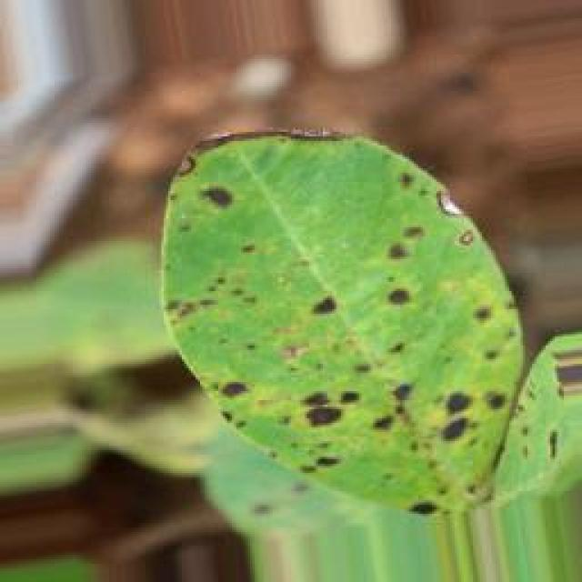
See the image and tell me what type of disease, visible symptoms and possible solution?
Option 1:
The image shows a leaf with a black spot, which could be a sign of a disease or infection. The leaf is green and appears to be affected by the disease. To address this issue, it is essential to identify the specific type of disease or infection affecting the leaf. Once the disease is diagnosed, appropriate measures can be taken to treat or prevent its spread. These measures may include applying appropriate pesticides, removing infected leaves, or providing proper care and nutrients to the plant to help it recover from the disease. It is also important to maintain a healthy environment for the plant, including regular watering, sunlight exposure, and proper spacing, to minimize the risk of diseases and infections.
Option 2:
The visible symptoms in the image include dark spots or lesions on the leaves, which are indicative of early leaf spot disease affecting the groundnut plant. These spots can be circular to irregularly shaped and may have a yellowish hue at their centers. The affected leaves may also show signs of wilting or drooping.
The possible solution for this disease is preventative measures such as using resistant varieties of groundnut plants, practicing crop rotation with other crops to avoid the buildup of fungal spores, and maintaining proper field sanitation by removing debris and controlling weeds. If the disease has already been detected, fungicides can be applied according to the recommended schedule for early leaf spot control in groundnuts. It's important to follow proper application techniques and adhere to any recommended guidelines by local agricultural extension services.

Which option do you prefer?

Sample 156

Ground Truth: early leaf spot
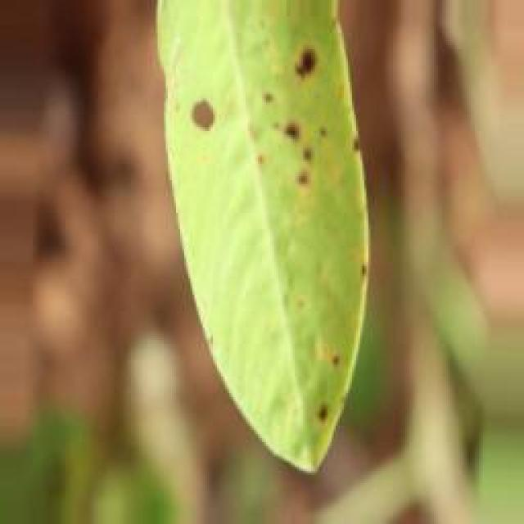
See the image and tell me what type of disease, visible symptoms and possible solution?
Option 1:
The image shows a leaf with a brown spot, which could be a sign of a disease or infection affecting the plant. The brown spot might be a symptom of various diseases or pests, such as fungal infections, bacterial infections, or insect infestations.
To identify the specific disease or pest causing the brown spot, it is essential to observe the surrounding leaves and the overall health of the plant. If the brown spot is widespread or accompanied by other symptoms like wilting, yellowing, or discoloration, it could be a sign of a more severe issue.
To address the problem, it is crucial to identify the cause of the brown spot. If it is a fungal infection, applying a fungicide specifically designed for the type of fungus can help control the spread and prevent further damage. If it is a bacterial infection, using a bactericide or applying a copper-based fungicide can help. If the brown spot is caused by insect infestation, using insecticides or employing natural methods like neem oil can help control the pests.
In addition to treating the disease or pest, it is essential to maintain proper plant care, such as providing adequate water, sunlight, and nutrients, to promote overall health and prevent future issues.
Option 2:
The visible symptoms in the image include dark spots or lesions on the leaves, which are indicative of a disease known as early leaf spot. These spots can vary in size and shape but are typically round to irregularly shaped with a dark center surrounded by a yellow halo. The spots may also have a slightly raised texture compared to the surrounding leaf tissue.
The possible solution for this disease is preventative measures such as using resistant varieties of the plant, practicing crop rotation, and maintaining proper field sanitation by removing debris after harvest. If the disease has already occurred, fungicides can be used to control its spread and minimize damage to the crop. It's important to follow recommended application rates and intervals for these treatments as well as monitoring the health of the plants closely.

Which option do you prefer?

Sample 157

Ground Truth: early leaf spot
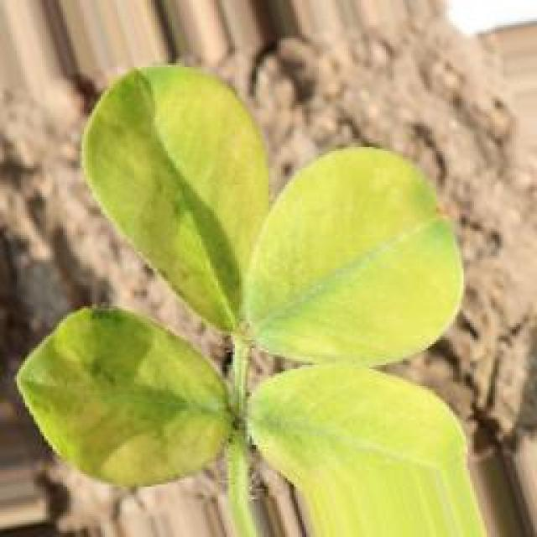
See the image and tell me what type of disease, visible symptoms and possible solution?
Option 1:
The image shows a leaf with yellow spots and brown patches, which indicates that the plant is affected by a disease. The leaf appears to be infected with a fungal disease, as the spots are brown and the leaf is yellow. This could be a result of overwatering, nutrient imbalances, or poor soil quality.
To address this issue, it is essential to identify the specific type of disease and take appropriate measures to prevent its spread. This may involve adjusting the watering schedule, ensuring proper nutrient balance, and improving soil quality. Additionally, using organic or chemical fungicides can help control the spread of the disease and protect the plant from further damage. Regularly inspecting the plant and addressing any signs of infection promptly can also help maintain the health of the plant and prevent further damage.
Option 2:
The visible symptoms in the image include yellowing of the leaves, with brown spots scattered across them. These are indicative of a disease known as early leaf spot, which can affect various plants including groundnuts. The spots are likely to be caused by fungal pathogens that infect the plant's leaves.
The possible solution for this disease would involve preventive measures such as crop rotation to avoid re-infection from previous crops, proper drainage to reduce moisture levels around the plants, and the use of resistant varieties if available. Additionally, fungicides can be applied at an early stage of the disease to control its spread. It's important to monitor the plants regularly and treat them promptly if symptoms appear.

Which option do you prefer?

Sample 158

Ground Truth: early leaf spot
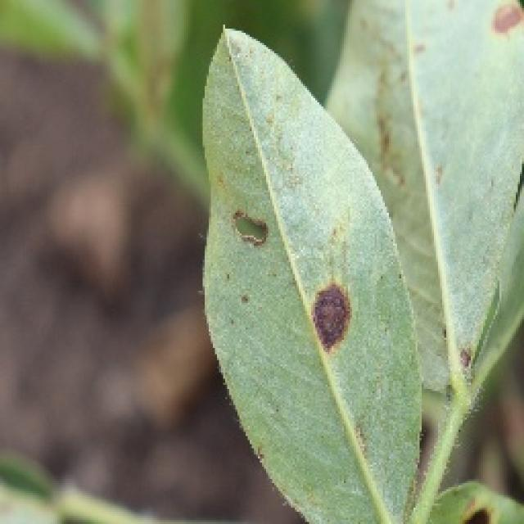
See the image and tell me what type of disease, visible symptoms and possible solution?
Option 1:
The image shows a leaf with brown spots and holes, which indicates that the plant is suffering from a disease called bacterial leaf spot. This disease is caused by bacteria that infect the plant's leaves, leading to the formation of brown spots and holes. The symptoms of bacterial leaf spot include the browning and decay of leaves, which can eventually lead to the death of the affected plant.
A possible solution to this problem is to practice good gardening practices, such as regular pruning, removing infected leaves, and ensuring proper drainage to prevent the spread of the disease. Additionally, using organic fertilizers and avoiding the use of excessive nitrogen-rich fertilizers can help in preventing the growth of bacteria that cause the disease. It is also essential to maintain a healthy plant by providing proper care, including adequate watering, sunlight, and nutrients.
Option 2:
The visible symptoms in the image include small, dark spots scattered across the leaves of the groundnut plant. These spots are indicative of a disease called early leaf spot, which is caused by fungal pathogens such as Cercospora spp. or Septoria spp. The possible solution for this disease would be to apply fungicides like chlorothalonil or mancozeb, following the recommended dosage and application schedule according to local agricultural practices. Additionally, proper crop rotation and maintaining good field hygiene can help prevent the spread of the disease.

Which option do you prefer?

Sample 159

Ground Truth: early leaf spot
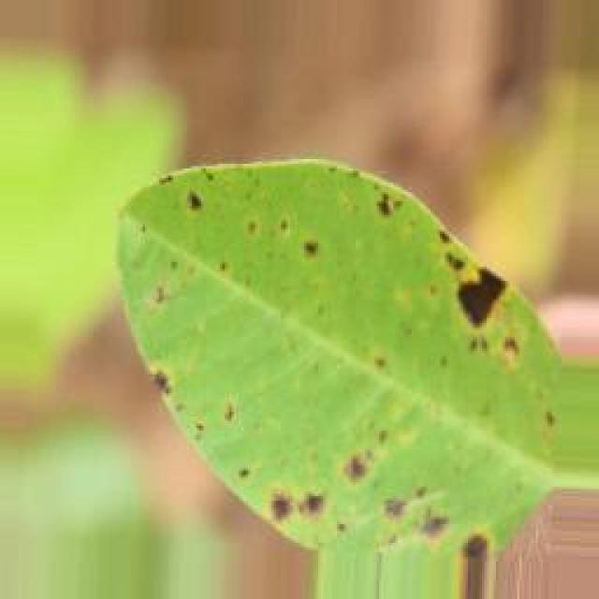
See the image and tell me what type of disease, visible symptoms and possible solution?
Option 1:
The image shows a leaf with brown spots and holes, which indicates that the plant is suffering from a disease called bacterial spot disease. This disease is caused by bacteria that infect the plant's leaves, leading to the formation of brown spots and holes. The symptoms of bacterial spot disease can vary depending on the type of bacteria and the plant species, but they generally involve the formation of lesions or spots on the leaves.
A possible solution to this problem is to practice good gardening practices, such as regular pruning, removing infected leaves, and ensuring proper drainage to prevent the growth of bacteria. Additionally, using organic fertilizers and pest control methods can help maintain a healthy plant and reduce the risk of bacterial spot disease. If the disease is severe, it may be necessary to consult a plant pathologist or a gardening expert to determine the best course of action for treating the affected plant.
Option 2:
The visible symptoms in the image include small, round spots with a yellowish center and a purple or brown border on the leaves of the groundnut plant. These spots are indicative of early leaf spot disease, which is caused by fungal pathogens such as Cercospora species.
The possible solution for this disease would involve preventative measures like crop rotation to avoid re-infection from previous crops, proper drainage to reduce moisture levels around the plants, and the use of fungicides like chlorothalonil or mancozeb to control the spread of the pathogen. Additionally, maintaining a healthy plant with adequate nutrition and removing infected leaves can help prevent further damage from the disease.

Which option do you prefer?

Sample 160

Ground Truth: early leaf spot
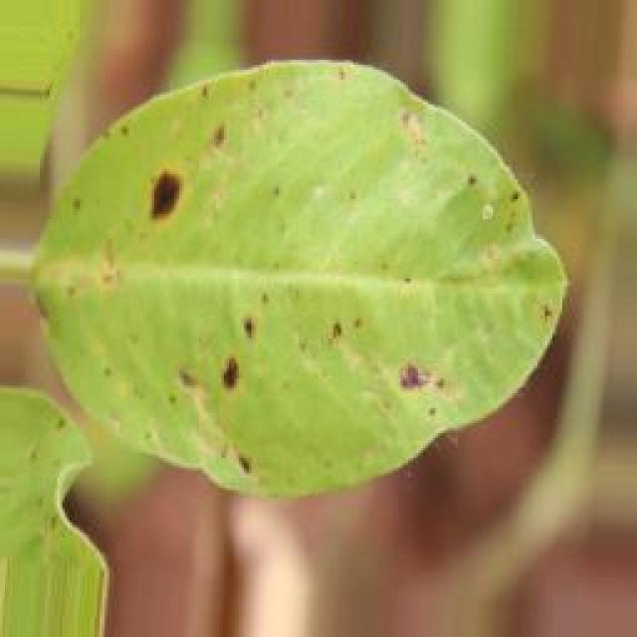
See the image and tell me what type of disease, visible symptoms and possible solution?
Option 1:
The image shows a leaf with brown spots and holes, which indicates that the plant is suffering from a disease called bacterial leaf spot. This disease is caused by bacteria that infect the plant's leaves, leading to the formation of brown spots and holes. The plant's leaves may also become discolored and wilted.
To address this issue, it is essential to identify the specific bacteria causing the disease and apply appropriate treatments. Some possible solutions include:
1. Practicing crop rotation: Rotating the affected plants with healthy plants can help prevent the spread of the disease.
2. Implementing proper irrigation: Ensuring that the plants receive adequate water without over-saturating the soil can help prevent the growth of bacteria.
3. Using organic or chemical pesticides: Depending on the bacteria species, using appropriate pesticides can help control the disease.
4. Improving soil quality: Adding organic matter to the soil can improve its structure and promote healthy plant growth, which can help prevent the disease from spreading.
5. Removing infected plants: Removing infected plants and disposing of them properly can help prevent the spread of the disease to healthy plants.
It is crucial to consult with a plant pathologist or an agricultural expert to determine the best course of action for treating the disease and preventing its recurrence.
Option 2:
The image shows a groundnut plant with early leaf spot disease. Visible symptoms include small, brown spots scattered across the leaves. These spots are indicative of the fungal infection that causes this disease.
The possible solution for managing this disease includes proper crop rotation to avoid re-infection from previous crops, removing and destroying affected plant parts, and applying fungicides such as mancozeb, chlorothalonil, or wettable sulphur according to local recommendations. It's important to follow proper application techniques and repeat the treatment if necessary. Additionally, maintaining good field hygiene and avoiding overcrowding can help prevent the spread of the disease.

Which option do you prefer?

Sample 161

Ground Truth: rust
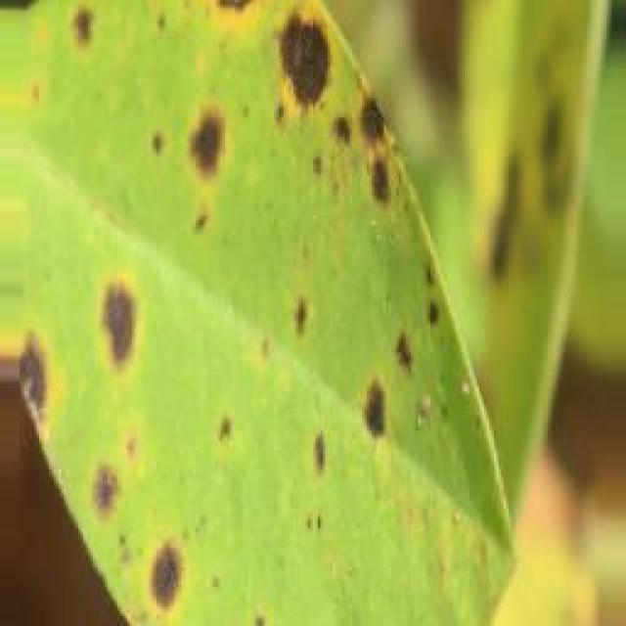
See the image and tell me what type of disease, visible symptoms and possible solution?
Option 1:
The image shows a leaf with brown spots and a yellowish-green color, which indicates that the leaf is affected by a disease. The brown spots are a symptom of the disease, and the yellowish-green color could be due to the presence of the disease or a result of the leaf's natural aging process.
The disease could be a fungal infection, bacterial infection, or a viral infection, depending on the specific symptoms and appearance of the leaf. To address the issue, it is essential to identify the type of disease and take appropriate measures to treat it. This may involve using fungicides, bactericides, or antiviral agents, depending on the diagnosis. Additionally, proper care and maintenance of the plant, such as regular pruning, watering, and pest control, can help prevent the spread of the disease and promote healthy growth.
Option 2:
The image shows a groundnut plant with visible symptoms of rust disease. The most noticeable signs are the reddish-brown spots or pustules on the leaves, which are characteristic of rust diseases. These spores can spread to other plants and cause damage to the foliage, leading to reduced photosynthesis and overall plant health.
To manage this disease, it is important to practice proper crop rotation, removing infected plants, and controlling weeds that may harbor the fungus. Additionally, using resistant varieties of groundnut plants can help prevent the spread of rust. If necessary, fungicides can be applied according to local recommendations for effective control.

Which option do you prefer?

Sample 162

Ground Truth: rust
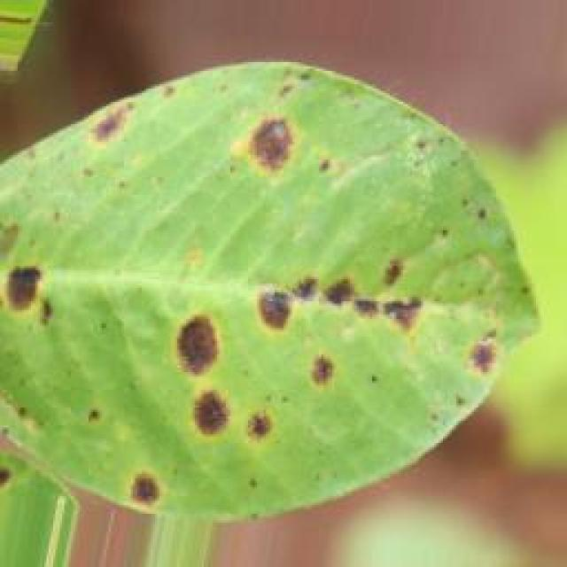
See the image and tell me what type of disease, visible symptoms and possible solution?
Option 1:
The image shows a leaf with brown spots and bumps, which indicates that the plant is affected by a disease. The disease appears to be affecting the plant's growth and overall health.
The visible symptoms of the disease include brown spots and bumps on the leaf, which could be a sign of fungal infection or other plant diseases. The presence of these spots and bumps on the leaf suggests that the plant is experiencing stress or damage, which can be caused by various factors such as overwatering, underwatering, nutrient deficiencies, or exposure to extreme temperatures.
To address this issue, it is essential to identify the specific disease causing the symptoms and take appropriate measures to treat it. This may involve using fungicides, applying appropriate nutrients, or adjusting the plant's watering schedule to ensure that it receives the right amount of water. Additionally, it is crucial to maintain a healthy environment for the plant by providing proper sunlight, temperature, and humidity conditions.
Option 2:
The visible symptoms in the image include dark brown or black spots on the leaves, which are indicative of a fungal disease known as rust. These spots can be seen on the upper surface of the leaf and may also appear on the underside. The affected areas may become deformed or die, leading to reduced plant growth and yield.
A possible solution for this disease would involve the use of fungicides such as mancozeb, chlorothalonil, or wettable sulphur. These treatments can help prevent the spread of the fungus and protect the plant from further damage. Additionally, proper crop rotation, removing infected plant debris, and maintaining good field hygiene can also help in managing this disease.

Which option do you prefer?

Sample 163

Ground Truth: rust
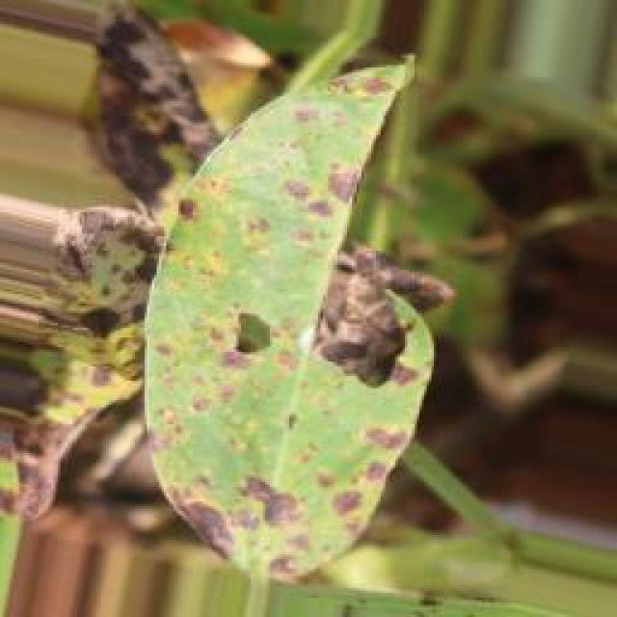
See the image and tell me what type of disease, visible symptoms and possible solution?
Option 1:
The image shows a leaf with brown spots and a yellowish-green color, which indicates that it is affected by a disease. The leaf appears to be infected with a fungal disease, as suggested by the presence of brown spots and the overall yellowish-green color.
To address this issue, it is essential to identify the specific type of fungal disease affecting the leaf and take appropriate measures to prevent its spread. This may involve removing infected leaves and branches, ensuring proper air circulation, and maintaining a healthy plant by providing adequate nutrients, water, and sunlight. Additionally, using organic or chemical fungicides can help protect the plant from further infections. It is also important to practice good gardening practices, such as regular pruning and removing dead or damaged plant parts, to prevent the spread of diseases.
Option 2:
The visible symptoms in the image include brown spots and lesions on the leaves of the groundnut plant. These are indicative of a fungal disease, likely rust given the characteristic orange or reddish-brown coloration of the spots. The affected leaves may also show signs of wilting or reduced vigor.
A possible solution for this issue would be to apply fungicides such as mancozeb, chlorothalonil, or wettable sulphur to protect the plant from further infection. It's important to follow proper application rates and repeat treatments if necessary, as well as practicing good crop rotation and maintaining a healthy environment for the groundnut plants to minimize disease pressure.

Which option do you prefer?

Sample 164

Ground Truth: rust
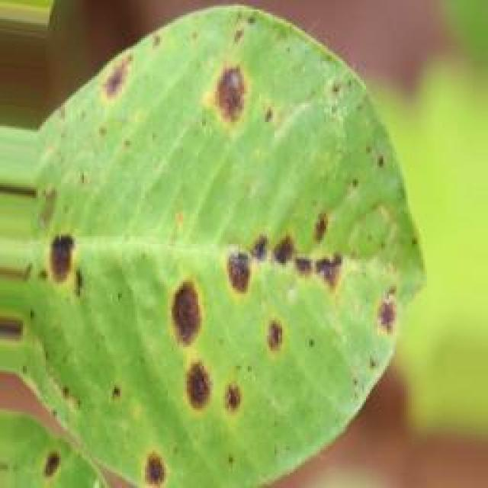
See the image and tell me what type of disease, visible symptoms and possible solution?
Option 1:
The image shows a leaf with brown spots and a hole in the middle, which indicates that the leaf is affected by a disease. The disease appears to be a fungal infection, as the spots are brown and the leaf has a hole in the center. This type of infection can be caused by various fungi, such as fungi from the genus Rhizoctonia, which can affect a wide range of plants, including leafy greens and ornamental plants.
The visible symptoms of the disease include brown spots on the leaf and a hole in the center. These symptoms can lead to the leaf's eventual death and the spread of the disease to other plants in the same area.
A possible solution to this problem is to practice good gardening practices, such as regular watering, proper spacing of plants, and removing infected leaves and plants promptly. Additionally, using organic mulch and compost can help improve soil quality and promote healthy plant growth. If the disease is severe, it may be necessary to consult a plant pathologist or a local agricultural extension service for further guidance on managing the disease and preventing its spread.
Option 2:
The visible symptoms in the image include yellowing of the leaf, which indicates chlorosis, and the presence of numerous small, reddish-brown spots on the surface of the leaf. These spots are characteristic of rust diseases, which affect plants by causing the formation of pustules or spores on the leaves and stems.
The possible solution for this disease would be to apply fungicides such as mancozeb, chlorothalonil, or wettable sulphur to control the spread of the rust pathogen. Additionally, proper crop rotation and removal of infected plant debris can help prevent the recurrence of the disease in future crops.

Which option do you prefer?

Sample 165

Ground Truth: rust
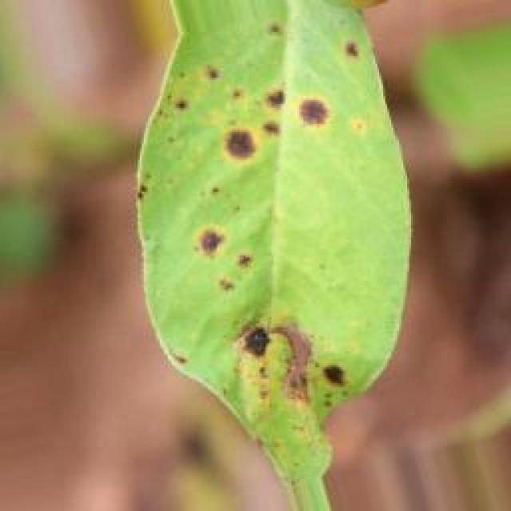
See the image and tell me what type of disease, visible symptoms and possible solution?
Option 1:
The image shows a leaf with brown spots and a yellowish-green color, which indicates that it might be affected by a fungal disease. The spots are irregularly shaped and can be seen on the surface of the leaf.
The visible symptoms of the disease include the brown spots on the leaf, which are likely caused by the fungus spreading through the plant's tissues. This can lead to the degradation of the leaf's structure and eventually result in the leaf's death.
A possible solution to this problem is to practice good gardening practices, such as regular pruning, removing infected leaves, and ensuring proper drainage and air circulation around the plant. Additionally, using organic or chemical fungicides can help prevent the spread of the disease and protect the plant from further damage. It is essential to identify the specific type of fungus causing the disease and choose the appropriate treatment method to ensure the health and longevity of the plant.
Option 2:
The visible symptoms in the image include brown spots or lesions on the leaves of the groundnut plant. These spots are indicative of a fungal disease known as rust, which affects plants by causing small, reddish-brown pustules on the underside of leaves and stems. The affected areas can become necrotic and die, leading to reduced plant growth and yield.
To manage this disease, it is important to practice proper crop rotation, remove infected plant debris, and apply fungicides such as mancozeb, chlorothalonil, or wettable sulphur according to local recommendations. Regular inspections should be conducted to identify and treat the disease early on. Additionally, maintaining good field hygiene and avoiding overcrowding of plants can help prevent the spread of rust.

Which option do you prefer?

Sample 166

Ground Truth: rust
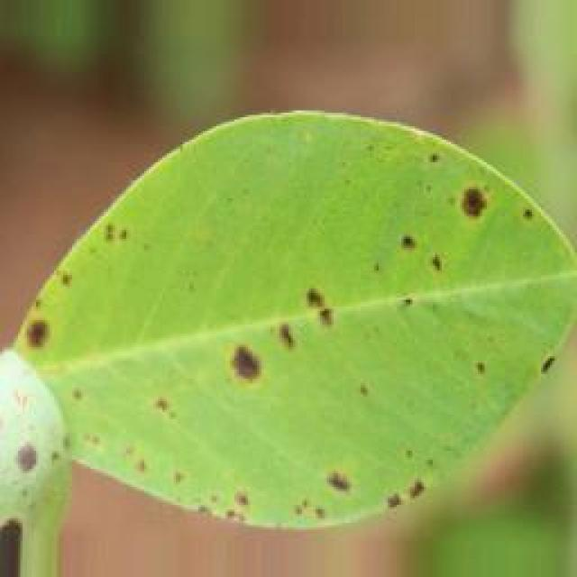
See the image and tell me what type of disease, visible symptoms and possible solution?
Option 1:
The image shows a leaf with brown spots and a yellowish-green color, which indicates that it is affected by a disease. The leaf appears to be infected with a fungal disease, as suggested by the presence of brown spots and the overall yellowish-green color.
To address this issue, it is essential to identify the specific type of fungal disease affecting the leaf and take appropriate measures to prevent its spread. This may involve removing the affected leaves and disposing of them properly, ensuring that the plant is not overcrowded, and providing proper care, such as regular watering and fertilization, to promote healthy growth. Additionally, it is important to maintain a clean and well-ventilated environment to minimize the risk of fungal infections. If the disease is severe or widespread, it may be necessary to consult a professional to determine the best course of action for treating and preventing further damage.
Option 2:
The visible symptoms in the image include yellowing leaves with brown spots, which are indicative of a fungal disease known as rust. This type of disease affects plants by causing small pustules or spores to form on the underside of leaves and stems. The affected areas become deformed and can eventually lead to leaf drop and reduced plant growth.
A possible solution for this issue would be to apply fungicides such as mancozeb, chlorothalonil, or wettable sulphur to the groundnut plants. These treatments can help prevent the spread of the disease and protect the plant from further damage. Additionally, proper crop rotation and maintaining good field hygiene can also help in managing this type of disease.

Which option do you prefer?

Sample 167

Ground Truth: rust
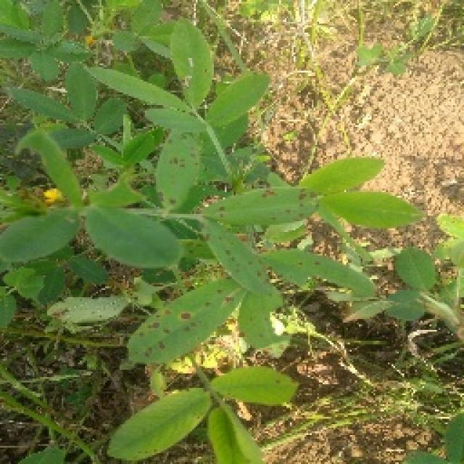
See the image and tell me what type of disease, visible symptoms and possible solution?
Option 1:
The image shows a leaf with brown spots and a yellowish-green color, which indicates that it is affected by a disease. The leaf appears to be infected with a fungal disease, as suggested by the presence of brown spots and the overall yellowish-green color.
To address this issue, it is essential to identify the specific type of fungal disease affecting the leaf and take appropriate measures to prevent its spread. This may involve removing infected leaves and branches, ensuring proper drainage and air circulation, and applying a suitable fungicide to the affected plant. Additionally, maintaining a healthy plant by providing adequate nutrients, water, and sunlight can help prevent the development of diseases and promote overall plant health.
Option 2:
The visible symptoms in the image include brown spots and yellowing on the leaves of the groundnut plant, which are indicative of a rust disease. Rust diseases can be caused by various fungi that infect plants. The spots are likely to be due to the presence of rust pustules on the underside of the leaves.
The possible solution for this type of disease would involve preventive measures such as using resistant varieties of groundnut plants, practicing crop rotation with other crops to avoid the spread of the fungus, and maintaining good field hygiene by removing volunteer plants and debris after harvest. If the disease has already occurred, fungicides can be used for control, although their use should be carefully considered due to potential environmental impacts.

Which option do you prefer?

Sample 168

Ground Truth: rust
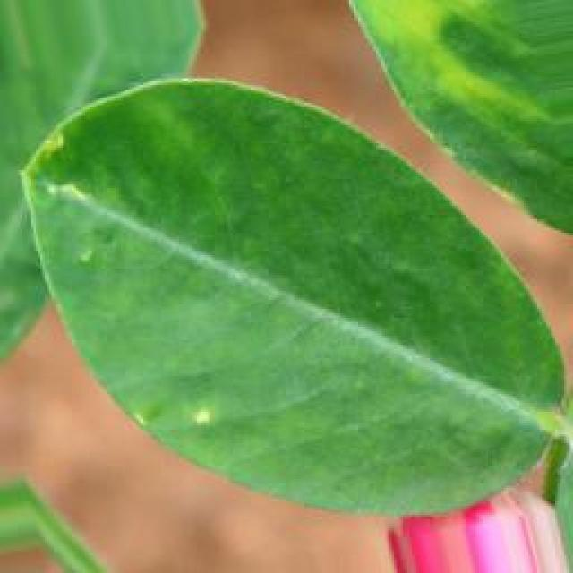
See the image and tell me what type of disease, visible symptoms and possible solution?
Option 1:
The image shows a leaf with brown spots and a yellowish-green color, which indicates that it might be affected by a fungal disease. The spots are irregularly shaped and can be seen on the surface of the leaf.
The possible solution to this issue is to practice good gardening practices, such as regular pruning, removing infected leaves, and ensuring proper drainage and air circulation around the plant. Additionally, using organic or chemical fungicides can help prevent the spread of the disease and protect the plant from further damage. It is essential to identify the specific type of fungal disease and consult with a local nursery or gardening expert to determine the most effective treatment method.
Option 2:
The visible symptoms in the image include brown spots and patches on the leaves of the groundnut plant, which are indicative of a rust disease. Rust diseases are caused by fungi that infect plants, leading to the formation of reddish-brown pustules on the leaves and stems.
The possible solution for this disease would be to implement preventive measures such as using resistant varieties of groundnut plants, practicing crop rotation with other crops, and maintaining good field hygiene by removing debris after harvest. If the disease has already occurred, fungicides can be sprayed on the affected plants to control the spread of the rust fungus. It's important to follow recommended application rates and intervals for these treatments to minimize environmental impact while still protecting the crop.

Which option do you prefer?

Sample 169

Ground Truth: rust
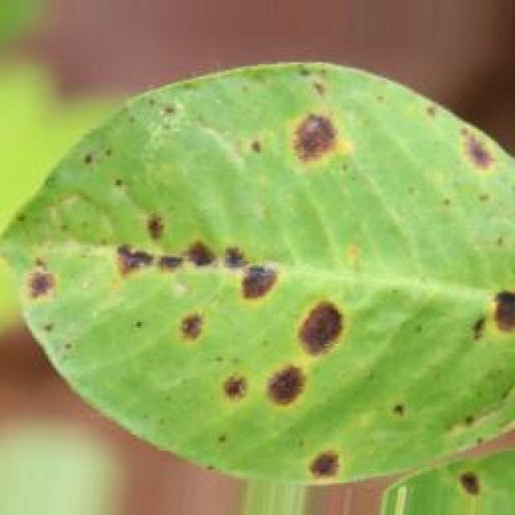
See the image and tell me what type of disease, visible symptoms and possible solution?
Option 1:
The image shows a leaf with brown spots and a yellowish-green color, which indicates that it is affected by a fungal disease. The spots are likely caused by a fungus that has infected the leaf, leading to the discoloration and potential damage to the plant.
To address this issue, it is essential to identify the specific type of fungus causing the disease and take appropriate measures to prevent its spread. This may include removing infected leaves, practicing proper plant care, and using fungicides if the disease is severe or widespread. Additionally, it is important to maintain a healthy plant environment by ensuring adequate sunlight, water, and nutrient availability, as well as proper spacing and air circulation to minimize the risk of fungal infections.
Option 2:
The visible symptoms in the image include brown spots and patches on the leaves of the groundnut plant, which are indicative of a rust disease. Rust diseases can be caused by various fungi that affect plants. The affected areas appear to be necrotic (dead) tissue, which is characteristic of rust diseases.
A possible solution for this issue would involve preventative measures such as using resistant varieties of groundnut plants, practicing crop rotation to avoid re-infection from previous crops, and maintaining good field hygiene by removing volunteer plants and debris after harvest. If the disease has already occurred, fungicides can be used for control, although this is generally not recommended due to environmental concerns and the potential for increased resistance in the pathogen.

Which option do you prefer?

Sample 170

Ground Truth: rust
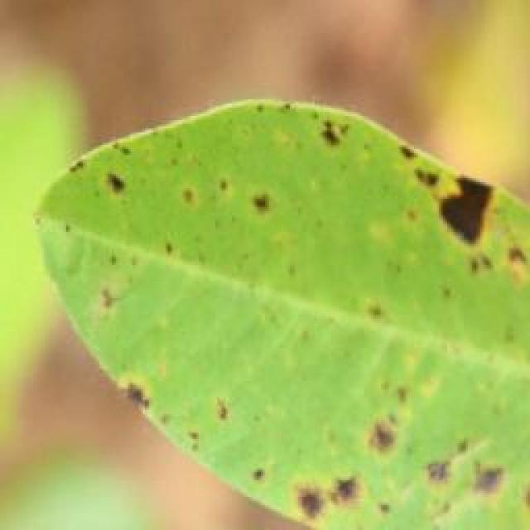
See the image and tell me what type of disease, visible symptoms and possible solution?
Option 1:
The image shows a leaf with brown spots and bumps, which could be indicative of a fungal infection or a bacterial disease. The leaf appears to be affected by a disease, causing it to lose its green color and develop brown spots.
To address this issue, it is essential to identify the specific type of disease affecting the leaf. Once the disease is diagnosed, appropriate treatment measures can be taken. For fungal infections, it is crucial to remove infected leaves and branches, maintain proper plant spacing, and ensure proper drainage to prevent the spread of the disease. For bacterial diseases, it is important to practice good hygiene, such as washing hands and tools before handling the plant, and using organic or chemical-free fertilizers to prevent the spread of the disease.
In addition, it is essential to monitor the plant's health regularly and address any signs of disease promptly to prevent further damage and promote the plant's overall well-being.
Option 2:
The image shows a leaf from a groundnut plant with several small, round, reddish-brown spots scattered across its surface. These spots are indicative of a fungal infection known as rust. The visible symptoms include the presence of rust pustules on the underside of the leaf and possibly on other parts of the plant as well.
The possible solution for this disease would be to apply fungicides such as mancozeb, chlorothalonil, or wettable sulphur to control the spread of the fungus. It's also important to practice good crop rotation and ensure proper drainage and air circulation around the plants to minimize humidity levels that can contribute to the development of rust.

Which option do you prefer?

Sample 171

Ground Truth: rust
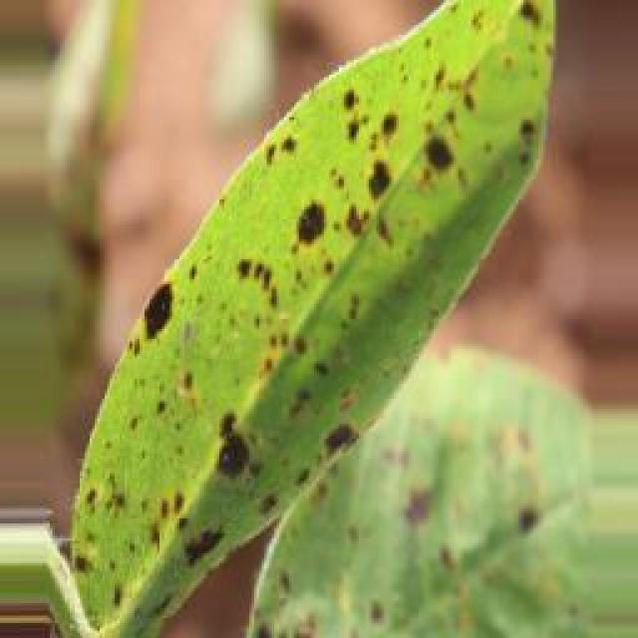
See the image and tell me what type of disease, visible symptoms and possible solution?
Option 1:
The image shows a leaf with a brown spot, which could be a sign of a disease or infection. The leaf appears to be affected by a fungal infection, as indicated by the presence of brown spots. To address this issue, it is essential to identify the specific type of fungus causing the infection and apply appropriate treatment methods. This may involve using fungicides, pruning affected branches, or removing the affected leaves to prevent the spread of the disease. Additionally, maintaining proper plant care, such as regular watering, pest control, and ensuring adequate sunlight, can help prevent the development of fungal infections in the future.
Option 2:
The visible symptoms in the image include brown spots and yellowing on the leaves of the groundnut plant, which are indicative of a rust disease. Rust diseases are caused by fungi that infect plants and can lead to significant damage if left untreated.
The possible solution for this type of disease would be to apply fungicides such as mancozeb, chlorothalonil, or wettable sulphur to the affected plants. These treatments can help prevent the spread of the rust fungus and reduce its impact on the plant's health. Additionally, proper crop rotation and maintaining a healthy soil environment can also help in preventing such diseases from occurring in the future.

Which option do you prefer?

Sample 172

Ground Truth: rust
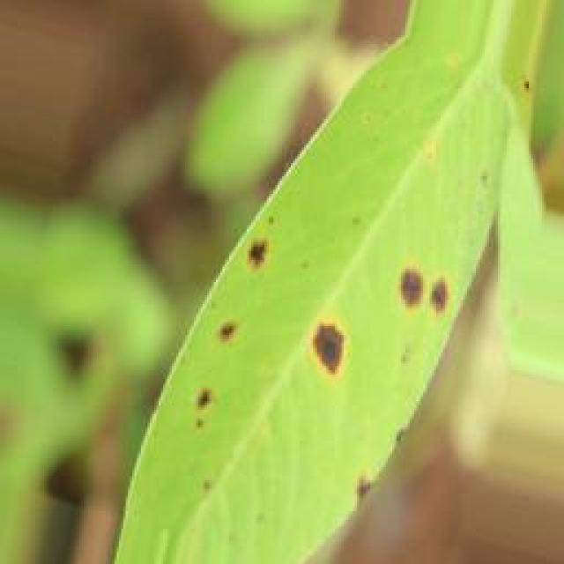
See the image and tell me what type of disease, visible symptoms and possible solution?
Option 1:
The image shows a leaf with brown spots and a yellowish-green color, which indicates that it is affected by a disease. The leaf appears to be infected with a fungal disease, as suggested by the presence of brown spots and the overall yellowish-green color.
To address this issue, it is essential to identify the specific type of fungal disease affecting the leaf and take appropriate measures to prevent its spread. This may involve removing infected leaves and branches, ensuring proper air circulation, and maintaining a healthy plant by providing adequate nutrients, water, and sunlight. Additionally, using organic or chemical fungicides can help protect the plant from further infections. It is also important to practice good gardening practices, such as regular pruning and removing dead or damaged plant parts, to minimize the risk of fungal diseases.
Option 2:
The visible symptoms in the image include brown spots and yellowing on the leaves of the groundnut plant. These are indicative of a fungal disease known as rust, which affects plants by causing small orange or red pustules to form on the underside of leaves. The affected leaves may also curl upwards and become deformed.
A possible solution for this disease would be to apply fungicides such as mancozeb, chlorothalonil, or wettable sulphur to the plant, following the recommended dosage according to the package instructions. It's important to monitor the plants regularly and reapply the fungicide if necessary, as well as practicing good crop rotation and maintaining a healthy environment for the plants to minimize the risk of disease outbreaks.

Which option do you prefer?

Sample 173

Ground Truth: rust
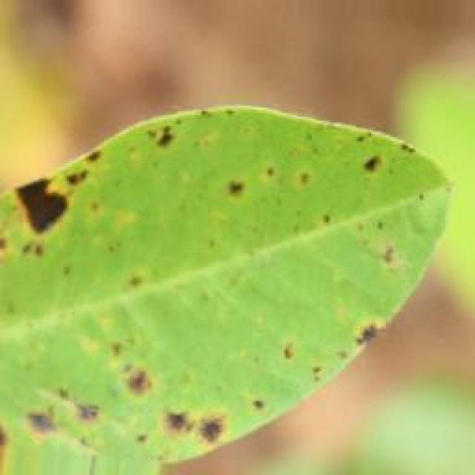
See the image and tell me what type of disease, visible symptoms and possible solution?
Option 1:
The image shows a leaf with brown spots and black dots, which could be indicative of a fungal infection or a bacterial disease. The spots and dots are spread across the leaf, and the leaf appears to be curled up.
To address this issue, it is essential to identify the specific type of disease causing the spots and dots. Once the disease is diagnosed, appropriate treatment measures can be taken to prevent further damage to the plant and to promote its recovery. This may involve using fungicides or bactericides, removing infected leaves, and ensuring proper care and maintenance of the plant. Additionally, it is crucial to practice good gardening practices, such as regular pruning, proper watering, and providing adequate sunlight, to help prevent the spread of diseases and maintain the health of the plant.
Option 2:
The visible symptoms in the image include dark brown or black spots on the leaves, which are characteristic of a fungal disease known as rust. These spots can be seen as circular or irregularly shaped lesions that may have a yellow halo around them. The affected leaves appear to be discolored and may eventually fall off the plant.
The possible solution for this disease would involve preventative measures such as using resistant varieties of groundnut plants, practicing crop rotation with other crops to avoid the spread of the fungus, and maintaining good field hygiene by removing debris after harvest. If the infection is already present, fungicides can be applied according to local recommendations to control the disease. It's important to follow proper application techniques and to repeat treatments if necessary.

Which option do you prefer?

Sample 174

Ground Truth: rust
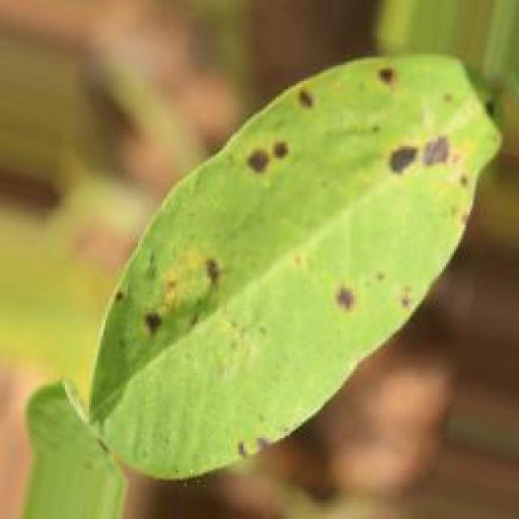
See the image and tell me what type of disease, visible symptoms and possible solution?
Option 1:
The image shows a leaf with brown spots and holes, which indicates that the plant is suffering from a disease called bacterial soft rot. This disease is caused by bacteria that enter the plant through wounds or natural openings and cause the decay of the plant tissue. The visible symptoms include brown spots, holes, and a general wilting of the leaf.
A possible solution to this problem is to remove the affected leaves and branches, as well as any infected plant parts, to prevent the spread of the disease. Additionally, it is essential to practice proper plant care, such as regular watering, adequate sunlight, and proper soil drainage, to maintain the health of the plant and prevent the development of diseases. If the disease is severe, it may be necessary to consult a plant pathologist or a gardening expert to determine the best course of action for treating the plant and preventing further damage.
Option 2:
The visible symptoms in the image include brown spots and patches on the leaves of the groundnut plant, which are indicative of a fungal disease known as rust. Rust is caused by various species of fungi that infect plants, causing them to develop small pustules or spores on their surfaces. These spores can spread to other plants and cause further damage.
The possible solution for this disease would involve preventative measures such as using resistant varieties of groundnut plants, practicing crop rotation with other crops to avoid the spread of fungi, and maintaining proper field sanitation by removing debris and keeping weeds to a minimum. Additionally, if the infection is already present, fungicides can be applied according to the recommended schedule for the specific type of rust affecting the plant. It's important to consult with an agricultural expert for accurate identification and appropriate treatment options.

Which option do you prefer?

Sample 175

Ground Truth: rust
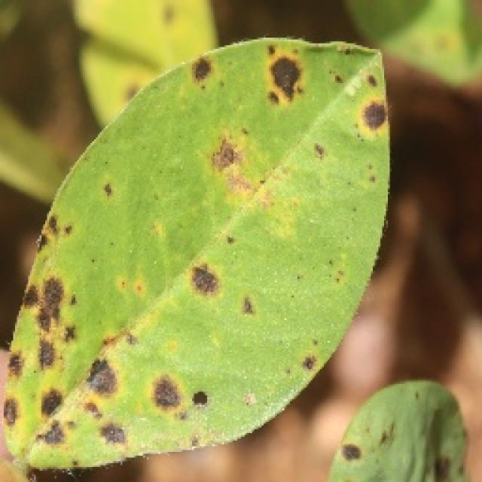
See the image and tell me what type of disease, visible symptoms and possible solution?
Option 1:
The image shows a leaf with brown spots and a yellowish color, which indicates that the leaf is affected by a disease. The spots are likely caused by a fungal infection, which can be identified by the presence of brown or black spots on the leaf.
To address this issue, it is essential to identify the specific type of fungal infection affecting the leaf and take appropriate measures to prevent its spread. This may involve removing infected leaves, practicing proper plant care, and using fungicides to control the growth of the fungus. Additionally, it is important to maintain a healthy plant by providing adequate nutrients, water, and sunlight, as well as ensuring proper spacing and air circulation to minimize the risk of infection.
Option 2:
The leaf in the image shows signs of a disease known as rust, which affects plants by causing small, reddish-brown spots on the leaves. These spots are caused by the fungus Puccinia spp., which infects the plant through its natural openings like stomata. The visible symptoms include the presence of these spots and possibly some discoloration or chlorosis (yellowing) of the leaf tissue around the spots.
A possible solution for this disease would be to apply fungicides such as mancozeb, chlorothalonil, or wettable sulphur to protect the plant from further infection. It's also important to practice good crop management practices like proper irrigation, fertilization, and weed control to minimize stress on the plant and reduce susceptibility to diseases like rust.

Which option do you prefer?

Sample 176

Ground Truth: rust
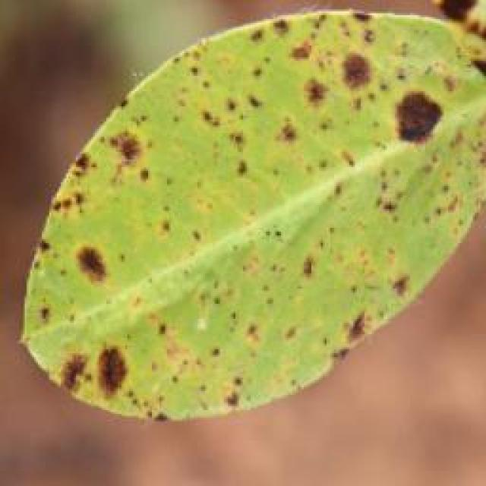
See the image and tell me what type of disease, visible symptoms and possible solution?
Option 1:
The image shows a leaf with brown spots and purple dots, which could indicate a disease or infection affecting the plant. The presence of these spots and dots suggests that the plant might be experiencing stress or damage due to various factors such as pests, fungi, or nutrient deficiencies.
To address this issue, it is essential to identify the cause of the problem and take appropriate measures to treat or prevent it. This may involve removing affected leaves, applying appropriate pesticides or fungicides, or providing the plant with the necessary nutrients to promote healthy growth. Additionally, regular monitoring of the plant's health and early detection of any signs of disease can help prevent further damage and ensure the plant's overall well-being.
Option 2:
The visible symptoms in the image include brown spots and discoloration on the leaves of the groundnut plant. These are indicative of a rust disease, which can affect plants by causing the formation of reddish-brown pustules on the leaves, stems, and pods. The rust fungus feeds on the plant's tissue, leading to the discoloration and eventual death of the affected parts.
To manage this disease, it is important to practice proper crop rotation, removing infected plants, and using resistant varieties if available. Additionally, controlling weeds that can host the rust fungus and maintaining a healthy soil with organic matter can help prevent the spread of the disease. If necessary, fungicides can also be used to control the rust infection.

Which option do you prefer?

Sample 177

Ground Truth: rust
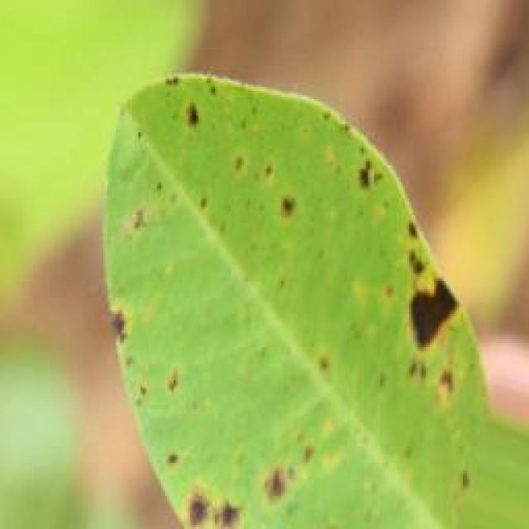
See the image and tell me what type of disease, visible symptoms and possible solution?
Option 1:
The image shows a leaf with brown spots and a yellowish-green color, which indicates that it might be affected by a fungal disease. The leaf appears to be infected with a fungus, which can cause the spots and discoloration.
To address this issue, it is essential to identify the specific type of fungus causing the infection and take appropriate measures to prevent its spread. This may involve removing infected leaves and branches, ensuring proper air circulation, and maintaining a healthy plant by providing adequate nutrients and water. Additionally, using organic or chemical fungicides can help protect the plant from further infections. It is also important to practice good gardening practices, such as regular pruning and removing dead or infected plant parts, to prevent the spread of fungal diseases.
Option 2:
The visible symptoms in the image include brown spots and patches on the leaves of the groundnut plant, which are indicative of a rust disease. Rust diseases can affect various plants, including groundnuts. These diseases are caused by fungi that infect the leaves and stems of plants, leading to discoloration and eventual decay.
The possible solution for this type of disease would involve preventative measures such as using resistant varieties of groundnut plants, practicing crop rotation to avoid re-infection from previous crops, and maintaining good field hygiene by removing debris after harvest. If the disease has already occurred, fungicides can be used to control its spread and minimize damage to the plant. It's important to consult with a local agricultural extension service for specific recommendations tailored to the region and the type of groundnut being grown.

Which option do you prefer?

Sample 178

Ground Truth: rust
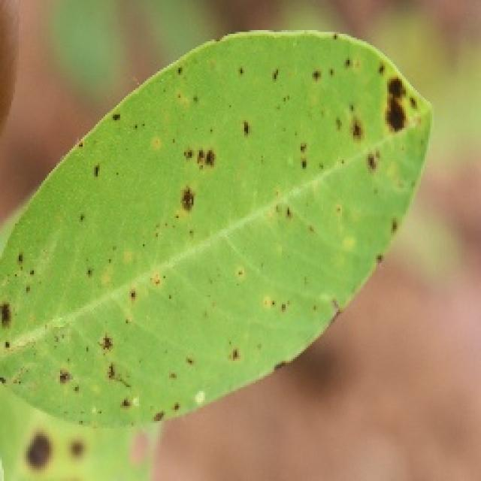
See the image and tell me what type of disease, visible symptoms and possible solution?
Option 1:
The image shows a leaf with brown spots and yellowish-brown patches, which indicates that the leaf is affected by a fungal disease. The spots and patches are likely caused by a fungus that has infected the leaf, leading to the discoloration and potential damage to the plant.
To address this issue, it is essential to identify the specific type of fungal disease affecting the plant and take appropriate measures to prevent its spread. This may include removing infected leaves, practicing proper plant care, and using fungicides if the disease is severe. Additionally, it is important to maintain a healthy plant environment by ensuring adequate sunlight, water, and nutrient availability, as well as proper spacing and air circulation to minimize the risk of fungal infections.
Option 2:
The visible symptoms in the image include brown spots and patches on the leaves, which are characteristic of a fungal disease known as rust. This disease affects plants by causing small yellow or orange pustules to form on the underside of leaves, petioles, pegs, and stems. The spores of the fungus can spread through wind and water splashes, infecting healthy tissue and causing it to die.
A possible solution for this disease would be to use fungicides such as mancozeb, chlorothalonil, or wettable sulphur, which are commonly used to control rust infections. It is also important to practice good agricultural practices like crop rotation, removing debris after harvest, and maintaining a healthy soil environment to prevent the spread of the disease.

Which option do you prefer?

Sample 179

Ground Truth: rust
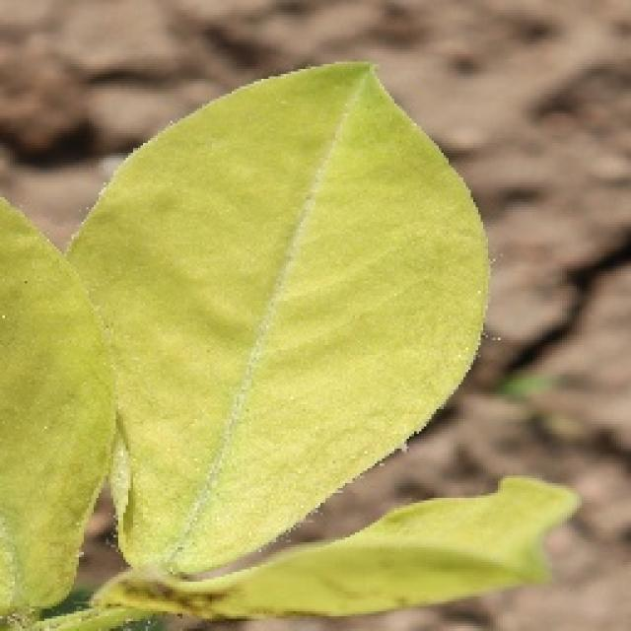
See the image and tell me what type of disease, visible symptoms and possible solution?
Option 1:
The image shows a leaf with brown spots and a yellowish-green color, which indicates that it is affected by a disease. The leaf appears to be infected with a fungal disease, as suggested by the presence of brown spots and the overall yellowish-green color.
The visible symptoms of the disease include the brown spots and the yellowish-green coloration of the leaf. These symptoms suggest that the plant is experiencing stress or damage due to the fungal infection.
A possible solution to this problem is to practice good gardening practices, such as regular pruning, removing infected leaves, and ensuring proper drainage and air circulation around the plant. Additionally, using organic or chemical fungicides can help prevent the spread of the disease and protect the plant from further damage. It is essential to identify the specific type of fungal disease and consult with a plant expert or a local nursery for the best course of action.
Option 2:
The visible symptoms in the image include brown spots and patches on the leaves, which are indicative of a fungal disease known as rust. This disease affects plants by causing small pustules or spores to develop on the underside of leaves, stems, and pods. The affected areas turn yellow, dry out, and eventually die.
A possible solution for managing this disease would be to use fungicides such as mancozeb, chlorothalonil, or wettable sulphur. These chemicals can help prevent the spread of the fungus and reduce its impact on the plant's health. Additionally, proper crop rotation, removing infected plant parts, and maintaining good field hygiene are important practices to minimize the risk of rust infection.

Which option do you prefer?

Sample 180

Ground Truth: rust
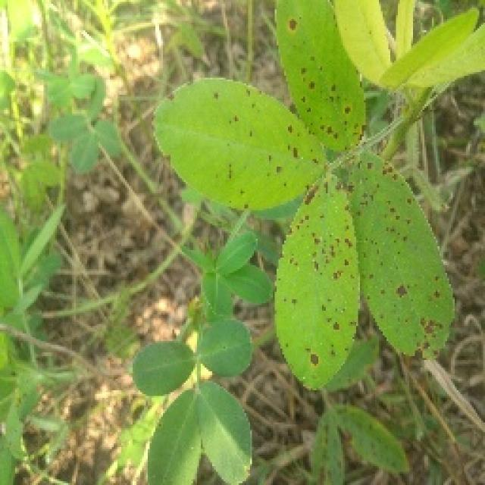
See the image and tell me what type of disease, visible symptoms and possible solution?
Option 1:
The image shows a leaf with brown spots and bumps, which could be indicative of a fungal infection or a bacterial disease. The leaf appears to be infected, and the spots are spreading across the surface.
To address this issue, it is essential to identify the specific type of disease causing the spots and bumps. Once the disease is diagnosed, appropriate treatment measures can be taken. For fungal infections, it is crucial to remove infected leaves and branches, and apply fungicides to prevent the spread of the disease. For bacterial infections, it is necessary to remove the affected leaves and branches, and apply antibiotics to the plant to combat the bacteria.
In addition to these treatments, it is also important to maintain proper plant hygiene, such as regular pruning, removing dead or infected plant parts, and ensuring proper drainage and air circulation to prevent the growth of pathogens.
Option 2:
The visible symptoms in the image include brown spots or lesions on the leaves of the groundnut plant, which are indicative of a fungal disease known as rust. Rust is caused by various species of fungi that infect plants and can lead to significant crop losses if left untreated.
The possible solution for this disease would be to apply fungicides such as mancozeb, chlorothalonil, or wettable sulphur to the affected plants. These treatments can help prevent the spread of the fungus and reduce the severity of the symptoms. Additionally, proper crop rotation and maintaining good field hygiene can also help in managing this disease.

Which option do you prefer?

Sample 181

Ground Truth: rust
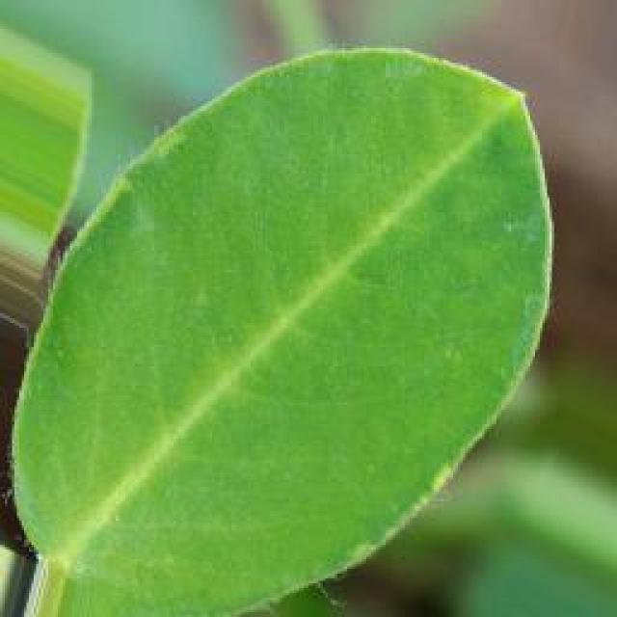
See the image and tell me what type of disease, visible symptoms and possible solution?
Option 1:
The image shows a leaf with brown spots and a yellowish-green color, which indicates that it is affected by a disease. The leaf appears to be infected with a fungal disease, as suggested by the presence of brown spots and the overall yellowish-green color.
To address this issue, it is essential to identify the specific type of fungal disease affecting the leaf and take appropriate measures to prevent its spread. This may involve removing infected leaves and branches, ensuring proper drainage and air circulation, and applying a suitable fungicide to the affected plant. Additionally, maintaining a healthy plant by providing adequate nutrients, water, and sunlight can help prevent the development of diseases and promote overall plant health.
Option 2:
The visible symptoms in the image include brown spots and discoloration on the leaves of a groundnut plant, which are indicative of rust disease. Rust is a fungal disease that affects plants by causing small, reddish-brown spots to develop on the leaves and stems. The affected areas may become necrotic and die, leading to reduced plant growth and yield.
A possible solution for this disease would be to implement preventative measures such as using resistant varieties of groundnut plants, practicing crop rotation with other crops to avoid the spread of the fungus, and maintaining proper field sanitation by removing debris after harvest. Additionally, fungicides can be used to control the disease if it becomes severe enough to require chemical intervention. It's important to consult with a local agricultural extension service for specific recommendations tailored to the region and conditions.

Which option do you prefer?

Sample 182

Ground Truth: rust
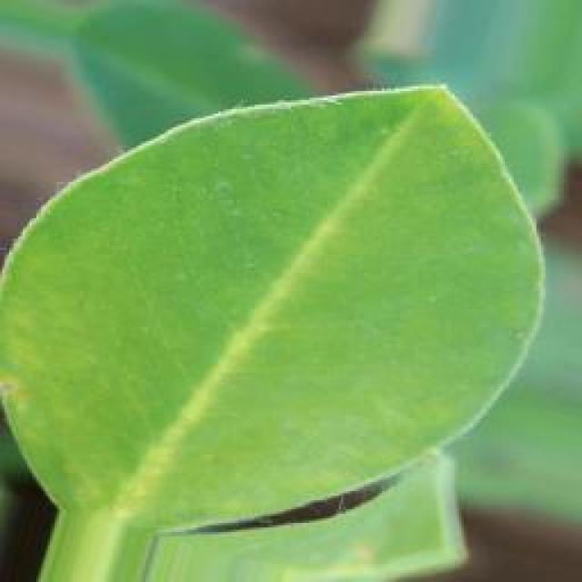
See the image and tell me what type of disease, visible symptoms and possible solution?
Option 1:
The image shows a leaf with brown spots, which could be a sign of a disease or infection. The leaf appears to be affected by a fungal infection, as indicated by the presence of brown spots. The spots are spread across the leaf, and the overall appearance of the leaf is discolored.
To address this issue, it is essential to identify the specific type of fungal infection affecting the leaf. Once the infection is diagnosed, appropriate measures can be taken to prevent the spread of the disease and protect the plant. These measures may include removing infected leaves, applying fungicides, and ensuring proper care and maintenance of the plant. Additionally, it is crucial to maintain a healthy environment for the plant, including regular watering, adequate sunlight, and proper soil conditions, to minimize the risk of infections and promote overall plant health.
Option 2:
The visible symptoms in the image show brown spots on the leaves of a groundnut plant, which are indicative of a rust disease. Rust diseases can affect various plants and are caused by fungi that infect the leaves, stems, and pods of plants. The spots are usually round or irregularly shaped and may have a yellow hue before turning brown.
The possible solution for this type of disease would involve preventative measures such as using resistant varieties of groundnut plants, practicing crop rotation to avoid re-infection from previous crops, and maintaining good field hygiene by removing debris after harvest. If the disease has already occurred, fungicides can be used to control its spread and minimize damage to the plant. It's important to identify the specific type of rust disease and follow recommended treatments for that particular pathogen.

Which option do you prefer?

Sample 183

Ground Truth: rust
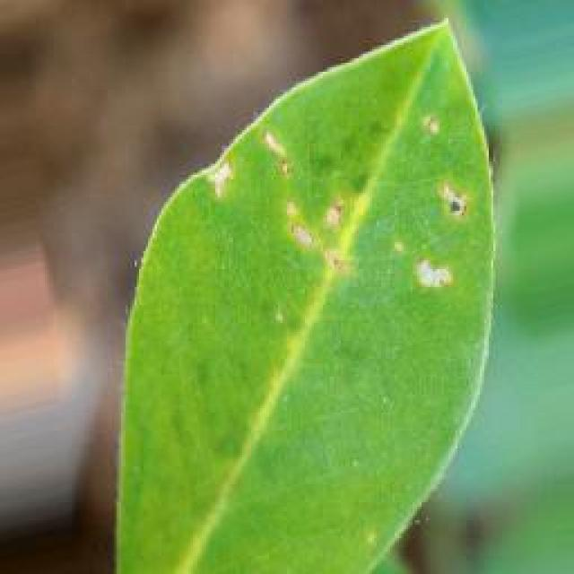
See the image and tell me what type of disease, visible symptoms and possible solution?
Option 1:
The image shows a leaf with brown spots and a yellowish-green color, which indicates that the leaf is affected by a fungal disease. The spots are likely caused by a fungus that has infected the leaf, leading to the discoloration and spots.
To address this issue, it is essential to identify the specific type of fungus causing the disease and take appropriate measures to prevent its spread. This may involve removing infected leaves, practicing good garden hygiene, and using fungicides to treat the affected plants. Additionally, it is important to maintain a healthy plant environment by providing proper nutrition, watering, and pest control to reduce the risk of fungal infections in the future.
Option 2:
The visible symptoms in the image include brown spots and patches on the leaves, which are indicative of a rust disease affecting the groundnut plant. Rust diseases are caused by fungi that infect plants, leading to the formation of reddish-brown pustules on the leaves.
The possible solution for this disease would be to implement preventive measures such as using resistant varieties of groundnut plants, practicing crop rotation with other crops to avoid the spread of the fungus, and maintaining good field hygiene by removing debris after harvest. If the infection is already present, fungicides can be used for control, although their use should be carefully considered due to potential environmental impacts.

Which option do you prefer?

Sample 184

Ground Truth: rust
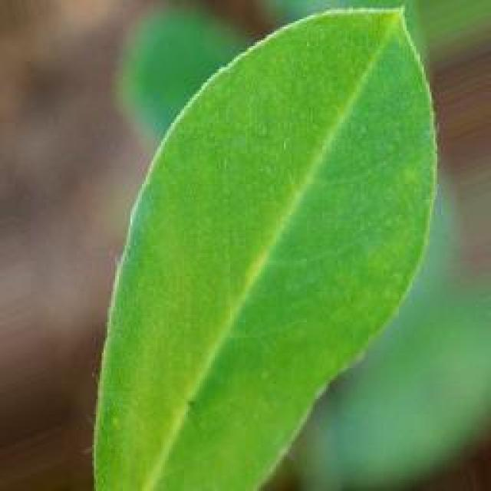
See the image and tell me what type of disease, visible symptoms and possible solution?
Option 1:
The image shows a leaf with brown spots and holes, which indicates that it is affected by a disease. The leaf appears to be infected with a fungal disease, as the spots and holes are characteristic of fungal infections. The visible symptoms include brown spots and holes on the leaf, which can lead to the degradation of the leaf's structure and eventually its death.
A possible solution to this problem is to practice good gardening practices, such as regular pruning, removing infected leaves, and ensuring proper drainage and air circulation around the affected plant. Additionally, using organic fertilizers and pest control methods can help prevent the spread of the disease and promote healthy plant growth. If the disease is severe, it may be necessary to consult a professional to identify the specific type of fungus and recommend appropriate treatment options.
Option 2:
The visible symptoms in the image include brown spots and lesions on the leaves of the groundnut plant. These are indicative of a fungal disease known as rust, which affects plants by causing the formation of reddish-brown pustules on the underside of leaves. The affected leaves may also curl upwards or become deformed.
To address this issue, it is important to practice proper crop management techniques such as removing and destroying infected plant parts, maintaining a healthy soil environment by avoiding over-watering and using organic matter, and using fungicides if necessary. Additionally, monitoring the health of the entire plant population and considering the use of resistant varieties can help prevent the spread of the disease.

Which option do you prefer?

Sample 185

Ground Truth: rust
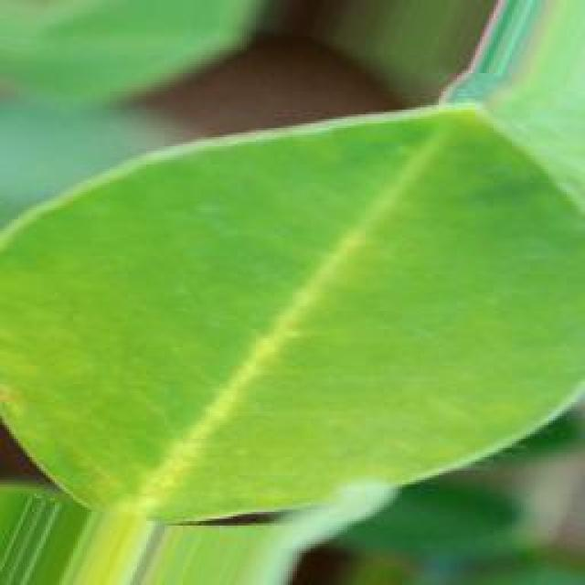
See the image and tell me what type of disease, visible symptoms and possible solution?
Option 1:
The image shows a leaf with brown spots and a yellowish-green color, which indicates that it is affected by a disease. The leaf appears to be infected with a fungal disease, as suggested by the presence of brown spots and the overall yellowish-green color.
To address this issue, it is essential to identify the specific type of fungal disease affecting the leaf and take appropriate measures to prevent its spread. This may involve removing infected leaves and branches, ensuring proper air circulation, and maintaining a healthy plant by providing adequate nutrients, water, and sunlight. Additionally, using organic or chemical fungicides can help protect the plant from further infections. It is also important to practice good gardening practices, such as regular pruning and removing dead or damaged plant parts, to minimize the risk of fungal diseases.
Option 2:
The visible symptoms in the image include brown spots and lesions on the leaves of the groundnut plant. These are indicative of a fungal disease known as rust, which affects plants by causing small yellow or orange spots that can eventually turn brown and lead to leaf necrosis.
The possible solution for this disease would be to apply fungicides such as mancozeb, chlorothalonil, or wettable sulphur to control the spread of the fungus. It's also important to practice good agricultural practices like proper drainage, avoiding overhead irrigation, and removing infected plant debris to prevent further infection.

Which option do you prefer?

Sample 186

Ground Truth: rust
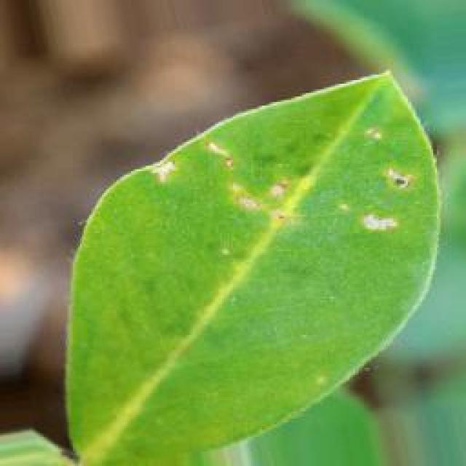
See the image and tell me what type of disease, visible symptoms and possible solution?
Option 1:
The image shows a leaf with brown spots and bumps, which could be indicative of a fungal infection or a bacterial disease. The leaf appears to be affected by a disease, possibly a fungal infection, as the spots and bumps are spread across the surface of the leaf.
To address this issue, it is essential to identify the specific type of disease affecting the leaf and take appropriate measures to prevent its spread. This may involve removing infected leaves, practicing proper plant care, and using organic or chemical fungicides to control the disease. Additionally, it is important to maintain a healthy environment for the plant by providing adequate sunlight, water, and nutrients.
Option 2:
The visible symptoms in the image include brown spots and yellowing on the leaves of the groundnut plant, which are indicative of a rust disease. Rust diseases can affect plants by causing small pustules or spots to form on the leaves, stems, and pods. These spots can vary in color from orange to brown and may have yellow halos around them.
The possible solution for this type of disease would be to apply fungicides such as mancozeb, chlorothalonil, or wettable sulphur to control the spread of the rust pathogen. It's also important to practice good crop rotation and remove infected plant debris after harvest to prevent the disease from spreading further.

Which option do you prefer?

Sample 187

Ground Truth: rust
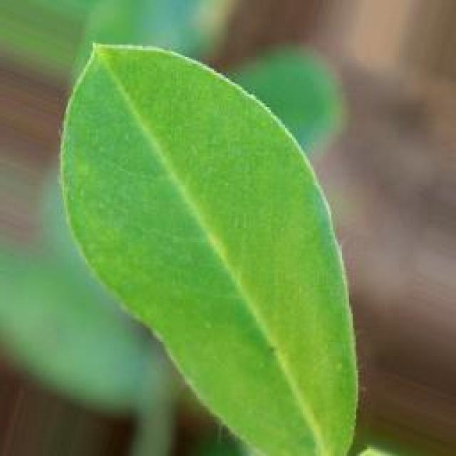
See the image and tell me what type of disease, visible symptoms and possible solution?
Option 1:
The image shows a leaf with brown spots and a yellowish-green color, which indicates that the leaf is affected by a disease. The disease appears to be a fungal infection, as the spots are irregularly shaped and the leaf has a yellowish-green color.
To address this issue, it is essential to identify the specific type of fungal infection affecting the leaf and take appropriate measures to prevent its spread. This may involve removing infected leaves and branches, ensuring proper drainage and air circulation, and applying a fungicide specifically designed to combat the fungus causing the infection. Additionally, maintaining a healthy plant by providing adequate nutrients, water, and sunlight can help prevent the development of diseases and promote overall plant health.
Option 2:
The visible symptoms in the image include brown spots and yellowing on the leaves of the groundnut plant, which are indicative of a rust disease. Rust diseases can be caused by various fungi that infect plants. The spots are typically round or irregularly shaped and may have a yellow hue around them.
The possible solution for this type of disease would involve preventative measures such as using resistant varieties of groundnut plants, practicing crop rotation to avoid re-infection from previous crops, and maintaining good field hygiene by removing volunteer plants and debris. If the disease has already occurred, fungicides can be used for control, although this is generally not recommended due to environmental concerns.

Which option do you prefer?

Sample 188

Ground Truth: rust
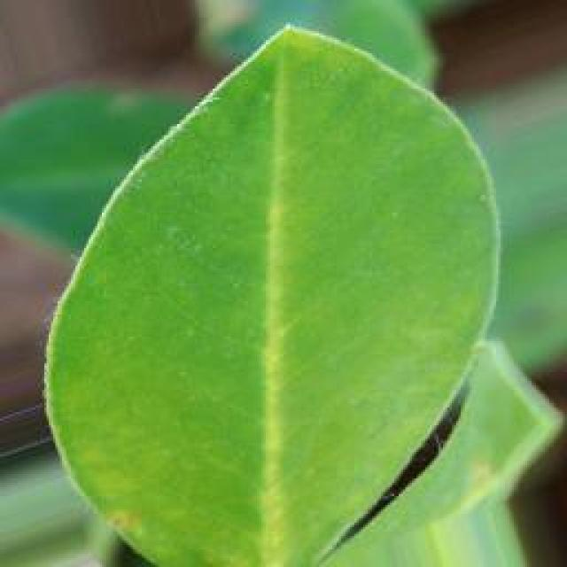
See the image and tell me what type of disease, visible symptoms and possible solution?
Option 1:
The image shows a leaf with brown spots and holes, which indicates that the plant is affected by a disease called bacterial soft rot. This disease is caused by the bacterium Erwinia tracheiphila and can affect various plants, including tomatoes, peppers, and eggplants. The visible symptoms include brown spots, wilting, and rotting of the plant tissue.
A possible solution to prevent the spread of this disease is to practice proper crop rotation, where the affected plants are removed from the soil and replaced with healthy plants of the same species. Additionally, it is essential to maintain a clean and healthy growing environment by avoiding overcrowding, ensuring adequate drainage, and using organic mulch to prevent the spread of bacteria. Proper irrigation and pest management practices can also help in preventing the disease from spreading and causing further damage to the plants.
Option 2:
The visible symptoms in the image include brown spots and patches on the leaves, which are indicative of a rust disease affecting the groundnut plant. Rust diseases are caused by fungi that infect plants, leading to the formation of reddish-brown pustules on the leaves.
The possible solution for this disease would be to implement preventive measures such as using resistant varieties of groundnut plants, practicing crop rotation with other crops to avoid the spread of the fungus, and maintaining good field hygiene by removing debris after harvest. If the infection is already present, fungicides can be used for control, although their use should be minimized as much as possible to reduce environmental impact.

Which option do you prefer?

Sample 189

Ground Truth: rust
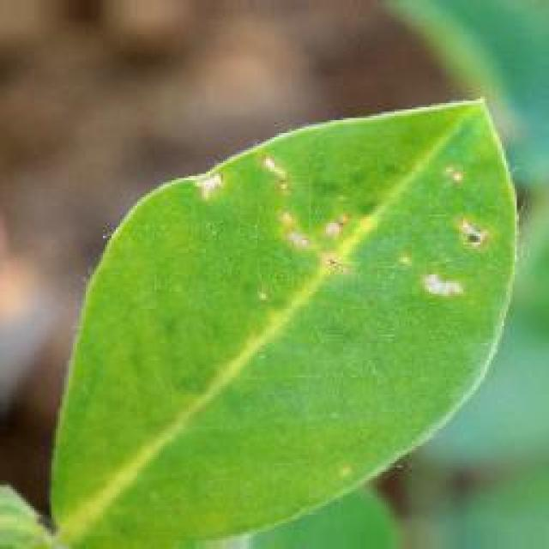
See the image and tell me what type of disease, visible symptoms and possible solution?
Option 1:
The image shows a leaf with brown spots and a yellowish-green color, which indicates that the leaf is affected by a disease. The disease appears to be a fungal infection, as the spots are brown and the leaf is yellowish-green. This could be a result of overwatering, nutrient imbalances, or poor soil quality.
To address this issue, it is essential to identify the specific type of fungal infection and take appropriate measures to prevent its spread. This may include adjusting the watering schedule, ensuring proper nutrient balance, and improving the soil quality. Additionally, using organic or chemical fungicides can help control the infection and protect the plant from further damage. Regularly inspecting the plant and addressing any signs of infection promptly can also help prevent the disease from worsening and causing significant damage to the plant.
Option 2:
The visible symptoms on the groundnut leaf in the image include brown spots with a yellow hue, which are indicative of rust disease. Rust is a fungal disease that affects plants by causing small, reddish-brown pustules on the leaves and stems. The affected areas may become necrotic and die, leading to reduced plant growth and yield.
A possible solution for this disease would be to apply fungicides such as mancozeb, chlorothalonil, or wettable sulphur to control the spread of the rust fungus. It's also important to practice good agricultural practices like proper crop rotation, removing infected plant debris, and maintaining a healthy soil environment to prevent the disease from recurring.

Which option do you prefer?

Sample 190

Ground Truth: rust
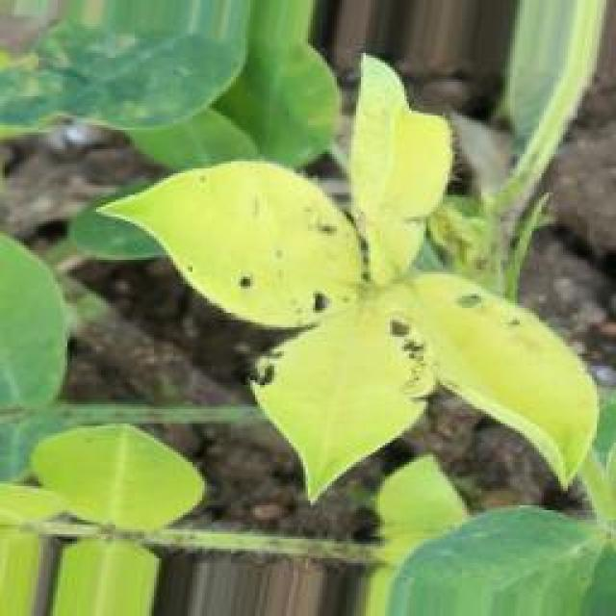
See the image and tell me what type of disease, visible symptoms and possible solution?
Option 1:
The image shows a leaf with brown spots and a yellowish-green color, which indicates that it is affected by a disease. The leaf appears to be infected with a fungal disease, as suggested by the presence of brown spots.
To address this issue, it is essential to identify the specific type of fungal disease affecting the leaf and take appropriate measures to prevent its spread. This may involve removing infected leaves and branches, ensuring proper air circulation around the tree, and applying a fungicide specifically designed to combat the disease. Additionally, regular maintenance of the tree, such as pruning and watering, can help prevent the growth of fungi and promote overall health.
Option 2:
The visible symptoms in the image include brown spots and patches on the leaves, which are indicative of a disease known as rust. This disease affects plants by causing small pustules or spores to form on the underside of leaves, stems, and other parts of the plant. The affected areas turn brown and die, leading to reduced photosynthesis and overall plant health.
A possible solution for this disease would be to use fungicides such as mancozeb, chlorothalonil, or wettable sulphur, which can help control the spread of rust and prevent further damage to the plant. It's important to apply these treatments at regular intervals, usually every 10-14 days, until 14 days before harvest. Additionally, proper crop rotation, removing infected plant debris, and maintaining good air circulation around the plants can also help prevent the spread of rust.

Which option do you prefer?

Sample 191

Ground Truth: rust
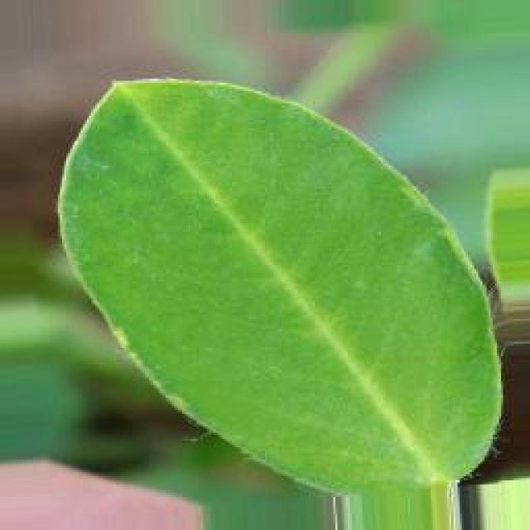
See the image and tell me what type of disease, visible symptoms and possible solution?
Option 1:
The image shows a leaf with brown spots and a yellowish-green color, which indicates that the leaf is affected by a disease. The disease appears to be a fungal infection, as the spots are irregularly shaped and the leaf has a yellowish-green color.
The visible symptoms of the disease include the brown spots on the leaf, which are likely caused by the fungus spreading through the plant's tissues. The yellowish-green color of the leaf could be a result of the fungus affecting the plant's chlorophyll production.
To solve this issue, it is essential to identify the specific type of fungus causing the infection and apply appropriate fungicides to the affected plant. Additionally, it is crucial to maintain proper plant hygiene, such as removing infected leaves and ensuring proper spacing between plants to prevent the spread of the disease. It is also important to monitor the plant's health regularly and address any signs of infection promptly to minimize the impact of the disease on the plant's overall health and productivity.
Option 2:
The visible symptoms in the image show that the groundnut plant is affected by a disease known as rust. Rust typically causes small, round spots or pustules on the leaves and stems of plants. These spots are usually reddish-brown and can vary in size. In severe cases, the rust can cause the leaves to turn yellow, die, and fall off.
The possible solution for this disease would be to use fungicides such as mancozeb, chlorothalonil, or wettable sulphur to control the spread of the rust pathogen. It's also important to practice good crop rotation and ensure proper drainage and air circulation around the plants to prevent the disease from spreading further.

Which option do you prefer?

Sample 192

Ground Truth: rust
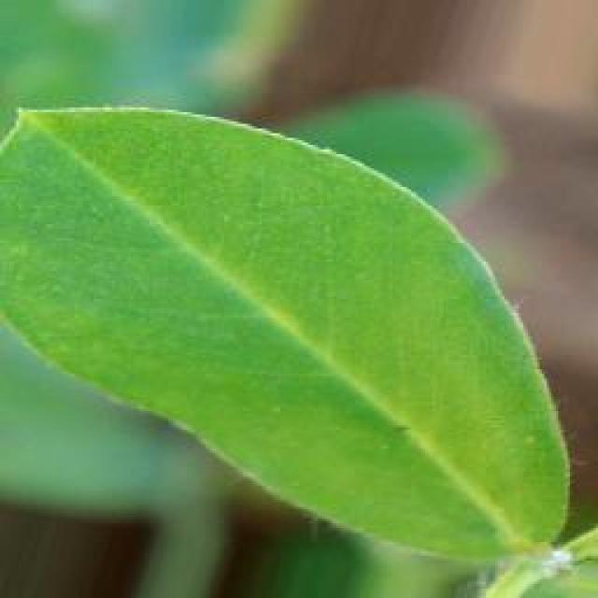
See the image and tell me what type of disease, visible symptoms and possible solution?
Option 1:
The image shows a leaf with brown spots and a yellowish-green color, which indicates that the plant is affected by a disease. The disease appears to be affecting the plant's growth and overall health.
The visible symptoms of the disease include brown spots on the leaf, which could be a sign of fungal infection or bacterial disease. The yellowish-green color of the leaf might be due to the plant's response to the disease, as it tries to compensate for the affected areas.
To address this issue, it is essential to identify the specific disease causing the symptoms and take appropriate measures to treat it. This may involve using organic or chemical treatments, such as fungicides or bactericides, depending on the disease's nature. Additionally, proper care and maintenance of the plant, including regular watering, pest control, and ensuring adequate sunlight and nutrients, can help prevent the disease from spreading and causing further damage to the plant.
Option 2:
The visible symptoms in the image include brown spots and discoloration on the leaves of the groundnut plant. These are indicative of a fungal disease known as rust, which affects plants by causing small yellow or orange pustules to form on the underside of leaves. The spores of the fungus can spread to other plants and cause further damage.
To manage this disease, it is important to practice proper crop rotation, removing infected plant debris, and using fungicides such as chlorothalonil or mancozeb. Regular inspections should be conducted to identify and treat the disease early on. Additionally, maintaining good field hygiene and avoiding overhead irrigation can help prevent the spread of the disease.

Which option do you prefer?

Sample 193

Ground Truth: rust
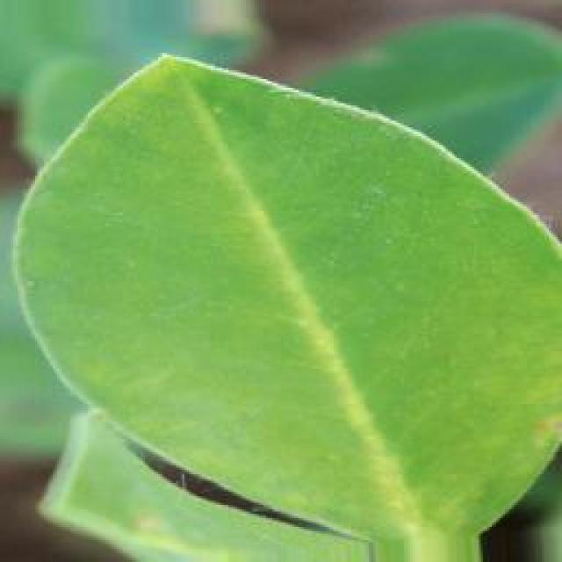
See the image and tell me what type of disease, visible symptoms and possible solution?
Option 1:
The image shows a leaf with brown spots and a yellowish-green color, which indicates that it is affected by a disease. The leaf appears to be infected with a fungal disease, as suggested by the presence of brown spots and the overall yellowish-green color.
To address this issue, it is essential to identify the specific type of fungal disease affecting the leaf and take appropriate measures to prevent its spread. This may involve removing infected leaves and branches, ensuring proper drainage and air circulation, and applying a suitable fungicide to protect the plant from further infection. Additionally, maintaining a healthy plant by providing adequate nutrients, water, and sunlight can help prevent the development of diseases and promote overall plant health.
Option 2:
The visible symptoms in the image include yellowing of the leaf, which indicates chlorosis, and the presence of brown or reddish-brown spots that are characteristic of rust diseases. These spots can be seen on both the upper and lower surfaces of the leaf.
The disease appears to be a type of rust, which is caused by fungi in the genus Puccinia. Rusts are known for their distinctive orange or reddish-brown spores that grow on the underside of leaves. The presence of these spores suggests that the plant has been affected by this disease.
The possible solution for this type of disease would involve preventative measures such as crop rotation to avoid re-infection from the same family of plants, and the use of fungicides to control the spread of the rust fungus. Additionally, proper irrigation and fertilization practices can help maintain the health of the plant and reduce stress, which may exacerbate the symptoms of rust.

Which option do you prefer?

Sample 194

Ground Truth: rust
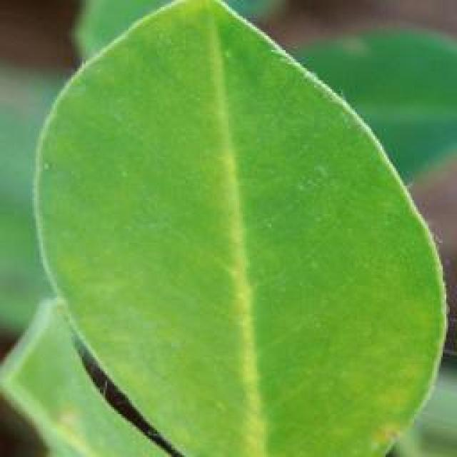
See the image and tell me what type of disease, visible symptoms and possible solution?
Option 1:
The image shows a leaf with brown spots and a yellowish-green color, which indicates that it might be affected by a fungal disease. The spots are spread across the leaf, and the overall appearance of the leaf is discolored.
To address this issue, it is essential to identify the specific type of fungal disease affecting the leaf and take appropriate measures to prevent its spread. This may involve removing infected leaves, pruning affected branches, and applying fungicides to the plant to prevent further infection. Additionally, ensuring proper care, such as regular watering, adequate sunlight, and well-draining soil, can help maintain the health of the plant and reduce the risk of fungal diseases.
Option 2:
The leaf in the image shows signs of a disease commonly known as rust, which affects plants by causing small, reddish-brown spots on the leaves. These spots can eventually lead to the death of the plant tissue if not treated.
The visible symptoms include:
- Small, round or irregularly shaped spots with a yellowish center and a reddish-brown border.
- The spots are often accompanied by small, black pustules that contain the rust fungus.
- The affected areas may become necrotic (dead) and fall off the plant.
The possible solution for this disease is to use fungicides such as mancozeb, chlorothalonil, or wettable sulphur to control the spread of the rust fungus. It's important to apply these treatments at regular intervals and to monitor the plants closely for any signs of new infections. Additionally, proper planting practices, such as selecting resistant varieties and avoiding overhead irrigation that can spread the disease, can help prevent rust infections.

Which option do you prefer?

Sample 195

Ground Truth: rust
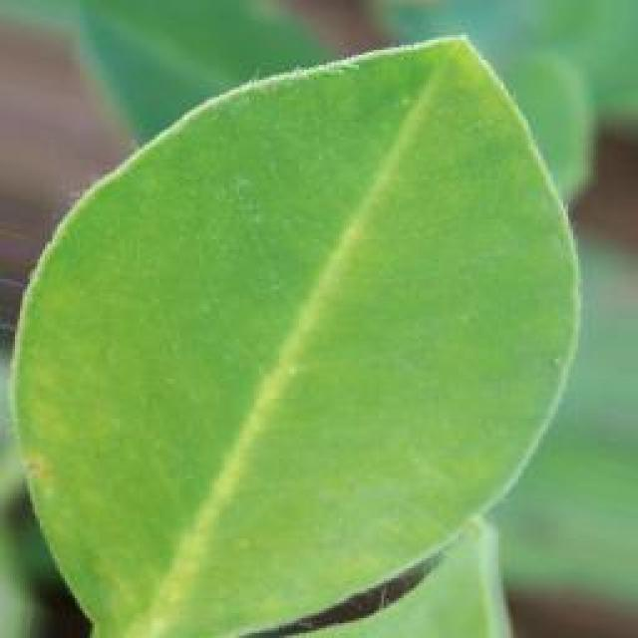
See the image and tell me what type of disease, visible symptoms and possible solution?
Option 1:
The image shows a leaf with brown spots and a yellowish-green color, which indicates that it is affected by a disease. The leaf appears to be infected with a fungal disease, as suggested by the presence of brown spots and the overall yellowish-green color.
To address this issue, it is essential to identify the specific type of fungal disease affecting the leaf and take appropriate measures to prevent its spread. This may involve removing infected leaves and branches, ensuring proper air circulation, and maintaining a healthy plant by providing adequate nutrients, water, and sunlight. Additionally, using organic or chemical fungicides can help protect the plant from further infections. It is also important to practice good gardening practices, such as regular pruning and removing dead or damaged plant parts, to minimize the risk of fungal diseases.
Option 2:
The visible symptoms in the image include brown spots and patches on the leaves of the groundnut plant, which are indicative of a fungal disease known as rust. These spots can vary in size and shape, and they often have a yellow or orange hue with red-brown pustules. The affected areas may become necrotic and die, leading to reduced photosynthetic capacity and overall plant health.
The possible solution for this disease would involve preventative measures such as using resistant varieties of groundnut plants, practicing crop rotation to avoid re-infection from previous crops, and maintaining proper field sanitation by removing debris and controlling weeds that can harbor the fungus. Additionally, fungicides can be used for control if necessary, but it is important to follow recommended application rates and guidelines to minimize environmental impact.

Which option do you prefer?

Sample 196

Ground Truth: rust
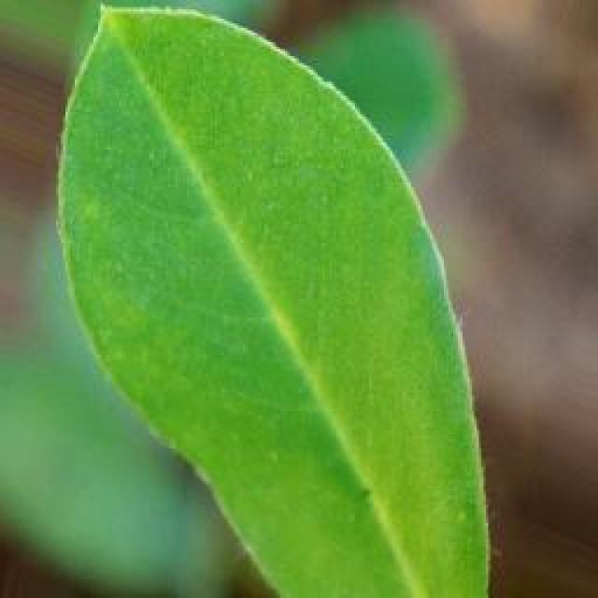
See the image and tell me what type of disease, visible symptoms and possible solution?
Option 1:
The image shows a leaf with brown spots and a yellowish-green color, which indicates that it might be affected by a fungal disease. The spots are spread across the leaf, and the overall appearance of the leaf is discolored.
To address this issue, it is essential to identify the specific type of fungal disease affecting the leaf and take appropriate measures to prevent its spread. This may involve removing infected leaves, practicing proper plant care, and using fungicides if the disease is severe. Additionally, it is important to maintain a healthy environment for the plant by providing adequate sunlight, water, and nutrients, as well as ensuring proper spacing between plants to allow for better air circulation and prevent overcrowding.
Option 2:
The image shows a groundnut plant with visible symptoms of rust disease. The most noticeable signs are the reddish-brown spots on the leaves, which are characteristic of rust infections. These spots can vary in size and shape, and they often coalesce to form larger patches on the leaf surface.
The rust disease is caused by a fungus that infects plants through their stems or leaves. It is more common during wet conditions and can spread rapidly if not treated promptly. The visible symptoms suggest that the plant has been affected by this disease, which could lead to reduced growth, decreased yield, and even death of the plant if left untreated.
To address this issue, an agricultural professional would typically recommend applying fungicides specifically designed for rust diseases. These treatments can help prevent the spread of the fungus and protect the plant from further damage. Additionally, proper crop management practices such as maintaining good drainage, avoiding overcrowding, and ensuring adequate nutrient supply can also help minimize the risk of rust infection.

Which option do you prefer?

Sample 197

Ground Truth: rust
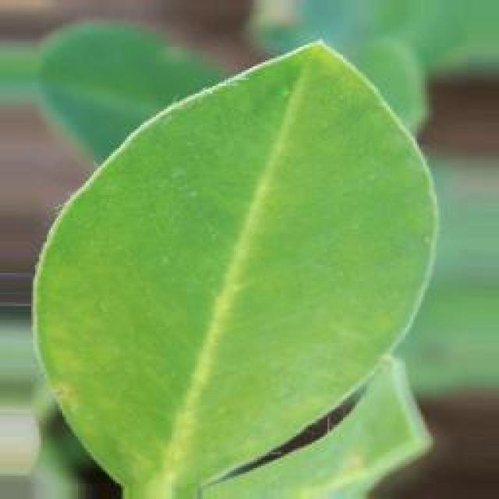
See the image and tell me what type of disease, visible symptoms and possible solution?
Option 1:
The image shows a leaf with brown spots and bumps, which could be indicative of a fungal infection or a bacterial disease. The leaf appears to be affected by a disease, causing it to lose its vibrant green color and develop brown spots.
To address this issue, it is essential to identify the specific type of disease affecting the leaf and take appropriate measures to prevent its spread. This may involve removing infected leaves, pruning affected branches, and applying appropriate fungicides or bactericides to the plant. Additionally, ensuring proper care, such as regular watering, adequate sunlight, and well-draining soil, can help maintain the health of the plant and prevent future infections.
Option 2:
The visible symptoms in the image show that the groundnut plant has been affected by a disease known as rust. Rust is a fungal disease that affects plants, causing yellowing or browning of leaves and the formation of small, reddish-brown spots on the underside of the leaves. The affected leaves may also curl upwards or become deformed.
The possible solution for this disease would involve preventative measures such as using resistant varieties of groundnut plants, practicing crop rotation to avoid continuous cropping in the same area, and maintaining good field hygiene by removing volunteer plants and debris after harvest. If the disease has already occurred, fungicides can be used for control, although their use should be minimized as much as possible to reduce environmental impact.

Which option do you prefer?

Sample 198

Ground Truth: rust
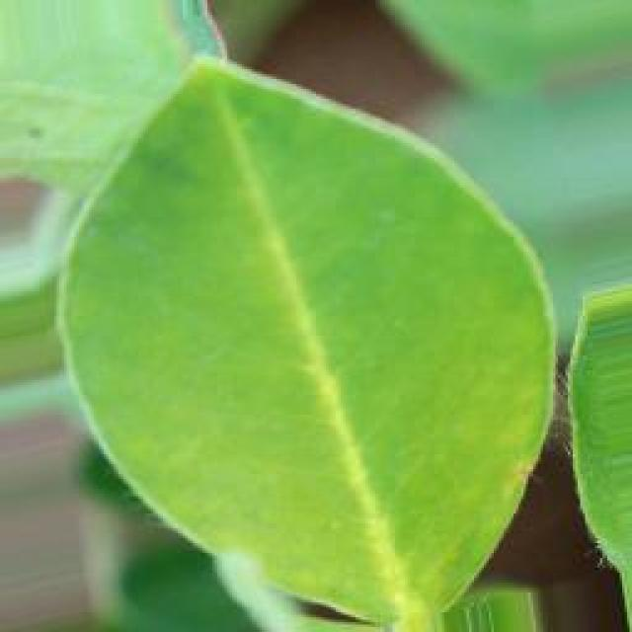
See the image and tell me what type of disease, visible symptoms and possible solution?
Option 1:
The image shows a leaf with brown spots and purple dots, which could indicate a disease or infection affecting the plant. The presence of these spots and dots suggests that the plant might be experiencing a fungal or bacterial infection, which can cause damage to the plant's tissues and overall health.
To address this issue, it is essential to identify the specific type of disease causing the spots and dots. Once the disease is identified, appropriate treatment measures can be taken, such as applying fungicides or bactericides to the affected plant, removing infected leaves, and ensuring proper care and maintenance of the plant to prevent future infections. Additionally, it is crucial to practice good gardening practices, such as regular pruning, proper watering, and ensuring adequate sunlight and nutrient availability, to promote overall plant health and prevent the development of diseases.
Option 2:
The leaf in the image appears to be affected by a disease known as rust, which is caused by fungi from the genus Puccinia. Visible symptoms include small, reddish-brown spots on the underside of the leaf and possibly yellowing or browning of the leaf edges. The rust can cause significant damage to plants, leading to reduced growth, yield, and overall health of the plant.
A possible solution for this disease would be to use fungicides such as mancozeb, chlorothalonil, or wettable sulphur, which are commonly used to control rust infections in crops like groundnuts. It's important to follow proper application guidelines and repeat treatments if necessary, as well as practicing good agricultural hygiene and crop rotation to prevent the spread of the disease.

Which option do you prefer?

Sample 199

Ground Truth: rust
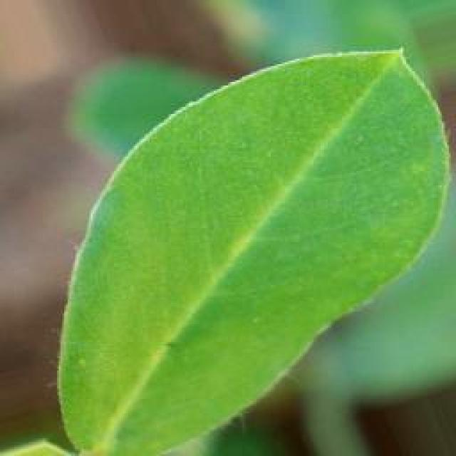
See the image and tell me what type of disease, visible symptoms and possible solution?
Option 1:
The image shows a leaf with brown spots, which could be a sign of a disease or infection. The leaf is lying on a dirt ground, possibly a garden or a field. The brown spots on the leaf indicate that the plant is experiencing some form of stress or damage, which could be caused by various factors such as pests, fungal infections, or nutrient deficiencies.
To address this issue, it is essential to identify the cause of the brown spots and take appropriate measures to treat the affected plant. If the spots are caused by pests, it is crucial to remove the affected leaves and use organic or chemical pest control methods to prevent further damage. If the spots are due to fungal infections, it is necessary to remove the affected leaves, improve the soil's drainage, and apply fungicides to prevent the spread of the disease.
In addition, it is important to ensure that the plant receives adequate nutrients and water to promote healthy growth and prevent future damage. Regularly inspecting the plant and addressing any signs of stress or damage promptly can help maintain the plant's health and prevent further damage.
Option 2:
The visible symptoms in the image include brown spots and patches on the leaves, which are indicative of a rust disease affecting the groundnut plant. Rust diseases can be caused by various fungi that infect plants, leading to the formation of reddish-brown pustules on the leaves and stems.
The possible solution for this issue would involve preventative measures such as using resistant varieties of groundnut plants, practicing crop rotation to avoid re-infection from previous crops, and maintaining good field hygiene by removing debris after harvest. Additionally, fungicides can be applied if the rust infection is severe enough to warrant chemical intervention. It's important to consult with a local agricultural extension service for specific recommendations tailored to the region and the type of groundnut variety being grown.

Which option do you prefer?

Sample 200

Ground Truth: rust
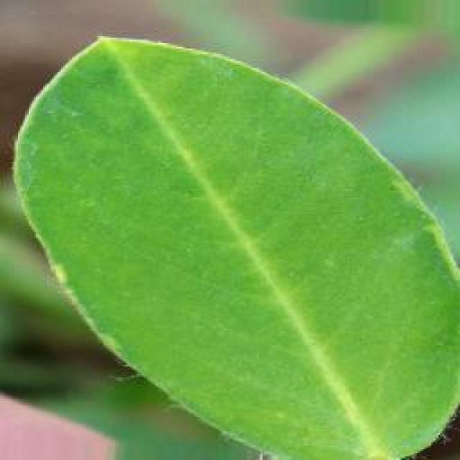
See the image and tell me what type of disease, visible symptoms and possible solution?
Option 1:
The image shows a leaf with brown spots and a yellowish-green color, which indicates that it might be affected by a fungal disease. The spots are likely caused by a fungus that has infected the leaf, leading to the discoloration and potential damage to the plant.
To address this issue, it is essential to identify the specific type of fungal disease affecting the plant and take appropriate measures to prevent its spread. This may include removing infected leaves, practicing proper plant care, and using fungicides if the disease is severe. Additionally, it is important to maintain a healthy plant environment by ensuring adequate sunlight, water, and nutrient availability, as well as proper spacing and air circulation.
Option 2:
The image shows a groundnut leaf with visible symptoms consistent with rust disease. The most noticeable feature is the presence of small, reddish-brown spots scattered across the leaf surface. These spots are indicative of the rust fungus infecting the plant.
The visible symptoms include:
- Discoloration: The affected areas of the leaf turn a reddish or purple color due to the presence of rust pigments produced by the fungus.
- Spotting: Small, round spots that are characteristic of rust disease on plants.
- Leaf deformation: The edges of the leaves may become crinkled or curled as a result of the infection.
The possible solution for this disease would be to implement preventative measures such as using resistant varieties of groundnut plants, practicing crop rotation, and maintaining proper field sanitation by removing debris after harvest. If the disease has already occurred, fungicides can be used to control the spread of the rust fungus.

Which option do you prefer?

