**CHAPTER 1: INTRODUCTION**

## INTRODUCTION

Packaging machines are machines that complete stages of the packaging process. Examples include filling machines, sealing machines, wrapping machines, strapping machines, labeling machines and coding machines. Packaging machines have advantages such as reducing labor costs associated and increasing the efficiency of the packaging process through the use of automation. L-Sealers are perfect low volume packaging solution able to seal up to 20packages a minute. Automatic L Sealers use a conveyor fed automatic operation that can process up 15 to 20 packages a minute. Soft feed conveyors carry products into the system and places them inside the folded shrink film. An adjustable sealing arm raises and lowers as products move through the system.

Packaging machines are used to package products or components. This product area includes equipment that forms, fills, seals, wraps, cleans, and packages at different levels of automation. Packaging machines also include related machinery for sorting, counting, and accumulating. There are many different package types. Examples include: aerosol containers, bags and pouches, blister packs, bottles and jars, cartons and boxes, cans, capsules, cartridges, cases, cups and trays, drums, kegs and pails, pallets and intermediate bulk containers (IBC), tubes, and vials. Closing methods for packaging machinery can use caps and lids, cork, glue, heat seals, nails or staples, tamper-evident or tamper-resistant tape, tuck and fold techniques, and wrapping paper. Suppliers of packaging machines also provide: palletizers, de-palletizers, pallet dispensers, unloading machinery, sealing machinery, shrink machinery, strapping machinery and banding machinery, sorting machinery, tape dispensers, vacuum chambers, and wrapping machinery. Palletizers and de-palletizers place and remove goods on pallets in an orderly fashion. Pallet dispensers hold a number of pallets and dispense them on demand. Unloading machines remove products or goods from packaging.

**1.2 SCOPE**

In today’s world, packaging has not only become a source for tracing and tracking a product, it is also responsible to prevent counterfeit of any valuables. It consists of important information such as hologram which ensures the safety of the product, labeling which encompasses the mandatory compliances for nutritional facts of a food product. A lot of advancement has been observed in the field of packaging technology such as the use of retort processing is ready to eat food products, UHT processes, modified atmosphere packaging, Nano packaging, active and responsive packaging. These emerging technologies have diversified the study of packaging technologies and hence increased the scope of the same. With the ever-increasing production of multiple product ranges into market on daily basis, the need for packaging experts has grown manifold and this profession is also getting increasingly recognized. Aspiring students can benefit from this industry as it provides national as well as international platform. This article will present all important details about packaging courses and its vast career opportunity.These emerging technologies have diversified the study of packaging technologies and hence increased the scope of the same. With the ever-increasing production of multiple product ranges into market on daily basis, the need for packaging experts has grown manifold and this profession is also getting increasingly recognized. Aspiring students can benefit from this industry as it provides national as well as international platform. This article will present all important details about packaging courses and its vast career opportunity.

The packaging market in India has become the sunshine Industry which is well supported by favorable demographic aspects such as growing urbanization, rising proportion of middle-class consumers, increasing disposable income levels, rising consumer awareness and demand for convenience and processed food. The multinational giants taking rapid strides in the food, beverages, cosmetics & toiletries and pharmaceuticals space, are expected to be the key drivers of this growth story in the field of packaging. These changes drive the need for packaging reforms, such as different sizes, materials, and strength. This key factor is responsible for both packaging suppliers

## ORGANIZATION OF REPORT

# The organization of the entire project and its report has been done logically considering the order of execution of project and flow of the subject matter.

# In chapter 1 the domain of working and type of device is included. it gives introduction, scope of project and the organization of the project report. the project was chosen such that it will have a wide range of applications . also, it was decided to use different and current technologies for execution of this project.

# In chapter 2 contains understanding of all the components and processes involved in this project. various papers, internet websites, articles and books were referred for knowledge. all the links and references are given in detail. it also includes results of survey taken to realize demands or conditions for l sealer automatic machine.

# Next chapter 3 has specifications of the board and user instructions are included in this chapter. It also contains generalized block diagram used for the system and description is given for understanding.

# In chapter 4 shows specific working of software and its requirement.in the project report, the introduction gives the basic idea of project and what we hope to achieve through it. then, the available literature on the subject matter and present system used for this purpose has been studied. The system schematic, specifications and block diagram is given followed by the system design.

# In chapter 5 it shows the circuit diagram and its explanation.the circuit diagram is simulated in the proteus software.

In **chapter 6** it shows the result of the machine and shows the performance evaluation of the circuit.it also contains the advantages and limitations of the l sealer machine.

# Chapter 2: Review of the related literature

**2.1 literature introduction**

L sealer packing machines are commonly known as Seal Machines. There are classified as two main types– Vertical Form Fill and Seal Machines and Horizontal Form Fill and Seal Machines. Vertical Form Fill and Seal Machines (VFFS Machine) are used to pack regular shaped solid products or liquids while, Horizontal Form Fill and Seal Machines are used to pack irregular shaped products. Fully automated machine requires no human intervention while Semi automated machines require humans to perform some part of packing operation. The machine discussed in the paper can be classified as an intermittent motion machine or fully Automatic machine.packing machines are commonly known as Form Fill and Seal Machines. There are classified as two main types– Vertical Form Fill and Seal Machines and Horizontal Form Fill and Seal Machines.

Vertical Form Fill and Seal Machines (VFFS Machine) are used to pack regular shaped solid products or liquids while, Horizontal Form Fill and Seal Machines are used to pack irregular shaped products. In this paper we focus on the Vertical Form Fill and Seal Machines. VFFS machines are widely used in most of the industries to pack products of various sizes.Intermittent motion machine makes the vertical seal while the film is in motion but for the horizontal seal the film stops whereas, the continuous motion machine makes the vertical and the horizontal seal without stopping the film.

Hence, higher production rates can be achieved by the continuous motion machine. On the other hand, fully automated machine requires no human intervention while Semi automated machines require humans to perform some part of packing operation

**2.2 literature SURVEY**

**AUTOMATIC SEALING MACHINE FOR METAL CONTAINER**

Packaging of food material is final stage in food industry. The life of the material packed is depending on the structure and quality of packaging. So there is need of precisions in the packaging, especially for the food material.In many industries for packaging of large quantity of material, metal containers are used. These containers cannot seal by plastic coating. So there is need of metal sealing by means of solder that container. This kind of packaging is done manually which create many problems.

To overcome these problems, an approach has to be made to find a proper platform for the design and testing of the sealing projects which makes the packaging proper and perfect. In this proposed system, an invention made for solving a problem of packaging of metal containers in food industry. This Project details the mechanical design and software requirements. This paper describes the Automation done for the sealing the metal container to fulfill the industrial need.

**2.3 PRESENT SCENARIO**

Packaging is very crucial step in the rice industry as the good packaging provides not only convenient handling in transportation and storage but also keep intact the flavor of rice. In the rice industry, the packaging is done in order to avoid spoilage and to prolong the quality of rice. Our packaging support to the industry is enough for the entire packaging process starting from filling bags till their sealing.

L-Sealer Shrink Tunnel Combinations seal one or several products, after which they are shrunk. They can be flexibly deployed and used everywhere as a complete compact packaging unit. The Mini combiset in particular may be used in any situation due to its single-phase power supply.

**2.4 Problem Definition**

In the industries the various packaging machines are of two types and they are manually operating and PLC based packaging machines. But both these machines are time consuming and they required manual connection.so we have develop a fully automatic l sealer machine which uses a microcontroller.

**CHAPTER 3: BLOCK DIAGRAM** **OF SYSTEM**

* 1. **BLOCK DIAGRAM**

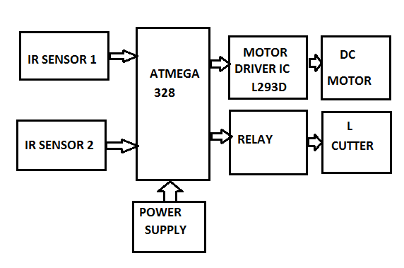

**Fig3.1 Block diagram of system**

IR sensor 1, IR sensor 2 sense the object and then it gives the signal to AT mega microcontroller. AT mega microcontroller is connected to Motor Driver IC and Relay. When IR sensor1 sense the object, then the controller control the movement of DC Motor through Motor Driver IC L293d.then IR sensor 2 will sense the object and microcontroller control the L cutter with the help of Relay.

### **3.2 MICROCONTROLLER**

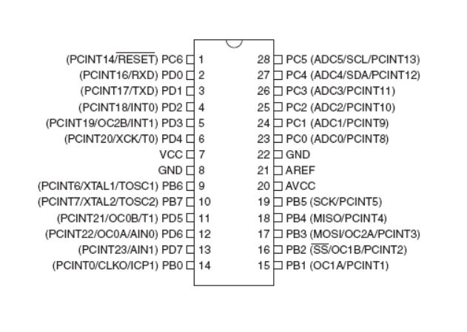

**Fig 3.2 Pin diagram of microcontroller (ATmega328)**

The ATmega328 is a single-chip microcontroller created by Atmel in the megaAVR family (later Microchip Technology acquired Atmel in 2016). It has a modified Harvard architecture 8-bit RISC processor core.

The Atmel 8-bit AVR RISC-based microcontroller combines 32 kB ISP flash memory with read-while-write capabilities, 1 kB EEPROM, 2 kB SRAM, 23 general purpose I/O lines, 32 general purpose working registers, three flexible timer/counters with compare modes, internal and external interrupts, serial programmable USART, a byte-oriented 2-wire serial interface, SPI serial port, 6-channel 10-bit A/D converter (8-channels in TQFP and QFN/MLF packages), programmable watchdog timer with internal oscillator, and five software selectable power saving modes.

The device operates between 1.8-5.5 volts. The device achieves throughput approaching 1 MIPS per MHz

**FEATURES:-**

1. High Performance, Low Power AVR® 8-Bit Microcontroller

2. Advanced RISC Architecture

– 131 Powerful Instructions – Most Single Clock Cycle Execution

– 32 x 8 General Purpose Working Registers

– Up to 20 MIPS Throughput at 20 MHz

– On-chip 2-cycle Multiplier

3. High Endurance Non-volatile Memory Segments

In-System Programming by On-chip Boot Program

True Read-While-Write Operation

4. Peripheral Features

– Two 8-bit Timer/Counters with Separate Prescaler and Compare Mode

– One 16-bit Timer/Counter with Separate Prescaler, Compare Mode, and Capture

Mode

5. Real Time Counter with Separate Oscillator

– Six PWM Channels

– 8-channel 10-bit ADC in TQFP and QFN/MLF package

Temperature Measurement

– Programmable Serial USART

**3.3 IR SENSOR**

The IR Sensor-Single is a general purpose proximity sensor. Here we use it for collision detection. The module consist of a IR emitter and IR receiver pair. The high precision IR receiver always detects a IR signal. The module consists of 358 comparator IC. The output of sensor is high whenever it IR frequency and low otherwise. The on-board LED indicator helps user to check status of the sensor without using any additional hardware.

The power consumption of this module is low. It gives a digital output.

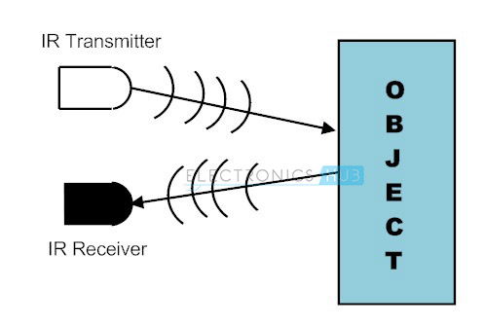

**Fig 3.3 Transmitter and Receiver of IR sensor.**

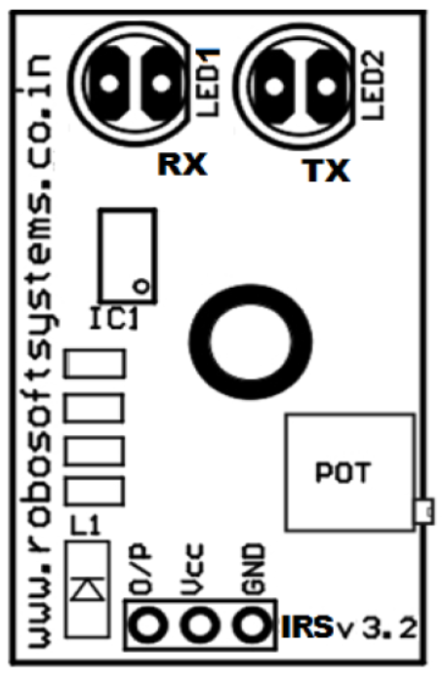

**Fig 3.3 Pin diagram of IR sensor.**

**Pin Configuration**

The figure to the right is a top view of the IR Sensor module. The

following table gives its pin description.

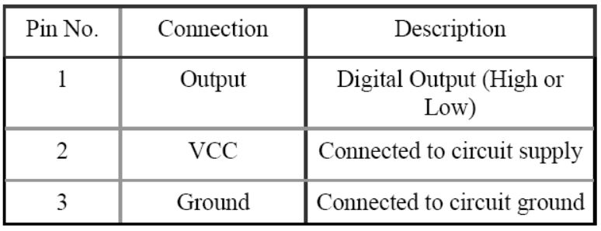

**Application Ideas:-**

**Night Vision Devices**

Infrared technology is implemented in night vision equipment if there is not enough visible light available to see unaided. Night vision devices convert ambient photons of light into electrons and then amplify them using a chemical and electrical process before finally converting them back into visible light.

**Infrared Astronomy**

Infrared astronomy is a field of astronomy which studies astronomical objects that are visible in infrared radiation. By using telescopes and solid-state detectors, astronomers are able to observe objects in the universe which are impossible to detect using light in the visible range of the electromagnetic spectrum.

.

**3.4 Light Emitting Diode**

Light-Emitting Diodes are elements for light signalization in electronics. The basic principle behind the working of LED is electroluminescence. The Light emitting diode should be forward biased to get the light. In Light emitting diodes, electrons are injected from low work function cathode to the conduction band of the n-type semiconducting material and holes are injected from high work function anode to the valence band to the type semiconducting material. When the electron in the conduction band combines with the hole in the valence band, energy is released. In case of indirect band gap semiconductors, phonon will be released to conserve of both energy and momentum. But in case of direct band gap semiconductor, light will be emitted whose wavelength depends on the band gap of the semiconductor.

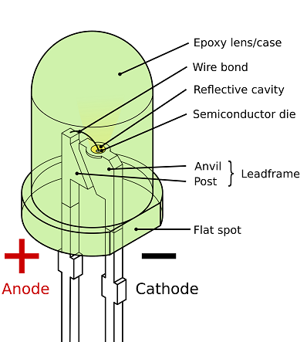

**Fig 3.4 Construction of LED**



**Fig 3.4 Symbol of LED**

The main advantage of Light emitting diode over other light sources is its increased efficiency. LEDs are available in red, orange, amber, yellow, green, and blue and white. Blue and white LEDs are much more expensive than the other colors. We have employed low cost Red LED in our electronic circuit.

**3.5 Relay**

A relay is an [electromagnetic](http://www.explainthatstuff.com/magnetism.html) switch operated by a relatively small [electric](http://www.explainthatstuff.com/electricity.html) current that can turn on or off a much larger electric current. The heart of a relay is an electromagnet (a coil of wire that becomes a temporary [magnet](http://www.explainthatstuff.com/magnetism.html) when electricity flows through it). Current flowing through the coil of the relay creates a magnetic field which attracts a lever and changes the switch contacts.

The coil current can be on or off so relay have two switch positions and most have double throw (changeover) switch contacts. A relay is an electrically operated switch. Current flowing through the coil of the relay creates a magnetic field which attracts a lever and changes the switch contacts.

The coil current can be on or off so relays have two switch positions and they are double throw (changeover) switches.

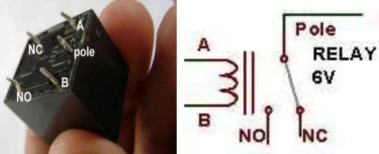

**Fig 3.5 Relay diagram.**

**3.6 Motor driver IC(L293D)**[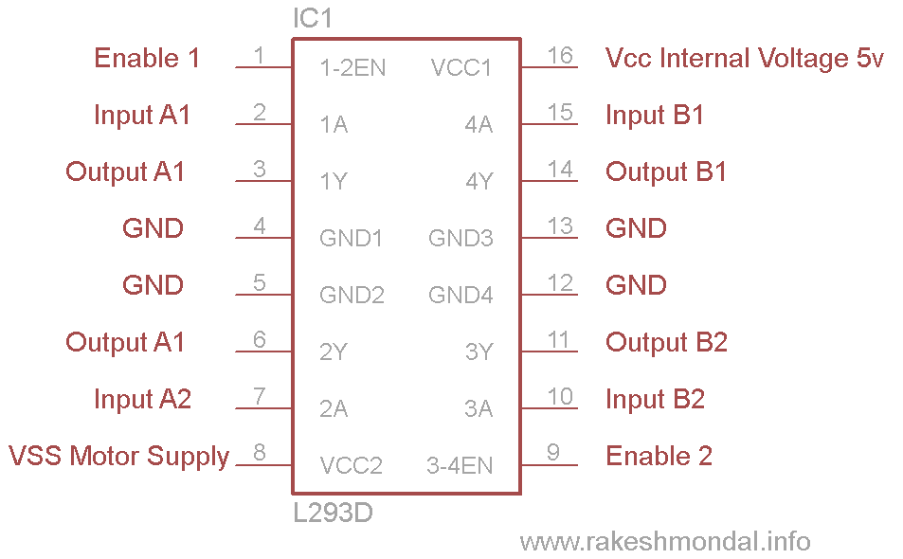](https://www.rakeshmondal.info/pik/l293d%20pin%20diagram.png)

**Fig 3.6 diagram of Motor driver IC (L293D)**

## Working of L293D-

There are 4 input pins for l293d, pin 2,7 on the left and pin 15 ,10 on the right as shown on the pin diagram. Left input pins will regulate the rotation of motor connected across left side and right input for motor on the right hand side. The motors are rotated on the basis of the inputs provided across the input pins as LOGIC 0 or LOGIC 1.

In simple you need to provide Logic 0 or 1 across the input pins for rotating the motor. It works on the concept of H-bridge. H-bridge is a circuit which allows the voltage to be flown in either direction. As you know voltage need to change its direction for being able to rotate the motor in clockwise or anticlockwise direction, Hence H-bridge IC are ideal for driving a DC motor.

In a single L293D chip there are two h-Bridge circuit inside the IC which can rotate two dc motor independently. Due its size it is very much used in robotic application for controlling DC motors. Given below is the pin diagram of a L293D motor controller.

There are two Enable pins on l293d. Pin 1 and pin 9, for being able to drive the motor, the pin 1 and 9 need to be high. For driving the motor with left H-bridge you need to enable pin 1 to high. And for right H-Bridge you need to make the pin 9 to high. If anyone of the either pin1 or pin9 goes low then the motor in the corresponding section will suspend working. It’s like a switch.

## L293D Logic Table-

Let’s consider a Motor connected on left side output pins (pin 3,6). For rotating the motor in clockwise direction the input pins has to be provided with Logic 1 and Logic 0.

• **Pin 2** = **Logic 1** and **Pin 7** = **Logic 0** | Clockwise Direction  
• **Pin 2** = **Logic 0** and **Pin 7** = **Logic 1** | Anticlockwise Direction  
• **Pin 2** = **Logic 0** and **Pin 7** = **Logic 0** | Idle [No rotation] [Hi-Impedance state]  
• **Pin 2** = **Logic 1** and **Pin 7** = **Logic 1** | Idle [No rotation]

## Voltage Specification:-

VCC is the voltage that it needs for its own internal operation 5v; L293D will not use this voltage for driving the motor. For driving the motors it has a separate provision to provide motor supply VSS (V supply).  L293d will use this to drive the motor. It means if you want to operate a motor at 9V then you need to provide a Supply of 9V across VSS Motor supply.

The maximum voltage for VSS motor supply is 36V. It can supply a max current of 600mA per channel. Since it can drive motors Up to 36v hence you can drive pretty big motors with this l293d.

**3.7 DC MOTOR**

[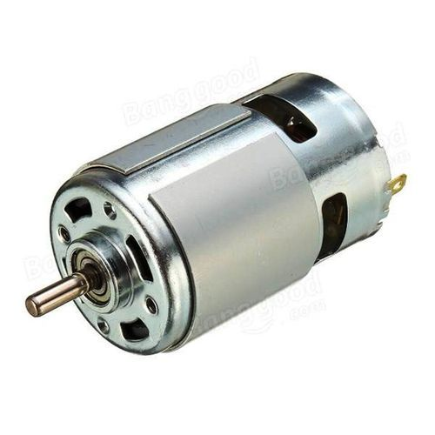](https://www.google.com/url?sa=i&rct=j&q=&esrc=s&source=images&cd=&cad=rja&uact=8&ved=2ahUKEwiuvNHr7qjfAhWJwI8KHWFKBKcQjRx6BAgBEAU&url=https://www.indiamart.com/proddetail/rs-775-7000rpm-12v-dc-motor-16865102788.html&psig=AOvVaw2CaKJoYshQ94bECrFja0Yy&ust=1545204823881264)

**Fig 3.7 DC Motor**

A motor is an electrical machine which converts electrical energy into mechanical energy. The principle of working of a DC motor is that "whenever a current carrying conductor is placed in a magnetic **field**, it experiences a mechanic.

DC motors were the first type widely used, since they could be powered from existing direct-current lighting power distribution systems. A DC motor's speed can be controlled over a wide range, using either a variable supply voltage or by changing the strength of current in its field windings. Small DC motors are used in tools, toys, and appliances.

The [universal motor](https://en.wikipedia.org/wiki/Universal_motor) can operate on direct current but is a lightweight [brushed](https://en.wikipedia.org/wiki/Brush_(electric)) motor used for portable power tools and appliances. Larger DC motors are used in propulsion of electric vehicles, elevator and hoists, or in drives for steel rolling mills. The advent of power electronics has made replacement of DC motors with [AC motors](https://en.wikipedia.org/wiki/AC_motors) possible in many applications.

**Features:**

* 12V – 200RPM –
* 3.6KG/CM torque DC gearhead motor
* 30:1 Gear Ratio
* 2mm rear encoder shaft
* Good compromise between speed and torque for small robotic designs

**Specifications:**

**Characteristic Value Unit**

Operating voltage 4.5-18 V

Startup torque (kilogram-force centimeter) 3.6 KG/CM

Startup torque (inch-pound) 3.1 Inch/lbf

Gear ratio 30:1

No-Load Current (12V) 0.053 A

Stall Current 1.5 A

No-Load Speed (12V) 200 RPM

**Chapter 4 Software of System.**

**4.1 Proteus software:-**

The **Proteus Design Suite** is a proprietary software tool suite used primarily for electronic design automation. The software is used mainly by electronic design engineers and technicians to create schematics and electronic prints for manufacturing printed circuit boards. The **Proteus**is an electronic circuit design software which includes a schematic capture, simulation and PCB (Printed Circuit Board) Layout modules. But generally now a day **Eagle CAD** is highly preferred over Proteus for PCB designing because of its flexibility.

Even though if u are not using for PCB designing u can view the PCB layout of the component individually while selecting the component it helps during the soldering of components in PCB.

Proteus is ahead in simulating the circuits containing the micro controllers where we can simulate the circuit by uploading the hex code to the Micro-controller whereas Multisim can’t do this.

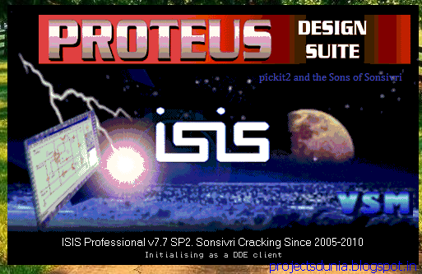

**Fig 4.1 Proteus software**

**4.2 ARDUINO IDE**

**Arduino** consists of both a physical programmable circuit board (often referred to as a microcontroller) and a piece of software, or **IDE** (Integrated Development Environment) that runs on your computer, used to write and upload computer code to the physical board. Arduino is an open-source electronics platform based on easy-to-use hardware and software. Arduino boards are able to read inputs - light on a sensor, a finger on a button, or a Twitter message - and turn it into an output - activating a motor, turning on an LED, publishing something online.

You can tell your board what to do by sending a set of instructions to the microcontroller on the board. To do so you use the Arduino programming language (based on Wiring), and the Arduino Software (IDE), based on Processing.

Over the years Arduino has been the brain of thousands of projects, from everyday objects to complex scientific instruments. A worldwide community of makers - students, hobbyists, artists, programmers, and professionals - has gathered around this open-source platform, their contributions have added up to an incredible amount of accessible knowledge that can be of great help to novices and experts alike.

[](https://www.google.com/url?sa=i&rct=j&q=&esrc=s&source=images&cd=&cad=rja&uact=8&ved=2ahUKEwiL77jw6KjfAhUWbo8KHQw9B0EQjRx6BAgBEAU&url=https://thestempedia.com/tutorials/arduino-ide/&psig=AOvVaw1Jqcn5jsKVxf5eEOshlwVv&ust=1545203260237037)

**Fig 4.2**  **ARDUINO IDE Software**

**Chapter 5 :- Circuit Detailing**

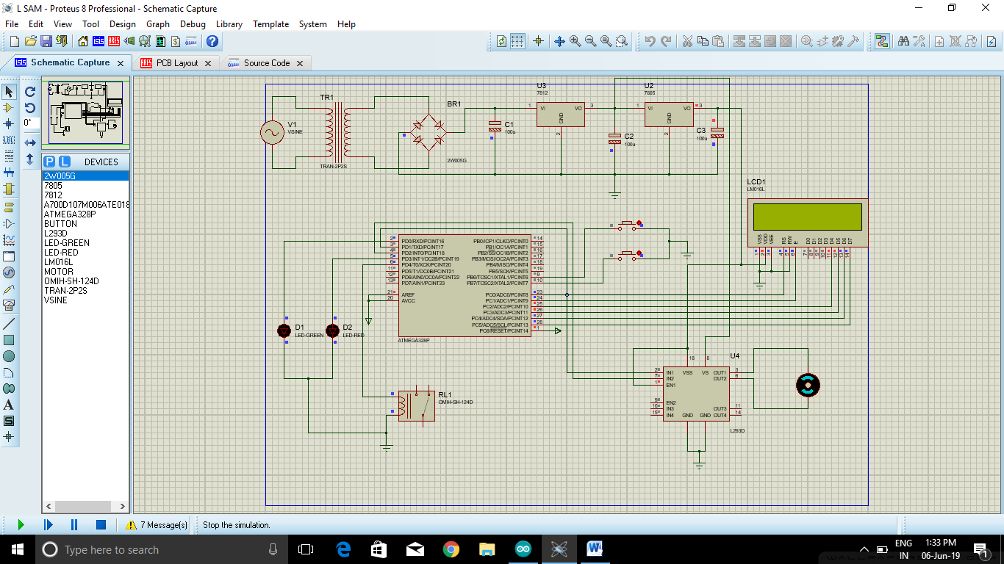

**Fig 5.1: Circuit diagram & simulation**

The components used in the circuit diagram are AT mega 328 microcontroller, Relay, Motor Driver IC, DC Motor, LCD, Voltage Regulator 7805 & 7812, two IR sensor, two LED.

* IR SENSOR: It is connected to pin no 9, 10 of microcontroller.
* RELAY: It is connected to pin no 6.
* MOTOR DRIVER IC: It is connected to pin no 3, 4.
* LCD: It is connected to pin no 23,24,25.26.27,28.
* LED: It is connected to pin no 2, 5.

Voltage Regulator is used in the power supply to give 5v supply to microcontroller , IR sensor, LCD & Motor Driver Ic and 12v supply to Motor driver ic.

**Chapter 6:- PERFORMANCE EVAUATION OF THE SYSTEM**

**6.1 RESULT**

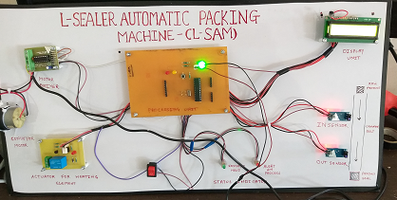

**Fig 6.1 System Results**

Above experimental setup of l sealer automatic packaging machine.ir sensor sense the object and pack the object by polythene then send it for next process through conveyor.

**6.2.CONCLUSION**

The industries were using the semi automatic machine and some of the machines were plc based.In our project we have perform the conversion of semi automatic machine to fully automatic machine.

**6.3 ADVANTAGES**

* Increase in accuracy & repeatability.
* Less human errors.
* Less employee cost.
* Increased safety.
* High volume production.

. **Chapter 7:- Applications and References**

**7.1:- APPLICATIONS**

* Medical, Pharmaceuticals
* Hardware & Electronics product
* It is used in Food materials
* Industrial Use

**7.2:-** **REFERENCES**

[1]Pressman, Abraham I. (1998), Switching Power Supply Design (2nd ed.), McGraw-Hill, ISBN 0-07-052236-7\

[2]Ms. Swarupa Kulkarni (2014), Automatic Sealing Machine For Metal Container

# [3] Steven f. Barrett (2013), Arduino microcontroller processing for everyone! Third edition

[4] <http://www.warade.in/>

[5] [**https://www.sevana.com/products/item/258-automatic-l-sealer**](https://www.sevana.com/products/item/258-automatic-l-sealer)

[6]**[https://](https://www.youtube.com/results?search_query=semi+automatic+packaging+machine)**[**www.youtube.com/results?search_query=semi+automatic+packaging+machine**](https://www.youtube.com/results?search_query=semi+automatic+packaging+machine)

[7] <https://www.proto-electronics.com/>

**7.3:- DATA SHEETS**

**1. AT Mega 328**

**1.1 Pin Descriptions**

**1.1.1 VCC**

Digital supply voltage.

**1.1.2 GND**

Ground.

**1.1.3 Port B (PB7:0) XTAL1/XTAL2/TOSC1/TOSC2**

Port B is an 8-bit bi-directional I/O port with internal pull-up resistors (selected for each bit). The Port B output buffers have symmetrical drive characteristics with both high sink and source capability.

As inputs, Port B pins that are externally pulled low will source current if the pull-up resistors are activated. The Port B pins are tri-stated when a reset condition becomes active, even if the clock is not running. Depending on the clock selection fuse settings, PB6 can be used as input to the inverting Oscillator amplifier and input to the internal clock operating circuit.

Depending on the clock selection fuse settings, PB7 can be used as output from the inverting Oscillator amplifier. If the Internal Calibrated RC Oscillator is used as chip clock source, PB7..6 is used as TOSC2.1input for the Asynchronous Timer/Counter2 if the AS2 bit in ASSR is set The various special features of Port B are elaborated in.

**1.1.4 Port C (PC5:0)**

Port C is a 7-bit bi-directional I/O port with internal pull-up resistors (selected for each bit). The PC5.0 output buffers have symmetrical drive characteristics with both high sink and source capability.

As inputs, Port C pins that are externally pulled low will source current if the pull-up resistors are activated. The Port C pins are tri-stated when a reset condition becomes active, even if the clock is not running.

**1.1.5 PC6/RESET**

If the RSTDISBL Fuse is programmed, PC6 is used as an I/O pin. Note that the electrical characteristics of PC6 differ from those of the other pins of Port C. If the RSTDISBL Fuse is unprogrammed, PC6 is used as a Reset input.

A low level on this pin for longer than the minimum pulse length will generate a Reset, even if the clock is not running. The minimum pulse length is given in. Shorter pulses are not guaranteed to generate a Reset. The various special features of Port C are elaborated in

**1.1.6 Port D (PD7:0)**

Port D is an 8-bit bi-directional I/O port with internal pull-up resistors (selected for each bit). The Port D output buffers have symmetrical drive characteristics with both high sink and source capability.

As inputs, Port D pins that are externally pulled low will source current if the pull-up resistors are activated. The Port D pins are tri-stated when a reset condition becomes active, even if the clock is not running.

**2. DC MOTOR**

**TECHNICAL DESCRIPTION:**

**OPERATING PRECAUTIONS**

DC motors are compact and display high output, and their speed is easy to control. They may be driven by battery or any other power supply and are therefore also easy to use. However, inappropriate power supply may lead to burnout or abnormal brush wear. Problems with power supply, installation, and general precautions and problems with a motor installed in-circuit will be described.

**• OVERLOAD AND LOCK-UP**

An excessive amount of load torque is applied during overloaded driving or when locked up, causing an excessive current flow with heat damage being incurred by the motor. Therefore, overloaded or locked-up use is to be avoided. (Locking up for 5 or more seconds results in damage to a motor. Do not lock up a motor for 5 or more seconds.)

**• APPLIED VOLTAGE**

Be sure to use a motor at its rated voltage (+IUVI), and avoid any surge voltage. We can specially manufacture motors designed with an electrical path protecting the motor from surges and reversed polarity. Please contact us for details.

**• APPLYING NON-RATED SUPPLY VOLTAGES**

Applying a voltage higher than the motor’s rating results in a temperature increase, leading to heat damage or lowered service life. Scoring of the commutator surface by sparks and mechanical brush wear arising from vibration may also occur.

Applying a voltage lower than the motors rating may eventually result in the motor failing to start. This is due to the build up of carbon powder on the commutator . Motors are manufactured for use within +IOVo of their rated specifications. Please contact us if you need to use motors outside their ratings.

**• BRUSH WEAR PROMOTED BY POWER SUPPLY RIPPLES**

Brush wear may be mechanical wear due to brush and commutator abrasion or electrical wear due to sparking between the brush and commutator, the latter being the most common.

Brush wear is therefore greatly affected by ripples in the power supply voltage, and use of general regulated DC is recommended. However, when rectifying AC for use by a motor, be sure to use full-wave rectification with a capacitor or similar element in a smoothing circuit.

**• AMBIENT CONDITIONS**

The service life of a DC motor is defendant upon its rectifying action. Care must be taken to ensure good commutation, as dust, oil, gas, water, etc. Water on the commutator surface results in poor rectification and increases brush wear.

**• CHANGING THE BRUSH POSITION**

The brushes are generally fixed in position such that rotational speed and current characteristics are maintained equivalent in both clockwise and counter-clockwise directions. These are basically determined based on the position of the magnetic poles. Rotating the motor after not carefully relocating parts such as the brush holder (for fixing the brushes) or rear cover results in misalignment of the brushes and magnets.

This will produce change in the above characteristics in the rotational direction or cause poor rectification, leading to abnormal brush wear. Therefore, changing of the

brush positioning is to be avoided.

**• INSTALLED ORIENTATION**

Motors are generally designed for use with a horizontal output shaft. Special consideration must be given to components including bearings and grease washers when intended for an upward- or downward-facing output shaft. Please contact us for details.

Further, avoid installing a motor in a manner in which grease from the gear head would tend to enter the motor (e.g., with an upward-facing output shaft).

**• NOISE GENERATION**

Electrical noise is generated as a result of sparks from commutation between the brushes and commutator. Please contact us for assistance with lowering noise.

.**• MOTOR AND GEAR HEAD COMBINATION**

When combining a gear head with a pinion shaft, gently fit the gear head on turning it right and left, being careful that the pinion and the gear in the gear head do not strongly clash with each other. Using force will cause noise-producing scratches in the pinion and the gear. Scratches are Failures by a decreased service life and are the cause of unforeseen accidents.

**• LOAD VARIATION**

Even with torque below the rated load, a motor will incur more damage than might be imagined if there is frequent load variation. Exercise caution with operating conditions and load restrictions.

**• INSULATION RESISTANCE**

The insulation resistance of a brush motor will naturally continue to decrease as its running time increases. The figures for resistance given in the catalog are for a new motor.

**• SERVICE LIFE**

Service life depends greatly on operating conditions and environment. Please contact us for details.

**• OTHER ASPECTS**

Oil may seep out of the grease in the gear head depending on operating conditions, storage environment, etc. This does not present any problems in the use of the gear head. However, contamination of the machine or equipment to which the geared motor is fitted may occur.

**3. IR SENSOR**

* **GENERAL DESCRIPTION**

The IR Sensor-Single is a general purpose proximity sensor. Here we use it for collision detection. The module consist of a IR emitter and IR receiver pair. The high precision IR receiver always detects a IR signal. The module consists of 358 comparat or IC.

The output of sensor is high whenever it IR frequency and low otherwise. The on-board LED indicator helps user to check status of the sensor without using any additional hardware. The power consumption of this module is low. It gives a digital output.

* **OVERVIEW OF SCHEMATIC**

The sensitivity of the IR Sensor is tuned using the potentiometer. The potentiometer is tuneable in both the directions. Initially tune the potentiometer in clockwise direction such that the Indicator LED starts glowing. Once that is achieved, turn the potentiometer just enough in anti-clockwise direction to turn off the Indicator LED. At this point the sensitivity of the receiver is maximum.

Thus, its sensing distance is maximum at this point. If the sensing distance (i.e., Sensitivity) of the receiver is needed to be reduced, then one can tune the potentiometer in the anti-clockwise direction from this point. Further, if the orientation of both Tx and Rx LED’s is parallel to each other, such that both are facing outwards, then their sensitivity is maximum.

If they are moved away from each other, such that they are inclined to each

other at their soldered end, then their sensitivity reduces. Tuned sensitivity of the sensors is limited to the surroundings. Once tuned for a particular surrounding, they

will work perfectly until the IR illumination conditions of that region nearly constant. For example, if the potentiometer is tuned inside room/building for maximum sensitivity and then taken out in open sunlight, its will require retuning, since sun’s rays also contain Infrared (IR) frequencies, thus acting as a IR source (transmitter). This will disturb the receiver’s sensing capacity.

Hence it needs to be retuned to work perfectly in the new surroundings. The output of IR receiver goes low when it receives IR signal. Hence the output pin is normally low because, though the IR LED is continuously transmitting, due to no obstacle, nothing is reflected back to the IR receiver.

The indication LED is off. When an obstacle is encountered, the output of IR receiver goes low, IR signal is reflected from the obstacle surface. This drives the output of the comparator low. This output is connected to the cathode of the LED, which then turns ON.

**4. LCD**

This document concerns the Matrix LCD Display code

* **TRADEMARKS AND COPYRIGHT**

PIC, PIC micro are registered trademarks of Arizona Microchip Inc. E-blocks is a trademark of Matrix Multimedia Limited. EB-005-00-1 and associated software and documentation are Copyright ©2004 Matrix Multimedia Limited.

* **OTHER SOURCES OF INFORMATION**

There are various other documents and sources that you may find useful:

* **GETTING STARTED WITH E-BLOCKS.PDF**

This describes the E-blocks system and how it can be used to develop complete systems for learning electronics and for PICmicro programming.

* **PPP HELP FILE**

This describes the PPP software and its functionality. PPP software is used for transferring hex code to a PICmicro microcontroller.

* **DISCLAIMER**

The information in this document is correct at the time of going to press. Matrix Multimedia reserves the right to change specifications from time to time.

* **TECHNICAL SUPPORT**

If you have any problems operating this product then please refer to the troubleshooting section of this document first. You will find the latest software updates, FAQs and other information on our web site: www.matrixmultimedia.co.uk. If you still have problems please email us at: support@matrixmultimedia.co.uk. When emailing please state the operating system, the version of PPP you are using.

**GENERAL INFORMATION**

* **DESCRIPTION**

This is an LCD Display designed for E-blocks. It is a 16 character, 2-line alphanumeric LCD display connected to a single 9-way D-type connector. This allows the device to be connected to most E-Block I/O ports.

The LCD display requires data in a serial format, which is detailed in the user guide below. The display also requires a 5V power supply. Please take care not to exceed 5V, as this will cause damage to the device. The 5V is best generated from the E-blocks Multipogrammer or a 5V fixed regulated power supply.

The potentiometer RV1 is a contrast control that should be used to adjust the contrast of the display for the environment it is being used in.

* **FEATURES**

1. E-blocks compatible
2. Low cost
3. Compatible with most I/O ports in the E-Block range (requires 5 I/O lines via 9 way D-type connector)
4. Ease to develop programming code using Flowcode icons.
5. **RELAY**

* **A POWER RELAY WITH VARIOUS MODELS**

• High-sensitivity (250 mW) and High-capacity (16 A) versions.

• Designed for cooking and HVAC controls: blower motor, damper, active air purification, duct flow boost fans, etc.

• Conforms to VDE (EN61810-1). UL recognized/ CSA certiified

• Meets EN60335-1 requirements for household products.

• Clearance and creepage distance: 10 mm/10 mm.

• Tracking resistance: CTI>250

• Coil Insulation system: Class F.

• Rohs compliant

1**. Definitions**: The words used herein are defined as follows.

(a) Terms: These terms and conditions

(b) Seller: Omron Electronic Components LLC and its subsidiaries

(c) Buyer: The buyer of Products, including any end user in section III through VI

(d) Products: Products and/or services of Seller

(e) Including: Including without limitation

**2**. **Offer; Acceptance**: These Terms are deemed part of all quotations, acknowledgments ,invoices, purchase orders and other documents, whether electronic or in writing, relatingto the sale of Products by Seller. Seller hereby objects to any Terms proposed in Buyer's purchase order or other documents which are inconsistent with, or in addition to, these Terms.

**3**. **Distributor**: Any distributor shall inform its customer of the contents after and including section III of these Terms.

* **INFORMATION**
* **Intellectual Property**: The intellectual property embodied in the Products is the exclusive property of Seller and its affiliates and Buyer shall not attempt to duplicate it in any way without the written permission of Seller. Buyer (at its own expense) shall indemnify and hold harmless Seller and defend or settle any action brought against Seller to the extent that it is based on a claim that any Product made to Buyer specifications infringed intellectual property rights of another party.
* **Property**; Confidentiality: Notwithstanding any charges to Buyer for engineering or tooling, all engineering and tooling shall remain the exclusive property of Seller. All information and materials supplied by Seller to Buyer relating to the Products are confidential and proprietary, and Buyer shall limit distribution thereof to its trusted employees and strictly prevent disclosure to any third party.
* **Performance Data**: Performance data is provided as a guide in determining suitability and does not constitute a warranty. It may represent the result of Seller's test conditions, and the users must correlate it to actual application requirements.
* **Change In Specifications:** Product specifications and descriptions may be changed at any time based on improvements or other reasons. It is Seller’s practice to change part numbers when published ratings or features are changed, or when significant engineering changes are made. However, some specifications of the Product may be changed without any notice.
* **Errors And Omissions**: The information on Seller’s website or in other documentation has been carefully checked and is believed to be accurate; however, no responsibility is assumed for clerical, typographical or proofreading errors or omissions.
* **Export Controls**: Buyer shall comply with all applicable laws, regulations and licenses regarding

(a) export of the Products or information provided by Seller;

(b) sale of Products to forbidden or other proscribed persons or organizations; (c) disclosure to noncitizens of regulated technology or information.