Teleco

Sangamesh

24 September 2018

# PHASE 1: Reading the Dataset

# PHASE 2 => Data Pre-Processing

Step 1: Checking for any Missing Data and Statistical Summary

## data   
##   
## 42 Variables 1000 Observations  
## ---------------------------------------------------------------------------  
## region   
## n missing distinct Info Mean Gmd   
## 1000 0 3 0.889 2.022 0.8888   
##   
## Value 1 2 3  
## Frequency 322 334 344  
## Proportion 0.322 0.334 0.344  
## ---------------------------------------------------------------------------  
## tenure   
## n missing distinct Info Mean Gmd .05 .10   
## 1000 0 72 1 35.53 24.65 4 7   
## .25 .50 .75 .90 .95   
## 17 34 54 66 70   
##   
## lowest : 1 2 3 4 5, highest: 68 69 70 71 72  
## ---------------------------------------------------------------------------  
## age   
## n missing distinct Info Mean Gmd .05 .10   
## 1000 0 60 0.999 41.68 14.33 23 26   
## .25 .50 .75 .90 .95   
## 32 40 51 59 64   
##   
## lowest : 18 19 20 21 22, highest: 73 74 75 76 77  
## ---------------------------------------------------------------------------  
## marital   
## n missing distinct Info Sum Mean Gmd   
## 1000 0 2 0.75 495 0.495 0.5005   
##   
## ---------------------------------------------------------------------------  
## address   
## n missing distinct Info Mean Gmd .05 .10   
## 1000 0 50 0.998 11.55 10.92 0.0 1.0   
## .25 .50 .75 .90 .95   
## 3.0 9.0 18.0 26.1 31.0   
##   
## lowest : 0 1 2 3 4, highest: 45 46 48 49 55  
## ---------------------------------------------------------------------------  
## income   
## n missing distinct Info Mean Gmd .05 .10   
## 1000 0 218 1 77.53 75.3 18.0 21.0   
## .25 .50 .75 .90 .95   
## 29.0 47.0 83.0 155.4 232.2   
##   
## lowest : 9 10 11 12 13, highest: 732 928 944 1131 1668  
## ---------------------------------------------------------------------------  
## ed   
## n missing distinct Info Mean Gmd   
## 1000 0 5 0.946 2.671 1.369   
##   
## Value 1 2 3 4 5  
## Frequency 204 287 209 234 66  
## Proportion 0.204 0.287 0.209 0.234 0.066  
## ---------------------------------------------------------------------------  
## employ   
## n missing distinct Info Mean Gmd .05 .10   
## 1000 0 46 0.997 10.99 10.93 0 0   
## .25 .50 .75 .90 .95   
## 3 8 17 25 31   
##   
## lowest : 0 1 2 3 4, highest: 41 43 44 45 47  
## ---------------------------------------------------------------------------  
## retire   
## n missing distinct Info Sum Mean Gmd   
## 1000 0 2 0.134 47 0.047 0.08967   
##   
## ---------------------------------------------------------------------------  
## gender   
## n missing distinct Info Sum Mean Gmd   
## 1000 0 2 0.749 517 0.517 0.4999   
##   
## ---------------------------------------------------------------------------  
## reside   
## n missing distinct Info Mean Gmd   
## 1000 0 8 0.923 2.331 1.52   
##   
## Value 1 2 3 4 5 6 7 8  
## Frequency 375 272 138 120 60 29 4 2  
## Proportion 0.375 0.272 0.138 0.120 0.060 0.029 0.004 0.002  
## ---------------------------------------------------------------------------  
## tollfree   
## n missing distinct Info Sum Mean Gmd   
## 1000 0 2 0.748 474 0.474 0.4991   
##   
## ---------------------------------------------------------------------------  
## equip   
## n missing distinct Info Sum Mean Gmd   
## 1000 0 2 0.711 386 0.386 0.4745   
##   
## ---------------------------------------------------------------------------  
## callcard   
## n missing distinct Info Sum Mean Gmd   
## 1000 0 2 0.655 678 0.678 0.4371   
##   
## ---------------------------------------------------------------------------  
## wireless   
## n missing distinct Info Sum Mean Gmd   
## 1000 0 2 0.625 296 0.296 0.4172   
##   
## ---------------------------------------------------------------------------  
## longmon   
## n missing distinct Info Mean Gmd .05 .10   
## 1000 0 425 1 11.72 9.559 2.998 3.645   
## .25 .50 .75 .90 .95   
## 5.200 8.525 14.413 23.960 31.615   
##   
## lowest : 0.90 1.05 1.10 1.35 1.45, highest: 62.30 75.45 81.55 89.40 99.95  
## ---------------------------------------------------------------------------  
## tollmon   
## n missing distinct Info Mean Gmd .05 .10   
## 1000 0 162 0.855 13.27 16.92 0.00 0.00   
## .25 .50 .75 .90 .95   
## 0.00 0.00 24.25 34.75 41.77   
##   
## lowest : 0.00 5.75 9.00 9.25 9.50, highest: 77.75 78.75 84.00 87.00 173.00  
## ---------------------------------------------------------------------------  
## equipmon   
## n missing distinct Info Mean Gmd .05 .10   
## 1000 0 310 0.769 14.22 19.2 0.00 0.00   
## .25 .50 .75 .90 .95   
## 0.00 0.00 31.47 42.66 48.65   
##   
## lowest : 0.00 15.40 19.55 19.75 19.80, highest: 64.20 69.40 70.05 73.80 77.70  
## ---------------------------------------------------------------------------  
## cardmon   
## n missing distinct Info Mean Gmd .05 .10   
## 1000 0 176 0.967 13.78 14.67 0.00 0.00   
## .25 .50 .75 .90 .95   
## 0.00 12.00 20.50 31.50 37.79   
##   
## lowest : 0.00 2.75 3.75 4.50 4.75, highest: 74.00 82.25 84.75 87.50 109.25  
## ---------------------------------------------------------------------------  
## wiremon   
## n missing distinct Info Mean Gmd .05 .10   
## 1000 0 263 0.651 11.58 17.76 0.00 0.00   
## .25 .50 .75 .90 .95   
## 0.00 0.00 24.71 42.11 51.35   
##   
## lowest : 0.00 14.90 15.10 16.85 17.45, highest: 83.70 85.85 96.25 109.70 111.95  
## ---------------------------------------------------------------------------  
## longten   
## n missing distinct Info Mean Gmd .05 .10   
## 1000 0 960 1 574.1 699 12.30 29.18   
## .25 .50 .75 .90 .95   
## 90.14 285.48 755.02 1537.09 2144.79   
##   
## lowest : 0.90 1.05 1.10 1.35 1.45  
## highest: 4333.00 5464.60 5988.50 6353.90 7257.60  
## ---------------------------------------------------------------------------  
## tollten   
## n missing distinct Info Mean Gmd .05 .10   
## 1000 0 473 0.854 551.3 823.1 0.0 0.0   
## .25 .50 .75 .90 .95   
## 0.0 0.0 846.9 1838.4 2424.3   
##   
## lowest : 0.00 5.75 20.75 23.05 26.50  
## highest: 4748.45 4905.85 4938.60 5850.25 5916.00  
## ---------------------------------------------------------------------------  
## equipten   
## n missing distinct Info Mean Gmd .05 .10   
## 1000 0 386 0.769 465.6 736.6 0.0 0.0   
## .25 .50 .75 .90 .95   
## 0.0 0.0 579.5 1854.9 2435.6   
##   
## lowest : 0.00 15.40 17.25 22.60 22.80  
## highest: 3925.50 4167.70 4758.05 4980.80 5028.65  
## ---------------------------------------------------------------------------  
## cardten   
## n missing distinct Info Mean Gmd .05 .10   
## 1000 0 338 0.967 605.8 775.2 0.0 0.0   
## .25 .50 .75 .90 .95   
## 0.0 332.5 910.0 1505.5 2181.0   
##   
## lowest : 0.00 2.75 5.00 10.00 15.00  
## highest: 4975.00 5115.00 5455.00 5520.00 7515.00  
## ---------------------------------------------------------------------------  
## wireten   
## n missing distinct Info Mean Gmd .05 .10   
## 1000 0 297 0.651 442.7 743.3 0.0 0.0   
## .25 .50 .75 .90 .95   
## 0.0 0.0 316.5 1833.7 2727.6   
##   
## lowest : 0.00 10.45 16.85 20.95 24.20  
## highest: 4399.60 4828.20 6132.20 6444.95 7856.85  
## ---------------------------------------------------------------------------  
## multline   
## n missing distinct Info Sum Mean Gmd   
## 1000 0 2 0.748 475 0.475 0.4992   
##   
## ---------------------------------------------------------------------------  
## voice   
## n missing distinct Info Sum Mean Gmd   
## 1000 0 2 0.635 304 0.304 0.4236   
##   
## ---------------------------------------------------------------------------  
## pager   
## n missing distinct Info Sum Mean Gmd   
## 1000 0 2 0.579 261 0.261 0.3861   
##   
## ---------------------------------------------------------------------------  
## internet   
## n missing distinct Info Sum Mean Gmd   
## 1000 0 2 0.698 368 0.368 0.4656   
##   
## ---------------------------------------------------------------------------  
## callid   
## n missing distinct Info Sum Mean Gmd   
## 1000 0 2 0.749 481 0.481 0.4998   
##   
## ---------------------------------------------------------------------------  
## callwait   
## n missing distinct Info Sum Mean Gmd   
## 1000 0 2 0.749 485 0.485 0.5001   
##   
## ---------------------------------------------------------------------------  
## forward   
## n missing distinct Info Sum Mean Gmd   
## 1000 0 2 0.75 493 0.493 0.5004   
##   
## ---------------------------------------------------------------------------  
## confer   
## n missing distinct Info Sum Mean Gmd   
## 1000 0 2 0.75 502 0.502 0.5005   
##   
## ---------------------------------------------------------------------------  
## ebill   
## n missing distinct Info Sum Mean Gmd   
## 1000 0 2 0.7 371 0.371 0.4672   
##   
## ---------------------------------------------------------------------------  
## loglong   
## n missing distinct Info Mean Gmd .05 .10   
## 1000 0 425 1 2.182 0.829 1.098 1.293   
## .25 .50 .75 .90 .95   
## 1.649 2.143 2.668 3.176 3.454   
##   
## lowest : -0.105361 0.048790 0.095310 0.300105 0.371564  
## highest: 4.131961 4.323470 4.401216 4.493121 4.604670  
## ---------------------------------------------------------------------------  
## logtoll   
## n missing distinct Info Mean Gmd .05 .10   
## 475 525 161 1 3.24 0.4583 2.621 2.757   
## .25 .50 .75 .90 .95   
## 2.970 3.209 3.489 3.751 3.928   
##   
## lowest : 1.749200 2.197225 2.224624 2.251292 2.277267  
## highest: 4.353499 4.366278 4.430817 4.465908 5.153292  
## ---------------------------------------------------------------------------  
## logequi   
## n missing distinct Info Mean Gmd .05 .10   
## 386 614 309 1 3.568 0.3162 3.121 3.201   
## .25 .50 .75 .90 .95   
## 3.368 3.572 3.757 3.933 3.994   
##   
## lowest : 2.734368 2.972975 2.983153 2.985682 2.990720  
## highest: 4.162003 4.239887 4.249209 4.301359 4.352855  
## ---------------------------------------------------------------------------  
## logcard   
## n missing distinct Info Mean Gmd .05 .10   
## 678 322 175 1 2.854 0.6274 1.946 2.169   
## .25 .50 .75 .90 .95   
## 2.464 2.848 3.209 3.577 3.732   
##   
## lowest : 1.011601 1.321756 1.504077 1.558145 1.609438  
## highest: 4.304065 4.409763 4.439706 4.471639 4.693639  
## ---------------------------------------------------------------------------  
## logwire   
## n missing distinct Info Mean Gmd .05 .10   
## 296 704 262 1 3.598 0.417 3.033 3.140   
## .25 .50 .75 .90 .95   
## 3.334 3.595 3.862 4.083 4.192   
##   
## lowest : 2.701361 2.714695 2.824351 2.859340 2.873565  
## highest: 4.427239 4.452602 4.566949 4.697749 4.718052  
## ---------------------------------------------------------------------------  
## lninc   
## n missing distinct Info Mean Gmd .05 .10   
## 1000 0 218 1 3.957 0.8912 2.890 3.045   
## .25 .50 .75 .90 .95   
## 3.367 3.850 4.419 5.046 5.448   
##   
## lowest : 2.197225 2.302585 2.397895 2.484907 2.564949  
## highest: 6.595781 6.833032 6.850126 7.030857 7.419381  
## ---------------------------------------------------------------------------  
## custcat   
## n missing distinct Info Mean Gmd   
## 1000 0 4 0.936 2.487 1.252   
##   
## Value 1 2 3 4  
## Frequency 266 217 281 236  
## Proportion 0.266 0.217 0.281 0.236  
## ---------------------------------------------------------------------------  
## churn   
## n missing distinct Info Sum Mean Gmd   
## 1000 0 2 0.597 274 0.274 0.3982   
##   
## ---------------------------------------------------------------------------

So, we find missing data in 4 columns namely logtoll, logequi, logcard, logwire.

Since all the data that have missing values are of [log of the user], we will replace the missing values with mean of the data.

## data   
##   
## 42 Variables 1000 Observations  
## ---------------------------------------------------------------------------  
## region   
## n missing distinct Info Mean Gmd   
## 1000 0 3 0.889 2.022 0.8888   
##   
## Value 1 2 3  
## Frequency 322 334 344  
## Proportion 0.322 0.334 0.344  
## ---------------------------------------------------------------------------  
## tenure   
## n missing distinct Info Mean Gmd .05 .10   
## 1000 0 72 1 35.53 24.65 4 7   
## .25 .50 .75 .90 .95   
## 17 34 54 66 70   
##   
## lowest : 1 2 3 4 5, highest: 68 69 70 71 72  
## ---------------------------------------------------------------------------  
## age   
## n missing distinct Info Mean Gmd .05 .10   
## 1000 0 60 0.999 41.68 14.33 23 26   
## .25 .50 .75 .90 .95   
## 32 40 51 59 64   
##   
## lowest : 18 19 20 21 22, highest: 73 74 75 76 77  
## ---------------------------------------------------------------------------  
## marital   
## n missing distinct Info Sum Mean Gmd   
## 1000 0 2 0.75 495 0.495 0.5005   
##   
## ---------------------------------------------------------------------------  
## address   
## n missing distinct Info Mean Gmd .05 .10   
## 1000 0 50 0.998 11.55 10.92 0.0 1.0   
## .25 .50 .75 .90 .95   
## 3.0 9.0 18.0 26.1 31.0   
##   
## lowest : 0 1 2 3 4, highest: 45 46 48 49 55  
## ---------------------------------------------------------------------------  
## income   
## n missing distinct Info Mean Gmd .05 .10   
## 1000 0 218 1 77.53 75.3 18.0 21.0   
## .25 .50 .75 .90 .95   
## 29.0 47.0 83.0 155.4 232.2   
##   
## lowest : 9 10 11 12 13, highest: 732 928 944 1131 1668  
## ---------------------------------------------------------------------------  
## ed   
## n missing distinct Info Mean Gmd   
## 1000 0 5 0.946 2.671 1.369   
##   
## Value 1 2 3 4 5  
## Frequency 204 287 209 234 66  
## Proportion 0.204 0.287 0.209 0.234 0.066  
## ---------------------------------------------------------------------------  
## employ   
## n missing distinct Info Mean Gmd .05 .10   
## 1000 0 46 0.997 10.99 10.93 0 0   
## .25 .50 .75 .90 .95   
## 3 8 17 25 31   
##   
## lowest : 0 1 2 3 4, highest: 41 43 44 45 47  
## ---------------------------------------------------------------------------  
## retire   
## n missing distinct Info Sum Mean Gmd   
## 1000 0 2 0.134 47 0.047 0.08967   
##   
## ---------------------------------------------------------------------------  
## gender   
## n missing distinct Info Sum Mean Gmd   
## 1000 0 2 0.749 517 0.517 0.4999   
##   
## ---------------------------------------------------------------------------  
## reside   
## n missing distinct Info Mean Gmd   
## 1000 0 8 0.923 2.331 1.52   
##   
## Value 1 2 3 4 5 6 7 8  
## Frequency 375 272 138 120 60 29 4 2  
## Proportion 0.375 0.272 0.138 0.120 0.060 0.029 0.004 0.002  
## ---------------------------------------------------------------------------  
## tollfree   
## n missing distinct Info Sum Mean Gmd   
## 1000 0 2 0.748 474 0.474 0.4991   
##   
## ---------------------------------------------------------------------------  
## equip   
## n missing distinct Info Sum Mean Gmd   
## 1000 0 2 0.711 386 0.386 0.4745   
##   
## ---------------------------------------------------------------------------  
## callcard   
## n missing distinct Info Sum Mean Gmd   
## 1000 0 2 0.655 678 0.678 0.4371   
##   
## ---------------------------------------------------------------------------  
## wireless   
## n missing distinct Info Sum Mean Gmd   
## 1000 0 2 0.625 296 0.296 0.4172   
##   
## ---------------------------------------------------------------------------  
## longmon   
## n missing distinct Info Mean Gmd .05 .10   
## 1000 0 425 1 11.72 9.559 2.998 3.645   
## .25 .50 .75 .90 .95   
## 5.200 8.525 14.413 23.960 31.615   
##   
## lowest : 0.90 1.05 1.10 1.35 1.45, highest: 62.30 75.45 81.55 89.40 99.95  
## ---------------------------------------------------------------------------  
## tollmon   
## n missing distinct Info Mean Gmd .05 .10   
## 1000 0 162 0.855 13.27 16.92 0.00 0.00   
## .25 .50 .75 .90 .95   
## 0.00 0.00 24.25 34.75 41.77   
##   
## lowest : 0.00 5.75 9.00 9.25 9.50, highest: 77.75 78.75 84.00 87.00 173.00  
## ---------------------------------------------------------------------------  
## equipmon   
## n missing distinct Info Mean Gmd .05 .10   
## 1000 0 310 0.769 14.22 19.2 0.00 0.00   
## .25 .50 .75 .90 .95   
## 0.00 0.00 31.47 42.66 48.65   
##   
## lowest : 0.00 15.40 19.55 19.75 19.80, highest: 64.20 69.40 70.05 73.80 77.70  
## ---------------------------------------------------------------------------  
## cardmon   
## n missing distinct Info Mean Gmd .05 .10   
## 1000 0 176 0.967 13.78 14.67 0.00 0.00   
## .25 .50 .75 .90 .95   
## 0.00 12.00 20.50 31.50 37.79   
##   
## lowest : 0.00 2.75 3.75 4.50 4.75, highest: 74.00 82.25 84.75 87.50 109.25  
## ---------------------------------------------------------------------------  
## wiremon   
## n missing distinct Info Mean Gmd .05 .10   
## 1000 0 263 0.651 11.58 17.76 0.00 0.00   
## .25 .50 .75 .90 .95   
## 0.00 0.00 24.71 42.11 51.35   
##   
## lowest : 0.00 14.90 15.10 16.85 17.45, highest: 83.70 85.85 96.25 109.70 111.95  
## ---------------------------------------------------------------------------  
## longten   
## n missing distinct Info Mean Gmd .05 .10   
## 1000 0 960 1 574.1 699 12.30 29.18   
## .25 .50 .75 .90 .95   
## 90.14 285.48 755.02 1537.09 2144.79   
##   
## lowest : 0.90 1.05 1.10 1.35 1.45  
## highest: 4333.00 5464.60 5988.50 6353.90 7257.60  
## ---------------------------------------------------------------------------  
## tollten   
## n missing distinct Info Mean Gmd .05 .10   
## 1000 0 473 0.854 551.3 823.1 0.0 0.0   
## .25 .50 .75 .90 .95   
## 0.0 0.0 846.9 1838.4 2424.3   
##   
## lowest : 0.00 5.75 20.75 23.05 26.50  
## highest: 4748.45 4905.85 4938.60 5850.25 5916.00  
## ---------------------------------------------------------------------------  
## equipten   
## n missing distinct Info Mean Gmd .05 .10   
## 1000 0 386 0.769 465.6 736.6 0.0 0.0   
## .25 .50 .75 .90 .95   
## 0.0 0.0 579.5 1854.9 2435.6   
##   
## lowest : 0.00 15.40 17.25 22.60 22.80  
## highest: 3925.50 4167.70 4758.05 4980.80 5028.65  
## ---------------------------------------------------------------------------  
## cardten   
## n missing distinct Info Mean Gmd .05 .10   
## 1000 0 338 0.967 605.8 775.2 0.0 0.0   
## .25 .50 .75 .90 .95   
## 0.0 332.5 910.0 1505.5 2181.0   
##   
## lowest : 0.00 2.75 5.00 10.00 15.00  
## highest: 4975.00 5115.00 5455.00 5520.00 7515.00  
## ---------------------------------------------------------------------------  
## wireten   
## n missing distinct Info Mean Gmd .05 .10   
## 1000 0 297 0.651 442.7 743.3 0.0 0.0   
## .25 .50 .75 .90 .95   
## 0.0 0.0 316.5 1833.7 2727.6   
##   
## lowest : 0.00 10.45 16.85 20.95 24.20  
## highest: 4399.60 4828.20 6132.20 6444.95 7856.85  
## ---------------------------------------------------------------------------  
## multline   
## n missing distinct Info Sum Mean Gmd   
## 1000 0 2 0.748 475 0.475 0.4992   
##   
## ---------------------------------------------------------------------------  
## voice   
## n missing distinct Info Sum Mean Gmd   
## 1000 0 2 0.635 304 0.304 0.4236   
##   
## ---------------------------------------------------------------------------  
## pager   
## n missing distinct Info Sum Mean Gmd   
## 1000 0 2 0.579 261 0.261 0.3861   
##   
## ---------------------------------------------------------------------------  
## internet   
## n missing distinct Info Sum Mean Gmd   
## 1000 0 2 0.698 368 0.368 0.4656   
##   
## ---------------------------------------------------------------------------  
## callid   
## n missing distinct Info Sum Mean Gmd   
## 1000 0 2 0.749 481 0.481 0.4998   
##   
## ---------------------------------------------------------------------------  
## callwait   
## n missing distinct Info Sum Mean Gmd   
## 1000 0 2 0.749 485 0.485 0.5001   
##   
## ---------------------------------------------------------------------------  
## forward   
## n missing distinct Info Sum Mean Gmd   
## 1000 0 2 0.75 493 0.493 0.5004   
##   
## ---------------------------------------------------------------------------  
## confer   
## n missing distinct Info Sum Mean Gmd   
## 1000 0 2 0.75 502 0.502 0.5005   
##   
## ---------------------------------------------------------------------------  
## ebill   
## n missing distinct Info Sum Mean Gmd   
## 1000 0 2 0.7 371 0.371 0.4672   
##   
## ---------------------------------------------------------------------------  
## loglong   
## n missing distinct Info Mean Gmd .05 .10   
## 1000 0 425 1 2.182 0.829 1.098 1.293   
## .25 .50 .75 .90 .95   
## 1.649 2.143 2.668 3.176 3.454   
##   
## lowest : -0.105361 0.048790 0.095310 0.300105 0.371564  
## highest: 4.131961 4.323470 4.401216 4.493121 4.604670  
## ---------------------------------------------------------------------------  
## logtoll   
## n missing distinct Info Mean Gmd .05 .10   
## 1000 0 162 0.855 3.24 0.2626 2.757 2.918   
## .25 .50 .75 .90 .95   
## 3.240 3.240 3.240 3.548 3.732   
##   
## lowest : 1.749200 2.197225 2.224624 2.251292 2.277267  
## highest: 4.353499 4.366278 4.430817 4.465908 5.153292  
## ---------------------------------------------------------------------------  
## logequi   
## n missing distinct Info Mean Gmd .05 .10   
## 1000 0 310 0.769 3.568 0.1544 3.240 3.372   
## .25 .50 .75 .90 .95   
## 3.568 3.568 3.568 3.753 3.885   
##   
## lowest : 2.734368 2.972975 2.983153 2.985682 2.990720  
## highest: 4.162003 4.239887 4.249209 4.301359 4.352855  
## ---------------------------------------------------------------------------  
## logcard   
## n missing distinct Info Mean Gmd .05 .10   
## 1000 0 176 0.967 2.854 0.4806 2.079 2.277   
## .25 .50 .75 .90 .95   
## 2.674 2.854 3.020 3.450 3.632   
##   
## lowest : 1.011601 1.321756 1.504077 1.558145 1.609438  
## highest: 4.304065 4.409763 4.439706 4.471639 4.693639  
## ---------------------------------------------------------------------------  
## logwire   
## n missing distinct Info Mean Gmd .05 .10   
## 1000 0 263 0.651 3.598 0.16 3.231 3.425   
## .25 .50 .75 .90 .95   
## 3.598 3.598 3.598 3.740 3.939   
##   
## lowest : 2.701361 2.714695 2.824351 2.859340 2.873565  
## highest: 4.427239 4.452602 4.566949 4.697749 4.718052  
## ---------------------------------------------------------------------------  
## lninc   
## n missing distinct Info Mean Gmd .05 .10   
## 1000 0 218 1 3.957 0.8912 2.890 3.045   
## .25 .50 .75 .90 .95   
## 3.367 3.850 4.419 5.046 5.448   
##   
## lowest : 2.197225 2.302585 2.397895 2.484907 2.564949  
## highest: 6.595781 6.833032 6.850126 7.030857 7.419381  
## ---------------------------------------------------------------------------  
## custcat   
## n missing distinct Info Mean Gmd   
## 1000 0 4 0.936 2.487 1.252   
##   
## Value 1 2 3 4  
## Frequency 266 217 281 236  
## Proportion 0.266 0.217 0.281 0.236  
## ---------------------------------------------------------------------------  
## churn   
## n missing distinct Info Sum Mean Gmd   
## 1000 0 2 0.597 274 0.274 0.3982   
##   
## ---------------------------------------------------------------------------

Result: So no missing values present now.

Step 2: Checking for any outliers by histogram method. 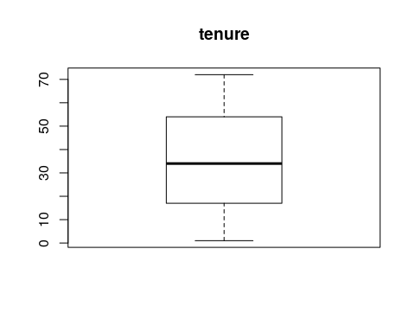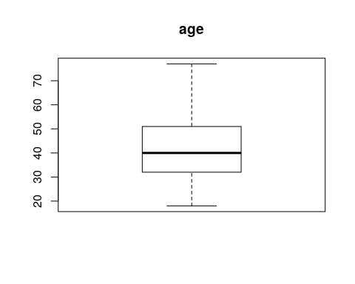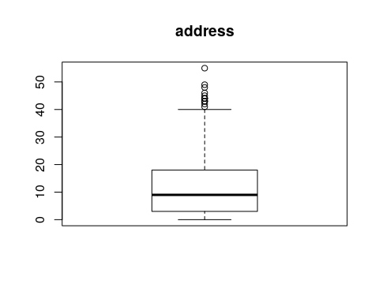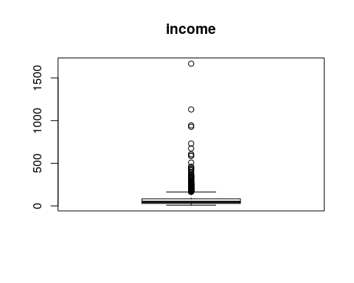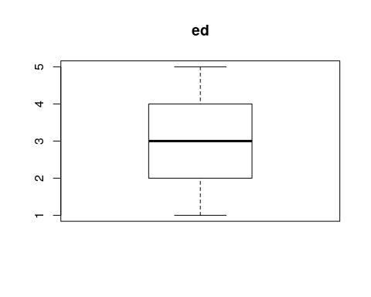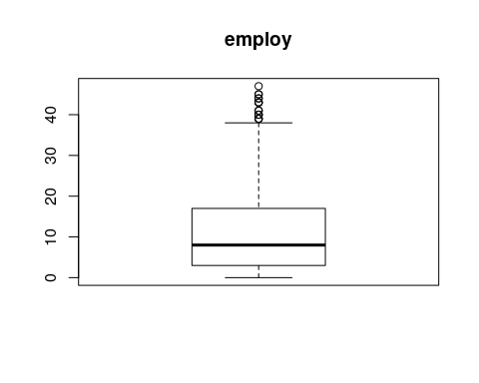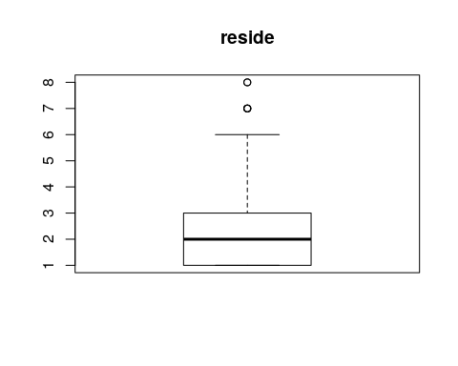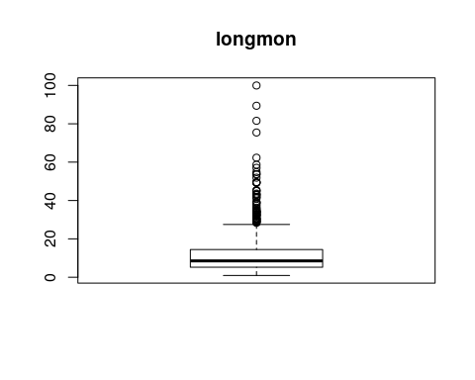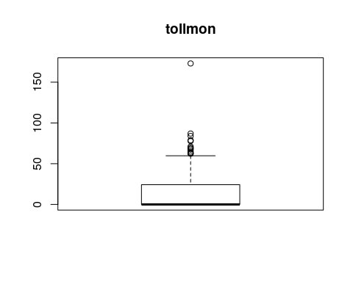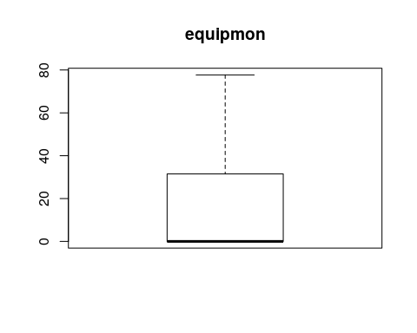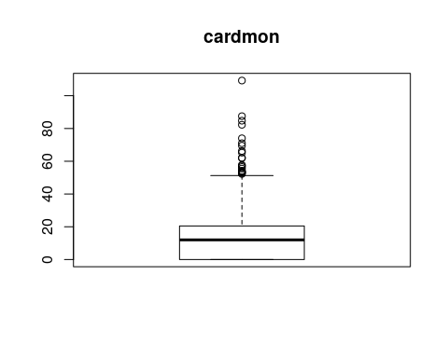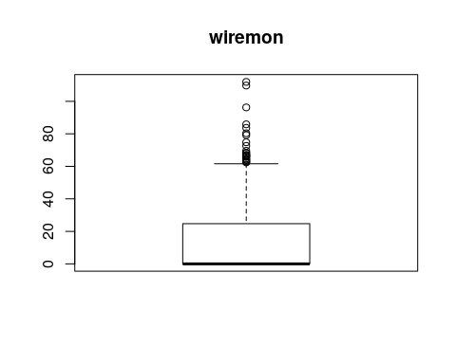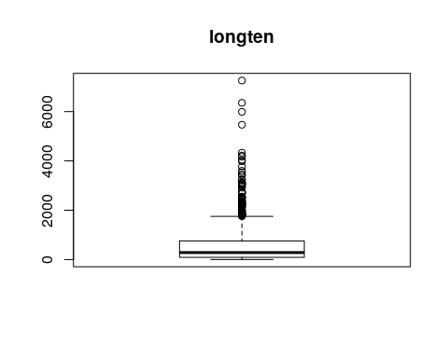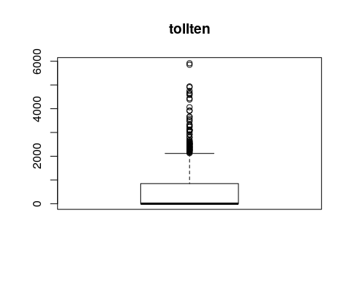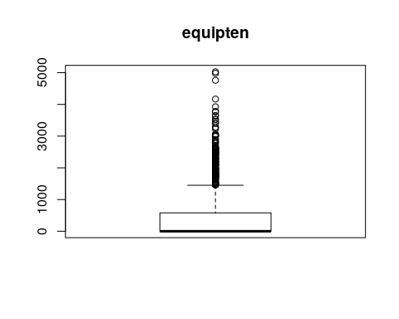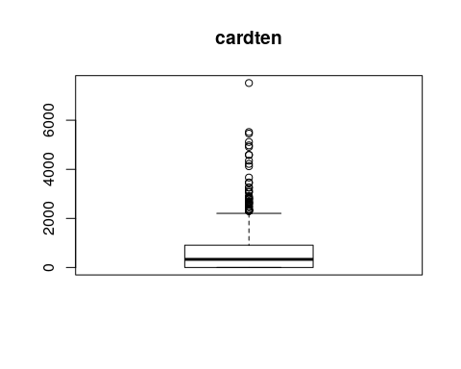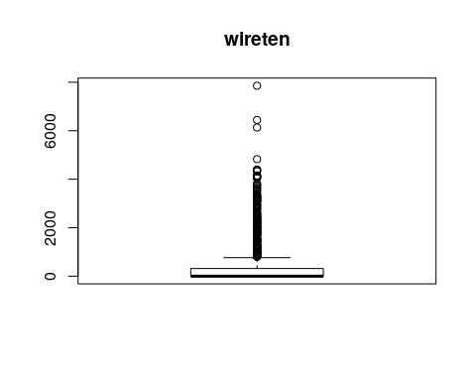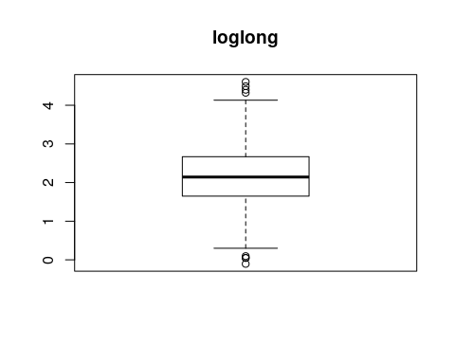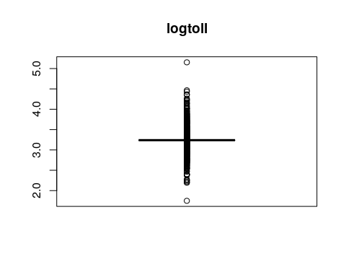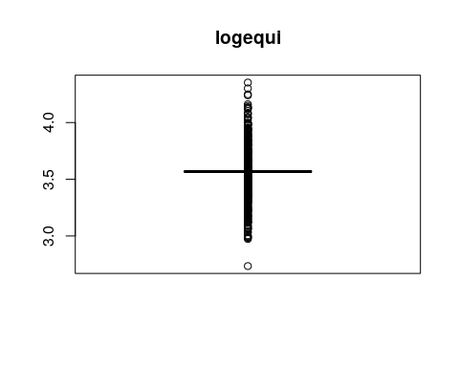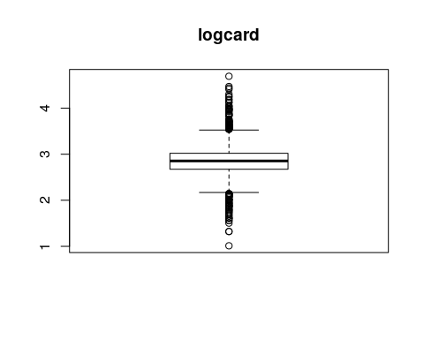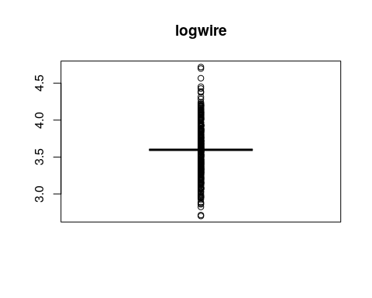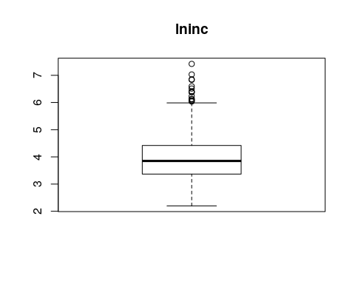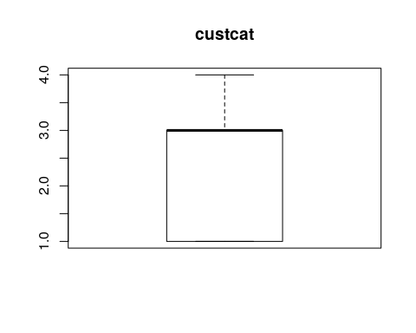

Result : There are outliers in many columns but it is not necessary that all the parameters of the same row are having extreme data, so we are not removing any data from it.

Step 3: Normality test

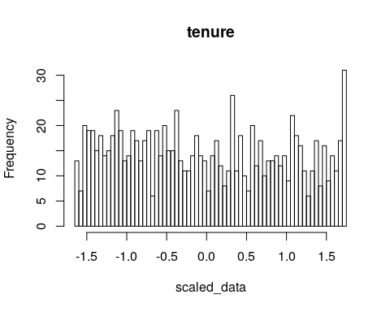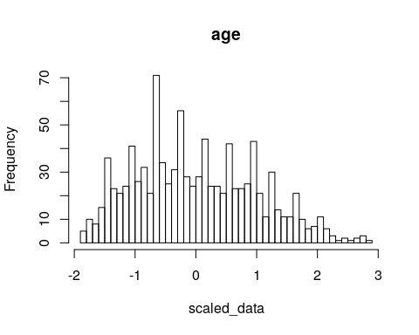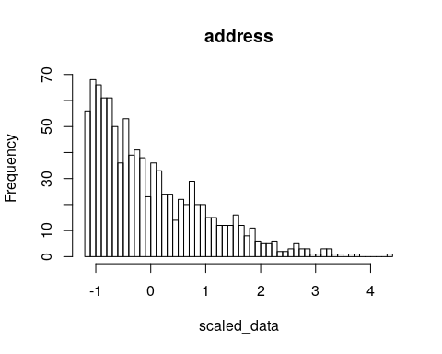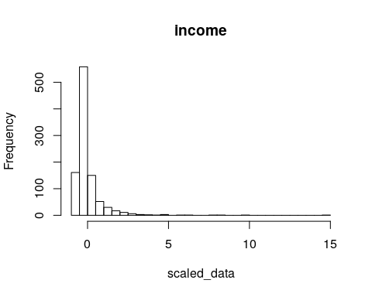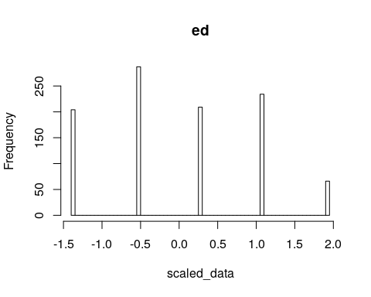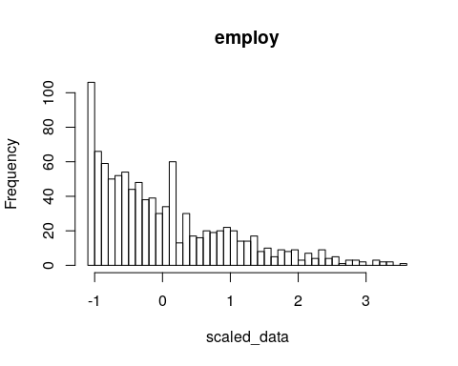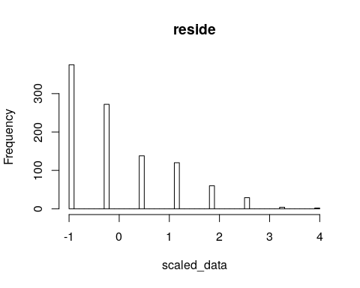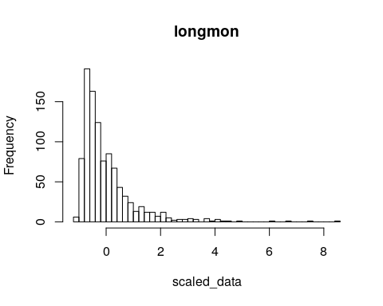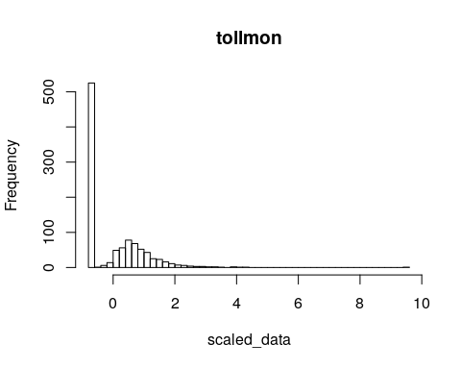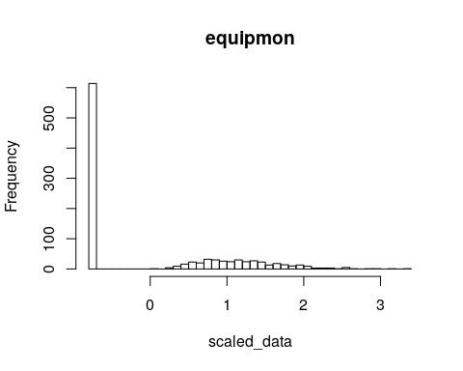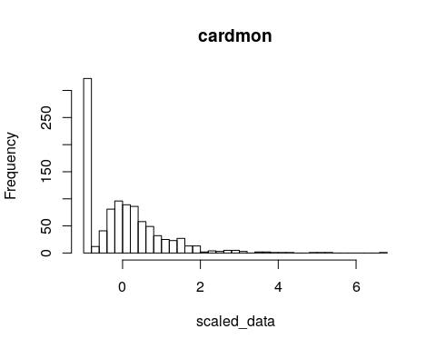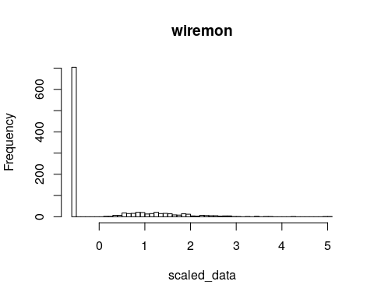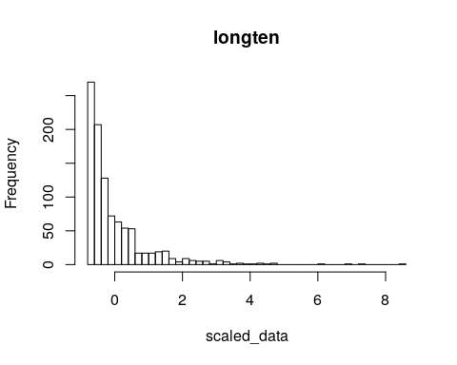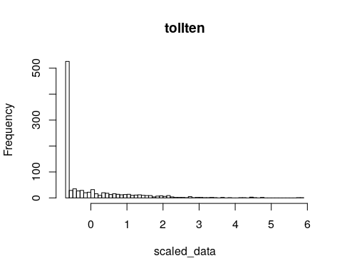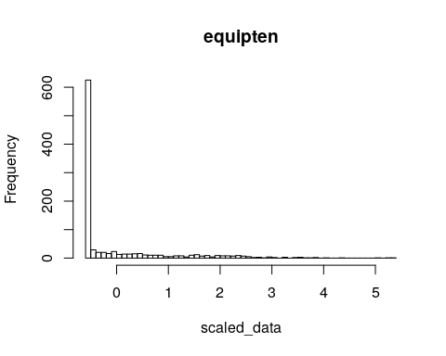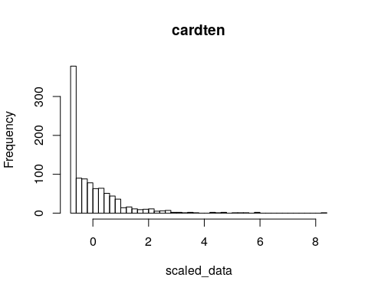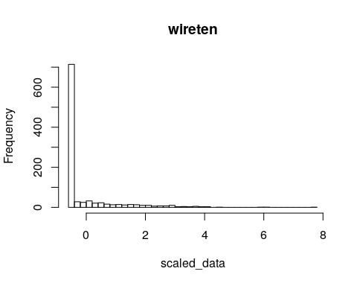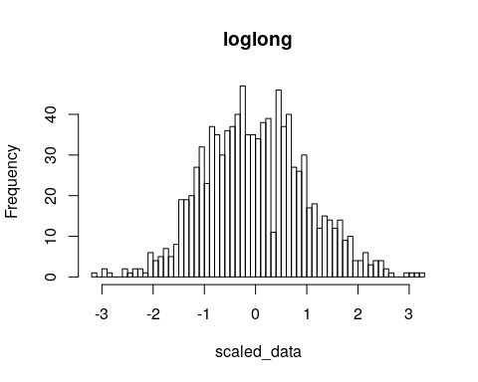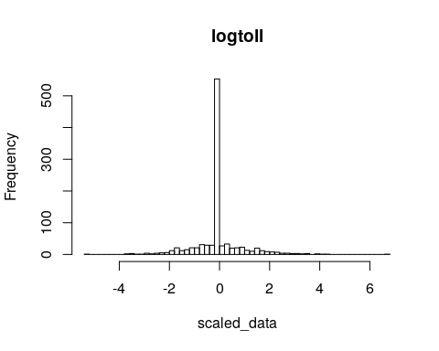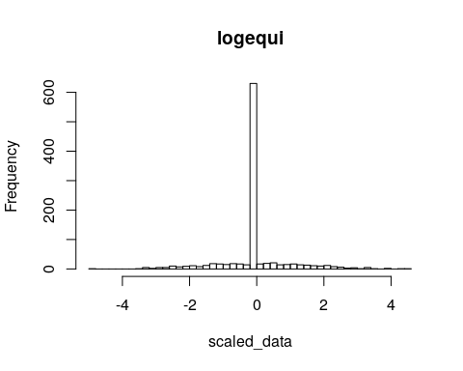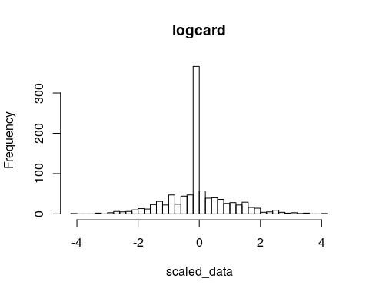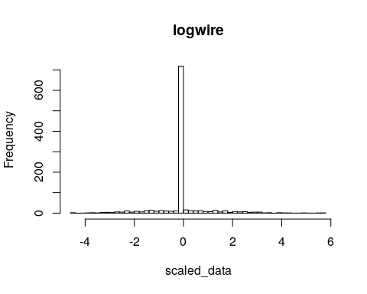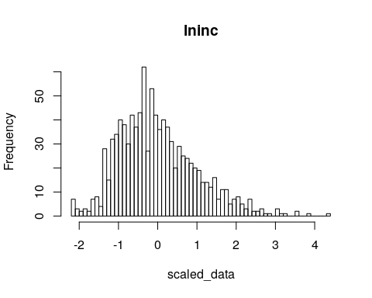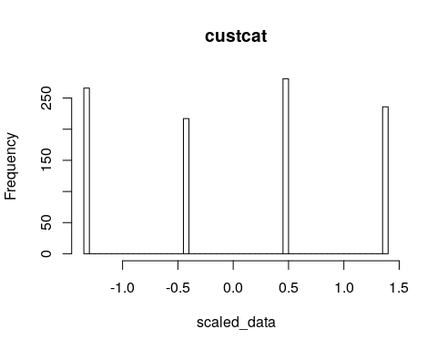 # PCA

##   
## Attaching package: 'psych'

## The following object is masked from 'package:Hmisc':  
##   
## describe

## The following objects are masked from 'package:ggplot2':  
##   
## %+%, alpha

## [1] 9.823359505 6.505848576 3.780714649 2.175201926 1.699936153  
## [6] 1.590329085 1.435394281 1.229607311 1.107029731 1.050384890  
## [11] 0.961237994 0.879722315 0.847131000 0.756102813 0.700202168  
## [16] 0.679398324 0.626977650 0.609703400 0.545505915 0.519643825  
## [21] 0.482914445 0.464304575 0.427325745 0.404074529 0.369886297  
## [26] 0.359121143 0.347785126 0.312170599 0.269923156 0.208735419  
## [31] 0.172115635 0.133646565 0.125537227 0.118615676 0.096433199  
## [36] 0.089033965 0.041735109 0.026603402 0.017445103 0.004853706  
## [41] 0.003102540 0.001205325