Assignment3_B_1_1

Sangamesh

25 September 2018

Reading data and making data into training and test data.

## [1] "head of training data"

## Y1 X1 X2  
## 1 -1.0565192 -6.236444 0.9615355  
## 2 -0.5754127 -3.873848 0.5050130  
## 3 5.0910630 5.640287 0.7175317  
## 4 2.9475637 1.191125 0.3074231  
## 5 2.9519538 -10.849769 0.5960600  
## 6 3.1685278 2.603705 0.3109550

## [1] "head of testing data"

## Y1 X1 X2  
## 10 -0.7316911 -2.2906586 0.43611757  
## 20 1.1998000 7.7123714 0.47222562  
## 30 0.6124209 -1.4169026 0.01161898  
## 40 -0.1139879 0.6901132 0.48192669  
## 50 3.5655124 1.3302962 0.49526489  
## 60 4.3900710 3.1920603 0.98896327

Fitting data for linear regression model

##   
## Call:  
## lm(formula = Y1 ~ X1 + X2, data = trainData)  
##   
## Residuals:  
## Min 1Q Median 3Q Max   
## -3.1226 -1.3189 -0.0519 1.1825 3.3815   
##   
## Coefficients:  
## Estimate Std. Error t value Pr(>|t|)   
## (Intercept) 2.77301 0.33680 8.233 1.66e-12 ***  
## X1 0.19480 0.03465 5.623 2.24e-07 ***  
## X2 -0.15753 0.61320 -0.257 0.798   
## ---  
## Signif. codes: 0 '***' 0.001 '**' 0.01 '*' 0.05 '.' 0.1 ' ' 1  
##   
## Residual standard error: 1.711 on 87 degrees of freedom  
## Multiple R-squared: 0.2666, Adjusted R-squared: 0.2498   
## F-statistic: 15.81 on 2 and 87 DF, p-value: 1.387e-06

Several metrics useful for regression diagnostics : model.diag.metrics

## # A tibble: 6 x 11  
## .rownames Y1 X1 X2 .fitted .se.fit .resid .hat .sigma  
## <chr> <dbl> <dbl> <dbl> <dbl> <dbl> <dbl> <dbl> <dbl>  
## 1 1 -1.06 -6.24 0.962 1.41 0.460 -2.46 0.0724 1.70  
## 2 2 -0.575 -3.87 0.505 1.94 0.265 -2.51 0.0240 1.70  
## 3 3 5.09 5.64 0.718 3.76 0.272 1.33 0.0252 1.71  
## 4 4 2.95 1.19 0.307 2.96 0.203 -0.00905 0.0141 1.72  
## 5 5 2.95 -10.8 0.596 0.566 0.480 2.39 0.0788 1.70  
## 6 6 3.17 2.60 0.311 3.23 0.206 -0.0627 0.0145 1.72  
## # ... with 2 more variables: .cooksd <dbl>, .std.resid <dbl>

Meta Data for model.diag.metrics Among the table columns, there are:

Y1: original values X1, X2: the observed values .fitted: the fitted values .resid: the residual errors

#### Let’s see correlation between the features:

We can see the plot in residual and fitted plot here now: 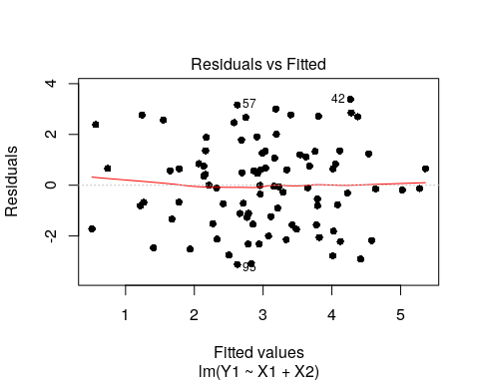

Note how the residuals plot of this last model shows some important points still lying far away from the middle area of the graph. Since the behaviour is random in nature we were successful in this test.

## Loading required package: carData

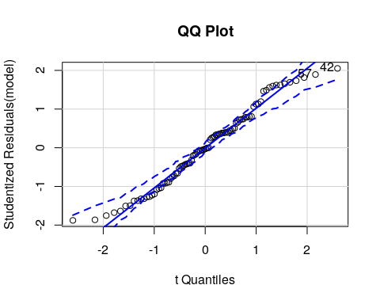

## 42 57   
## 38 52

Check outliers: 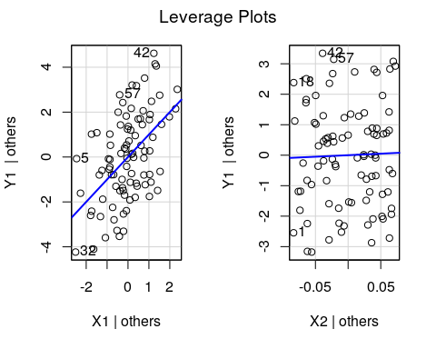

We can see that there are outliers in this dataset mainly row 5,42,57,32 from X1, and 18,42,57,1 from X2. So, overall number 42 and 57 are outliers.

Influential Variables : Fiding influential data points is required. So let us look at variable plots: 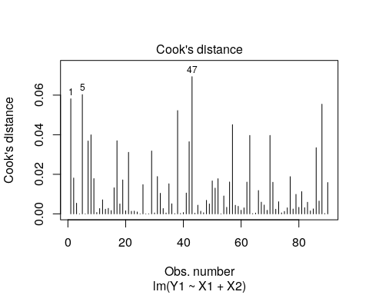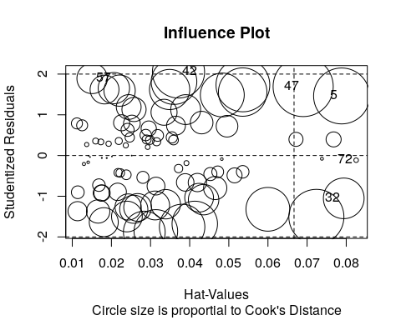

## StudRes Hat CookD  
## 5 1.463036 0.07882556 0.0602640116  
## 32 -1.052152 0.07936606 0.0317723820  
## 42 2.051376 0.03714193 0.0521849091  
## 47 1.692974 0.06899694 0.0693171600  
## 57 1.893423 0.01507526 0.0177631223  
## 72 -0.115048 0.08253501 0.0004014576

Checking for Multi-collinearity:

## X1 X2   
## 1.004315 1.004315

## X1 X2   
## FALSE FALSE

Non-constant Error Variance:

## Non-constant Variance Score Test   
## Variance formula: ~ fitted.values   
## Chisquare = 0.0003181395, Df = 1, p = 0.98577

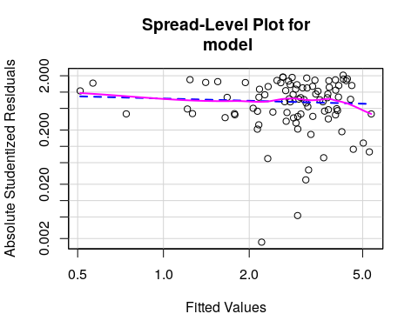

##   
## Suggested power transformation: 1.136489

Nonlinearity test: 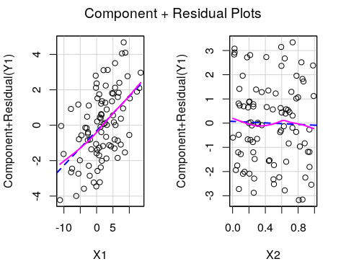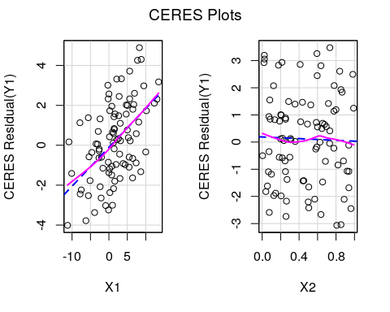 So all the factors are linear which is required.

Non-independence of Errors:

## lag Autocorrelation D-W Statistic p-value  
## 1 -0.1061408 2.17664 0.444  
## Alternative hypothesis: rho != 0