Report by Sangam Sahai

**TTU – IR Mobile Android App**

**10th February 2016**

Contents

Extract 2

About US Screen 4

Trends Screens 6

Contact Us Screen 8

Integrated Map 9

Integrated Email 10

Staff Screen 11

FactBook Screen 12

Figures

Figure 1 - Screenshot of the Home Screen 3

Figure 2 - Screenshot of 'About Us' option 5

Figure 3 - Screenshot 1 for 'Trends' Option 6

Figure 4 - Screenshot 2 for 'Trends' option 7

Figure 5 - Screenshot of 'About Us' option 8

Figure 6 - Screenshot of 'Integrated Map' option 9

Figure 7 - Screenshot of 'Integrated Mail' option 10

Figure 8 - Screenshot of 'Staff Screen' 11

Figure 9 - Screenshot 1 for ' Fact Screen' option 12

Figure 10 - Screenshot 2 for 'FactBook Screen' 13

Figure 11 - Screenshot 3 for 'FactBook Screen' 14

**TTU – IR Mobile Android App**

# Extract

The Institutional Research Department at Texas Tech tracks data for students, faculty and research, all of which can be displayed for the university as a whole or for individual colleges.

The Trends Web Application (http://techdata.irs.ttu.edu/Trends/) displays multiple years of data for key measures like Enrollment, Graduation Rates etc. This application shows the data visually in the form of charts so that it easy for the users to see the data and analyze the data pattern.

TTU IR mobile app aims to present a condensed view of the Trends application for mobile users. Apart from the Trends data, this app gives some other information about the IR department.

A quick view and the basic functionalities (with screen shots) of the mobile app are as follows –

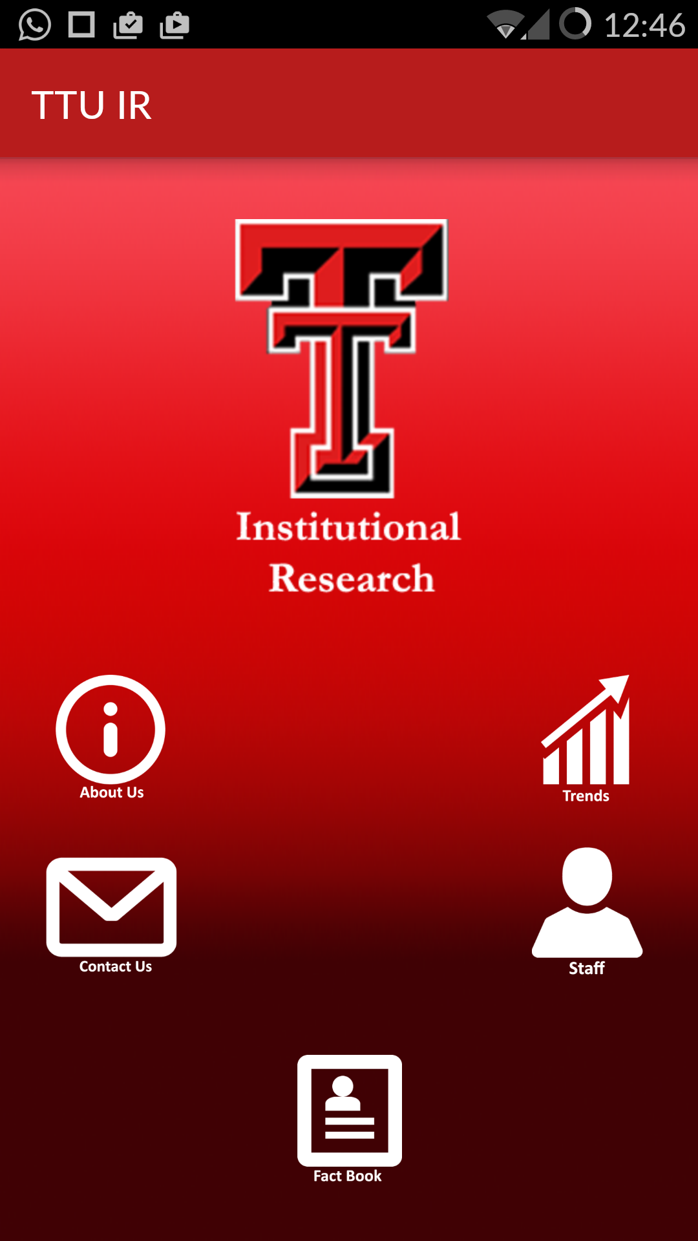

**Figure 1 - Screenshot of the Home Screen**

It has got 5 buttons which are as follows –

1. *The About Us button* – This button takes us to the screen which tells about the Mission, Vision Statement and Department Values of Institutional Research department.
2. *Trends* – This button takes us to the screens which show the Trends application data in form of charts as in the web application.
3. *Contact Us* – This button takes us to the contact us screen where we can see the Mailing Address and Physical Address of the department. This screen also has integrated email and map facility which this document will explain in detail.
4. *Staff* – This button takes us to the screen which shows the name of staff members along with their designation and phone number (as in the web application).
5. *Factbook* – This button takes us to the screens which show quick facts about the University in the form of Graphs and Tables. Data includes – Total enrollment in last 10 years, new students by College, One year Retention rate etc.

Now we will discuss the functionalities in detail and also see the screen shots of the screens.

# About US Screen

Below is the screen shot which shows the ‘About Us’ screen. This shows the Mission statement. Also, this is a scrollable view and as we scroll down, we will be able to see Vision Statement and the Departmental Values. This data has been taken from our Web Application.

Also, there is a home button (shown by the home icon), which will take us back to our home screen.

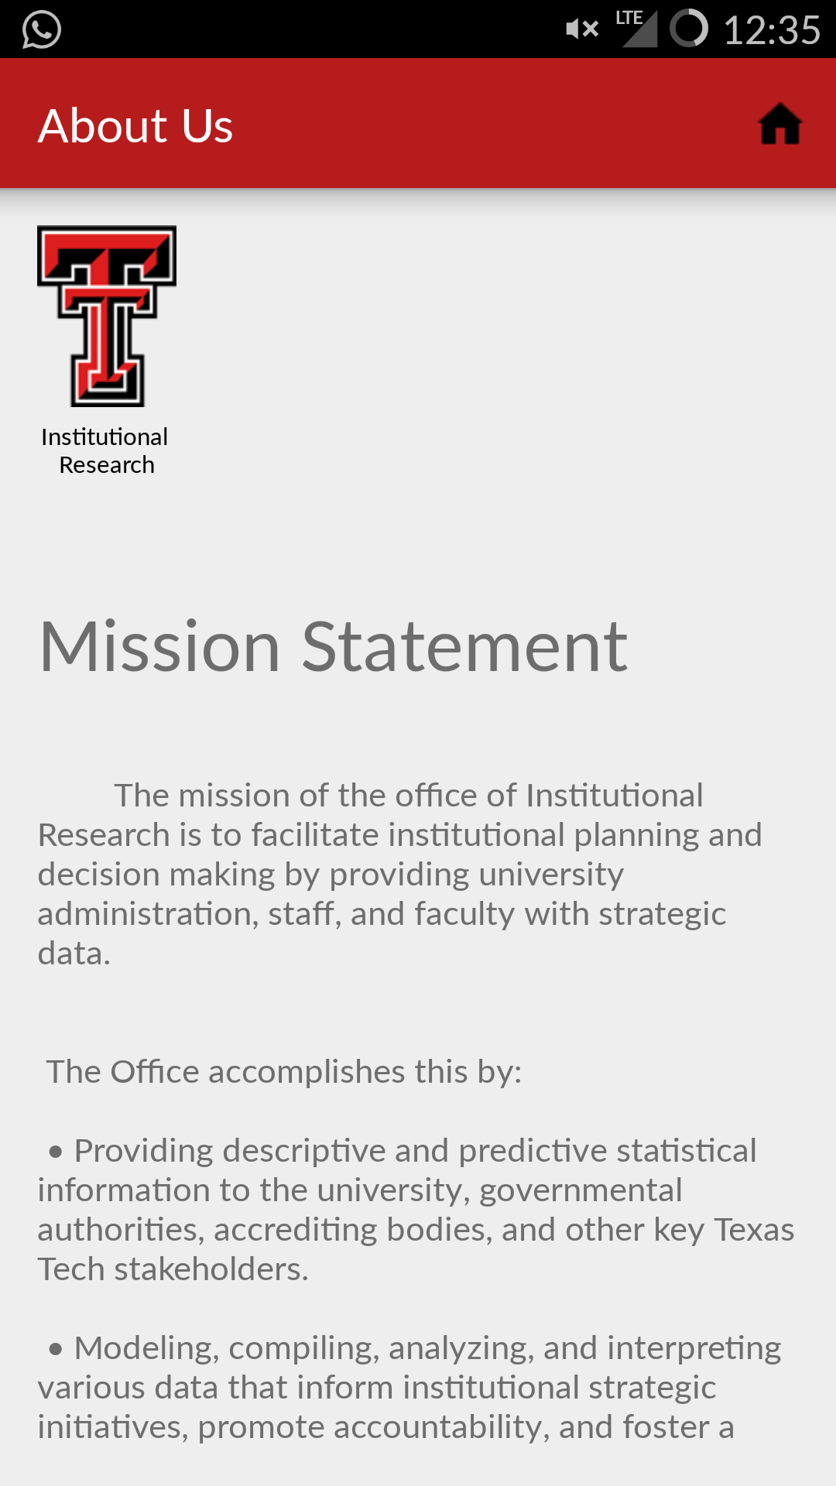

**Figure 2 - Screenshot of 'About Us' option**

# Trends Screens

Below are a few Trends Screens. These show the Trends data in visual form (charts), like in the Trends Web Application.

Please note that this app contains a condensed view of the Trends application. So all the screens from the web application have not been added in this app. If users want more detailed data with more search parameters, they can easily navigate to the Trends Website by the *navigate button* in the top right corner (shown by the *arrow* icon).

Also the users can either the swipe the pages (left or right) to go to the next Trends screen, or they can use the Trends menu by the menu button in the top right corner (shown by three dots in white).

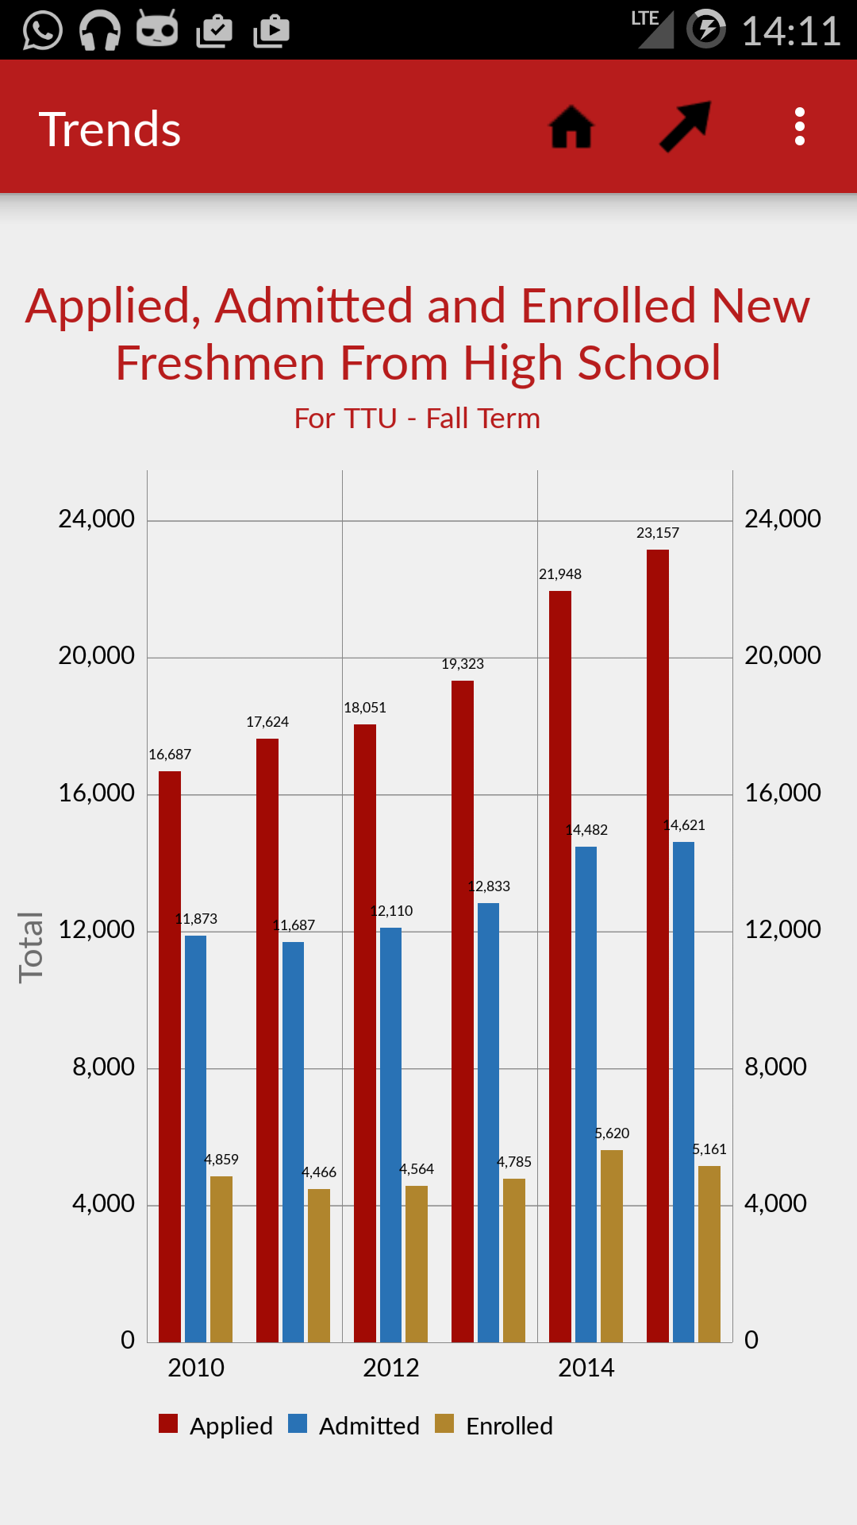

**Figure 3 - Screenshot 1 for 'Trends' Option**

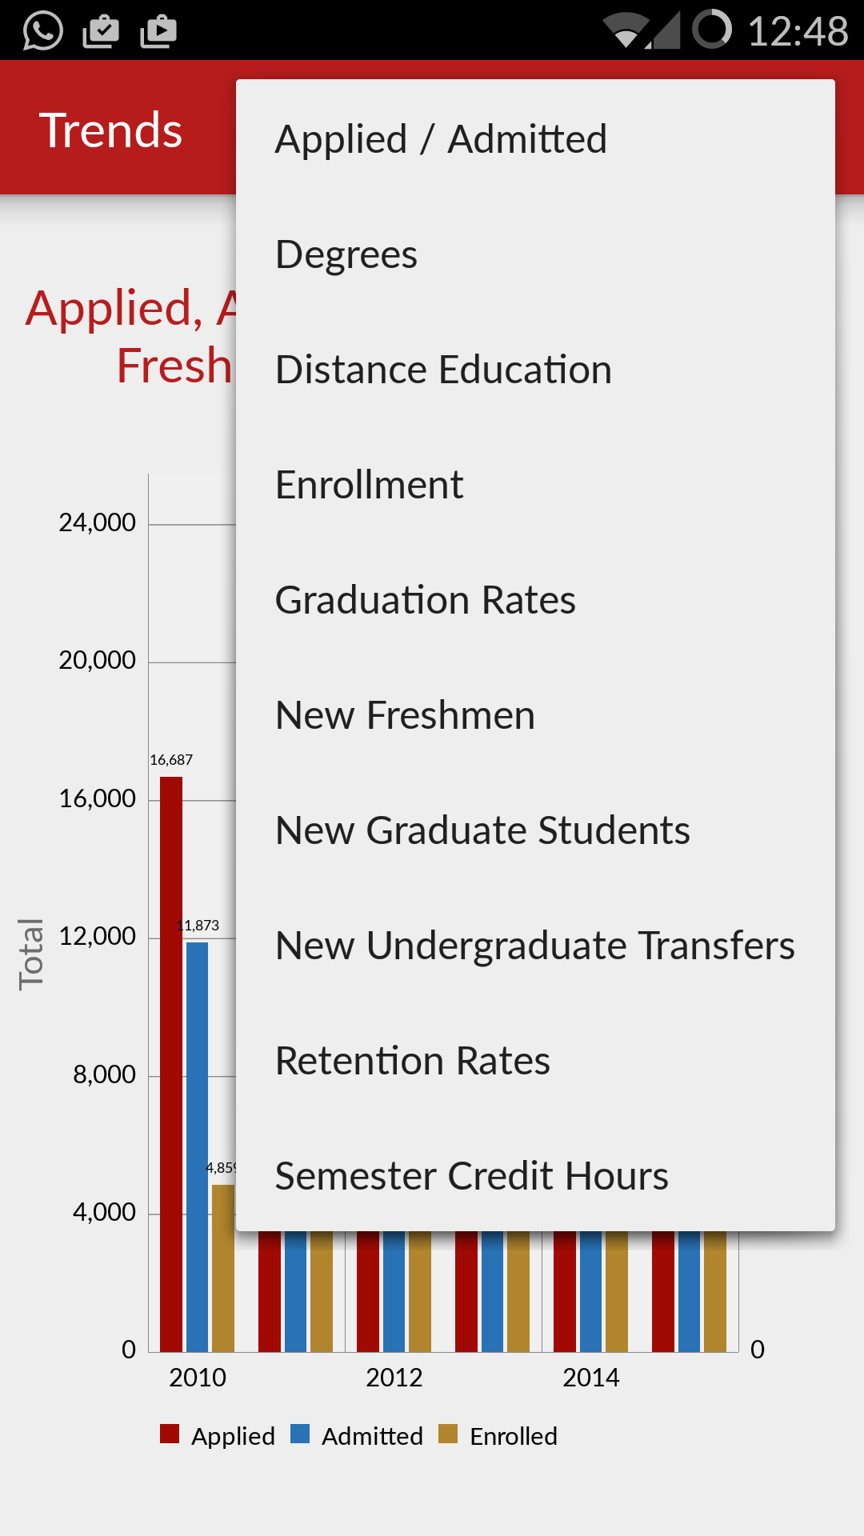

**Figure 4 - Screenshot 2 for 'Trends' option**

# Contact Us Screen

This screen shows the Mailing and the Physical Address of our department.

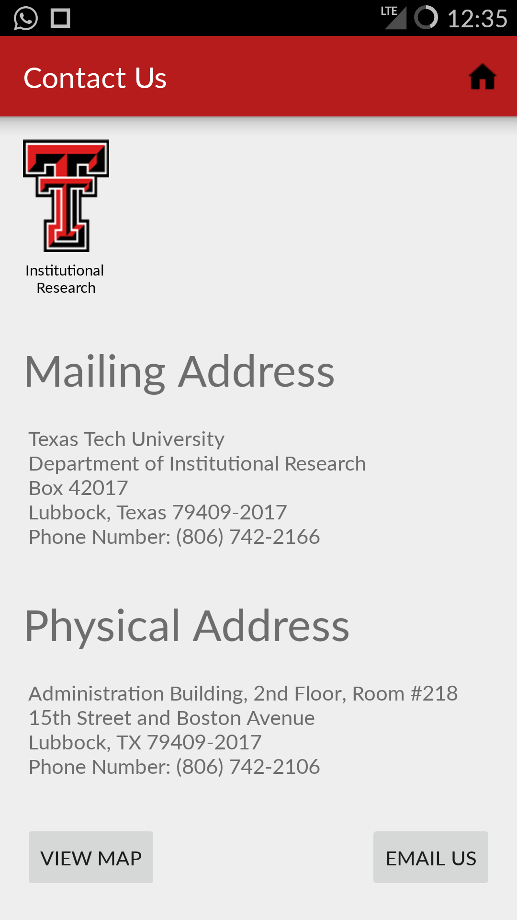

**Figure 5 - Screenshot of 'About Us' option**

The above screen has 2 added functionalities –

Integrated Map – If the users click the View Map button in the bottom left, they can navigate to the map screen which shows the location of our department in the map.

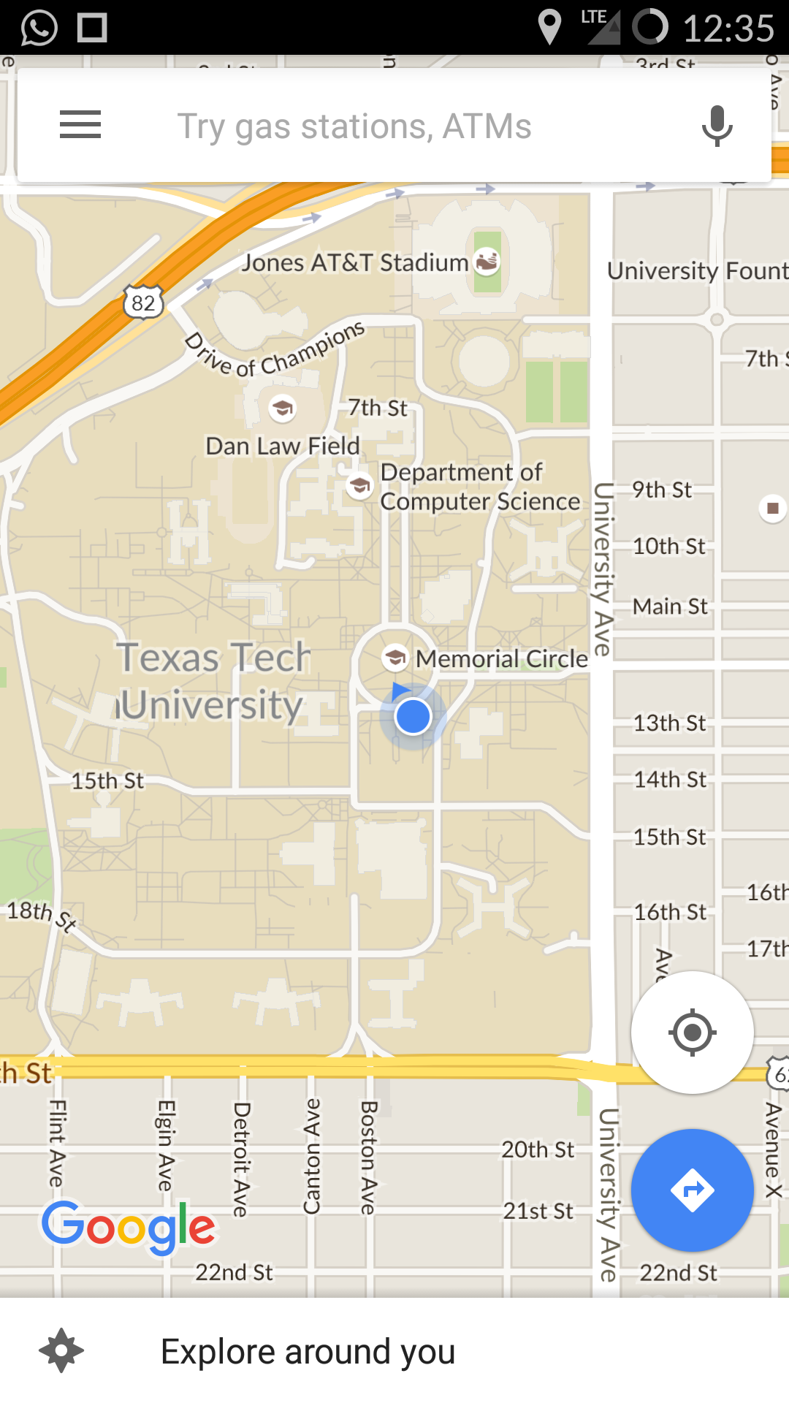

**Figure 6 - Screenshot of 'Integrated Map' option**

Integrated Email – If the users want to reach out to us or submit a query/feedback then they can tap the Email Us button, which will take them to the email client (Gmail, Outlook etc.) which they use. And the compose email screen will automatically open up, in which the ‘to address’ and the ‘Subject’ will be populated as shown below.

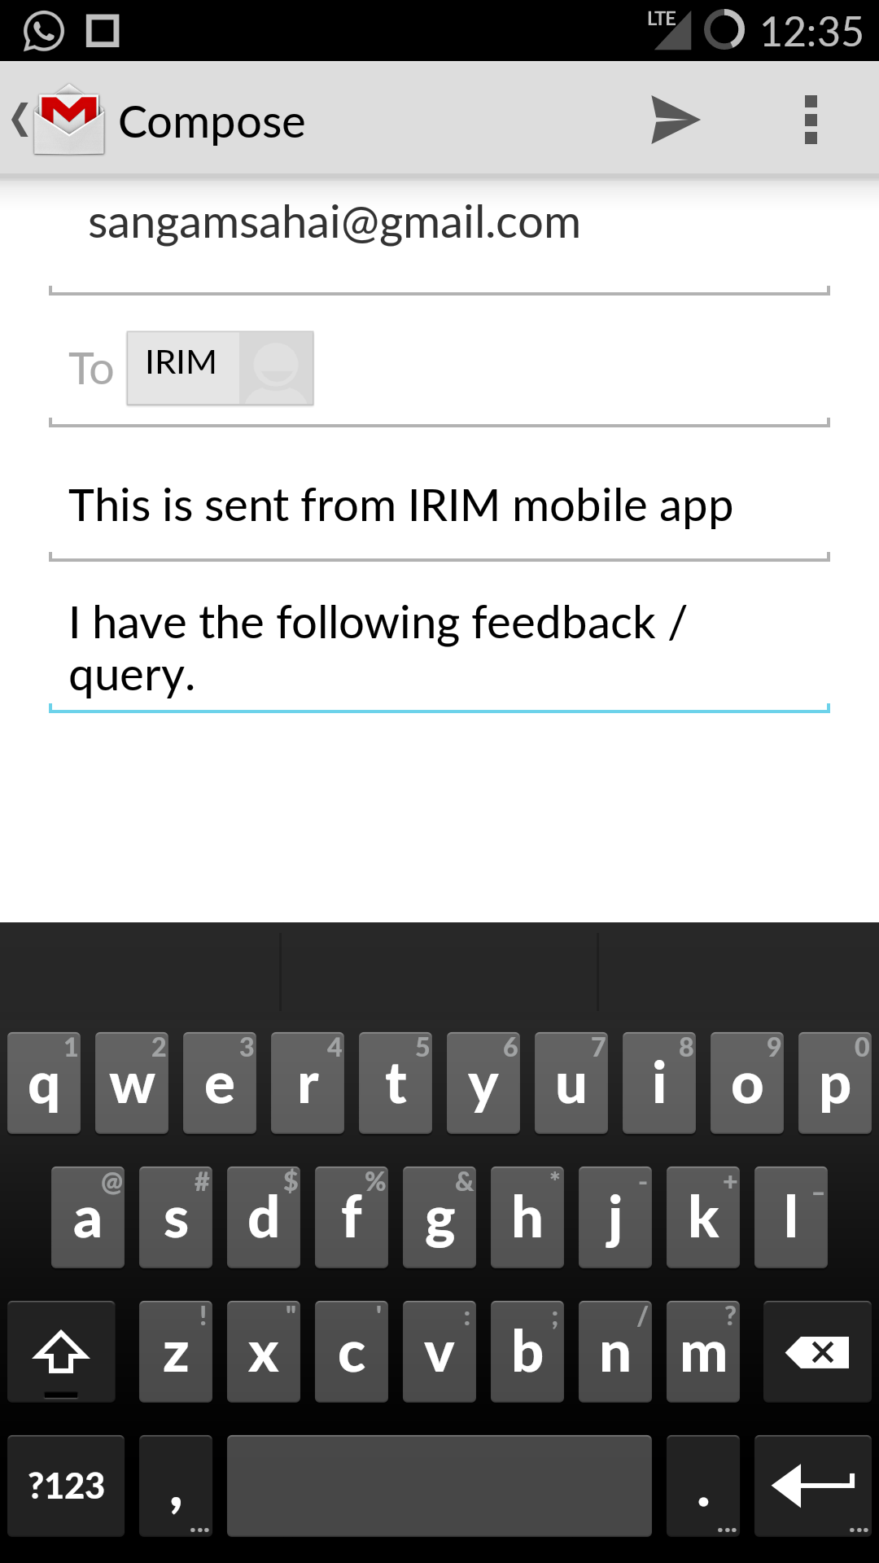

**Figure 7 - Screenshot of 'Integrated Mail' option**

# Staff Screen

This button takes us to the staff screen which shows the details of the staff members as follows.

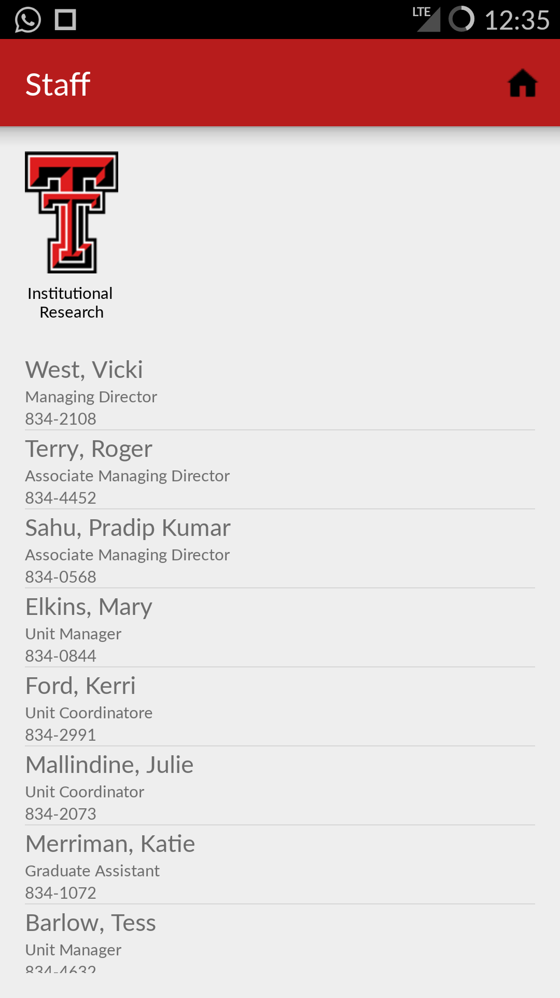

**Figure 8 - Screenshot of 'Staff Screen'**

# FactBook Screen

This button takes us to screens which show the quick facts about the University in the form of Graphs and Tables. Data includes – Total enrollment in last 10 years, new students by College, One year Retention rate etc.

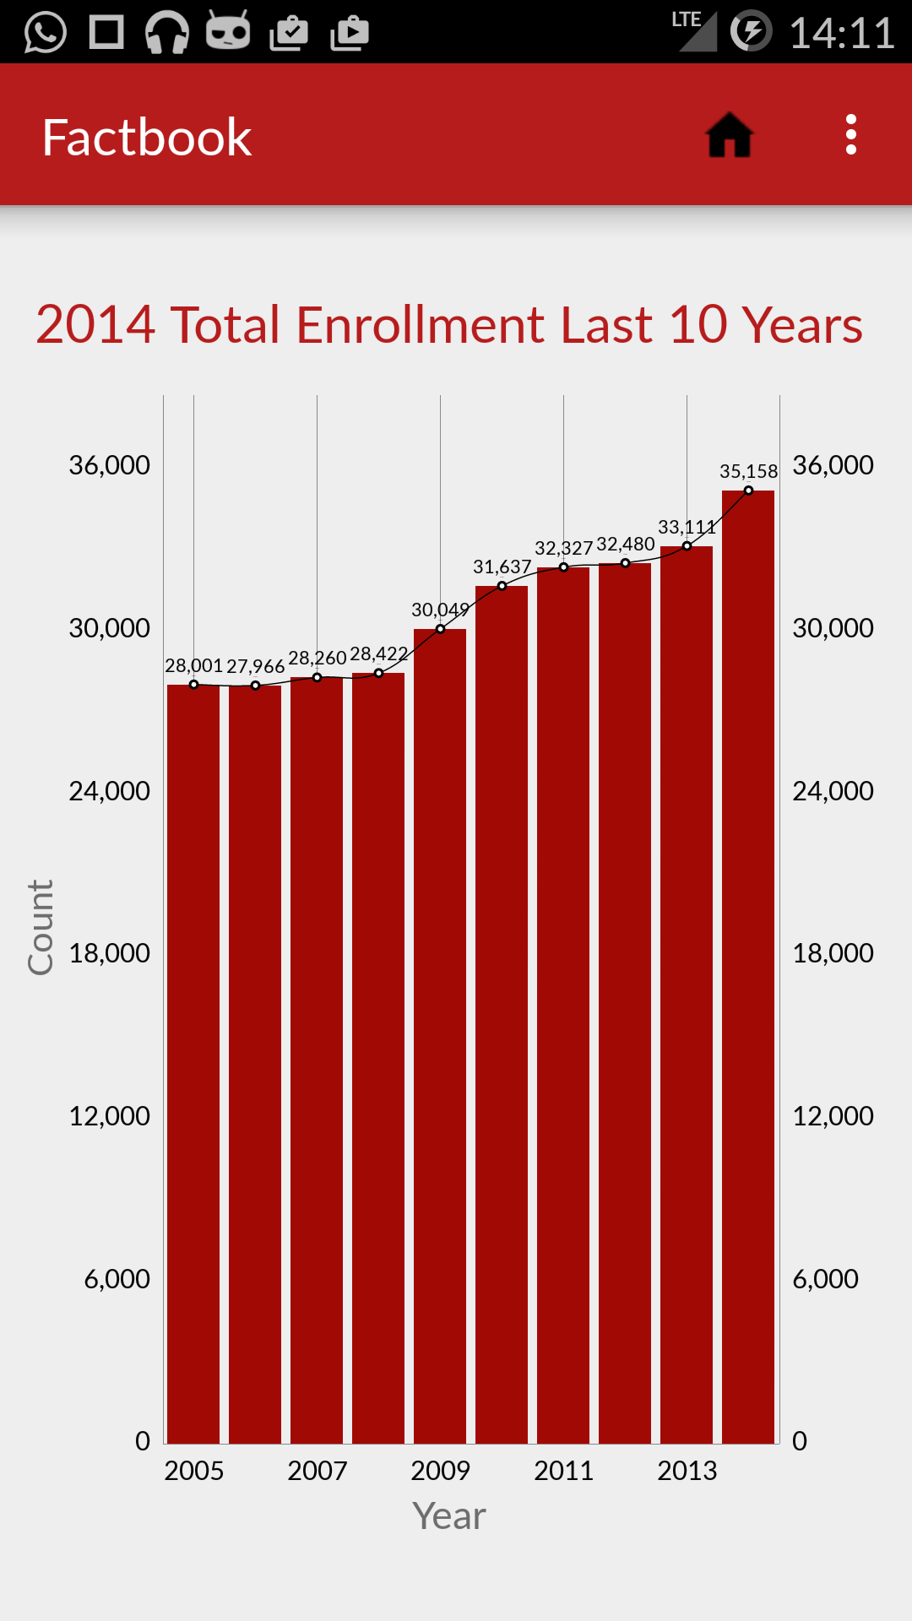

**Figure 9 - Screenshot 1 for ' Fact Screen' option**

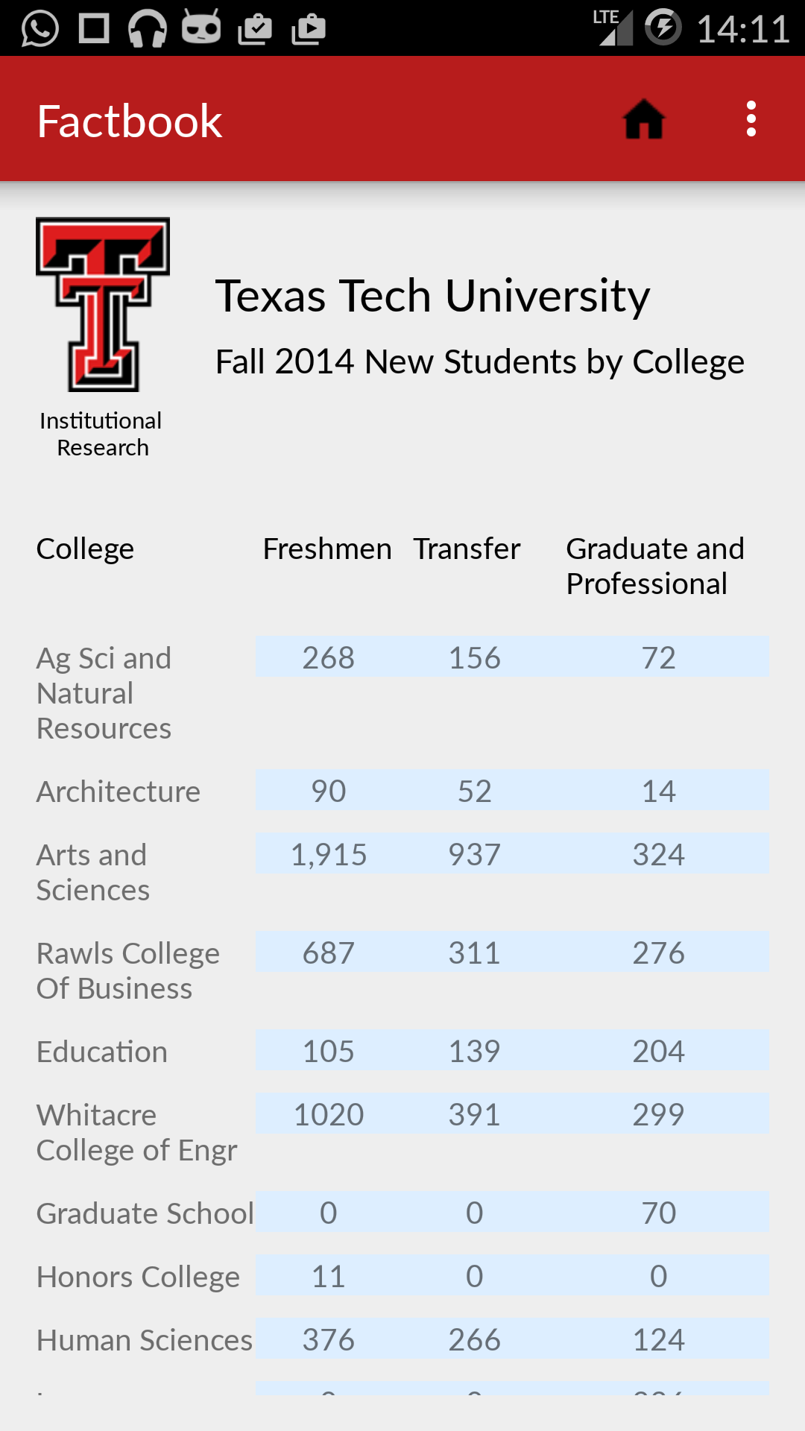

**Figure 10 - Screenshot 2 for 'FactBook Screen'**

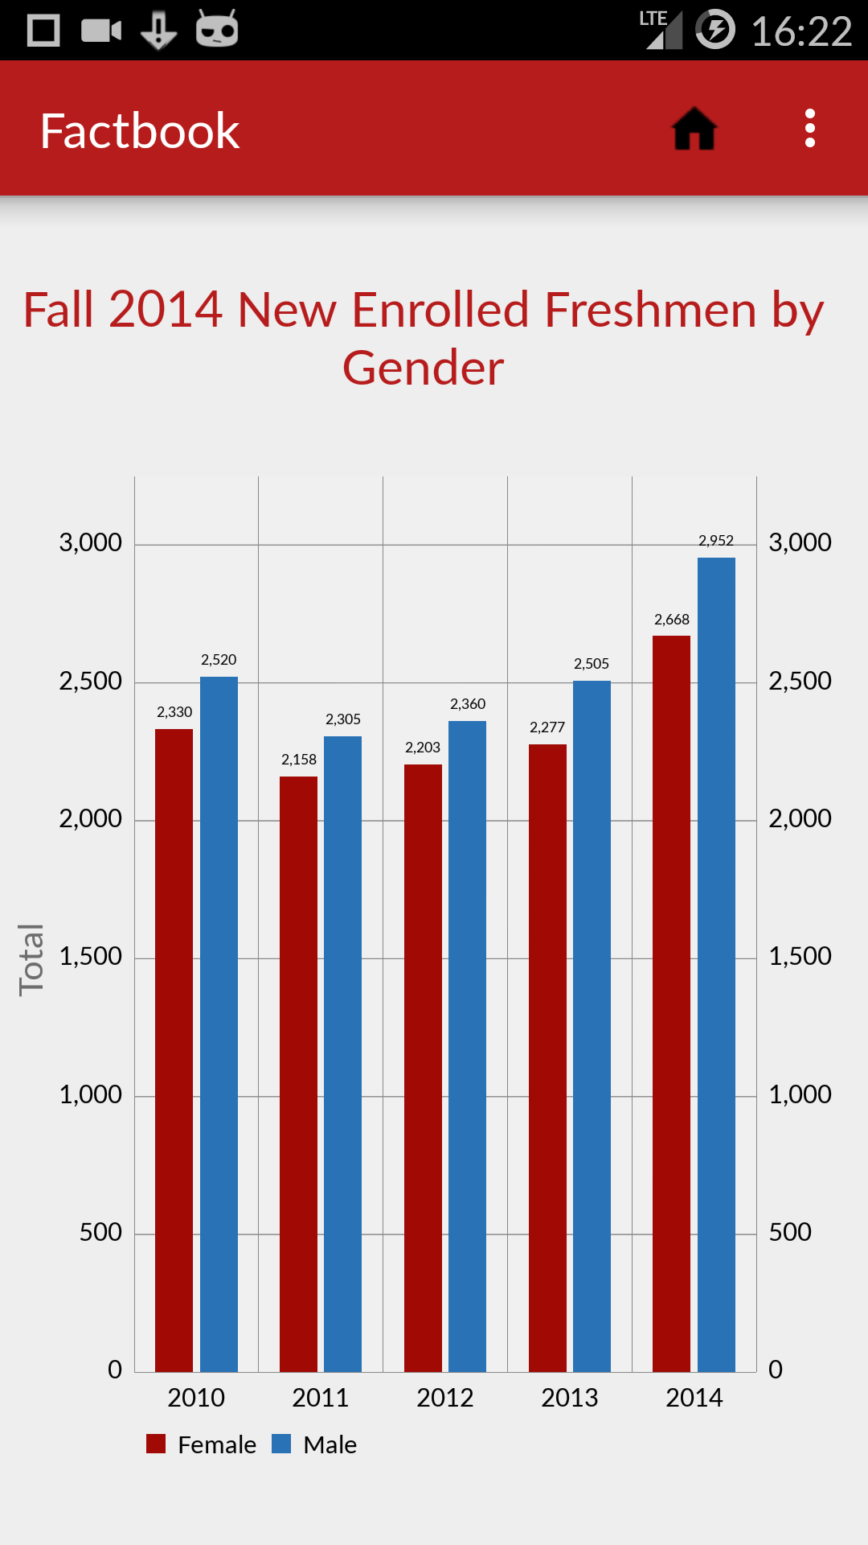

**Figure 11 - Screenshot 3 for 'FactBook Screen'**

Also, we plan to develop the Apple (iOS) version of the mobile app which will be similar to this Android app in terms of the look and the functionalities.

--------------------------------------------***End of the Document***-------------------------------------------