**Instructions to Run the Code**

Following steps must be followed:

1. Set the following parameters in the GlobalParameters.java file:
   1. Your color and opponent’s color (black ‘b’ or white ‘w’)
   2. Size of the board (ROWS and COLUMNS)
   3. Depth of the search tree
2. In TestClass.java file:
   1. Set the initial board configuration by populating startingArray.
   2. Create an object of Minimax Class and set it’s configuration as follows:
   3. Call getTheMiniMaxNextMove function to get the next move.
   4. Print the boardState for this move.

**(All of the above is documented in the TestClass.java file)**

1. Assuming that JRE is installed on the system and classpath is set, run the TestClass.java file using:

javac TestClass.java

java TestClass

For example, the initial board configuration can be set as follows:

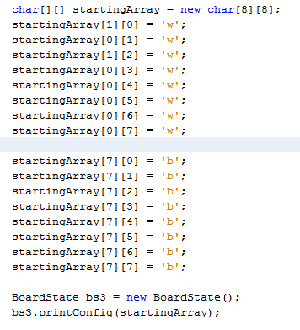 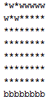

Note that we only need to specify the position of black or white pieces on the board, the unoccupied squares are implicitly handled in the code.

To get the next move:

