This is an implementation of the Tree Barrier.

Barrier is a mechanism, which is used to synchronize the execution of code running parallel on different nodes.

This application assumes that the total number of nodes will a power of 2 (like 2, 4 , 8 etc.).

Please refer to the picture attached which explains the working of this Barrier.

In order to explain the Algorithm, we will assume that the number of nodes are 8 (numbered from 0-7).

Algorithm –

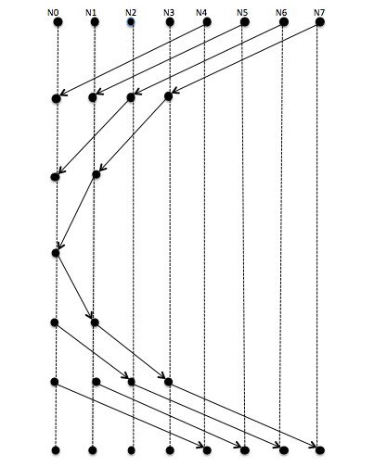

1) This is the first Iteration where we pair up nodes and one node sends the message to the other node when the barrier is reached.

Node 4 sends the message to node 0 .

Node 5 sends the message to node 1 .

Node 6 sends the message to node 2 .

Node 7 sends the message to node 3 .

2)

Node 2 sends message to 0.

Node 3 sends message to 1.

3)

Node 1 sends message to node 0.

By this step , the process 0 knows that all the other processes have reached the Barrier.

4) At this point of time, the process 0 needs to broadcast this information to all other nodes.

It broadcasts this information back to all other processes.

And it does that in a similar manner.

Precisely, a procedure which is exact mirror image of the first half of the picture which is attached.

How to Run:-

1. The command used to compile the code is ->

mpicc –o <executable name> <filename>

2) The command used to run the code is ->

mpirun –np <no of parallel processors> <executable name>