

Project Initialization and Planning Phase

Date | 25/09/2026
Team ID | SWTID-2026-2701
Project Name | EduGenie: Google Gemini powered learning assistant
Maximum Marks | 3 Marks

Define Problem Statements (Customer Problem Statement Template):
Create a problem statement to understand your customer's point of view. The Customer Problem Statement template helps you focus on what matters to create experiences people will love. A well-articulated customer problem statement allows you and your team to find the ideal solution for your customers' challenges. Throughout the process, you’ll also be able to empathize with your customers, which helps you better understand how they perceive your product or service.

Example:
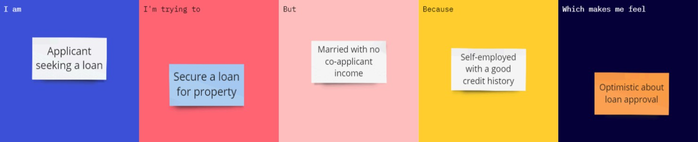
Completed Customer Problem Statements
Problem Statement | I am (Customer) | I'm trying to | But | Because | Which makes me feel
PS-1 | A student / learner | Understand difficult academic topics quickly | Textbooks and online explanations can be lengthy or difficult to understand | I need simple, clear explanations suited to my learning level | Confused and less confident about the topic
PS-2 | A student preparing for exams | Test my understanding of a topic | Creating useful practice questions manually takes time | I need quick quizzes with relevant multiple-choice questions and answers | Uncertain about my level of preparation
PS-3 | A learner studying a new subject | Follow a structured path from beginner to advanced level | I may not know which concepts to learn first or which resources to use | I need personalized topic order, guidance and learning resources | Overwhelmed and unsure where to start

