Data Flow Diagram

Date | 25/09/2026
Team ID | SWTID-2026-2701
Project Name | EduGenie: Google Gemini powered learning assistant
Maximum Marks | 2 Marks

Data Flow Diagram
Create a Data Flow Diagram (DFD) to show how data moves through your system - between external entities, processes, and data stores. Use the symbol legend below as a guide.

DFD Symbol Legend

Symbol | Name | Description
Oval / Rounded shape | External Entity | A person, organization, or system outside the project that sends or receives data (e.g., Customer, Payment Gateway).
Rectangle with  numbered header | Process | An activity that transforms incoming data into outgoing data (e.g., Validate Request, Process Order).
Rectangle (solid fill, no number) | Data Store | A place where data is held for later use (e.g., Customer Database, Inventory).
Labeled arrow | Data Flow | The movement of data between entities, processes, and data stores, labeled with what data is being passed.

Example
The diagram below illustrates how the symbols above come together to form a complete data flow diagram.

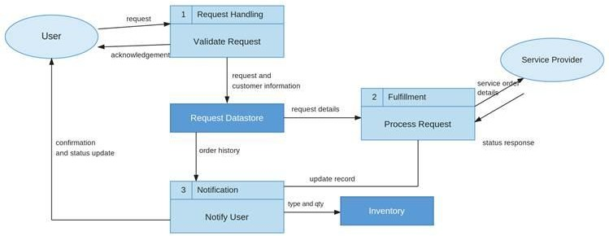
Completed EduGenie DFD
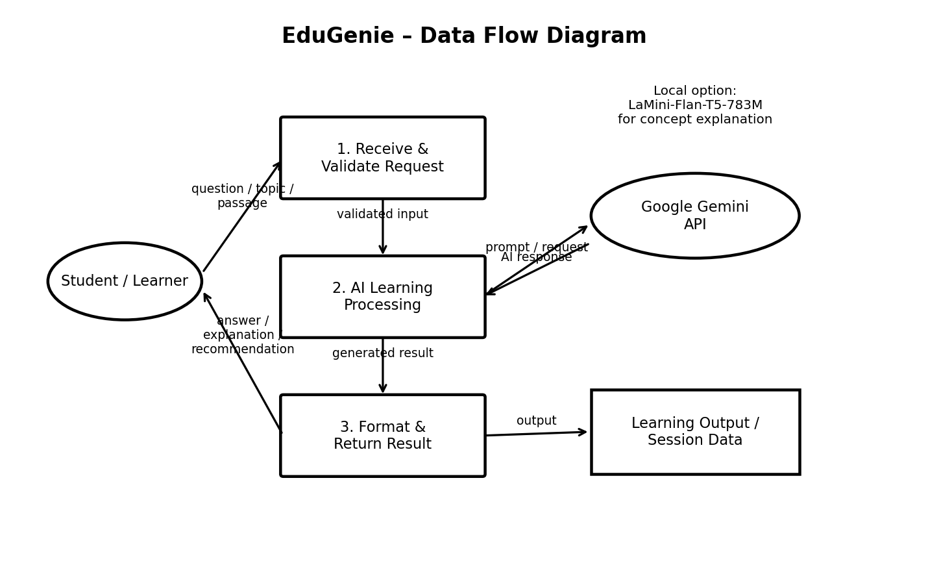
Data flow summary: The learner submits a question, topic or passage. FastAPI validates and routes it to the selected AI module. Gemini handles Q&A, quizzes, summaries and learning recommendations, while the local LaMini-Flan-T5 model can handle concept explanations. The formatted result is returned to the learner.

