Performance Testing

Date | 25/09/2026
Team ID | SWTID-2026-2701
Project Name | EduGenie: Google Gemini powered learning assistant
Maximum Marks | 5 Marks

Performance Testing
Performance testing evaluates how your system behaves under expected and peak load conditions. Complete the sections below to document your testing approach, tools used, and results obtained.

Step 1: Testing Overview

Field | Details
Testing Tool Used | Not specified / not independently recorded
Type of Testing | Functional testing documented; dedicated load/stress testing not recorded
Target Module / API | /qa, /explain, /quiz, /summarize, /learn/recommendations
Test Environment | Local development environment (FastAPI / Uvicorn)
Test Date | 25/09/2026

Step 2: Test Scenarios

S.No | Test Scenario / Description | No. of Virtual Users | Duration (sec) | Expected Outcome
1 | Functional request to Q&A endpoint | Not measured | Not measured | Question receives an appropriate response.
2 | Concept explanation request | Not measured | Not measured | Concept is returned in simplified form.
3 | Quiz generation request | Not measured | Not measured | Quiz is generated with MCQ options in the expected format.
4 | Summary / learning recommendation request | Not measured | Not measured | Summary or personalized recommendation is returned.

Step 3: Performance Test Results

S.No | Metric | Target Value | Actual Value | Status (Pass / Fail) | Remarks
1 | Response Time (Avg) | < 2 seconds | Not measured | Not assessed | No dedicated performance-test measurement was provided.
2 | Response Time (Max) | < 5 seconds | Not measured | Not assessed | No dedicated performance-test measurement was provided.
3 | Throughput (Req/sec) | To be established | Not measured | Not assessed | No load-testing result was provided.
4 | Error Rate | < 1% | Not measured | Not assessed | Functional error handling is documented, but a measured performance error rate was not provided.
5 | CPU Utilization | < 80% | Not measured | Not assessed | No CPU monitoring result was provided.
6 | Memory Utilization | < 80% | Not measured | Not assessed | No memory monitoring result was provided.

Step 4: Observations & Analysis
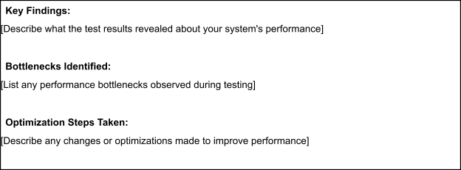

Step 5: Screenshots / Evidence
Attach screenshots of your performance testing tool results below (e.g., JMeter report, Locust graphs, k6 output):

Step 4: Observations & Analysis
Based on the supplied EduGenie project documentation, the core learning functions were functionally tested: Q&A, concept explanation, quiz generation, summarization, and personalized learning recommendations. Dedicated load/stress performance measurements were not provided, so response time, throughput, CPU, and memory results are marked as Not measured rather than being estimated.
Step 5: Screenshots / Evidence
No JMeter, Locust, k6, or equivalent performance-test report/screenshots were supplied with the project details. Performance evidence can be attached later if such testing is performed.

