Project Executable Files

Date | 25/09/2026
Team ID | SWTID-2026-2701
Project Name | EduGenie: Google Gemini powered learning assistant
Maximum Marks | 3 Marks

Project Executable Files
This section requires submission of all executable and deployable files for your project. Ensure all files are properly organized, named, and uploaded to the specified submission platform. The evaluator must be able to run or deploy your solution using the provided files and instructions.

Step 1: Submission Checklist

S.No | Item to Submit | Submitted (Yes / No / NA)
1 | Complete source code (all files and folders) | Yes
2 | README / Setup Guide (instructions to run the project) | Yes
3 | requirements.txt / package.json / dependency file | Yes
4 | Database schema / seed files (if applicable) | NA – No database is documented for the current EduGenie version
5 | Environment configuration file (.env.example or similar)
6 | Deployed application URL (if hosted) | No – Local application documented
7 | APK / Executable binary (if applicable for mobile/desktop apps)
8 | Dockerfile / Containerization config (if applicable) | NA – Not documented in the supplied project details
9 | Test files and test results | Partial – Functional testing is documented; separate automated test files/results were not provided
10 | Demo video or walkthrough (if required) | Pending – Link not provided

Step 2: File / Folder Structure
EduGenie/
├── main.py
├── explanation_module.py
├── qna.py
├── quiz_module.py
├── summary_module.py
├── learning_path.py
├── templates/
│ └── index.html
├── static/
│ └── style.css
└── requirements.txt
The backend is implemented with FastAPI. The frontend uses HTML/CSS. Gemini 1.5 Pro is used through the API for Q&A, summarization, quiz generation, and learning recommendations, while LaMini-Flan-T5-783M is used locally for concept explanation.
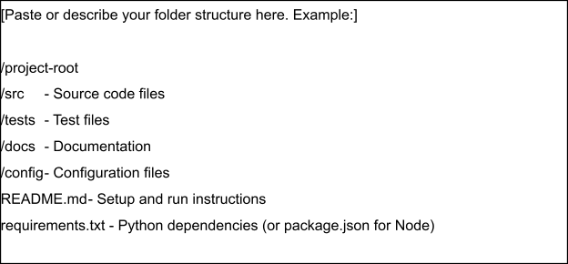

Step 3: Deployment / Access Details

Field | Details
Hosted / Deployed URL | Not deployed – run locally at http://127.0.0.1:8000
Login Credentials (Demo) | [Provide demo username and password for evaluator access]
Platform / Hosting Provider | [e.g., Render, Vercel, AWS, Heroku, Azure]
Repository Link | Not provided – Pending GitHub/GitLab link
Demo Video Link | Not provided – Pending

Step 4: Run Instructions
1. Install Python 3.10 or later.
2. Open a terminal in the EduGenie project folder.
3. Create and activate a virtual environment.
4. Install dependencies using: pip install -r requirements.txt
5. Configure the Gemini API key as required by the project; do not expose the secret key.
6. Start the application using: uvicorn main:app --reload
7. Open http://127.0.0.1:8000 in a web browser.
8. Select a task, enter the required learning content/question, and submit to view the generated result.
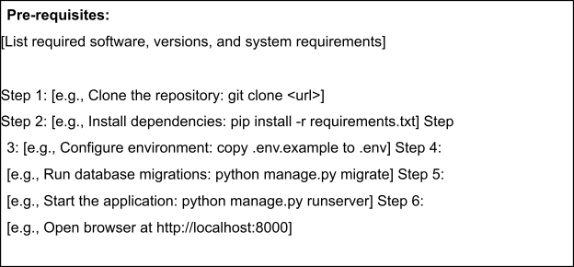

Step 5: Known Issues / Limitations

S.No | Known Issue / Limitation | Workaround / Status
1 | AI response accuracy may vary depending on prompts and generated content. | Use clear, specific prompts and review generated educational content.
2 | Gemini API availability and API-key configuration are required for Gemini-powered features. | Configure a valid API key and handle API failures through the documented error handling.
3 | Advanced features such as voice, multilingual support, progress tracking, gamification, mobile/offline support, dashboards, LMS integration, and image/PDF input are not yet implemented. | Planned as future enhancements.

