Project 2
Sang Bo Yoon
2025-11-11
Table of Contents

CO & O3 Plot
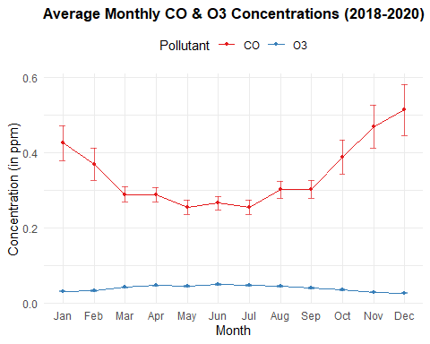

PM2.5 Plot
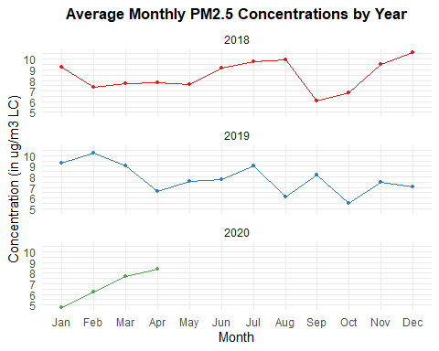

Github Link
https://github.com/sangbo1099/project2

