20192403 컴퓨터학부 박상철

fopen.c

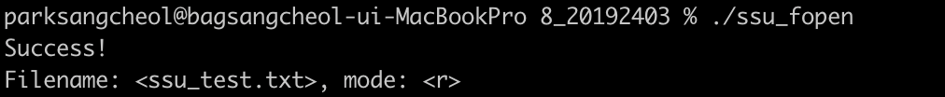

freopen.c



fclose.c

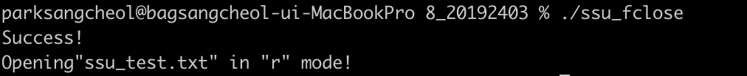

setbuf_1.c

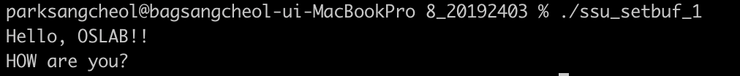

setbuf_2.c

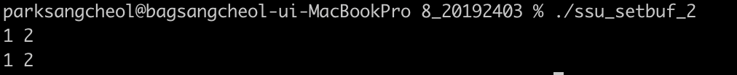

setvbuf.c