**ANNTL User Manual**

Nguyen Duy Sang Updated: May 2023

[ndsang@ctu.edu.vn](mailto:ndsang@ctu.edu.vn)

Summary

What is ANNTL? 2

Compatibility 3

How do I start using it? 4

Clone the repository 5

Run a simple command in the Terminal 6

Make your database file 7

Run ANNTL Example 8

python main.py 8

Errors and warnings when running the program 9

# What is ANNTL?

Github repository: [**ANNTL**](https://github.com/andrewrgarcia/XRDpy)(https://github.com/sangduynguyen/ANNTL) Needed: [**Python**](https://www.python.org/)[(https://www](http://www.python.org/)).p[ython.org/)](http://www.python.org/))

ANNTL is an TL pattern plotting Python program which estimates the kinetic parameters of the thermoluminescence (TL) glow curves by the Artificial neural network (ANN) combined with finding the peak by interacting between the computer mouse and the screen. This program executes through the Terminal (’command line’) and the execution is easy and straightforward.

The script, **python main.py**, calculates the TL patterns and plots them in a figure, where the order of the plots can be easily customized by the user through the Terminal.

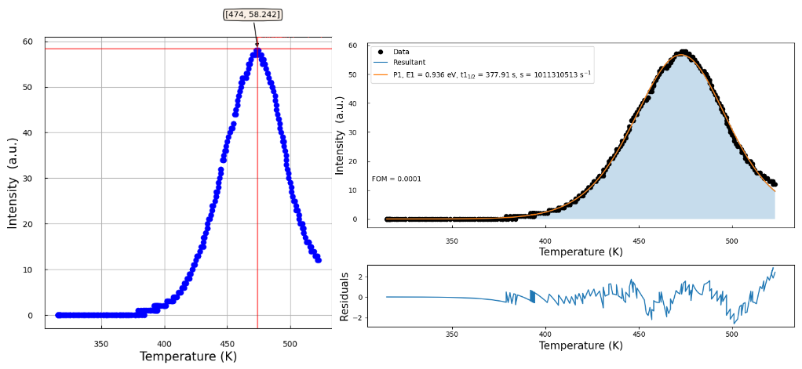

Figure 1: This is the output after running the command: **python main.py** of the Cg1 (file Cg1.csv in Github) curve data. Note: This curve is matched to one peak and selected by mouse click.

# Compatibility

ANNTL runs on Python, which technically makes it multiplatform. However, I have only tested it in **Windows** operating systems.

# How do I start using it?

Taking a pragmatic approach you may find the use of ANNTL to be very straightforward. You’re encouraged to watch the instructional video of ANNTL in github (file: **demo.gif**).

## Clone the repository

Github repository: [**ANNTL**](https://github.com/andrewrgarcia/XRDpy)(https://github.com/sangduynguyen/ANNTL) Needed: **Git** (git-scm.com)

Optional: **Github account** (github.com)

You may need to learn the basics of Git, which aren’t complicated to do. Creating a Github account will allow you to fork my repository and share any changes you may make of your forked version(s).

In the main ANNTL Github repository, there should be a button called ”Code” or clone. Click on it and copy the HTTP address

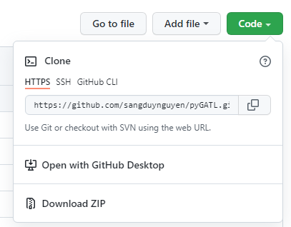

Figure 2: It looks like this

Open your Terminal and select the folder or path where you want to place the ANNTL program (i.e. use cd command).

In the Terminal, type: **git clone [pasted HTTP address]**

## Run a simple command in the Terminal

Open your Terminal (or command line, or shell, whatever you call it)

Change to the folder containing your cloned version of ANNTL (Use the cd command to get there)

While in that folder, type: **python main.py**. This should bring up the lists of all the arguments available to customize and make your plot(s).



## Make your database file

Your database file should contain the names of all your files with their .csv extension (they should be converted or be in csv format).

## Run ANNTL Example

Type the following commands in your terminal (with the Terminal path set to the ANNTL folder):

### python main.py

This will display your database in the Terminal; You will choose the model (i.e. use the numbers 1 2 3 in this example)



Figure 3: This is what you see.

The above command will give you this figure:

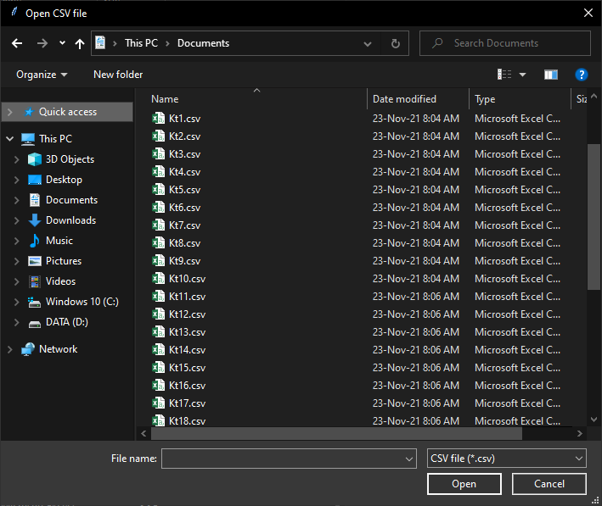

Figure 4: ANNTL Example, Window will open to select csv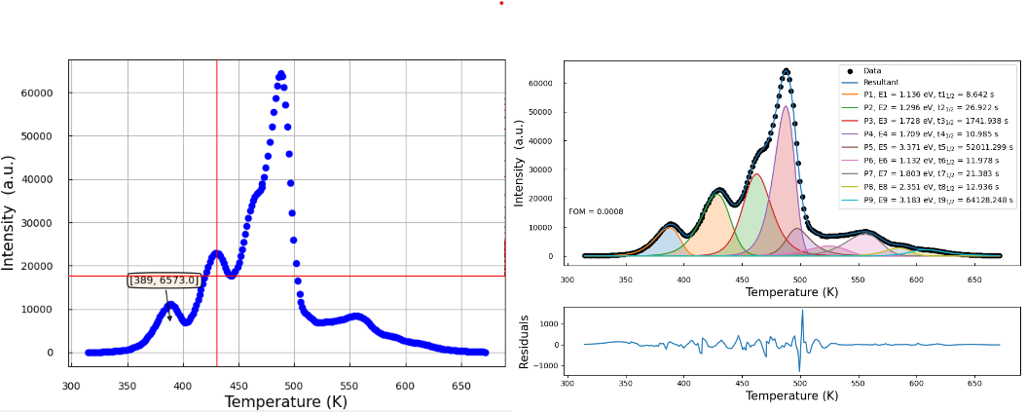

Figure 5: This is the output after running the command: **python main.py** of the Rg9 (file Rg9.csv in github) curve data. Note: This curve is matched to nine peaks and selected by mouse click.

## Errors and warnings when running the program

While running the program there may be some warnings in cmd due to the division by zero error. However, if the values are still calculated and the result executes well (small FOM) then the result is acceptable.

If the program does not execute, the user needs to check the steps of this tutorial or review the Demo.gif video.