Cyber Risk in Internet of Things World
Now-a-days IOT sensor devices are used to monitor or control road side traffic monitoring, patient body temperature monitoring or controlling home equipment’s such as AC, TV, Fridge and many more by using internet connections. This devices are used to sense data from their environments and then by using internet connection that data can be send to centralized server which will process that command and send response back to IOT devices to take some action such as SWITCH ON AC or fridge etc.
This devices often can be hacked or attack and control by malicious users to send and receive false information and sometime they can steal information or collect user locations from their mobile GPS sensor and can make this devices to JAM network traffic and report false information and this attack can cause financial and technology loss. In this paper author is describing many such attacks and then describing recommended solutions.
In this paper author is recommending to use Artificial Intelligence algorithms such as CLUSTERING and CLASSIFICATION to avoid cyber-attack. In propose paper author using following modules
- IOT past traffic dataset will be used to train and test classifications algorithms
- Features extraction will be applied to select important features from training data and to avoid negative consequences such as false prediction of attack
- Matching process will be applied by using classification algorithm to check whether new traffic data contains normal or attack traffic signature
- Clustering: using this algorithm we will group similar data into one cluster so all normal traffic will go to one cluster and attack traffic will go to another cluster.
To implement this project we have used below IOT traffic dataset which contains 6 different types of attack and contains NORMAL traffic and this dataset will be used to train classification algorithm called Random Forest and clustering algorithm called KMEANS.
Below is the dataset screen shots which we downloaded from KAGGLE website
https://www.kaggle.com/francoisxa/ds2ostraffictraces
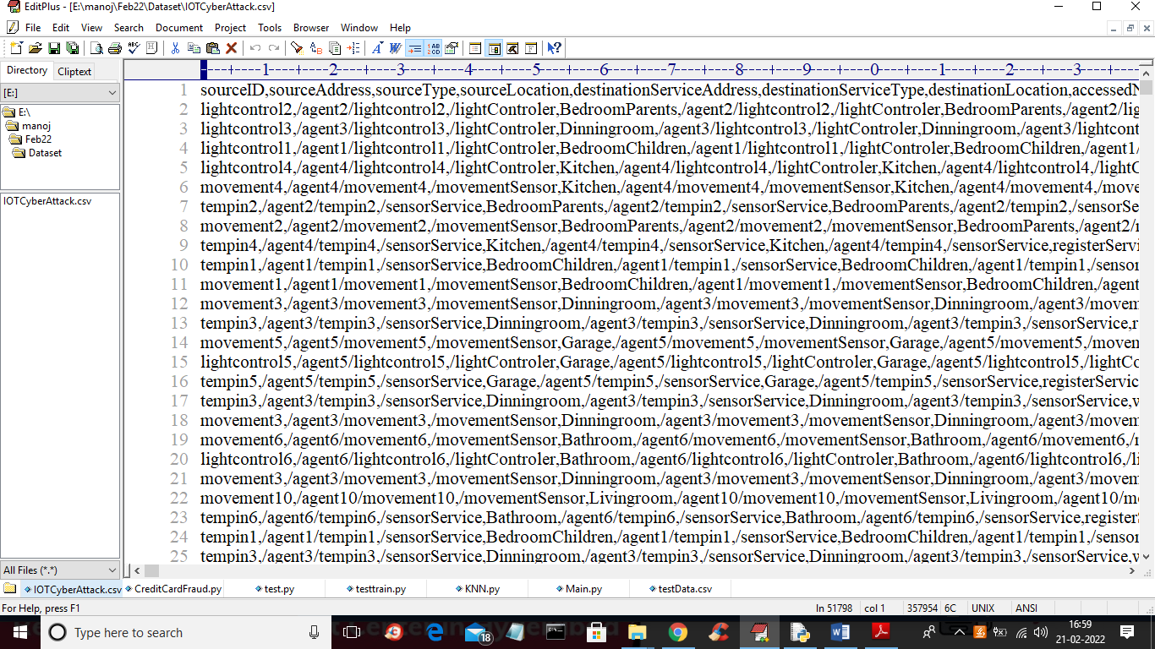
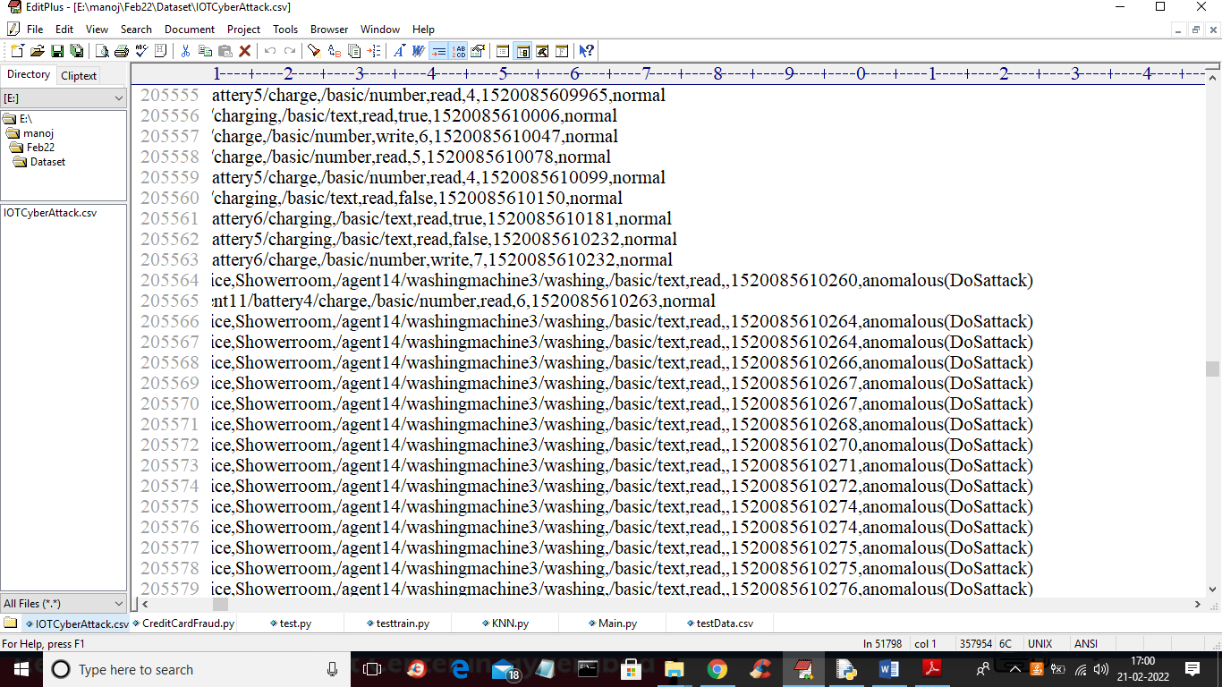
In above two screens first row contains dataset column names and remaining are the IOT traffic values and in last column we have class label as whether traffic is NORMAL or contains DOS attack.
To implement this project we have designed following modules
- Upload IOT Cyber Attack Dataset: using this module we will upload dataset to application
- Preprocess Dataset: in above screens we can see dataset contains non-numeric values and classification algorithms only work on NUMERIC data and so we need to convert all non-numeric data into numeric data by assigning ID to each values
- Run Features Selection Algorithm: using this module we will apply PCA (principal component algorithm) algorithm to select important features from dataset and then split all those features into train and test where classification algorithm get TRAINED on training data and test its performance by using TESTING data
- Run KMeans Clustering: using this module we will group normal and attack traffic into different clusters as normal traffic contains similar data so it will goes into same cluster and attack traffic will go to different cluster.
- Run Random Forest Classification Algorithm: using this module we will train Random Forest classification algorithm by using above processed dataset
- Predict Attack from Test Data: using this module we will upload new TEST data and then classification algorithm will predict whether TEST data is normal or contains attack signatures
SCREEN SHOTS
To run project double click on ‘run.bat’ file to get below screen
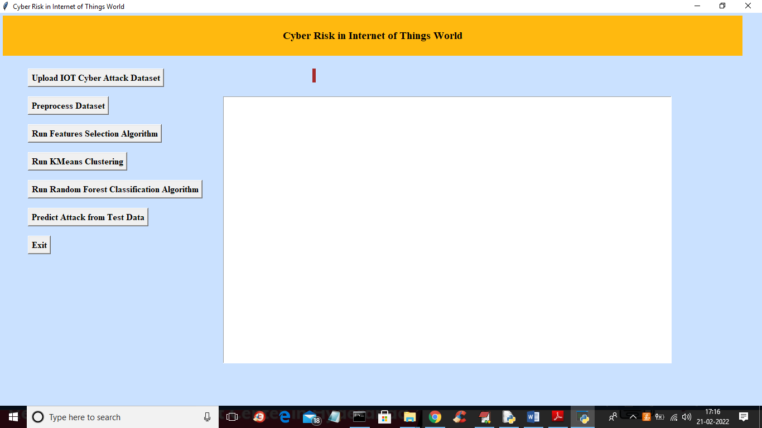
In above screen click on ‘Upload IOT Cyber Attack Dataset’ button to upload dataset and to get below screen
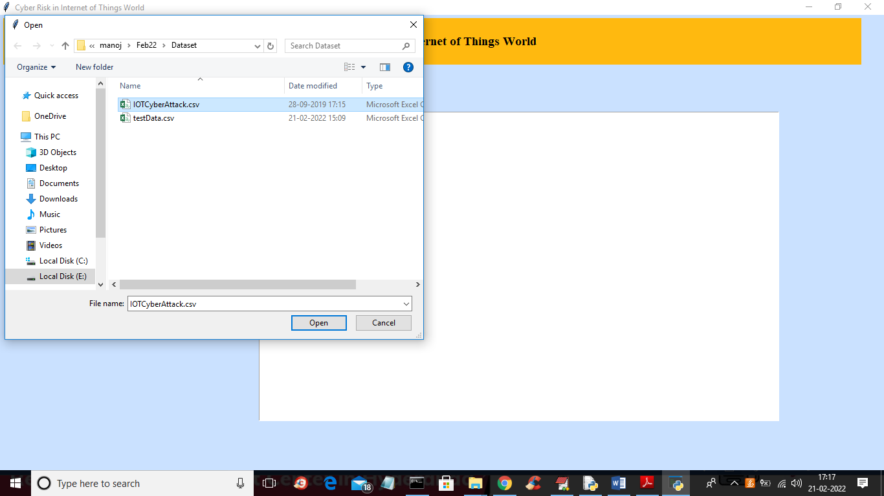
In above screen select and upload ‘IOTCyberAttack.csv’ file and then click on ‘Open’ button to load dataset and to get below screen
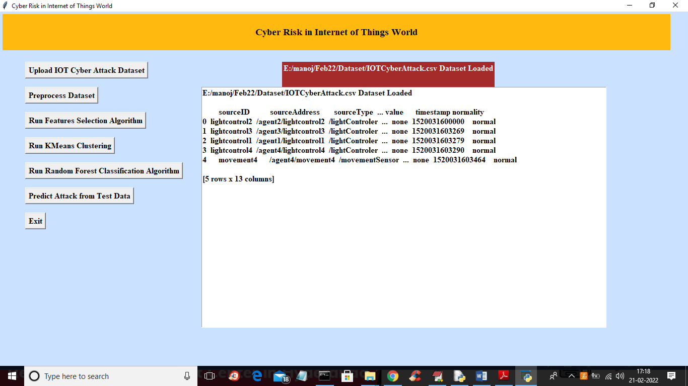
In above screen dataset loaded but all values are non-numeric and we need to convert to numeric so click on ‘Preprocess Dataset’ button to assign numeric ID to each values and to get below screen
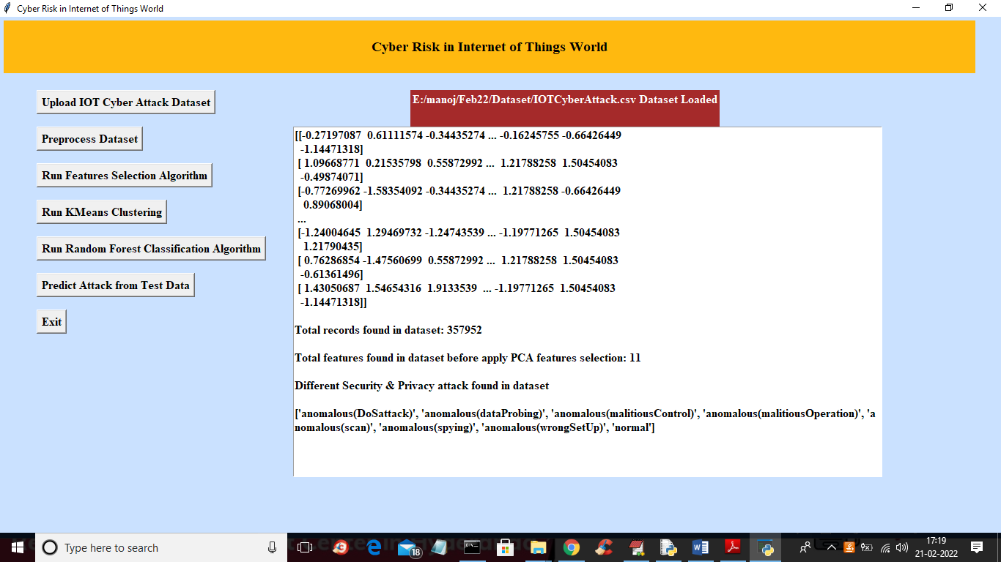
In above screen we can see all values are converted to numeric and in last line we can see before applying PCA features selection algorithm dataset contains 11 features and we can see different attack names found in dataset and now click on ‘Run Features Selection Algorithm’ button to select features from dataset and get below output
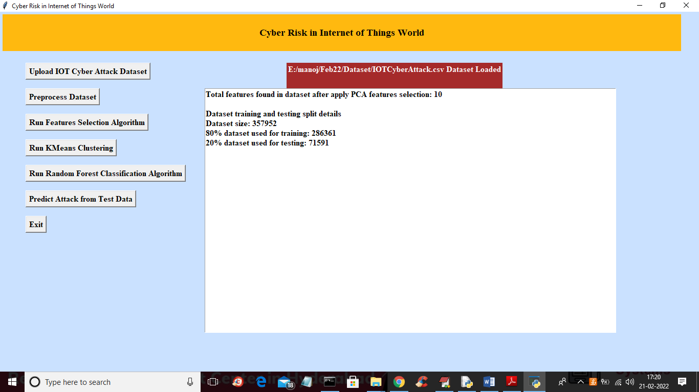
In above screen we can see after applying features selection algorithm we got 10 important features out of 11 and we can see total dataset with training and testing size. Now process dataset is ready with train and test data and now click on ‘Run KMeans Clustering’ button to group data into different clusters and get below output
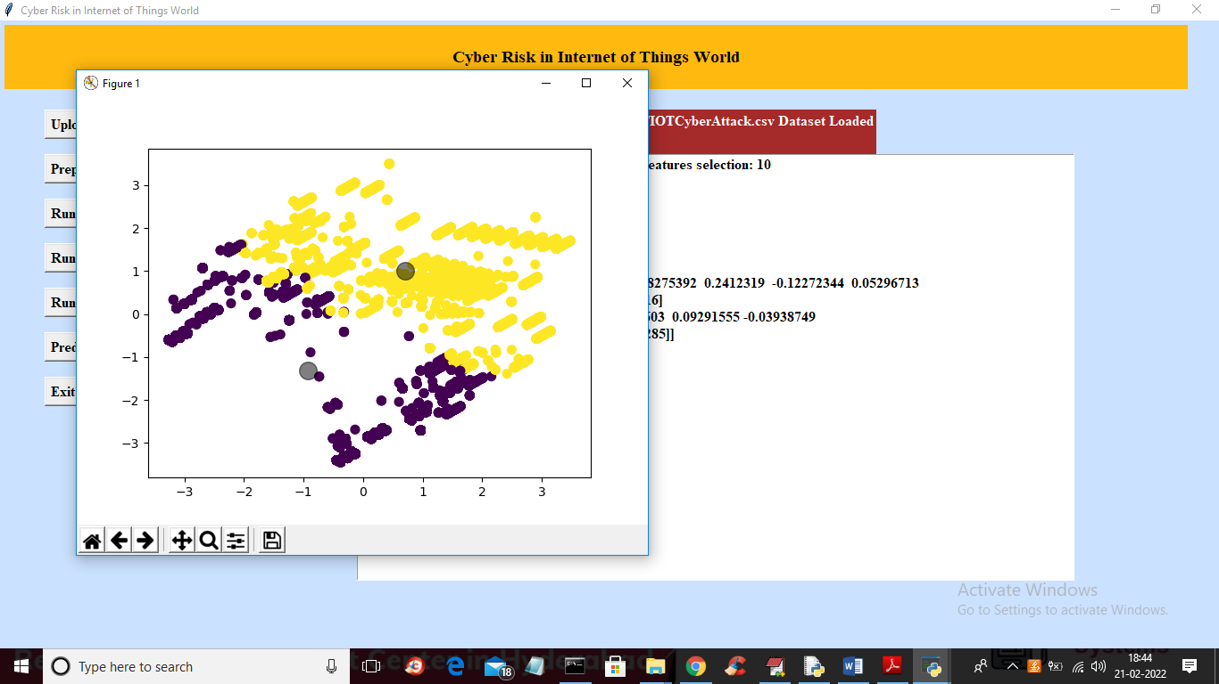
In above graph we can see same data are group into same cluster with same dots and different data is group into different clusters so in above screen we got two colours dots where one colour dot contains normal traffic and other colour dot contains attack traffic and now close above graph and then click on ‘Run Random Forest Classification Algorithm’ button to train dataset with random forest algorithm and get below output
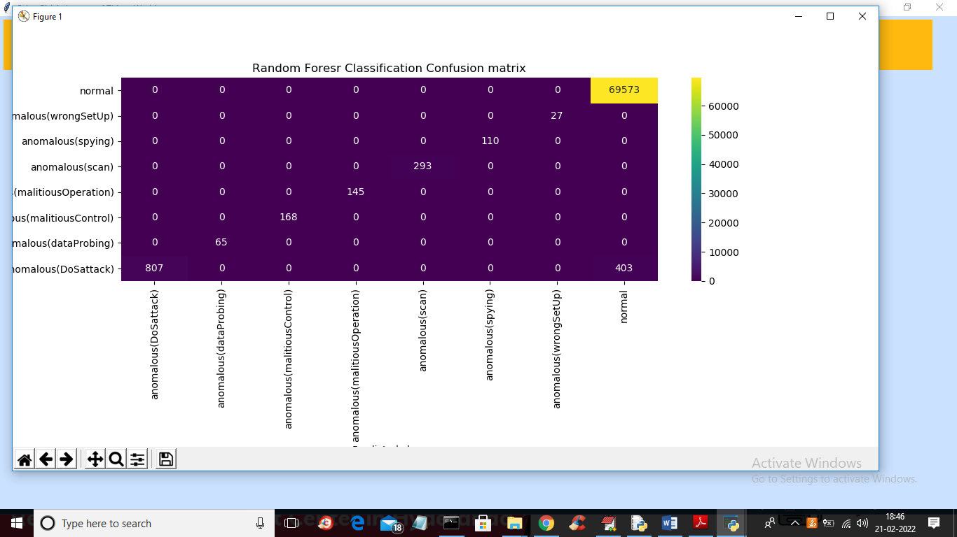
In above classification confusion matrix x-axis represents PREDICTED classes and y-axis represents TRUE TEST classes and we can see that in both X and y-axis we can see values > 0 which means TEST and predicted classes are correct and now close above graph to get below output
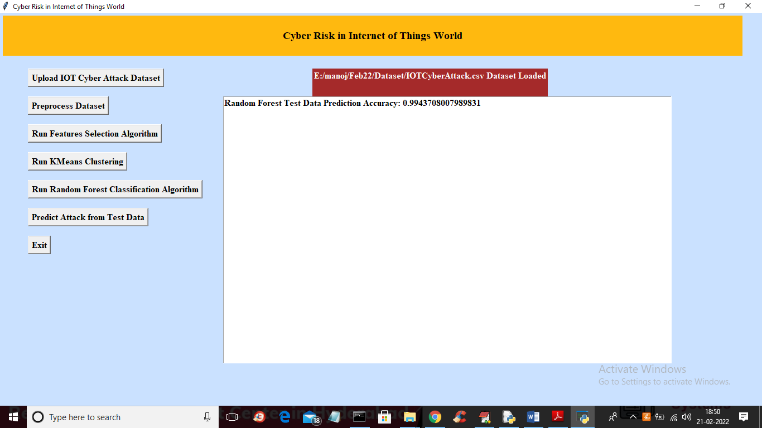
In above screen with Random Forest we got 0.99% accuracy and now click on ‘Predict Attack from Test Data’ button to upload test data and get below prediction or classification result
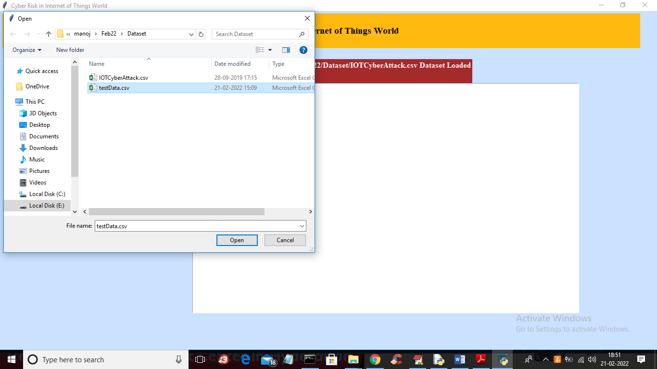
In above screen selecting and uploading ‘testData.csv’ file and then click on ‘Open’ button to load test data and get below output
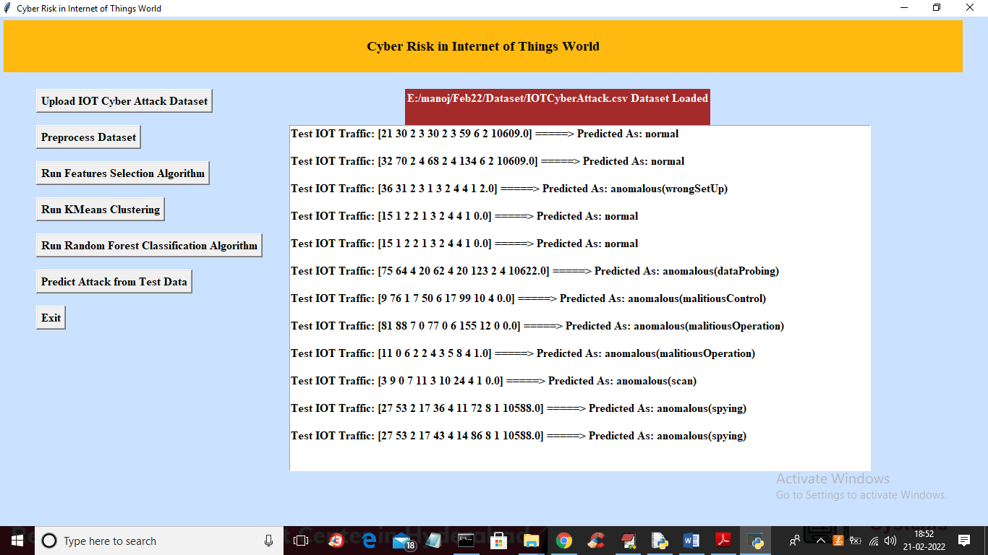
In above screen in square bracket we can see test data and after square bracket we can see predicted traffic as NORMAL or attack names. So with this model we can predict or classify attack from IOT traffic

