IBM ASSIGNMENT 2

|  |  |
| --- | --- |
| Name | SANGEETHA R |
| Register Number | 111519104123 |
| Project Title | Global Sales Data Analytics |
| College | RMD Engineering College |

PHARMA SALES DASHBOARD

1. Sales by Customer

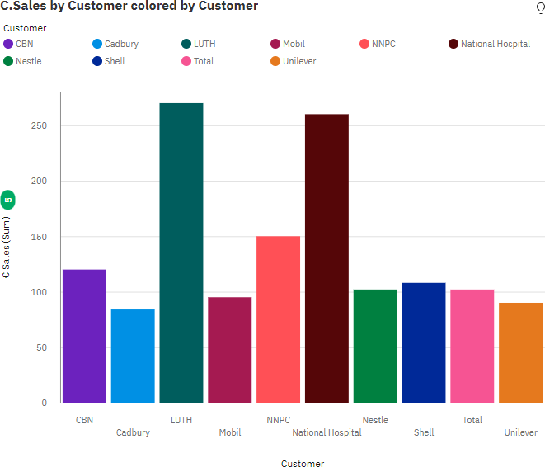

1. Sales by location

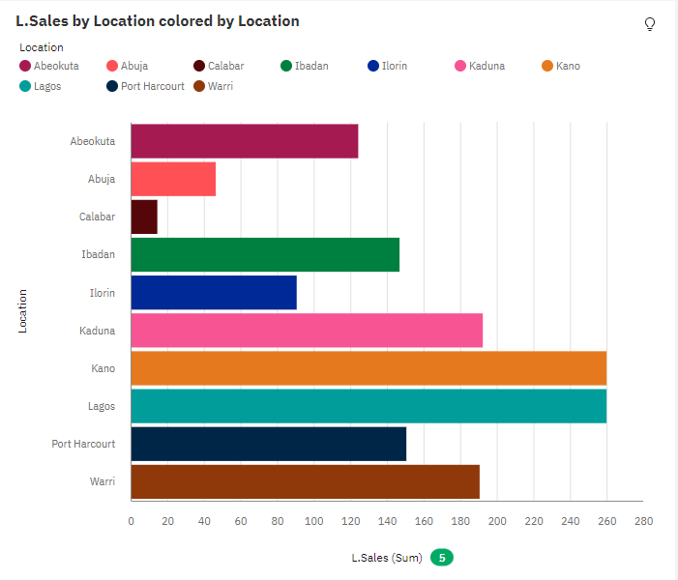

1. Sales by sales representative

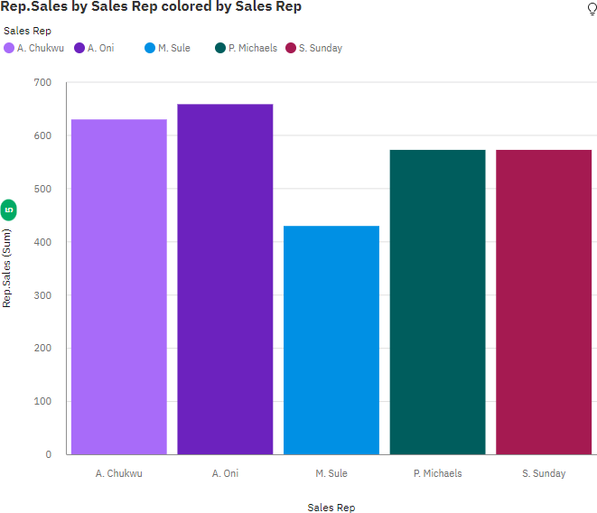

1. Received inventory from supplier

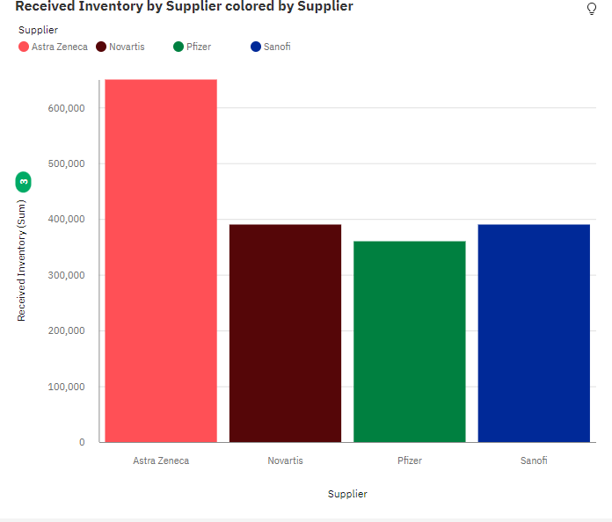

1. Inventory stock for warehouse locations

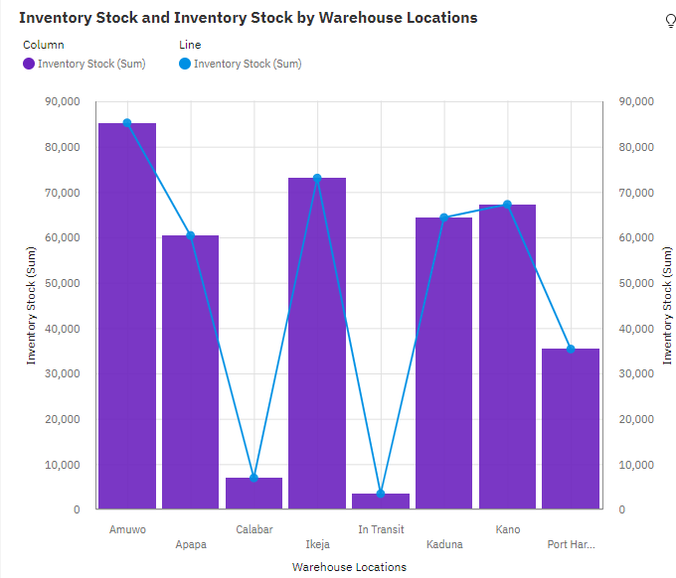

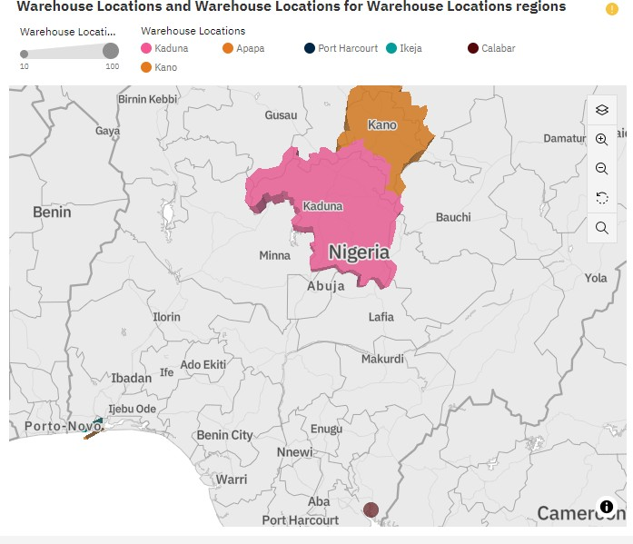

1. Sales trend

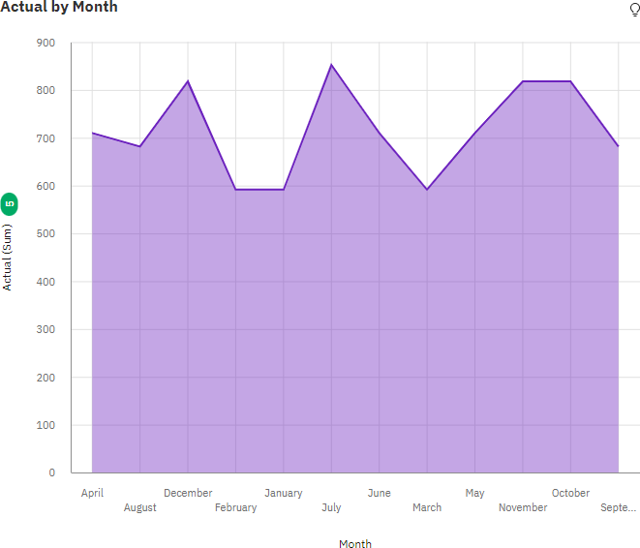

1. Monthly sales

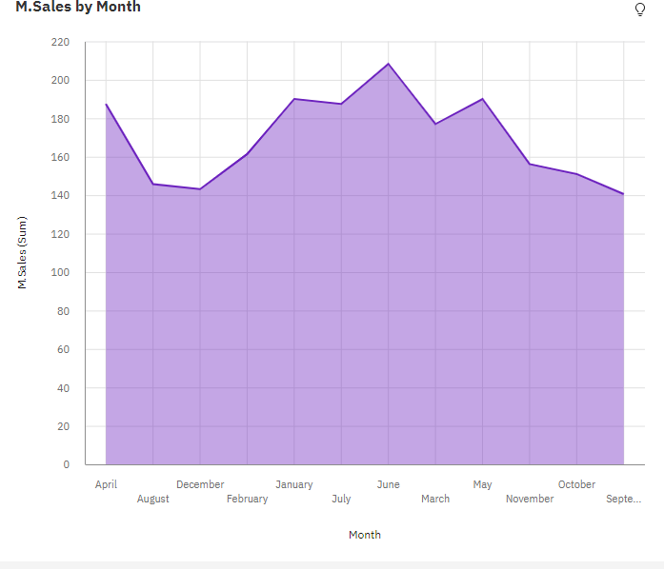

1. Actual and received inventory by month

