INTERNET OF THINGS

Smart public restroom

Phase 5: Project Documentation

Overview:

The project aims to revolutionize public restroom management by implementing IoT sensors to monitor restroom occupancy and maintenance needs. The primary objective is to provide real-time data on restroom availability and cleanliness to the public through a user-friendly platform or mobile app. This initiative seeks to enhance user experience, promote efficient restroom usage, and ensure cleanliness.

**Aim of smart public restroom:**

The aim of smart public restrooms is to revolutionize the way we experience and manage public sanitation. These advanced facilities integrate cutting-edge technology to enhance hygiene, accessibility, and overall user experience.

**Objective of smart public restroom:**

Real-time Restroom Availability Information: Provide the public with up-to-the-minute data on restroom availability to reduce waiting times and improve convenience.

Cleanliness Monitoring: Implement sensors to detect cleanliness levels in restrooms and offer real-time feedback to maintain high hygiene standards.

Improved User Experience: Enhance the overall restroom experience for the public by reducing wait times and ensuring clean facilities.

Efficient Restroom Management: Enable restroom operators to optimize maintenance schedules and resource allocation based on real-time data

**Problem statement:**

Inadequate sanitation, hygiene, and accessibility in public restrooms pose a significant urban challenge. The Smart Public Restroom project aims to address these issues by integrating advanced technology and inclusive design for a cleaner, safer, and more user-friendly experience.

Components Required:

* LED

# Hc-sr04

# Servo

# ESP32 Simulation

* Power Source

Circuit Design:

The components were connected as given below

**Standard 5mm LED:**



## Pin names[​](https://docs.wokwi.com/parts/wokwi-led#pin-names)

| **Name** | **Description** |
| --- | --- |
| A | Anode (positive pin) |
| C | Cathode (negative pin) |

**HC-SR04 Ultrasonic Distance Sensor:**

## 

## Pin names[​](https://docs.wokwi.com/parts/wokwi-hc-sr04#pin-names)

| **Name** | **Description** |
| --- | --- |
| VCC | Voltage supply (5V) |
| TRIG | Pulse to start the measurement |
| ECHO | Measure the high pulse length to get the distance |
| GND | Ground |

**Standard Micro Servo Motor:**

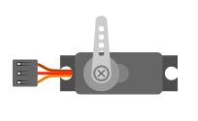

## Pin names[​](https://docs.wokwi.com/parts/wokwi-servo#pin-names)

| **Name** | **Description** |
| --- | --- |
| PWM | Servo control signal |
| V+ | Positive voltage (5V) |
| GND | Ground |

# ESP32 Simulation:

The ESP32 is a popular WiFi and Bluetooth-enabled microcontroller, widely used for IoT Projects.

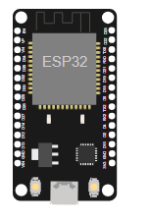

## ESP32 boards[​](https://docs.wokwi.com/guides/esp32#esp32-boards)

| **Name** | **Chip** | **Description** |
| --- | --- | --- |
| ESP32 DevKit v1 | ESP32 | Popular ESP32 development board |
| ESP32-S2-DevKitM-1 | ESP32-S2 | Entry-level ESP32-S2 development board |
| [Franzininho WiFi](https://docs.wokwi.com/parts/board-franzininho-wifi) | ESP32-S2 | Board by the Franzininho Community |
| Wemos S2 mini | ESP32-S2 | Small ESP32-S2 board by Wemos |
| ESP32-S3-DevKitC-1 | ESP32-S3 | Entry-level ESP32-S3 development board |
| ESP32-C3-DevKitM-1 | ESP32-C3 | Entry-level ESP32-C3 development board |
| Rust Board ESP32-C3 | ESP32-C3 | ESP32-C3 board designed for Rust trainings |
| ESP32-C6-DevKitC-1 | ESP32-C6 | Entry-level ESP32-C6 development board (beta) |
| ESP32-H2-DevKitM-1 | ESP32-H2 | Entry-level ESP32-H2 development board (alpha) |

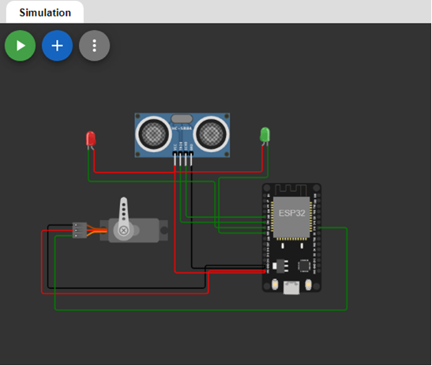

The Program Execution Code:

C Program

#include<ESP32Servo.h>

#define TRIGGERPIN 32

#define ECHOPIN    35

#define RED_LED    33

#define GREEN_LED  25

Servo servo_1;

long duration;

int pos, distance, i=0;

void setup()

{

  servo_1.attach(18);

  Serial.begin(115200);

  pinMode(TRIGGERPIN, OUTPUT);

  pinMode(ECHOPIN, INPUT);

  pinMode(RED_LED, OUTPUT);

  pinMode(GREEN_LED, OUTPUT);

  Serial.println(" ");

  Serial.println("Sensing the Height");

  digitalWrite(RED_LED, HIGH);

  digitalWrite(GREEN_LED, LOW);

  pos = 0;

  servo_1.write(pos);

}

void loop()

{

  digitalWrite(TRIGGERPIN, LOW);

  delayMicroseconds(3);

  digitalWrite(TRIGGERPIN, HIGH);

  delayMicroseconds(12); // it may be 10 us

  digitalWrite(TRIGGERPIN, LOW);

// Reads the echoPin, returns the sound wave travel time in microseconds

  duration = pulseIn(ECHOPIN, HIGH);

// Calculating the distance

  distance = (duration/2) / 29.1;

  // for Adult

  if (distance >= 100 && distance <= 150)

    {

      i = 1;

      if (pos != 180)

      {

        servo_1.write(180);

        pos = 180;

        i = 1;

      }

    }

  // for Child

    else if (distance >= 200 && distance <= 250)

      {

        i = 1;

        if (pos != 0)

        {

         servo_1.write(0);

         pos = 0;

         i = 1;

        }

      }

    else if (distance > 300 && i == 1)

      {

        digitalWrite(RED_LED, LOW);

        digitalWrite(GREEN_LED, HIGH);

        delay(5000);

        digitalWrite(RED_LED, HIGH);

        digitalWrite(GREEN_LED, LOW);

        i = 0;

      }

       delay (500);

  Serial.println(" ");

  Serial.print("Free Level : ");

  Serial.print(distance);

  Serial.print("   ");

  Serial.print("Position : ");

  Serial.print(pos);

  delay (500);

}

**OUTPUT:**

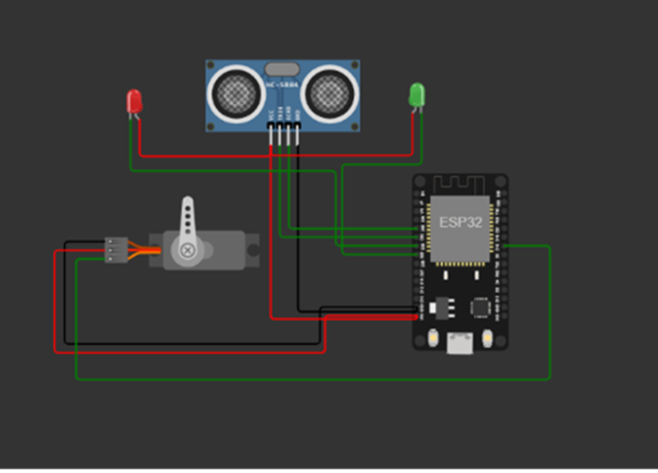

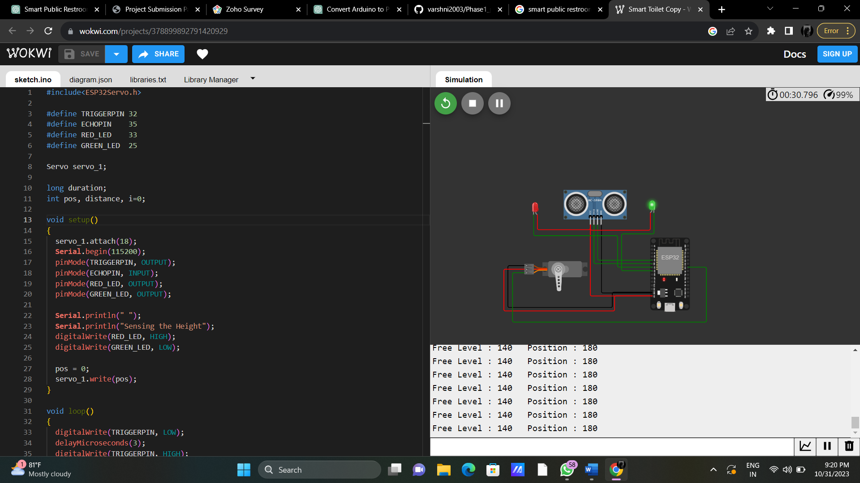

PYTHON Program

from gpiozero import Servo, DistanceSensor, LED

from time import sleep

TRIGGER_PIN = 32

ECHO_PIN = 35

RED_LED_PIN = 33

GREEN_LED_PIN = 25

servo_1 = Servo(18)

ultrasonic = DistanceSensor(echo=ECHO_PIN, trigger=TRIGGER_PIN)

red_led = LED(RED_LED_PIN)

green_led = LED(GREEN_LED_PIN)

pos = 0

i = 0

print("\nSensing the Height")

red_led.on()

green_led.off()

servo_1.value = pos

try:

while True:

distance = ultrasonic.distance * 100 # Convert to centimeters

if 100 <= distance <= 150: # for Adult

i = 1

if pos != 1:

servo_1.value = 1

pos = 1

elif 200 <= distance <= 250: # for Child

i = 1

if pos != -1:

servo_1.value = -1

pos = -1

elif distance > 300 and i == 1:

red_led.off()

green_led.on()

sleep(5)

red_led.on()

green_led.off()

i = 0

sleep(0.5)

print("\nFree Level: {:.2f} cm Position: {}".format(distance, pos))

sleep(0.5)

except KeyboardInterrupt:

servo_1.detach()

ultrasonic.close()

red_led.off()

green_led.off()

Html code:

<!DOCTYPE html>

<html>

<head>

<title>Restroom Information</title>

<link rel="stylesheet" type="text/css" href="styles.css">

</head>

<body>

<h1>Restroom Information</h1>

<div id="restroom-data">

<p>Availability: <span id="availability">Available</span></p>

<p>Cleanliness: <span id="cleanliness">Clean</span></p>

</div>

<script src="script.js"></script>

</body>

</html>

Css code:

/* Add CSS styling here */

body {

font-family: Arial, sans-serif;

text-align: center;

background-color: #f0f0f0;

}

h1 {

color: #333;

}

#restroom-data {

background-color: #fff;

padding: 20px;

border-radius: 5px;

box-shadow: 0 0 10px rgba(0, 0, 0, 0.2);

margin: 20px auto;

width: 300px;

}

span {

font-weight: bold;

}

Javascript:

// JavaScript for fetching and updating real-time data

function fetchRestroomData() {

// Simulate fetching data from a server (replace with actual data retrieval logic)

const data = {

availability: "Available",

cleanliness: "Clean"

};

// Update the HTML with real-time data

document.getElementById("availability").textContent = data.availability;

document.getElementById("cleanliness").textContent = data.cleanliness;

}

// Fetch data on page load

fetchRestroomData();

**WEBCODE OUTPUT:**



Simulation Output:

<https://wokwi.com/projects/378899892791420929>

**Benefits:**

1. Hygiene

2. Accessibility

3. Efficiency

4. Sustainability

5. Safety

6. Convenience

7. Innovation

8. Inclusivity

9. Transparency

10. Comfort

**CONCLUSION:**

Smart public restrooms have the potential to revolutionize the way we use and manage public restroom facilities. They can provide a more convenient and comfortable experience for users, promote hygiene, and contribute to environmental sustainability. To successfully implement these facilities, it is essential to address design, privacy, security, and maintenance issues. Additionally, public and private stakeholders should work together to ensure that these facilities are accessible and cater to the diverse needs of the community.