**Frontend Development with React.js**

**Project Documentation for Rhythmic Tunes**

**1.Introduction**

* Project Title : **Rhythmic Tunes**
* Team Members :
* **Sangeetha R(Team Leader)**

**[**Email Id :[sangeetharamamoorthy2004@gmail.com](mailto:sangeetharamamoorthy2004@gmail.com)]

* **Sahithyavarshini E**

**[**Email Id :[sahithyavarshini1233@gmail.com](mailto:sahithyavarshini1233@gmail.com)]

* **Reshma M**

**[**Email Id :[resmaresma471@gmail.com](mailto:resmaresma471@gmail.com)]

* **Annalakshmi S**

[Email Id :[lakshmiannalakshmi60@gmail.com](mailto:lakshmiannalakshmi60@gmail.com)]

**2.Project Overview**

* **Purpose:**

Rhythmic Tunes is a web application designed to provide users with a seamless music listening experience. The applications allows users to browse, search, and play music tracks, create playlists, and discover new music based on their preferences.

* **Features:**
* Music player with play, pause, skip, and volume control.
* Search functionality to find songs, albums, and artists.
* User authentication (login/signup).
* Playlist creation and management.
* Responsive design for mobile and desktop.

**3.Architecture**

* **Component Structure:**

The application is built using React.js with a component-based architecture.Major components include:

* **Header:** Contains the navigation bar and search bar.
* **Player:** Music player controls (play, pause, volume, etc).
* **Sidebar:** Displays user playlists and navigation links.
* **HomePage:** Displays featured tracks, recommended playlists, and new releases.
* **SearchPage:** Allow users to search for songs, albums, and artists.
* **PlaylistPage:** Display user-created playlists and allows playlist management.
* **State Management:**

The application uses **Redux** for global state management. The Redux store manages user authentication, current playing track, playlist data, and search results.

* **Routing:**

The application uses **React Router**for navigation. Routes include:

* /: Home page
* /search: Search page
* /playlist/:id: Playlist details page
* /login: User login page

**4. Setup Instructions**

* **Prerequisites:**
* Node.js (v16 or higher)
* Npm (v8 or higher)
* Git
* **Installation**

1. Clone the repository: git clone <https://github.com/sangeeindhra20122004/RHYTHMIC_TUNES>
2. Navigate to the client directory: cd rhythmic-tunes/client
3. Install dependencies: npm install
4. Configure environment variables: Create a .env file in the client directory and add the necessary variables (e.g., API keys).
5. Start the development server: npm start

**5.Folder Structure**

* **Client:**
* **src/components**: # Reusable components (Header, Player, etc.)
* **src/pages**: # Page components (HomePage, SearchPage, etc.)
* **src/assets:** # Images, icons, and other static files
* **src/redux**: # Redux store, actions, and reducers
* **src/utils**: # Utility functions and helpers
* **App.js**: # Main application component
* **Index.js**: # Entry point
* **Utilities:**
* **api.js:** Handles API requests to the backend.
* **auth.js:** Manages user authentication and token storage.
* **hooks/usePlayer.js**: Custom hook for managing the music player state.

**6.Running the Application**

* **Frontend:**
* To start the frontend server, run the following command in the client directory:npm start
* npm install
* npx json-server –watch db.json
* npm run dev
* The application will be available at http://localhost:5173

**7.Component Documentation**

* **Key Components:**

* **Header:** Displays the navigation bar and search bar.
* Props: on Search (function to handle search queries).
* **Player:** Controls the music playback.
* Props: currentTrack (object containing track details), onPlay, onPause, onSkip.
* **PlaylistCard:** Displays a playlist with its name and cover image.
* Props: playlist (object containing playlist details), onClick (function to handle playlist selection).

* **Reusable Components:**
* **Button:** A customizable button component.
* Props: text, onClick, disabled.
* **Input:** A reusable input field for forms and search.
* Props: type, placeholder, value, onChange.

**8. State Management**

* **Global State :**

The Redux store manages the following global states:

* **user:** Current authenticated user.
* **player:** Current playing track, playback status (playing/paused), and volume.
* **playlist:** User-created playlists.
* **searchResults:** Results from the search functionality.

* **Local State:**

Local state is managed using React’s useState hook within components. For example, the SearchPage component manages the search query input locally.

**9. User Interface**

* **Screenshots**

* **Home Page:** Display featured tracks and recommended plalists.

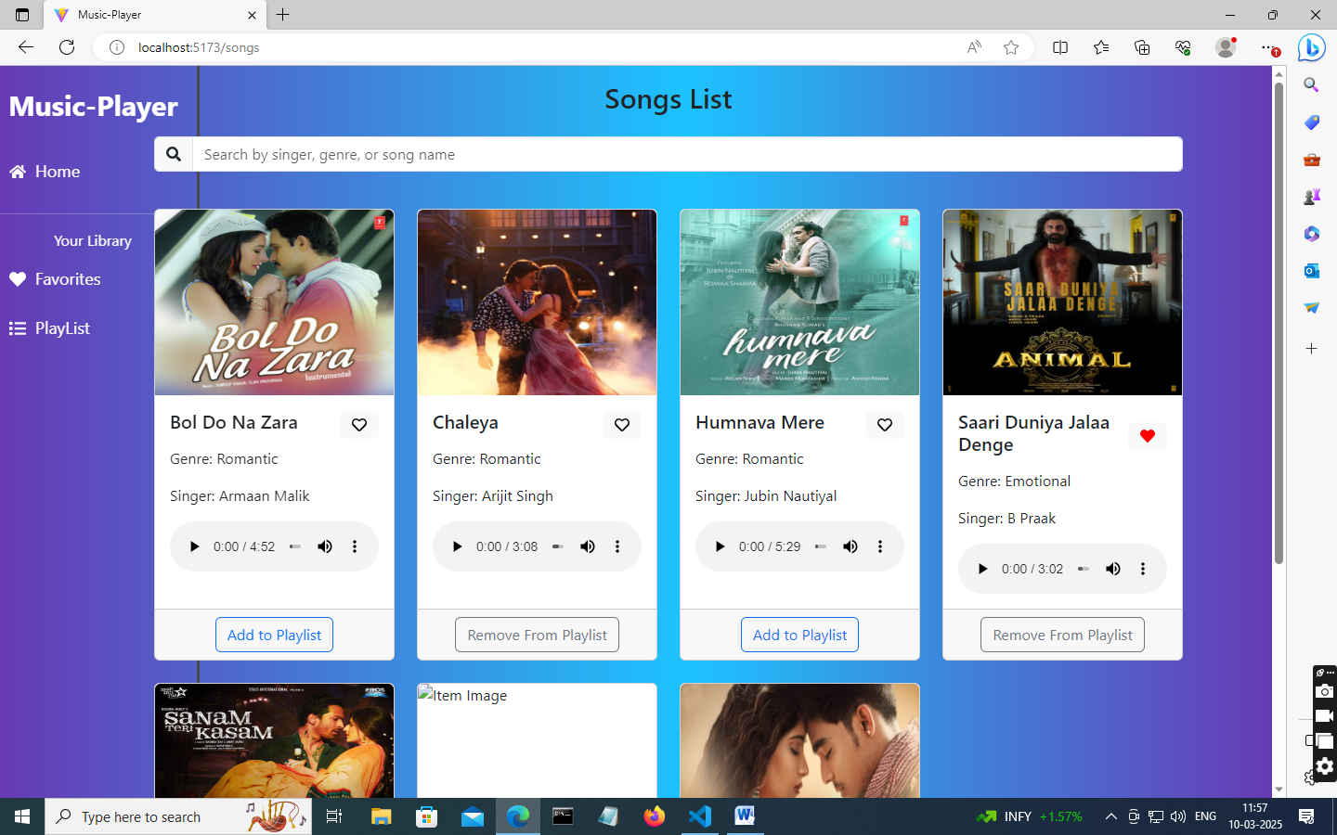

* **Search Page:** Allows users to search for songs, albums, and artists.

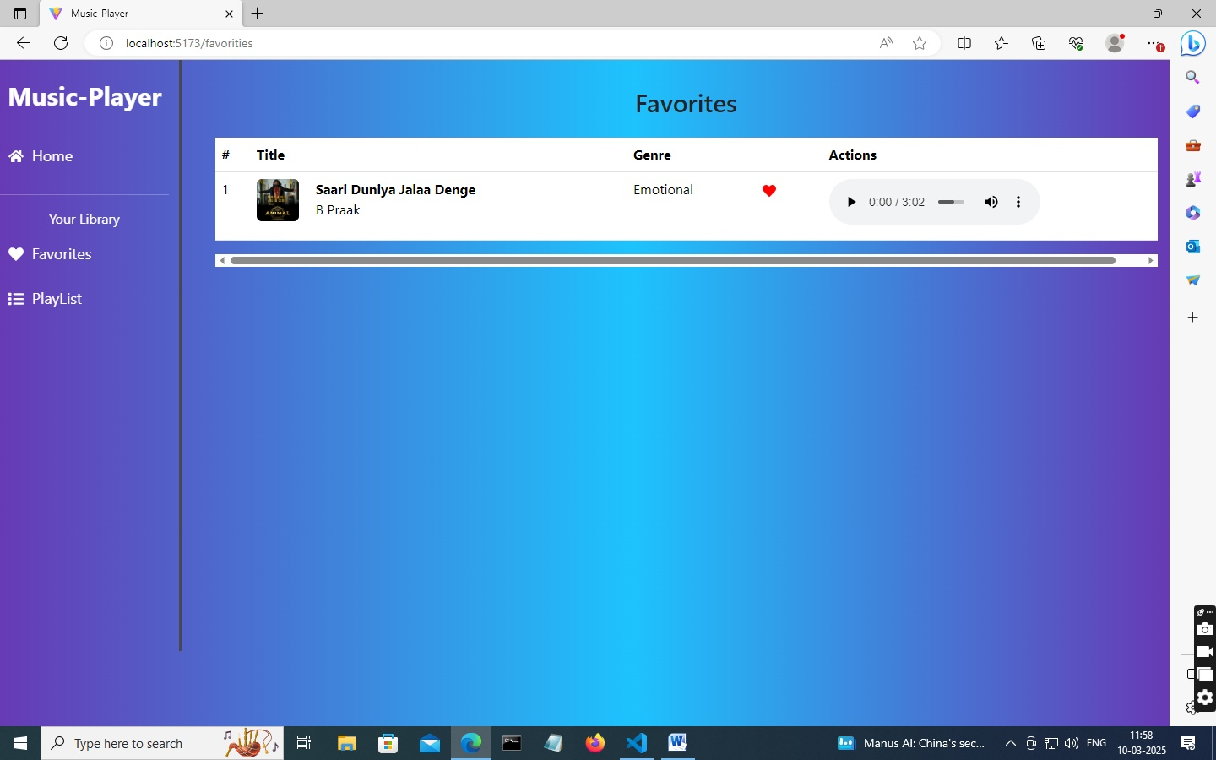

* **Playlist Page:**  Displays user-created playlists and allows playlist management.

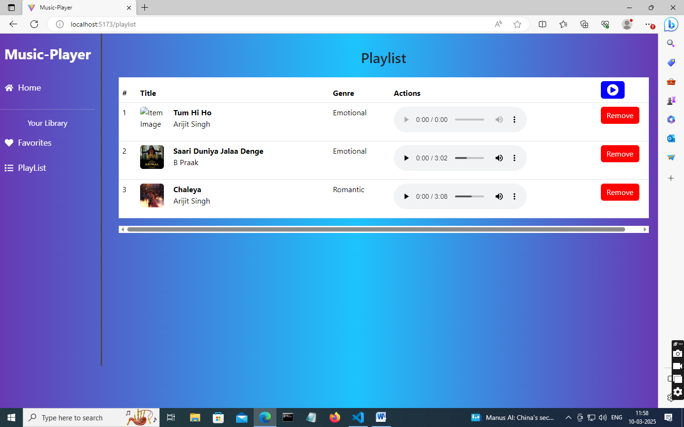

**10. Styling**

* **CSS Frameworks/Libraries:**

The application uses Styled-Components for styling. This allows for modular and scoped CSS within components.

* **Theming:**

A custom theme is implemented using Styled-Components, with support for light and dark modes.

**11. Testing**

* **Testing Strategy:**

* **Unit Testing:** Using  **Jest** and **React Testing Library.**
* **Integration Testing**: Is performed to ensure that components work together as expected.
* **End-to-End Testing:** Cypress is used for end-to-end testing of user flows.
* **Code Coverage:**
* Code coverage is monitored using Jest’s built in coverage tool. The current coverage is 85%

**12. Screenshot or Demo**

* **Demo Link:**
* **Screenshots:** See section 9 for UI screenshots.

**13. Known Issues**

* **Issue 1 :** The music player sometimes skips tracks unexpectedly.
* **Issue 2 :** The search functionality is slow with large datasets.

**14. Future Enhancements**

* **Future Features:**
* Add support for user profiles and social sharing.
* Implement a recommendation engine for personalized music suggestions.
* Add animations and transitions for a smoother user experience.

This documentation provides a comprehensive overview of the **Rhythmic Tunes** project, including its architecture, setup instructions, and future plans.