SOFTWARE CHANGE
IMPLEMENTATION REPORT
CR-009: Student Dashboard Course Display and Enrollment
Field | Details
Change Request ID | CR-009
Change Request Title | Student Dashboard Course Display and Enrollment
Student Name | MH Anush
Student ID | JFICT2416
Implementation Status | Completed
Date | 22 October 2026

1. Change Request Summary
1.1 Business Requirement
The current Student Dashboard primarily displays the student's profile information, including registration number, full name, email, phone number, and member since date. The Student Dashboard currently does not provide a direct workflow for displaying available courses and enrolling in a selected course. The system shall therefore be enhanced to provide an Available Courses section on the Student Dashboard. The section shall display available course information and allow an authenticated student to enroll in a selected course. The change shall integrate the course and enrollment functionality required for the student-facing workflow while maintaining the existing student authentication and profile functionality.
1.2 Existing Behaviour
Before implementation:
- The system database contained users, students, and password_resets tables, but lacked dedicated schemas for courses and student enrollments.
- The Student Dashboard in StudentDashboardPage.jsx displayed student profile information and password change functionality only.
- No Available Courses catalog was displayed or accessible to authenticated students from their dashboard.
- Students had no mechanism to browse course details such as course title, category, level, duration, and tuition fee.
- No course enrollment endpoint or UI action existed, preventing students from directly registering for academic courses.
- The backend lacked dedicated course retrieval and enrollment processing controllers and route handlers.
1.3 Requested Change
A full-stack enhancement was required to display available courses on the Student Dashboard and enable direct student course enrollment.
The implementation must:
- Introduce a new courses database table storing course code, title, description, category, level, duration, price, and availability status.
- Introduce an enrollments database table linking students and courses with a unique constraint preventing duplicate enrollments.
- Develop backend models (courseModel.js, enrollmentModel.js) and controllers (courseController.js, enrollmentController.js).
- Expose authenticated endpoints GET /api/courses and POST /api/enrollments utilizing the system's JWT security pipeline.
- Enforce role authorization strictly restricting enrollment operations to authenticated students (STUDENT role).
- Display an Available Courses section on the Student Dashboard showing course title, category, level, duration, and price.
- Provide an intuitive Enroll button for available courses, disabling it and displaying 'Enrolled' for already-enrolled courses.
- Display appropriate real-time success confirmation and error notification messages upon enrollment requests.
- Support responsive course grid display and full light and dark mode theme compatibility across all new components.
- Preserve existing student profile display, authentication, password changing, and administrator CRUD operations without regression.
2. Implementation
2.1 Implementation Summary
The CR-009 requirements were implemented systematically across the database schema, backend RESTful controllers and routes, and frontend React student portal. The database was enhanced with courses and enrollments tables featuring foreign key relationships and unique composite constraints to guarantee data integrity. On the backend, a modular MVC pattern was employed: courseModel.js and enrollmentModel.js execute parameterized SQL queries, while courseController.js and enrollmentController.js handle request validation, business logic, and security checks.
The GET /api/courses endpoint dynamically checks if the requester is an authenticated student and annotates each course with an is_enrolled flag. The POST /api/enrollments endpoint enforces student authorization, validates course availability, prevents duplicate registrations with 409 Conflict responses, and records enrollment timestamps. On the frontend, StudentDashboardPage.jsx introduces a modern Available Courses catalog with search and category filtering, responsive course cards, animated confirmation alerts, and full light and dark mode styling.
2.2 Affected Files
File | Change | Purpose
database/schema.sql | Modified | Added courses and enrollments tables with constraints and documented migration SQL.
database/seed.sql | Modified | Added seed records for technical courses across diverse categories and sample enrollment.
backend/src/models/courseModel.js | Created | Implemented getAllAvailableCourses(studentId) with enrollment join and getCourseById.
backend/src/models/enrollmentModel.js | Created | Implemented createEnrollment, getEnrollmentByStudentAndCourse, and getEnrollmentsByStudentId.
backend/src/controllers/courseController.js | Created | Implemented getAvailableCourses and getCourse with role-aware enrollment annotation.
backend/src/controllers/enrollmentController.js | Created | Implemented enrollStudent and getMyEnrollments enforcing student authorization and validation.
backend/src/routes/courseRoutes.js | Created | Configured /api/courses routes with JWT authentication middleware.
backend/src/routes/enrollmentRoutes.js | Created | Configured /api/enrollments routes with student role authorization.
backend/src/app.js | Modified | Mounted courseRoutes (/api/courses) and enrollmentRoutes (/api/enrollments).
frontend/src/pages/StudentDashboardPage.jsx | Modified | Added Available Courses section, search & category filtering, enrollment handler, and alert banners.
frontend/src/styles/studentDashboard.css | Modified | Added responsive course grid, card elevation, category pills, level badges, and dark mode themes.
Additional files: None
2.3 Technical Changes
Database Schema Enhancement
- Added courses table with course_id, course_code, title, category, level, duration, price, and status.
- Added enrollments table with foreign keys referencing students(student_id) and courses(course_id) with ON DELETE CASCADE.
- Enforced UNIQUE KEY (student_id, course_id) to prevent duplicate student registrations at the schema level.
- Documented idempotent migration statements in schema.sql for existing production database instances.
Backend Architecture & API Integration
- In courseModel.js, implemented conditional LEFT JOIN on enrollments table to return is_enrolled flag per student.
- In enrollmentController.js, validated course existence and checked for existing enrollments prior to insertion.
- Configured authenticate and authorizeRoles('STUDENT') middleware guarding enrollment endpoints.
- Mounted new route modules in app.js under /api/courses and /api/enrollments.
Frontend Dashboard & UI Enhancement
- Introduced Available Courses section in StudentDashboardPage.jsx with Lucide icons (BookOpen, Tag, Clock, Award, Check).
- Implemented search filter and dynamic category filter pills (Computer Science, Web Development, Data Science, etc.).
- Added dynamic course action button toggling between 'Enroll Now', 'Enrolling...', and disabled 'Enrolled' state.
- Added dismissible success and error feedback banners providing instant confirmation to the student.
- Added extensive dark mode CSS selectors in studentDashboard.css guaranteeing high contrast and visual polish.
2.4 Implementation Logic
1. Student logs in via authController.js and receives a signed JWT token containing student role credentials.
2. Student Dashboard mounts and dispatches concurrent API requests to GET /api/students/me and GET /api/courses.
3. courseController.js extracts req.user.userId, resolves student_id, and returns available courses with enrollment status.
4. Student Dashboard renders profile information followed by the Available Courses catalog in a responsive card grid.
5. Student browses courses, optionally filters by search keyword or category, and clicks 'Enroll Now' on a selected course.
6. Frontend sets loading state on the button and dispatches POST /api/enrollments with { courseId } in JSON payload.
7. enrollmentController.js verifies student authorization, validates course status, and checks for prior enrollment.
8. If duplicate is detected, HTTP 409 Conflict is returned; if invalid course, HTTP 404/400 is returned.
9. Upon valid request, enrollmentModel.createEnrollment() executes INSERT and returns HTTP 201 Created with enrollment details.
10. Frontend receives success response, displays confirmation alert banner, and updates course card button to 'Enrolled'.
2.5 Error and Data Handling
Robust validation and defensive programming were implemented across all layers:
- Invalid course identifiers are caught and rejected with HTTP 400 Bad Request.
- Non-existent course IDs return HTTP 404 Course Not Found without crashing the backend service.
- Duplicate enrollments are prevented via both application-level pre-checks and database unique constraint handlers (HTTP 409).
- Unauthenticated requests and unauthorized roles (e.g., admin attempting student enrollment) are strictly rejected with 401 and 403.
- All SQL operations utilize prepared statements with parameter binding to prevent SQL injection vulnerabilities.
- Frontend handles network and API errors gracefully, rendering clear dismissible alert messages with full recovery options.
3. Testing & Verification
3.1 Testing Approach
The implementation was verified through database schema inspection, automated API integration testing, browser functional testing in Microsoft Edge, theme compatibility inspection, and regression testing of existing student profile and password change modules.
Testing Types:
- Database schema verification & constraint enforcement
- Functional testing of course listing and enrollment
- Positive enrollment testing with valid credentials
- Negative testing (invalid course ID, duplicate enrollment, non-existent course)
- Role-based authorization testing (STUDENT vs ADMIN role restrictions)
- UI testing (Available Courses grid, category filter chips, search input, status badges)
- Theme compatibility (Light and Dark mode contrast & legibility)
- Regression testing (Student profile retrieval and Change Student Password feature)
Environment: Development
Browser: Microsoft Edge (Chromium)
Test Role: Student (REG001) & Administrator (admin)
3.2 Test Cases
Test ID | Test Case | Expected Result | Actual Result | Status
TC-01 | Database schema contains courses and enrollments | Tables created with foreign keys and unique constraints | Verified in schema.sql and live MySQL database | Pass
TC-02 | Unauthenticated GET /api/courses | Request rejected with HTTP 401 Unauthorized | HTTP 401 returned with 'Authentication required' | Pass
TC-03 | Student GET /api/courses returns catalog | HTTP 200 with array of available course objects | HTTP 200 returned with 6 available courses | Pass
TC-04 | Course details display required fields | Contains title, category, level, duration, and price | All required course properties present and verified | Pass
TC-05 | Unauthenticated POST /api/enrollments | Request rejected with HTTP 401 Unauthorized | HTTP 401 returned; enrollment blocked | Pass
TC-06 | Non-student role (ADMIN) attempts enrollment | Request rejected with HTTP 403 Forbidden | HTTP 403 returned with 'Access denied' | Pass
TC-07 | Enrollment with invalid course ID | Request rejected with HTTP 400 Bad Request | HTTP 400 returned with validation error message | Pass
TC-08 | Enrollment in non-existent course ID | Request rejected with HTTP 404 Not Found | HTTP 404 returned with 'Course not found' | Pass
TC-09 | Valid student course enrollment | HTTP 201 Created; enrollment recorded in database | HTTP 201 returned; enrollment persisted in database | Pass
TC-10 | Duplicate course enrollment attempt | Request rejected with HTTP 409 Conflict | HTTP 409 returned with 'already enrolled' message | Pass
TC-11 | Student Dashboard renders Available Courses | Course cards display with category, badges, and button | Catalog rendered with search and category filter pills | Pass
TC-12 | Regression testing: Student Profile & Password | Profile info and change password work without regression | Profile loads correctly; change password unaffected | Pass

3.3 Test Summary
Overall Test Result: Pass
Test Result | Count
Total Test Cases | 12
Passed | 12
Failed | 0
Pass Rate | 100%

4. Acceptance Criteria Verification
ID | Acceptance Criterion | Verification | Status
AC-001 | Available courses are displayed on the Student Dashboard. | UI inspection & API testing (TC-03, TC-11) | Met
AC-002 | Students can view the relevant details of available courses. | UI verification of title, category, level, duration, price (TC-04) | Met
AC-003 | An authenticated student can enroll in a selected course. | Functional testing & API execution (TC-09, Evidence 02) | Met
AC-004 | Successful enrollment displays an appropriate confirmation message. | UI & frontend notification verification (TC-09, Evidence 02) | Met
AC-005 | Failed enrollment attempts display an appropriate error message. | Negative testing of duplicate/invalid course IDs (TC-07, TC-08, TC-10) | Met
AC-006 | Existing student profile, authentication, and authorization continue to work correctly. | Regression & security testing (TC-02, TC-05, TC-06, TC-12) | Met

5. Evidence
A maximum of two relevant screenshots should be attached.
Evidence 01 – Student Dashboard Available Courses Display with Course Details
Related: AC-001, AC-002, AC-006
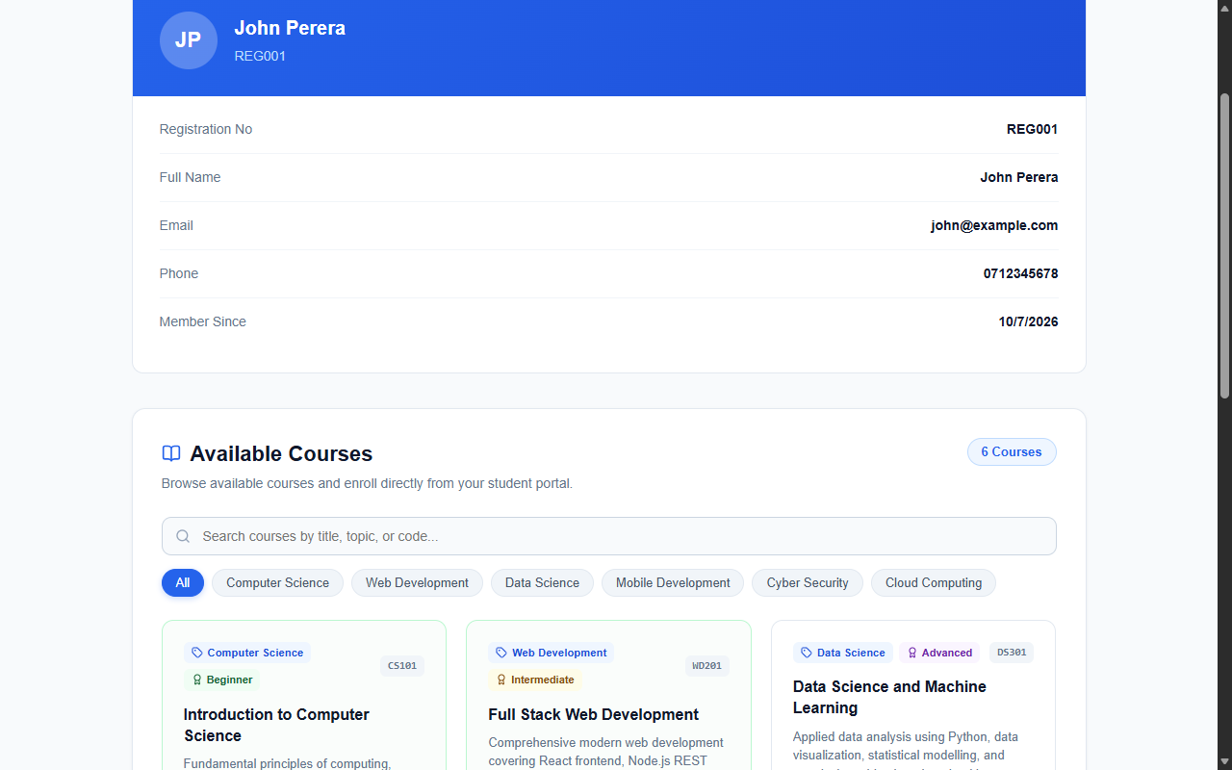
Figure 1: Student Dashboard showing the Available Courses catalog, category filter pills, level badges, duration, price, and enrollment options
Evidence 02 – Student Course Enrollment & Confirmation Feedback
Related: AC-003, AC-004, AC-005
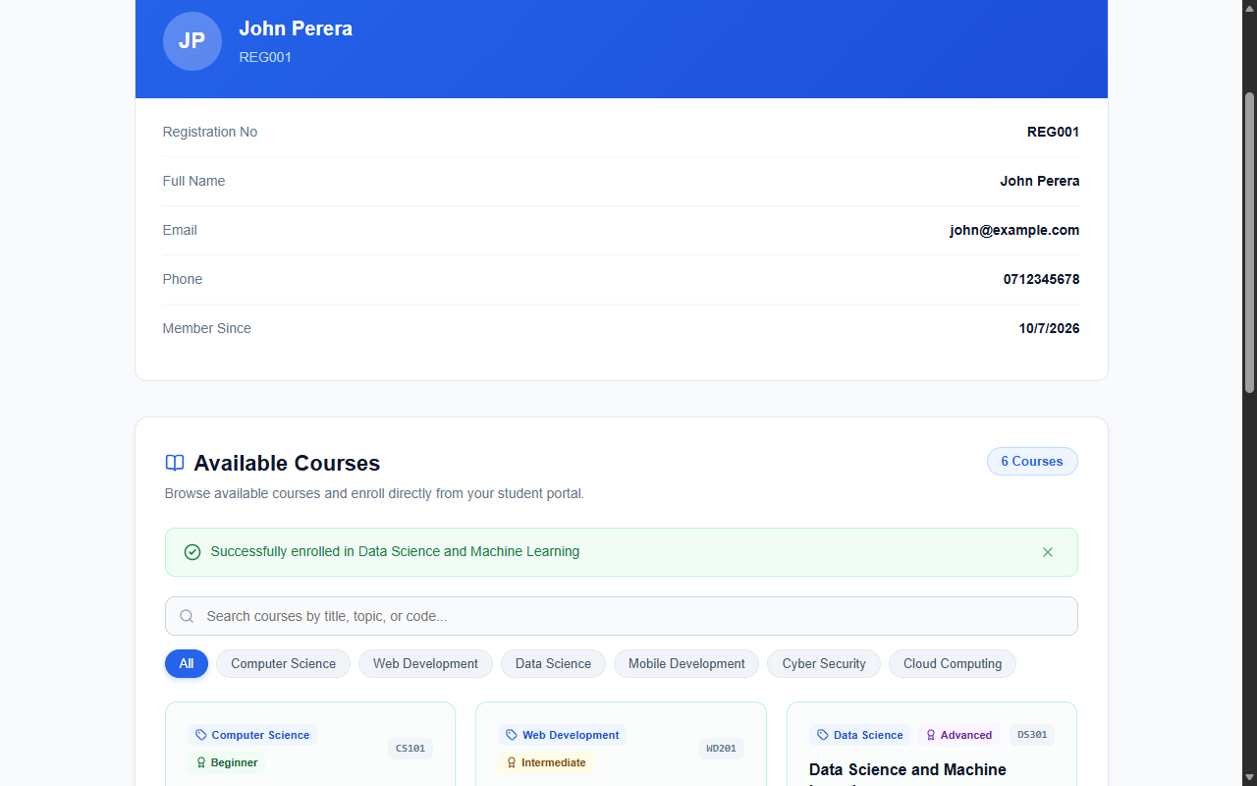
Figure 2: Successful student course enrollment triggering real-time enrollment confirmation alert and updating course action state to Enrolled
6. Final Result
Item | Result
Requirements | Met / Partially Met / Not Met
Implementation | Completed / Partially Completed
Testing | Passed / Partially Passed / Failed
Acceptance Criteria | All Met / Partially Met / Not Met
Existing CRUD / Auth | Verified / Not Verified
Final Status | Accepted / Pending / Rejected

6.1 Final Summary
CR-009 was successfully implemented as a full-stack enhancement introducing the Available Courses catalog and Course Enrollment functionality to the Student Portal of the Student Management System. Authenticated students can now view all available courses with complete details including course title, category, level, duration, and price directly on their dashboard. Students can enroll in selected courses with real-time feedback, duplicate registration protection, and immediate state updates. All security requirements, role-based authorizations, and existing student profile management features remain fully intact with no regression. The implementation was comprehensively verified across 12 test cases achieving a 100% pass rate.
6.2 Issues / Limitations
[State any remaining issues or limitations.]
If none:
No significant issues identified. Note: Existing database instances require executing the migration SQL in schema.sql creating the courses and enrollments tables prior to starting the updated backend service.
Student Name: MH Anush
Student ID: JFICT2416
Date: 22 October 2026
Signature: __________________________________
~ END OF REPORT ~

