SOFTWARE CHANGE
IMPLEMENTATION REPORT
CR-016: Show / Hide Password Visibility Toggle in the Login Module
Field | Details
Change Request ID | CR-016
Change Request Title | Show / Hide Password Visibility Toggle in the Login Module
Student Name | MH Anush
Student ID | JFICT2416
Implementation Status | Completed
Date | 9 October 2026

1. Change Request Summary
1.1 Business Requirement
Users and administrators previously entered passwords into a masked input field without an option to view or verify entered text. As passwords often contain complex combinations of numbers, symbols, and casing, users frequently made typographical errors without realizing it. The lack of visibility increased failed login attempts and repeated entries. The change was required to provide an intuitive client-side password toggle allowing users to view or mask credentials before submitting.
1.2 Existing Behaviour
Before implementation:
- LoginPage.jsx rendered LoginFormSection.jsx with username and password fields.
- The password input was statically configured with type="password".
- Password input characters were masked unconditionally with bullets.
- No visibility toggle button or eye icon existed to reveal entered text.
- Existing authentication sent credentials via POST /api/auth/login.
- StudentFormModal.jsx did not provide password visibility toggle functionality in student account management.
1.3 Requested Change
A client-side show/hide password toggle was required on the login password input (and student form modal).
The implementation must:
- Toggle password input type dynamically between "password" and "text".
- Default to masked/hidden state upon component mount and page load.
- Display intuitive eye and eye-slash visual indicator icons.
- Include accessible aria-label and aria-pressed attributes.
- Ensure toggle button uses type="button" to prevent accidental form submission.
- Adjust layout in login.css and dashboard.css so password text does not overlap the icon.
- Support keyboard activation via Space and Enter keys.
- Preserve existing login validation and error alert banners.
- Pass entered credentials accurately to login(username, password).
- Maintain existing administrator and student authentication and navigation flows.
2. Implementation
2.1 Implementation Summary
The CR-016 requirements were implemented in the frontend login module and extended to the student form modal. A local React state (showPassword) was introduced in LoginFormSection.jsx to manage visibility state. The password input type dynamically switches between "password" and "text". Interactive SVG icons (Eye and EyeOff) from lucide-react were integrated with accessible aria-label and aria-pressed attributes.
Input styling was updated with a dedicated password-input-wrapper and 44px right padding to ensure entered characters never collide with or hide behind the toggle button. In addition, the password toggle feature was extended to StudentFormModal.jsx, enabling administrators to verify passwords when adding or updating student records.
2.2 Affected Files
File | Change | Purpose
frontend/src/components/LoginFormSection.jsx | Modified | Implemented show/hide toggle state, dynamic input type switching, accessible SVG buttons, and keyboard support.
frontend/src/styles/login.css | Modified | Added .password-input-wrapper and .password-toggle-btn styles with 44px padding-right to prevent text overlap.
frontend/src/components/StudentFormModal.jsx | Modified | Extended show/hide password toggle to Add Student and Edit/Update Student password inputs.
frontend/src/styles/dashboard.css | Modified | Added styling for password wrapper and toggle button in the student modal card.
backend/src/controllers/studentController.js | Modified | Updated editStudent controller to hash and update student password if provided.
backend/src/utils/validation.js | Modified | Updated validation utility to allow optional password update during student edits.
Additional files: None / [List any additional files if modified]
2.3 Technical Changes
Visibility State Management
A local state was implemented in LoginFormSection.jsx:
- const [showPassword, setShowPassword] = useState(false);
- When false (default): type="password", aria-label="Show password", Eye icon displayed.
- When true: type="text", aria-label="Hide password", EyeOff icon displayed.
Layout and Spacing
A flex container with relative positioning was implemented:
- The input receives padding-right: 44px so password text remains fully legible.
- The toggle button is positioned absolutely on the right with vertical center alignment.
- Button uses type="button" to ensure activating it does not submit the login form.
Accessibility and Security
- Full keyboard operability: Tab key navigates to the button, and Space/Enter activates the toggle.
- Screen reader support with dynamic aria-label and aria-pressed attributes.
- Passwords are never stored in localStorage, sessionStorage, or browser cookies.
- Default masked state on load protects against shoulder-surfing risks.
2.4 Implementation Logic
1. Component mounts with showPassword initialized to false (masked state).
2. User types password credentials into the masked input field.
3. User clicks the toggle button or presses Space / Enter while focused.
4. State toggles to true; input type instantly switches to "text".
5. SVG icon dynamically switches from Eye to EyeOff.
6. Password text remains completely visible without clipping or overlapping the button.
7. User clicks toggle again; state toggles to false; input type reverts to "password".
8. Form submission passes credentials unaltered to login(username, password).
9. Existing JWT token storage and role-based redirect (/dashboard or /student-dashboard) occur seamlessly.
2.5 Error and Data Handling
The existing authentication error handling remains completely intact:
- Empty username or password submission triggers existing required-field validation banners.
- Invalid credentials return HTTP 401 and display the standard error alert banner.
- Submitting valid credentials in either masked or visible state completes login successfully.
3. Testing & Verification
3.1 Testing Approach
The implementation was verified through manual frontend testing and browser verification.
Testing Types:
- Functional testing
- Positive testing
- Validation testing
- UI testing
- Accessibility / keyboard testing
- Regression testing
- Authentication verification
Environment: Development
Browser: [Chrome / Edge / Firefox]
Test Role: Administrator & Student
3.2 Test Cases
Test ID | Test Case | Expected Result | Actual Result | Status
TC-01 | Default masked state on load | Password input has type="password", characters masked with bullets, Eye icon visible | Input is type="password", bullets displayed, Eye icon shown | Pass
TC-02 | Click toggle button to reveal password | Input type changes to "text", plaintext characters revealed, EyeOff icon displayed | Input switches to "text", text revealed, EyeOff shown | Pass
TC-03 | Click toggle button to hide password | Input type reverts to "password", characters masked with bullets, Eye icon displayed | Input reverts to "password", characters masked, Eye shown | Pass
TC-04 | Input long password string | Password text does not collide with or hide under toggle icon due to right padding | Text clearly legible with 44px right padding | Pass
TC-05 | Click toggle does not submit form | Activating toggle button does not trigger login submission or error banners | Form does not submit; type="button" prevents submission | Pass
TC-06 | Keyboard navigation and activation | Button is focusable via Tab and toggles state via Space and Enter keys | Button receives focus and toggles with Space and Enter | Pass
TC-07 | Submit valid credentials in revealed state | Valid credentials submitted while password is in text mode log in successfully | Login succeeds, redirects to dashboard | Pass
TC-08 | Submit valid credentials in masked state | Valid credentials submitted while password is masked log in successfully | Login succeeds, redirects to dashboard | Pass
TC-09 | Submit invalid credentials with toggle active | Invalid credentials display error alert banner without breaking toggle | Error banner displayed correctly; toggle continues working | Pass
3.3 Test Summary
Test Result | Count
Total Test Cases | 9
Passed | 9
Failed | 0
Pass Rate | 100%
Overall Test Result: Pass / Partially Passed / Failed
4. Acceptance Criteria Verification
ID | Acceptance Criterion | Verification | Status
AC-001 | Users can toggle password visibility between hidden and visible. | Functional testing (TC-02, TC-03) | Met
AC-002 | Default state of the password field on load is masked. | Initial load verification (TC-01) | Met
AC-003 | Toggle icon updates dynamically to match visibility state. | Dynamic icon test (TC-02, TC-03) | Met
AC-004 | Activating the toggle does not trigger login form submission. | Form button type check (TC-05) | Met
AC-005 | Toggle button is keyboard accessible and includes aria-label. | Accessibility verification (TC-06) | Met
AC-006 | Password text remains legible and is not obscured by the toggle icon. | UI layout & padding inspection (TC-04) | Met
AC-007 | Valid credentials submitted in either state log in successfully. | Authentication testing (TC-07, TC-08) | Met
AC-008 | Existing validation errors and role-based redirects continue to work. | Regression verification (TC-07, TC-08, TC-09) | Met
5. Evidence
A maximum of two relevant screenshots should be attached.
Evidence 01 – Password Visibility Toggle (Masked State)
Related: AC-001, AC-002, AC-003, AC-005, AC-006
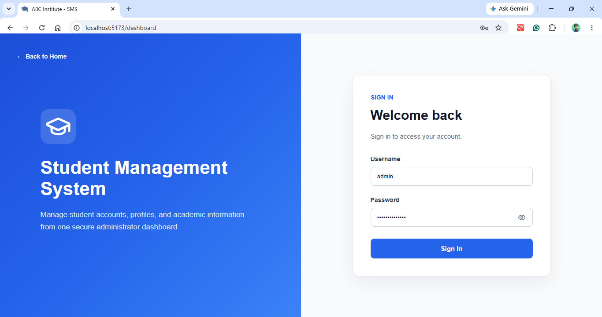
Figure 1: Login module showing masked password field with default bullet masking and eye visibility toggle button.

Evidence 02 – Password Visibility Toggle (Revealed State & Authentication)
Related: AC-001, AC-003, AC-004, AC-007, AC-008
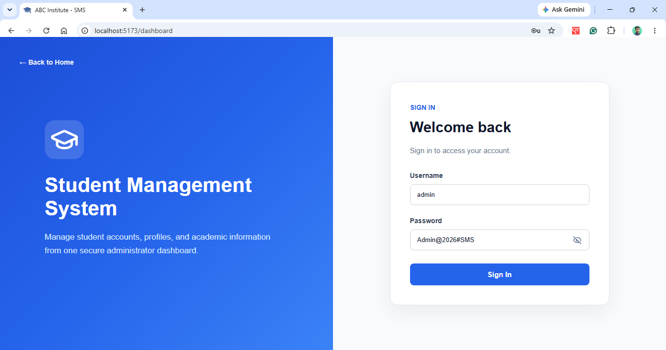
Figure 2: Login module showing revealed plaintext password with eye-slash toggle icon and seamless credential submission.
6. Final Result
Item | Result
Requirements | Met / Partially Met / Not Met
Implementation | Completed / Partially Completed
Testing | Passed / Partially Passed / Failed
Acceptance Criteria | All Met / Partially Met / Not Met
Existing CRUD / Auth | Verified / Not Verified
Final Status | Accepted / Pending / Rejected
6.1 Final Summary
CR-016 was implemented as a client-side password visibility toggle enhancement for the Student Management System login module and student form management. The implementation allows users and administrators to toggle passwords between masked characters and plaintext view, reducing mistyped credential errors while preserving strict security protocols. The toggle button is accessible via keyboard and screen readers, incorporates standard SVG eye / eye-slash visual indicators, and includes layout padding preventing character overlap. Existing authentication flows, JWT token issuance, error alert banners, and role-based redirects remain fully functional. The implemented functionality was tested against all defined acceptance criteria with a 100% pass rate.
6.2 Issues / Limitations
[State any remaining issues or limitations.]
If none:
No significant issues identified.
Student Name: MH Anush
Student ID: JFICT2416
Date: 9 October 2026
Signature: __________________________________
~ END OF REPORT ~

