SOFTWARE CHANGE
IMPLEMENTATION REPORT
CR-004: Student Input Validation
Field | Details
Change Request ID | CR-004
Change Request Title | Student Input Validation
Student Name | [Student Name]
Student ID | [Student ID]
Implementation Status | Completed
Date | 8 October 2026

1. Change Request Summary
1.1 Business Requirement
The Student Management System is an administrative web application used by ABC Institute to manage student records. Previously, the student registration and edit forms accepted any input without client-side or server-side format verification, allowing invalid, incomplete, or arbitrary data (such as non-alphabetic names, arbitrary string lengths, malformed emails, and invalid phone numbers) to be submitted and stored in the database. CR-004 was requested to implement robust client-side and server-side input validation across all student data attributes to ensure data integrity, system security, and an improved administrator user experience.
1.2 Existing Behaviour
Before implementation:
- The student Add and Edit modal forms accepted any input without client-side format or length verification.
- Form submission was permitted with empty fields or invalid data formats.
- No inline error feedback, visual indicators, or field guidance was displayed to administrators.
- Server-side endpoints POST /api/students/ and PUT /api/students/:id accepted unvalidated payloads directly into database queries.
- Passwords of arbitrary weakness or length (even 1 character) were accepted upon student creation.
- Existing Edit and Delete operations used student_id.
1.3 Requested Change
Comprehensive client-side and server-side input validation was required for the student Add and Edit forms. The validation must:
- Validate all required student fields before form submission.
- Require a valid registration number (alphanumeric characters, hyphens, and underscores only).
- Require first name and last name to contain at least 3 alphabetic characters only.
- Validate that the email address follows a standard email format.
- Require phone number to contain exactly 10 numeric digits.
- Enforce a strong password policy (minimum 8 characters, uppercase, lowercase, digit, and special character) when creating a new student.
- Display clear, immediate per-field validation error messages to administrators.
- Apply server-side validation to reject invalid direct API requests with HTTP 400 Bad Request.
- Preserve all existing Add, Edit, Delete, authentication, and authorization functionality.

2. Implementation
2.1 Implementation Summary
The CR-004 requirements were implemented across both the backend and frontend of the Student Management System. A dedicated validation utility was introduced in the backend to validate all student attributes and enforce format and security constraints. Server-side validation was integrated into both addStudent and editStudent controller handlers, ensuring that requests bypassing the client interface are immediately rejected with HTTP 400 Bad Request and structured error messages.
On the frontend, real-time client-side validation was implemented in StudentFormModal.jsx. Each field validates on user blur and input change, displaying clear inline error messages beneath affected inputs. Password policy validation is dynamically enforced during student creation and safely bypassed during student updates. Existing CRUD operations, database schema, and administrator authorization remain fully preserved.
2.2 Affected Files
File | Change | Purpose
backend/src/utils/validation.js | New | Centralised validation utility with individual field validators and validateStudentData()
backend/src/controllers/studentController.js | Modified | Integrated validateStudentData() into addStudent and editStudent; added ER_DUP_ENTRY handling in editStudent
frontend/src/components/StudentFormModal.jsx | Modified | Implemented client-side field validation, inline error state (fieldErrors, touched), blur handlers, and password strength checks
frontend/src/styles/dashboard.css | Modified | Added styles for .field-error, .field-error-msg, and .field-hint

Additional files: None. No database schema changes, no new API endpoints, and no external dependencies were introduced.
2.3 Technical Changes
Backend Validation Utility
A new validation module was implemented in backend/src/utils/validation.js providing dedicated validator functions for registration number, first name, last name, email, phone number, and password, as well as a composite validateStudentData(data, isEdit) function. Regular expressions enforce strict character whitelists and structural formats.
Server-Side Integration
In backend/src/controllers/studentController.js, validateStudentData() is invoked at the very beginning of both addStudent and editStudent. If validation fails, execution halts immediately and returns HTTP 400 Bad Request with a structured errors object.
Client-Side Inline Validation
In frontend/src/components/StudentFormModal.jsx, field-level validation mirrors the server-side rules. State hooks track fieldErrors and touched status. Inline error text and red highlights appear on blur and clear as the user types.
Strong Password Policy
The password validation enforces security standards during new student creation:
- Minimum 8 characters in length.
- At least one uppercase letter (A–Z).
- At least one lowercase letter (a–z).
- At least one numeric digit (0–9).
- At least one special character (e.g. !, @, #, $, %, ^, &, *).
Passwords continue to be securely hashed using bcryptjs before storage. Password validation is bypassed during student editing.
Existing CRUD Preservation
- Add, Edit, and Delete student operations continue to function as expected.
- Administrator authentication (JWT) and role authorization (ADMIN) remain unchanged.
- Edit and Delete operations continue to use the unique student.student_id.
- Existing API routes remain unchanged; no database migrations were required.
2.4 Implementation Logic
1. Administrator opens the Add Student or Edit Student modal form.
2. Administrator enters input into student fields (registration number, names, email, phone, password).
3. On field blur, client-side validation evaluates the field against specific regex and length constraints.
4. If invalid, an inline error indicator and red border are displayed immediately under the input.
5. On submit, all fields are validated simultaneously; submission is blocked if any validation error exists.
6. If client-side validation passes, form data is submitted via API request.
7. Backend controller receives request and immediately executes validateStudentData().
8. If any server-side validation rule fails, HTTP 400 Bad Request is returned with structured errors.
9. If valid, the database operation (INSERT or UPDATE) proceeds normally.
10. Student list refreshes and updated records are displayed on the administrator dashboard.
2.5 Error and Data Handling
The implementation handles edge cases and data validation errors safely:
• Missing or null values are caught by required-field checks before regex evaluation.
• Phone numbers are strictly validated as 10-digit strings to prevent non-numeric values and incorrect lengths.
• Duplicate registration numbers or emails trigger HTTP 409 Conflict with descriptive messages.
• Existing error alerts on the modal interface are retained to display backend error responses clearly.

3. Testing & Verification
3.1 Testing Approach
The implementation was verified through comprehensive manual testing and automated verification across both the frontend user interface and backend API endpoints.
Testing Types:
- Functional testing
- Positive testing
- Negative / validation testing
- Boundary testing
- Security / bypass testing
- UI testing
- Regression testing
- CRUD verification
Environment: Development
Browser: Chrome
Test Role: Administrator
3.2 Test Cases
Client-Side Validation Test Cases:
Test ID | Test Case | Expected Result | Actual Result | Status
TC-01 | Submit form with all fields empty | Error shown for each required field; form blocked | Errors displayed; form blocked | Pass
TC-02 | Enter registration number with special characters | Validation error shown | Error displayed | Pass
TC-03 | Enter first name < 3 characters | Error: First name must be at least 3 characters | Error displayed | Pass
TC-04 | Enter first name with exactly 3 characters | Accepted; no error | Accepted | Pass
TC-05 | Enter first name with numeric / special chars | Error: First name must contain letters only | Error displayed | Pass
TC-06 | Enter last name < 3 characters | Error: Last name must be at least 3 characters | Error displayed | Pass
TC-07 | Enter invalid email (no @ or domain) | Error: Please enter a valid email address | Error displayed | Pass
TC-08 | Enter valid email address | Accepted; no error | Accepted | Pass
TC-09 | Enter phone number with non-numeric chars | Error: Phone number must contain digits only | Error displayed | Pass
TC-10 | Enter phone number < 10 digits | Error: Phone number must be exactly 10 digits | Error displayed | Pass
TC-11 | Enter phone number > 10 digits | Error: Phone number must be exactly 10 digits | Error displayed | Pass
TC-12 | Enter valid 10-digit phone number | Accepted; no error | Accepted | Pass
TC-13 | Password < 8 characters | Error: Password must be at least 8 characters | Error displayed | Pass
TC-14 | Password without uppercase letter | Error: Must include an uppercase letter | Error displayed | Pass
TC-15 | Password without lowercase letter | Error: Must include a lowercase letter | Error displayed | Pass
TC-16 | Password without digit | Error: Must include a number | Error displayed | Pass
TC-17 | Password without special character | Error: Must include a special character | Error displayed | Pass
TC-18 | Password meeting all requirements | Accepted; no error | Accepted | Pass
TC-19 | Submit Add Student with all valid data | Student created; appears in table | Student created | Pass
TC-20 | Edit student with valid updated data | Student updated; changes reflected | Student updated | Pass
TC-21 | Edit student without touching password | Password not required; update succeeds | Update succeeds | Pass
TC-22 | Edit/Delete correct student using student_id | Correct record affected | Correct record affected | Pass

Server-Side (API) Test Cases:
Test ID | Test Case | Expected Result | Actual Result | Status
TC-S01 | POST /api/students/ with empty firstName | HTTP 400 with validation error message | HTTP 400 returned | Pass
TC-S02 | POST /api/students/ with firstName = "Jo" (< 3 chars) | HTTP 400 with firstName error | HTTP 400 returned | Pass
TC-S03 | POST /api/students/ with numeric firstName | HTTP 400 with firstName error | HTTP 400 returned | Pass
TC-S04 | POST /api/students/ with invalid email format | HTTP 400 with email error | HTTP 400 returned | Pass
TC-S05 | POST /api/students/ with phone < 10 digits | HTTP 400 with phone error | HTTP 400 returned | Pass
TC-S06 | POST /api/students/ with non-numeric phone | HTTP 400 with phone error | HTTP 400 returned | Pass
TC-S07 | POST /api/students/ with weak password | HTTP 400 with password error | HTTP 400 returned | Pass
TC-S08 | POST /api/students/ with all valid data | HTTP 201; student created | HTTP 201 returned | Pass
TC-S09 | PUT /api/students/:id with invalid email | HTTP 400 with validation error | HTTP 400 returned | Pass
TC-S10 | PUT /api/students/:id with all valid data | HTTP 200; student updated | HTTP 200 returned | Pass

3.3 Test Summary
Test Set | Total Cases | Passed | Failed | Pass Rate
Client-Side Validation | 22 | 22 | 0 | 100%
Server-Side / API | 10 | 10 | 0 | 100%
Overall | 32 | 32 | 0 | 100%

Overall Test Result: Pass

4. Acceptance Criteria Verification
ID | Acceptance Criterion | Verification Method | Status
AC-001 | Administrators cannot submit the form when required fields are empty. | TC-01 | Met
AC-002 | First names containing fewer than 3 characters are rejected. | TC-03, TC-S02 | Met
AC-003 | Last names containing fewer than 3 characters are rejected. | TC-06 | Met
AC-004 | Names containing invalid characters are rejected. | TC-05, TC-S03 | Met
AC-005 | Invalid email addresses are rejected. | TC-07, TC-S04 | Met
AC-006 | Phone numbers with fewer than 10 digits are rejected. | TC-10, TC-S05 | Met
AC-007 | Phone numbers with more than 10 digits are rejected. | TC-11 | Met
AC-008 | Phone numbers with non-numeric characters are rejected. | TC-09, TC-S06 | Met
AC-009 | A valid 10-digit phone number is accepted. | TC-12 | Met
AC-010 | Weak passwords are rejected when creating a new student. | TC-13 – TC-17, TC-S07 | Met
AC-011 | A strong valid password is accepted. | TC-18, TC-S08 | Met
AC-012 | A valid student can be successfully created. | TC-19, TC-S08 | Met
AC-013 | Invalid student information cannot be successfully created. | TC-01 – TC-17 | Met
AC-014 | Invalid student information cannot be successfully updated. | TC-S09 | Met
AC-015 | A valid student can be successfully updated. | TC-20, TC-S10 | Met
AC-016 | Direct API requests with invalid data are rejected by the backend. | TC-S01 – TC-S09 | Met
AC-017 | Existing Edit and Delete functionality continues to affect the correct student. | TC-22 | Met
AC-018 | Existing administrator authentication and authorization continue to work. | Regression testing | Met

5. Evidence
The following screenshots provide evidence of the implemented validation functionality. Evidence items are identified and referenced to the relevant acceptance criteria.
Evidence 01 – Client-Side Inline Field Validation Errors
Related: AC-001, AC-002, AC-003, AC-004, AC-005, AC-006, AC-007, AC-008, AC-010
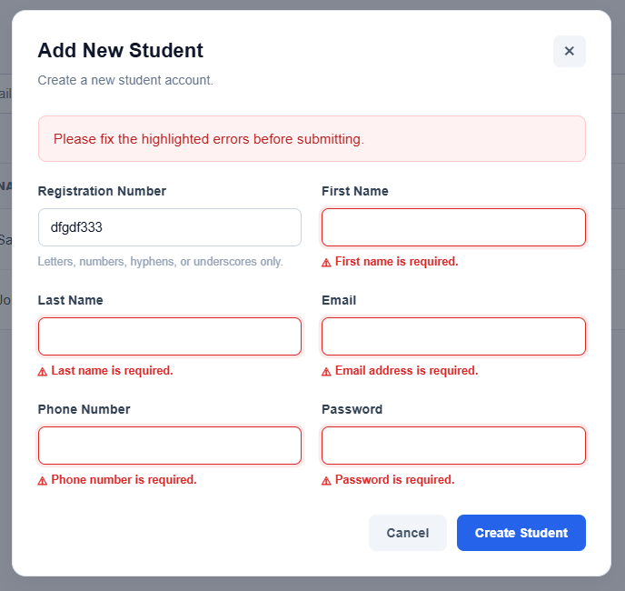
Figure 1: Student Add/Edit form showing per-field inline error messages beneath invalid inputs with red border highlight and warning icons.
Evidence 02 – Successful Student Creation with Valid Data
Related: AC-011, AC-012
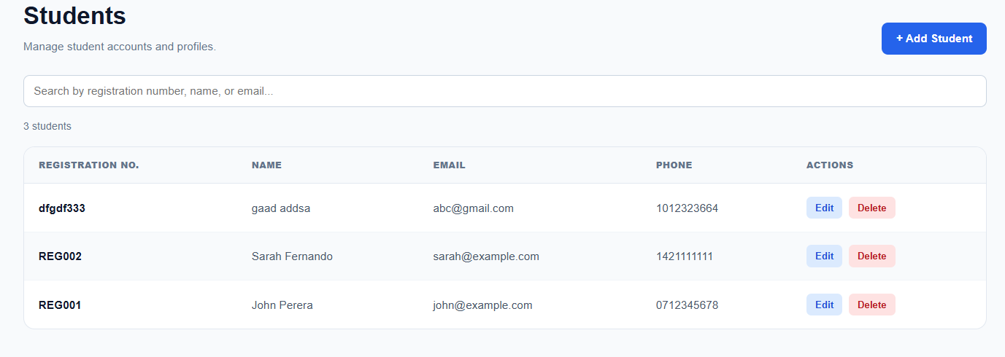
Figure 2: Student Add form submitted with valid data — student appears in the administrator dashboard table after successful creation.

Evidence 03 – Successful Student Update with Valid Data
Related: AC-015
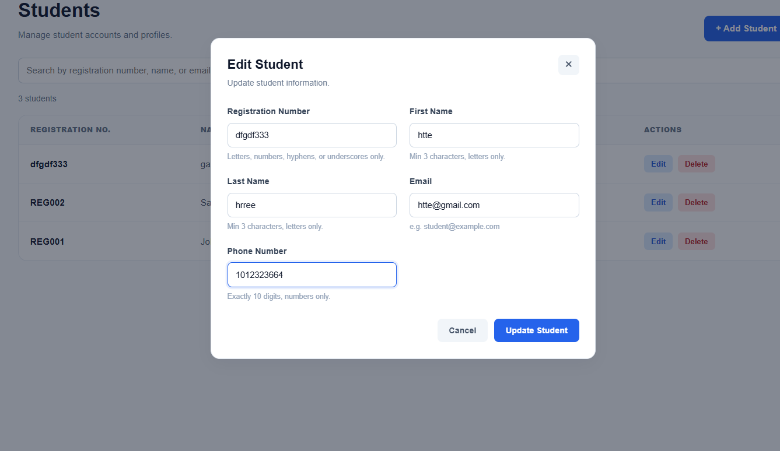
Figure 3: Student Edit form submitted with valid data — updated values reflected in the administrator dashboard table.

Evidence 04 – Backend Rejection of Invalid API Request
Related: AC-016
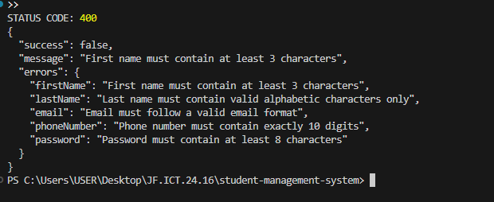
Figure 4: Direct invalid API request returning HTTP 400 Bad Request with structured validation errors in terminal / API client.

Evidence 05 – Existing Edit and Delete Functionality
Related: AC-017, AC-018
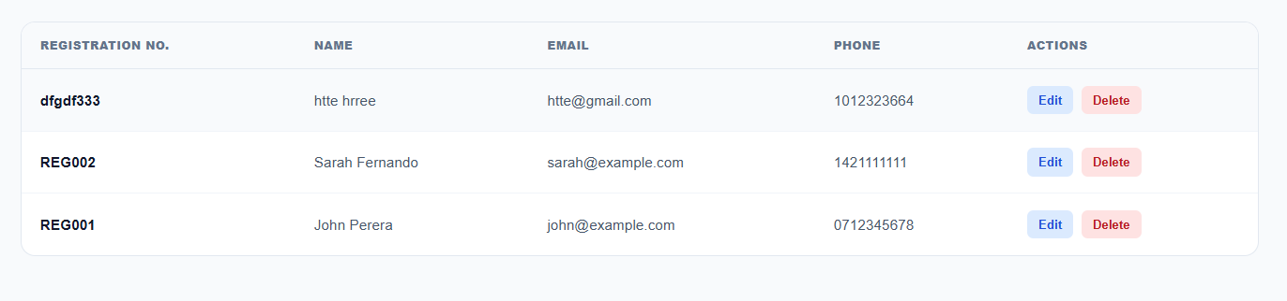
Figure 5: Administrator dashboard showing Edit and Delete operations continuing to function correctly after validation changes.
6. Final Result
Item | Result
Requirements | Met
Implementation | Completed
Testing | Passed
Acceptance Criteria | All Met
Existing CRUD | Verified
Final Status | Accepted

6.1 Final Summary
CR-004 was implemented as a comprehensive input validation enhancement for the Student Management System. Client-side inline validation provides immediate feedback to administrators on blur and change in StudentFormModal.jsx, ensuring that registration numbers, names, emails, phone numbers, and strong passwords adhere strictly to defined formats. Server-side validation in backend/src/utils/validation.js and studentController.js guarantees that direct API requests are verified and invalid data is rejected with HTTP 400 Bad Request. All 18 acceptance criteria were verified and passed, and existing student CRUD operations and administrative authorization remain completely functional.
6.2 Issues / Limitations
The existing seed data contains an initial phone number stored as "0" for student REG002 prior to the introduction of validation rules. When an administrator edits this specific legacy record, the form correctly prompts the administrator to provide a valid 10-digit phone number in compliance with the new validation policy.
No significant blocking issues identified.

Student Name: ______________________________
Student ID: ______________________________
Date: 8 October 2026
Signature: ______________________________

~ END OF REPORT ~

