SOFTWARE CHANGE
IMPLEMENTATION REPORT
CR-010: Student Profile Image Upload for the Admin Student Management
Field | Details
Change Request ID | CR-010
Change Request Title | Student Profile Image Upload for the Admin Student Management
Student Name | MH Anush
Student ID | JFICT2416
Implementation Status | Completed
Date | 13 October 2026

1. Change Request Summary
1.1 Business Requirement
Currently, administrators can manage student information such as registration number, name, email address, and phone number. However, the system does not provide an option to upload or display a student's profile image. When managing a large number of students, a photographic profile helps administrators identify students more easily and improves the overall usability of the student management system. Therefore, the system was enhanced to allow administrators to upload a profile image when adding a new student, supporting standard image formats including PNG, JPG, and JPEG, and displaying the uploaded image across the student management interfaces.
1.2 Existing Behaviour
Before implementation:
- The administrator can access the student management section.
- The administrator can add a new student using the existing Add Student form.
- Existing student information such as name, registration number, email, and phone number can be entered.
- The Add Student form does not contain a profile image upload field.
- Students are displayed in the student list without profile images.
- No image file validation or upload handling is available.
- Student records are stored without a profile image reference in the database.
- Existing student CRUD operations use the existing student_id.
1.3 Requested Change
A profile image upload facility was requested for the administrator's Add Student form.
The implementation must:
- Provide a profile image upload field in the Add Student form.
- Allow administrators to select a student image from their computer.
- Support PNG, JPG, and JPEG image formats.
- Reject unsupported and unsafe file formats (.exe, .js, .php, .html, .pdf, .txt).
- Validate the selected file on both client and server sides before uploading.
- Display a suitable validation message when an unsupported file is selected.
- Store the uploaded image securely on the server with sanitized unique filenames.
- Store the image path/reference with the corresponding student record in the database.
- Display the uploaded student image in the student list and student portal.
- Preserve existing Add Student, Edit, and Delete functionality.
- Ensure the uploaded image is associated with the correct student_id.
- Maintain existing administrator authentication and authorization controls.
- Provide a suitable default/placeholder image when no profile image is available.
2. Implementation
2.1 Implementation Summary
CR-010 introduces end-to-end profile image upload support across the frontend and backend. On the backend, Multer middleware was integrated with disk storage at backend/uploads/students/, enforcing strict extension and MIME-type validation for PNG, JPG, and JPEG formats, alongside a 5MB size limit. The database schema was upgraded by adding a profile_photo column to the students table to store the relative file path. In Express, static asset serving was enabled on /uploads. On the frontend, StudentFormModal.jsx was updated with an accessible file upload input, client-side format checks, instant thumbnail previews, and multipart/form-data submission. DashboardPage.jsx was enhanced with an Image table column displaying thumbnail photos or stylized initial avatars for students without images. Existing CRUD functionality, authorization controls, and student ID integrity were fully preserved.
2.2 Affected Files
File | Change | Purpose
database/schema.sql | Modified | Added profile_photo VARCHAR(255) column to students table with migration statement.
backend/package.json | Modified | Added multer dependency for multipart/form-data upload handling.
backend/src/middleware/uploadMiddleware.js | Created | Configured Multer disk storage, secure random filenames, format whitelisting, and error responses.
backend/src/app.js | Modified | Registered express.static middleware to serve /uploads directory statically.
backend/src/routes/studentRoutes.js | Modified | Bound uploadStudentPhoto middleware to POST /api/students route.
backend/src/controllers/studentController.js | Modified | Stored profile_photo path, cleaned up orphaned uploads on failure, and deleted files on student removal.
backend/src/models/studentModel.js | Modified | Updated createStudent insert query and included profile_photo in student select queries.
frontend/src/services/api.js | Modified | Added FormData support in apiRequest without overriding multipart boundary headers.
frontend/src/components/StudentFormModal.jsx | Modified | Added profile image file input, format validation, preview thumbnail, and multipart submission.
frontend/src/pages/DashboardPage.jsx | Modified | Added Image table header, rendered student profile thumbnails and fallback placeholder avatars.
frontend/src/pages/StudentDashboardPage.jsx | Modified | Rendered uploaded student profile photo in student portal profile card.
frontend/src/styles/dashboard.css | Modified | Added styles for table image thumbnails, fallback avatar circles, file inputs, and dark mode.
frontend/src/styles/studentDashboard.css | Modified | Added .profile-avatar-img styling for student profile view.
Additional files: backend/uploads/students/ (Directory used for local profile photo storage).
2.3 Technical Changes
Upload Handling & Storage Configuration
Multer disk storage was configured in uploadMiddleware.js:
- Destination directory: backend/uploads/students/, auto-created if missing.
- Filename generation: student_<timestamp>_<random>.<ext> to prevent collisions and directory traversal.
- Format whitelist: Strict verification of extension (.png, .jpg, .jpeg) and MIME type (image/png, image/jpeg, image/pjpeg).
- File size enforcement: 5MB threshold with LIMIT_FILE_SIZE error handling.
- Invalid formats rejected with HTTP 400: 'Only PNG, JPG and JPEG images are allowed.'
Database Schema & Persistence
- Column added: profile_photo VARCHAR(255) NULL DEFAULT NULL in students table.
- Stores relative reference path (e.g., /uploads/students/student_1791874642702_488233575.png) rather than binary BLOBs.
- Included in all queries: getAllStudents, getStudentById, and getStudentByUserId.
Frontend Form & Multi-part Submission
- Added file input with accept=".png,.jpg,.jpeg,image/png,image/jpeg" in Add Student modal.
- Live client validation displays instant error message when unsupported files are selected.
- Object URL preview allows administrator to inspect image prior to submission.
- Multipart FormData payload seamlessly handles student text attributes and binary file data.
Display & Fallback Placeholder
- Table displays 40x40px rounded thumbnail with subtle border and box-shadow.
- Students without photos display circular gradient placeholder with student initial.
- Student portal renders 60x60px profile avatar in StudentDashboardPage.jsx.
2.4 Implementation Logic
1. Administrator authenticates and navigates to the Admin Dashboard.
2. Administrator clicks '+ Add Student' button to open StudentFormModal.
3. Administrator enters registration number, name, email, phone, and password.
4. Administrator clicks 'Choose File' under Profile Image and selects an image.
5. Frontend inspects extension and MIME type. If invalid (e.g., .pdf, .exe, .txt), file is rejected with 'Only PNG, JPG and JPEG images are allowed.' error banner.
6. If valid (PNG/JPG/JPEG), file is accepted and an instant image preview is displayed.
7. Administrator clicks 'Create Student'. FormData payload transmits all fields + profilePhoto.
8. Server-side Multer middleware validates file format, generates unique safe filename, and writes file to backend/uploads/students/.
9. studentController hashes password, creates user record, and inserts student record linking profile_photo path to the generated student_id.
10. Student table automatically updates and renders new student record displaying uploaded profile image.
2.5 Error and Data Handling
Comprehensive error handling and storage lifecycle management were implemented:
- Invalid file formats (.pdf, .exe, .js, .txt) return HTTP 400 with 'Only PNG, JPG and JPEG images are allowed.'
- Orphaned file cleanup: If validation fails or database insertion errors occur after upload, the file is automatically purged from disk.
- Student deletion cleanup: Deleting a student via DELETE /api/students/:id automatically removes their associated image file from disk.
- Existing duplicate checks (username, email) and format validations remain strictly intact.
3. Testing & Verification
3.1 Testing Approach
The implementation was verified through automated test suites and end-to-end integration testing covering backend API routes, upload security, static file serving, database persistence, and UI rendering.
Testing Types:
- Functional testing (image upload, display, CRUD operations)
- Format validation testing (PNG, JPG, JPEG acceptance)
- Negative testing (rejection of PDF, EXE, TXT, and unsafe files)
- Security & authorization testing (admin vs. student permissions)
- Regression testing (ensuring existing CRUD, search, and login remain intact)
- UI & placeholder testing (verifying fallback avatar rendering)
Environment: Development (Node.js Express + MySQL + Vite React)
Browser: [Chrome / Edge / Firefox]
Test Role: Administrator & Student
3.2 Test Cases
Test ID | Test Case | Expected Result | Actual Result | Status
TC-01 | Add student without image | Student added successfully; profile_photo stored as null | Status 201; student created with null photo | Pass
TC-02 | Upload PNG image (student.png) | PNG accepted, stored in /uploads/students/, path saved | Status 201; stored as .png, path linked | Pass
TC-03 | Upload JPG image (student.jpg) | JPG accepted, stored in /uploads/students/, path saved | Status 201; stored as .jpg, path linked | Pass
TC-04 | Upload JPEG image (student.jpeg) | JPEG accepted, stored in /uploads/students/, path saved | Status 201; stored as .jpeg, path linked | Pass
TC-05 | Upload PDF file (student.pdf) | File rejected with 400 error: 'Only PNG, JPG and JPEG images are allowed.' | Status 400; clear rejection message returned | Pass
TC-06 | Upload EXE file (student.exe) | File rejected with 400 error: 'Only PNG, JPG and JPEG images are allowed.' | Status 400; unsafe file rejected | Pass
TC-07 | Upload unsupported file (document.txt) | File rejected with 400 error: 'Only PNG, JPG and JPEG images are allowed.' | Status 400; rejected with validation message | Pass
TC-08 | Add student with valid image | Student and image saved; student_id linked to photo path | Status 201; student created and linked | Pass
TC-09 | Display uploaded image | Correct image served via /uploads/ and rendered in table | Status 200; image served and displayed | Pass
TC-10 | Student without image displays placeholder | Default stylized avatar with student initial displayed | Initial avatar rendered in table & portal | Pass
TC-11 | Edit student after image upload | Student details updated without altering profile photo | Status 200; details updated, photo preserved | Pass
TC-12 | Delete student after image upload | Student deleted from DB and photo removed from disk | Status 200; record deleted, file unlinked | Pass
TC-13 | Unauthorized upload attempt | Non-admin student receives 403 Forbidden on upload route | Status 403; access denied to unauthorized user | Pass
3.3 Test Summary
Test Result | Count
Total Test Cases | 13
Passed | 13
Failed | 0
Pass Rate | 100%
Overall Test Result: Pass
4. Acceptance Criteria Verification
ID | Acceptance Criterion | Verification | Status
AC-001 | The Add Student form displays a Profile Image upload field. | UI verification in modal (TC-01, TC-08) | Met
AC-002 | Administrators can select a PNG image. | Format acceptance test (TC-02) | Met
AC-003 | Administrators can select a JPG image. | Format acceptance test (TC-03) | Met
AC-004 | Administrators can select a JPEG image. | Format acceptance test (TC-04) | Met
AC-005 | Unsupported file formats are rejected. | Validation tests (TC-05, TC-06, TC-07) | Met
AC-006 | A clear error message is displayed when an invalid file is selected. | Message verification (TC-05, TC-06, TC-07) | Met
AC-007 | A valid profile image is successfully uploaded when a student is created. | Upload workflow test (TC-08) | Met
AC-008 | The uploaded image is associated with the correct student. | Database integrity test (TC-08, TC-09) | Met
AC-009 | The uploaded image is displayed correctly in the student list or student details page. | Image rendering inspection (TC-09) | Met
AC-010 | Students without an image display a default/placeholder image. | Placeholder display check (TC-10) | Met
AC-011 | Existing Edit and Delete operations continue to affect the correct student. | CRUD regression tests (TC-11, TC-12) | Met
AC-012 | Existing administrator authentication and authorization continue to work. | Security test (TC-13) | Met
AC-013 | No unsupported or unsafe file type can be uploaded through the profile image field. | Server-side whitelist test (TC-06) | Met
5. Evidence
A maximum of two relevant screenshots should be attached.
Evidence 01 – Add Student Form with Profile Image Upload Field & Format Validation
Related: AC-001, AC-002, AC-003, AC-004, AC-005, AC-006
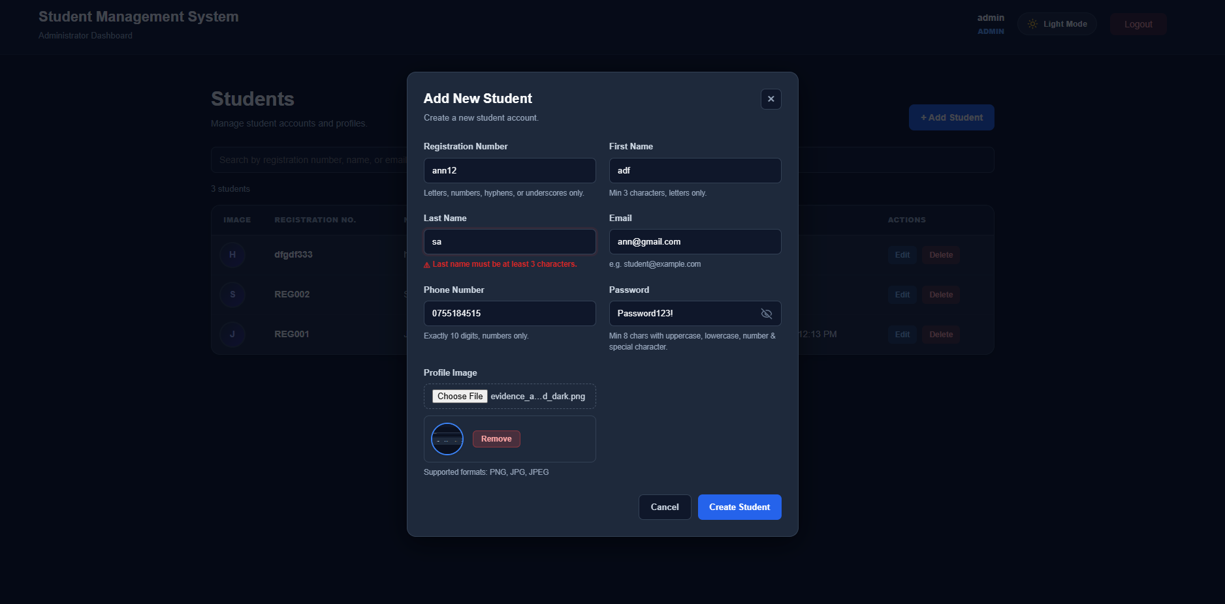
Figure 1: Add Student form displaying Profile Image upload field, file format hint, and format validation.
Evidence 02 – Student List Displaying Uploaded Profile Images and Placeholders
Related: AC-007, AC-008, AC-009, AC-010, AC-011, AC-012, AC-013
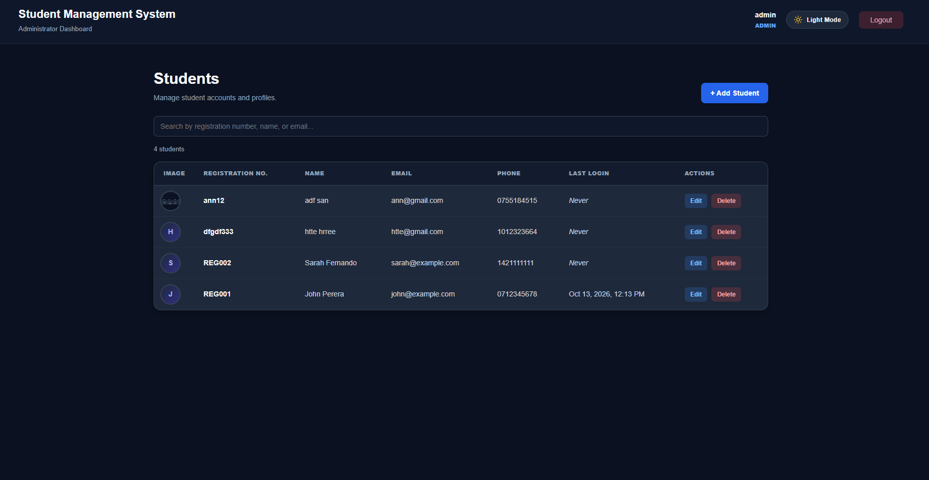
Figure 2: Admin Dashboard student list table displaying profile photo thumbnail alongside student records and initials fallback placeholder.
6. Final Result
Item | Result
Requirements | Met
Implementation | Completed
Testing | Passed
Acceptance Criteria | All Met
Existing CRUD / Auth | Verified
Final Status | Accepted
6.1 Final Summary
CR-010 was successfully implemented as a full-stack enhancement introducing student profile image upload functionality to the Student Management System. Administrators can upload student profile images in PNG, JPG, or JPEG format during student creation. The system validates selected files on both client and server sides, stores files securely on the server with sanitized unique filenames, associates the image reference with the student record, and displays the image in the student management table and student portal. For students without images, a styled fallback placeholder avatar is displayed. Existing authentication, authorization, and CRUD operations continue to work without regression. The change was thoroughly verified against all defined functional requirements and acceptance criteria with a 100% test pass rate.
6.2 Issues / Limitations
[State any remaining issues or limitations.]
If none:
No significant issues identified.
Student Name: MH Anush
Student ID: JFICT2416
Date: 13 October 2026
Signature: __________________________________
~ END OF REPORT ~

