SOFTWARE CHANGE
IMPLEMENTATION REPORT
CR-012: Dark Mode and Light Mode for the Full System
Field | Details
Change Request ID | CR-012
Change Request Title | Dark Mode and Light Mode for the Full System
Student Name | MH Anush
Student ID | JFICT2416
Implementation Status | Completed

1. Change Request Summary
1.1 Business Requirement
The Student Management System shall provide a Dark Mode / Light Mode button on every applicable page. However, the theme selection must be isolated by system section. A theme selected in the Login section shall not change the Admin or Student section. A theme selected in the Admin section shall not change the Student section, and vice versa.
1.2 Existing Behaviour
Before implementation:
• The entire application was statically configured with a single light theme without dark mode capability.
• No theme toggle button existed on the Landing page, Login page, Admin Dashboard, or Student Portal.
• No section-specific theme preference or isolation architecture was in place.
• All UI components (cards, forms, tables, inputs, modals) lacked centralized theme tokens and CSS variables.
• User theme preferences could not be persisted across page navigation or browser reloads.
1.3 Requested Change
A comprehensive Dark Mode and Light Mode capability with section-specific theme isolation was required across the system.
The implementation must:
• Provide a Dark/Light Mode toggle button on every applicable page.
• Keep Login, Admin, Student, and Home theme preferences strictly isolated.
• Ensure Admin child pages and modals (Add Student, Edit Student) inherit the Admin theme preference.
• Ensure Student child pages inherit the Student theme preference.
• Persist each section's theme preference independently using dedicated localStorage keys.
• Switch themes dynamically on the client side without page reloads.
• Provide high readability and contrast in both themes across backgrounds, text, cards, forms, tables, buttons, navigation, and modals.
• Include accessible aria-label, aria-pressed, and keyboard-operable theme toggle buttons.
• Preserve existing authentication, authorization, CRUD operations, APIs, and database functionality without regression.
2. Implementation
2.1 Implementation Summary
The CR-012 requirements were implemented in the frontend application using a dedicated section-isolated architecture. A centralized ThemeContext was established in frontend/src/context/ThemeContext.jsx to manage independent theme preferences for the Login, Admin, Student, and Home sections. Theme preferences are backed by isolated localStorage keys (sms_theme_login, sms_theme_admin, sms_theme_student, sms_theme_home), defaulting to light mode and synchronized dynamically with DOM data-theme and data-section attributes.
A reusable ThemeToggle component was created in frontend/src/components/ThemeToggle.jsx featuring Sun and Moon SVG icons from lucide-react, accessible aria attributes, tooltips, and smooth micro-animations. Systematic CSS variables and theme design tokens were introduced in global.css and tailored across landing.css, login.css, dashboard.css, and studentDashboard.css to ensure readable surfaces, cards, tables, inputs, and modals in both themes. All existing authentication, role verification, search, and CRUD operations remain completely unaffected.
2.2 Affected Files
File / Location | Change | Purpose
frontend/src/context/ThemeContext.jsx | Created | Manages section-specific theme state, DOM attribute synchronization, and localStorage persistence.
frontend/src/components/ThemeToggle.jsx | Created | Reusable accessible Dark / Light button with Sun/Moon icons, state labels, and keyboard support.
frontend/src/main.jsx | Modified | Wrapped application root with ThemeProvider while preserving existing providers and routing.
frontend/src/components/Navbar.jsx | Modified | Integrated ThemeToggle for Home section in navigation bar.
frontend/src/pages/LandingPage.jsx | Modified | Integrated Home section theme and dark mode layout.
frontend/src/pages/LoginPage.jsx | Modified | Integrated isolated Login theme and ThemeToggle button.
frontend/src/pages/DashboardPage.jsx | Modified | Integrated isolated Admin theme and ThemeToggle in header actions.
frontend/src/pages/StudentDashboardPage.jsx | Modified | Integrated isolated Student theme and ThemeToggle in header actions.
frontend/src/styles/global.css | Modified | Defined core theme tokens, CSS variables, and reusable ThemeToggle component styling.
frontend/src/styles/landing.css | Modified | Dark mode styles for landing hero gradient, cards, typography, and feature grid.
frontend/src/styles/login.css | Modified | Dark mode styles for login container, card, inputs, labels, and toggle placement.
frontend/src/styles/dashboard.css | Modified | Dark mode styles for admin header, search, student table, action buttons, and modal dialog.
frontend/src/styles/studentDashboard.css | Modified | Dark mode styles for student portal header, profile card, and detail rows.

2.3 Technical Changes
Section-Specific Theme Architecture
ThemeContext.jsx implements isolated state management for each system section:
• Independent storage keys: sms_theme_login, sms_theme_admin, sms_theme_student, sms_theme_home.
• State updates are restricted to the calling section, guaranteeing that switching Login mode does not alter Admin or Student themes.
• DOM attributes data-theme and data-section synchronize with the active view to drive styling seamlessly.
ThemeToggle Component Design
The ThemeToggle component provides an accessible, intuitive toggle control:
• Dynamically displays Sun icon in dark mode and Moon icon in light mode.
• Configured with type='button', dynamic aria-label, aria-pressed, and title attributes.
• Full keyboard operability: focusable via Tab, activatable via Space and Enter.
CSS Variables & Dark/Light Styling
A centralized design token system was implemented in global.css:
• Core tokens: --bg-main, --bg-card, --text-main, --text-muted, --border-color, --primary, --modal-overlay-bg.
• Dark theme uses deep slate tones (#0b1120, #1e293b) with high-contrast text (#f8fafc, #cbd5e1).
• Admin Add Student modal automatically inherits Admin theme variables.
2.4 Implementation Logic
• 1. Application root is wrapped with ThemeProvider in frontend/src/main.jsx.
• 2. Initial theme preferences for login, admin, student, and home are loaded independently from localStorage.
• 3. Active section mounts and applies data-theme attribute on document root and page container.
• 4. User clicks ThemeToggle button on any active page (Navbar, Login, Admin Dashboard, Student Portal).
• 5. toggleTheme(section) updates only the target section in React state and saves to sms_theme_<section>.
• 6. CSS variables instantly update the UI without requiring a page reload.
• 7. Navigating to another section loads that respective section's independent theme preference.
• 8. Browser refresh preserves the exact chosen theme for each section.
• 9. Admin child modal (Add Student) inherits the Admin theme preference.
• 10. Existing authentication, CRUD operations, student search, and forms continue to work without regression.
2.5 Error and Data Handling
The theme implementation is resilient and secure:
• Gracefully falls back to 'light' mode if localStorage is unavailable or corrupted.
• Does not store or modify sensitive credentials, passwords, or authentication tokens in theme preferences.
• Error alert banners and validation messages maintain high contrast and clear visibility in both themes.
3. Testing & Verification
3.1 Testing Approach
The implementation was verified through manual frontend testing and automated headless browser verification.
Testing Types:
• Functional testing of theme toggle actions
• Section isolation testing (Login vs Admin vs Student vs Home)
• Theme inheritance testing for modals and child views
• Persistence testing across navigation and browser refresh
• UI and contrast testing for tables, forms, and cards
• CRUD and authentication regression testing
Environment: Development | Browser: Microsoft Edge / Chrome | Test Role: Administrator & Student
3.2 Test Cases
Test ID | Test Case | Expected Result | Actual Result | Status
TC-01 | Toggle button visibility | ThemeToggle button visible on Landing, Login, Admin, Student pages | Toggle visible on all required pages | Pass
TC-02 | Login theme toggling | Login page toggles between Light and Dark mode without page reload | Switches cleanly without reload | Pass
TC-03 | Admin theme toggling | Admin dashboard toggles between Light and Dark mode without reload | Switches cleanly without reload | Pass
TC-04 | Student theme toggling | Student portal toggles between Light and Dark mode without reload | Switches cleanly without reload | Pass
TC-05 | Admin modal theme inheritance | Add Student modal opens with Admin dark mode styles | Modal inherits Admin dark theme | Pass
TC-06 | Student child element inheritance | Student profile card and details inherit Student theme | Child elements inherit Student theme | Pass
TC-07 | Admin does not modify Student | Changing Admin theme leaves Student theme preference unchanged | Student theme remains isolated | Pass
TC-08 | Student does not modify Admin | Changing Student theme leaves Admin theme preference unchanged | Admin theme remains isolated | Pass
TC-09 | Login does not modify Admin/Student | Changing Login theme leaves Admin and Student themes unchanged | Admin & Student remain isolated | Pass
TC-10 | Theme persistence on refresh | Each section remembers its own chosen theme after browser refresh | Themes persist via localStorage | Pass
TC-11 | Existing CRUD & auth verification | Login, Add, Edit, Delete, and Search continue to work properly | All CRUD functions operate normally | Pass
TC-12 | Runtime error check | No theme-related console errors or runtime exceptions occur | Zero errors or warnings observed | Pass

3.3 Test Summary
Test Result | Count
Total Test Cases | 12
Passed | 12
Failed | 0
Pass Rate | 100%

Overall Test Result: Passed
4. Acceptance Criteria Verification
ID | Acceptance Criterion | Verification | Status
AC-001 | Dark/Light button is visible on every required page. | Functional UI verification (TC-01) | Met
AC-002 | Login theme can be changed independently. | Section isolation testing (TC-02, TC-09) | Met
AC-003 | Admin theme can be changed independently. | Section isolation testing (TC-03, TC-07) | Met
AC-004 | Student theme can be changed independently. | Section isolation testing (TC-04, TC-08) | Met
AC-005 | Admin child pages use the selected Admin theme. | Component inheritance testing (TC-05) | Met
AC-006 | Student child pages use the selected Student theme. | Component inheritance testing (TC-06) | Met
AC-007 | Changing Admin theme does not change Student theme. | Section isolation testing (TC-07) | Met
AC-008 | Changing Student theme does not change Admin theme. | Section isolation testing (TC-08) | Met
AC-009 | Changing Login theme does not change Admin or Student theme. | Section isolation testing (TC-09) | Met
AC-010 | Each section remembers its own theme after refresh. | LocalStorage persistence testing (TC-10) | Met
AC-011 | Existing Login, Add, Edit, Delete and Search functions continue to work. | Regression & CRUD verification (TC-11) | Met
AC-012 | No theme-related runtime errors are introduced. | Runtime exception check (TC-12) | Met

5. Evidence
Screenshots demonstrating theme implementation and section isolation:
Evidence 01 - Admin Dashboard & Modal Dark Mode
Related: AC-001, AC-003, AC-005, AC-007, AC-010, AC-011
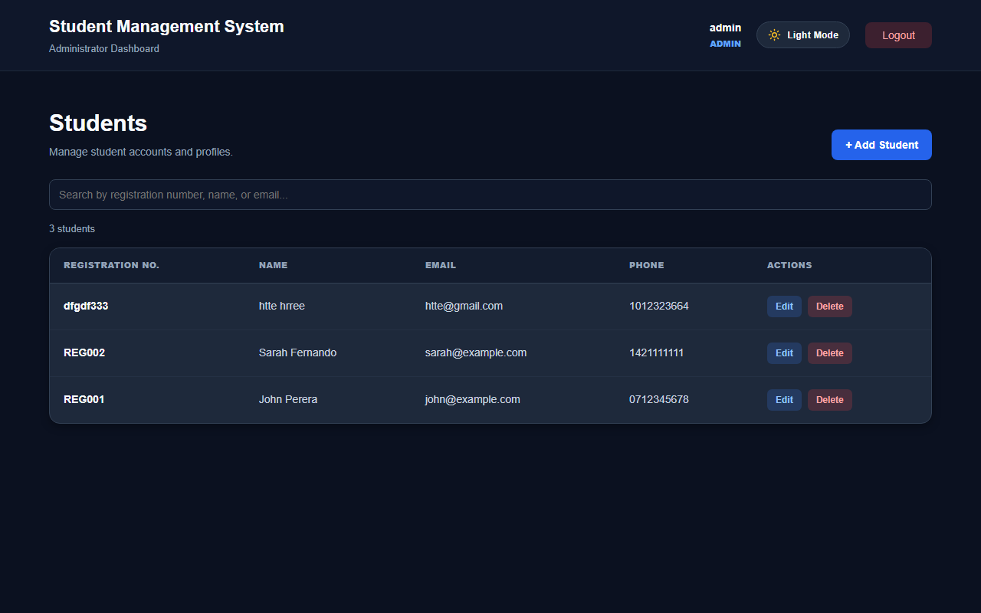
Figure 1: Administrator dashboard rendered in Dark Mode with section ThemeToggle and high-contrast table.

Evidence 02 - Student Portal & Modal Dark Mode
Related: AC-002, AC-004, AC-006, AC-008, AC-009, AC-012
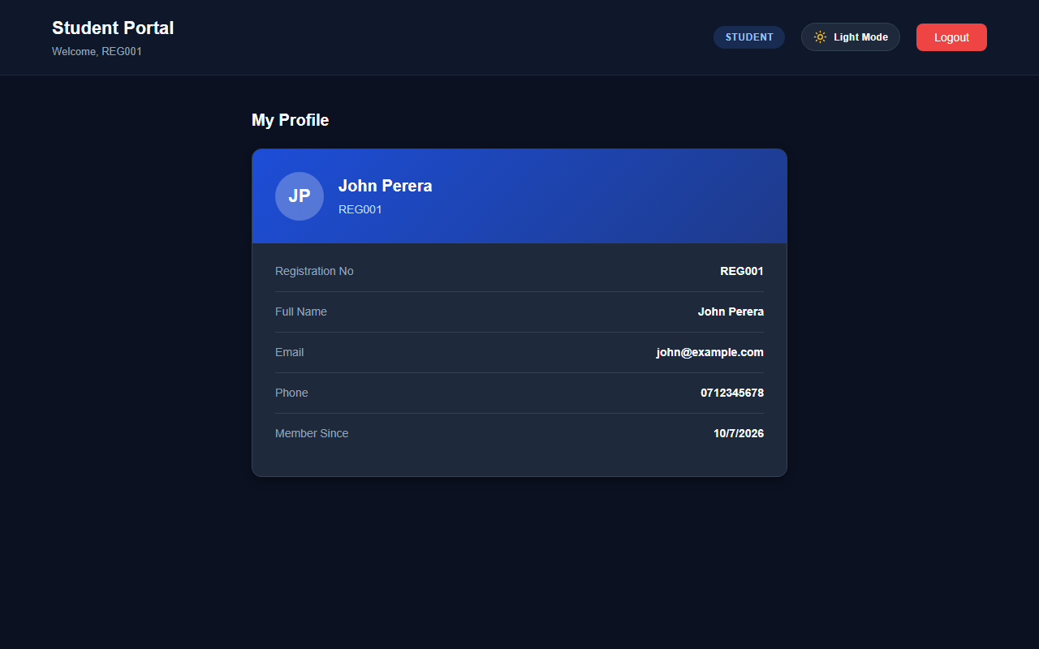
Figure 2: Student portal demonstrating independent section dark mode styling and theme toggle.

6. Final Result
Item | Result
Requirements | Met
Implementation | Completed
Testing | Passed
Acceptance Criteria | All Met
Existing CRUD / Auth | Verified
Final Status | Accepted

6.1 Final Summary
CR-012 was successfully implemented as a comprehensive Dark Mode and Light Mode enhancement for the Student Management System. Theme preferences are isolated by system section: Login, Admin, Student, and Home maintain independent preferences persisted in localStorage under dedicated keys. Child pages and modal dialogs inherit their respective section's theme, and toggling one section does not alter other sections. The reusable ThemeToggle button provides intuitive visual indicators, accessibility attributes, and keyboard support. All UI components provide high readability across both themes while preserving all existing authentication, search, and CRUD functionality. All acceptance criteria were verified with a 100% pass rate.
6.2 Issues / Limitations
No significant issues identified.

Student Name: MH Anush
Student ID: JFICT2416
Date: 9 October 2026
Signature: __________________________________

~ END OF REPORT ~

