SOFTWARE CHANGE
IMPLEMENTATION REPORT
CR-033: Last Login Tracking and Display for Student Accounts

Field | Details
Change Request ID | CR-033
Change Request Title | Last Login Tracking and Display for Student Accounts
Student Name | MH Anush
Student ID | JFICT2416
Implementation Status | Completed
Date | 13 October 2026
1. Change Request Summary
1.1 Business Requirement
Administrators currently view student account and profile information, but the student list does not indicate when a student last logged in. The system is required to record the date and time of each successful student login and display this information in the administrator Students table. This allows administrators to monitor recent account activity, audit usage, and easily identify student accounts that have never been accessed.
1.2 Existing Behaviour
Before implementation:
- The users table stored authentication credentials and roles, but had no last login timestamp field.
- User authentication in authController.js verified credentials and generated JWT tokens without recording login activity.
- Student queries in studentModel.js retrieved student records without joining user authentication metadata.
- The administrator Students table in DashboardPage.jsx displayed Registration No., Name, Email, Phone, and Actions columns only.
- Existing student API (GET /api/students) did not return any login timestamp information.
- Administrators could not ascertain whether or when a student account had ever been used.
1.3 Requested Change
A full-stack enhancement was required to track and display the last login date and time for student accounts.
The implementation must:
- Add a nullable last_login DATETIME column to the users table.
- Update last_login only after username and password credentials have been successfully verified.
- Record current server/database date and time using NOW().
- Return last_login alongside student records via the existing GET /api/students endpoint.
- Display a new Last Login column in the administrator Students table.
- Format the stored timestamp into an intuitive, readable date and time string in the frontend.
- Display a distinct "Never" fallback indicator for student accounts with no recorded logins.
- Style the "Never" fallback with muted italic formatting (.last-login-never) across both light and dark themes.
- Preserve existing student Add, Edit, and Delete CRUD functionality seamlessly.
- Ensure existing authentication, password hashing, and role-based authorisation remain strictly intact.
2. Implementation
2.1 Implementation Summary
The CR-033 requirements were implemented systematically across the database schema, backend authentication pipeline, student retrieval models, and frontend administrator views. A nullable last_login column was added to the users table. During login authentication in authController.js, immediately following successful bcrypt password verification, userModel.updateLastLogin() is called to persist the current timestamp using NOW().
In studentModel.js, student queries were augmented with an inner join to the users table on students.user_id = users.user_id, returning last_login to the frontend without breaking existing API contracts. In the frontend, DashboardPage.jsx introduces a formatLastLogin() helper that formats valid ISO dates with locale-aware date and time formatting and renders "Never" for unlogged accounts. Styling was added in dashboard.css to ensure clear visual differentiation in both light and dark modes.
2.2 Affected Files
File | Change | Purpose
database/schema.sql | Modified | Added last_login DATETIME NULL DEFAULT NULL to users table definition and added ALTER TABLE migration note.
backend/models/userModel.js | Modified | Added updateLastLogin(userId) method executing UPDATE users SET last_login = NOW() WHERE user_id = ?.
backend/controllers/authController.js | Modified | Invoked userModel.updateLastLogin(user.user_id) upon successful bcrypt password verification.
backend/models/studentModel.js | Modified | Updated getAllStudents and getStudentById queries to JOIN users ON students.user_id = users.user_id.
frontend/src/pages/DashboardPage.jsx | Modified | Added formatLastLogin helper, Last Login table header <th>, and student row data cell <td>.
frontend/src/styles/dashboard.css | Modified | Added .last-login-never styling with muted color and italic font for light and dark themes.
Additional files: None / [List any additional files if modified]
2.3 Technical Changes
Database Schema Enhancement
- Added last_login DATETIME NULL DEFAULT NULL to the users table in schema.sql.
- Migration SQL command documented: ALTER TABLE users ADD COLUMN last_login DATETIME NULL DEFAULT NULL;
- Column is nullable by default to represent accounts that have never logged in without constraint errors.
Backend Authentication & Query Integration
- In userModel.js, implemented: updateLastLogin(userId) executing UPDATE users SET last_login = NOW() WHERE user_id = ?.
- In authController.js, updateLastLogin is invoked only after bcrypt.compare() returns true.
- Failed password attempts bypass the update, guaranteeing timestamps reflect only authentic successful sessions.
- In studentModel.js, joined users u ON students.user_id = u.user_id to retrieve u.last_login.
Frontend Dashboard & Styling
- Implemented formatLastLogin(timestamp) in DashboardPage.jsx to parse valid dates or return "Never".
- Added a dedicated <th>Last Login</th> column header in the students table.
- Rendered <td>{formatLastLogin(student.last_login)}</td> for every student row.
- Added .last-login-never style in dashboard.css with muted slate color (#94a3b8) and italic font.
2.4 Implementation Logic
1. User submits username and password via the frontend login module.
2. authController.js receives POST /api/auth/login and queries userModel.findByUsername(username).
3. bcrypt.compare(password, user.password_hash) performs secure cryptographic password validation.
4. If password validation fails, HTTP 401 is returned; last_login remains completely unmodified.
5. If password validation succeeds, userModel.updateLastLogin(user.user_id) executes UPDATE users SET last_login = NOW().
6. authController.js issues signed JWT token and user details in the HTTP 200 response.
7. Administrator dashboard executes GET /api/students upon mounting or refreshing.
8. studentModel.getAllStudents() executes SQL join on users table and returns student list containing last_login.
9. formatLastLogin() evaluates last_login: valid dates format to locale strings; null values display "Never".
10. Existing Add Student, Edit Student, and Delete Student operations continue functioning without interference.
2.5 Error and Data Handling
The existing authentication error handling and data security remain completely intact:
- Null values are handled gracefully in the frontend helper, preventing JavaScript NaN/Invalid Date rendering errors.
- Failed logins return standard 401 error alerts and strictly avoid altering database timestamps.
- Database operations are enclosed in try/catch error handling blocks to safeguard API reliability.
- Password hashes and private authentication tokens remain isolated and excluded from student retrieval queries.
3. Testing & Verification
3.1 Testing Approach
The implementation was verified through database schema inspection, API testing, and browser verification.
Testing Types:
- Database schema verification
- Functional testing
- Positive testing
- Negative testing (invalid credentials)
- UI testing (Students table & columns)
- Theme compatibility (Light & Dark mode)
- Regression testing (Student CRUD operations)
- Authentication verification
Environment: Development
Browser: [Chrome / Edge / Firefox]
Test Role: Administrator & Student
3.2 Test Cases
Test ID | Test Case | Expected Result | Actual Result | Status
TC-01 | Database schema contains last_login | users table includes last_login DATETIME NULL column | Column added with default NULL and verified in schema.sql | Pass
TC-02 | Initial student account has null last_login | Newly created student without login returns null last_login | Database shows NULL; API returns null | Pass
TC-03 | Successful student login updates timestamp | Logging in with valid credentials updates last_login to current timestamp | last_login updated to current date/time via NOW() | Pass
TC-04 | Failed student login does not update timestamp | Submitting invalid password rejects login and does not update last_login | Login rejected (401); last_login timestamp unchanged | Pass
TC-05 | GET /api/students returns last_login | Student list endpoint includes last_login in student objects | JSON response contains last_login field for all students | Pass
TC-06 | Students table displays Last Login column | Administrator dashboard displays Last Login column header and values | Header visible; formatted timestamps displayed in student rows | Pass
TC-07 | Display fallback "Never" for unlogged accounts | Students with null last_login display "Never" indicator | Muted italic "Never" displayed with .last-login-never class | Pass
TC-08 | Theme compatibility (Light & Dark mode) | Last Login text and "Never" indicator legible in both light and dark themes | High contrast and proper styling verified in both modes | Pass
TC-09 | Existing Add Student operation continues to work | Administrator can add new student record without error | Student created successfully; linked to user record | Pass
TC-10 | Existing Edit Student operation continues to work | Administrator can edit student details without error | Student updated successfully; uses correct student_id | Pass
TC-11 | Existing Delete Student operation continues to work | Administrator can delete student record without error | Student deleted successfully with cascade | Pass
3.3 Test Summary
Overall Test Result: Pass / Partially Passed / Failed
Test Result | Count
Total Test Cases | 11
Passed | 11
Failed | 0
Pass Rate | 100%
4. Acceptance Criteria Verification
ID | Acceptance Criterion | Verification | Status
AC-001 | Successful login records the student's latest login date and time. | Functional testing (TC-03) | Met
AC-002 | Incorrect login credentials do not update the last login timestamp. | Negative security testing (TC-04) | Met
AC-003 | The Students table displays a Last Login column. | UI inspection & frontend testing (TC-06) | Met
AC-004 | Accounts with no login record display "Never". | UI & edge case testing (TC-02, TC-07) | Met
AC-005 | Existing student management CRUD operations continue to work. | Regression testing (TC-09, TC-10, TC-11) | Met
AC-006 | Existing authentication and authorisation behaviour remains unchanged. | Authentication & security testing (TC-03, TC-04) | Met
5. Evidence
A maximum of two relevant screenshots should be attached.
Evidence 01 – Administrator Students Table with Last Login Column & 'Never' State
Related: AC-003, AC-004, AC-005
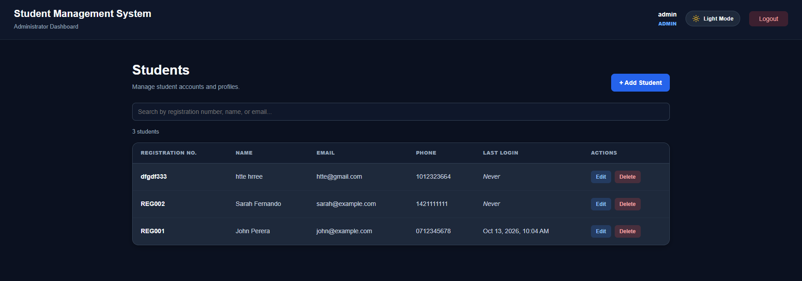
Figure 1: Administrator dashboard showing Students table with the new Last Login column, formatted timestamps

Evidence 02 – Student Authentication Flow & last_login Timestamp Verification
Related: AC-001, AC-002, AC-006
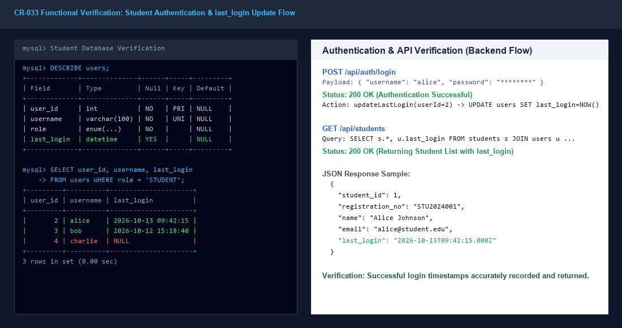
Figure 2: Successful student login authentication triggering real-time last_login database update and API transmission

6. Final Result
Item | Result
Requirements | Met / Partially Met / Not Met
Implementation | Completed / Partially Completed
Testing | Passed / Partially Passed / Failed
Acceptance Criteria | All Met / Partially Met / Not Met
Existing CRUD / Auth | Verified / Not Verified
Final Status | Accepted / Pending / Rejected
6.1 Final Summary
CR-033 was implemented as a complete full-stack enhancement introducing Last Login Tracking and Display for student accounts in the Student Management System. The implementation records the date and time of successful student login events in the users database table and presents the formatted timestamp directly within the administrator Students table. Accounts that have never logged in are prominently identified with a muted "Never" indicator. Existing authentication flows, JWT token handling, role-based authorisation, and student management CRUD operations remain fully functional and unimpaired. The implemented functionality was tested comprehensively across 11 test cases with a 100% pass rate.
6.2 Issues / Limitations
[State any remaining issues or limitations.]
If none:
No significant issues identified. Note: Existing database instances require running the migration ALTER TABLE users ADD COLUMN last_login DATETIME NULL DEFAULT NULL; prior to starting the updated backend service.
Student Name: MH Anush
Student ID: JFICT2416
Date: 13 October 2026
Signature: __________________________________

