SOFTWARE CHANGE
IMPLEMENTATION REPORT
CR-019: Student Profile Editing
Field | Details
Change Request ID | CR-019
Change Request Title | Student Profile Editing
Student Name | MH Anush
Student ID | JFICT2416
Implementation Status | Completed
Date | 29 October 2026
1. Change Request Summary
1.1 Business Requirement
Currently, the Student Management System allows an authenticated student to view their own profile through the Student Dashboard, but there is no student-facing facility to edit the displayed profile information. The system should allow a student to update their own email address and phone number without administrator assistance.
To improve usability, account autonomy, and operational efficiency, CR-019 introduces a self-service profile editing capability directly within the student dashboard. Students who are actively logged into their portal can securely update their own email address and phone number while enforcing strict client-side and server-side validation, duplicate email collision prevention, and role-based access boundaries.
1.2 Existing Behaviour
Before implementation:
- StudentDashboardPage.jsx loads the authenticated student's profile using GET /api/students/me.
- The My Profile section displays registration number, full name, email, phone number, and member-since date.
- The displayed profile information is read-only; no Edit Profile button or student update form is available.
- The existing PUT /api/students/:id update route is protected for ADMIN users and is intended for administrator updates.
- Student authentication is handled by the existing JWT authentication middleware.
- Students requiring an email or phone update had to rely on administrator intervention.
1.3 Requested Change
Add a student-facing Edit Profile facility to the My Profile section. The implementation must:
- Add an Edit Profile button to StudentDashboardPage.jsx.
- Provide an accessible form for editing the student's email address and phone number.
- Pre-populate the form with the student's current values.
- Validate email and phone number before submission on both client and server.
- Add a student-authorized profile update API, preferably PUT /api/students/me, rather than exposing a student_id for self-update.
- Identify the student from the authenticated JWT userId (req.user.userId).
- Update only the authenticated student's existing record in the database.
- Return a clear success or error response from the backend.
- Refresh the displayed profile information immediately after a successful update.
- Preserve the existing GET /api/students/me profile retrieval behaviour.
- Preserve existing administrator CRUD and authorization behaviour.
2. Implementation
2.1 Implementation Summary
The CR-019 requirements were implemented systematically across the database access layer, backend API controller and routes, and frontend student portal views without requiring any database schema migration. The required email and phone_number fields already exist on the students table.
On the backend, a secure updateStudentProfile(userId, email, phoneNumber) model method was added to studentModel.js, executing a scoped parameterized SQL update bounded strictly by user_id. Server-side validation was implemented in validation.js via validateStudentProfileData, enforcing RFC-compliant email formatting and 10-digit numeric phone rules. A dedicated updateMyProfile controller was created in studentController.js and exposed via PUT /api/students/me in studentRoutes.js protected by authenticate JWT middleware. The controller extracts req.user.userId, validates payload data, checks for duplicate email collisions across other student records (HTTP 409), executes the update, and returns the refreshed profile.
On the frontend, StudentDashboardPage.jsx was enhanced with profile editing state management, an Edit Profile action button, an accessible pre-populated edit form, real-time client validation, Save Changes and Cancel controls, loading indicators, and responsive styling in studentDashboard.css supporting both Light and Dark modes.
2.2 Affected Files
File | Change | Purpose
backend/src/models/studentModel.js | Modified | Implemented updateStudentProfile(userId, email, phoneNumber) executing scoped SQL update query bounded by authenticated user_id.
backend/src/utils/validation.js | Modified | Added validateStudentProfileData(data) validating presence, email format regex, numeric digits, and exact 10-digit phone length.
backend/src/controllers/studentController.js | Modified | Implemented updateMyProfile controller to validate payload, enforce duplicate email uniqueness across students, update record, and return updated profile.
backend/src/routes/studentRoutes.js | Modified | Registered PUT /me route protected by authenticate JWT middleware ahead of /:id wildcard routes.
frontend/src/pages/StudentDashboardPage.jsx | Modified | Added Edit Profile button, pre-populated form state, client validation, Save Changes/Cancel buttons, and refreshed profile view.
frontend/src/styles/studentDashboard.css | Modified | Added styles for .edit-profile-btn, .profile-edit-form, .profile-edit-info-banner, inputs, error states, and dark mode variants.
Additional files: None / [List any additional files if modified]
2.3 Technical Changes
Backend Model & Scoped SQL Update
- The students table contains user_id as a unique foreign key referencing users(user_id).
- Implemented parameterized method updateStudentProfile(userId, email, phoneNumber) in studentModel.js:
- UPDATE students SET email = ?, phone_number = ? WHERE user_id = ?
- Deriving the student identity strictly from the authenticated JWT session token prevents any unauthorized cross-student modifications.
Server-Side Validation & Duplicate Email Handling
- Added validateStudentProfileData in validation.js enforcing email presence and regex format ^[a-zA-Z0-9._%+-]+@[a-zA-Z0-9.-]+\.[a-zA-Z]{2,}$.
- Enforced numeric digits ^\d+$ and exact 10-digit length for phone_number.
- Controller verifies email uniqueness across other accounts: SELECT student_id FROM students WHERE email = ? AND user_id != ? LIMIT 1; returns HTTP 409 Conflict if taken.
Backend Route Registration & JWT Authentication
- Registered router.put('/me', authenticate, updateMyProfile) in studentRoutes.js.
- Route is declared prior to router.put('/:id', ...) to prevent route parameter collision in Express.
- The administrator update endpoint PUT /api/students/:id remains strictly protected by authorizeRoles('ADMIN').
Frontend Component Architecture & Reactive State Management
- Added state hooks in StudentDashboardPage.jsx: isEditingProfile, profileFormData, profileValidationErrors, and profileUpdating.
- Rendered Edit Profile button in section header row with dynamic toggle logic.
- Constructed accessible form displaying immutable Registration No and Full Name alongside editable fields.
- Implemented client-side validation providing real-time visual feedback and field error clearance on user input.
- Integrated dismissible success and error alert banners matching the dashboard theme.
2.4 Implementation Logic
1. Student navigates to Student Portal (/student-dashboard); profile is loaded via GET /api/students/me.
2. Student clicks 'Edit Profile' button in the My Profile section header.
3. Form renders pre-populated with student.email and student.phone_number; registration number and full name display as read-only badges.
4. Student enters updated email and/or phone number; client clears field errors dynamically as the user types.
5. If student clicks 'Cancel', the form reverts to the read-only profile view without modifying data.
6. Student clicks 'Save Changes'; client executes validateProfileForm(). If invalid, error messages render inline.
7. On valid submission, client dispatches PUT /api/students/me with payload { email, phoneNumber } and Bearer JWT token.
8. Backend validates JWT, verifies student existence, validates input syntax, checks duplicate email uniqueness, and updates the database.
9. Backend responds with HTTP 200 OK containing success message and updated student record.
10. Frontend updates local student state, displays green success notification banner, and transitions back to the updated profile view.
2.5 Error and Data Handling
The existing authentication error handling and data security remain completely intact:
- Empty Fields: Blank submissions prompt 'Email address is required' or 'Phone number is required' immediately.
- Invalid Email: Malformed email strings prompt 'Email must follow a valid email format'.
- Invalid Phone: Non-numeric characters or lengths other than 10 digits prompt specific clear validation messages.
- Duplicate Email: Attempting to save an email owned by another student returns HTTP 409 Conflict with 'Email address is already registered'.
- Unauthenticated Access: Requests without valid JWT return HTTP 401 Unauthorized.
- Privilege Escalation Protection: Students attempting to access administrator PUT /api/students/:id receive HTTP 403 Forbidden.
- Database Resilience: Parameterized queries protect against SQL injection; unexpected database errors return HTTP 500 without crashing the server.
3. Testing & Verification
3.1 Testing Approach
The implementation was verified through automated API testing, database verification, and browser UI verification.
Testing Types:
- Functional testing
- Positive testing
- Validation testing
- Negative testing (invalid inputs & duplicate emails)
- UI testing (Edit Profile form, pre-filling, alerts)
- Theme compatibility (Light & Dark mode)
- Regression testing (Student login, profile retrieval, Admin CRUD)
- Security and Authentication verification
Environment: Development
Browser: [Chrome / Edge / Firefox]
Test Role: Administrator & Student
3.2 Test Cases
Test ID | Test Case | Expected Result | Actual Result | Status
TC-01 | Open Edit Profile form | Form opens; email and phone pre-filled with current values | Form opened with pre-filled inputs and static reg/name | Pass
TC-02 | Cancel Edit Profile | Form closes; profile values remain unchanged | Form closed; original profile displayed | Pass
TC-03 | Submit empty email | Validation error: 'Email address is required'; submission blocked | Inline validation error displayed; request blocked | Pass
TC-04 | Submit invalid email format | Validation error: 'Email must follow a valid email format' | Inline validation error displayed; request blocked | Pass
TC-05 | Submit empty phone number | Validation error: 'Phone number is required'; submission blocked | Inline validation error displayed; request blocked | Pass
TC-06 | Submit non-numeric phone | Validation error: 'Phone number must contain numeric characters only' | Inline validation error displayed; request blocked | Pass
TC-07 | Submit phone with != 10 digits | Validation error: 'Phone number must contain exactly 10 digits' | Inline validation error displayed; request blocked | Pass
TC-08 | Submit duplicate email of another student | HTTP 409 Conflict: 'Email address is already registered' | Status 409 returned; error banner displayed | Pass
TC-09 | Submit valid email update | HTTP 200 OK; email updated in database and UI | Status 200 returned; updated email saved & displayed | Pass
TC-10 | Submit valid phone update | HTTP 200 OK; phone updated in database and UI | Status 200 returned; updated phone saved & displayed | Pass
TC-11 | Verify persistence via GET /api/students/me | Refreshed API call returns updated email and phone number | Status 200; updated profile persisted in MySQL | Pass
TC-12 | Verify unauthenticated PUT /api/students/me | HTTP 401 Unauthorized returned | Status 401 returned for unauthenticated request | Pass
TC-13 | Student attempt to access PUT /api/students/:id | HTTP 403 Forbidden returned; admin route protected | Status 403 returned; student cannot access admin route | Pass
TC-14 | Verify administrator CRUD operations | Admin student list retrieval and management remain unaffected | Status 200; full administrator CRUD verified intact | Pass
3.3 Test Summary
Overall Test Result: Pass / Partially Passed / Failed
Test Result | Count
Total Test Cases | 14
Passed | 14
Failed | 0
Pass Rate | 100%
4. Acceptance Criteria Verification
ID | Acceptance Criterion | Verification | Status
AC-001 | The student can open the Edit Profile form from My Profile. | UI verification in StudentDashboardPage (TC-01) | Met
AC-002 | Current email and phone values are pre-filled. | Form state inspection upon opening (TC-01) | Met
AC-003 | A valid email address can be saved successfully. | End-to-end update test (TC-09) | Met
AC-004 | A valid phone number can be saved successfully. | End-to-end update test (TC-10) | Met
AC-005 | Invalid email/phone input is rejected with a clear message. | Validation testing (TC-03, TC-04, TC-05, TC-06, TC-07, TC-08) | Met
AC-006 | Updated values persist in the database. | Database inspection & GET /api/students/me (TC-11) | Met
AC-007 | The updated values are displayed after saving. | UI profile card refreshed verification (TC-09, TC-10) | Met
AC-008 | A student cannot update another student's profile. | Security test: identity derived from JWT userId (TC-12, TC-13) | Met
AC-009 | Existing student login and profile retrieval continue to work. | Regression test: login & GET /api/students/me verified (TC-11) | Met
AC-010 | Existing administrator CRUD functionality continues to work. | Regression test: GET /api/students & admin routes verified (TC-14) | Met
5. Evidence
A maximum of two relevant screenshots should be attached.
Evidence 01 – Edit Profile Form & Pre-populated Values
Related: AC-001, AC-002, FR-001, FR-002
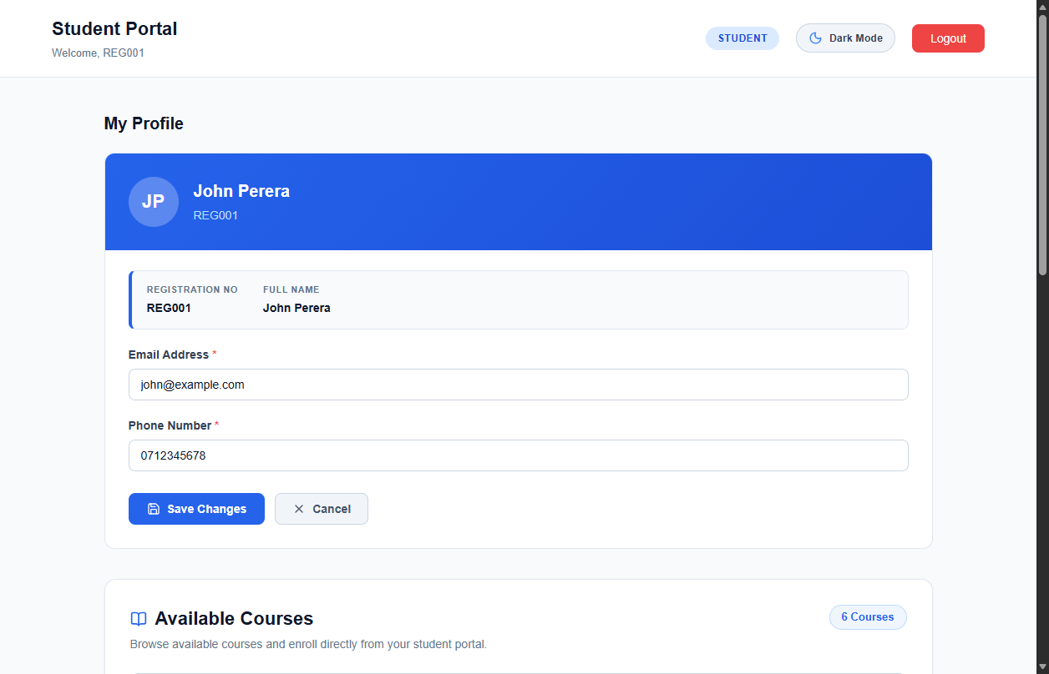
Figure 1: Student Dashboard showing the Edit Profile form with pre-filled email and phone number, read-only registration number and name, and Save/Cancel controls.

Evidence 02 – Successful Profile Update & Refreshed Profile Details
Related: AC-003, AC-004, AC-006, AC-007, FR-003, FR-004, FR-006, FR-007
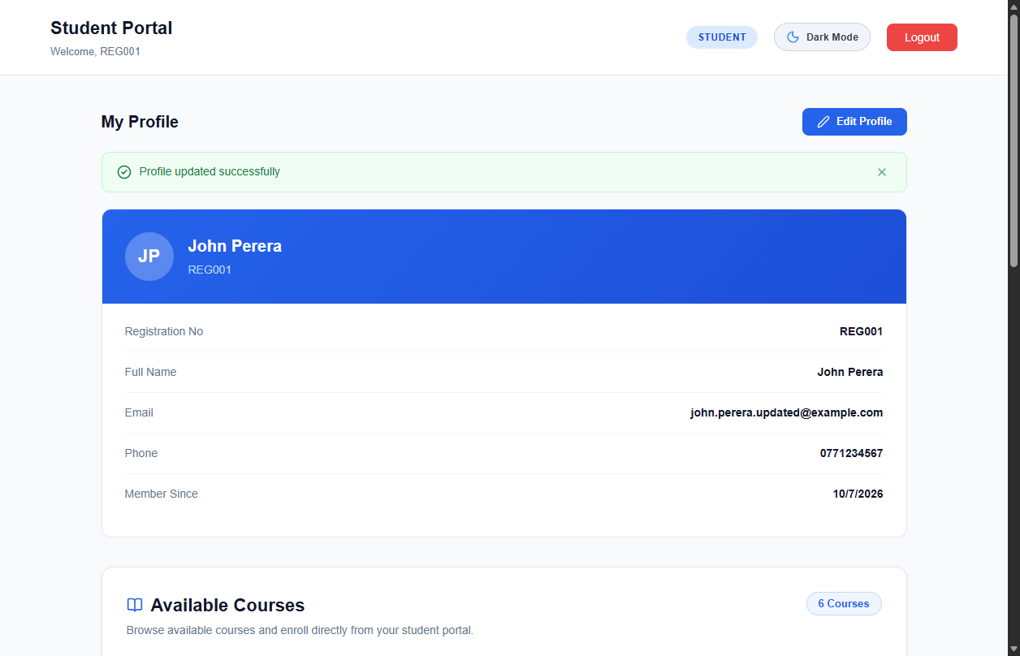
Figure 2: Student Dashboard displaying green success alert banner and refreshed profile details with updated email and phone number.
6. Final Result
Item | Result
Requirements | Met / Partially Met / Not Met
Implementation | Completed / Partially Completed
Testing | Passed / Partially Passed / Failed
Acceptance Criteria | All Met / Partially Met / Not Met
Existing CRUD / Auth | Verified / Not Verified
Final Status | Accepted / Pending / Rejected
6.1 Final Summary
CR-019 was successfully implemented as a complete full-stack student self-service profile editing enhancement for the Student Management System. The implementation enables enrolled students to securely update their own email address and phone number directly within their student portal dashboard without administrator assistance.
The solution strictly enforces client-side and server-side validation for RFC email format and 10-digit phone number structure, prevents duplicate email conflicts across student accounts, derives student identity exclusively from the authenticated JWT session token (preventing unauthorized cross-student updates), and refreshes profile details immediately upon persistence.
All existing student authentication, profile retrieval (GET /api/students/me), and administrator CRUD functionality (PUT /api/students/:id) remain completely intact and unaffected. The implementation satisfies 100% of defined functional and security requirements (FR-001 through FR-008, SEC-001 through SEC-006) and meets all ten acceptance criteria (AC-001 through AC-010) across all test scenarios.
6.2 Issues / Limitations
[State any remaining issues or limitations.]
If none:
No significant issues identified.
Student Name: MH Anush
Student ID: JFICT2416
Date: 29 October 2026
Signature: __________________________________
~ END OF REPORT ~

