**Assignment 1**

**1)Report View – In Report view we make the reports for any project which may include the graphs and visualizations for better understanding for the end user/stakeholders.**

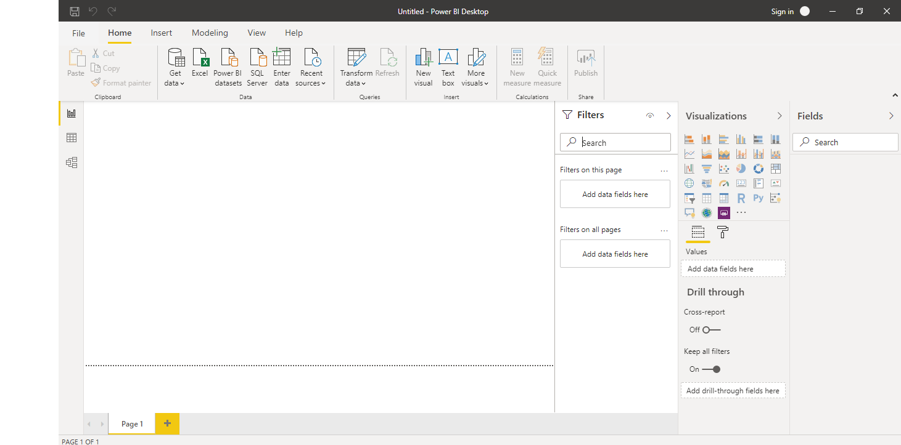

**2)Data View- In data view we view the data and make any changes in the dataset like adding columns or removing rows etc if required, after which we can make the reports.**

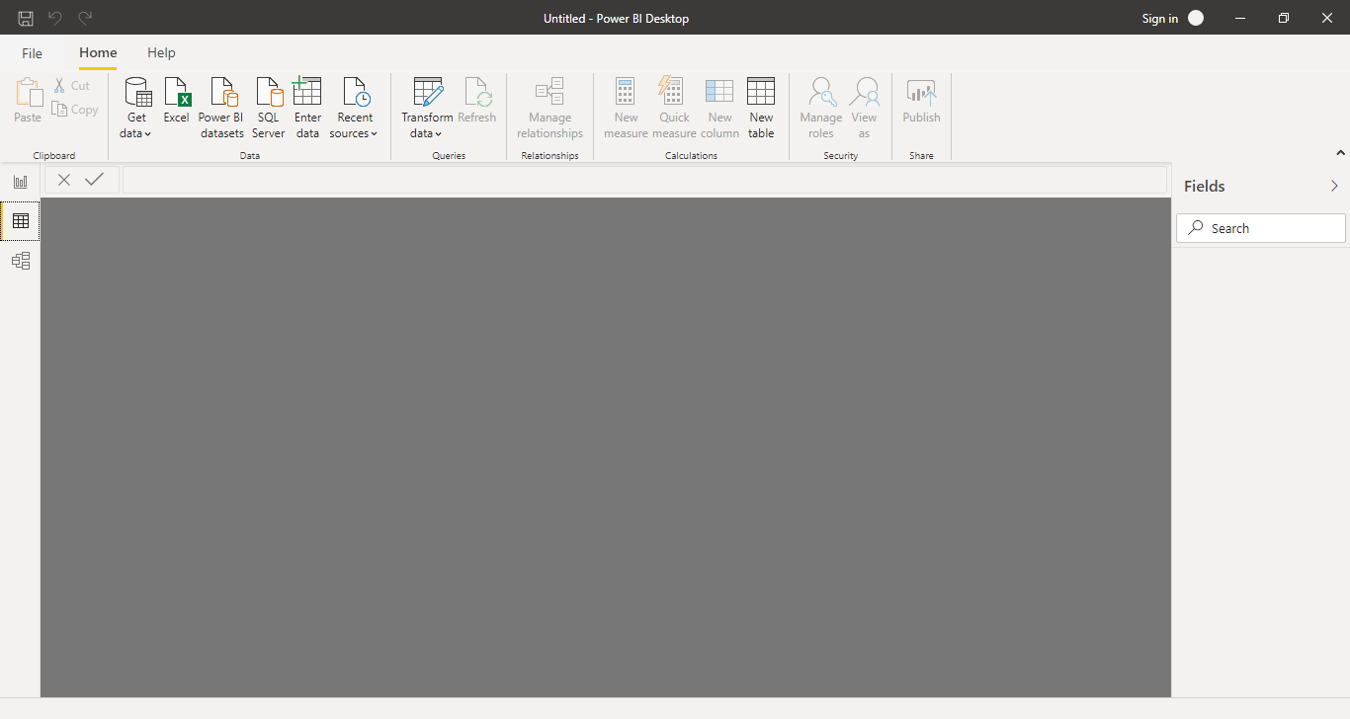

**3)Model View- we create a model of the project in model view , to establish a link among various tables.**

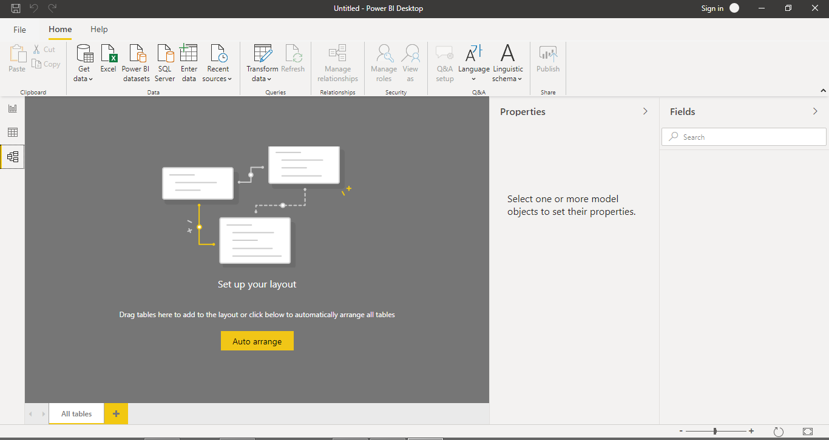

**4)Power Query Editor- when we load any files, we use power query editor to transform the data before loading it into PowerBI desktop**

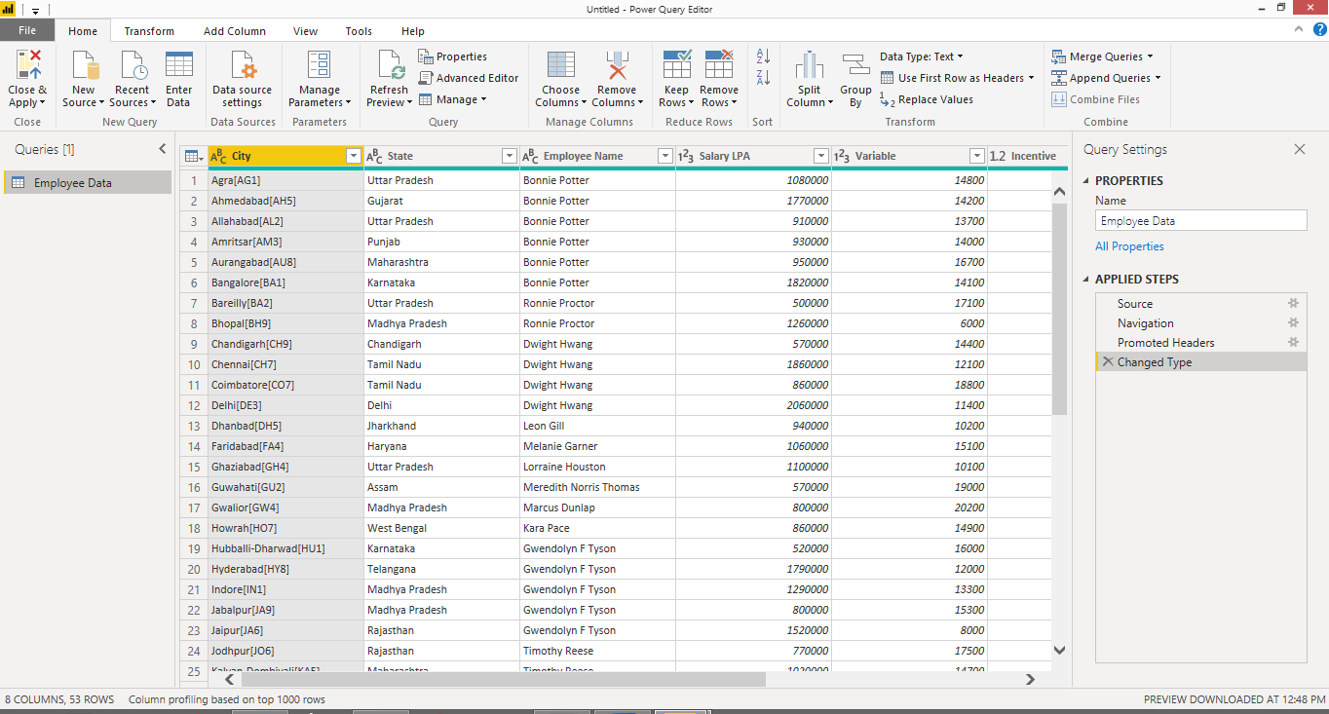

**5)Advance Editor- It contains the editable code for the data in the files.**

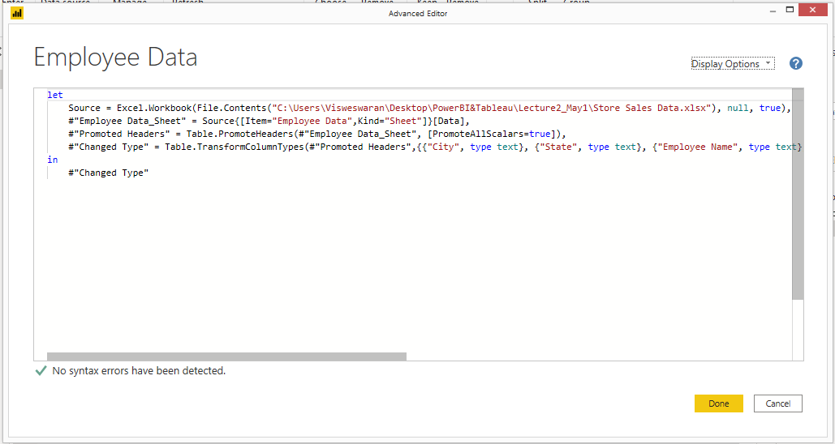

**\*PowerBI Desktop/Pro/Premium:**

**PowerBI Desktop- It is free to any single user and includes data cleaning and preparation, custom visualizations and the ability to publish to power BI service.**

**PowerBI Pro- It is for individual user which costs $9.99/user/month. It includes data collaboration, data governance, building dashboards and the ability to publish reports anywhere. There is a free trial for 60days.**

**PowerBI Premium- It is mainly for large organization which costs $4995/month per dedicate cloud compute and storage resource.**