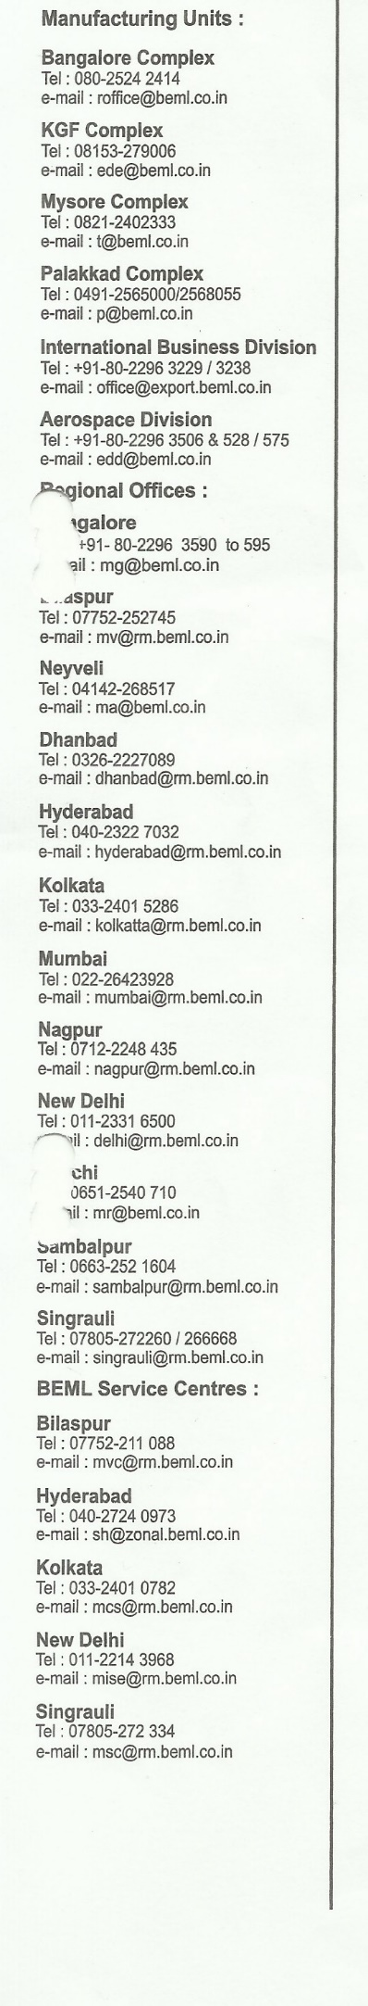07654 02/17/2021



The Administrator,

ManipalHospital

KormangalaBangalore

Dear Sir/Madam,

Subject : Medical treatment under Direct Billing System.

We are referring [Patient Name], [Patient RelationShip] [Staff Name], Staff No.[Staff No], DGM, Corporate Office, Bangalore, [Reason for Hospitality] at your Hospital, Under Direct billing system.

2. Please note that the accommodation entitlement is for a single bed in double bedded ward(Semi-private). If the patient opts for private room facilities, you may provide the same, subject to collection of difference amount from the patient at the time of discharge. Please do not refer the patient to any other hospital without our knowledge and contest. The Medicals bills as per the agreed tariff may be sent to the following address for settlement with a copy to the undersigned:

The Asst. General Manager(HQ-Payrolls)

BEML Limited

BEML Soudha, SR Nagar,

Banglore – 560 027.

3. The cost of diet, special nursing care, attendant charges, service charges and medicines having more dietary value, if any, may be indicated separately in your bill.

\*\*\*\*\*

Your faithfully,

for BEML Limied.

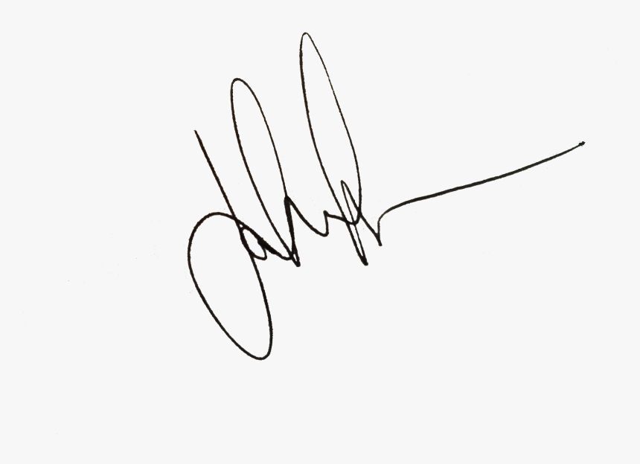

[Signatory], SR. Manager.