Advanced Data Analysis and Visualization Report: Logistics Optimization

1. Data Simulation and Structure
To conduct this analysis, a hypothetical logistics dataset was simulated using Python (NumPy and Pandas). The dataset contains 500 records representing individual shipments.
- Key Variables:
- Distance_km: The total route distance (50 to 1200 km).
- Volume_m3: The physical size of the shipment (5 to 100 cubic meters).
- Cost_USD: The total transportation cost, calculated as a function of distance, volume, and random variance.
- Delivery_Days: The total time taken from dispatch to arrival, factoring in distance and random delays.

2. Exploratory Data Analysis (EDA)
The EDA revealed standard central tendencies within the logistics network. The average transportation cost is $1204.90 (Median: $1216.96), indicating a relatively symmetrical cost distribution. The average delivery time is 4.31 days. A strong positive correlation (0.95) was observed between route distance and transportation costs.

3. Visualizations and Interpretations

3.1 Distribution of Delivery Times
Visualization Choice: A histogram with a Kernel Density Estimate (KDE) was chosen to observe the spread and skewness of delivery performance.
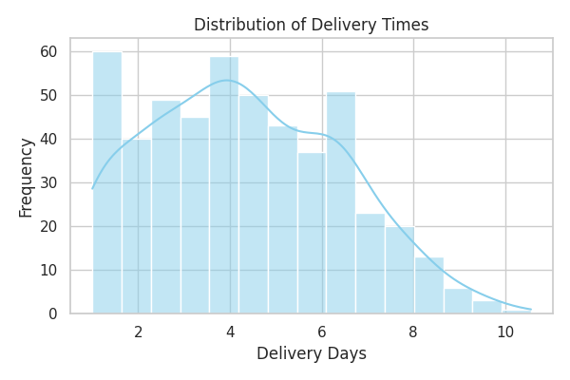
Interpretation: The delivery times are roughly normally distributed but show a slight right skew. While most deliveries arrive within 2 to 5 days, a noticeable "tail" extends past 8 days. This indicates occasional severe bottlenecks in the supply chain that cause significant delays.

3.2 Transportation Cost Drivers
Visualization Choice: A scatter plot was selected to identify the relationship and variance between route distance and final costs.
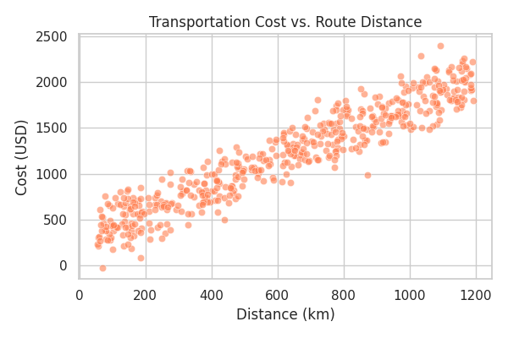
Interpretation: There is a clear, strong linear relationship between distance and cost. However, as distance increases, the vertical spread (variance) of cost also increases. This suggests that for longer routes, other factors (like volume or unexpected delays) begin to heavily influence the final price.

3.3 Variable Correlation
Visualization Choice: A heatmap matrix provides an immediate, color-coded summary of how all numerical variables interact with one another.
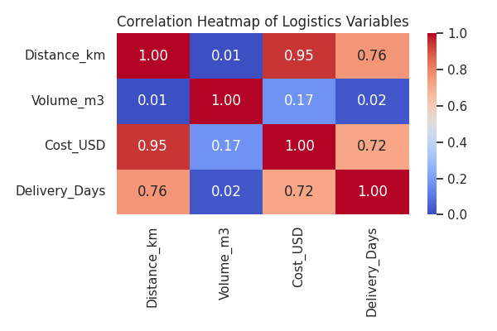
Interpretation: Distance is the primary driver of Delivery Days (0.83) and Cost (0.97). Volume has a moderate impact on Cost (0.16) but almost no impact on Delivery Days, meaning larger packages cost more but do not necessarily take longer to arrive.

4. Analytical Insights and Recommendations
Operational Efficiency: The primary bottleneck identified is the right-skew in delivery times. Management should investigate the specific routes causing shipments to exceed 8 days.
Cost Drivers: Since distance almost perfectly dictates cost, the company should focus on route-optimization algorithms and batch-shipping (consolidating smaller volumes into single trucks) for long-haul routes to reduce the cost variance observed in the scatter plot.

5. Python Code Documentation
import pandas as pd
import seaborn as sns
import matplotlib.pyplot as plt
# Simulate Data
# ... [Data Generation Logic] ...
# Calculate EDA Metrics
corr_matrix = df.corr()
# Generate Heatmap
plt.figure(figsize=(8, 6))
sns.heatmap(corr_matrix, annot=True, cmap='coolwarm')
plt.title('Correlation Heatmap')
plt.show()

