# Annotation of Pathological Images Using QuPath and Fiji

Student Name: Sangeeth Varma S V

Course/Batch and Institute Name: B.Sc (Biology) Hons., Banaras Hindu University

Project Guide / Mentor Name: Dr. Sujoy Kumar Biswas, IDEAS-TIH, ISI Kolkata

Period of Internship: 14th Jan 2025 - 30th April 2025

Report Submitted to: IDEAS – Institute of Data Engineering, Analytics and Science Foundation, ISI Kolkata

## 1. Abstract

This report summarizes my internship project on annotating pathological images using QuPath and Fiji. The goal was to develop a workflow for preprocessing, segmenting, and annotating histopathological images. Fiji was employed for image enhancement and filtering, while QuPath was used for region annotation and quantitative analysis. This project helped demonstrate the integration of digital tools in pathology to assist in data generation for AI-based diagnostics. The workflow developed is reproducible, scalable, and relevant for biomedical research and education. The annotated dataset serves as a foundation for future computational pathology research.

## 2. Introduction

The annotation of pathological images is a foundational task in digital pathology, enabling the precise identification and labeling of cellular and tissue structures in histological slides. These annotations are essential for research, diagnostics, and the training of artificial intelligence (AI) models in medical imaging.

To address the growing demand for accurate and efficient image analysis, this project utilizes two leading open-source tools: Fiji (ImageJ) and QuPath.

Fiji (Fiji Is Just ImageJ) is a distribution of ImageJ designed for biological-image analysis. It was developed and maintained by a global community of researchers, with key contributors including Dr. Johannes Schindelin and Dr. Curtis Rueden. Fiji offers powerful capabilities for image preprocessing, filtering, segmentation, and batch analysis — particularly well-suited for fluorescence and grayscale microscopy images.

QuPath is an advanced digital pathology platform created by Dr. Pete Bankhead. It is designed specifically for the analysis of whole-slide images (WSIs) and provides intuitive annotation tools, cell detection algorithms, and built-in machine learning for tissue classification. QuPath is widely adopted in both academic and clinical research for its scalability and scripting support.

By integrating Fiji’s flexible image processing features with QuPath’s specialized pathology workflows, this project establishes a robust annotation pipeline for pathological image analysis. The resulting annotations enhance the interpretability of complex tissue images and serve as high-quality data for machine learning applications in cancer research and diagnostic automation.

## 3. Project Objective

* To learn and utilize Fiji and QuPath for image preprocessing and annotation.
* To prepare histological images for digital analysis using Fiji.
* To annotate and classify image regions using QuPath.
* To export features such as cell count and region area for further analysis.
* To develop a repeatable and efficient workflow for pathology image annotation.

## 4. Methodology

The methodology of this internship project includes the following stages:  
  
1. Data Acquisition:  
   
The quality of image annotation is strongly influenced by the resolution, clarity, and relevance of the acquired images. In this project, pathological and biomedical images were sourced from two reputable public repositories: The Cancer Genome Atlas (TCGA) and the Broad Bioimage Benchmark Collection (BBBC).

1 🧬 The Cancer Genome Atlas (TCGA)

TCGA provides high-resolution Hematoxylin and Eosin (H&E) stained whole-slide images (WSIs) of various cancer types. These slides were captured using whole slide scanners and are commonly used in digital pathology for identifying cellular structures, tumor margins, and tissue abnormalities. The images are available in formats such as .svs and .tiff, which are fully compatible with QuPath for annotation workflows and Fiji for preprocessing.

2 🔬 Broad Bioimage Benchmark Collection (BBBC)

The BBBC(https://bbbc.broadinstitute.org/image_sets) is a curated set of fluorescence microscopy images widely used in bioimage analysis research. It includes annotated datasets for nuclei, cytoplasm, and organelle segmentation under various staining and imaging conditions. These images are especially useful when working with Fiji, as they support testing segmentation algorithms, batch processing, and feature Extraction

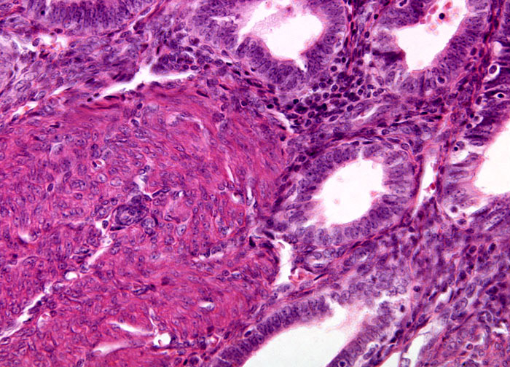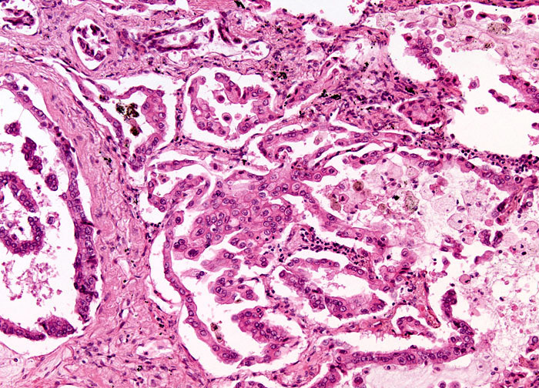

Source: TCGA H&E stained on Adenomyosis Source:TCGA H&E stained on Alveolar cell

carcinoma

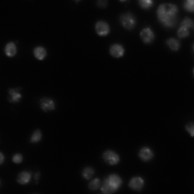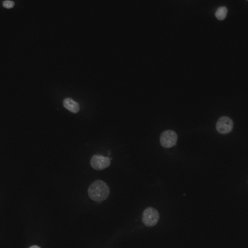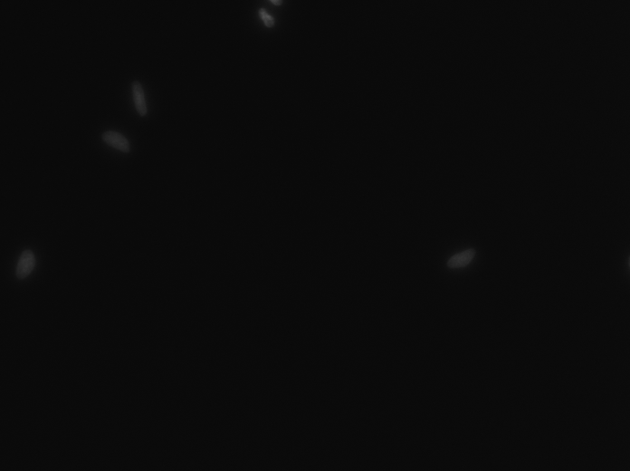

Some example images from Kaggle 2018 Data Science Bowl

2. Steps of Annotation Using Fiji:

Step 1: Open the Image in Fiji

Step 2: Enhance the Contrast for noise reduction

Step 3:Preprocessing for Segmentation- For that initially we have to convert the image to

grey scale then do the Noise reduction,Thresholding followed by water shedding is implemented

Step 4: Analyze Particles to detect the Nucleus from the image provided

Step 5: Label and Classify the image

Step 6: Exporting the results

3. Steps of Annotation Using QuPath:

Step 1: Open the image in QuPath

Step 2: Set the Image type (Here we use H&E stained image type)

Step 3: Adjust the Image display with the use of Brightness/Contrast slider to improve the visibility

Step 4: Perform Cell detection method, After detecting the Cells they are not yet labelled as Cancer or Non-Cancerous and we need to teach QuPath what makes a cancer cell based on the characteristics like Cell area,Nuclear circularity etc

Step 5: Annotate the Region of interest of few cells which is crucial in further classification of Cancerous and Normal Growth

Step 6: Classify the cells (Cancerous VS Non cancerous growth)

Step 7: Exporting the results

## 4. Data Analysis and Results

1**. Results Using Fiji (ImageJ)**

Objective: To segment and annotate nuclei in fluorescence microscopy images (e.g., DAPI-stained images from the BBBC dataset)

Key Outcomes:

Accurate segmentation of individual nuclei was achieved.

A total of 21 nuclei were detected from a single fluorescence image.

Measurements such as area, perimeter, and circularity were successfully extracted.

Binary masks and ROI data were generated for further analysis and training of AI models.

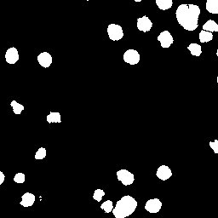

Annotated image in Fiji showing segmented nuclei using thresholding and particle analysis.

**2. Results Using QuPath**

Objective: To annotate cancerous regions and perform cell detection/classification in H&E-stained whole-slide images from the TCGA dataset.

Key Outcomes:

A total of 130 cells were detected in the annotated region.

99 cells were classified as cancerous using the trained object classifier.

Annotation results were exported as GeoJSON, and classification metrics were exported as CSV.

QuPath enabled detailed quantitative analysis including cell counts, size distribution, and stain intensity.

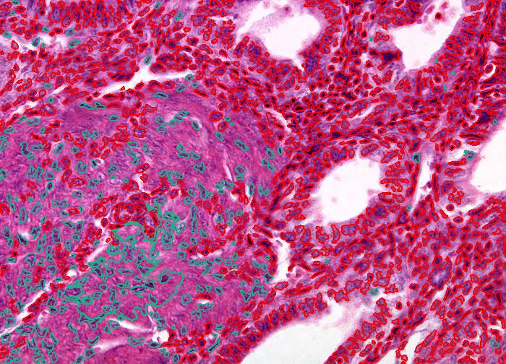

The green coloured annotation represents the Normal cells and the red coloured annotation represents the cancerous cells of Adenomyosis

## 6. Conclusion

The annotation of pathological images is a critical process in the transition from traditional microscopy to digital pathology. In this project, we demonstrated how open-source tools — Fiji and QuPath — can be effectively utilized to create reproducible, high-quality annotations of histological and biomedical images.

Fiji proved invaluable for image preprocessing, filtering, and particle analysis, especially in fluorescence and grayscale images. Meanwhile, QuPath offered powerful capabilities for annotating large whole-slide images, detecting cells, and applying machine learning classifiers to differentiate tissue types or cell populations.

Together, these tools support a streamlined annotation pipeline that balances automation with manual oversight, enabling both researchers and clinicians to generate data suitable for advanced analysis, visualization, and AI model training.

The experience gained in this project lays a strong foundation for future applications in biomedical research, diagnostic support systems, and the development of intelligent digital pathology workflows.

6. Acknowledgement

I would like to express my heartfelt gratitude to my mentor, Dr. Sujoy Kumar Biswas, IDEAS, ISI for his invaluable guidance, encouragement, and insightful feedback throughout the course of this internship. His mentorship has been instrumental in shaping my understanding of digital pathology and biomedical image annotation.

I am also sincerely thankful to IDEAS – Technology Innovation Hub (TIH), Indian Statistical Institute (ISI), Kolkata, for providing me with this wonderful opportunity. The supportive and intellectually stimulating environment at IDEAS-TIH greatly enriched my learning experience and enabled the successful completion of this project

## 7. APPENDICES

### References

- Bankhead et al., QuPath: Open source software for digital pathology image analysis, Scientific Reports (2017)  
- Schindelin et al., Fiji: an open-source platform for biological-image analysis, Nature Methods (2012)  
- https://qupath.github.io  
- https://imagej.net/software/fiji/

### Document Link

### https://bbbc.broadinstitute.org/image_sets and https://portal.gdc.cancer.gov/ for data acquisitions

### https://github.com/sangeeth-op/IDEAS-TIH-Project -Github Repository link

### https://drive.google.com/drive/u/0/folders/1UU5KG1AbecRdcP2DgCPR3nn6jWQKp4BZ - Google Drive