Name: Sangeeth Kumar V
Register No: 16BIS0072

Artificial Intelligence with Python
Lab Assignment – 01 (L39 & L40)
Prof Hemprasad Yashwant Patil

https://colab.research.google.com/drive/1TlUzSCsP0a9o0-OIwgXua5-BA3Zjjrvg
Question – 1
Write a series of Python statements that will import the math module, read a number from the user that represents an angle given in radians, and then prints the sine and cosine from the given angle.

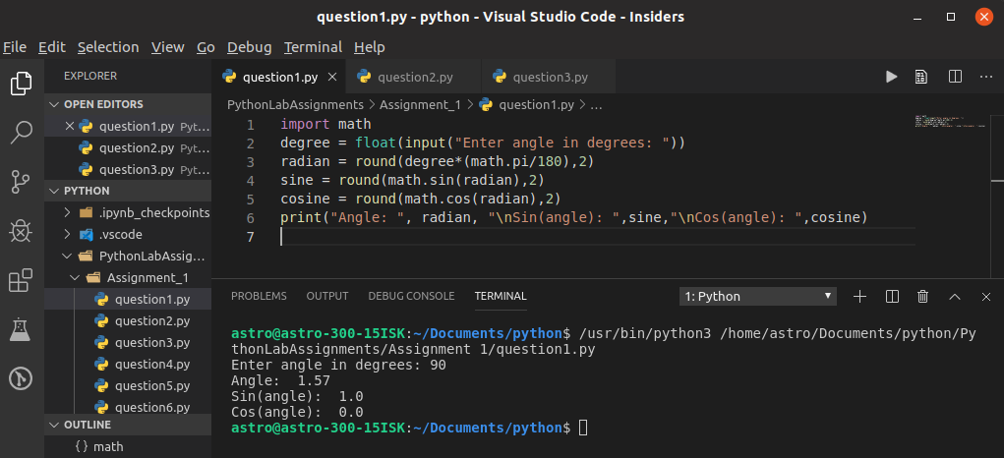
Question – 2
Try writing a print statement that uses the escape character \b. What do you think this is doing? Try placing several characters before and after the \b. Try typing several in a row after a series of characters.
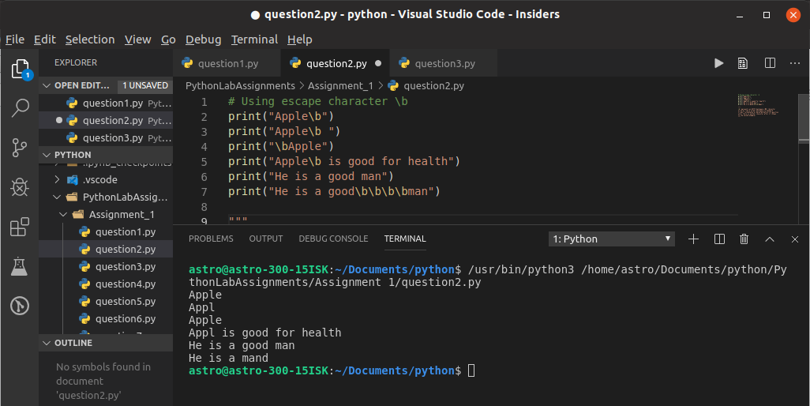
\b represents an ASCII backspace (BS) character It works like a normal backspace in keyboard It won't eliminates a characted before its position until there is another character after it (Shown in the second example)
For multiple \b symbols it will remove previous elements as many times used in the print function.

Quesiton – 3
Try writing a print statement that uses the escape character \a. What do you think this is doing? Can you think of a use for this feature?

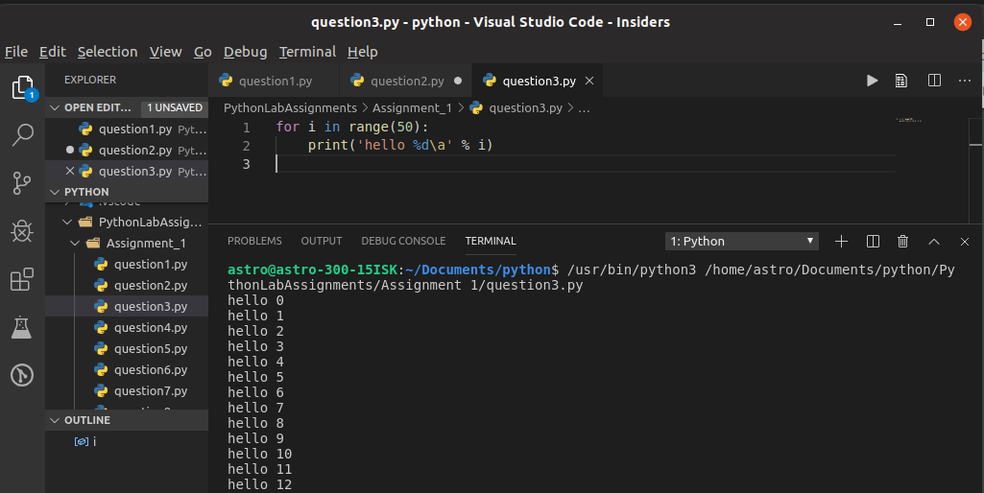
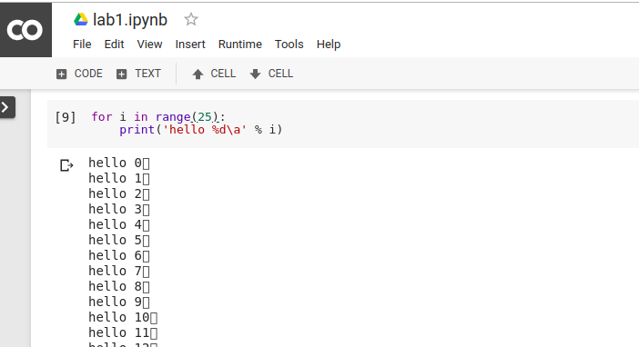
\a is an ASCII Bell symbol it make a ringing alert (like a BEEP sound) if run outside of IDLE. If you run in IDLE it will print odd characters instead of beeping.
Output is NULL for \a

Quesiton – 4
Write three Python statements. The first should read a number from the user that represents a temperature in Fahrenheit, placing the value into a variable named f. The second statement should convert the value into celcius, placing the result into a variable named c. The third statement should print the values of f and s with a descriptive notation.

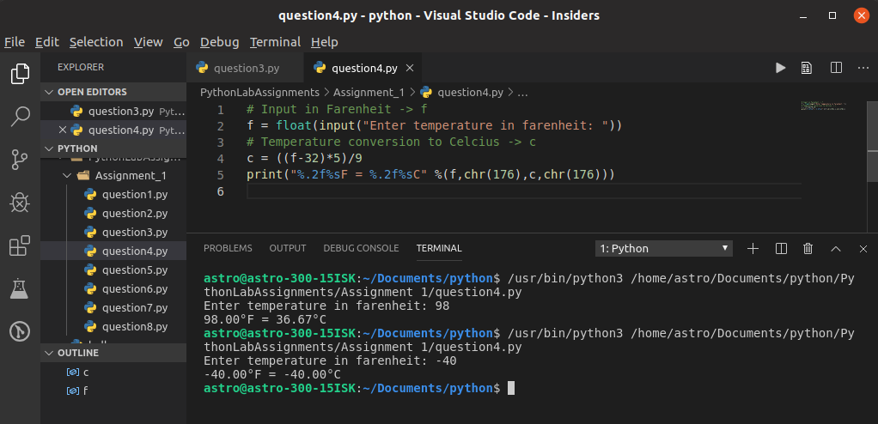
Question – 5
Write a series of Python statements that will read a number from the user that represents the radius of a circle. Then use a print statement to show the circles diameter, circumference and area. You can import the math module and use the constant math.pi to represent the constant pi.

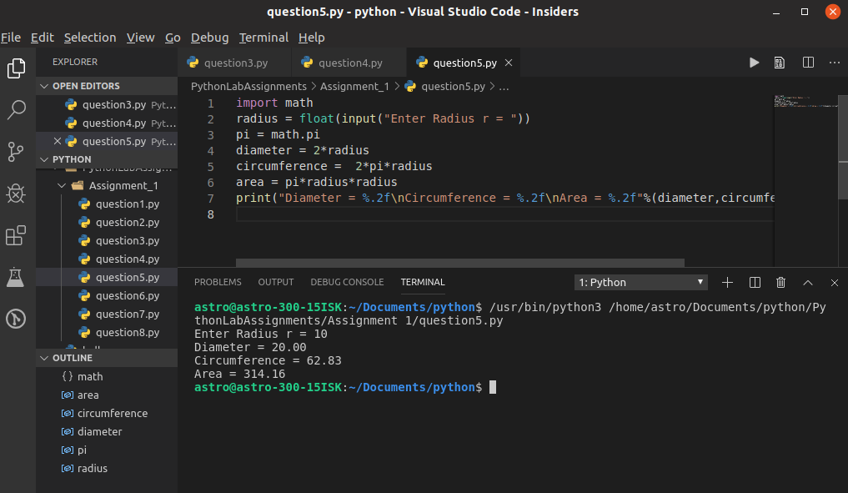

Question – 6
Using a while loop, produce a simple table of sines, cosines and tangents. Make the variable x range from 0 to 3 in steps of 0.1. For each value of x, print the value of math.sin(x), math.cos(x) and math.tan(x)
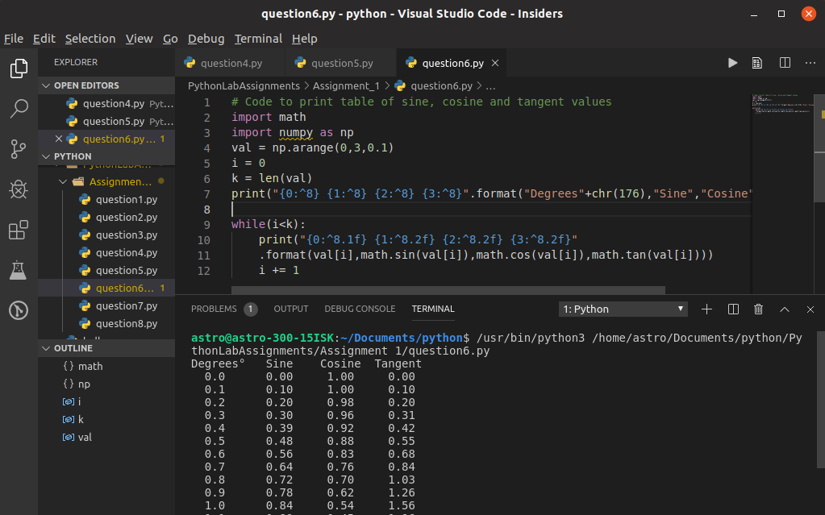
Question – 7
Using a series of nested for loops, find all Pythagorean triples consisting of positive integers less than or equal to 20
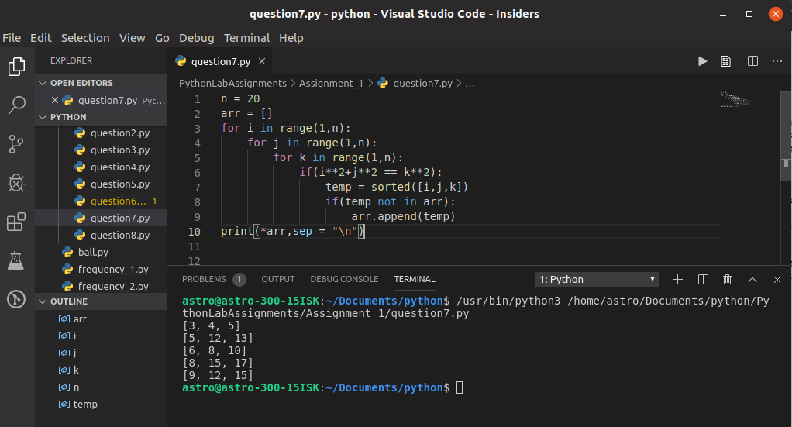

Question – 8
Write a program that reads an integer value n from the user, then produces n lines of output. The first line contains 1 star, the second 2 stars, and so on until the last line, which should have n stars. Can you write this using only a single loop?
