Name: Sangeeth Kumar V
Register No: 16BIS0072

Artificial Intelligence with Python
Lab Task – 02 (L39 & L40)
Prof Hemprasad Yashwant Patil

Question:

The Census Income Data Set (Income_data.txt) presents a challenge of predicting whether income exceeds $50K/yr based on census data. The data is stored in Income_data.txt file. There are two distinct classes namely ‘<=50K’ and ‘>50K’. Apply necessary pre-processing steps on this data and state them clearly. Note that there should not be more than 70% data in train. The model has to be built which will accurately classify the test data. Use various classification techniques and indicate the results in tabular form. Perform a benchmarking analysis of the results.

Solution:

Sample dataset:

39, State-gov, 77516, Bachelors, 13, Never-married, Adm-clerical, Not-in-family, White, Male, 2174, 0, 40, United-States, <=50K

50, Self-emp-not-inc, 83311, Bachelors, 13, Married-civ-spouse, Exec-managerial, Husband, White, Male, 0, 0, 13, United-States, <=50K

SVM and LinearSVM classifier

Code:

import numpy as np
import matplotlib.pyplot as plt
from sklearn import preprocessing
from sklearn.svm import LinearSVC
from sklearn.svm import SVC
from sklearn.multiclass import OneVsOneClassifier
import warnings
warnings.filterwarnings("ignore")
from sklearn.model_selection import train_test_split
from sklearn.model_selection import cross_val_score
import warnings
warnings.filterwarnings("ignore")

# Input file containing data
input_file = 'income_data.txt'

# Read the data
X = []
y = []
count_class1 = 0
count_class2 = 0
max_datapoints = 25000

with open(input_file, 'r') as f:
for line in f.readlines():
if count_class1 >= max_datapoints and count_class2 >= max_datapoints:
break

if '?' in line:
continue

data = line[:-1].split(', ')

if data[-1] == '<=50K' and count_class1 < max_datapoints:
X.append(data)
count_class1 += 1

if data[-1] == '>50K' and count_class2 < max_datapoints:
X.append(data)
count_class2 += 1

# Convert to numpy array
X = np.array(X)

# Convert string data to numerical data
label_encoder = []
X_encoded = np.empty(X.shape)
for i,item in enumerate(X[0]):
if item.isdigit():
X_encoded[:, i] = X[:, i]
else:
label_encoder.append(preprocessing.LabelEncoder())
X_encoded[:, i] = label_encoder[-1].fit_transform(X[:, i])

X = X_encoded[:, :-1].astype(int)
y = X_encoded[:, -1].astype(int)

# Create SVM classifier
classifier = OneVsOneClassifier(LinearSVC(random_state=0))

# Train the classifier
classifier.fit(X, y)

# Cross validation
X_train, X_test, y_train, y_test = train_test_split(X, y, test_size=0.3, random_state=5)
classifier = OneVsOneClassifier(LinearSVC(random_state=0))
classifier.fit(X_train, y_train)
y_test_pred = classifier.predict(X_test)

# Compute the F1 score of the SVM classifier
f1 = cross_val_score(classifier, X, y, scoring='f1_weighted', cv=3)
print("F1 score: " + str(round(100*f1.mean(), 2)) + "%")

Output:
Using LinearSVC
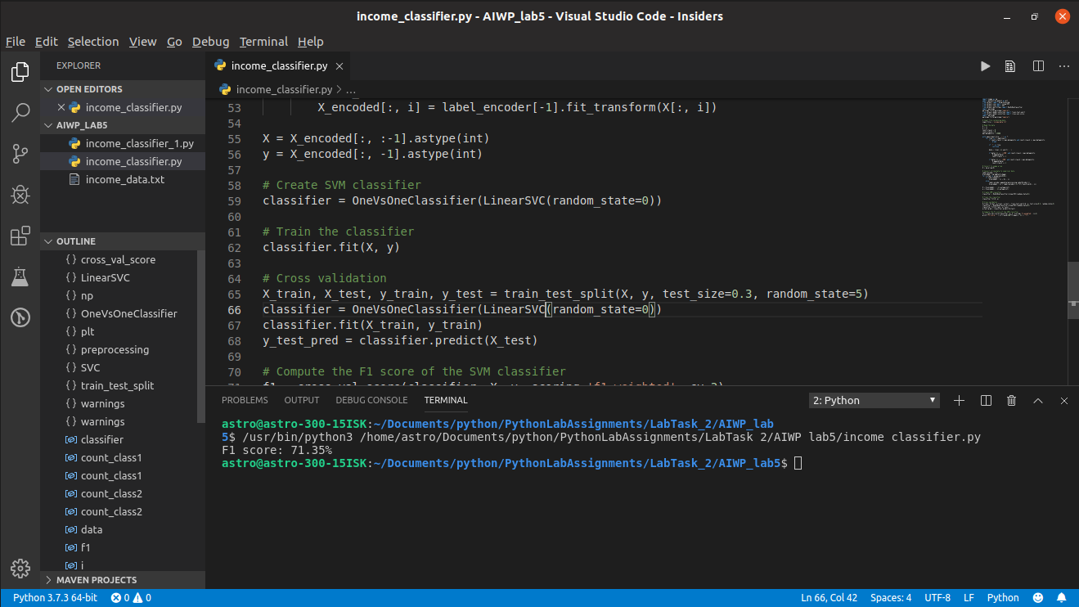
Using SVC
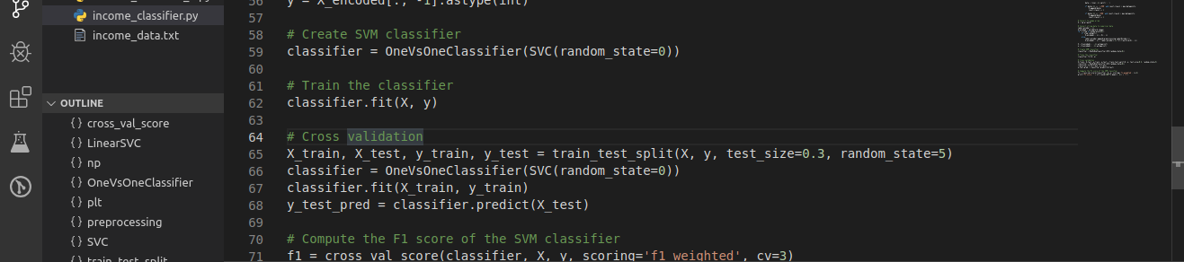
Comparison:
F1 Score
LinearSVC: 71.35%
SVC: 64.52%

------------------------------------------------------------------------------------------------------------------------

