Name: Sangeeth Kumar V
Register No: 16BIS0072

Artificial Intelligence with Python
Lab Task – 02 (L39 & L40)
Prof Hemprasad Yashwant Patil

Question:

The Census Income Data Set (Income_data.txt) presents a challenge of predicting whether income exceeds $50K/yr based on census data. The data is stored in Income_data.txt file. There are two distinct classes namely ‘<=50K’ and ‘>50K’. Apply necessary pre-processing steps on this data and state them clearly. Note that there should not be more than 70% data in train. The model has to be built which will accurately classify the test data. Use various classification techniques and indicate the results in tabular form. Perform a benchmarking analysis of the results.

Solution:

Sample dataset:

39, State-gov, 77516, Bachelors, 13, Never-married, Adm-clerical, Not-in-family, White, Male, 2174, 0, 40, United-States, <=50K

50, Self-emp-not-inc, 83311, Bachelors, 13, Married-civ-spouse, Exec-managerial, Husband, White, Male, 0, 0, 13, United-States, <=50K

SVM and LinearSVM classifier

Import required modules

import numpy as np
import matplotlib.pyplot as plt
from sklearn import preprocessing
from sklearn.metrics import classification_report
from sklearn.metrics import confusion_matrix
from sklearn.metrics import accuracy_score
import warnings
warnings.filterwarnings("ignore")
from sklearn.model_selection import train_test_split
from sklearn.model_selection import cross_val_score
import warnings
warnings.filterwarnings("ignore")
import itertools
import timeit

Preprocess the data

# Input file containing data
input_file = 'income_data.txt'

# Read the data
X = []
y = []
count_class1 = 0
count_class2 = 0
max_datapoints = 25000
# dictionaries to benchmark
scores = {}
time = {}

#Pre-processing
with open(input_file, 'r') as f:
for line in f.readlines():
if count_class1 >= max_datapoints and count_class2 >= max_datapoints:
break
if '?' in line:
continue

data = line[:-1].split(', ')

if data[-1] == '<=50K' and count_class1 < max_datapoints:
X.append(data)
count_class1 += 1

if data[-1] == '>50K' and count_class2 < max_datapoints:
X.append(data)
count_class2 += 1
# Convert to numpy array
X = np.array(X)

# Convert string data to numerical data
label_encoder = []
X_encoded = np.empty(X.shape)
for i,item in enumerate(X[0]):
if item.isdigit():
X_encoded[:, i] = X[:, i]
else:
label_encoder.append(preprocessing.LabelEncoder())
X_encoded[:, i] = label_encoder[-1].fit_transform(X[:, i])

X = X_encoded[:, :-1].astype(int)
y = X_encoded[:, -1].astype(int)

Linear SVM

# Linear SVM
from sklearn.svm import LinearSVC
from sklearn.multiclass import OneVsOneClassifier

Train and compute accuracy

# Create SVM classifier
classifier = OneVsOneClassifier(LinearSVC(random_state=0))
X_train, X_test, y_train, y_test = train_test_split(X, y, test_size=0.3, random_state=5)

# Note down start time
start = timeit.default_timer()
# Train the classifier
classifier.fit(X, y)
# Cross validation
classifier.fit(X_train, y_train)
y_test_pred = classifier.predict(X_test)
# Note down stop time
stop = timeit.default_timer()

# Compute the F1 score of the SVM classifier
f1 = cross_val_score(classifier, X, y, scoring='f1_weighted', cv=3)
print("SVM classifier results")
print("F1 score: " + str(round(100*f1.mean(), 2)) + "%")
# Accuracy
a = accuracy_score(y_test_pred,y_test)
print("Accuracy: " + str(a*100) + "%")

Print confusion matrix

# Confusion matrix
conf_mat = confusion_matrix(y_test,y_test_pred)
plt.imshow(conf_mat, interpolation='nearest', cmap=plt.cm.Blues)
plt.title('Confusion Matrix - SVM Classifier')
plt.colorbar()
ticks = np.arange(2)
plt.xticks(ticks,ticks)
plt.yticks(ticks,ticks)

thresh = conf_mat.max()/2.
for i,j in itertools.product(range(conf_mat.shape[0]),range(conf_mat.shape[1])):
plt.text(j,i,format(conf_mat[i,j],'d'),
horizontalalignment = "center",
color="white" if conf_mat[i,j]>thresh else"black")
plt.ylabel('True Labels')
plt.xlabel('Predicted Labels')
plt.show()
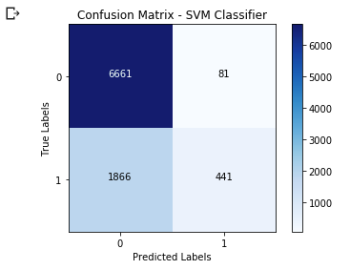
Accuracy and classification report
# Accuracy and Classification report
print(classification_report(y_test_pred,y_test))
print('Time taken for SVM',stop-start)
scores['SVM'] = a*100
time['SVM'] = stop-start

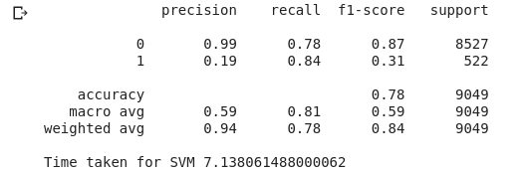
GaussiaNB (naive Bayes classifier)
# GaussianNB classifier
from sklearn.naive_bayes import GaussianNB
classifier = GaussianNB()

Train model
# Note start time
start = timeit.default_timer()
# Train classifier
classifier.fit(X,y)
# predict the values for training data
y_pred = classifier.predict(X)
# Note stop time
stop = timeit.default_timer()

Compute accuracy and time taken
# Computing accuracy and time taken
accuracy = 100*(y == y_pred).sum()/X.shape[0]
print("Gaussian Native Bayes classfier results")
print("Accuracy: " + str(round(accuracy,2)), "%")
print("Time",stop-start)
time['Naive Bayes'] = stop-start

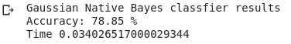
Print confusion matrix
conf_mat = confusion_matrix(y,y_pred)
plt.imshow(conf_mat, interpolation='nearest', cmap=plt.cm.Blues)
plt.title('Confusion Matrix for Naive Bayes')
plt.colorbar()
ticks = np.arange(2)
plt.xticks(ticks,ticks)
plt.yticks(ticks,ticks)

thresh = conf_mat.max()/2
for i,j in itertools.product(range(conf_mat.shape[0]),range(conf_mat.shape[1])):
plt.text(j,i, format(conf_mat[i,j],'d'),
horizontalalignment = 'center',
color = 'white' if conf_mat[i,j]>thresh else 'black')
plt.ylabel('True Labels')
plt.xlabel('Predicted Labels')
plt.show()

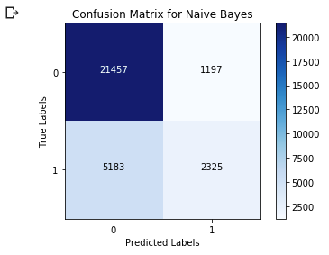
Accuracy of naive bayes classification
# Accuracy and Classification of naive bayes
tn, fp, fn, tp = conf_mat.ravel()
print("True Negatives: ",tn)
print("True Positives: ",tp)
print("False Negatives: ",fn)
print("False Positives: ",fp)
Accuracy = (tn+tp)*100/(tp+tn+fp+fn)
print("Accuracy %.2f"%(Accuracy))
scores['Naive Bayes'] = Accuracy

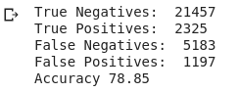
Classification report
# Classification report
print(classification_report(y,y_pred))

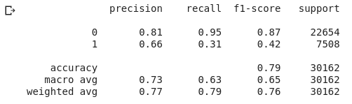
Logistic Regression
Import modules
# Logistic Regression
from sklearn.linear_model import LogisticRegression
classifier = LogisticRegression()

x_train,x_test,y_train,y_test = train_test_split(X,y,test_size = 0.3)

Train model
# Note start time
start = timeit.default_timer()
# Train classifier
classifier.fit(x_train,y_train)
# Predict the value of training data
predicted = classifier.predict(x_test)
# Note stop time
stop = timeit.default_timer()
print(predicted)
Print confusion matrix
conf_mat = confusion_matrix(y_test,predicted)
plt.imshow(conf_mat, interpolation = 'nearest', cmap=plt.cm.Blues)
plt.title("Confusion matrix for Logistic regression")
plt.colorbar()
ticks = np.arange(2)
plt.xticks(ticks,ticks)
plt.yticks(ticks,ticks)

thresh = conf_mat.max()/2
for i,j in itertools.product(range(conf_mat.shape[0]),range(conf_mat.shape[1])):
plt.text(j,i,format(conf_mat[i,j],'d'),
horizontalalignment='center',
color = 'white' if conf_mat[i,j]>thresh else 'black')
plt.ylabel('True Labels')
plt.xlabel('Predicted labels')
plt.show()

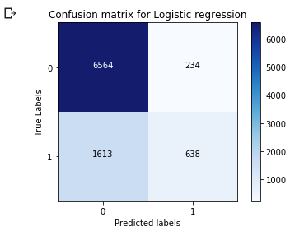
Accuracy and time taken
accuracy = accuracy_score(predicted,y_test)
print("Accuracy: " + str(accuracy*100) + "%")
scores['Logistic Regression'] = accuracy*100
print("Time taken", stop-start)
time['Logistic Regression'] = stop-start

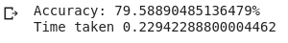
Classification report
print(classification_report(y_test,predicted))
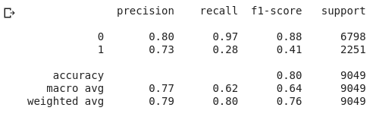
BENCHMARKING RESULTS OBTAINED FROM DIFFERENT CLASSIFIERS
Comparing accuracy of algorithms
# BENCHMARKING THE RESULTS OBTAINED IN DIFFERENT CLASSIFIERS

plot_y = np.array(list(scores.keys()))
plot_x = np.array(list(scores.values()))
print(*plot_x,sep = " ")
print(*plot_y,sep = " ")

index = np.arange(len(plot_y))
plt.bar(index,plot_x)
plt.title("Classifier vs Accuracy")
plt.ylabel('Accuracy Score')
plt.xlabel('Classifiers')
plt.xticks(index,plot_y,fontsize = 10)
plt.ylim(75,80)
for i in range(len(index)):
plt.text(x = i-0.2, y = plot_x[i]+0.1, s = plot_x[i].round(2),size = 10)
plt.show()

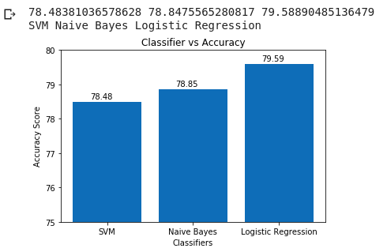
Comparing the time taken for each algorithms
time_x = np.array(list(time.values()))
time_y = np.array(list(time.keys()))
print(*time_x,sep=" ")
print(*time_y,sep=" ")

index = np.arange(len(time_y))
plt.bar(index,time_x)
plt.title("Classifier vs Time")
plt.ylabel('Time taken')
plt.xlabel('Classifiers')
plt.xticks(index,time_y,fontsize = 10)
for i in range(len(index)):
plt.text(x = i-0.2, y = time_x[i]+0.1, s = str(time_x[i].round(2))+'s',size = 10)
plt.show()

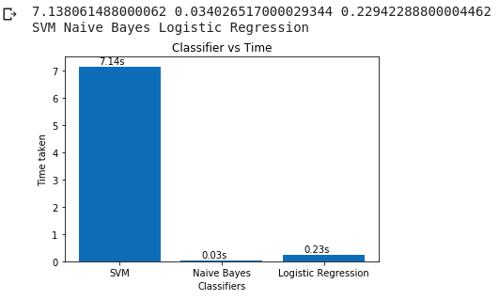
Conclusion
Thus from the observation tabulated while benchmarking accuracy and time of the algorithms taken into account we can notice that Logistic regression has more accuracy when we train with 70% of the dataset. And considering the time consumed Naive Bayes works 9 time more efficiently compared to Logistic regression. Hence, a trade-off should be made for accuracy and time when using Logistic regression and Naive Bayes for classification. Overall Logistic regression performs better than all other.
------------------------------------------------------------------------------------------------------------------------

