Name: Sangeeth Kumar V
Register No: 16BIS0072

Artificial Intelligence with Python
Lab Task – 03 (L39 & L40)
Prof Hemprasad Yashwant Patil

Question:

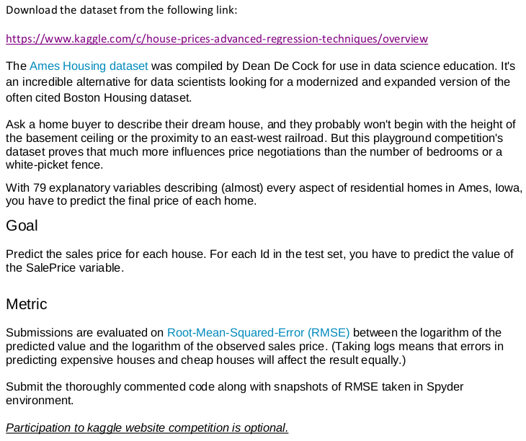

Code:

#!/usr/bin/env python3
# -*- coding: utf-8 -*-
"""
Created on Sun Sep 1 04:26:39 2019

@author: astro
"""
# %%
import pandas as pd
from sklearn.tree import DecisionTreeRegressor
from sklearn.metrics import mean_absolute_error
from sklearn.metrics import mean_squared_log_error

# %%
# Read csv file
train_file = '~/Documents/AIWP/Lab/LabTask_3\
/house-prices-advanced-regression-techniques\
/train.csv'
data = pd.read_csv(train_file)
summary = data.describe()

# %%
# Select features
y = data.SalePrice
data_features = [x for x in data.columns if str(data[x][0]).isdigit()][:-1]
X = data[data_features]
describe = X.describe()
head = X.head()

# %%
# Define and Fit model
data_model = DecisionTreeRegressor(random_state=1)
data_model.fit(X, y)

# %%
# Predict
test_file = '~/Documents/AIWP/Lab/LabTask_3\
/house-prices-advanced-regression-techniques\
/test.csv'
test_data = pd.read_csv(test_file)
X_test = test_data[data_features]
X_test = pd.DataFrame(X_test).fillna(X_test.mean())
print(X_test)
result = data_model.predict(X_test)
print(result)

# %%
# Evaluate model
submission_file = '~/Documents/AIWP/Lab/LabTask_3\
/house-prices-advanced-regression-techniques\
/sample_submission.csv'
submission_data = pd.read_csv(submission_file)
# RMSE && RMSLE
print('RMSE: ', (mean_absolute_error(
submission_data['SalePrice'], result)
) ** 0.5)
print('RMSLE: ', (mean_squared_log_error(
submission_data['SalePrice'], result)
) ** 0.5)

Results:

Data:

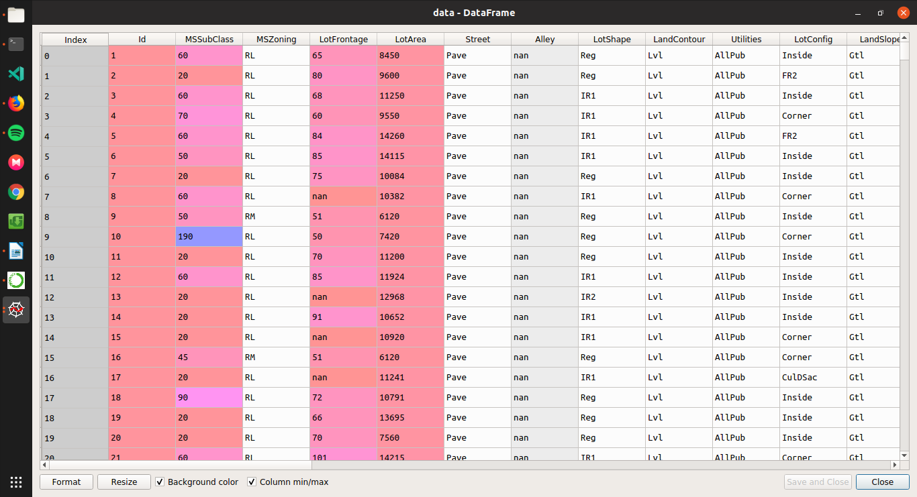
Feature Vector summary

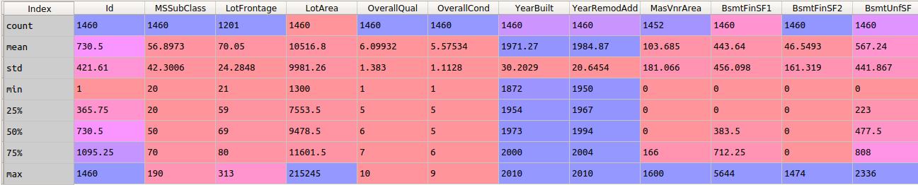
Features present in train dataset

- Id
- MSSubClass
- MSZoning
- LotFrontage
- LotArea
- Street
- Alley
- LotShape
- LandContour
- Utilities
- LotConfig
- LandSlope
- Neighborhood
- Condition1
- Condition2
- BldgType
- HouseStyle
- OverallQual
- OverallCond
- YearBuilt
- YearRemodAdd
- RoofStyle
- RoofMatl
- Exterior1st
- Exterior2nd
- MasVnrType
- MasVnrArea
- ExterQual
- ExterCond
- Foundation
- BsmtQual
- BsmtCond
- BsmtExposure
- BsmtFinType1
- BsmtFinSF1
- BsmtFinType2
- BsmtFinSF2
- BsmtUnfSF
- TotalBsmtSF
- Heating
- HeatingQC
- CentralAir
- Electrical
- 1stFlrSF
- 2ndFlrSF
- LowQualFinSF
- GrLivArea
- BsmtFullBath
- BsmtHalfBath
- FullBath
- HalfBath
- BedroomAbvGr
- KitchenAbvGr
- KitchenQual
- TotRmsAbvGrd
- Functional
- Fireplaces
- FireplaceQu
- GarageType
- GarageYrBlt
- GarageFinish
- GarageCars
- GarageArea
- GarageQual
- GarageCond
- PavedDrive
- WoodDeckSF
- OpenPorchSF
- EnclosedPorch
- 3SsnPorch
- ScreenPorch
- PoolArea
- PoolQC
- Fence
- MiscFeature
- MiscVal
- MoSold
- YrSold
- SaleType
- SaleCondition
- SalePrice

# Out of them, numerical features are taken into consideration
Using DecisionTreeClassifier for model.fit

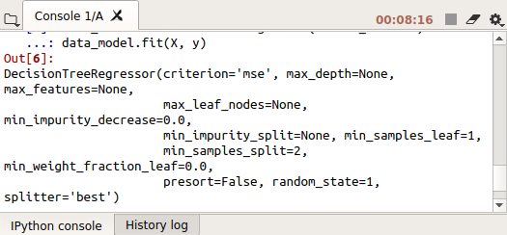
Predicted Values
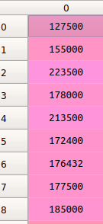
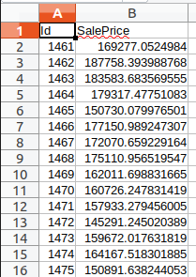

They indicate the predicted vs actual values from sample_submission.csv

Evaluating model:

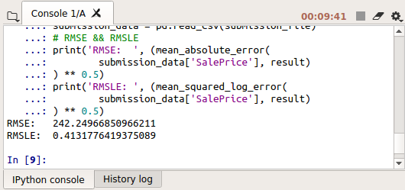
Root Mean Square Error
RMSE: 242.24966850966211
Root Mean Square Log Error
RMSLE: 0.4131776419375089

Conclusion:
Thus we predicted the final price of each home in the given test.csv file by training train.csv, and eventually evaluated the model with the sample_submission.csv file.

