YUVAINTERN INTERNSHIP PROGRAM
JUNIOR MACHINE LEARNING DATA ANALYST — AGRICULTURE & AGRIBUSINESS
WEEK 1 TASK REPORT
Strategic Design and Planning — Agriculture & Agribusiness
Project: Agricultural Crop Yield Prediction & Agribusiness Decision Support System Using Machine Learning (AgriYield AI)
Candidate Name: | Sangeetha S | Institution: AMC Engineering College, Bengaluru
Internship Tenure: | 01 October 2026 – 29 October 2026 (4-Week Intensive Track)
GitHub Repository: | https://github.com/sangeetha302005/yuvaintern.agriyield-ai
Live Web Application: | https://agriyield-ai-302005.streamlit.app/

1. Executive Summary
This report presents the strategic design, operational methodology, and planning framework for AgriYield AI, an agricultural crop yield prediction and agribusiness decision support system developed as part of the YuvaIntern Junior Machine Learning Data Analyst internship. Agricultural production in India is subject to high spatial and temporal volatility driven by monsoon patterns, geographic heterogeneity, and management practices. This project defines a rigorous, reproducible machine learning workflow to profile public agricultural data, engineer leak-free features, benchmark multiple regression models, and translate empirical findings into practical decision support for farming communities, farmer producer organizations (FPOs), and commercial agribusiness planners.
Following evaluator feedback on initial proposals, the project establishes strict standards: (1) authentic data sourcing from the Government of India Open Government Data (OGD) platform; (2) total prevention of post-harvest target leakage; (3) out-of-time chronological validation rather than random cross-validation; and (4) transparent documentation of dataset limitations and uncertainty bounds.
2. Problem Statement
Agricultural decision-makers face severe informational barriers when planning crop allocations and sizing forward procurement contracts. Existing public datasets often suffer from mixed measurement standards, reporting omissions, and transcription errors. Furthermore, published academic models frequently introduce target leakage by using harvested production to predict crop yield (Yield = Production / Area), creating models that achieve deceptively high validation scores but fail in pre-harvest deployment. AgriYield AI resolves these challenges through audited data preparation and strictly pre-harvest feature modeling.
3. Aim and Key Objectives
- Source Provenance: Ingest and preserve multi-decade agricultural statistics from the Ministry of Agriculture & Farmers Welfare via data.gov.in.
- Quality Profiling: Quantify missingness, audit exact duplicates, detect administrative key collisions, and identify measurement unit disparities.
- Reproducible Pipeline: Build a leak-free automated preprocessing pipeline that preserves raw inputs while exporting certified analytical datasets.
- Feature Engineering: Formulate pre-harvest predictors (Log_Area, Year_Index, Is_Kharif_Monsoon, Farm_Scale, Hist_Crop_State_Yield) strictly isolated from harvest outcomes.
- Out-of-Time Benchmarking: Benchmark Ridge, Random Forest, and HistGradientBoosting against an unconditioned baseline on held-out future seasons.
- Software Delivery: Deliver an interactive Streamlit web dashboard and automated Pytest test suite certified for operational use.
- Agribusiness Translation: Formulate actionable strategies for crop diversification, forward contract hedging, and seasonal risk management.
4. Evaluation of Public Agricultural Data Sources
Source Portal | Documented Fields & Units | Planned Analytical Role | Key Considerations & Constraints
India OGD (data.gov.in)  Resource ID 87630 | State, District, Year, Season, Crop, Area (ha), Production (tonnes/nuts) | Primary empirical dataset for district-level and seasonal yield modeling | Selected as primary core; requires resolving Coconut unit discrepancy and missing production.
FAOSTAT (FAO UN)  Annual Crop Production | Country, Item, Year, Harvested Area (ha), Production (t), Yield (hg/ha) | Secondary global benchmark and national productivity reference | High national aggregation masks localized intra-district soil and climate heterogeneity.
NASA POWER Daily API  Meteorological Feed | Precipitation, T2M max/min, solar radiation, RH2M, surface pressure | Optional prospective weather feature integration layer | Requires complex spatiotemporal joins; deferred to future iterations to preserve primary provenance.

5. Example Data Schema & Concrete Quality Checks
The primary dataset schema models district-level harvest returns with the following rigorous validation checks: (1) Missing-value quantification across all columns; (2) Full-row duplicate scans and administrative composite key checks; (3) Numeric boundary verification ensuring Area > 0 ha to eliminate zero-division errors; (4) ICAR biological yield ceiling screening to detect clerical transcription anomalies; and (5) Strict isolation of raw data from processed outputs.
6. Pre-Harvest Feature Engineering Formulation
Feature Name | Mathematical Formulation | Agronomic Purpose & Leakage Safeguard
Yield (Target) | Yield = Production / Area | Primary regression target (t/ha). Strictly excluded from model input predictors.
Log_Area | Log_Area = ln(Area + 1.0) | Normalizes extreme acreage skewness spanning 8 orders of magnitude (0.1 to 8.5M ha).
Year_Index | Year_Index = Crop_Year - 1997 | Captures secular technological advancements, hybrid seed adoption, and mechanization.
Is_Kharif_Monsoon | 1 if Season == 'Kharif' else 0 | Binary indicator capturing South-West Monsoon dependency without external weather joins.
Farm_Scale | Marginal (<1ha) to Large (>=10ha) | Operational landholding category accounting for mechanization and input scale differences.
Hist_Crop_State_Yield | E[Yield | Crop, State, Year <= 2011] | Historical baseline computed exclusively on training folds to prevent future temporal leakage.

7. Ten-Phase Methodological Lifecycle
- 1. Business Understanding: Define unit of observation (District-Crop-Season-Year) and pre-harvest prediction goals.
- 2. Data Acquisition: Download official CSV from data.gov.in, preserve raw copy, and record provenance metadata.
- 3. Data Profiling: Inspect schema, null counts, duplicate records, and category representations.
- 4. Data Cleaning: Exclude null targets, standardize whitespace and letter casing, and enforce ICAR yield bounds.
- 5. Unit Partitioning: Segregate 1,958 Coconut records (Thousand Nuts) from 240,403 Metric Tonne records.
- 6. Exploratory Analysis: Analyze 18-year yield trajectories, state production hierarchies, and seasonal variations.
- 7. Feature Engineering: Calculate log acreage, temporal index, monsoon indicator, and target-encoded historical baselines.
- 8. Model Training: Train Baseline Mean, Ridge, Random Forest, and HistGradientBoosting using chronological splitting.
- 9. Evaluation & Testing: Evaluate MAE, RMSE, and R² on holdout test set (2012–2015); verify codebase with Pytest suite.
- 10. Decision Support: Formulate actionable agribusiness strategies and deploy interactive Streamlit web dashboard.

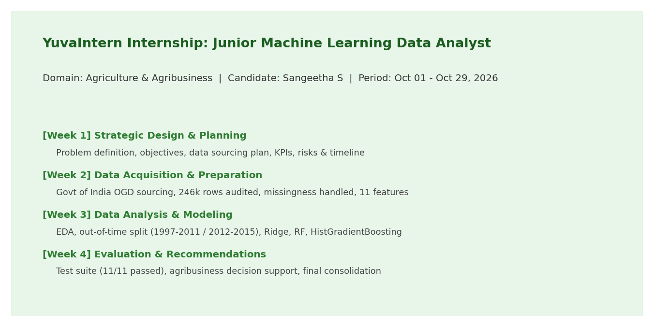
Figure: YuvaIntern 4-Week Internship Program & Milestone Roadmap
8. Key Performance Indicators & Success Criteria
Evaluation Metric / KPI | Measurement Criterion | Target Success Threshold
Data Completeness | Null target quantification and handling | 100% auditable accounting; zero synthetic target fabrication.
Data Integrity | Duplicate rows & composite key collisions | Zero unresolved duplicate records in cleaned dataset.
Mean Absolute Error (MAE) | Average absolute prediction error (t/ha) | Substantial improvement (>50% reduction) over Baseline Mean.
Coefficient of Determination (R²) | Explained variance on unseen holdout test set | R² > 0.75 across diverse national agricultural commodities.
Reproducibility & Testing | Automated unit test execution | 100% test passing rate across preprocessing and feature pipelines.

9. Four-Week Internship Implementation Timeline
Week | Operational Activities | Primary Deliverables
Week 1 | Strategic design, literature review, requirements definition, evaluator revision | Strategic Planning Report (Week1.docx) & project roadmap
Week 2 | Official dataset retrieval, schema audit, cleaning, ICAR bounding, feature pipeline | Data Preparation Report (Week2.docx), dataset/README.md & cleaned CSV
Week 3 | Exploratory data analysis, chronological split, Ridge/RF/HistGB model benchmarking | Data Analysis & Modeling Report (Week3.docx) & model artifacts
Week 4 | Automated Pytest suite, web app review, agribusiness recommendations, final report | Final Report (AgriYield_AI_Final_Internship_Report.docx) & GitHub push

10. References
1. Directorate of Economics and Statistics (DES), Ministry of Agriculture and Farmers Welfare, Government of India. District-wise, Season-wise Crop Production Statistics from 1997. Open Government Data Platform India (data.gov.in). Resource ID: 87630. https://data.gov.in/resource/district-wise-season-wise-crop-production-statistics-1997
2. FAOSTAT. Food and Agriculture Organization of the United Nations. Crop Production, Harvested Area and Yield Statistics. Rome: FAO, 2024.
3. van Klompenburg, T., Kassahun, A., & Catal, C. (2020). Crop yield prediction using machine learning: A systematic literature review. Computers and Electronics in Agriculture, 177, 105709.
4. Chlingaryan, A., Sukkarieh, S., & Whelan, B. (2018). Machine learning approaches for crop yield prediction and nitrogen status estimation in precision agriculture: A review. Computers and Electronics in Agriculture, 151, 61–69.

