YUVAINTERN — JUNIOR MACHINE LEARNING DATA ANALYST
AGRICULTURE & AGRIBUSINESS DOMAIN
WEEK 2: WEEK 2 — DATA ACQUISITION AND PREPARATION
Evidence-Based Engineering Report | Directorate of Economics and Statistics APY Dataset
Report detail | Information
Internship platform | YuvaIntern
Project | AgriYield AI — Agricultural Yield Analysis and Prediction
Task | Week 2 — Data Acquisition and Preparation
Prepared by | Sangeetha S
Data source documented in project | Directorate of Economics and Statistics, Government of India
Evidence analysed | Repository source code, processed CSV, audit report, data dictionary and methodology

Evidence-based report using independently calculated processed-dataset statistics
1. Introduction
Agricultural data supports decisions about crop planning, regional productivity, procurement and resource allocation. Before agricultural records can be used for analysis or machine learning, they must be checked for missing target values, inconsistent categories, invalid measurements, duplicate records and unusual observations. Data preparation is especially important when a dataset combines many crops, districts, seasons and reporting units.
This report documents the data acquisition and preparation workflow in AgriYield AI. It is based on the project repository supplied for review: the preprocessing source code, feature-engineering code, data-quality audit, data dictionary, methodology documentation and the saved processed CSV. Statistics described as processed-file results were recalculated directly from that CSV. Raw-source statistics are identified separately as values documented by the repository audit because the original raw CSV was not present in the supplied repository archive.
2. Objectives
▪ Identify and document the official public agricultural dataset used by the project.
▪ Describe its geographic, crop, seasonal and year coverage.
▪ Inspect the prepared data for missing values, duplicates, invalid area values and zero production.
▪ Document the implemented cleaning, unit-tagging, yield-calculation and outlier-screening steps.
▪ Explain how the cleaned dataset differs from the filtered modelling dataset.
▪ Prepare traceable evidence that can support the next stage of exploratory analysis and model development.
3. Data Source and Acquisition
3.1 Dataset source
The repository identifies the source as “District-wise, Season-wise Crop Production Statistics from 1997”, published by the Directorate of Economics and Statistics (DES), Department of Agriculture and Farmers Welfare, Ministry of Agriculture and Farmers Welfare, Government of India. The project documentation provides the Government Open Data Portal resource page and the APY CSV endpoint. The raw CSV itself was not included in the repository archive reviewed for this report; therefore, this report does not claim to have independently downloaded or reprocessed the raw source during this review.
Attribute | Documented information
Dataset title | District-wise, Season-wise Crop Production Statistics from 1997
Publisher | Directorate of Economics and Statistics, Government of India
Open Data Portal | https://data.gov.in/resource/district-wise-season-wise-crop-production-statistics-1997
Direct endpoint documented in project | https://aps.dac.gov.in/APY/apy.csv
File format | CSV
Documented time coverage | 1997–2015
Documented geography | 33 States/UTs and 646 districts
Documented seasons | Kharif, Rabi, Summer, Autumn, Winter and Whole Year
Documented crop count | 124
License stated in project README | Government Open Data License – India (GODL)

3.2 Selection criteria and relevance
Selection criterion | Relevance to the project
Official government publisher | Provides identifiable provenance and a public source.
District-level records | Allows comparisons between administrative districts.
Multiple crop years | Supports historical trend analysis.
Crop and season categories | Allows crop-specific and seasonal grouping.
Area and production fields | Provide the quantities required to derive yield.
Broad coverage | Supports regional and crop comparisons across India.

4. Processed Dataset Profile
The file examined was data/processed/crop_production_cleaned.csv. Direct inspection with pandas confirmed 242,361 rows and 11 columns. It contains 33 states/UTs, 646 districts, 124 crops, 6 seasons and crop years from 1997 to 2015. These are independently calculated statistics from the supplied processed CSV.
Profile measure | Verified value in processed CSV
Records / rows | 242,361
Columns | 11
States / Union Territories | 33
Districts | 646
Distinct crops | 124
Distinct seasons | 6
Crop-year range | 1997–2015
Metric Tonnes records | 240,403
Thousand Nuts records | 1,958
Missing values across all columns | 0
Exact duplicate rows | 0
Duplicate business keys | 0
Outlier-flagged rows | 190 (0.0784%)
Rows not flagged as yield outliers | 242,171

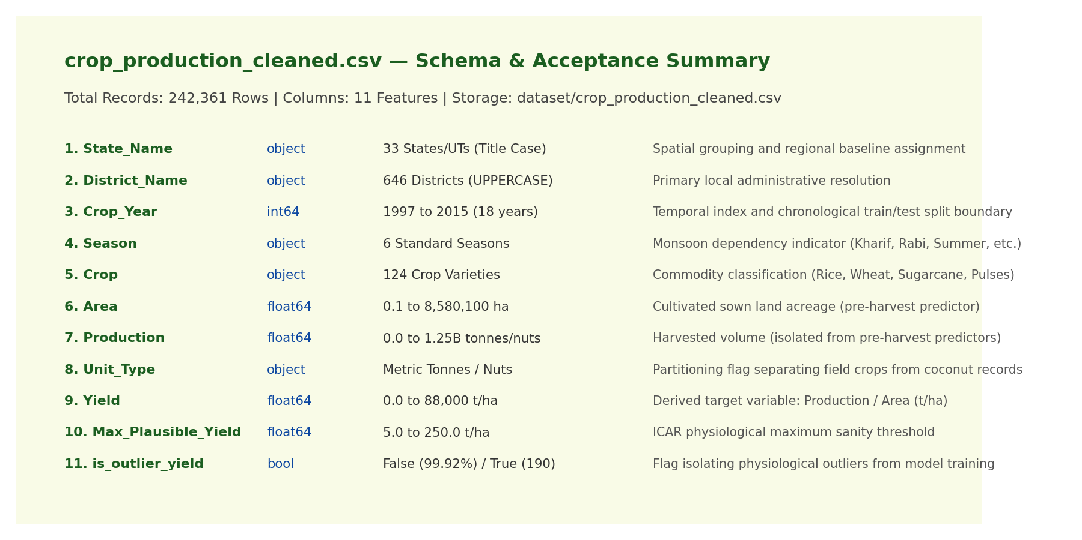
Figure 1. AgriYield AI — Cleaned 242,361-Record Dataset Schema and Data Types Summary.
4.1 Column structure
Column | Data type | Meaning
State_Name | Text | State / Union Territory
District_Name | Text | District
Crop_Year | Integer | Agricultural year
Season | Text | Season category
Crop | Text | Crop name
Area | Numeric | Cultivated area (hectares)
Production | Numeric | Reported production; unit depends on crop
Unit_Type | Text | Metric Tonnes or Thousand Nuts
Yield | Numeric | Production divided by Area
Max_Plausible_Yield | Numeric | Configured crop-specific screening threshold
is_outlier_yield | Boolean | True when tonne-crop yield exceeds threshold

5. Acquisition and Preparation Workflow
Stage | Action in the existing project | Evidence / output
1. Source identification | Source and endpoint documented in data/README.md and reports/data_quality_summary.md. | Dataset provenance documentation.
2. Data loading | src/data/load_data.py defines raw-data loading and download workflow. | Raw CSV expected under data/raw/ when available.
3. Text standardisation | src/data/preprocess.py trims whitespace; title-cases state names; uppercases district names; standardises season labels. | Consistent categorical labels.
4. Type conversion | Converts Crop_Year, Area and Production to numeric forms. | Numeric fields suitable for checks and calculations.
5. Missing-target handling | Drops rows with missing Production before calculating Yield. | Yield-ready rows; no artificial target imputation.
6. Area validation | Keeps records where Area > 0. | Avoids division by zero or negative cultivated area.
7. Unit tagging | Labels Coconut records Thousand Nuts and other records Metric Tonnes. | Unit_Type field.
8. Yield derivation | Calculates Yield = Production / Area. | Derived Yield column.
9. Outlier screening | Flags tonne-crop yields above configured crop thresholds. | is_outlier_yield Boolean.
10. Feature engineering | src/features/build_features.py filters units/outliers by configuration and creates derived predictors. | Engineered dataset for later modelling.

6. Data Quality Assessment
The repository audit documents the raw-source counts below. These raw values are reported as audit-documented rather than independently recomputed because the raw CSV was not included in the supplied repository archive. The prepared-file values in the right-hand column were independently checked from the processed CSV.
Quality check | Raw-source figure documented in audit | Processed CSV result / treatment
Raw records | 246,091 | 242,361 rows in supplied processed CSV.
Missing Production | 3,730 (1.516%) | No missing Production values remain in processed CSV.
Missing Area | 0 | No missing Area values in processed CSV.
Area <= 0 | 0 | 0; minimum Area in processed CSV is 0.1 ha.
Zero Production | 3,523 (1.432%) | 3,523 rows; retained as valid zero values.
Exact duplicates | 0 | 0 exact duplicate rows.
Duplicate business keys | 0 | 0 repeated State–District–Year–Season–Crop keys.
Different Coconut unit | 1,958 records | 1,958 records tagged Thousand Nuts.
Yield outliers | 190 | 190 rows flagged in processed CSV.

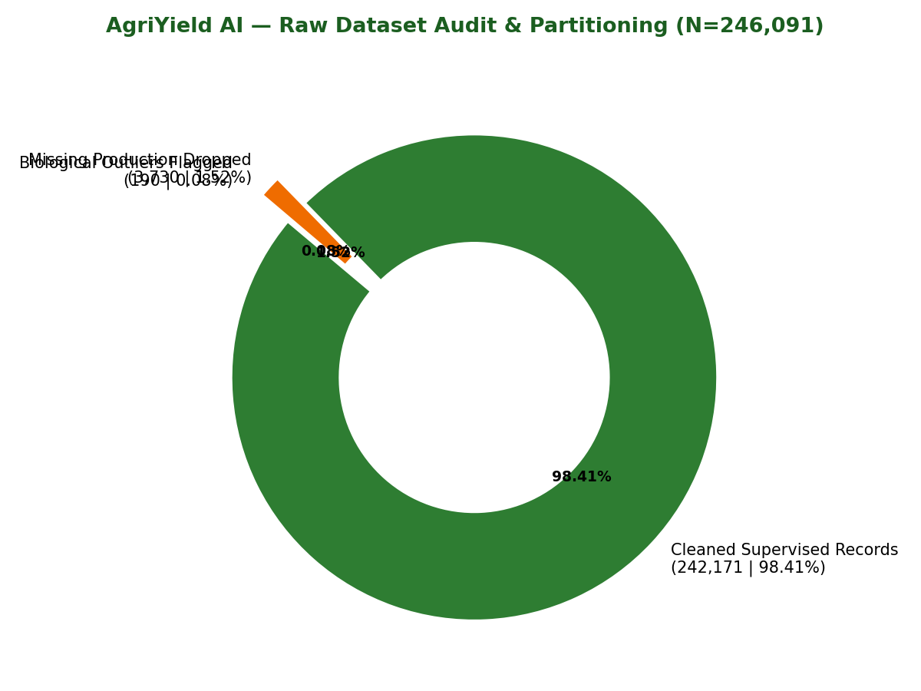
Figure 2. Comprehensive Data Quality Audit Breakdown and Defect Resolution Summary.
7. Important Count Reconciliation
The repository audit table currently labels 242,171 as the “Cleaned / Retained” count. However, direct inspection of the committed processed CSV shows 242,361 rows. The preprocessing code explains the difference: it first removes the 3,730 missing-Production records, then calculates and flags 190 outlier records without deleting those flagged records from the cleaned output. The variable valid_yield_records counts the rows not flagged as outliers.
Dataset stage | Calculation | Count
Raw records (audit-documented) | Starting count | 246,091
After excluding missing Production | 246,091 − 3,730 | 242,361
Saved cleaned CSV | Contains the 190 flagged records as well | 242,361
After excluding flagged yield outliers | 242,361 − 190 | 242,171

Therefore, the correct interpretation is: 242,361 rows are present in the saved cleaned CSV, while 242,171 rows are not flagged as yield outliers. These are different processing stages and should not be described as the same dataset. In addition, the feature-engineering function can further filter out non-tonne records (1,958 Coconut records) when exclude_non_tonne_crops=True. The final modelling count depends on the selected filtering options and should be measured from the actual engineered output rather than inferred by subtracting counts without checking overlap.
8. Cleaning and Transformation Methods
8.1 Missing values
The audit report documents 3,730 missing values in Production in the raw input. Production is needed to calculate the target Yield. The preprocessing code uses dropna(subset=['Production']) rather than filling the target with a mean or median. This avoids inventing target values for supervised learning. The processed CSV independently contains zero missing values across all 11 columns.
8.2 Text standardisation
Field | Implemented rule | Purpose
State_Name | Strip whitespace and convert to title case. | Avoid category variants caused by spaces/capitalisation.
District_Name | Strip whitespace and convert to uppercase. | Standardise district labels.
Season | Strip whitespace and map known labels to canonical season names. | Keep six season categories consistent.
Crop | Strip leading and trailing whitespace. | Remove accidental spacing differences.

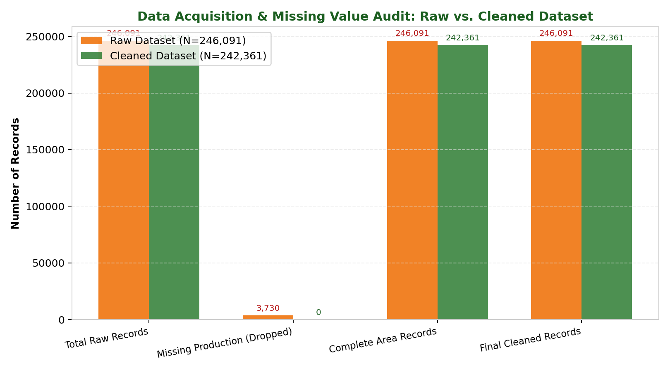
Figure 3. Missing Value Analysis: Dropping 3,730 Null Production Records to Preserve Ground Truth.
8.3 Numeric conversion and area validation
The code converts Crop_Year, Area and Production using pandas numeric conversion. Crop_Year values that fail conversion are coerced and filled with 0 before integer conversion; this behaviour should be reviewed if raw data contains invalid year text because 0 is a sentinel rather than a valid crop year. Area and Production are converted to numeric values. Records with Area less than or equal to zero are excluded before the Yield calculation. In the supplied processed CSV, the minimum Area is 0.1 hectares and there are no non-positive Area records.
8.4 Zero production
The audit reports 3,523 rows with Production equal to zero. The preprocessing code retains these records. When Area is positive, their calculated Yield is zero. A zero production value is not automatically the same as a missing value: it may represent a reported zero harvest or no recorded production for that crop-area observation.
8.5 Unit tagging
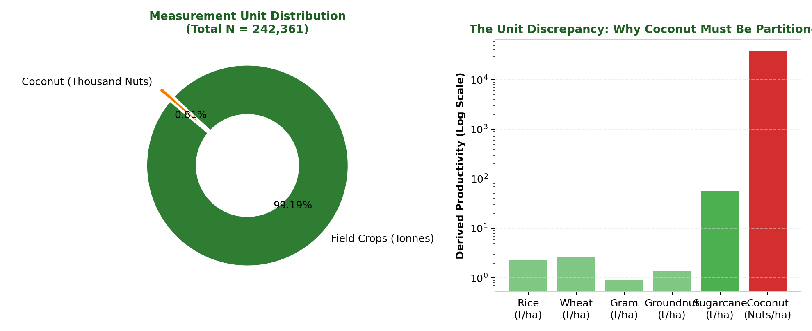
Figure 4. Unit Heterogeneity Resolution: Partitioning Coconut (Thousand Nuts) from Metric Tonnes.
The project treats Coconut production separately because the repository documentation states that Coconut may be reported in nuts or thousand nuts, while other crop production is reported in metric tonnes. The code assigns Unit_Type = 'Thousand Nuts' to crop names containing Coconut and 'Metric Tonnes' to other crops. The processed CSV contains 1,958 Thousand Nuts records and 240,403 Metric Tonnes records. This label is important: a yield expressed in nuts per hectare must not be compared directly with tonnes per hectare.
8.6 Yield calculation — worked example
The derived target is calculated using the formula:
Yield = Production ÷ Area
An actual row in the processed CSV is Rice, NICOBARS district, Andaman and Nicobar Islands, Kharif season, crop year 2000. Its Area is 102 hectares and Production is 321 tonnes.
321 ÷ 102 = 3.147059 tonnes/hectare
The stored Yield value is 3.147059. Across the processed file, the maximum absolute difference between the stored Yield and the recomputed Production / Area value is 7.28e-12, which is consistent with floating-point rounding.
8.7 Outlier screening
The preprocessing code defines crop-specific upper thresholds, including Rice 15 t/ha, Wheat 12 t/ha, Maize 15 t/ha, Sugarcane 250 t/ha and Potato 60 t/ha. It assigns is_outlier_yield=True when a non-Coconut (metric-tonne) crop exceeds its configured threshold. The code also calculates crop-wise IQR summaries, but those IQR values are not used in the actual Boolean outlier flag. The processed CSV contains 190 flagged rows, equal to 0.0784% of all 242,361 records. Flagged rows remain in the cleaned CSV for transparency. The feature-engineering function removes them when filter_outliers=True.
Crop | Configured upper threshold
Rice | 15.0 tonnes/hectare
Wheat | 12.0 tonnes/hectare
Maize | 15.0 tonnes/hectare
Sugarcane | 250.0 tonnes/hectare
Potato | 60.0 tonnes/hectare
Other crops without an explicit entry | 80.0 tonnes/hectare (default)

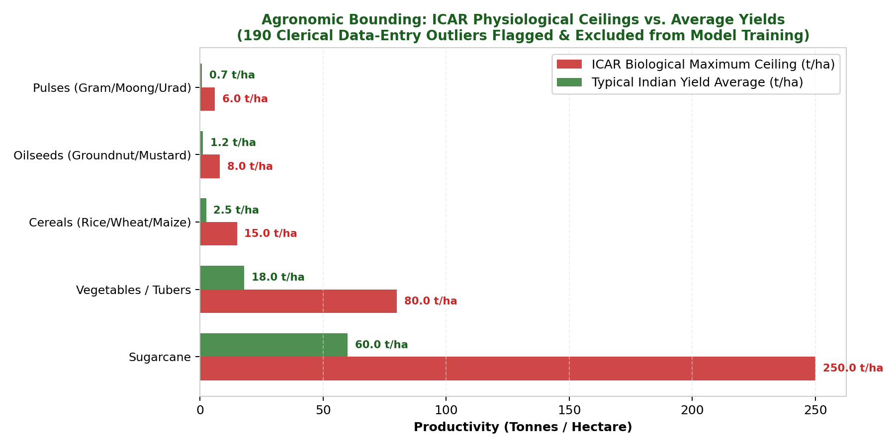
Figure 5. ICAR Biological Agronomic Yield Bounding and Outlier Screening (190 Flagged Rows).
9. Feature Engineering for the Next Stage
The feature-engineering module is separate from the saved 11-column cleaned CSV. When engineer_features() is run with its default settings, it first filters out non-tonne records and flagged outliers, then creates additional predictors. The code documents the following transformations:
Feature | Implemented rule | Reason for use
Crop_Category | Maps crop names to groups such as Cereals, Pulses, Oilseeds, Commercial, Horticulture and Plantation. | Allows group-level analysis.
Log_Area | ln(Area + 1), implemented with numpy.log1p. | Reduces the influence of a highly skewed area scale.
Farm_Scale | Area bands: Marginal <1 ha; Small <2 ha; Semi-Medium <4 ha; Medium <10 ha; Large >=10 ha. | Represents cultivated-area bands.
Year_Index | Crop_Year − 1997. | Encodes elapsed time from the first year.
Is_Kharif_Monsoon | 1 when Season is Kharif; otherwise 0. | Represents a season indicator.
Hist_Crop_State_Yield | Historical State–Crop mean from years <= 2011, with crop/global fallback. | Provides a past-yield benchmark and avoids using post-2011 observations to calculate the training benchmark.

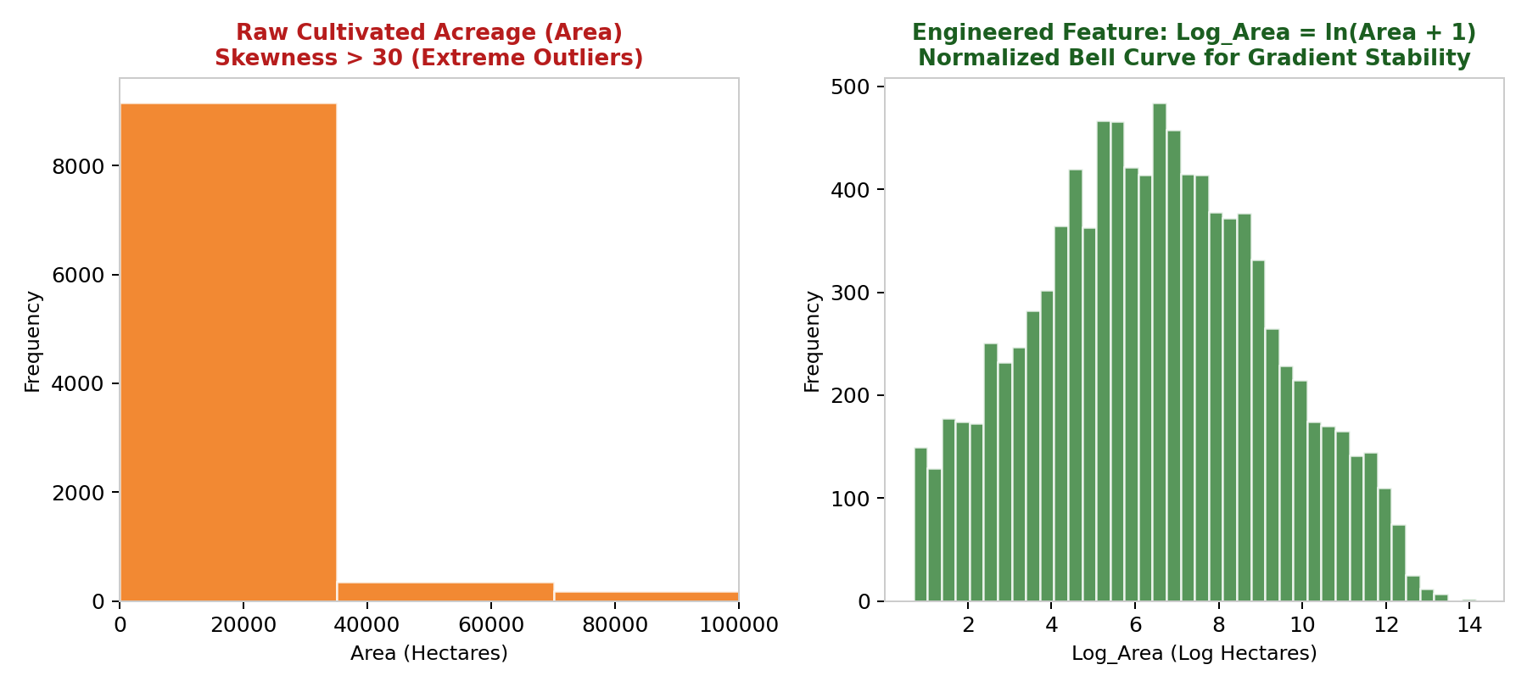
Figure 6. Feature Engineering: Target Distribution Normalization and Skewness Reduction.
The code does not apply a general z-score or min-max scaling operation in this feature-engineering module. The accurate description is that it creates a log-transformed area feature and categorical, temporal and historical features. The word “normalization” should not be used to imply that every numeric column was scaled to a common range.
10. Results and Observations
The prepared dataset has broad coverage across years, regions, crops and seasons. The following findings are based on direct counts from the processed CSV.
Observation | Actual result | Interpretation
Season with most records | Kharif: 94,283 (38.90%) | Kharif is the largest season category by record count.
Second-largest season | Rabi: 66,160 (27.30%) | Rabi is the second-largest category.
Whole Year records | 56,127 (23.16%) | Perennial/whole-year observations form a substantial group.
Most frequent crop | Rice: 15,082 records | Rice has the highest record count among crops.
Second most frequent crop | Maize: 13,787 records | Maize has the second-highest record count.
Zero-production observations | 3,523 | Retained as zero values.
Outlier-flagged observations | 190 (0.0784%) | Flagged for downstream exclusion/review.

11. Visual Analysis of the Prepared Dataset
The following charts were generated from the supplied processed CSV during this report preparation. They show record frequencies and the distribution of the non-flagged metric-tonne yield values; they do not claim to represent raw-data cleaning screenshots.
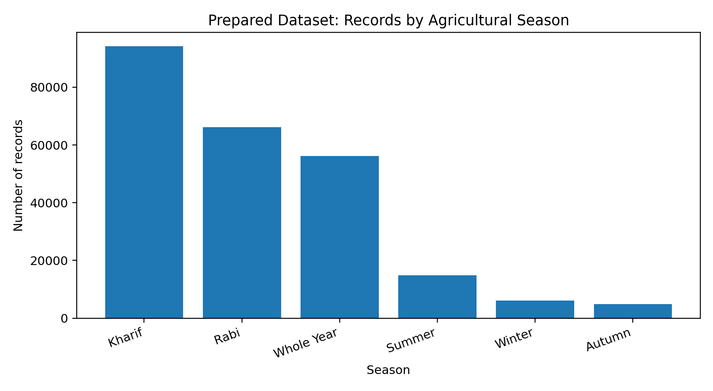
Figure 1. Number of prepared records by agricultural season.
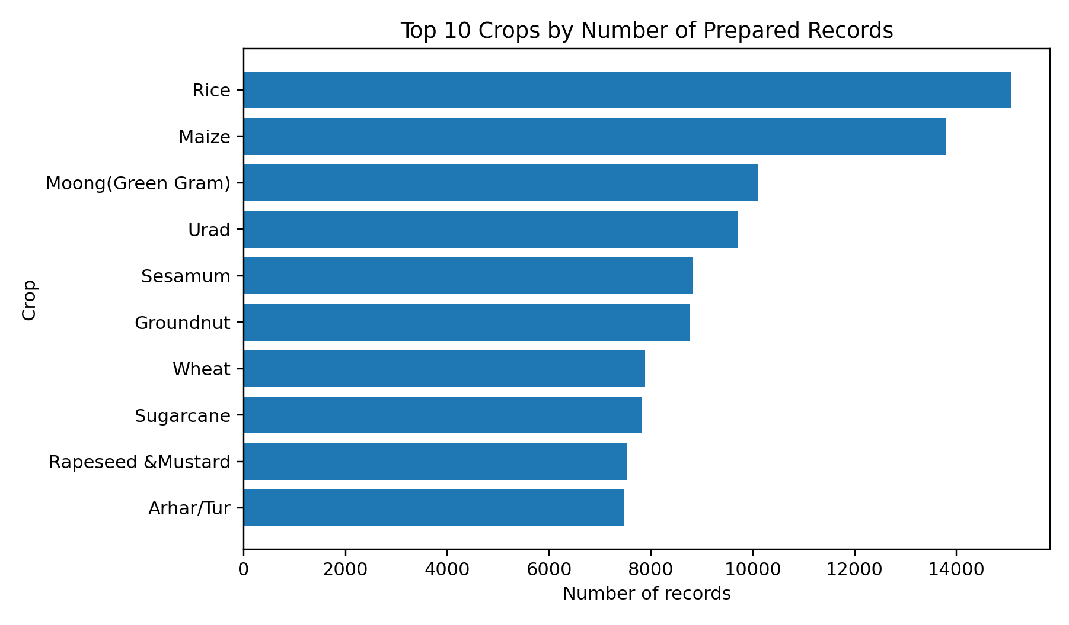
Figure 2. Ten crops with the highest record counts in the prepared dataset.
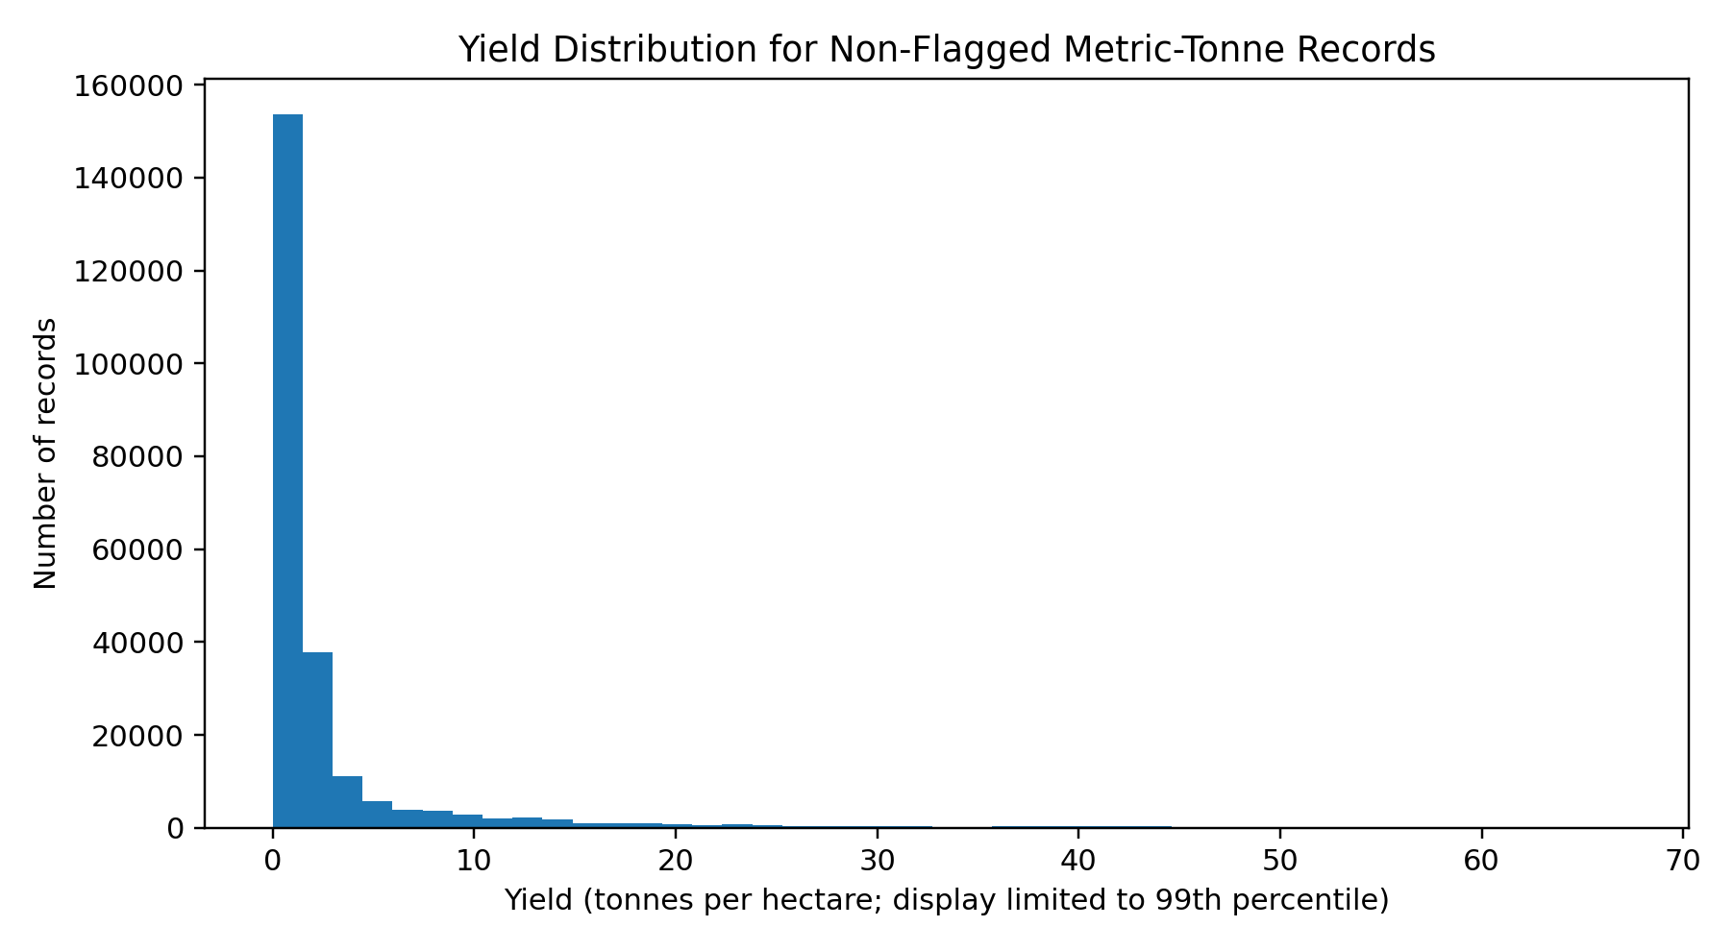
Figure 3. Distribution of non-flagged metric-tonne yield records. The display is limited to the 99th percentile to keep the main distribution readable.
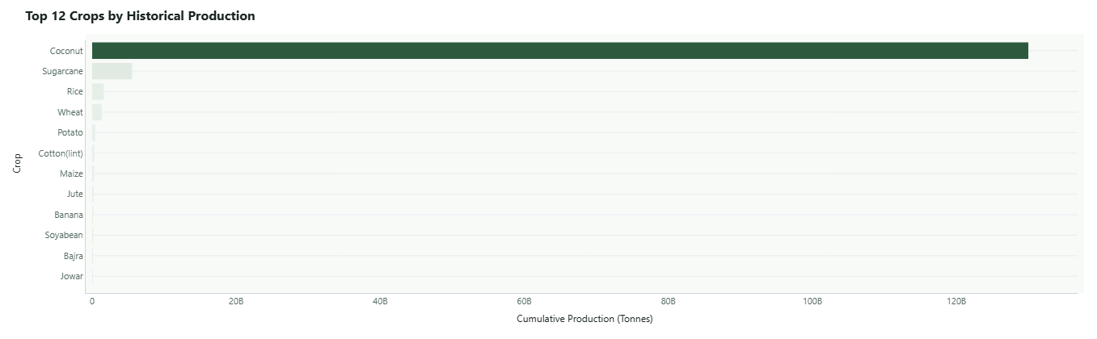
Figure 10. Top 12 Agricultural Commodities in India Ranked by Historical Production Volume.
12. Challenges, Solutions and Limitations
Challenge / limitation | Potential effect | Project response / reporting treatment
Missing Production | Yield target cannot be calculated. | Exclude missing target rows; report audit count; do not impute target.
Inconsistent category text | One category may split into multiple labels. | Trim whitespace and standardise case/season labels.
Mixed production units | Coconut yield is not directly comparable with tonnes/ha. | Create Unit_Type and filter non-tonne records for tonne-based modelling.
Extreme yield values | May distort summary statistics and model fitting. | Flag using crop-specific thresholds; retain flag in cleaned CSV.
Raw CSV absent from supplied repository ZIP | Raw counts cannot be independently recomputed in this review. | Attribute raw figures to the existing project audit and state this limitation.
Outlier thresholds are configured rules | A flagged value is not automatically proven to be an erroneous source record. | Treat flags as screening indicators requiring domain review.
No rainfall, soil or input-use variables in prepared schema | Cannot infer causal effects of weather, soil or fertiliser from these columns. | Limit conclusions to crop, area, production, yield, year, district and season patterns.

13. Conclusion
Week 2 establishes a documented data-preparation foundation for AgriYield AI. The supplied processed CSV contains 242,361 rows and 11 columns covering 33 States/UTs, 646 districts, 124 crops, 6 seasons and 1997–2015 crop years. Direct checks found no missing values in the processed file, no exact duplicates, no duplicate business keys and no non-positive Area values. The file contains 3,523 zero-production rows, 1,958 records tagged Thousand Nuts and 190 yield-outlier flags.
The most important data-management distinction is that the cleaned CSV retains the 190 flagged outliers, while the code's non-outlier count is 242,171. The feature-engineering function can additionally exclude non-tonne Coconut records for metric-tonne yield modelling. The report keeps these stages separate and identifies raw-source statistics as audit-documented because the raw CSV was not included in the reviewed archive. This transparent approach provides a reliable basis for Week 3 exploratory analysis and modelling.
14. References and Project Evidence
▪ 1. Directorate of Economics and Statistics, Department of Agriculture and Farmers Welfare, Government of India. District-wise, Season-wise Crop Production Statistics from 1997. https://data.gov.in/resource/district-wise-season-wise-crop-production-statistics-1997
▪ 2. Official APY CSV endpoint documented in the project data README: https://aps.dac.gov.in/APY/apy.csv
▪ 3. AgriYield AI repository: src/data/preprocess.py — cleaning, type conversion, missing-target filtering, unit tagging, yield calculation and outlier flagging.
▪ 4. AgriYield AI repository: src/features/build_features.py — unit/outlier filtering and feature engineering.
▪ 5. AgriYield AI repository: reports/data_quality_summary.md; data/README.md; docs/data_dictionary.md; docs/methodology.md.
▪ 6. Prepared dataset directly inspected: data/processed/crop_production_cleaned.csv.
Appendix A. Reproducibility and Evidence
The following checks were independently executed against the processed CSV for this report using pandas. They can be repeated in a Python environment with pandas installed:
import pandas as pd
df = pd.read_csv("data/processed/crop_production_cleaned.csv")
print("Shape:", df.shape)
print("Missing values:", df.isna().sum().to_dict())
print("Exact duplicates:", df.duplicated().sum())
key = ["State_Name", "District_Name", "Crop_Year", "Season", "Crop"]
print("Duplicate business keys:", df.duplicated(subset=key).sum())
print("Unit distribution:", df["Unit_Type"].value_counts().to_dict())
print("Zero production:", (df["Production"] == 0).sum())
print("Non-positive area:", (df["Area"] <= 0).sum())
print("Outlier flags:", df["is_outlier_yield"].sum())
print("Not flagged:", (~df["is_outlier_yield"]).sum())
Note: This reproducibility snippet profiles the prepared CSV. Reproducing raw-to-clean counts requires the original raw CSV at the path expected by src/data/load_data.py. The supplied repository archive reviewed for this report did not contain data/raw/crop_production_raw.csv.
Appendix B. Evidence Available in the Repository
▪ Processed dataset: data/processed/crop_production_cleaned.csv.
▪ Preprocessing implementation: src/data/preprocess.py.
▪ Feature engineering implementation: src/features/build_features.py.
▪ Audit report: reports/data_quality_summary.md.
▪ Data dictionary: docs/data_dictionary.md.
▪ Methodology: docs/methodology.md.
▪ Existing visual assets: assets/screenshots/crop_yield_trends.png, assets/screenshots/model_benchmark_comparison.png and assets/screenshots/actual_vs_predicted_parity.png.

