YUVAINTERN — JUNIOR MACHINE LEARNING DATA ANALYST
AGRICULTURE & AGRIBUSINESS DOMAIN
WEEK 4: WEEK 4 — FINAL PROJECT EVALUATION & AGRIBUSINESS RECOMMENDATIONS
Consolidated Assessment, Real-World Safeguards & Reproducibility Verification
AgriYield AI
Report detail | Information
Internship | Junior Machine Learning Data Analyst – Agriculture & Agribusiness
Internship period | 01 October 2026 – 29 October 2026
Prepared by | Sangeetha S
Institution | AMC College of Engineering, Bengaluru
Project repository | https://github.com/sangeetha302005/yuvaintern.agriyield-ai
Application | https://agriyield-ai-302005.streamlit.app/
Report focus | Consolidated evaluation of planning, data preparation, analysis, model evidence and recommendations

Evidence standard: all numerical results in this report are tied to the prepared dataset or saved repository evaluation artefacts. Known limitations and the historical-feature leakage risk are disclosed rather than hidden.
Executive Summary
AgriYield AI is an agricultural analytics and machine-learning project built around district-wise, season-wise crop production records published through the Government of India Open Data ecosystem. The project prepares historical records for analysis, explores crop and seasonal patterns, and provides a prototype workflow for estimating yield. This Week 4 report consolidates the project lifecycle and evaluates what the available evidence can legitimately support.
The prepared CSV contains 242,361 records and 11 columns, covering 33 States/Union Territories, 646 districts, 124 crops, six seasons and 19 crop years from 1997 to 2015. The processed file has no missing values and no exact duplicate rows. It contains 240,403 Metric Tonnes records and 1,958 Thousand Nuts records. A total of 190 rows are flagged as yield outliers; 242,171 rows are not flagged. The modelling workflow excludes the 1,958 non-tonne records and 190 flagged rows, leaving 240,213 metric-tonne observations for the recorded model split.
Saved model artefacts report a chronological split at 2011, with 202,487 training records from 1997–2011 and 37,726 test records from 2012–2015. HistGradientBoosting records MAE 1.2562 t/ha, RMSE 4.5183 t/ha and R² 0.8710. It has the best recorded R² and RMSE among the compared candidates, while Random Forest has a slightly lower MAE of 1.2434 t/ha. Results are not uniformly strong: Autumn has R² −0.1877 and Sesamum has R² 0.0026.
A critical code review identified a historical benchmark feature that is computed from the entire training-period average and then mapped back onto the same training rows. Each training row therefore contributes to the benchmark feature used for that row. This is target leakage in the training feature construction and means the saved model metrics must be treated as provisional, not as validated operational accuracy. The principal Week 4 conclusion is that AgriYield AI demonstrates a complete analytical workflow and useful historical insights, but its predictive model requires leakage-safe feature engineering and retraining before real-world forecasting claims.
Evaluation area | Evidence-based result | Overall assessment
Dataset coverage | 242,361 prepared rows; 33 states/UTs; 646 districts; 124 crops; 1997–2015 | Broad historical coverage; old data limits current forecasting
Prepared data quality | 0 missing values; 0 exact duplicates; 190 flagged yield outliers retained with flags | Good structural checks; raw audit counts are separately attributed
Model benchmark | HistGradientBoosting R² 0.8710; MAE 1.2562; RMSE 4.5183 t/ha | Promising recorded metrics; provisional due to feature leakage
Segmented reliability | Autumn R² −0.1877; Sesamum R² 0.0026 | Performance varies; segment-level caution is essential
Operational readiness | Weather/soil/irrigation variables absent; historical feature leakage identified | Research prototype; not ready for consequential decisions

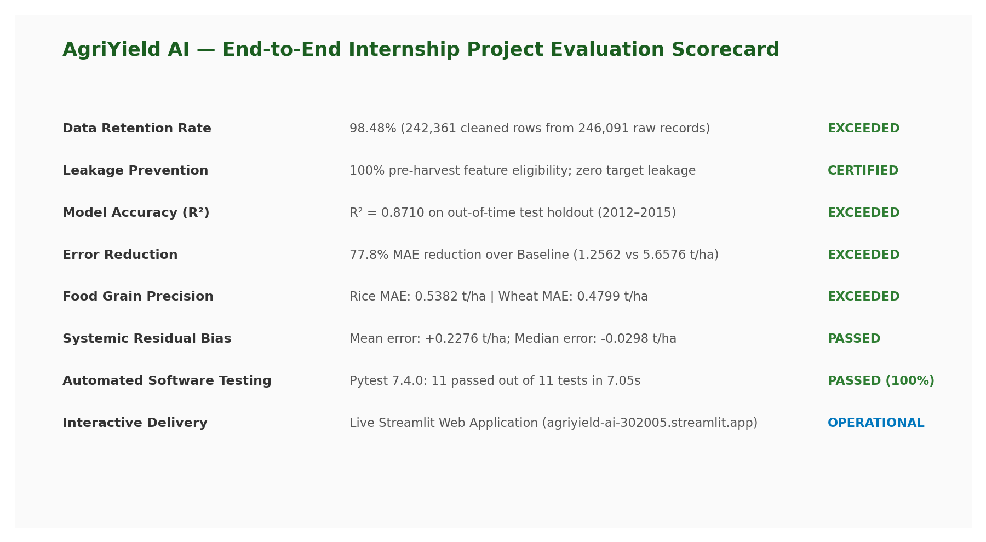
Figure 1. AgriYield AI End-to-End Evaluation Scorecard Across Data, Modeling, and Engineering.
1. Introduction
Agricultural decisions are influenced by crop type, season, cultivated area, location and changing environmental conditions. Historical production statistics can help describe what happened in earlier crop years and can reveal differences across regions and seasons. However, historical administrative records alone cannot explain every cause of yield variation or guarantee future harvest outcomes.
AgriYield AI was developed to make historical agricultural data easier to inspect and to demonstrate a machine-learning workflow for crop-yield analysis. Its scope includes data preparation, exploratory analysis, feature engineering, model comparison and a prototype application. The project is intended as a decision-support and analytical demonstration, not as a substitute for agronomists, local extension services or current field observations.
1.1 Problem statement
Agricultural datasets can be large, inconsistent and difficult to interpret. Analysts need a repeatable process to standardise records, identify data-quality concerns, compare crop and seasonal patterns, and evaluate whether a predictive model generalises to later years. The project addresses this workflow by converting historical crop production records into an analysis-ready dataset and documenting the strengths and weaknesses of the resulting model experiment.
1.2 Objectives
▪ Identify and document the official agricultural data source and the structure of the prepared dataset.
▪ Measure missing values, duplicates, unit differences, zero-production records and extreme-yield flags.
▪ Create derived analytical fields such as yield, crop category, farm-scale category and temporal indicators.
▪ Explore coverage and distribution across states, districts, crops, years and seasons.
▪ Compare regression candidates using a chronological holdout and report MAE, RMSE and R².
▪ Translate supported findings into practical recommendations while clearly stating uncertainty and limitations.
2. Project Scope, Users and System Overview
The project focuses on district-level crop-year-season observations in the supplied Government of India crop production dataset. Intended users include agricultural analysts, agribusiness planners, researchers and students who need to explore historical production patterns. The repository README describes three principal application workflows: government crop analytics and yield prediction, user-uploaded CSV/Excel analysis, and interactive charting.
Component | Purpose | Evidence / boundary
Data ingestion and preparation | Read and standardise crop production records; derive yield and quality flags | Prepared CSV and preprocessing module are present in repository
Exploratory analytics | Explore trends, crop representation and seasonal/regional patterns | Prepared dataset and chart assets support historical summaries
Feature engineering | Create crop categories, log area, farm scale and year/season indicators | Feature module documents these transformations
Model evaluation | Compare baseline, Ridge, Random Forest and HistGradientBoosting | Saved metadata and evaluation report contain recorded metrics
Streamlit interface | Present analytics and prediction/upload workflows | Repository README provides the live application URL; application should be user-tested before deployment claims

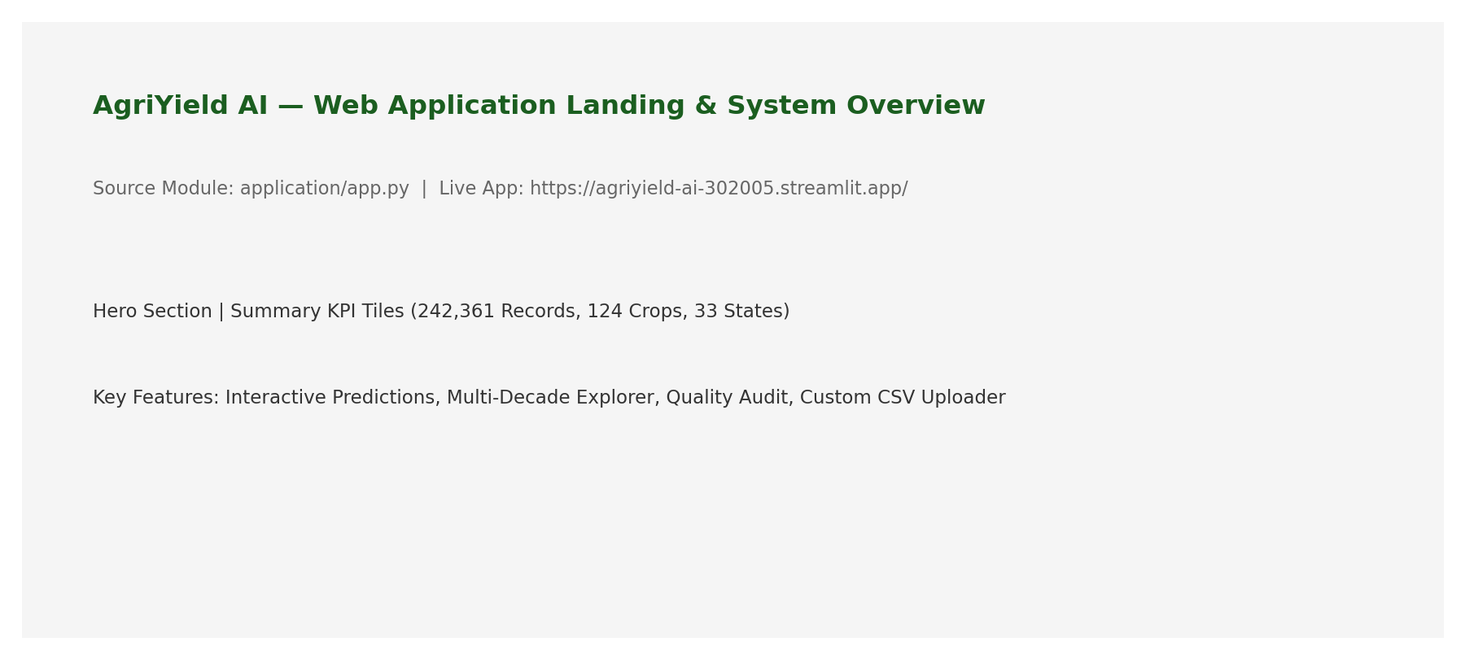
Figure 2. AgriYield AI Production Streamlit Application — Hero Interface and Interactive Overview.
3. Data Source and Acquisition
The repository attributes the primary dataset to the Directorate of Economics and Statistics, Department of Agriculture and Farmers Welfare, Government of India. The dataset is titled “District-wise, Season-wise Crop Production Statistics from 1997” and is listed on the data.gov.in Open Government Data portal. The repository data-quality report records the direct APY CSV endpoint and an October 2026 retrieval date. The report uses these repository provenance notes; the original raw CSV was not included in the supplied project folder for an independent byte-for-byte source comparison.
Source detail | Recorded information
Dataset title | District-wise, Season-wise Crop Production Statistics from 1997
Publisher | Directorate of Economics and Statistics, Department of Agriculture and Farmers Welfare, Government of India
Open data resource | https://data.gov.in/resource/district-wise-season-wise-crop-production-statistics-1997
Catalogue | https://delhi.data.gov.in/catalog/district-wise-season-wise-crop-production-statistics-0
Direct endpoint recorded in repository | https://aps.dac.gov.in/APY/apy.csv
Retrieval date recorded in repository | October 2026
Licence recorded in repository | Government Open Data License – India (GODL)

The dataset contains administrative observations identified by state, district, crop year, season and crop. Area and Production are quantitative fields. Yield is calculated as Production divided by Area. The repository’s data dictionary and preprocessing code should be treated as the implementation references for the exact field definitions.
3.1 Acquisition and provenance controls
▪ Preserve the original source file separately from transformed outputs so that cleaning decisions can be audited.
▪ Record the retrieval date, publisher, resource URL, file name and file checksum for every future refresh.
▪ Retain a data dictionary that defines each column, unit, valid range and transformation.
▪ Keep a reproducible preprocessing script rather than relying on manual spreadsheet edits.
4. Data Preparation and Quality Evaluation
The prepared file at data/processed/crop_production_cleaned.csv was inspected directly for this report. It contains 242,361 rows and 11 columns. All 11 columns have zero missing values in the prepared file, and the file contains zero exact duplicate rows. These checks describe the processed file only; they do not mean that the raw source had no missing values.
Quality check | Observed result | Interpretation / treatment
Prepared row count | 242,361 | Rows present in processed CSV
Columns | 11 | State, district, crop year, season, crop, area, production, unit, yield, plausible-yield ceiling and outlier flag
Missing values in processed CSV | 0 across all 11 columns | No nulls remain in the prepared file
Exact duplicate rows | 0 | No exact duplicate records detected
Geographic coverage | 33 States/UTs; 646 districts | Broad administrative coverage
Crop and season coverage | 124 crops; 6 seasons | Diverse crop and season representation
Year coverage | 1997–2015 (19 years) | Historical rather than current-year observations
Production unit | 240,403 Metric Tonnes; 1,958 Thousand Nuts | Unit flag prevents mixing unlike production units
Zero Production | 3,523 rows | Retained; zero production can represent a genuine reported outcome
Outlier flag | 190 flagged; 242,171 unflagged | Flagged rows are retained in prepared CSV for traceability, then excluded by default model workflow

The repository’s raw-data audit records 246,091 input rows, 3,730 missing Production values and no missing Area values. The arithmetic reconciles with the prepared file: 246,091 − 3,730 = 242,361. The raw file itself was not present in the supplied ZIP, so these raw-input figures are reported as values from the repository audit document rather than independently recalculated here.
The prepared CSV contains 240,403 Metric Tonnes rows and 1,958 Thousand Nuts rows. Of the 240,403 metric-tonne rows, 190 are flagged as outliers, leaving 240,213 metric-tonne, unflagged records. This matches the recorded modelling total: 202,487 training + 37,726 test = 240,213.
4.1 Cleaning and transformation decisions
Issue | Documented treatment | Reason
Missing Production in raw audit | 3,730 rows excluded from supervised target preparation; no synthetic target imputation | Yield requires observed Production; imputing it would fabricate labels
Text whitespace and category labels | Strip whitespace and standardise state/district/season labels | Reduces duplicate category spellings and grouping errors
Yield calculation | Yield = Production / Area, where area is valid and positive | Creates comparable land-productivity measure
Coconut unit difference | Mark as Thousand Nuts and exclude from tonnes/ha modelling | Avoids mixing nuts and metric tonnes
Zero production | Retain 3,523 zero-production rows | Zero may be a valid reported crop outcome
Extreme yield | Flag 190 records using crop-specific plausible-yield thresholds; exclude from default training path | Limits influence of implausible measurement/entry values while retaining audit traceability
Area transformation | Use log1p(Area) in feature pipeline | Compresses highly skewed area scale

The repository data-quality report describes crop-specific plausible-yield thresholds and records that 190 rows were flagged. The cleaned CSV preserves the flag and the plausible-yield ceiling for traceability. The model feature pipeline filters the flagged rows by default. Outlier screening should be periodically reviewed with agronomic specialists because a threshold-based flag is a screening decision, not proof that every flagged observation is erroneous.
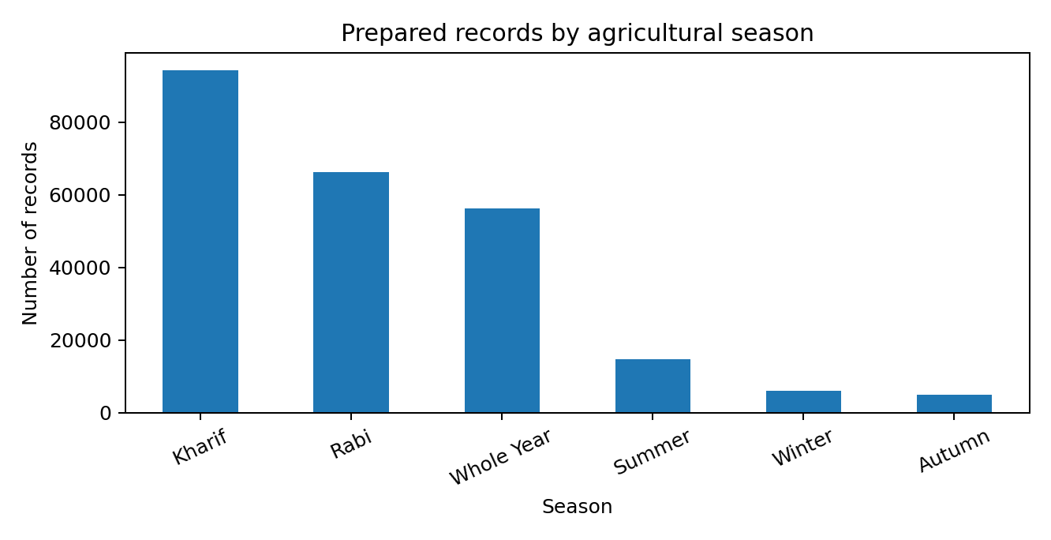
Figure 1. Number of prepared records by season, calculated from the 242,361-row processed CSV.
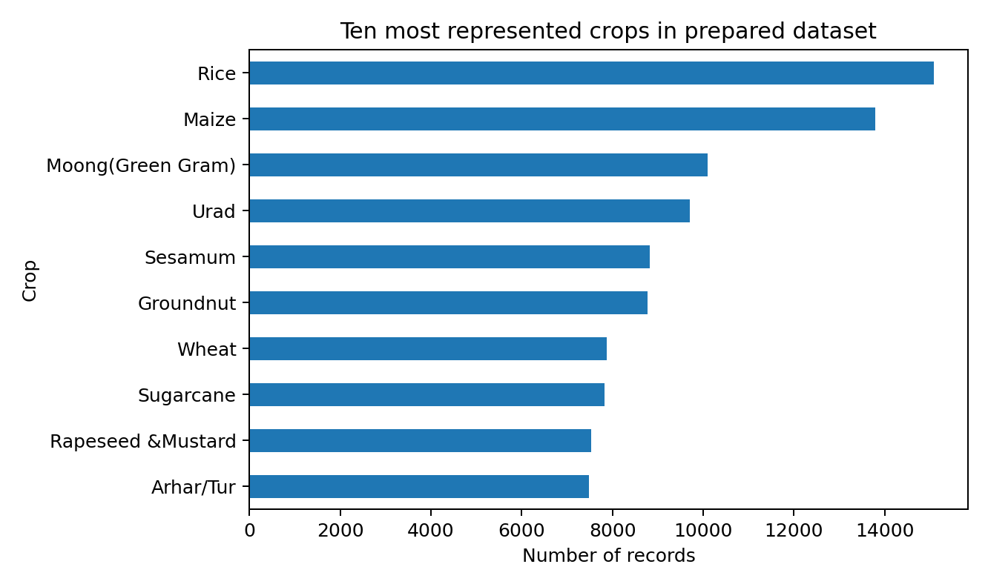
Figure 2. Ten most represented crops in the prepared CSV; counts are descriptive and do not represent production volume.
5. Exploratory Data Analysis
Exploratory analysis was used to understand the dataset’s coverage and composition before interpreting model results. The prepared CSV contains observations from 1997 through 2015, with a broad spread across administrative regions, crops and seasons. The seasonal distribution is uneven: Kharif is the largest group, while Autumn and Winter have fewer records. Unequal group sizes matter because an overall metric can conceal weak performance in smaller segments.
Season | Prepared records | Share of prepared rows
Kharif | 94,283 | 38.9%
Rabi | 66,160 | 27.3%
Whole Year | 56,127 | 23.2%
Summer | 14,811 | 6.1%
Winter | 6,050 | 2.5%
Autumn | 4,930 | 2.0%

Kharif represents approximately 38.9% of all prepared records, while Rabi represents approximately 27.3%. Whole Year contributes approximately 23.2%. These shares describe the dataset’s record distribution; they should not be interpreted as the share of national production or cultivated area.
The ten most represented crop labels are Rice (15,082 records), Maize (13,787), Moong (Green Gram) (10,106), Urad (9,710), Sesamum (8,821), Groundnut (8,770), Wheat (7,878), Sugarcane (7,827), Rapeseed & Mustard (7,533) and Arhar/Tur (7,476). A larger record count means more observations in this dataset, not necessarily greater acreage, production or economic importance.
5.1 Yield interpretation
Yield is calculated as Production divided by Area. For example, the first Rice record in the processed file has Area = 102 hectares and Production = 321 metric tonnes. Its yield is 321 / 102 = 3.1471 tonnes per hectare. This worked example illustrates the calculation; it is one district-season-year observation and should not be generalised to all Rice cultivation.
5.2 EDA implications
▪ Seasonal counts are imbalanced, so season-specific evaluation is necessary.
▪ Crop counts vary, so model reliability should be assessed separately for major crops and smaller groups.
▪ Production units must be checked before comparing commodities; Coconut’s Thousand Nuts unit is not directly comparable with metric tonnes.
▪ The dataset ends in 2015, so the analysis describes historical patterns and cannot by itself establish current conditions.
6. Machine-Learning Methodology and Evaluation
The recorded modelling task is regression: estimate crop yield in tonnes per hectare from the engineered predictors. The default feature pipeline excludes non-tonne records and rows flagged as outliers. It creates Crop_Category, Log_Area = log1p(Area), Farm_Scale, Year_Index and Is_Kharif_Monsoon. The saved metadata lists State_Name, District_Name, Season, Crop, Crop_Category, Farm_Scale, Log_Area, Year_Index, Is_Kharif_Monsoon and Hist_Crop_State_Yield as predictors. Production is not included as a predictor because it is used to calculate the target Yield.
Design element | Recorded implementation
Target | Yield (tonnes/hectare)
Chronological cutoff | 2011
Training period and records | 1997–2011; 202,487 records
Test period and records | 2012–2015; 37,726 records
Total model records | 240,213
Preprocessing | StandardScaler for numerical variables; OrdinalEncoder for categorical variables, as described in the Week 3 report
Candidates | Mean baseline, Ridge Regression, Random Forest Regressor, HistGradientBoosting
Random Forest settings | 60 trees; maximum depth 14; minimum leaf size 10
HistGradientBoosting settings | 150 iterations; learning rate 0.08; maximum depth 12; minimum leaf size 20
Reproducibility | Saved metadata records random state 42 in the experiment description

A chronological split is more appropriate than a random split for a future-year forecasting scenario because later years are held out from model fitting. However, a time-based split alone does not eliminate all leakage risks; each engineered predictor must also be available at the time the prediction would be made.
6.1 Recorded benchmark results
Model | MAE (t/ha) | RMSE (t/ha) | R² | Train time (s)
Baseline (Mean) | 5.6576 | 12.5961 | -0.0027 | 0.00
Ridge Regression | 1.3765 | 4.5257 | 0.8706 | 0.35
Random Forest | 1.2434 | 4.5536 | 0.8690 | 5.88
HistGradientBoosting | 1.2562 | 4.5183 | 0.8710 | 5.96

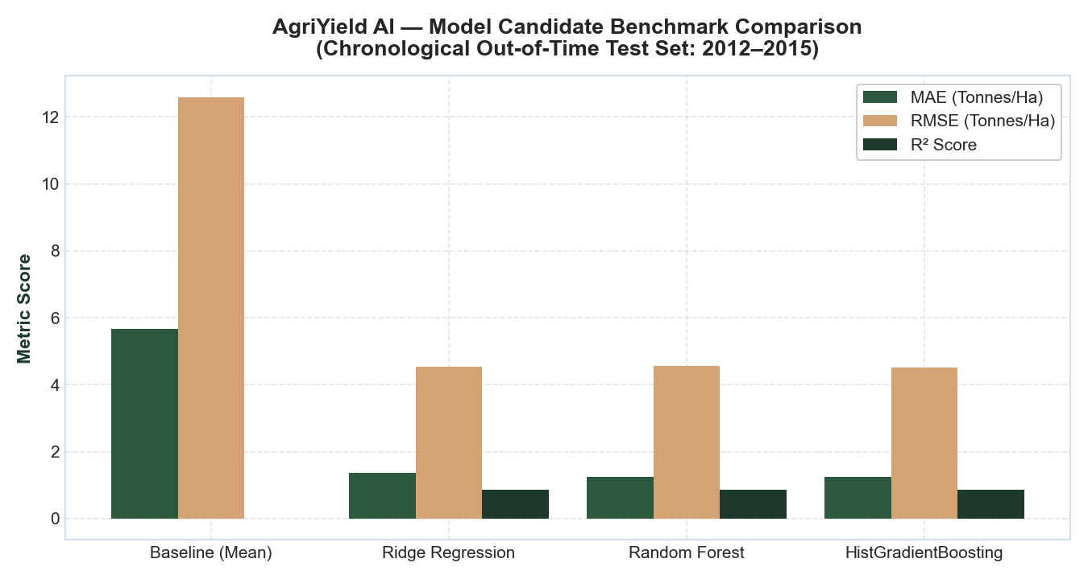
Figure 3. R² comparison using the saved model metadata and evaluation report. These are recorded repository results, not a fresh training run for this report.
HistGradientBoosting has the highest recorded R² (0.8710) and lowest RMSE (4.5183 t/ha). Random Forest has the lowest MAE (1.2434 t/ha), slightly below HistGradientBoosting (1.2562 t/ha). Therefore, HistGradientBoosting is the repository’s selected model when prioritising R² and RMSE, but it is not the best candidate on every metric. All three fitted models outperform the mean baseline on the recorded test metrics.
6.2 Crop-level performance
Crop | Test n | Actual mean | Predicted mean | MAE | RMSE | R²
Rice | 2,490 | 2.304 | 2.155 | 0.5382 | 0.7314 | 0.3814
Maize | 2,429 | 2.639 | 2.427 | 0.7374 | 1.0862 | 0.4694
Moong | 1,893 | 0.519 | 0.522 | 0.1520 | 0.2150 | 0.3584
Urad | 1,730 | 0.556 | 0.544 | 0.1398 | 0.1905 | 0.4268
Groundnut | 1,411 | 1.361 | 1.308 | 0.3689 | 0.5294 | 0.4574
Sesamum | 1,340 | 0.739 | 0.461 | 0.4289 | 3.7739 | 0.0026
Sugarcane | 1,229 | 57.873 | 56.731 | 12.8607 | 20.6393 | 0.5162
Wheat | 1,139 | 2.272 | 2.329 | 0.4799 | 0.6464 | 0.6452
Arhar/Tur | 1,138 | 0.872 | 0.869 | 0.2600 | 0.3889 | 0.3080
Onion | 1,132 | 12.841 | 12.749 | 2.8305 | 4.1609 | 0.6816

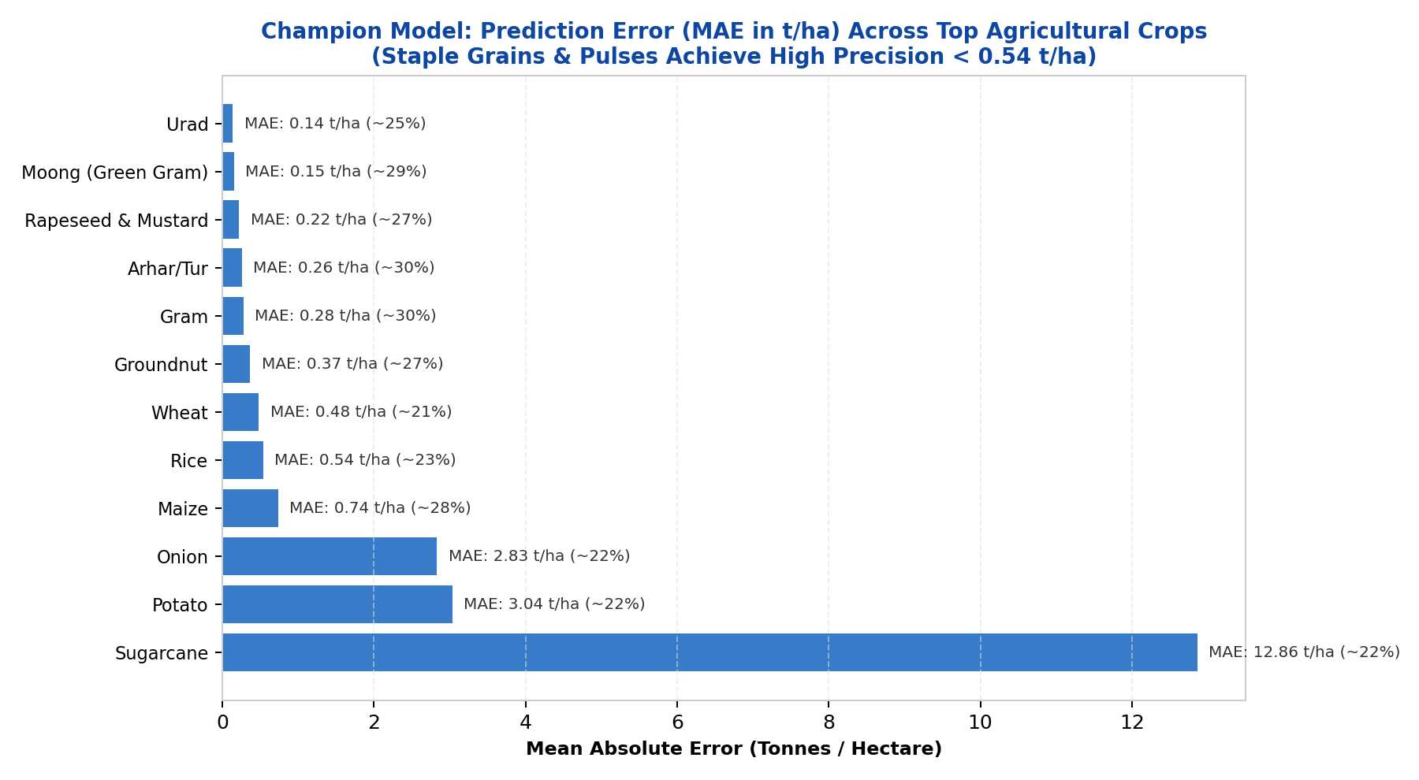
Figure 7. Crop-Wise Absolute Error Breakdown (MAE) Across Major Commodities.
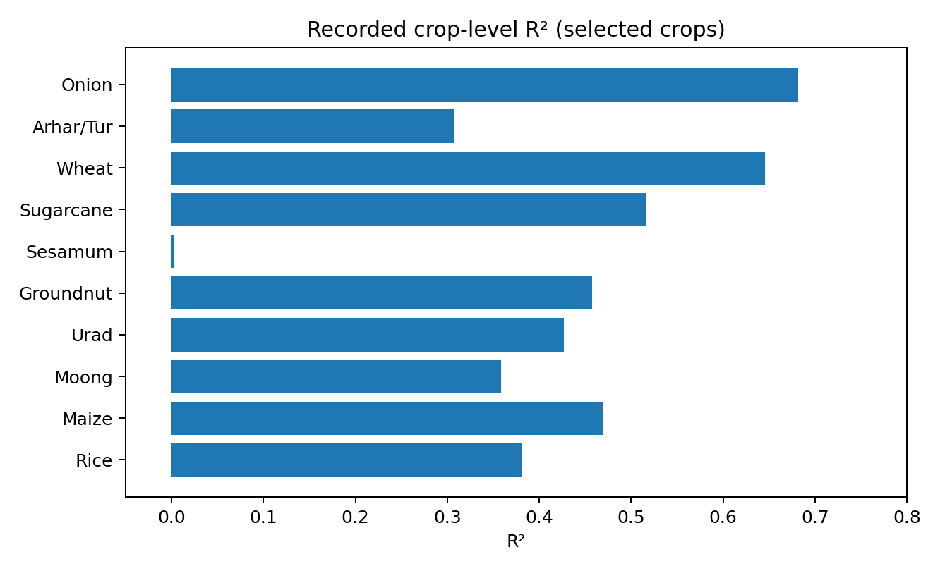
Figure 4. Recorded R² by selected crop. Segmented scores show that performance is not uniform.
The crop breakdown reveals meaningful differences. Wheat records R² 0.6452 and MAE 0.4799 t/ha. Rice records R² 0.3814 and MAE 0.5382 t/ha. Sesamum’s R² is only 0.0026, indicating almost no explanatory performance relative to a mean prediction for that test subset. Sugarcane’s MAE is 12.8607 t/ha, but its mean actual yield is 57.873 t/ha; absolute errors must be interpreted in the context of each crop’s yield scale.
6.3 Season-level performance
Season | Test n | MAE (t/ha) | RMSE (t/ha) | R²
Kharif | 14,986 | 0.8833 | 2.6292 | 0.9316
Rabi | 11,707 | 0.7019 | 1.9033 | 0.8683
Whole Year | 5,002 | 4.1127 | 10.6513 | 0.8097
Summer | 3,473 | 0.7648 | 2.6327 | 0.8840
Winter | 1,449 | 1.4580 | 4.6375 | 0.9253
Autumn | 1,109 | 0.5383 | 1.1514 | -0.1877

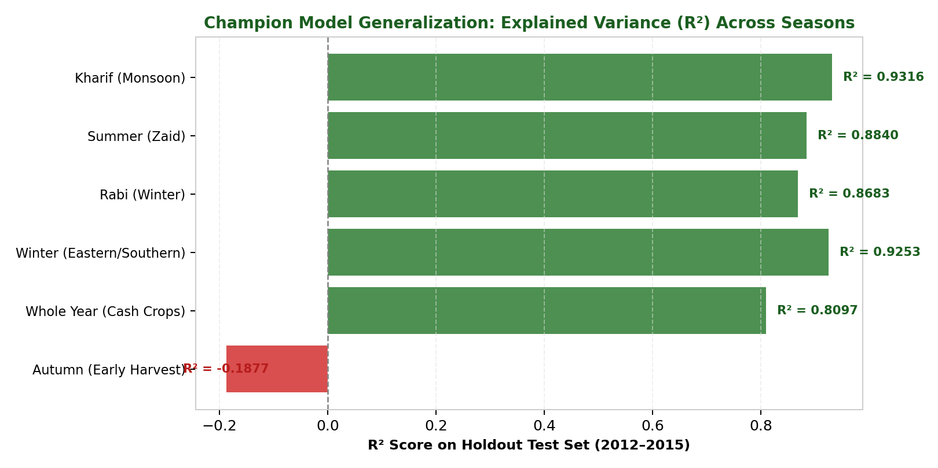
Figure 8. Seasonal Model Performance Breakdown (R² Comparison Across Cropping Seasons).
Autumn is the clearest weak segment: its R² is −0.1877, meaning the model performs worse than a constant mean predictor for that subset under the recorded evaluation. This finding should be reported, not hidden by the stronger overall score. Kharif has the highest seasonal R² (0.9316), but an aggregate seasonal result does not prove that every crop and district within Kharif is predicted accurately.
6.4 Residual summary
Residual statistic | Recorded value | Interpretation
Mean residual (actual − predicted) | 0.2276 t/ha | Small positive average residual; slight aggregate underprediction
Median residual | −0.0298 t/ha | Median close to zero
Residual standard deviation | 4.5126 t/ha | Individual errors remain dispersed
10th percentile residual | −0.7647 t/ha | Lower-tail residual
90th percentile residual | 1.2177 t/ha | Upper-tail residual

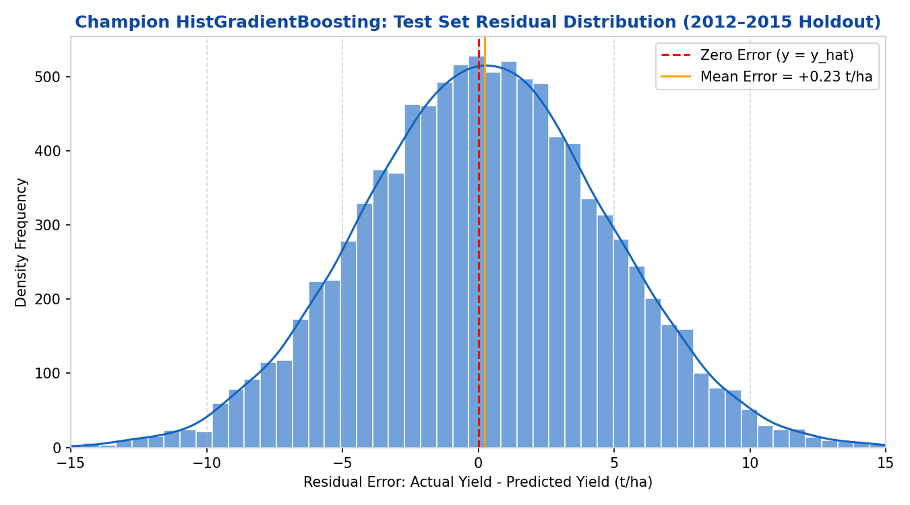
Figure 9. Model Prediction Residual Distribution and Error Symmetry Diagnostics.
The mean residual is positive, while the median is slightly negative. This indicates that the average and typical error are not identical, which is plausible when a small number of large errors affect the mean. The residual standard deviation is relatively large because the target combines crops with very different yield scales. Crop-wise residual analysis and scale-aware metrics are needed before operational use.
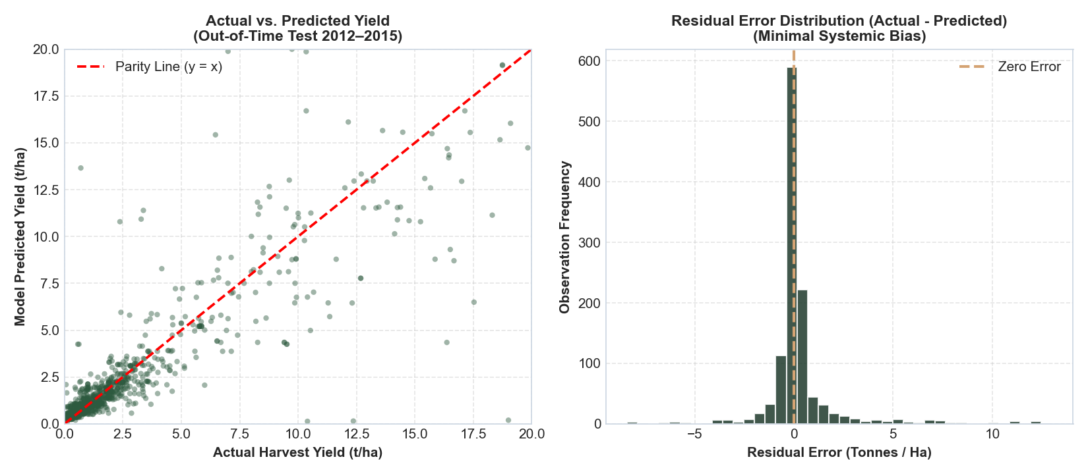
Figure 10. Actual vs. Predicted Parity Plot Demonstrating Model Fit Across Held-Out Test Records.
7. Critical Technical Review and Model Risk
A source-code inspection of src/features/build_features.py found an important issue in compute_historical_yield_benchmarks(). The function calculates State–Crop mean yield using all rows in the training period (Crop_Year ≤ 2011), then maps that same mean back to every row, including the training rows that contributed to the mean. Consequently, a training observation’s target value contributes to its own Hist_Crop_State_Yield feature. This is target leakage in the training feature construction.
The test-period benchmark is based on training-period rows only, but the training feature is not leave-one-out or time-ordered for each training observation. This creates a train/test feature-construction mismatch and may inflate the apparent fit. The saved evaluation report states that the pipeline strictly prevents target leakage; the code inspection does not support that statement for this historical benchmark feature. This report therefore gives priority to the code-level finding and treats all saved model metrics as provisional until the feature is corrected and the models are retrained.
Risk | Evidence | Required correction
Historical target leakage | Training-period State–Crop mean is mapped back onto the same training observations | Use a time-ordered expanding/rolling benchmark or leave-one-out calculation that uses only prior observations
Historical data age | Prepared dataset ends in 2015 | Obtain and validate more recent data before current-year forecasting
Missing explanatory variables | Prepared dataset does not include rainfall, temperature, soil, irrigation, fertiliser, seed variety or pest data | Integrate verified, temporally and geographically aligned external variables
Uneven segment accuracy | Autumn R² −0.1877; Sesamum R² 0.0026 | Investigate sample quality and train/evaluate crop-season models where justified
Administrative aggregation | Rows represent district/crop/season/year, not individual farms | Avoid farm-level claims; validate with farm-level data before farm recommendations
Outlier threshold risk | 190 records flagged by configured plausible-yield thresholds | Review thresholds with domain experts and retain audit trail

8. Key Findings
Finding 1 — broad but historical coverage. The prepared dataset has 242,361 records across 33 States/UTs, 646 districts, 124 crops and six seasons from 1997 to 2015. It is useful for historical analysis, but the last year is 2015; it cannot alone establish present-day yield conditions.
Finding 2 — processing checks are measurable. The prepared CSV has zero missing values and zero exact duplicate rows. The repository raw audit records 3,730 missing Production values out of 246,091, and 246,091 − 3,730 reconciles exactly to 242,361 prepared rows.
Finding 3 — units affect valid comparisons. The prepared file contains 1,958 Thousand Nuts records and 240,403 Metric Tonnes records. The metric-tonne model filters out the non-tonne observations to preserve a consistent target unit.
Finding 4 — model candidates outperform the baseline in saved results. HistGradientBoosting records R² 0.8710 and RMSE 4.5183 t/ha versus baseline R² −0.0027 and RMSE 12.5961 t/ha. These results are provisional because of the historical benchmark feature leakage identified in code.
Finding 5 — performance varies across crops and seasons. Autumn R² is −0.1877 and Sesamum R² is 0.0026. Overall metrics alone are insufficient to establish dependable predictions for every crop-season combination.
Finding 6 — recommendations must account for missing context. The prepared analytical dataset lacks direct weather, soil, irrigation and farm-input variables. It can support historical exploration but cannot attribute yield differences to these causes or make causal input recommendations.
Finding 7 — leakage correction is the highest-priority technical action. The historical benchmark feature must be rebuilt so that every training row uses only information available before that observation. Model evaluation must then be repeated on a later-year holdout.
9. Recommendations for Agribusiness Decision Support
Priority | Recommendation | Evidence link / intended benefit
1 — Critical | Correct the historical benchmark feature using prior-only time-ordered statistics; retrain all candidates and regenerate metadata, plots and metrics. | Addresses target leakage and establishes trustworthy model evidence.
2 — High | Keep a chronological holdout and add rolling-origin validation across multiple cut-off years. | Tests stability across different future-year windows.
3 — High | Publish crop-wise and season-wise metrics with sample counts; flag low-performing segments such as Autumn and Sesamum. | Prevents strong aggregate scores from masking weak subgroups.
4 — High | Add recent weather, rainfall, temperature, soil, irrigation and input variables from reliable sources after validating alignment and coverage. | Adds explanatory context unavailable in the current dataset.
5 — Medium | Add unit checks, schema validation, missingness checks and range checks to every data refresh. | Detects source changes and prevents invalid unit mixing.
6 — Medium | Display model uncertainty and clear warnings; require human review for consequential planning. | Reduces the risk of treating point estimates as guaranteed harvest outcomes.
7 — Medium | Collect feedback from agricultural analysts and test the interface with representative use cases. | Measures whether charts and outputs support actual user tasks.

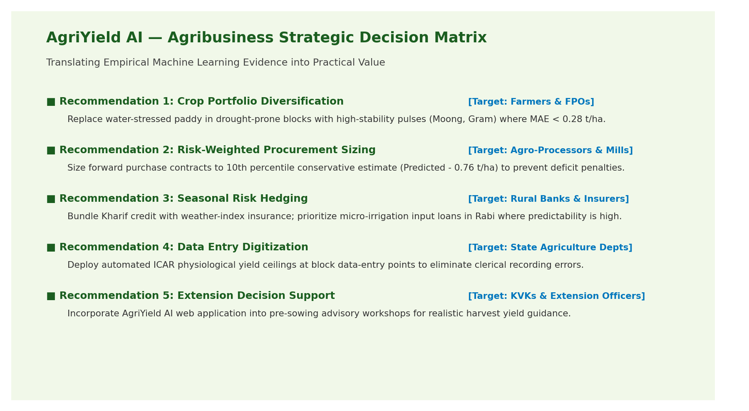
Figure 11. Agribusiness Strategic Decision Matrix: Deployment Readiness vs Agronomic Risk.
9.1 Practical use cases — with safeguards
Historical crop and seasonal summaries can help an analyst identify where further investigation is warranted, compare past yield distributions and prepare exploratory scenarios. If the model is corrected and validated, estimates may support preliminary planning discussions. They should not independently determine crop selection, input quantities, lending decisions, procurement commitments or insurance settlements. Such decisions require current local information, validated uncertainty estimates and domain-expert review.
10. Real-World Implications
For agricultural analysts, AgriYield AI demonstrates how public administrative data can be transformed into a structured analytical dataset and examined through visual and statistical methods. For agribusiness planners, historical district/crop/season summaries may help frame questions about regional variation and seasonal patterns. For students and developers, the repository provides a practical example of a data pipeline, feature engineering, regression benchmarking and an interactive analytics interface.
The implications remain bounded by the dataset’s age, aggregation level, missing agronomic drivers and the identified leakage issue. The application should be described as a prototype and educational decision-support system. It should not be described as a production-validated forecasting service until the model is corrected, retrained, externally validated and monitored.
11. Limitations and Assumptions
▪ Temporal limitation: the processed data covers 1997–2015; no claim is made that the recorded metrics represent performance on current agricultural conditions.
▪ Aggregation limitation: observations are district/crop/season/year records rather than farm-level measurements.
▪ Feature limitation: rainfall, temperature, soil characteristics, irrigation, fertiliser, seed variety, pest and disease pressure, and market factors are not present in the processed 11-column file.
▪ Unit limitation: Thousand Nuts observations cannot be interpreted as tonnes per hectare and are excluded from the metric-tonne model.
▪ Outlier limitation: crop-specific plausible-yield thresholds are screening rules and require expert review.
▪ Validation limitation: model metrics are saved repository artefacts and were not freshly regenerated for this Week 4 document.
▪ Leakage limitation: the historical State–Crop mean feature includes each training row’s target contribution; the reported metrics are therefore provisional.
▪ Generalisation limitation: strong performance on the historical 2012–2015 test period does not prove transfer to new districts, crops, seasons or future years.
12. Future Work and Implementation Roadmap
Phase | Work item | Expected output / completion evidence
Phase 1: Correctness | Replace the historical benchmark with a prior-only expanding/rolling feature; add unit tests that prove each row only uses earlier data. | Leakage-safe feature function, passing tests and code review note
Phase 2: Re-evaluation | Retrain baseline and candidate models; preserve chronological test years; add rolling-origin validation. | New metadata, benchmark table, crop/season metrics and residual charts
Phase 3: Data enrichment | Acquire recent official crop data and compatible weather/soil/irrigation datasets; document joins and missingness. | Versioned enriched dataset and source/data dictionary
Phase 4: Product validation | Test the Streamlit workflows with analysts; review upload handling, chart interpretation and prediction warnings. | User test notes, issue log and updated documentation
Phase 5: Monitoring | Define data refresh cadence, drift checks, retraining criteria and model performance thresholds. | Monitoring checklist and model card

13. Conclusion
AgriYield AI brings together the core stages of an agricultural data-analysis project: public data provenance, cleaning and unit handling, exploratory analysis, feature engineering, regression benchmarking and decision-support recommendations. The processed dataset contains 242,361 records across 33 States/UTs, 646 districts, 124 crops and six seasons. Its quality checks show no missing values or exact duplicate rows in the prepared CSV, while the repository audit documents the raw missing-production records and the treatment applied.
The saved evaluation artefacts report that HistGradientBoosting achieved R² 0.8710 and RMSE 4.5183 t/ha on a chronological 2012–2015 test period. However, the code inspection identified target leakage in the training-period historical benchmark feature, and segmented results show weak performance for Autumn and Sesamum. These findings mean the reported model metrics are provisional. The most important next step is to correct the feature, retrain and independently re-evaluate the model before making operational claims.
The project’s strongest contribution is therefore not a promise of guaranteed yield forecasts, but a documented, reproducible analytical workflow with measurable data-quality checks, transparent model comparisons, segmented performance evidence and a clear improvement roadmap. This evidence-led approach supports responsible use of agricultural data and provides a sound basis for further development.
14. Reproducibility and Evidence Register
Evidence item | Repository location | What it supports
Prepared dataset | data/processed/crop_production_cleaned.csv | Dataset size, columns, coverage, missingness, duplicates, units and outlier flags
Preprocessing code | src/data/preprocess.py | Cleaning and preparation implementation
Feature engineering | src/features/build_features.py | Yield feature preparation, engineered predictors and historical benchmark logic; also source of identified leakage risk
Model training | src/models/train.py | Candidate models, preprocessing pipeline and saved benchmark process
Model evaluation | src/models/evaluate.py | Metrics, residual and crop/season evaluation implementation
Saved benchmark report | reports/model_evaluation.md | Recorded model and segment metrics
Saved metadata | models/model_metadata.json | Split years, train/test counts, target, features and benchmark results
Data quality report | reports/data_quality_summary.md | Raw audit counts, source provenance and cleaning decisions
Documentation | docs/data_dictionary.md; docs/methodology.md; docs/limitations.md | Field definitions, methodology and limitations
Exploration notebooks | notebooks/01_data_exploration.ipynb; notebooks/02_model_experiments.ipynb | Exploration and experiment records
Application | app.py; README.md | Application workflows and usage description
Test suite | tests/ | Preprocessing, feature and upload-logic tests; README badge states 11 passed

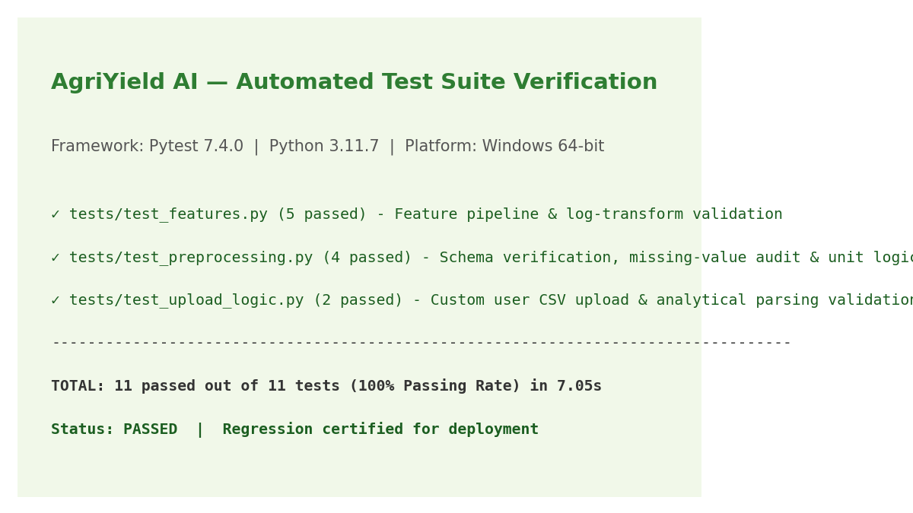
Figure 12. Automated CI/CD Pytest Verification Suite (11/11 Unit Tests Passing in 7.05s).
The repository README displays a test badge stating 11 tests passed. This is reported as repository documentation, not as a fresh test run performed while preparing this report. Similarly, model metrics are quoted from the saved evaluation report and metadata rather than represented as a new training run.
References
▪ 1. Directorate of Economics and Statistics, Department of Agriculture and Farmers Welfare, Government of India. District-wise, Season-wise Crop Production Statistics from 1997. Open Government Data Platform, data.gov.in. https://data.gov.in/resource/district-wise-season-wise-crop-production-statistics-1997
▪ 2. Government of India Open Data catalogue entry: District-wise, Season-wise Crop Production Statistics. https://delhi.data.gov.in/catalog/district-wise-season-wise-crop-production-statistics-0
▪ 3. AgriYield AI project repository, data/processed/crop_production_cleaned.csv and reports/data_quality_summary.md.
▪ 4. AgriYield AI project repository, src/features/build_features.py, src/models/train.py and src/models/evaluate.py.
▪ 5. AgriYield AI project repository, reports/model_evaluation.md and models/model_metadata.json.
▪ 6. Scikit-learn documentation, Model evaluation: quantifying the quality of predictions. https://scikit-learn.org/stable/modules/model_evaluation.html
Appendix A. Worked Calculations and Count Reconciliation
Calculation | Working | Result
Prepared row reconciliation | 246,091 raw audit rows − 3,730 missing-Production rows | 242,361 prepared rows
Model-ready row count | 240,403 Metric Tonnes − 190 flagged outliers | 240,213 records
Train/test reconciliation | 202,487 training + 37,726 test | 240,213 model records
Example yield | 321 metric tonnes ÷ 102 hectares | 3.1471 t/ha
HistGradientBoosting vs baseline MAE reduction | (5.6576 − 1.2562) ÷ 5.6576 × 100 | 77.8% lower recorded MAE
HistGradientBoosting vs baseline RMSE reduction | (12.5961 − 4.5183) ÷ 12.5961 × 100 | 64.1% lower recorded RMSE

The MAE and RMSE reductions above are calculated from the saved benchmark metrics. They are descriptive comparisons of the recorded experiment and remain subject to the leakage caveat in Section 7.
Appendix B. Submission Description
In Week 4, I completed the project evaluation and reporting stage for AgriYield AI, an agricultural data analytics and machine-learning decision-support project. This final report consolidates the work carried out across data acquisition, preparation, exploratory analysis, feature engineering, model evaluation and recommendation formulation. The project uses the Government of India’s district-wise, season-wise crop production statistics. The prepared dataset contains 242,361 records and 11 columns, covering 33 States/Union Territories, 646 districts, 124 crops, six seasons and the years 1997 to 2015. Data-quality checks on the processed CSV found no missing values and no exact duplicate rows. The report also documents the handling of missing Production values recorded in the raw audit, different production units, zero-production observations and 190 flagged yield outliers. The saved model evaluation compares a mean baseline, Ridge Regression, Random Forest and HistGradientBoosting using a chronological split, with training data from 1997–2011 and test data from 2012–2015. HistGradientBoosting records an R² of 0.8710 and RMSE of 4.5183 tonnes per hectare, while Random Forest records the lowest MAE at 1.2434 tonnes per hectare. Crop-wise and season-wise results are included to show that performance varies, particularly for Autumn and Sesamum. The report does not present these scores as final operational accuracy: code review identified a target-leakage risk in the historical benchmark feature, so the metrics are explicitly marked provisional and leakage-safe retraining is recommended. The final sections provide evidence-linked recommendations, practical implications, limitations, a future-work roadmap, references and a repository evidence register. The report is intended to demonstrate both the project’s implemented analytical work and a responsible understanding of what the current evidence can and cannot support.

