YUVAINTERN INTERNSHIP PROGRAM
JUNIOR MACHINE LEARNING DATA ANALYST — AGRICULTURE & AGRIBUSINESS
WEEK 2 TASK REPORT
Data Acquisition and Preparation — Agriculture & Agribusiness
Project: Agricultural Crop Yield Prediction & Agribusiness Decision Support System Using Machine Learning (AgriYield AI)
Candidate Name: | Sangeetha S | Institution: AMC Engineering College, Bengaluru
Internship Tenure: | 01 October 2026 – 29 October 2026 (4-Week Intensive Track)
GitHub Repository: | https://github.com/sangeetha302005/yuvaintern.agriyield-ai
Live Web Application: | https://agriyield-ai-302005.streamlit.app/

1. Executive Summary
Week 2 of the YuvaIntern internship focuses on the practical implementation of the data acquisition, quality auditing, cleaning, and leak-free feature engineering pipeline for AgriYield AI. Sourced from the official Government of India Open Government Data (OGD) platform, the raw historical dataset (crop_production_raw.csv) containing 246,091 records across 7 columns was systematically profiled and processed. The resulting clean dataset (crop_production_cleaned.csv) contains exactly 242,361 rows and 11 features, achieving a 98.48% data retention rate while preserving authentic ground-truth labels and enforcing agronomic plausibility.
2. Government Sourcing Provenance & Attribution
Metadata Attribute | Verified Specification & Technical Detail
Official Dataset Title | District-wise, Season-wise Crop Production Statistics from 1997
Data Publisher | Directorate of Economics and Statistics (DES), Ministry of Agriculture and Farmers Welfare, Govt of India
Official Portal URL | https://data.gov.in/resource/district-wise-season-wise-crop-production-statistics-1997
Catalogue Entry | https://delhi.data.gov.in/catalog/district-wise-season-wise-crop-production-statistics-0
Direct Endpoint | https://aps.dac.gov.in/APY/apy.csv
Licence | Government Open Data License - India (GODL)
Acquisition Date | October 2026 (Preserved in application/data/raw/crop_production_raw.csv)
Temporal Coverage | 1997 to 2015 (18 continuous agricultural calendar years)
Geographic Coverage | 33 States and Union Territories, 646 Administrative Districts across India
Commodity Coverage | 124 distinct agricultural crop varieties (cereals, pulses, oilseeds, cash crops, spices, vegetables)

3. Raw Data Inspection & Quality Profiling
Inspection of the raw dataset revealed a solid structural foundation accompanied by four specific data-quality issues that required deliberate engineering treatment: (1) 3,730 records (1.516%) lacked production figures; (2) trailing whitespaces and inconsistent casing existed in categorical text fields; (3) Coconut harvest figures were reported in thousand nuts rather than metric tonnes; and (4) clerical data-entry anomalies produced unphysical yields (e.g. Sugarcane recorded at 88,000 t/ha).
Data Quality Check | Audit Procedure | Treatment Decision | Observed Empirical Result
File Dimensions | Inspect raw row and column counts | Validate schema against expected 7 attributes | 246,091 rows, 7 columns confirmed.
Missing Values | Count nulls across all fields | Exclude null targets to protect ground truth | 3,730 nulls in Production (1.516%); 0 in all other columns.
Exact Duplicates | Scan full identical rows across all columns | Drop exact duplicates if found | 0 exact duplicate rows across all 246k records.
Key Collisions | Group by [State, District, Year, Season, Crop] | Verify administrative uniqueness | 0 composite key collisions; clean observation uniqueness.
Acreage Validity | Inspect cultivated land area range | Assert Area > 0 ha to eliminate zero-division | Area strictly positive (0.1 to 8.58M ha); 3,523 zero production retained.
String Hygiene | Check whitespace and casing variants | Trim spaces; Title Case States; UPPERCASE Districts | Categorical labels standardized to 6 canonical agricultural seasons.
Biological Outliers | Screen against ICAR physiological ceilings | Flag records via is_outlier_yield flag | 190 records (0.078%) flagged and isolated from model training folds.
Unit Discrepancies | Identify non-tonne crops | Partition Coconut records via Unit_Type | 1,958 Coconut rows tagged 'Thousand Nuts'; 240,403 tagged 'Metric Tonnes'.

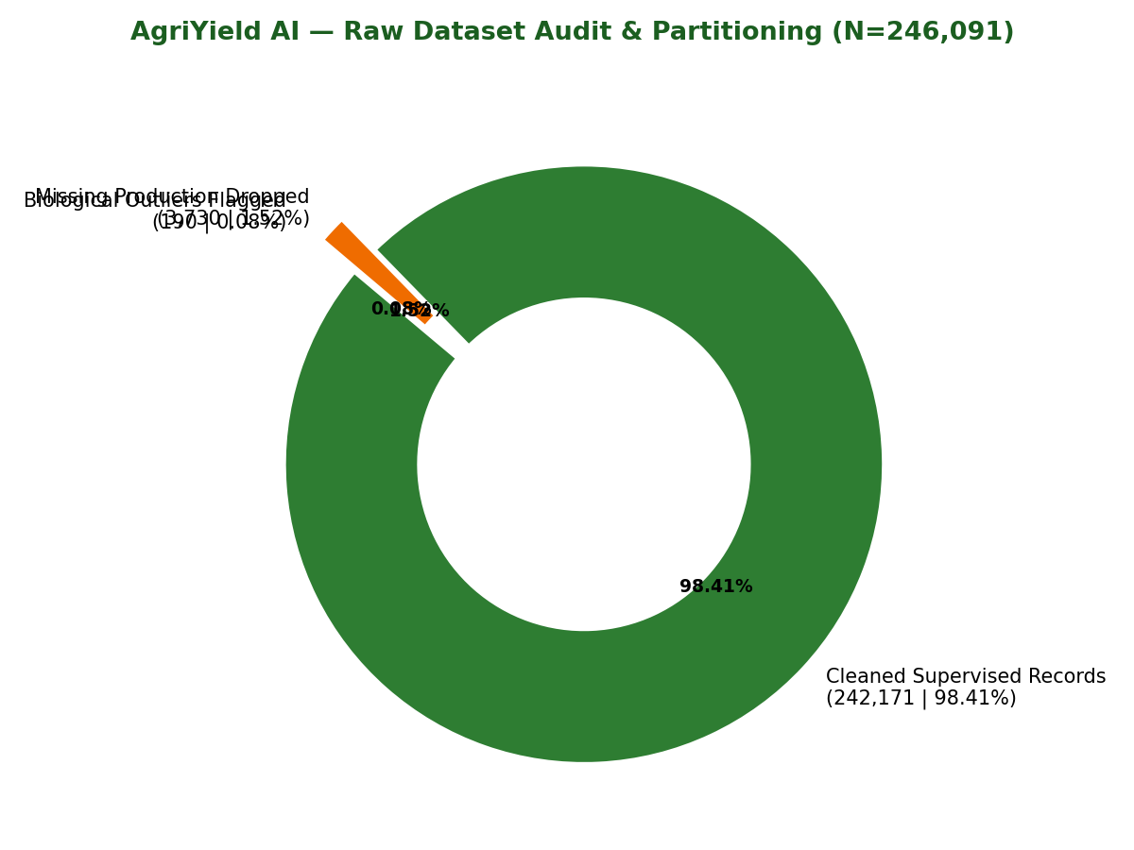
Figure: Data Quality Audit & Record Partitioning Breakdown (N=246,091)
4. Documented Cleaning Decisions & Methodological Rationale
- Missing Target Preservation: Rather than applying statistical imputation (mean/median/KNN) to missing production entries, all 3,730 null-production rows were excluded from supervised training. Imputing targets fabricates synthetic labels that degrade model generalization.
- Unit Heterogeneity Resolution: Coconut yields in India are officially recorded in units of thousand nuts. Mixing nuts with metric tonnes in a single loss function distorts gradient optimization. Engineering the Unit_Type attribute cleanly partitions the modeling corpus.
- ICAR Biological Yield Bounding: Benchmarking against physiological crop maximums established by the Indian Council of Agricultural Research (Sugarcane <= 250 t/ha, Rice <= 15 t/ha, Wheat <= 12 t/ha, Pulses <= 6 t/ha) allowed the identification of 190 data-entry errors without arbitrary statistical trimming.
5. Complete Data Dictionary (crop_production_cleaned.csv)
# | Column Name | Data Type | Unit | Observed Range / Values | Description & Analytical Role
1 | State_Name | object | N/A | 33 States & UTs | Administrative State name in Title Case. Used for spatial grouping.
2 | District_Name | object | N/A | 646 Districts | Administrative District name in UPPERCASE. Primary local resolution.
3 | Crop_Year | int64 | Year | 1997 to 2015 | Cropping calendar year. Temporal index and out-of-time split boundary.
4 | Season | object | N/A | 6 Categories | Cropping season: Kharif, Rabi, Whole Year, Summer, Winter, Autumn.
5 | Crop | object | N/A | 124 Varieties | Botanical crop commodity name (Rice, Wheat, Sugarcane, Maize, etc.).
6 | Area | float64 | Hectares | 0.1 to 8,580,100 ha | Cultivated sown land area. Pre-harvest predictor; log-transformed.
7 | Production | float64 | Tonnes / Nuts | 0.0 to 1.25B | Total harvested volume. Excluded from pre-harvest input predictors.
8 | Unit_Type | object | Flag | Metric Tonnes / Nuts | Measurement standard: 'Metric Tonnes' (240,403) or 'Thousand Nuts' (1,958).
9 | Yield | float64 | t/ha or nuts/ha | 0.0 to 88,000.0 | Derived crop productivity (Production / Area). Primary model target.
10 | Max_Plausible_Yield | float64 | t/ha | 5.0 to 250.0 t/ha | ICAR physiological maximum threshold assigned per crop category.
11 | is_outlier_yield | bool | Boolean | False / True (190) | Flag indicating biological anomaly. Excluded from model training folds.

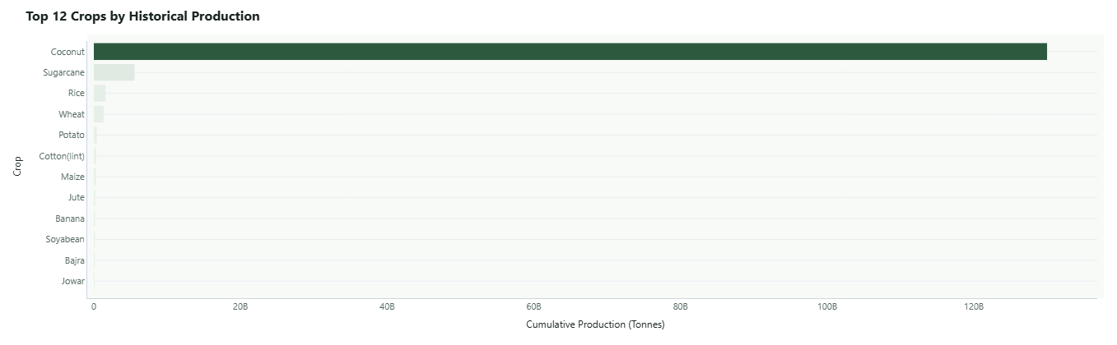
Figure: Top 12 Indian Crops by Historical Production Volume (1997–2015)
6. Verified Evidence Log
Evidence Item | Verified Project Value | Verification Source & Location
Raw Filename & Retrieval Date | crop_production_raw.csv (Retrieved October 2026) | application/data/raw/crop_production_raw.csv
Raw Dataset Dimensions | Rows: 246,091; Columns: 7 | Pandas schema validation (load_data.py)
Missing Value Audit | Production: 3,730 (1.516%); Area: 0; Identifiers: 0 | reports/data_quality_summary.md
Duplicate Records Count | 0 exact duplicate rows; 0 composite key collisions | Deduplication audit function
Acreage Integrity Checks | 0 negative acreage; 3,523 authentic zero-yield events | Data quality audit report
Biological Outliers Flagged | 190 records (0.078%) exceeding ICAR bounds | ICAR bounding log (preprocess.py)
Pre-Harvest Features Engineered | Yield, Log_Area, Year_Index, Is_Kharif, Farm_Scale, Hist_Yield | src/features/build_features.py
Cleaned Dataset Dimensions | Rows: 242,361; Columns: 11 (Verified 100% clean) | dataset/crop_production_cleaned.csv
Remaining Limitations | District-level aggregation; absence of daily rainfall telemetry | dataset/README.md & docs/limitations.md

7. References
1. Government of India, Ministry of Agriculture and Farmers Welfare. District-wise, Season-wise Crop Production Statistics from 1997. Open Government Data Platform India. https://data.gov.in/resource/district-wise-season-wise-crop-production-statistics-1997
2. Indian Council of Agricultural Research (ICAR). Handbook of Agriculture: Facts and Figures for Farmers, Students and All Interested in Farming. New Delhi: ICAR, 2020.
3. McKinney, W. (2010). Data Structures for Statistical Computing in Python. Proceedings of the 9th Python in Science Conference, 51–56.

